**Discrete Mathematics**

**HW4**

**共12題**

**Exercise 5.1**

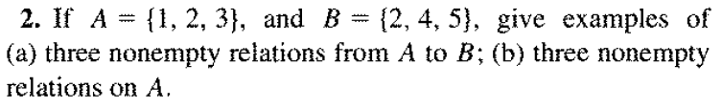



**Exercise 5.2**

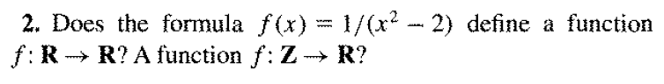

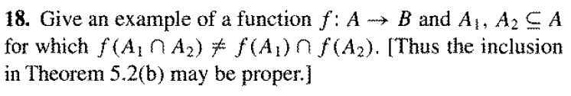

**Exercise 5.3**

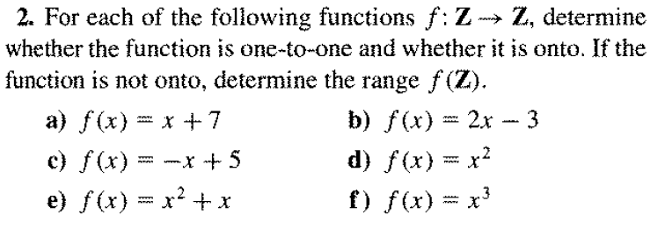

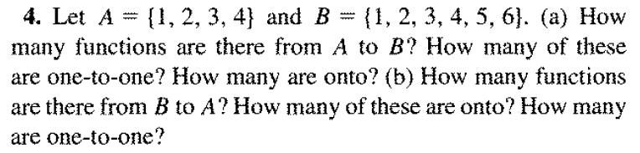

**Exercise 5.4**

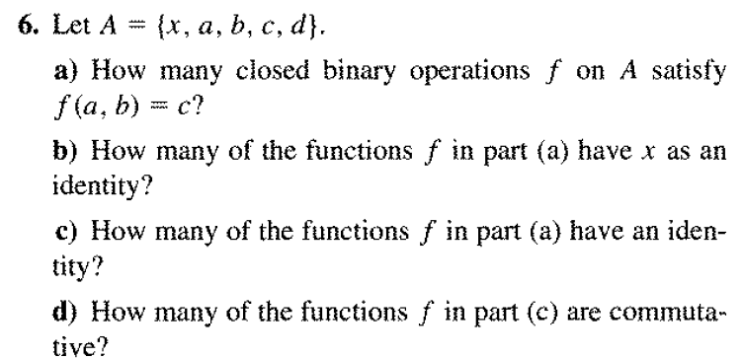

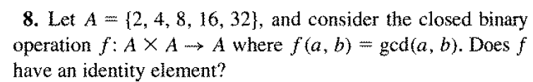

**Exercise 5.5**

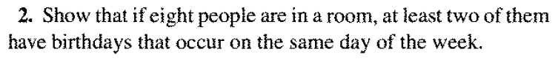

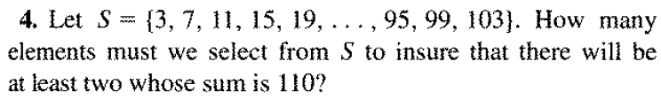

**Exercise 5.6**

