**Discrete Mathematics**

**HW5**

**共9題**

**Exercise 11.1**

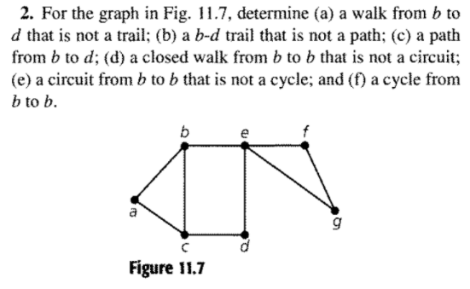

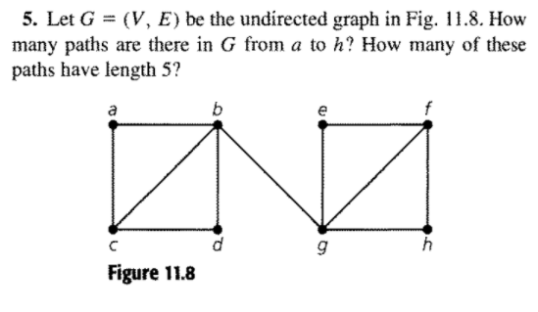

**Exercise 11.2**

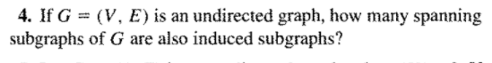

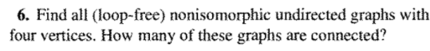

**Exercise 11.3**

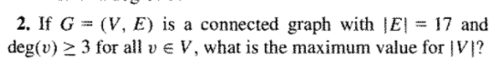

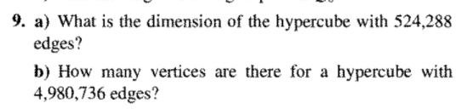

**Exercise 11.4**

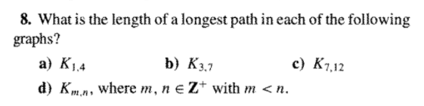

**Exercise 11.5**

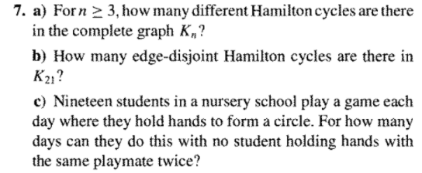

**Exercise 11.6**

