Tipos de Cifrados
- IDEA
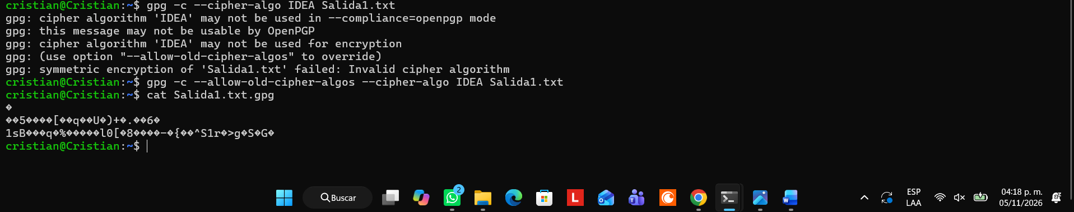
- 3DES:
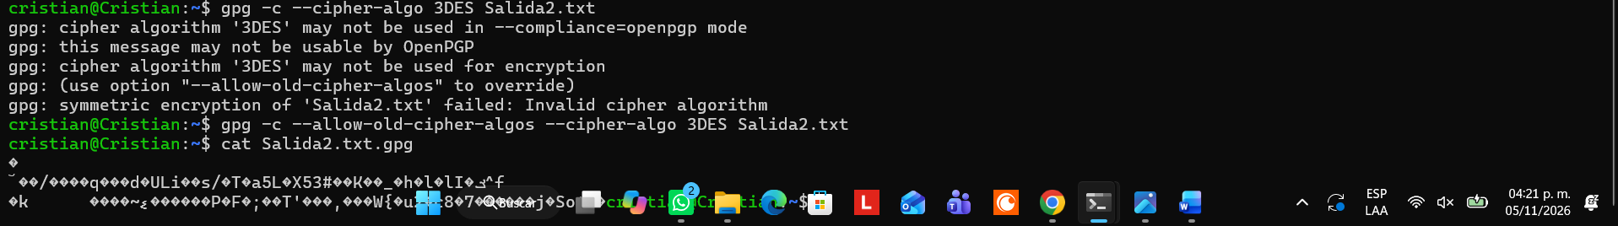
- CAST5
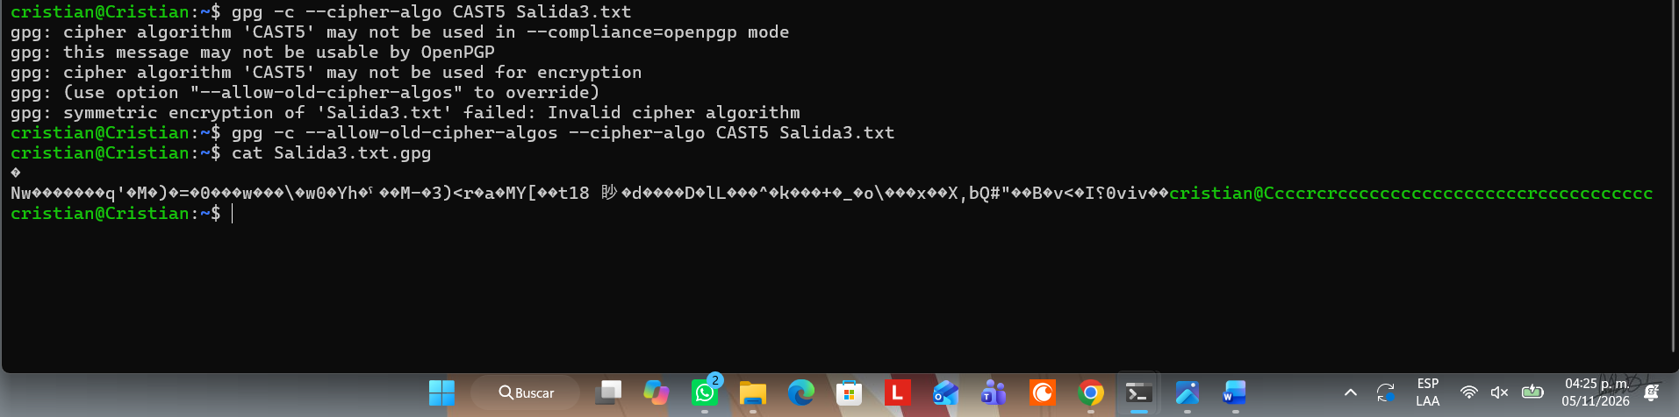
- BLOWFISH
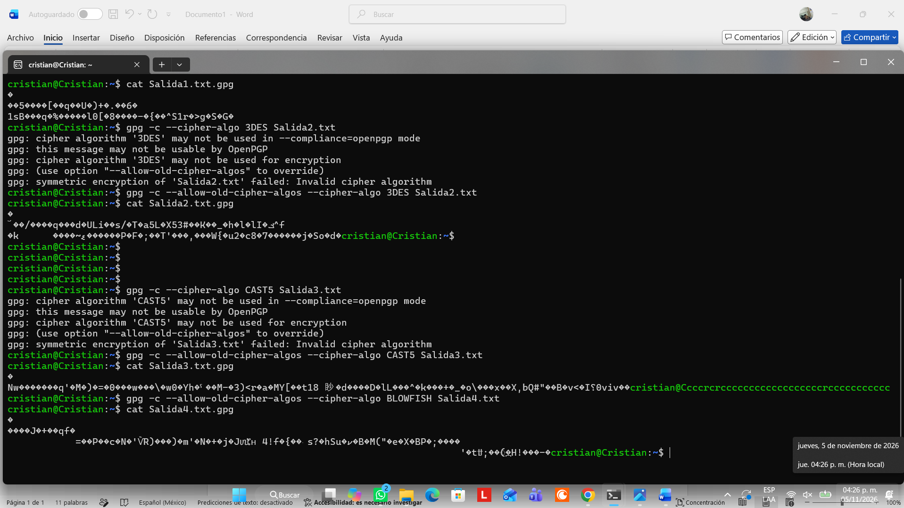
- AES
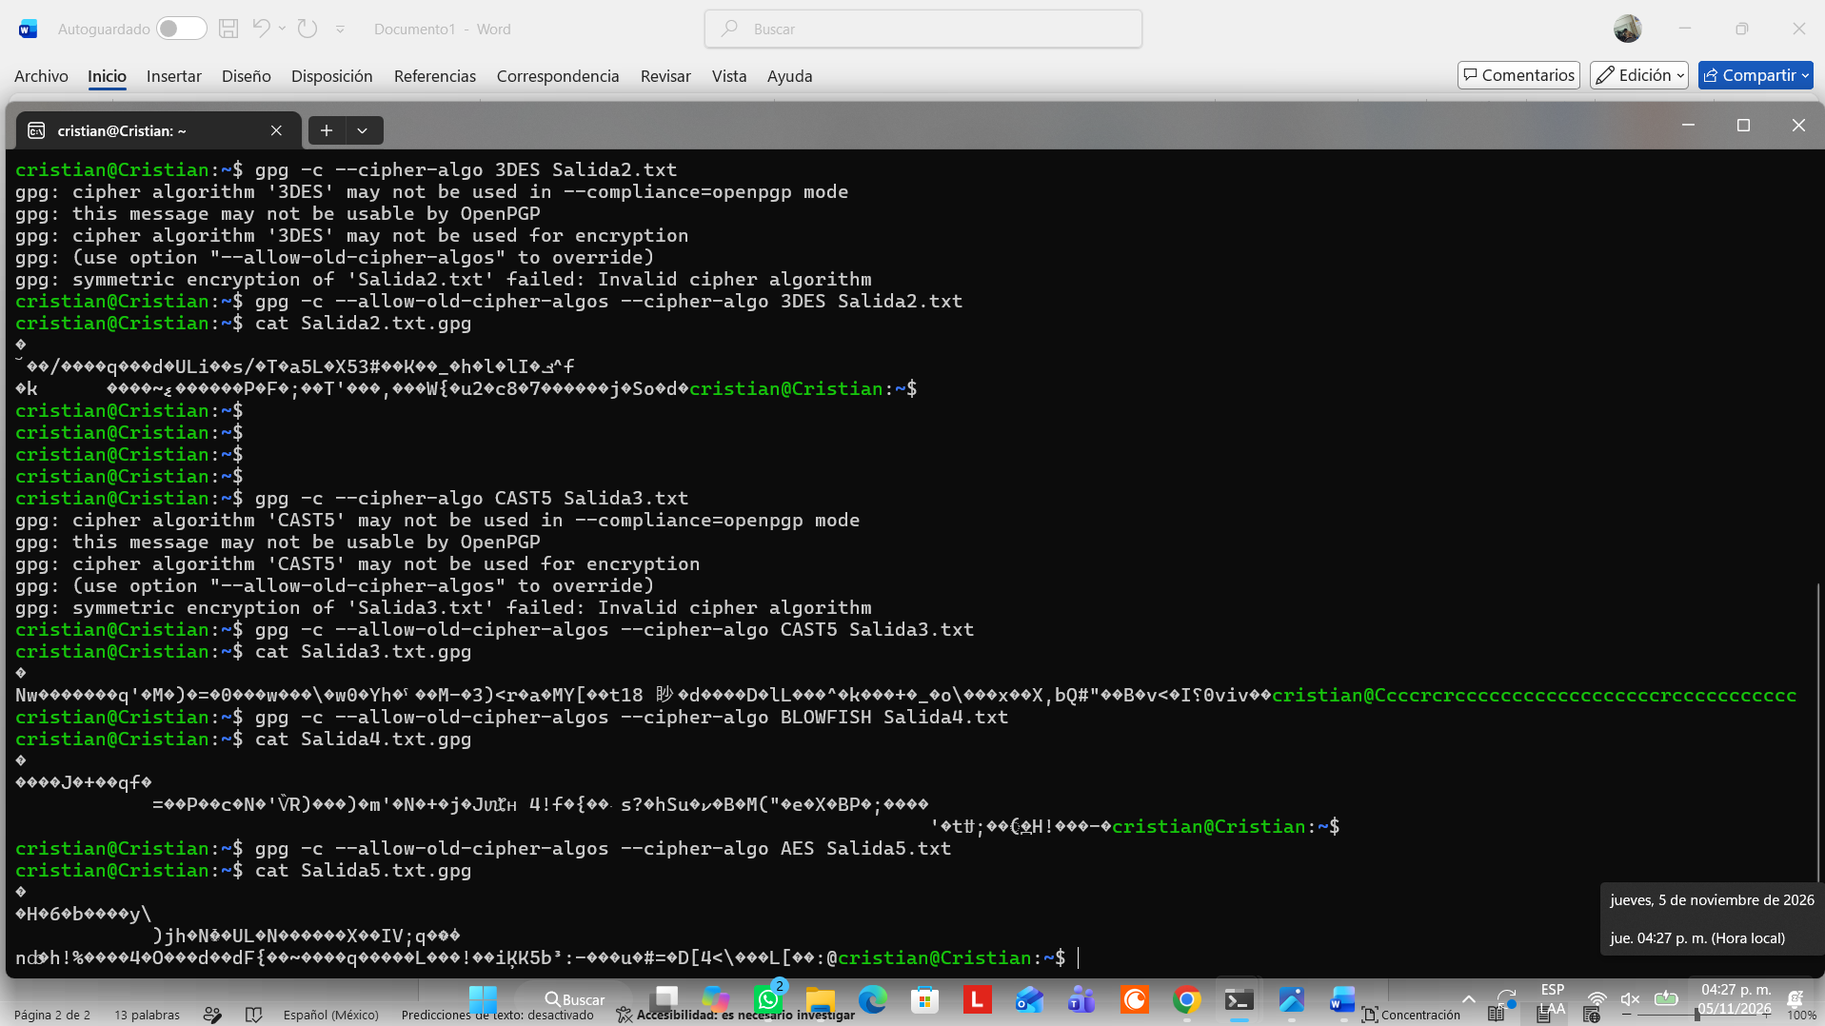
- TWOFISH
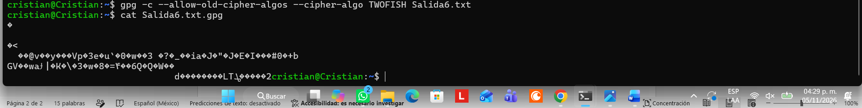
- CAMELLIA128
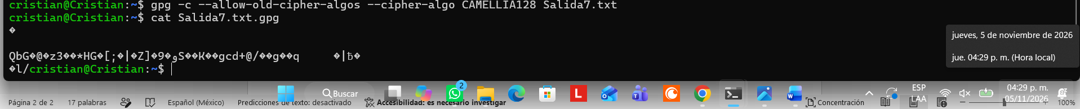
- CAMELLIA192
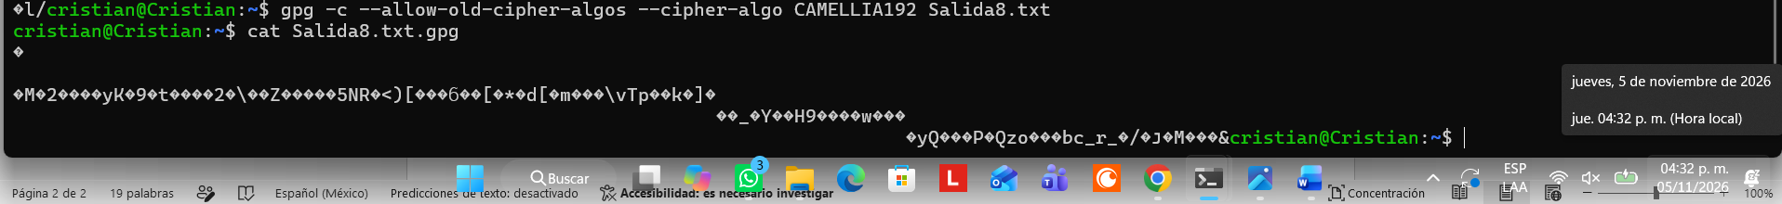
- CAMELLIA256

