[K-food] Site Plan

[Yedam Park]

WDD 130

Overview

Purpose
[To demonstrate and explain authentic Korean food recipes]

Audience
[People in the U.S.]

Branding

Website Logo
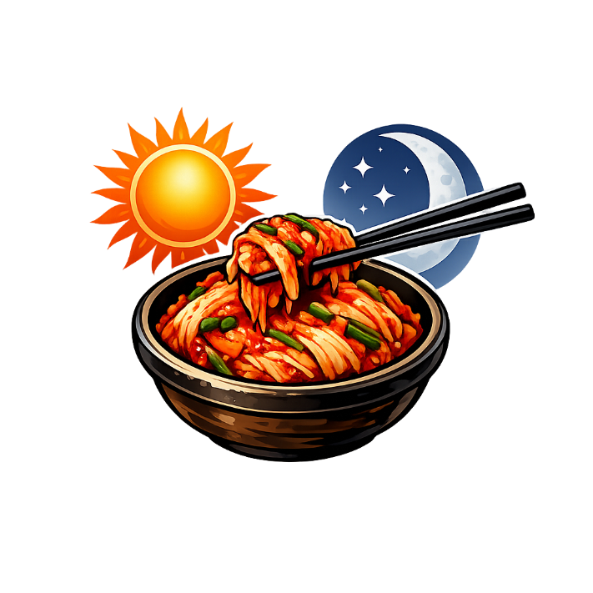

Style Guide

Color Palette
Primary | Secondary | Accent 1 | Accent 2
#FFEBE7 | #090C08 | #86CB92 | #AD5D4E

Typography

Heading Font: [Nanum brush script]

Paragraph Font: [원스토어 모바일 pop]

Navigation
Home Page2(recipe details) Page3(Ingredient explanation, measuring explanation)

Content

[put all content for the pages here, including written text and images]
Welcome message:
Welcome! Get some Korean food recipes and make your own.

Main image:
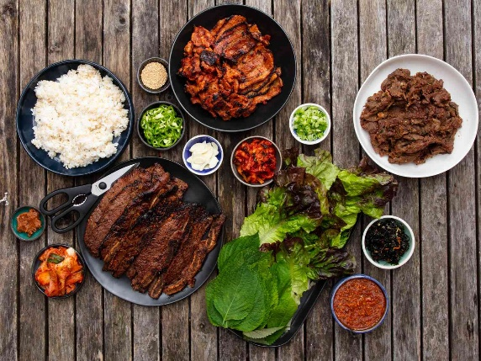
Recipes section:
Recipe1 – Kimchi jjigae
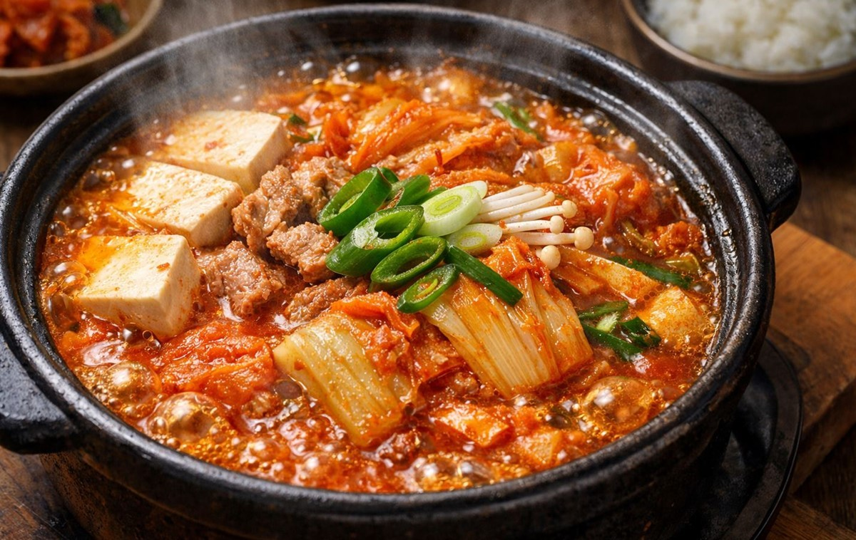
Recipe 2 – Bulgogi
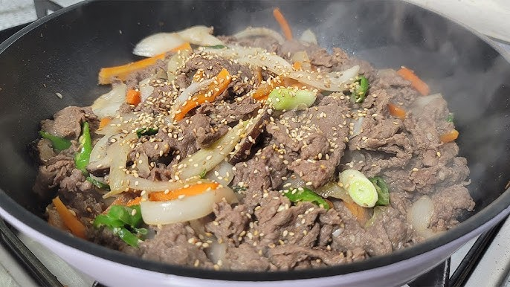
Recipe 3 – Gooksu
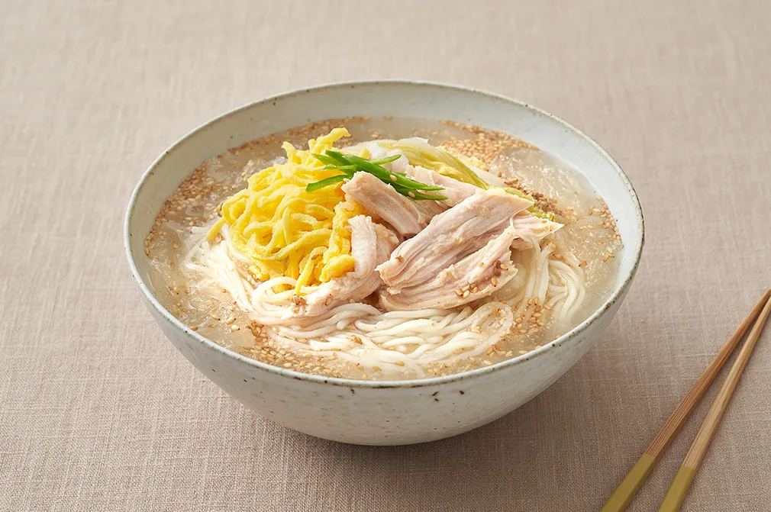

About us
We try our best to explain authentic recipes with authentic ingredients and style. Recipes are from several resources.

Footer
Do you want to work with us? xxx-xxx-xxxx

Copyright: K-Food

Page2
Recipe 1 – Kimchi Jjigae
https://chef-choice.tistory.com/372
Beef broth: 1L
Kimchi: 1 cabbage
Pork belly: 400g
Ground red pepper: 3tbsp
fish sauce: 3tbsp
Beef bouillon: 1tbsp
Minced garlic: 1tbsp
Water if needed
Tofu: as much as wanted
Green onion: 200g

Directions:
This is actually an easy recipe.
Put everything and then boil it until the meat is cooked.

Recipe 2 – Bulgogi
https://chef-choice.tistory.com/42
Ingredients for 2~3 people:
Pork arm shoulder 800g
Soy sauce : 50ml
Cooking wine: 50ml
Onion: 1/2 (grate or use blender)
Minced garlic: 1 tbsp
Sugar: 2tbsp
Beef bouillon: 1/2tbsp
Black pepper: 1/3tbsp
Black bean paste: 1tbsp
Green onion: a handful, cut into long pieces
Toasted sesame seed: a shake

Directions:
- Put together pork, soy sauce, cooking wine, grated onion, minced garlic, sugar, beef bouillon, black pepper, black bean paste.
- Mix them well, and then wrap it. Let it sit for a day.
- Grill it on low heat.
- When the meat is done, put green onion and toasted sesame seeds.

Recipe 3 – Gooksu
https://chef-choice.tistory.com/388
Zucchini: 700g (cut into long pieces)
Salt: 1tbsp
Cooking oil
Salted shrimp: 0.5tbsp
Noodles: as much as you want
Water : 1L
Seafood Dashi pack: 1pack
Soy sauce: 1tbsp
Fish sauce: 1tbsp
Crushed seaweed: a handful
Red pepper: to taste
Toasted Sesame seed: a shake
Crushed red pepper: to taste

Directions:
- Put zucchini and salt together. Pour away the water as it comes out.
- Put salted zucchini, salted shrimp on oiled pan and stir fry it.
- Now it is a broth part. Put water and Dashi pack together and boil it.
- When it is boiling, put fish sauce and soy sauce
- Cook noodles
- Now in a bowl put noodles, broth, zucchini, crushed seaweed, red pepper, crushed red pepper, toasted sesame seed.

Page3
Ingredients explanation:
Basically the kinds or brands of the ingredients doesn’t matter.
However, one ingredient could be taste different. For example: A Kimchi can be fresh made and it is sweet, salty, spicy, but other Kimchi could be aged and it is salty, spicy and sour. Then the recipe takes it differently, so check those taste-changing ingredients thoroughly. Also, there are different types of one ingredient such as soy sauce, so be careful with those too. Here are some lists of those:
Kimchi, different types of soy sauce, different types of tofu, different types of soybean paste, etc.

Substitutes of the ingredients
Dry Sweeteners: sugar, oligosaccharide, stevia
Wet Sweeteners: corn syrup, honey, fruit syrups
Butter (animal fat/oil) - perilla oil
Margarine (vegetable fat/oil) – sesame oil

Measuring explanation:
Teaspoon = t or tsp.
Tablespoon = T, TB, or tbsp.
Cup = C or c.
Pint = pt.
Quart = qt.
Gallon = gal.
Ounce = oz.
Fluid ounce = fl oz.
Gram = g
Kilogram = kg
Milliliters = ml
Liters = L
There could be different types of measurements, So be careful and check it thoroughly.
⭐ If the measurements are only numbers, it indicates the ratio. Use same measurement tool for all of the ingredients.

Wireframes

Home

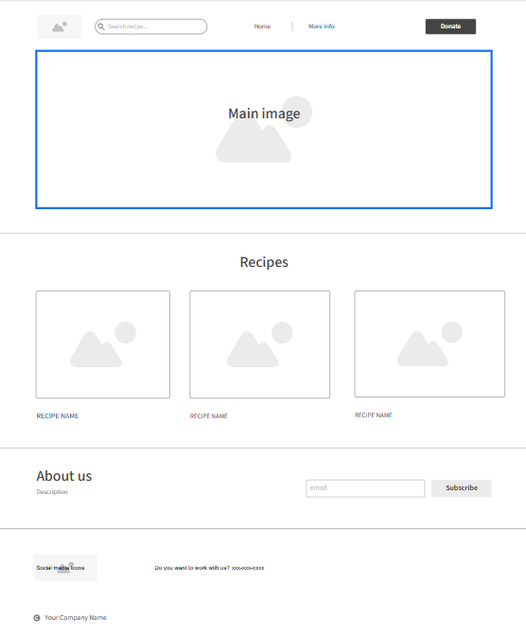

Page 2

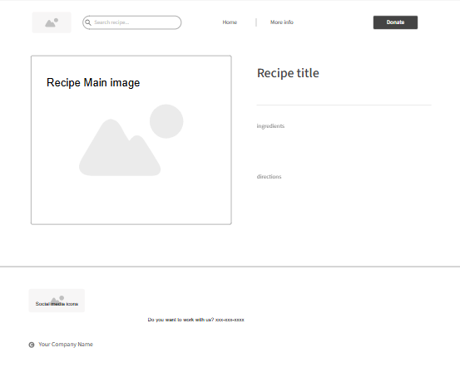

Page 3
