PROJECT REPORT
Script-Controlled ACL – Restrict Record Access Based on Field Value
Course: ServiceNow System Administrator – NM Eng (Skill Wallet Group Project)
Team Members
Anbarasan S
Monisha S
Anbuchselvan M
Arifa M
Platform: ServiceNow (Personal Developer Instance)
Project ID: SWTID-2026-5274

Table of Contents
1. Introduction
2. Ideation Phase
3. Requirement Analysis
4. Project Design
5. Project Planning & Scheduling
6. Functional and Performance Testing
7. Results
8. Advantages & Disadvantages
9. Conclusion
10. Future Scope
11. Appendix

1. INTRODUCTION

1.1 Project Overview
This project demonstrates record-level security in ServiceNow using Script-Controlled Access Control Lists (ACLs). A custom table, Institution Details (u_institution_details), stores student and faculty information for the branches ECE, EEE and CSE. Script-controlled ACLs for the READ, CREATE, WRITE and DELETE operations restrict which records a user can see and modify based on the value of the Branch field and the roles held by the logged-in user.
A Script-Controlled ACL restricts access to records by using a custom script. The script checks specific field values and user conditions before granting access, and users can access the record only when the ACL script evaluates to true.

1.2 Purpose
- To understand how script-controlled READ, WRITE, CREATE and DELETE ACLs enforce record-level security.
- To learn how user roles and record field values are evaluated together to make access decisions.
- To protect sensitive student and faculty data from unauthorized viewing, modification, creation and deletion across forms, lists and Service Portal interfaces.
- To gain hands-on experience with users, roles, tables and ACL scripting as required of a ServiceNow System Administrator.

2. IDEATION PHASE

2.1 Problem Statement
Educational institutions keep student and faculty details such as email, phone number and roll number in a single table. Without fine-grained security, any user with table access can view or change records belonging to other branches. A mechanism is needed so that a user sees and manipulates only the records permitted for their branch, while administrators retain full access.

2.2 Empathy Map Canvas
Quadrant | Description (Branch user / Institution staff)
Says | "I should only see my own branch's student records." "Why can others view our contact details?"
Thinks | Student phone numbers and emails are sensitive; access must be controlled; records should not be deleted by mistake.
Does | Opens the Institution Details list, searches records, tries to create, edit or delete entries.
Feels | Concerned about privacy and data misuse; reassured when only relevant records are shown.
Pain points | Records of all branches are visible; no control over who can edit or delete; role-only security is too coarse.
Gains | Branch-wise record isolation, controlled create/edit/delete, and administrator oversight.

2.3 Brainstorming
- Option 1: Restrict access using roles alone – rejected, as it cannot differentiate records inside one table.
- Option 2: Use condition-based ACLs – possible, but limited for complex logic.
- Option 3 (selected): Use Script-Controlled ACLs that evaluate the Branch field value together with user roles for each of the four operations.
- Test with a restricted user (EEE User) and an administrator to confirm correct behaviour for each operation.

3. REQUIREMENT ANALYSIS

3.1 Customer Journey Map
Stage | User action | Experience | System response
Login | EEE User signs in to the instance | Expects restricted view | Roles bb1–bb4 evaluated
View | Opens Institution Details list | Sees only relevant records | READ ACL filters to Branch = EEE (1 of 3)
Create | Clicks New | Able to add entries | CREATE ACL allows the New button
Edit | Updates Description field | Change saved | WRITE ACL permits update
Delete | Selects record and chooses Delete | Confirmation shown, record removed | DELETE ACL permits; list becomes empty

3.2 Solution Requirement
Functional requirements:
- Create a user and assign custom roles (bb1, bb2, bb3, bb4).
- Create the custom table Institution Details with fields Branch, Description, Email, Faculty Name, Phone Number, Student Name and Student Roll Number.
- Create script-controlled ACLs for READ, CREATE, WRITE and DELETE on the table.
- Allow access only when the ACL script evaluates to true.
Non-functional requirements: security, correctness of access decisions, usability of lists and forms, and maintainability of ACL scripts.

3.3 Data Flow Diagram
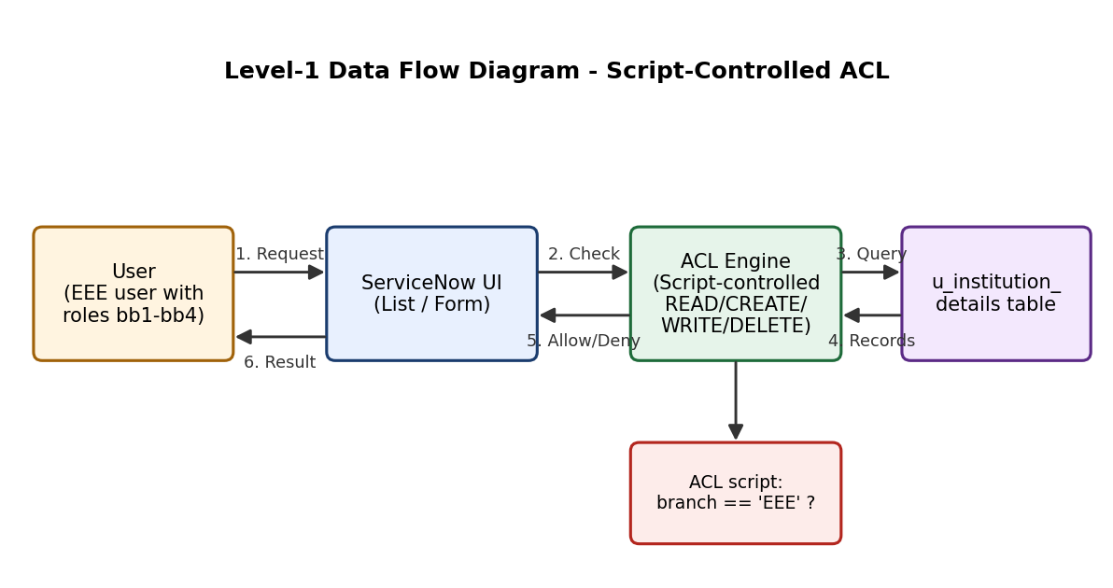
Figure 3.1 – Level-1 Data Flow Diagram

3.4 Technology Stack
Component | Technology
Platform | ServiceNow Personal Developer Instance (dev294024)
Security mechanism | Access Control Lists (ACL) with script condition
Scripting language | JavaScript (ServiceNow server-side scripting, GlideRecord / gs APIs)
Data store | Custom table u_institution_details (Application: Global)
Interfaces | Lists, Forms, Service Portal
Collaboration | Skill Wallet platform, GitHub (skill-wallet-project)

4. PROJECT DESIGN

4.1 Problem Solution Fit
The problem is uncontrolled visibility and modification of records inside a shared table. Script-controlled ACLs fit this problem directly because they allow access decisions to combine the user's roles with the value of a record field (Branch). The result is that an EEE User sees only EEE records, while an administrator sees all three branches.

4.2 Proposed Solution
- Create a user (EEE User) and assign roles bb1, bb2, bb3 and bb4.
- Create the table Institution Details with Branch as a Choice field and Student Name and Faculty Name as references to the User table.
- Write four script-controlled ACLs (READ, CREATE, WRITE, DELETE) that return true only when the Branch field value and user condition match.
- Verify each ACL by impersonating the restricted user and comparing with the administrator view.

4.3 Solution Architecture
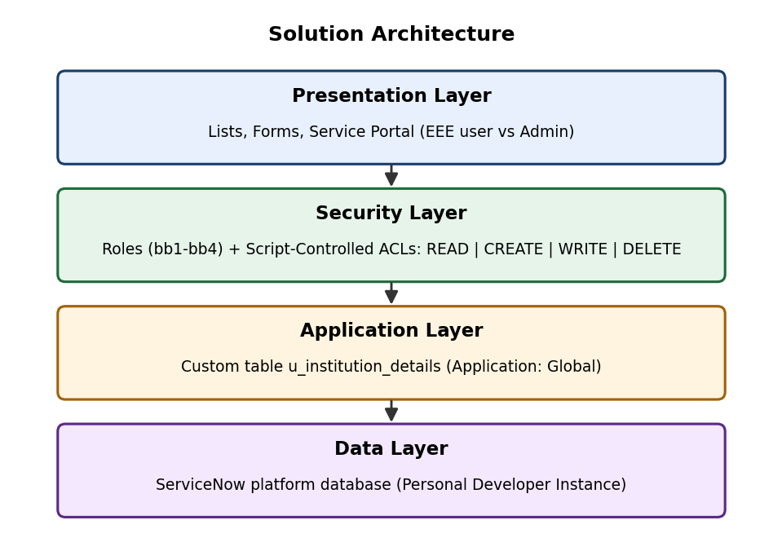
Figure 4.1 – Solution Architecture

5. PROJECT PLANNING & SCHEDULING

5.1 Project Planning
The project was organised into seven milestones on the Skill Wallet platform (7 epics, 8 stories). Execution dates are taken from the working screenshots in the project repository.
Milestone | Activity | Date | Status
1 | Creation of Users and Roles | 28 Sep 2026 | Completed
2 | Tables Creation | 29 Sep 2026 | Completed
3 | Creation of ACL – READ | 29 Sep 2026 | Completed
4 | Creation of ACL – CREATE | 29 Sep 2026 | Completed
5 | Creation of ACL – WRITE | 29 Sep 2026 | Completed
6 | Creation of ACL – DELETE | 29 Sep 2026 | Completed
7 | Conclusion and report | Oct 2026 | In progress

6. FUNCTIONAL AND PERFORMANCE TESTING

6.1 Performance Testing
Each ACL was tested by logging in as the restricted user (EEE User) and comparing the outcome with the administrator view.
No. | Test case | Expected result | Observed result | Status
1 | READ as EEE User | Only Branch = EEE record shown | 1 of 1 record (EEE) | Pass
2 | READ as Admin | All records shown | 3 of 3 records | Pass
3 | CREATE as EEE User | New button available | New button visible | Pass
4 | WRITE as EEE User | Description edit saved | Updated to "ACL is executed" | Pass
5 | DELETE as EEE User | Delete option and confirmation | Record deleted | Pass
6 | List after DELETE | No records for user | "No records to display" | Pass

Observation: before the CREATE ACL, the EEE User list had no New button. After the CREATE ACL was added, the New button appeared, confirming that the ACL was evaluated for that operation. The lists loaded promptly on the developer instance for all tests.

7. RESULTS

7.1 Output Screenshots
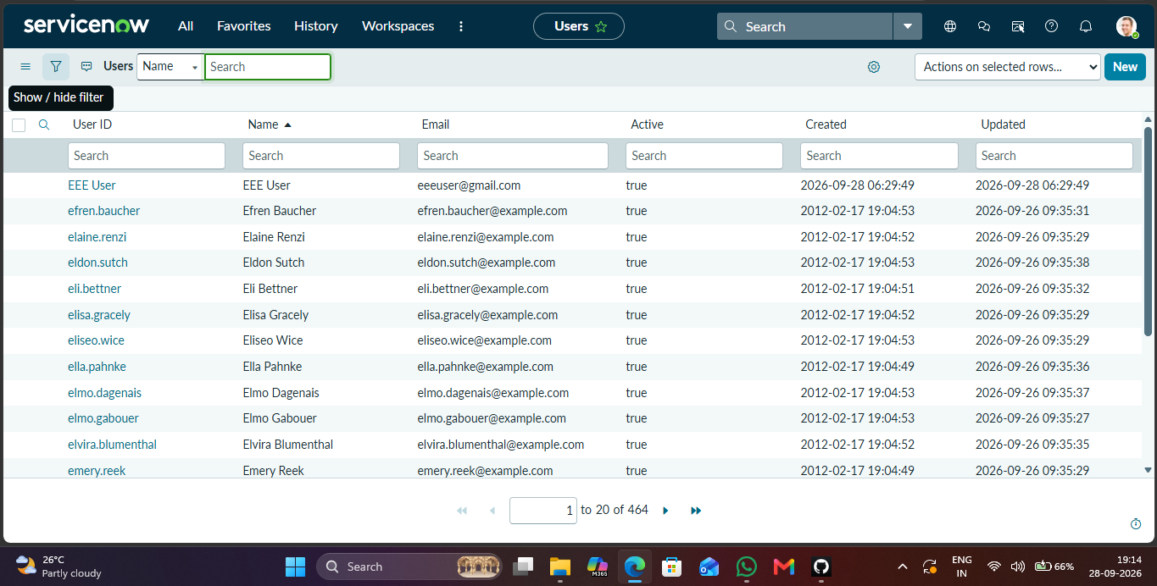
Figure 7.1 – Users list (464 users) in the instance
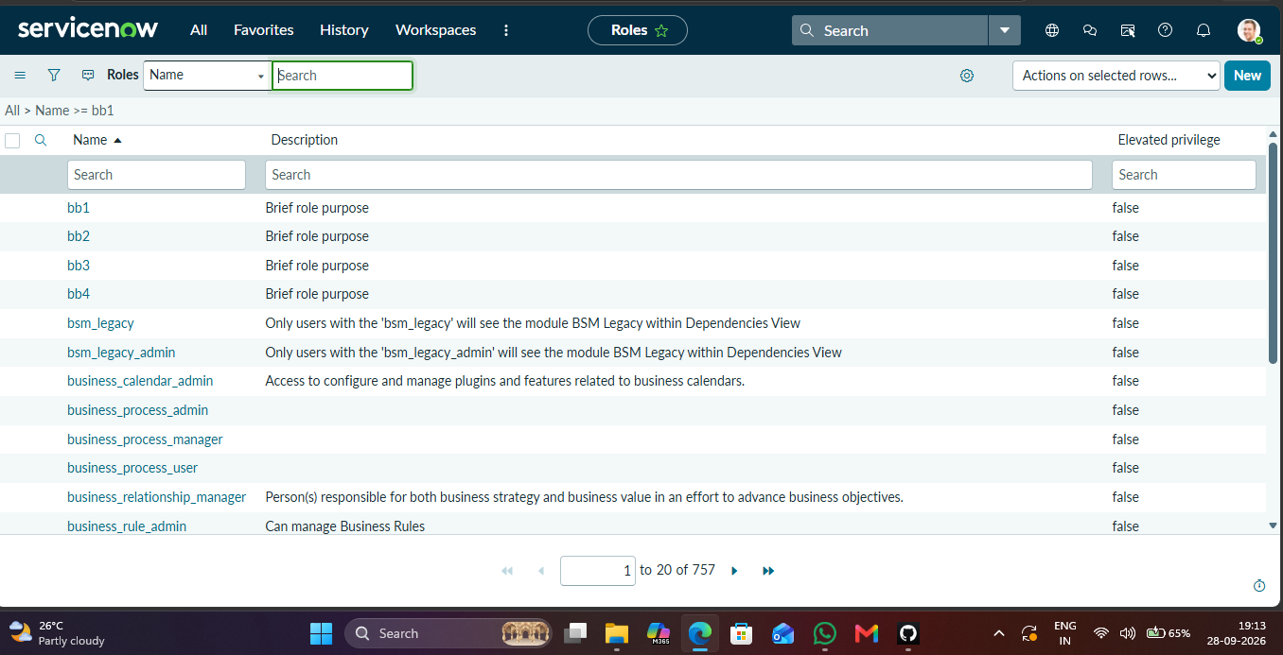
Figure 7.2 – Roles list including custom roles bb1–bb4
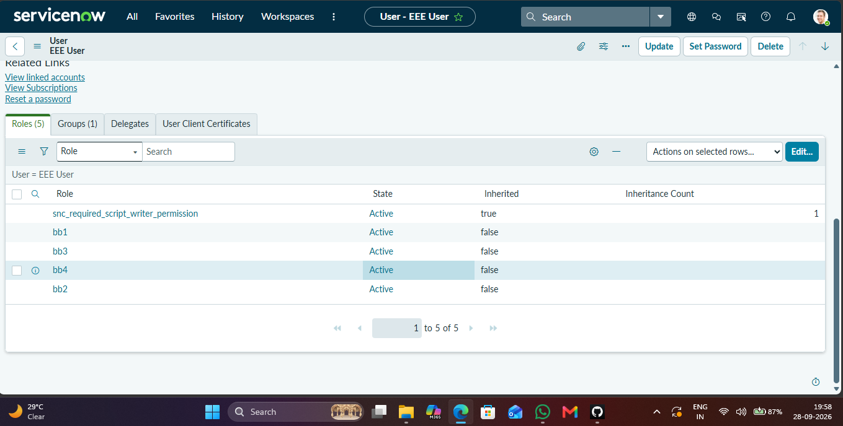
Figure 7.3 – Roles bb1, bb2, bb3, bb4 assigned to EEE User
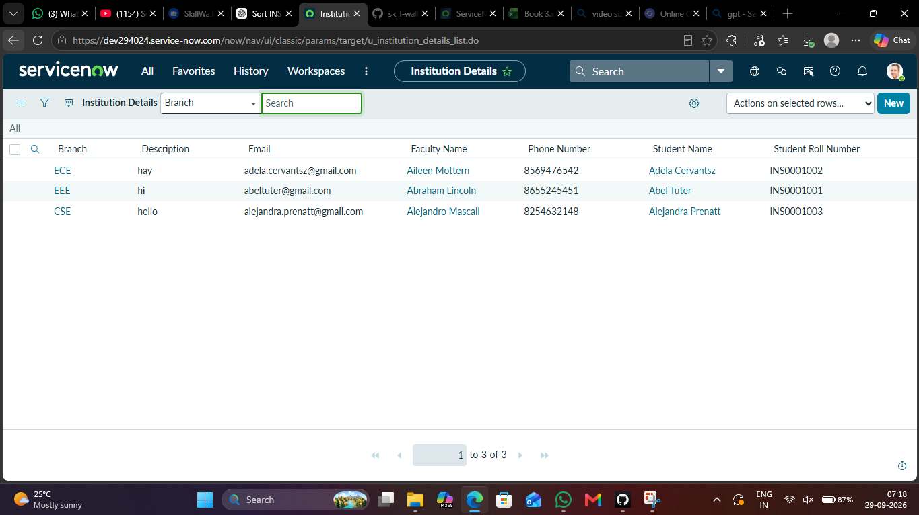
Figure 7.4 – Institution Details table with three records (ECE, EEE, CSE)
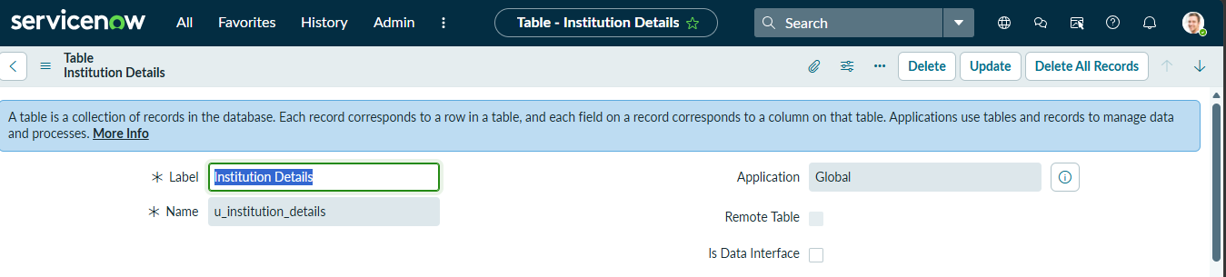
Figure 7.5 – Table definition: label Institution Details, name u_institution_details
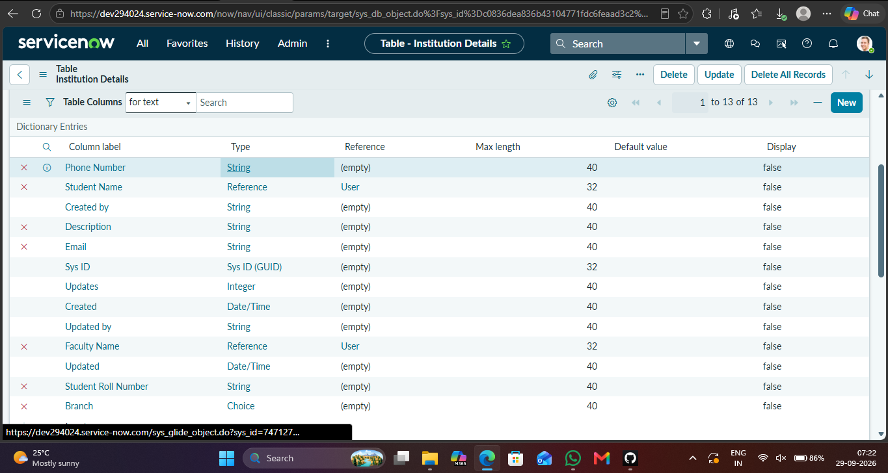
Figure 7.6 – Table columns and field types
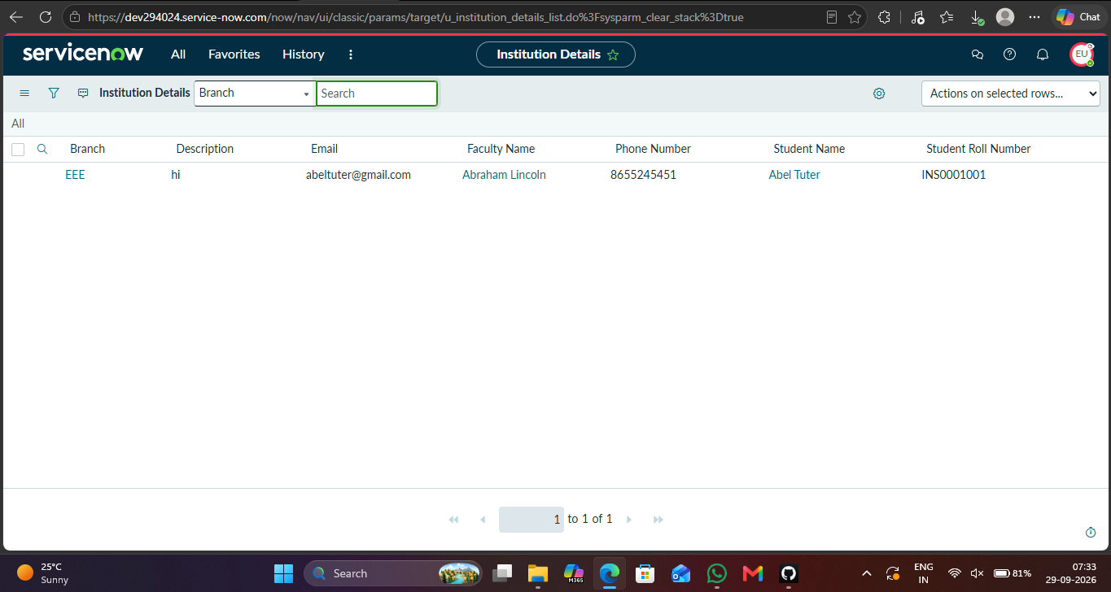
Figure 7.7 – READ ACL: EEE User sees only the EEE record
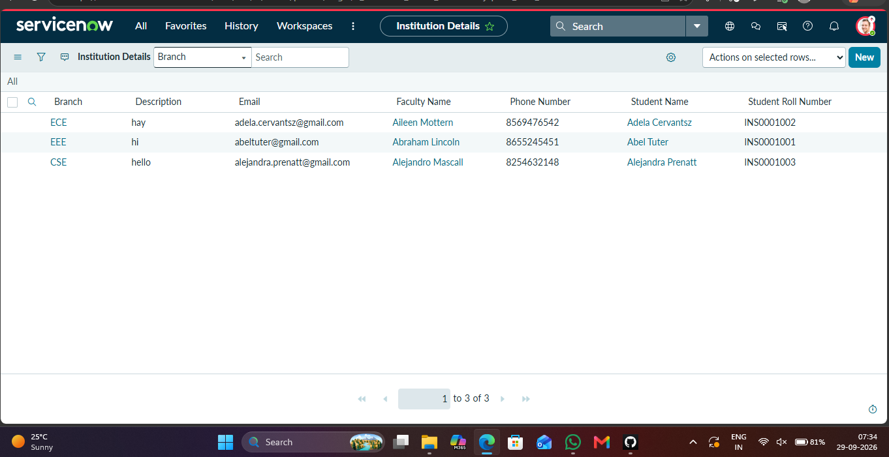
Figure 7.8 – Administrator view: all three records visible
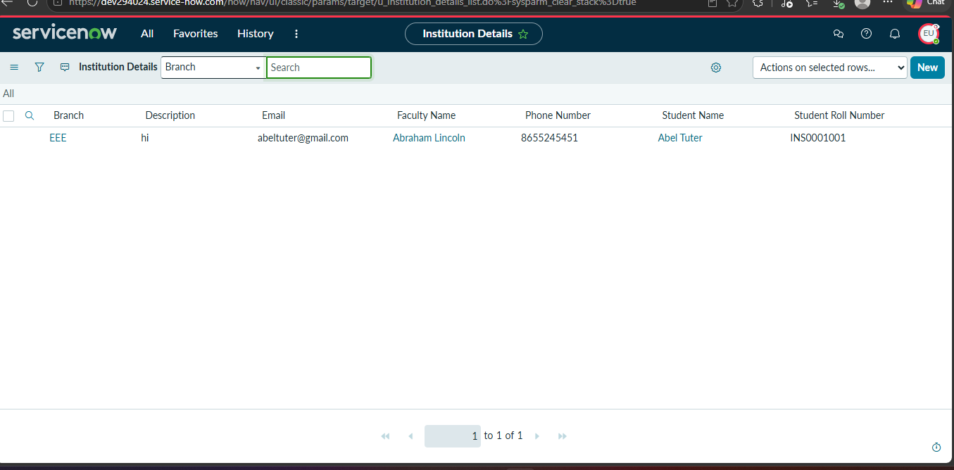
Figure 7.9 – CREATE ACL: New button available to EEE User
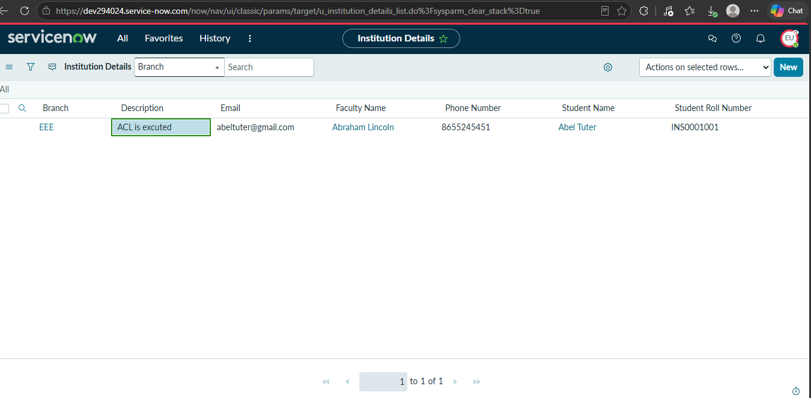
Figure 7.10 – WRITE ACL: Description edited by EEE User
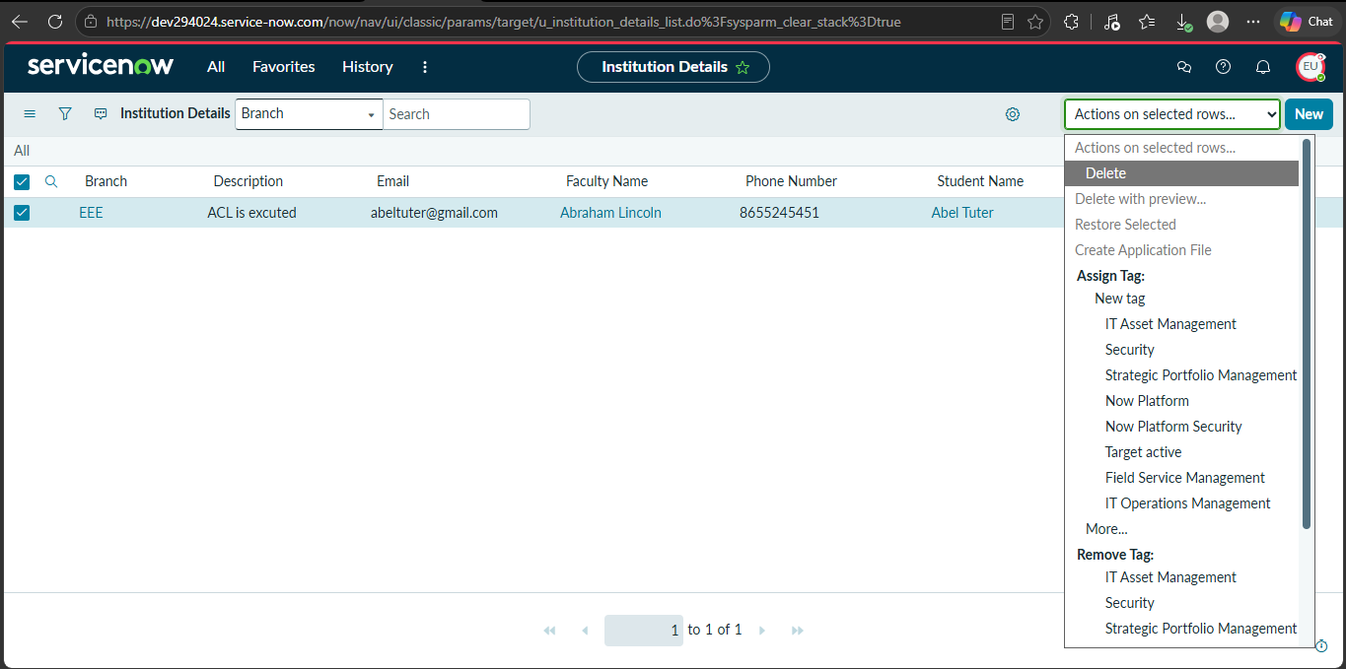
Figure 7.11 – DELETE ACL: Delete action available on the selected record
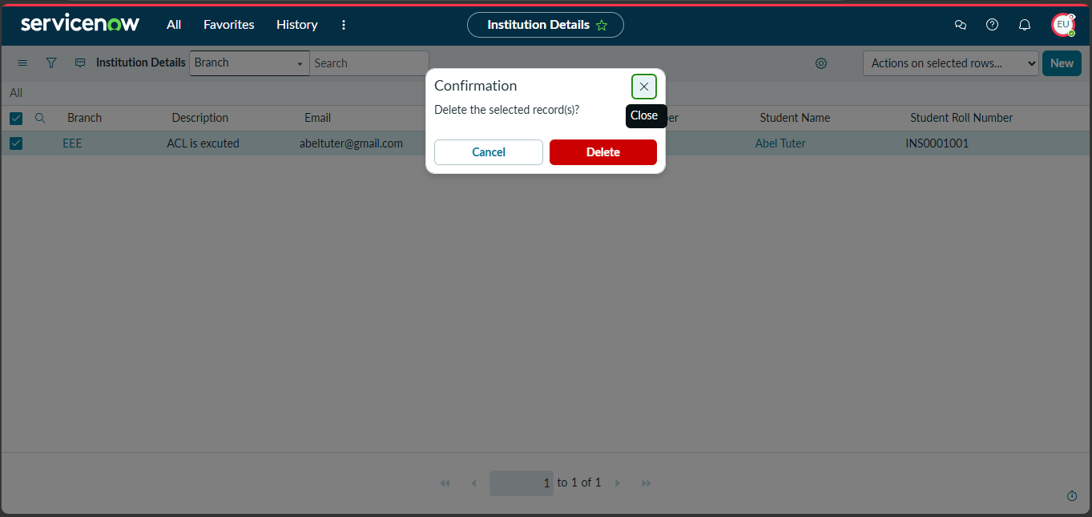
Figure 7.12 – Delete confirmation dialog
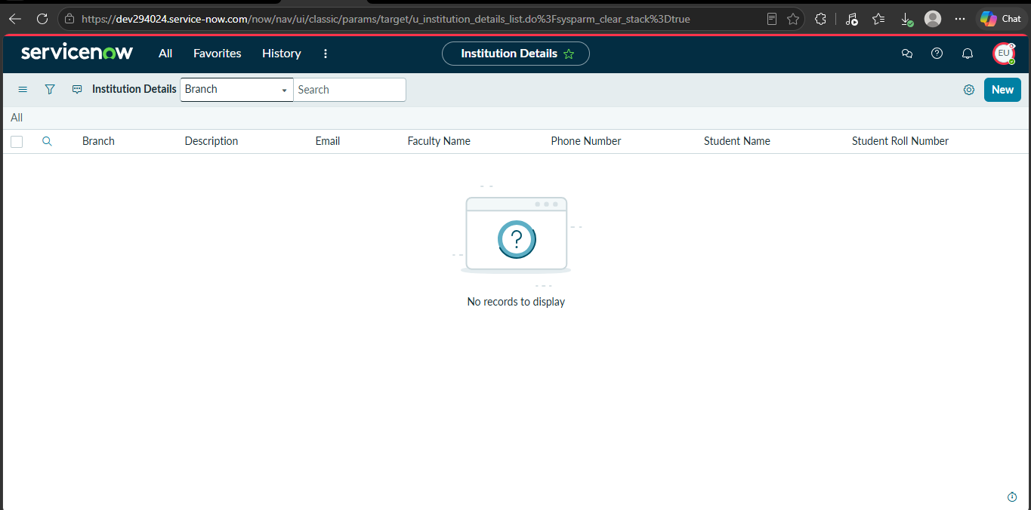
Figure 7.13 – List after deletion: No records to display
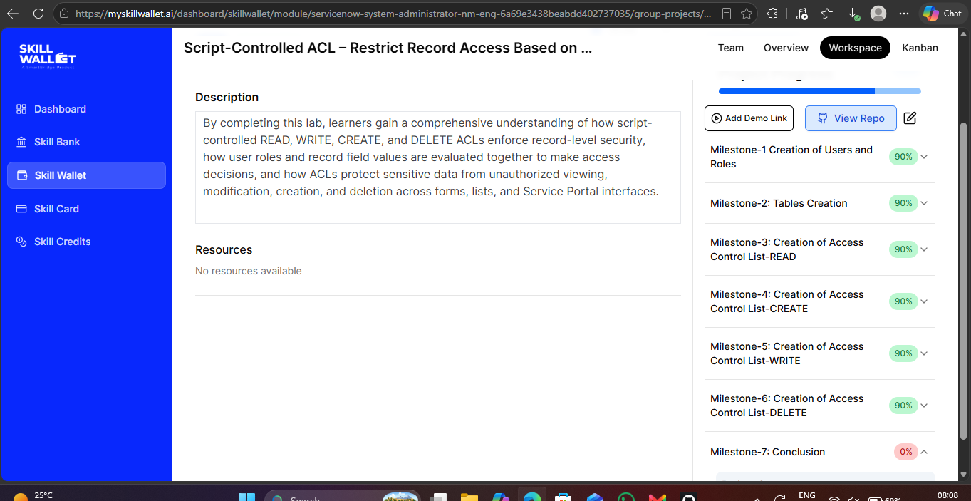
Figure 7.14 – Skill Wallet workspace showing the project milestones

8. ADVANTAGES & DISADVANTAGES
Advantages
- Fine-grained, record-level security based on field values.
- Combines role checks and field conditions in one script.
- Separate control over READ, CREATE, WRITE and DELETE.
- Protects data in lists, forms and Service Portal alike.
- Reusable pattern for other tables and fields.
Disadvantages
- Scripts need careful testing; an error can block legitimate users or expose data.
- Many scripted ACLs are harder to maintain and may slightly affect performance on large tables.
- Requires scripting knowledge and administrator access to configure.

9. CONCLUSION
The project successfully implemented script-controlled ACLs on the Institution Details table. Users and roles were created, the custom table was built, and four ACLs (READ, CREATE, WRITE, DELETE) were configured and verified. The tests showed that a restricted EEE User sees only the EEE record while an administrator sees all records, and that create, edit and delete operations work as defined by the ACL scripts. The project gives a clear understanding of how roles and field values together drive access decisions in ServiceNow.

10. FUTURE SCOPE
- Extend ACLs to field-level security for sensitive fields such as phone number and email.
- Add branch-specific roles (for example ECE, EEE, CSE) instead of the shared bb roles.
- Add Service Portal widgets for branch-wise record management.
- Log denied access attempts for auditing and build dashboards on them.
- Integrate with groups and approval workflows for controlled deletion.

11. APPENDIX

Source Code (reference ACL script)
The pattern below shows a script-controlled ACL for the Institution Details table. The same structure is applied to the READ, CREATE, WRITE and DELETE operations. Replace it with the exact script used in your instance if it differs.
// ACL: u_institution_details | Operation: read (repeat for create/write/delete)
// Type: record | Advanced: checked
answer = false;
if (gs.hasRole('bb1') || gs.hasRole('admin')) {
// Allow access only when the record's Branch field is EEE
if (current.u_branch == 'EEE' || gs.hasRole('admin')) {
answer = true;
}
}

Dataset Link
Not applicable. The project uses records created directly in the custom table (3 sample records: ECE, EEE, CSE).

GitHub & Project Demo Link
- GitHub repository: https://github.com/Darkdevil12344/skill-wallet-project
- Project demo video (YouTube): https://youtu.be/hQ--82Z7fsM
- Demo video file: demo_NM SWTID-2026-5274.mp4 (also included in the repository).

