PF

ProcureFlow User Manual
Farmer procurement scheduling, live queue management and direct support
Version 1.5 • 10 September 2026 • Software prototype for SIH26032
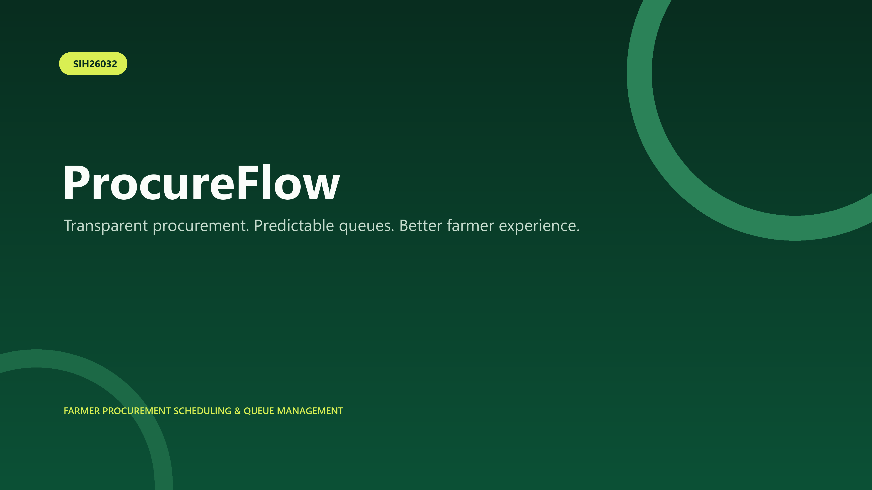
ProcureFlow — a focused, multilingual procurement-service MVP
This manual covers the public website, installable Android web app, automated ProcureBot assistant, farmer/staff-to-admin live chat, notifications and operational dashboards.

1. Product at a glance
ProcureFlow helps farmers choose a procurement centre, confirm eligibility, reserve a token, track queue wait time and follow produce through procurement and payment. Centre staff operate queues; administrators manage capacity, alerts, records and support conversations.
Farmer | Centre staff | Administrator
Book and track visits; contact support | Advance queues and procurement stages | Manage schedules, records, alerts and chats

Demo accounts
- Farmer — farmer@demo.in / farmer123
- Centre staff — staff@demo.in / staff123
- Administrator — admin@demo.in / admin123
No ChatGPT account is required. ProcureFlow uses its own demonstration role sign-in.
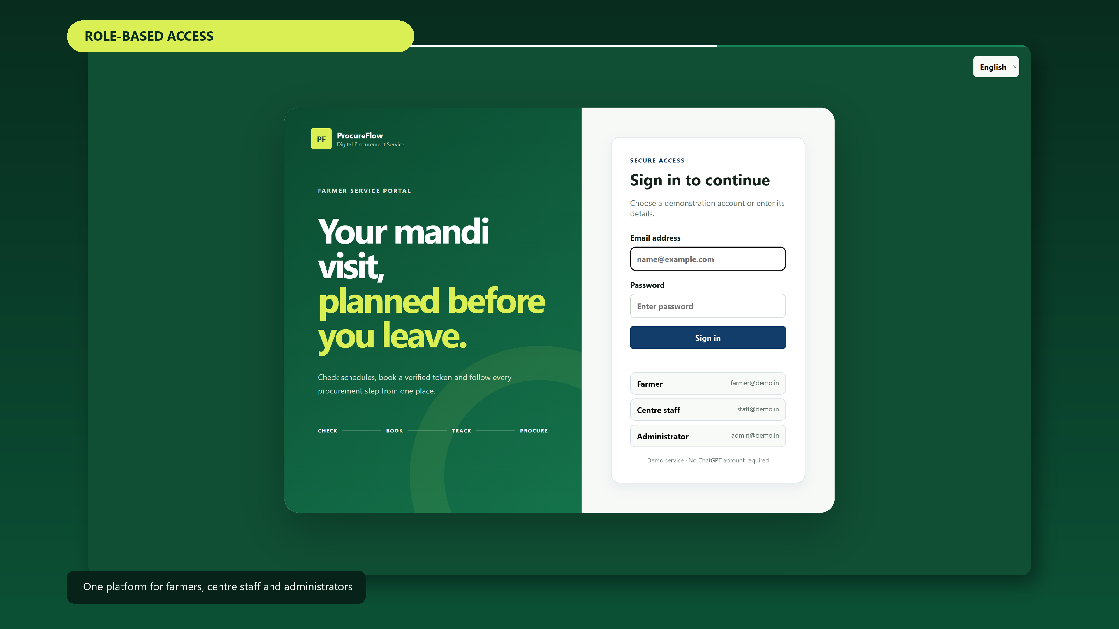
Role-based ProcureFlow access screen

2. Farmer journey

2.1 Choose the right centre
Open the Overview page and compare nearby centres by travel distance, available slots, queue size and estimated wait. The recommendation favours the least-congested practical option.
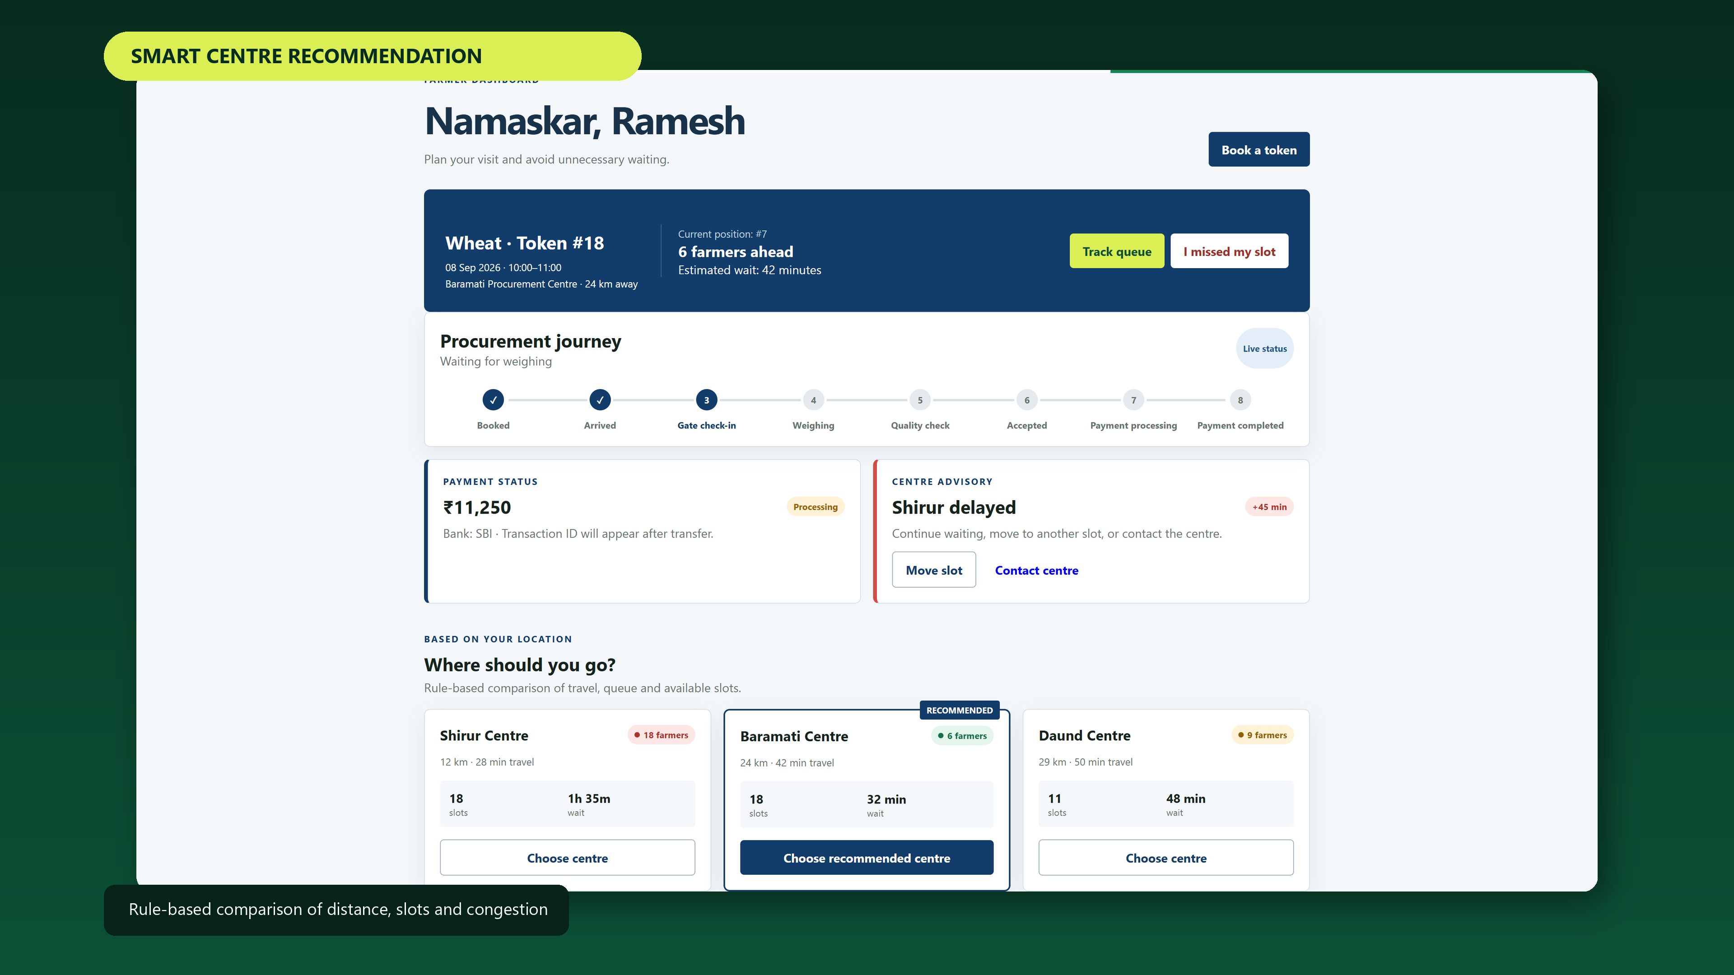
Centre recommendation and congestion comparison

2.2 Book a procurement token
- Open Schedules and select Check eligibility.
- Choose the procurement centre and preferred time window.
- Enter the quantity in quintals.
- Confirm government identity, verified bank account and land/tenancy documentation.
- Press Confirm and book token. Your token, position and ETA appear on the dashboard.
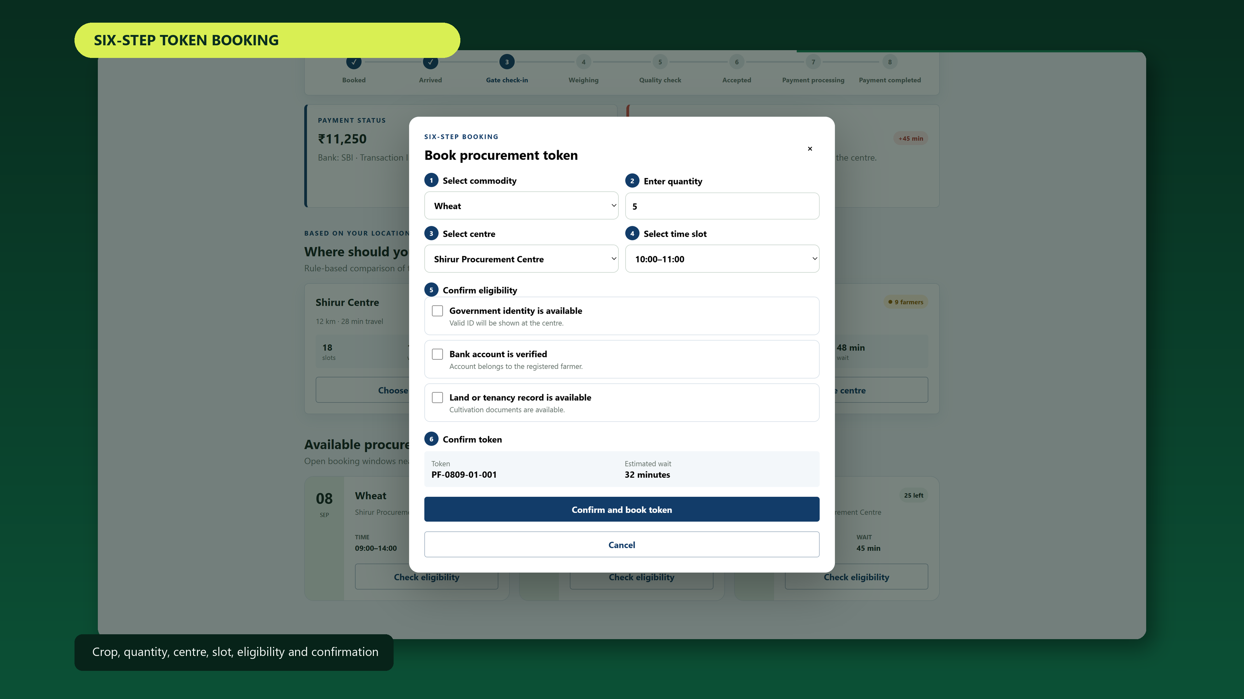
Eligibility and token-booking flow

2.3 Queue and procurement journey
The live journey is: Booked → Arrived → Gate check-in → Weighing → Quality check → Accepted → Payment processing → Payment completed. Wait time changes as centre staff progress the queue.
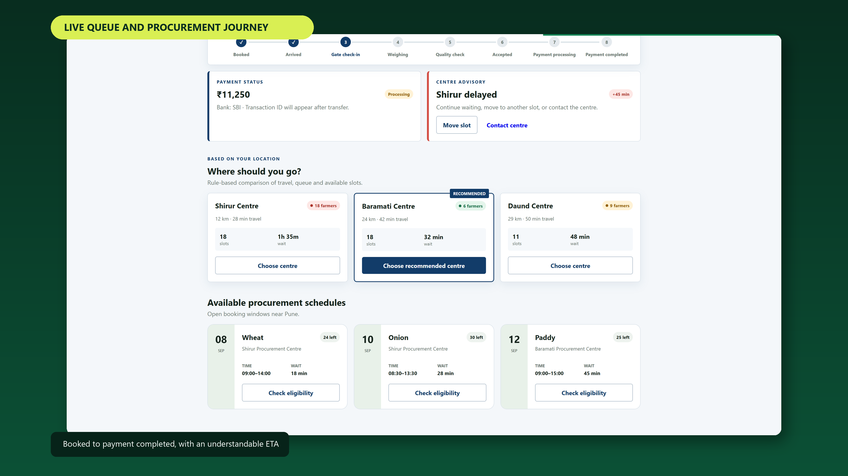
Farmer-facing procurement status and estimated wait

2.4 Missed-slot recovery
From the active token, select I missed my slot. Choose the next suitable centre/time and confirm rebooking. The previous visit is replaced with the selected recovery option.

3. ProcureBot automated assistant
Open Support and keep ProcureBot help selected. The rule-based assistant answers common questions instantly without an external AI account. It covers token booking, eligibility documents, queue ETA, missed slots, payment status, regional languages and escalation to an admin.
- Use a quick-question chip for the fastest demonstration.
- Type a natural short question such as “What documents are needed?”
- For an individual case, switch to Live admin chat.

4. Live admin chat
Farmers and centre staff can contact the administrator directly. The conversation displays the participant’s name, stores the history in the hosted database and places media in managed object storage.

4.1 Send text and media
- Select Live admin chat.
- Type a message, or press ＋ to attach a photo, short video or audio file.
- For a voice note, press ●, allow microphone access, speak, then press ● again.
- Press Send. Attachments are limited to 12 MB for reliable mobile use.

4.2 Read receipts, editing and deletion
- Sent ✓ means the message reached the service.
- Seen ✓✓ means the other role opened the conversation.
- Edit changes your own text and marks it as edited.
- Delete removes message content and its attachment; an admin may moderate any message.
- A short notification chime plays for new incoming messages after browser interaction.

4.3 Administrator workflow
Sign in as Administrator, open Live chat, select a named conversation in the left panel and reply. Unread badges identify pending requests. Opening a conversation issues the read receipt.

5. Centre staff and administrator operations

5.1 Centre staff
The centre dashboard shows green/yellow/red load indicators, expected arrivals and the active queue. Use the action button to progress the selected token through every procurement stage.
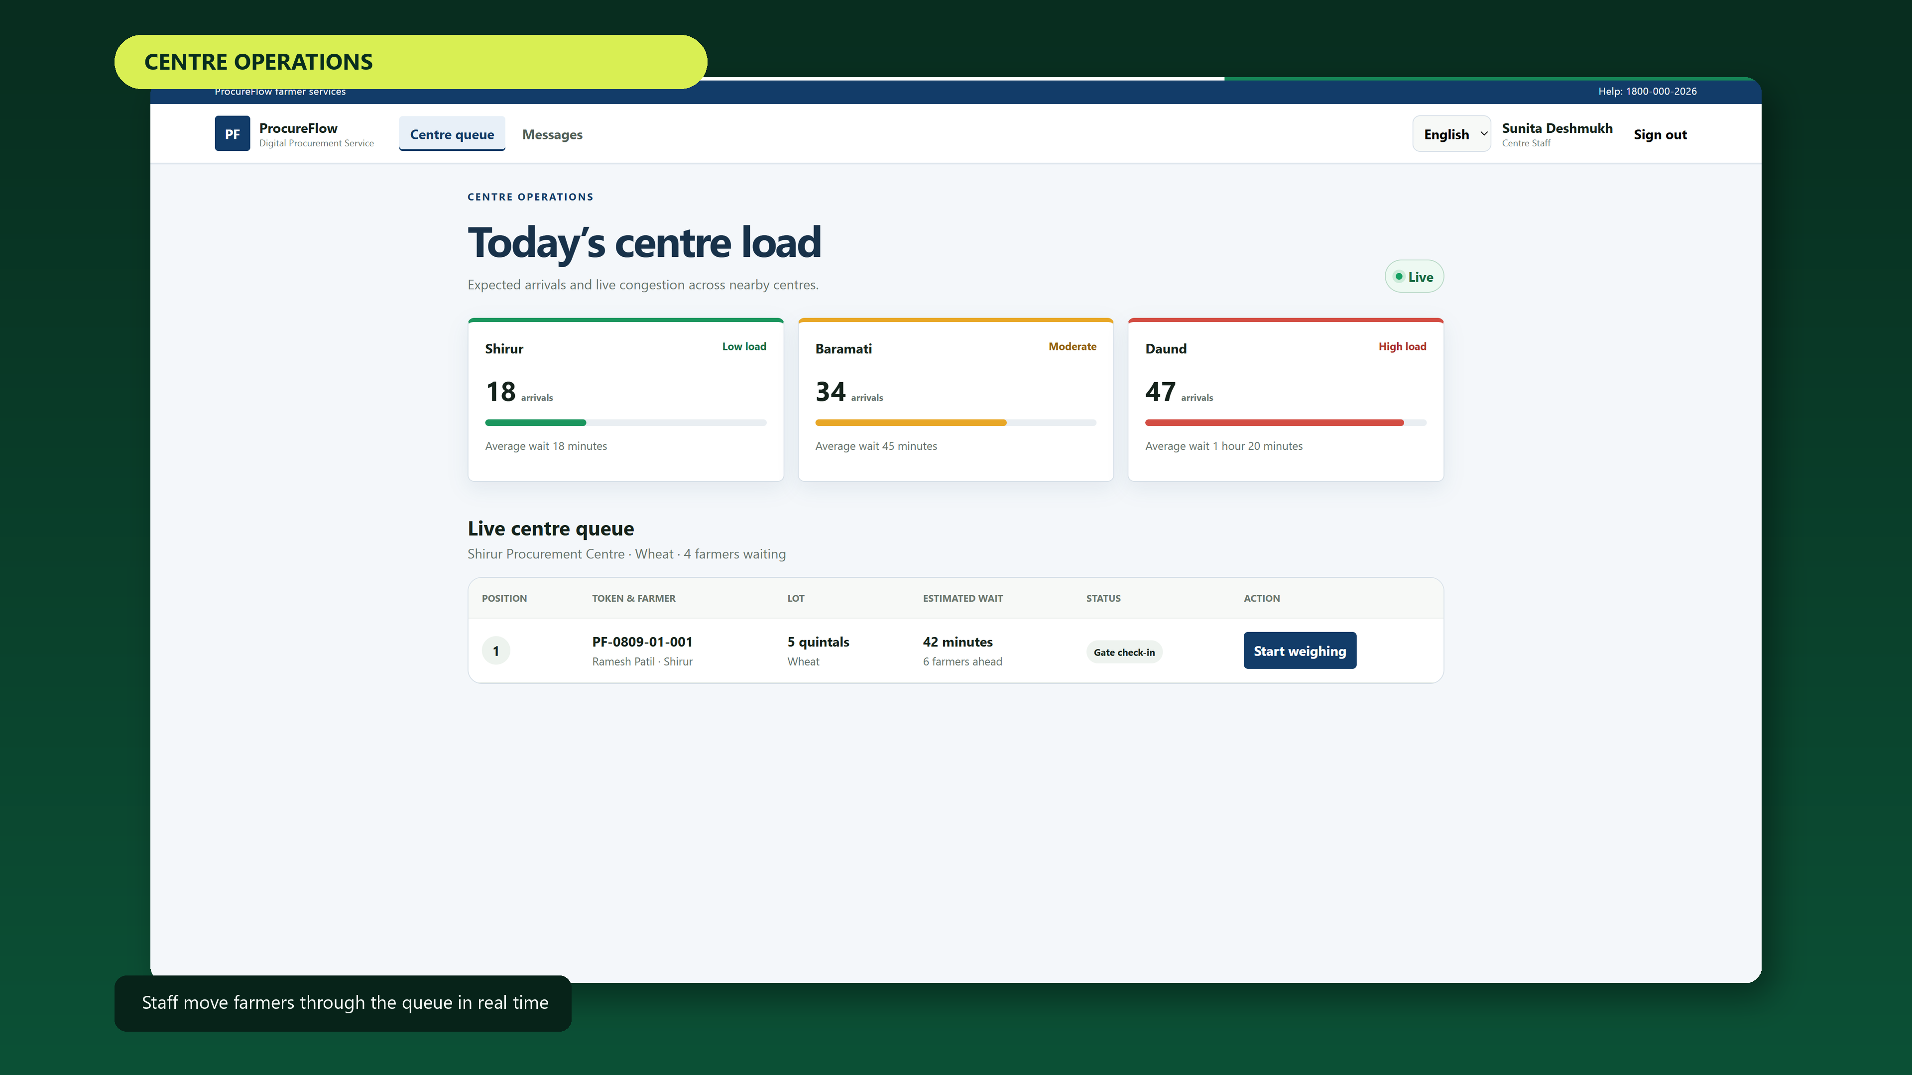
Centre load and live queue workflow

5.2 Administrator
The administrator monitors capacity and congestion, creates schedules, explores 100,000 deterministic demonstration records, sends farmer alerts and manages live support.
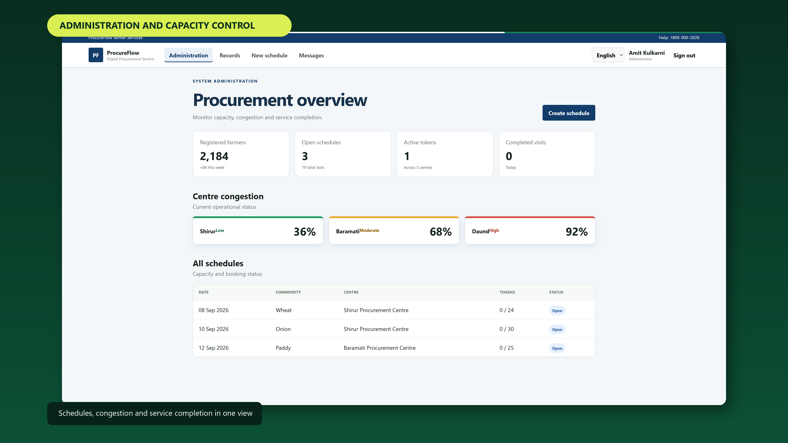
Administrative overview
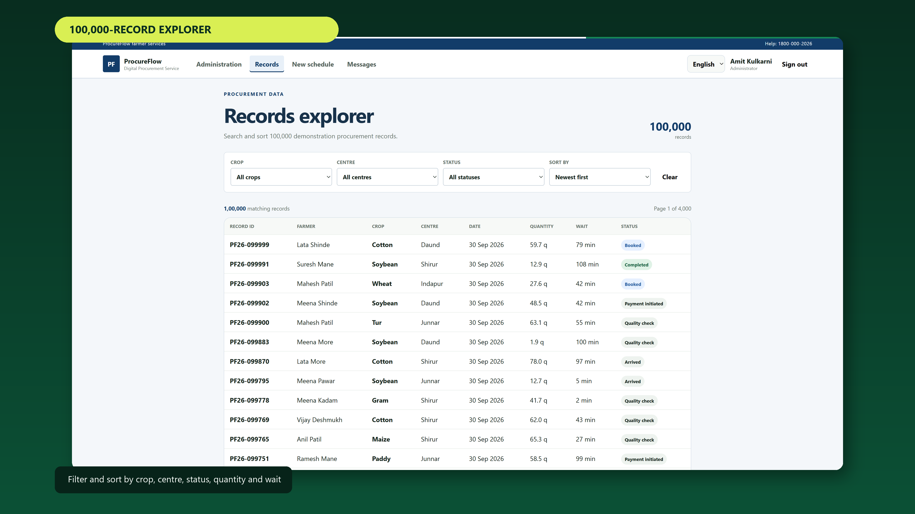
Filterable and sortable procurement records

6. Installable Android app
ProcureFlow is a Progressive Web App (PWA), so the same tested website can be installed without maintaining a separate APK during the hackathon.
- Open the public HTTPS URL in Chrome on Android.
- Select Install app in ProcureFlow when available, or Chrome menu → Add to Home screen.
- Confirm installation and launch ProcureFlow from its home-screen icon.
Core screens are cached for fast reopening. Live queue data, chats, media and alerts require connectivity.

7. Languages and accessibility
Use the language selector in the top bar to switch between English, Hindi and Marathi. The responsive layout uses large touch targets, readable status colours plus labels, and mobile bottom navigation.
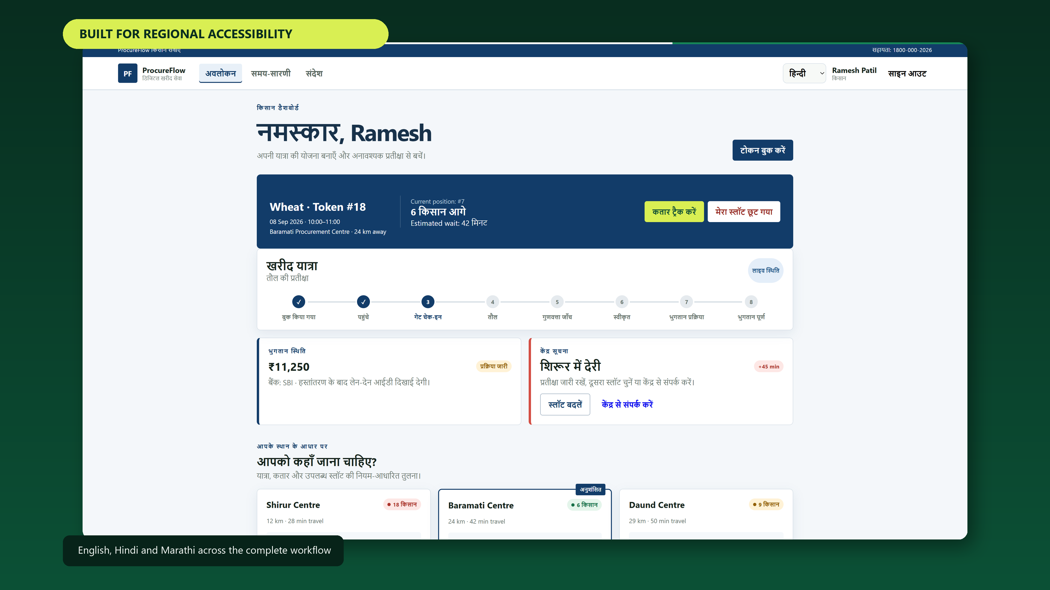
Regional-language interface

8. Alerts and notifications
Messages contains booking, queue, delay, procurement and payment updates. Enable phone alerts grants browser-notification permission. A custom alert appears in-app and on the current device. The preset Twilio button demonstrates trial SMS delivery; production custom SMS should use approved sender/template registration and applicable compliance controls.
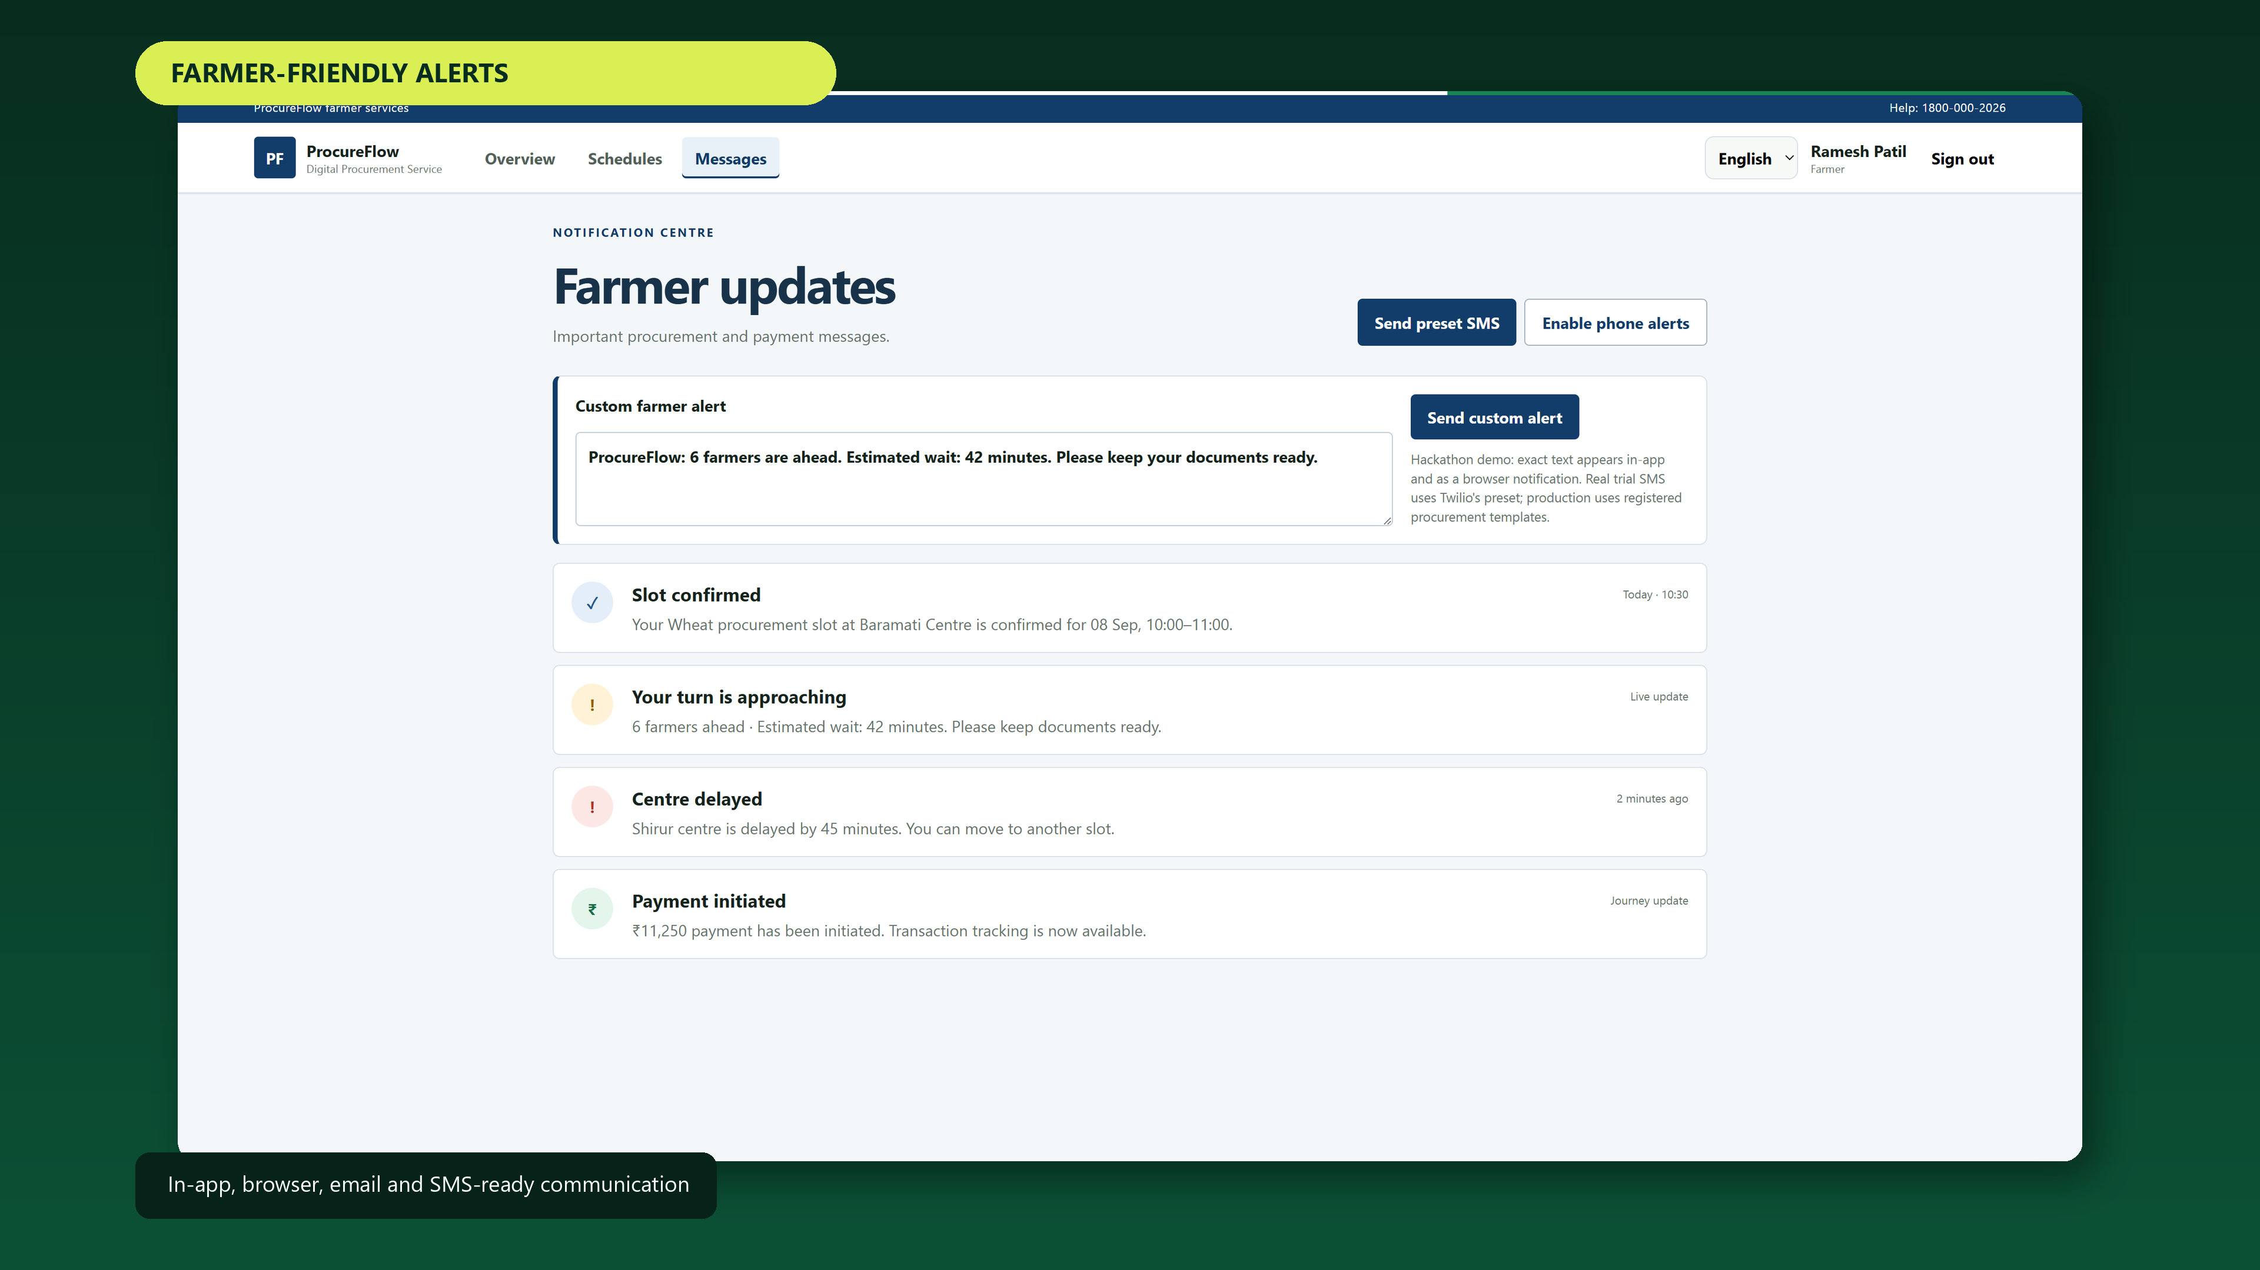
Notification centre and custom farmer alert

9. Troubleshooting
Issue | Resolution
Chat does not load | Check connectivity, refresh, and sign in again.
Microphone is blocked | Open browser site permissions and allow microphone access.
Install button is missing | Use Chrome menu → Add to Home screen.
No sound | Interact with the page once and check the device mute setting.
Media is rejected | Use a photo/video/audio file below 12 MB.
Language remains English | Select Hindi or Marathi again, then refresh the current route.

10. Demo and production boundaries
This is a hackathon MVP with deterministic sample procurement data and demonstration identities. The hosted chat does persist conversations and media, but a real rollout must integrate authoritative farmer authentication, role authorization, consent and retention policy, attachment malware scanning, audit logs, rate limiting, backups/restore testing, accessibility review and approved messaging templates.

Recommended 4-minute demonstration
- Farmer: compare centres and book a token.
- Staff: progress the queue and show the ETA/journey update.
- Farmer: ask ProcureBot, then send a photo or voice note to admin.
- Admin: open the named conversation, reply and demonstrate Seen ✓✓.
- Install the PWA and finish with multilingual and records views.

