JDK 1.8 Features
__________________________________________________________________
1. static method definition within interface
2. Default method definition within interface
3. Functional interfaces
4. Lambda expression
5. Method reference
6. Stream API
7. Comparable and comparator enhancements
8. Optional class
9. Date/Time API
10. Concurrency and I/O enhancements
etc

Note: From JDK 1.8 version of java we can define method within interface
JDK 1.8 version and later we can define static and default method within interface

Static method definition
_________________________________________________________________
If we use the static keyword with method then we can define method within interface because interface cannot create its object and static method not need to object for calling purpose
we can call static method by using interface so this is major reason we can use static method
without implementation of interface by using interface name so this is major reason we can
define static method in interface from JDK1.8 version
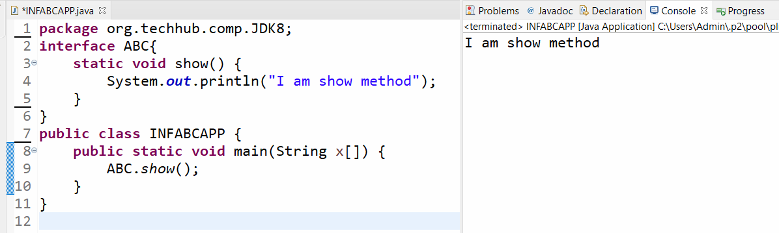

Default method definition within interface?
________________________________________________________________________
If we use the default keyword with method then we can define method within interface but when we use the default method within interface then we must be use that method using object of implementer class of interface.
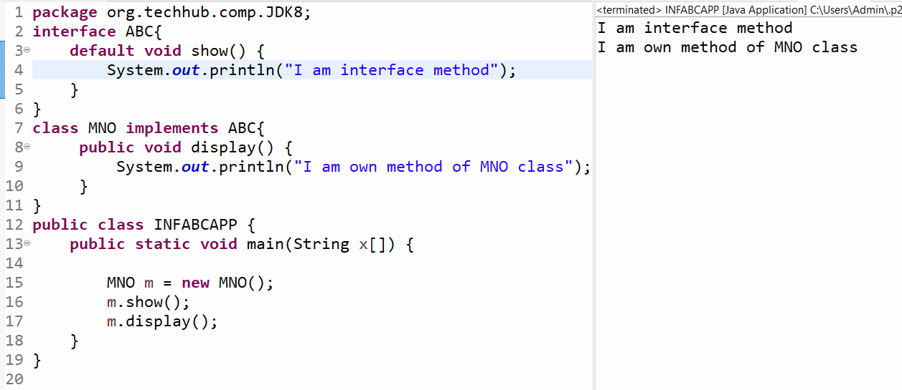

Functional interface
______________________________________________________________
Functional interface means an interface contain only one abstract method and may be more than one static or default methods.
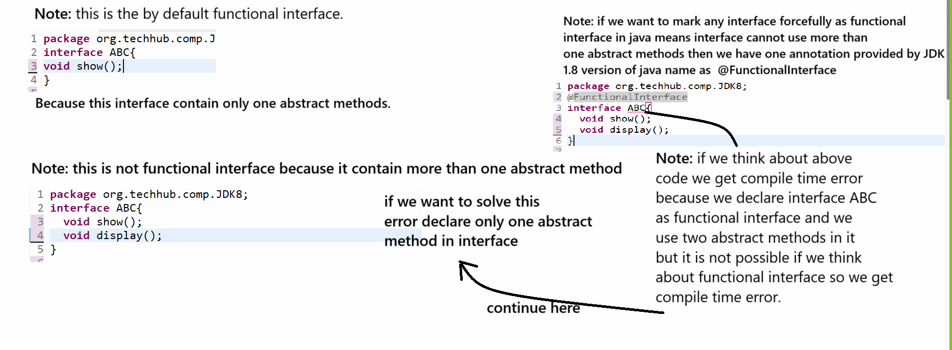
Q. Why use functional interface in java or what is benefit of functional interface in JAVA?
____________________________________________________________________________
Functional interface specially design for implement lambda expression

Note: if we want to work with lambda expression before that we should have to know anonymous inner class

Q. What is anonymous inner class?
______________________________________________________________________
Anonymous inner class is a local inner class where we create object of class or interface as well as provide run time definition of that object and override its method called as anonymous inner class.
Note: we can use interface or abstract class without inheritance with the help of anonymous inner class.

Syntax:
classname ref = new classname(){
access specifier return type functionname(datatype variablename){
write here your logics
}
};
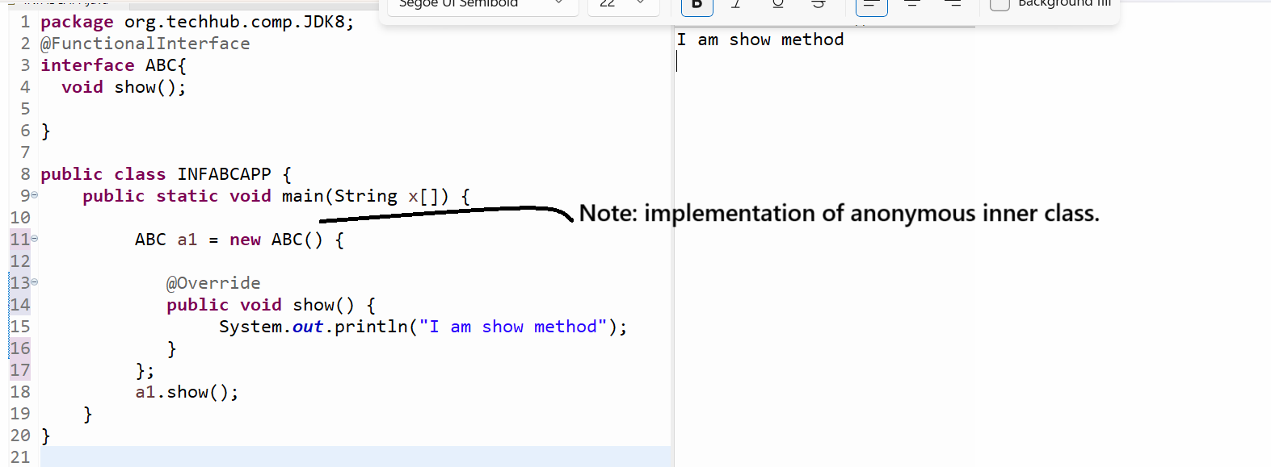
Example of functional interface is Runnable because Runnable interface contain only abstract method name as run()
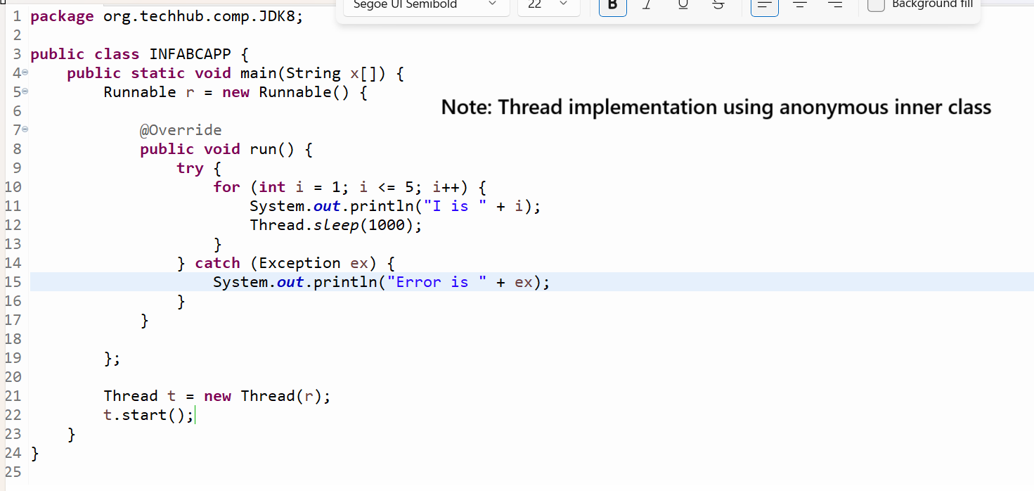

Lambda expression
____________________________________________________________________________
Lambda expression basically express instance of functional interface. Lambda expression implements the only abstract method on functional interface
Lambda expression is short cut anonymous inner class and it is used for avoid boiler plate code of anonymous inner class.

Note: if we think about anonymous inner class we can use with abstract method of functional interface as well as non function interface and can use the abstract class also.

Syntax of Lambda expression
____________________________________________________________________
interfacename ref =(parameter)->{
Write here logics
};

Example: Suppose consider we have functional interface name as A with one abstract method
show() and we want to use lambda expression with interface A.

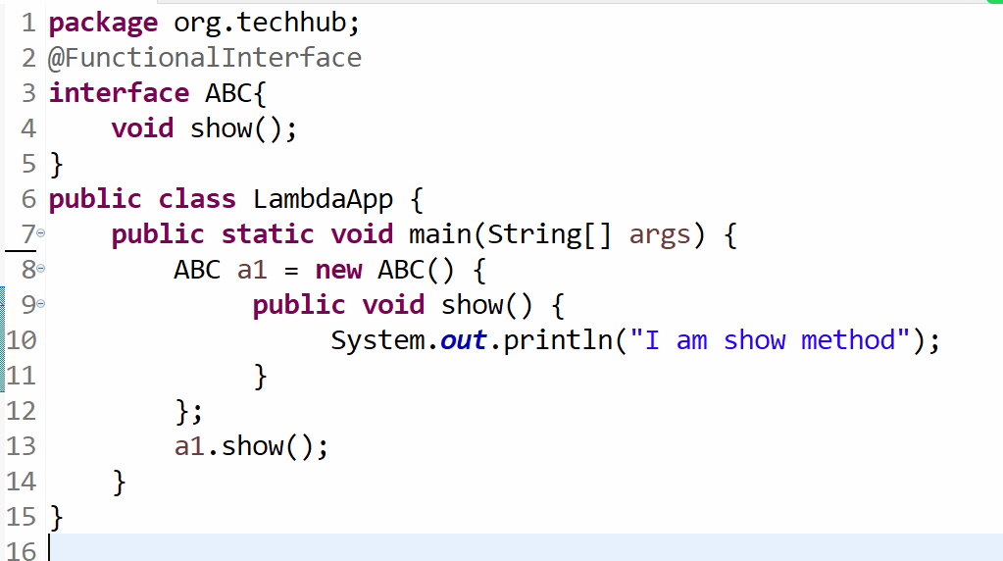
Note: you can create lambda expression by using above code.
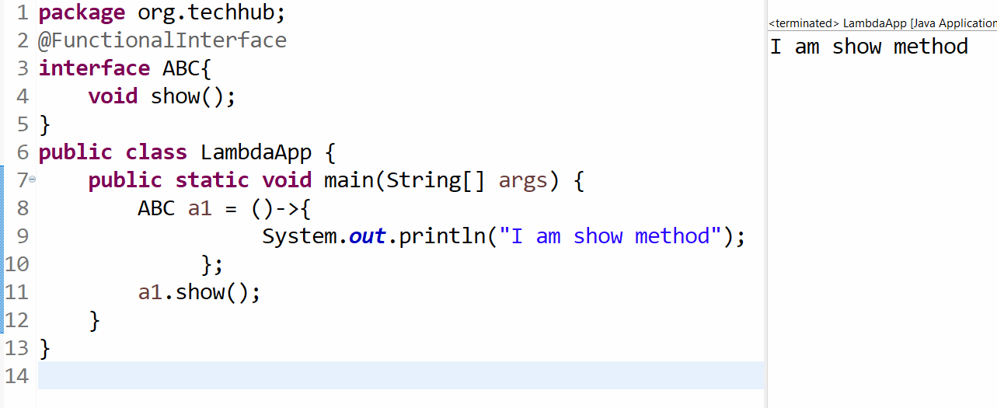
Note: if we want to work with lambda expression we have some important points.
1. If we have single statement in function not need to use opening and closing curly brace shown in following code.
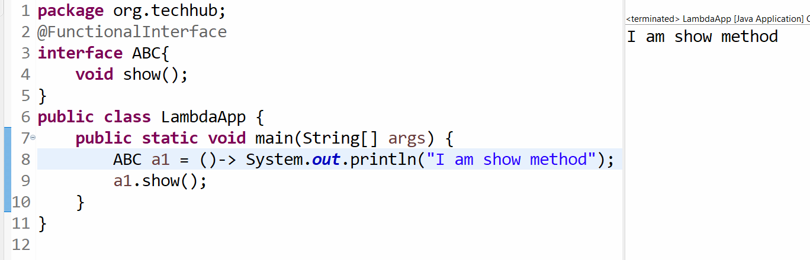
2. If we have single statement then not need to write return keyword in lambda expression
Example: Suppose we have functional interface name as Square and with one method int getSquare(int) this function can accept number as parameter and return its square.
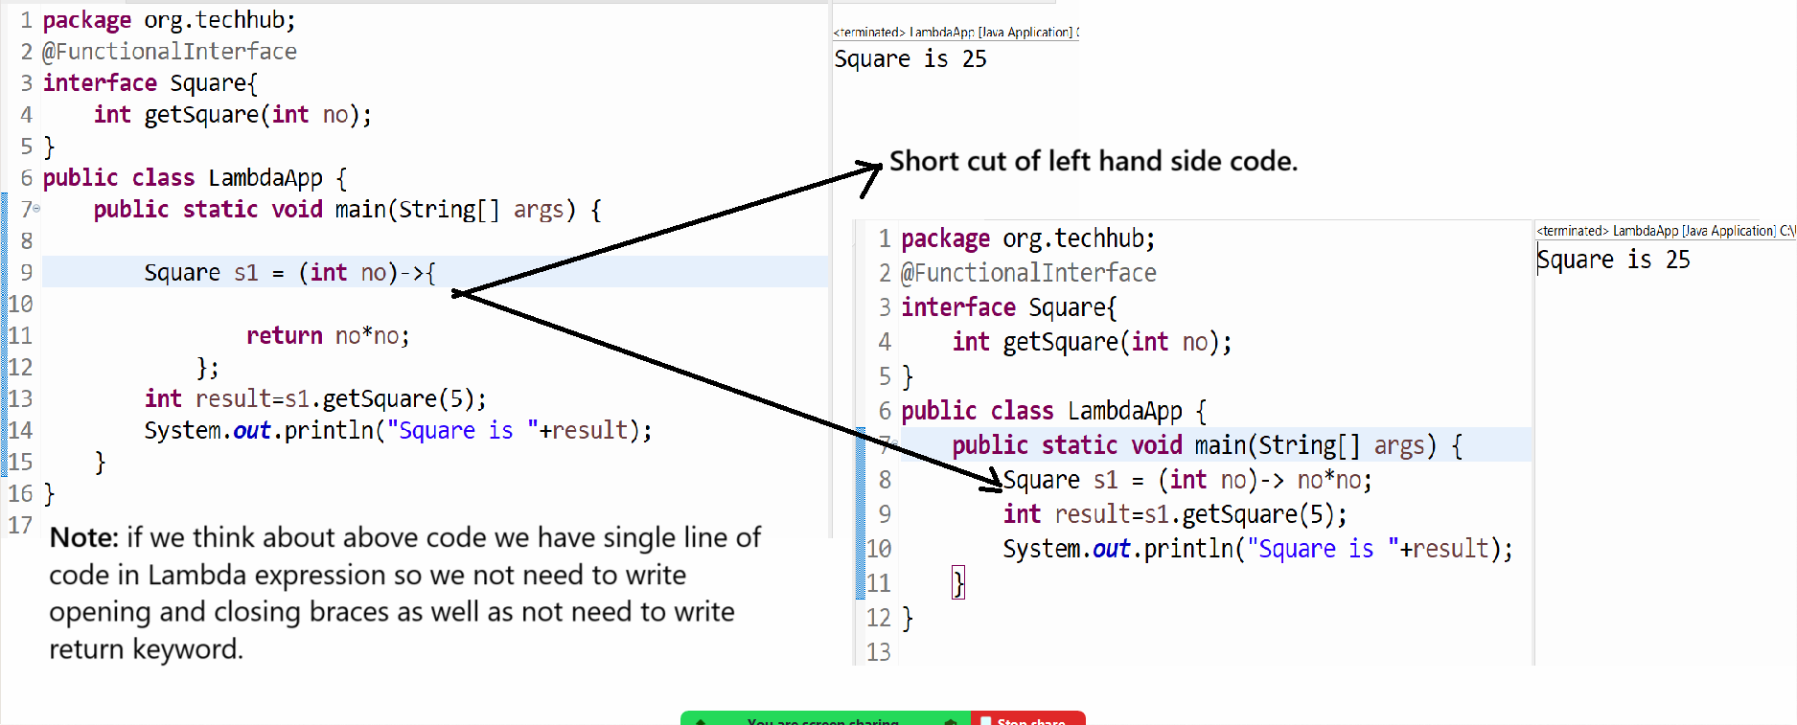
Note: if we use the throws clause with method definition not need to write throw clause if we use the lambda expression
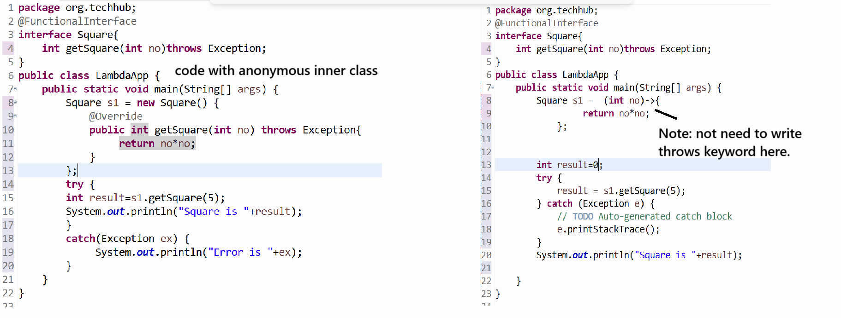

JDK1.8 version provide some inbuilt functional interfaces to us
____________________________________________________________________
1. Function
2. Consumer
3. Predicate
4. Supplier

Now we want to discuss about the Function interface
_____________________________________________________________________
Function interface contain only one abstract method name as R apply(T t) this method can accept input parameter and generate some result according to use logics.

Methods of Function interface
R apply(T t): accept the some input parameter and generate some result.
default <V> Function<V, R> compose(Function<? super V, ? extends T> before): this method can accept the function interface reference as parameter and return function interface as result
default <V> Function<T, V> andThen(Function<? super R, ? extends V> after): this method can accept the function interface as parameter and return function interface as parameter

Now we want to discuss about the apply() method
________________________________________________________________
Example: we want to pass radius as parameter to Function interface and calculate its area.

Source code with anonymous inner class
package org.techhub;
import java.util.function.*;
public class LambdaApp {
public static void main(String[] args) {

Function<Float, Float> f = new Function<Float, Float>() {

@Override
public Float apply(Float t) {
return t * t * 3.14f;
}

};

float circleArea = f.apply(3.0f);
System.out.printf("Area of circle is %f\n", circleArea);
}
}
Source code with lambda expression with short cut
package org.techhub;

import java.util.function.*;

public class LambdaApp {
public static void main(String[] args) {

Function<Float, Float> f = (Float t)->{
return t * t * 3.14f;
};

float circleArea = f.apply(3.0f);
System.out.printf("Area of circle is %f\n", circleArea);
}
}
Note: not need to use opening and closing brace as well as not need to use return keyword because we have single line of logic in apply() method

package org.techhub;
import java.util.function.*;
public class LambdaApp {
public static void main(String[] args) {
Function<Float, Float> f = (Float t)-> t * t * 3.14f;
float circleArea = f.apply(3.0f);
System.out.printf("Area of circle is %f\n", circleArea);
}
}

or

package org.techhub;
import java.util.function.*;
public class LambdaApp {
public static void main(String[] args) {
float circleArea = ((Function<Float,Float>)(Float t)-> t * t * 3.14f).apply(3.0f);
System.out.printf("Area of circle is %f\n", circleArea);
}
}
or
package org.techhub;
import java.util.function.*;
public class LambdaApp {
public static void main(String[] args) {
System.out.printf("Area of circle is %f\n", ((Function<Float,Float>)(Float t)-> t * t * 3.14f).apply(3.0f));
}
}

Consumer interface and forEach() method
_____________________________________________________________________
forEach() method is used for fetch data from collection with the help of Consumer interface

Syntax: public void forEach(Consumer): Consumer interface is functional interface which is used for fetch data from collection with the help of forEach method

public abstract void accept(T t): this method is used for accept the input parameter and perform any operation on it.

Example: we want to create ArrayList and fetch data using forEach() method

package org.techhub;
import java.util.*;
import java.util.function.Consumer;
public class ForEachApplication {
public static void main(String[] args) {
ArrayList<Integer> al = new ArrayList<Integer>();
al.add(10);
al.add(20);
al.add(30);
al.add(40);
al.add(50);
Consumer<Integer> c = new Consumer<Integer>() {
@Override
public void accept(Integer t) {
System.out.println(t);
}
};
al.forEach(c);
}
}
or
You can convert above code using lambda expression

package org.techhub;
import java.util.*;
import java.util.function.Consumer;
public class ForEachApplication {
public static void main(String[] args) {
ArrayList<Integer> al = new ArrayList<Integer>();
al.add(10);
al.add(20);
al.add(30);
al.add(40);
al.add(50);
Consumer<Integer> c =(Integer t)->{
System.out.println(t);
};
al.forEach(c);

}
}
or
package org.techhub;
import java.util.*;
import java.util.function.Consumer;
public class ForEachApplication {
public static void main(String[] args) {
ArrayList<Integer> al = new ArrayList<Integer>();
al.add(10);
al.add(20);
al.add(30);
al.add(40);
al.add(50);
Consumer<Integer> c =(Integer t)->System.out.println(t);
al.forEach(c);

}
}
or
package org.techhub;
import java.util.*;
import java.util.function.Consumer;
public class ForEachApplication {
public static void main(String[] args) {
ArrayList<Integer> al = new ArrayList<Integer>();
al.add(10);
al.add(20);
al.add(30);
al.add(40);
al.add(50);
al.forEach((Integer t)->System.out.println(t));
}
}

Example: We Want to create ArrayList and store 5 employee data in it and fetch it using forEach() method

package org.techhub;
import java.util.*;
import java.util.function.Consumer;
class Employee {
private int id;
public int getId() {
return id;
}
public void setId(int id) {
this.id = id;
}
public String getName() {
return name;
}
public void setName(String name) {
this.name = name;
}
private String name;
public Employee(int id, String name) {
this.id = id;
this.name = name;
}
}

public class ForEachApplication {
public static void main(String[] args) {
ArrayList<Employee> al = new ArrayList<Employee>();
al.add(new Employee(1,"ABC"));
al.add(new Employee(2,"MNO"));
al.add(new Employee(3,"PQR"));
Consumer<Employee> c = new Consumer<Employee>() {
@Override
public void accept(Employee t) {
System.out.println(t.getId()+"\t"+t.getName());
}
};

al.forEach(c);
}
}
or
package org.techhub;

import java.util.*;
import java.util.function.Consumer;

class Employee {
private int id;
public int getId() {
return id;
}
public void setId(int id) {
this.id = id;
}
public String getName() {
return name;
}
public void setName(String name) {
this.name = name;
}
private String name;
public Employee(int id, String name) {
this.id = id;
this.name = name;
}
}

public class ForEachApplication {
public static void main(String[] args) {
ArrayList<Employee> al = new ArrayList<Employee>();
al.add(new Employee(1,"ABC"));
al.add(new Employee(2,"MNO"));
al.add(new Employee(3,"PQR"));
Consumer<Employee> c = (Employee t)->{
System.out.println(t.getId()+"\t"+t.getName());
};
al.forEach(c);
}
}
or
package org.techhub;

import java.util.*;
import java.util.function.Consumer;

class Employee {
private int id;
public int getId() {
return id;
}
public void setId(int id) {
this.id = id;
}
public String getName() {
return name;
}
public void setName(String name) {
this.name = name;
}
private String name;
public Employee(int id, String name) {
this.id = id;
this.name = name;
}
}

public class ForEachApplication {
public static void main(String[] args) {
ArrayList<Employee> al = new ArrayList<Employee>();
al.add(new Employee(1,"ABC"));
al.add(new Employee(2,"MNO"));
al.add(new Employee(3,"PQR"));
Consumer<Employee> c = (Employee t)-> System.out.println(t.getId()+"\t"+t.getName());

al.forEach(c);
}
}
or
package org.techhub;

import java.util.*;
import java.util.function.Consumer;

class Employee {
private int id;
public int getId() {
return id;
}
public void setId(int id) {
this.id = id;
}
public String getName() {
return name;
}
public void setName(String name) {
this.name = name;
}
private String name;
public Employee(int id, String name) {
this.id = id;
this.name = name;
}
}

public class ForEachApplication {
public static void main(String[] args) {
ArrayList<Employee> al = new ArrayList<Employee>();
al.add(new Employee(1,"ABC"));
al.add(new Employee(2,"MNO"));
al.add(new Employee(3,"PQR"));
al.forEach((Employee t)-> System.out.println(t.getId()+"\t"+t.getName()));
}
}

Predicate interface
___________________________________________________________________
Predicate interface is used for check the conditions and it is functional interface and it contain one test() method which is used for check the condition and if condition is satisfy return true otherwise return false.

Methods of Predicate interface
___________________________________________________________________________
boolean test(T t): this is the abstract accept input parameter and check the condition if condition is satisfy return true otherwise return false.
default Predicate<T> and(Predicate<? super T> other) : this method is used for combine the one predicate or conditions and check it using and operation
default Predicate<T> negate(): this method is used for perform negation operation on Predicate
default Predicate<T> or(Predicate<? super T> other): this method can combine two or more predicates and perform OR operations on it.
static <T> Predicate<T> isEqual(Object targetRef): this method check two arguments are equal to according to conditions if equal return true otherwise return false.

static <T> Predicate<T> not(Predicate<? super T> target): this method can combine more than one predicate and perform not operation on it.

Example: We want to create program to check number is even or odd using Predicate interface
package org.techhub;

import java.util.*;
import java.util.function.Predicate;

public class ForEachApplication {
public static void main(String[] args) {
Predicate<Integer> p = new Predicate<Integer>() {
@Override
public boolean test(Integer t) {
return t % 2 == 0;
}

};
boolean b = p.test(10);
if(b) {
System.out.println("Number is Even");
}
else {
System.out.println("Number is ODD");
}

}
}
or
Manage it using Lambda expression
__________________________________________________________________
package org.techhub;

import java.util.*;
import java.util.function.Predicate;

public class ForEachApplication {
public static void main(String[] args) {
Predicate<Integer> p = (Integer t)->t % 2 == 0;
boolean b = p.test(10);
if(b) {
System.out.println("Number is Even");
}
else {
System.out.println("Number is ODD");
}
}
}
or
package org.techhub;

import java.util.*;
import java.util.function.Predicate;
public class ForEachApplication {
public static void main(String[] args) {
Predicate<Integer> p = (Integer t)->t % 2 == 0;
if(p.test(10)) {
System.out.println("Number is Even");
}
else {
System.out.println("Number is ODD");
}
}
}
or
package org.techhub;
import java.util.*;
import java.util.function.Predicate;
public class ForEachApplication {
public static void main(String[] args) {
Predicate<Integer> p = (Integer t)->t % 2 == 0;
String s=(p.test(10))?"Number is Even":"Number is ODD";
System.out.println(s);
}
}
or
package org.techhub;

import java.util.*;
import java.util.function.Predicate;

public class ForEachApplication {
public static void main(String[] args) {
Predicate<Integer> p = (Integer t)->t % 2 == 0;
System.out.println((p.test(10))?"Number is Even":"Number is ODD");
}
}
or
package org.techhub;
import java.util.*;
import java.util.function.Predicate;
public class ForEachApplication {
public static void main(String[] args) {
System.out.println((((Predicate<Integer>)(Integer t)->t % 2 == 0).test(11))?"Number is Even"
:"Number is ODD");
}
}

Example: WAP to check string ends with sh or not using Predicate interface.
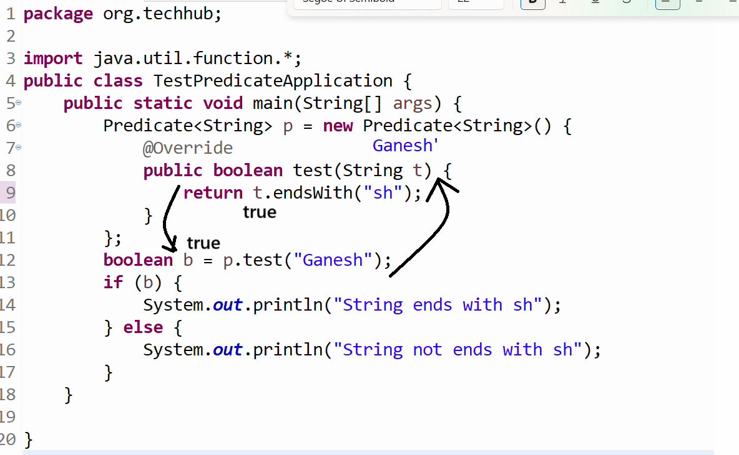
We want to change this anonymous inner class using lambda expression
package org.techhub;

import java.util.function.*;
public class TestPredicateApplication {
public static void main(String[] args) {
Predicate<String> p = (String t)->{
return t.endsWith("sh");
};

boolean b = p.test("Ganesh");
if (b) {
System.out.println("String ends with sh");
} else {
System.out.println("String not ends with sh");
}
}
}
or
package org.techhub;
import java.util.function.*;
public class TestPredicateApplication {
public static void main(String[] args) {
Predicate<String> p = (String t)->t.endsWith("sh");
boolean b = p.test("Ganesh");
if (b) {
System.out.println("String ends with sh");
} else {
System.out.println("String not ends with sh");
}
}
}
or
package org.techhub;
import java.util.function.*;
public class TestPredicateApplication {
public static void main(String[] args) {
boolean b = ((Predicate<String>)(String t)->t.endsWith("sh")).test("Ganesh");
if (b) {
System.out.println("String ends with sh");
} else {
System.out.println("String not ends with sh");
}
}
}
or
package org.techhub;
import java.util.function.*;
public class TestPredicateApplication {
public static void main(String[] args) {
if (((Predicate<String>)(String t)->t.endsWith("sh")).test("Ganesh")) {
System.out.println("String ends with sh");
} else {
System.out.println("String not ends with sh");
}
}
}
or
package org.techhub;
import java.util.function.*;
public class TestPredicateApplication {
public static void main(String[] args) {
String msg=(((Predicate<String>)(String t)->t.endsWith("sh")).test("Ganesh"))?
"String ends with sh":"String not ends with sh";
System.out.println(msg);
}
}
or
package org.techhub;
import java.util.function.*;
public class TestPredicateApplication {
public static void main(String[] args) {
System.out.println((((Predicate<String>)(String t)->t.endsWith("sh")).test("Ganesh"))?
"String ends with sh":"String not ends with sh");
}
}

Example: WAP to create ArrayList<Employee> and store 5 employee data in ArrayList and Search Employee using its id with the help of Predicate

package org.techhub;

import java.util.function.*;
import java.util.*;
class Employee {
private int id;

public Employee() {

}
public Employee(String name,int id,int sal) {
this.name=name;
this.id=id;
this.sal=sal;
}
public int getId() {
return id;
}

public void setId(int id) {
this.id = id;
}

public String getName() {
return name;
}

public void setName(String name) {
this.name = name;
}

public int getSal() {
return sal;
}

public void setSal(int sal) {
this.sal = sal;
}

private String name;
private int sal;

}

public class TestPredicateApplication {
static boolean flag=false;
public static void main(String[] args) {
Scanner xyz = new Scanner(System.in);
System.out.println("Enter id for search employee");
final int empId =xyz.nextInt();
ArrayList<Employee> al = new ArrayList<Employee>();
al.add(new Employee("ABC",1,1000));
al.add(new Employee("PQR",2,2000));
al.add(new Employee("STV",3,3000));
al.add(new Employee("XYZ",4,4000));

Predicate<Integer> p = new Predicate<Integer>() {
@Override
public boolean test(Integer t) {
// TODO Auto-generated method stub
return empId==t;
}
};
Consumer <Employee> c=new Consumer<Employee>() {
@Override
public void accept(Employee t) {
if(p.test(t.getId())) {
flag=true;

}
}
};
al.forEach(c);
if(flag) {
System.out.println("Employee found");
}
else {
System.out.println("Employee not found");
}
}
}
Now we want to convert above code using lambda expression
package org.techhub;

import java.util.function.*;
import java.util.*;
class Employee {
private int id;

public Employee() {

}
public Employee(String name,int id,int sal) {
this.name=name;
this.id=id;
this.sal=sal;
}
public int getId() {
return id;
}

public void setId(int id) {
this.id = id;
}

public String getName() {
return name;
}

public void setName(String name) {
this.name = name;
}

public int getSal() {
return sal;
}

public void setSal(int sal) {
this.sal = sal;
}

private String name;
private int sal;

}

public class TestPredicateApplication {
static boolean flag=false;
public static void main(String[] args) {
Scanner xyz = new Scanner(System.in);
System.out.println("Enter id for search employee");
final int empId =xyz.nextInt();
ArrayList<Employee> al = new ArrayList<Employee>();
al.add(new Employee("ABC",1,1000));
al.add(new Employee("PQR",2,2000));
al.add(new Employee("STV",3,3000));
al.add(new Employee("XYZ",4,4000));

Predicate<Integer> p = new Predicate<Integer>() {
@Override
public boolean test(Integer t) {
// TODO Auto-generated method stub
return empId==t;
}
};
Consumer <Employee> c=(Employee t)->{
if(p.test(t.getId()))
flag=true;
} ;
al.forEach(c);
if(flag) {
System.out.println("Employee found");
}
else {
System.out.println("Employee not found");
}
}
}
or
package org.techhub;

import java.util.function.*;
import java.util.*;
class Employee {
private int id;

public Employee() {

}
public Employee(String name,int id,int sal) {
this.name=name;
this.id=id;
this.sal=sal;
}
public int getId() {
return id;
}

public void setId(int id) {
this.id = id;
}

public String getName() {
return name;
}

public void setName(String name) {
this.name = name;
}

public int getSal() {
return sal;
}

public void setSal(int sal) {
this.sal = sal;
}

private String name;
private int sal;

}

public class TestPredicateApplication {
static boolean flag=false;
public static void main(String[] args) {
Scanner xyz = new Scanner(System.in);
System.out.println("Enter id for search employee");
final int empId =xyz.nextInt();
ArrayList<Employee> al = new ArrayList<Employee>();
al.add(new Employee("ABC",1,1000));
al.add(new Employee("PQR",2,2000));
al.add(new Employee("STV",3,3000));
al.add(new Employee("XYZ",4,4000));

Predicate<Integer> p = new Predicate<Integer>() {
@Override
public boolean test(Integer t) {
// TODO Auto-generated method stub
return empId==t;
}
};

al.forEach((Employee t)->{
if(p.test(t.getId()))
flag=true;
});
if(flag) {
System.out.println("Employee found");
}
else {
System.out.println("Employee not found");
}
}
}
or
package org.techhub;

import java.util.function.*;
import java.util.*;
class Employee {
private int id;

public Employee() {

}
public Employee(String name,int id,int sal) {
this.name=name;
this.id=id;
this.sal=sal;
}
public int getId() {
return id;
}

public void setId(int id) {
this.id = id;
}

public String getName() {
return name;
}

public void setName(String name) {
this.name = name;
}

public int getSal() {
return sal;
}

public void setSal(int sal) {
this.sal = sal;
}

private String name;
private int sal;

}

public class TestPredicateApplication {
static boolean flag=false;
public static void main(String[] args) {
Scanner xyz = new Scanner(System.in);
System.out.println("Enter id for search employee");
final int empId =xyz.nextInt();
ArrayList<Employee> al = new ArrayList<Employee>();
al.add(new Employee("ABC",1,1000));
al.add(new Employee("PQR",2,2000));
al.add(new Employee("STV",3,3000));
al.add(new Employee("XYZ",4,4000));

Predicate<Integer> p = (Integer t) ->empId==t;
al.forEach((Employee t)->{
if(p.test(t.getId()))
flag=true;
});
if(flag) {
System.out.println("Employee found");
}
else {
System.out.println("Employee not found");
}
}
}
or
package org.techhub;

import java.util.function.*;
import java.util.*;
class Employee {
private int id;

public Employee() {

}
public Employee(String name,int id,int sal) {
this.name=name;
this.id=id;
this.sal=sal;
}
public int getId() {
return id;
}

public void setId(int id) {
this.id = id;
}

public String getName() {
return name;
}

public void setName(String name) {
this.name = name;
}

public int getSal() {
return sal;
}

public void setSal(int sal) {
this.sal = sal;
}

private String name;
private int sal;

}

public class TestPredicateApplication {
static boolean flag=false;
public static void main(String[] args) {
Scanner xyz = new Scanner(System.in);
System.out.println("Enter id for search employee");
final int empId =xyz.nextInt();
ArrayList<Employee> al = new ArrayList<Employee>();
al.add(new Employee("ABC",1,1000));
al.add(new Employee("PQR",2,2000));
al.add(new Employee("STV",3,3000));
al.add(new Employee("XYZ",4,4000));

Predicate<Integer> p = (Integer t) ->empId==t;
al.forEach((Employee t)->{
if(p.test(t.getId()))
flag=true;
});
if(flag) {
System.out.println("Employee found");
}
else {
System.out.println("Employee not found");
}
}
}
or
package org.techhub;

import java.util.function.*;
import java.util.*;
class Employee {
private int id;

public Employee() {

}
public Employee(String name,int id,int sal) {
this.name=name;
this.id=id;
this.sal=sal;
}
public int getId() {
return id;
}

public void setId(int id) {
this.id = id;
}

public String getName() {
return name;
}

public void setName(String name) {
this.name = name;
}

public int getSal() {
return sal;
}

public void setSal(int sal) {
this.sal = sal;
}

private String name;
private int sal;

}

public class TestPredicateApplication {
static boolean flag=false;
public static void main(String[] args) {
Scanner xyz = new Scanner(System.in);
System.out.println("Enter id for search employee");
final int empId =xyz.nextInt();
ArrayList<Employee> al = new ArrayList<Employee>();
al.add(new Employee("ABC",1,1000));
al.add(new Employee("PQR",2,2000));
al.add(new Employee("STV",3,3000));
al.add(new Employee("XYZ",4,4000));

Predicate<Integer> p = (Integer t) ->empId==t;
al.forEach((Employee t)->{
if(p.test(t.getId()))
flag=true;
});
String s=flag?"Employee found":"Employee not found";
System.out.println(s);

}
}

Supplier interface
____________________________________________________________
Supplier interface is used for return some data and it contain one method name as get() and some interface return result without taking any kind of input.

Example: we want take System date using a Supplier interface.
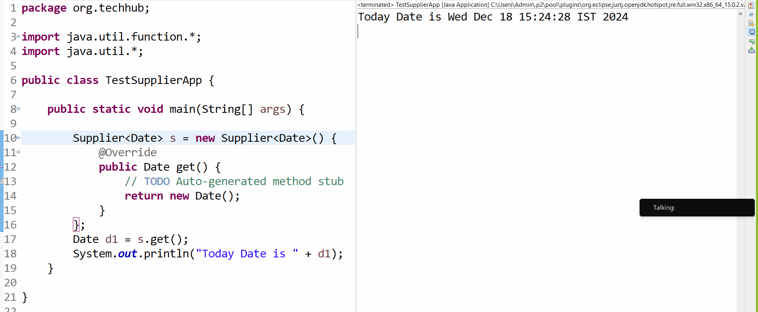
You can convert above code using lambda expression
package org.techhub;
import java.util.function.*;
import java.util.*;
public class TestSupplierApp {
public static void main(String[] args) {
Supplier<Date> s = ()->new Date();
Date d1 = s.get();
System.out.println("Today Date is " + d1);
}
}

Now we want to discuss about the Stream API
_________________________________________________________________________
Stream API is very strong feature of JDK8 which is used for minimize the boiler plate code as well as it is used for reduce the code and increase the performance of application.
Stream API in JDK1.8 is related to collection framework or group of objects. It is used for perform process on collection of data.
The Major benefit of Stream API is to reduce the code and increase performance of application.

How to create reference of Stream
________________________________________________________________________
If you want to create reference of Stream we have following syntax
Syntax: Stream<DataType> ref=collref.stream();
Example with source code
package org.techhub;
import java.util.function.*;
import java.util.*;
import java.util.stream.*;
public class TestSupplierApp {
public static void main(String[] args) {
List<Integer> list=List.of(10,20,30,40);
Stream<Integer> stream=list.stream();
stream.forEach((val)->System.out.println(val));
}
}

Now we want to understand the benefit of Stream API and for that we want to take one example

Example: We want to create List and filter the even number from List.
Example without stream API
________________________________________________________________________
package org.techhub;

import java.util.function.*;
import java.util.*;
import java.util.stream.*;
public class TestSupplierApp {
public static void main(String[] args) {
List<Integer> list=List.of(10,21,30,40,9,11,30,50);
for(Integer val:list) {
if(val%2==0) {
System.out.println(val);
}
}
}
}
If we want to solve above problem using Stream API we have filter method of Stream API
Stream<T> filter(Predicate<T>): this method accept Predicate as parameter and check the condition and return reference of Stream according to condition

Example with source code
package org.techhub;

import java.util.function.*;
import java.util.*;
import java.util.stream.*;
public class TestSupplierApp {
public static void main(String[] args) {
List<Integer> list=List.of(10,21,30,40,9,11,30,50);
Stream<Integer> stream=list.stream();
Predicate<Integer> p = new Predicate<Integer>() {

@Override
public boolean test(Integer t) {
return t%2==0;
}
};
Stream <Integer>stream1=stream.filter(p);
List<Integer> list1=stream1.collect(Collectors.toList());
list1.forEach((val)->System.out.println(val));

}
}
Minimize above code using a following fashion
______________________________________________________________________
Note: you can convert Predicate anonymous inner class in to lambda expression.
package org.techhub;

import java.util.function.*;
import java.util.*;
import java.util.stream.*;
public class TestSupplierApp {
public static void main(String[] args) {
List<Integer> list=List.of(10,21,30,40,9,11,30,50);
Stream<Integer> stream=list.stream();
Predicate<Integer> p = (Integer t)->t%2==0;
Stream <Integer>stream1=stream.filter(p);
List<Integer> list1=stream1.collect(Collectors.toList());
list1.forEach((val)->System.out.println(val));
}
}
or You can minimize code in given fashion
package org.techhub;

import java.util.function.*;
import java.util.*;
import java.util.stream.*;
public class TestSupplierApp {
public static void main(String[] args) {
List<Integer> list=List.of(10,21,30,40,9,11,30,50);
Stream<Integer> stream=list.stream();
Predicate<Integer> p = (Integer t)->t%2==0;
List<Integer> list1=stream.filter(p).collect(Collectors.toList());
list1.forEach((val)->System.out.println(val));
}
}
or
package org.techhub;

import java.util.function.*;
import java.util.*;
import java.util.stream.*;
public class TestSupplierApp {
public static void main(String[] args) {
List<Integer> list=List.of(10,21,30,40,9,11,30,50);
Stream<Integer> stream=list.stream();
List<Integer> list1=stream.filter((Integer t)->t%2==0).collect(Collectors.toList());
list1.forEach((val)->System.out.println(val));
}
}
or
package org.techhub;

import java.util.function.*;
import java.util.*;
import java.util.stream.*;
public class TestSupplierApp {
public static void main(String[] args) {
List<Integer> list=List.of(10,21,30,40,9,11,30,50);
List<Integer> list1=list.stream().filter((Integer t)->t%2==0).collect(Collectors.toList());
list1.forEach((val)->System.out.println(val));
}
}
or
package org.techhub;
import java.util.function.*;
import java.util.*;
import java.util.stream.*;
public class TestSupplierApp {
public static void main(String[] args) {
List<Integer> list=List.of(10,21,30,40,9,11,30,50);
list.stream().filter((Integer t)->t%2==0).collect(Collectors.toList()).
forEach((val)->System.out.println(val));
}
}
or
package org.techhub;
import java.util.function.*;
import java.util.*;
import java.util.stream.*;
public class TestSupplierApp {
public static void main(String[] args) {
List.of(10,21,30,40,9,11,30,50).stream().filter((Integer t)->t%2==0).
collect(Collectors.toList()).forEach((val)->System.out.println(val));
}
}
Example: WAP to create ArrayList and store five employee objects in it and employee object contain data id, name and salary and filter the employee whose salary is greater than 10000 and name contain more than 3 letters and perform above task using Stream API and filter method.

