Spring
____________________________________________________________________________
Q. What is spring?
__________________________________________________________________________
Spring is framework of framework means using a spring framework we can develop any kind of application like as console base, web base, using jdbc, enterprise level etc
Means we can spring framework is flexible framework for develop any kind of application
If we think about some framework of java like as struts can develop only web application if we think about hibernate can develop only database application etc but if we use spring we can develop web application or database etc so this is major reason people say spring is framework of framework

Q. Why use spring or what are the benefits of spring framework?
______________________________________________________________________________
1. Ability to develop any kind of application
2. Provide dependency injection and inversion of control
3. Provide loose coupling implementation
4. Provide Annotation based support or configuration as well as XML base configuration
5. Provide wide integration support to other framework like as hibernate etc
6. Huge API library
etc

Note: if we want to work with spring we should have to know the concept of dependency injection

Q. what is dependency injection?
______________________________________________________________________________
If particular class method/constructor/class is dependent on particular parameter or object called as dependency injection

Types of dependency Injection
_________________________________________________________________________
1. Setter injection
2. Constructor injection
3. Collection dependency
4. Object Dependency
5. Map dependency
6. Properties dependency
etc

Now we will discuss dependency injection one by one
Setter injection: setter injection means if we pass parameter to setter function called as setter injection

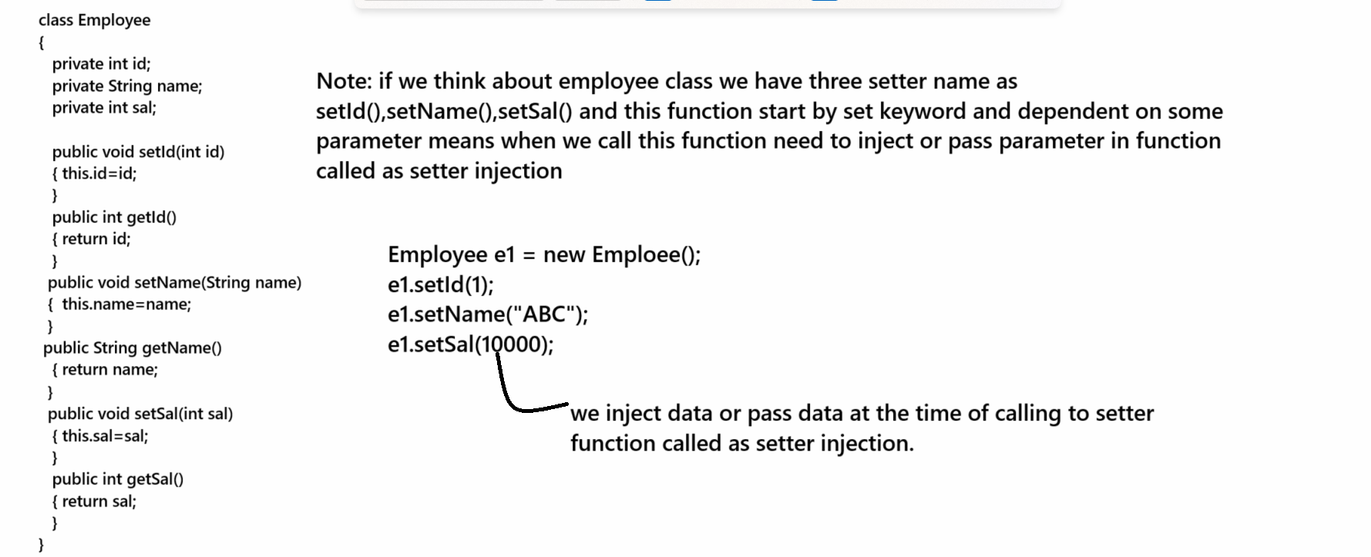

Constructor Injection
_____________________________________________________________________________
Constructor injection means when we pass parameter to constructor called as constructor injection or dependency.
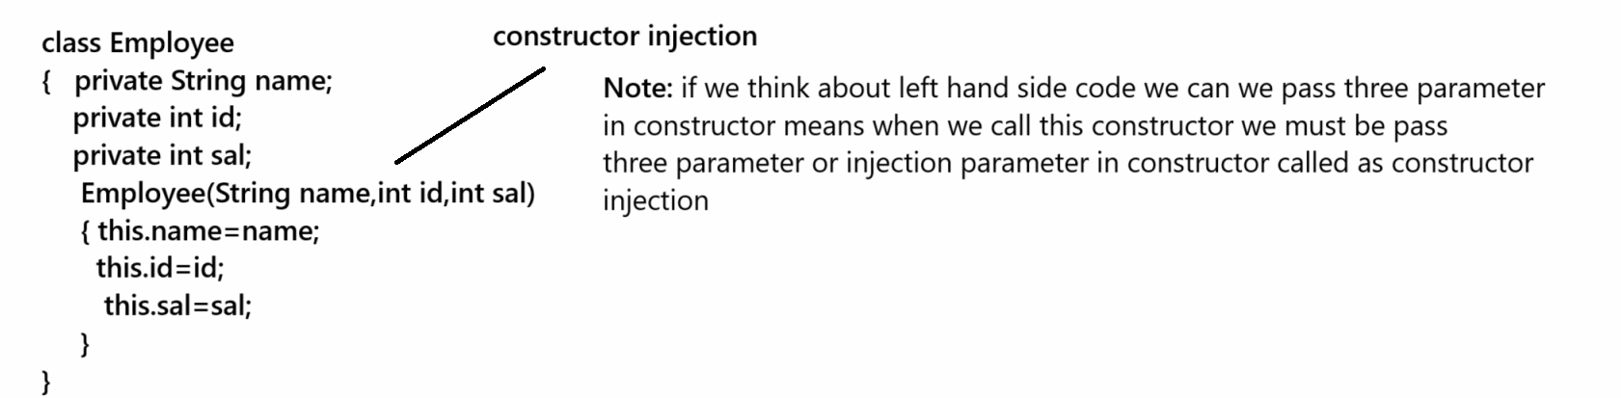
Collection dependency: When we pass collection as parameter in constructor or setter method called as collection dependency
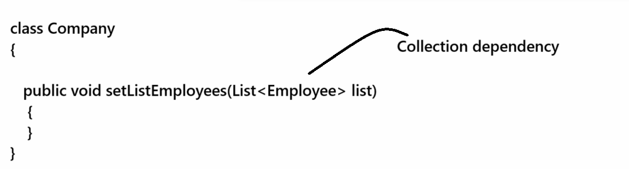
Map dependency: when we pass map as parameter in function/constructor called as Map dependency
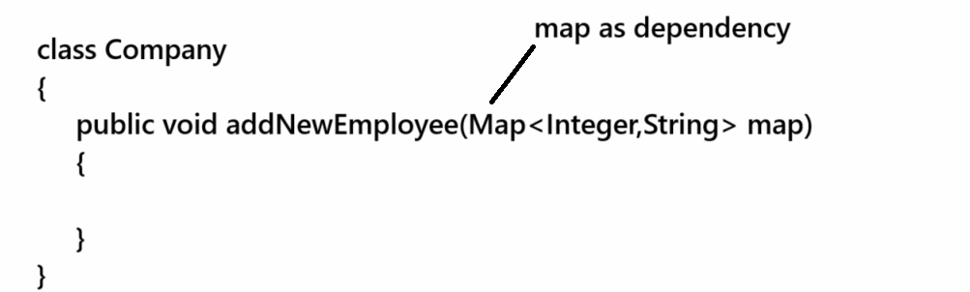

Object dependency
_________________________________________________________________________
Object dependency means when we pass Object as parameter in function or constructor called as object dependency
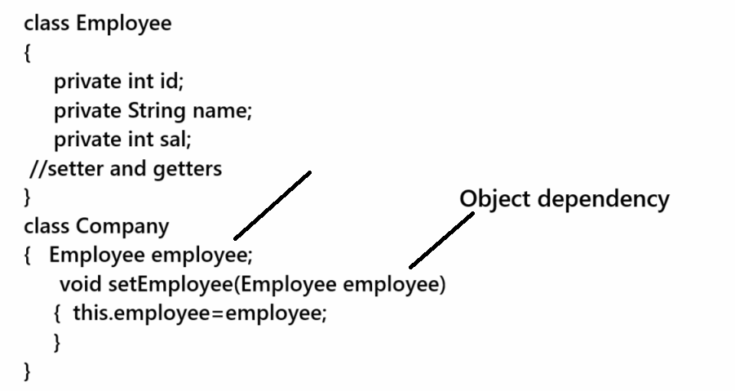
Properties dependency
___________________________________________________________________________
When we pass Properties as parameter in class called as Properties dependency
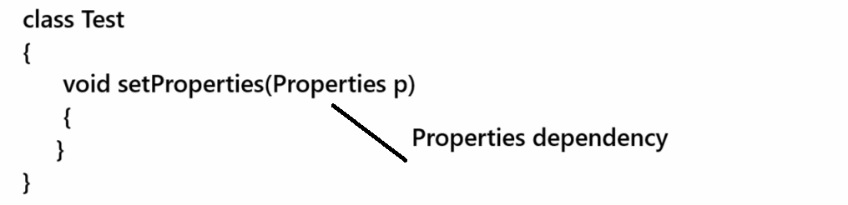

If we want to work with spring we should have to know the some important module of spring framework
_________________________________________________________________________
1. Spring core: this module provide API to us which help us to develop the console base application using spring core like as core java
2. Spring DAO: This Module helps us to connect your spring application with database by using JDBC concept
3. Spring MVC: This module can develop the web application using spring framework by using MVC Architecture
4. Spring Security: This module provides the implementation of spring security to application.
5. Spring ORM: This module can develop or can connect spring application with database by using ORM concept like as hibernate or JPA
6. Spring AOP: Spring with Aspect Oriented programming
etc

Now we want to start learning of Spring Core Module

Now we want to develop the first application using a spring core with setter injection concept
________________________________________________________________________________
1. Create Maven project
2. Add following maven dependencies
_________________________________________________________________________
If we want to work with spring core we required to add following maven dependencies
a) Spring core
b) Spring context

Example with source code
<dependencies>
<!-- https://mvnrepository.com/artifact/org.springframework/spring-core -->
<dependency>
<groupId>org.springframework</groupId>
<artifactId>spring-core</artifactId>
<version>6.1.6</version>
</dependency>
<!-- https://mvnrepository.com/artifact/org.springframework/spring-context -->
<dependency>
<groupId>org.springframework</groupId>
<artifactId>spring-context</artifactId>
<version>6.1.6</version>
</dependency>
</dependencies>

3. Create POJO class for perform setter injection

package org.techhub;

public class Employee {
private int id;
private String name;
public int getId() {
return id;
}
public void setId(int id) {
this.id = id;
}
public String getName() {
return name;
}
public void setName(String name) {
this.name = name;
}
public int getSal() {
return sal;
}
public void setSal(int sal) {
this.sal = sal;
}
private int sal;
}
Note: In the case of spring POJO known as bean

4. Configure POJO class as bean using XML for perform dependency injection and inversion of control by spring framework
___________________________________________________________________________
In the case of spring we not create manually object of bean classes and not call setter method or dependency injection manually it is responsibility spring framework and for that purpose we can configure bean class using XML or by using Annotation also.
So we want to configure bean class by XML Configuration

Steps to configure beans using XML
________________________________________________________________________
a) Create XML file under src/resources folder
Right click on src/resources folder --- new --- other --- XML ---- select XML file option ---- give file name and click on ok and finish button
b) Write DOCTYPE in XML file
_________________________________________________________________
Q. What is DOCTYPE?
________________________________________________________________________
DOCTYPE is used for reuse the XML tag develop by user means if we think XML it is custom tag language means user can develop and can reuse it more than one time and for that purpose use create own tag document called as DOCTYPE
If we think about spring framework spring developer team design own tag for configure java class as bean class in spring framework and any java developer want to configure his java class as bean class then he need to use bean configuration tags in XML file but that tag present in DOCTYPE design spring team so we required to add DOCTYPE at top of XML bean configuration

How to write DOCTYPE in XML?
________________________________________________________________________
Note: normally DOCTYPE present in .jar file in framework
If we want to configure DOCTYPE for spring bean we have to use following steps.

Click on maven dependency ----click on spring beans.jar ---- open org.springframework.beans.factory.xml ---- open the spring-beans.dtd file --- copy the doctype from commented section of XML file

DOCTYPE we required to add in .xml file
<!DOCTYPE beans PUBLIC "-//SPRING//DTD BEAN 2.0//EN"
"https://www.springframework.org/dtd/spring-beans-2.0.dtd">

Once we add DOCTYPE in XML file you have to write following tags

<beans>
<bean id=”ref” class=”packagename.classname”>
<property name=”variablename/attributename” value=”value”/>
</bean>
</beans>

<bean> tag indicate we have bean class or POJO class
id indicate the reference of bean class using that spring container can create object of bean class
class: this attribute indicate class whose object want to create by spring container.
property: indicate set keyword name indicate the setter method name and value is parameter which we want to pass to setter function by spring container.

Example of bean i.e emp.xml
<?xml version="1.0" encoding="UTF-8"?>
<!DOCTYPE beans PUBLIC "-//SPRING//DTD BEAN 2.0//EN"
"https://www.springframework.org/dtd/spring-beans-2.0.dtd">

<beans>
<bean id="e" class="org.techhub.Employee">
<property name="id" value="1"/>
<property name="name" value="ABC"/>
<property name="sal" value="10000"/>
</bean>
</beans>

5. Create Spring container
Q. What is spring container?
_______________________________________________________________
Spring container is Internal API which help us to manage all spring framework activity like as creating spring bean object, managing life cycle of spring bean , destroy the bean manage scope of etc

There are two types of Spring container
______________________________________________________
a) BeanFactory
b) ApplicationContext
Note: we will discuss difference between them later in spring core module.
Now we want to use BeanFactory
Steps to work with BeanFactory container
_______________________________________________________
a) Create Reference of Resource and load XML file from classpath of application
__________________________________________________________________________
Resource is interface and which help us to load the XML bean file from different location like as CLASSPATH or may be File System etc
So if we want to create reference of Resource we required to create object ClassPathResource() implementer class
Syntax: Resource ref = new ClassPathResource(String xmlfile);
Example: Resource r=new ClassPathResource("emp.xml");
b) Create Reference of BeanFactory
If we want to create reference of BeanFactory we have XMLBeanFactory class and it is implementer class of BeanFactory.
Syntax: BeanFactory ref=new XMLBeanFactory(Resource);

package org.techhub;
import org.springframework.beans.factory.BeanFactory;
import org.springframework.beans.factory.xml.XmlBeanFactory;
import org.springframework.core.io.ClassPathResource;
import org.springframework.core.io.Resource;

public class ClientApplication {
public static void main(String[] args) {
Resource r=new ClassPathResource("emp.xml");
BeanFactory b=new XmlBeanFactory(r);

}

}
6. Instantiate bean and perform dependency injection
_______________________________________________________________
if we want to create bean object using spring framework we have getBean() method of BeanFactory which help us to create instance of bean and perform setter injection internally by spring framework.
Syntax: Object getBean(“beanid”);
package org.techhub;
import org.springframework.beans.factory.BeanFactory;
import org.springframework.beans.factory.xml.XmlBeanFactory;
import org.springframework.core.io.ClassPathResource;
import org.springframework.core.io.Resource;
public class ClientApplication {
public static void main(String[] args) {
Resource r=new ClassPathResource("emp.xml");
BeanFactory b=new XmlBeanFactory(r);
Employee e=(Employee)b.getBean("e");
e.show();
}

}

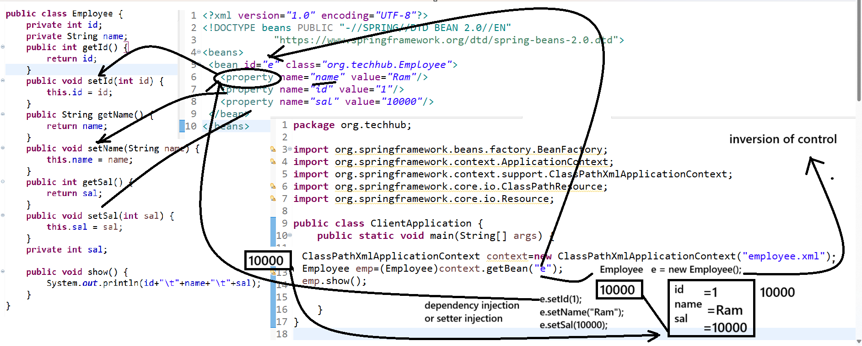
Note: when we call getBean() method then internally spring container create object of bean class known as inversion of control process and after that call setter method automatically according to property configured in bean tag known as setter injection and it is part of dependency injection so we can say spring framework dependency injection and inversion of control

How to perform setter injection using annotation
_____________________________________________________________________________
Annotation is the some interfaces and which is used for provide configuration in java and it help us minimize the XML configuration in java means when configure your application using annotation we not required to write XML for configuration and if we want to identify the annotation in java we have symbol i.e @annotation name

If we want to perform setter injection using annotation we have following steps and we required following annotations

a) @Configuration: This annotation help us to write class where we configure our beans means @Configuration annotation with class work like as Config XML file.
Example:
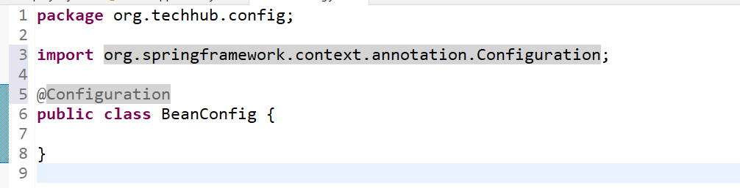
b) @ComponentScan: this annotation helps us to scan the packages where we use the stereo annotation like as find the service layer package, repository layer package etc
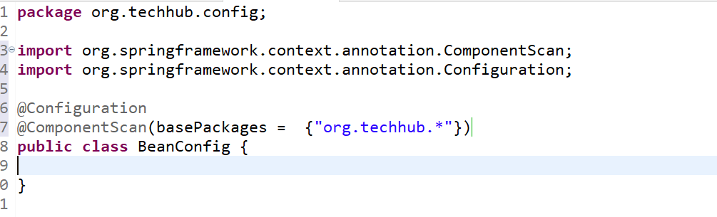
if we think about above @ComponentScan here we can say this annotation find the stereo type of annotation in org.techhub.* packages according to our example.

C) @Bean: this annotation helps us to create the bean object by spring container by its name or id.
package org.techhub.config;

import org.springframework.context.annotation.Bean;
import org.springframework.context.annotation.ComponentScan;
import org.springframework.context.annotation.Configuration;
import org.techhub.*;

@Configuration
@ComponentScan(basePackages = { "org.techhub.*" })
public class BeanConfig {
@Bean(name = "e")
public Employee getBean() {
return new Employee();
}
}

D) @Component: @Component annotation is also known as bean means if we use @Component with any user defined class then it is a consider bean class
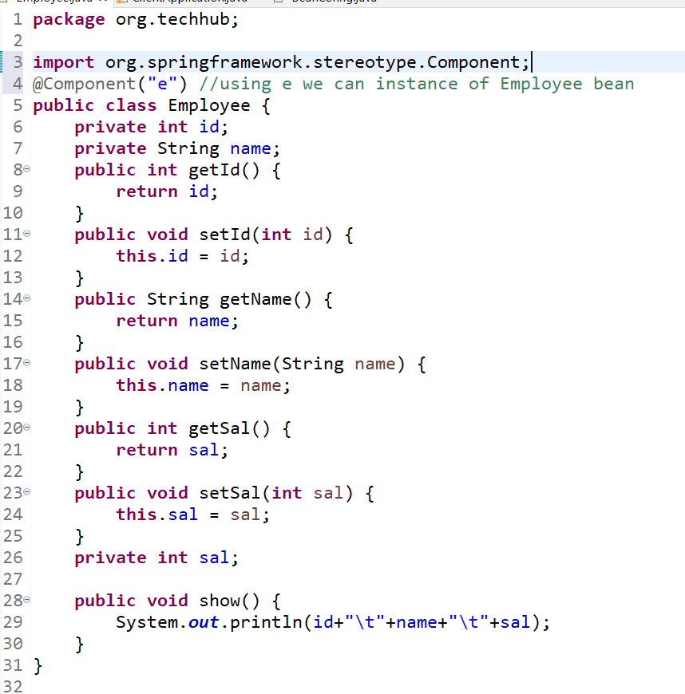

Q. What is difference between @Bean and @Component?
___________________________________________________________________
@Bean annotation normally recommended when we want to create object of build in class or library class and @Component normally use when developer want to mark user defined class as bean.

E) @Value: @Value annotation is used for initialize the value to property at the time of declaration as well as @Value help us to read data from .properties file and @Value is field level annotation.
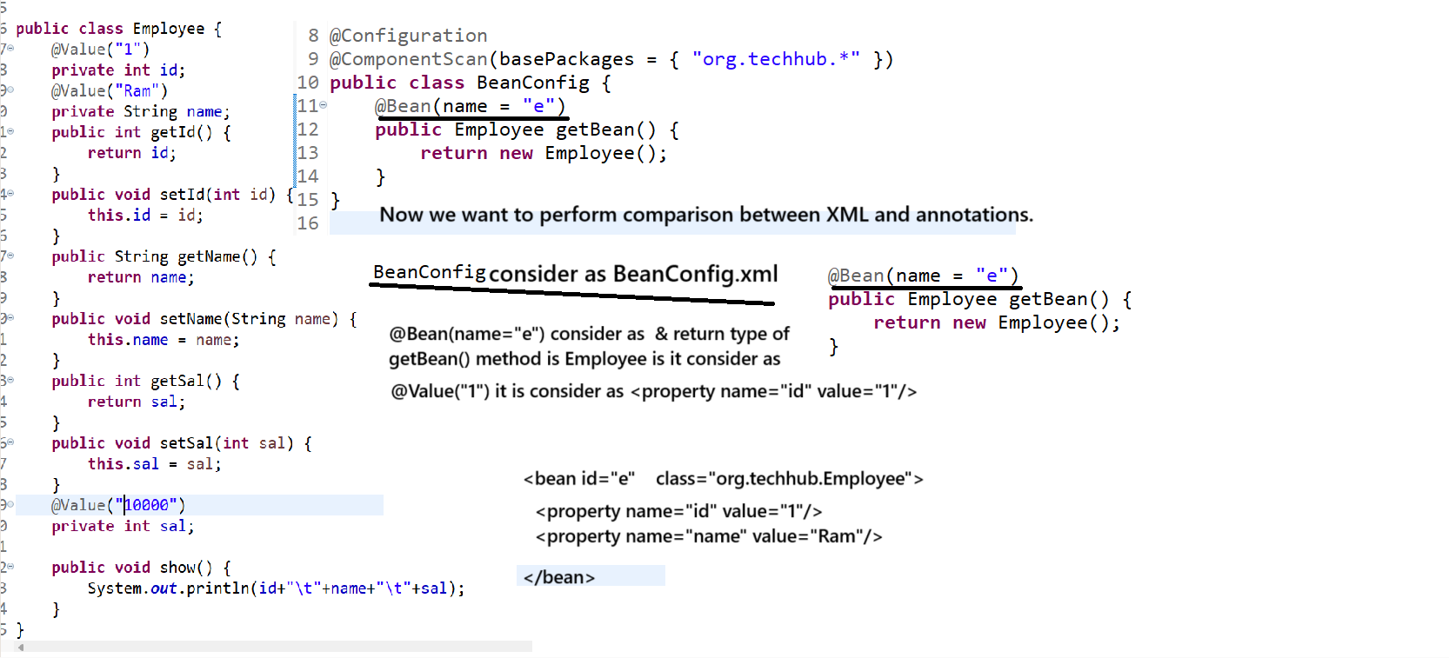
Note: when we use annotation then we need to use following type of classes as container
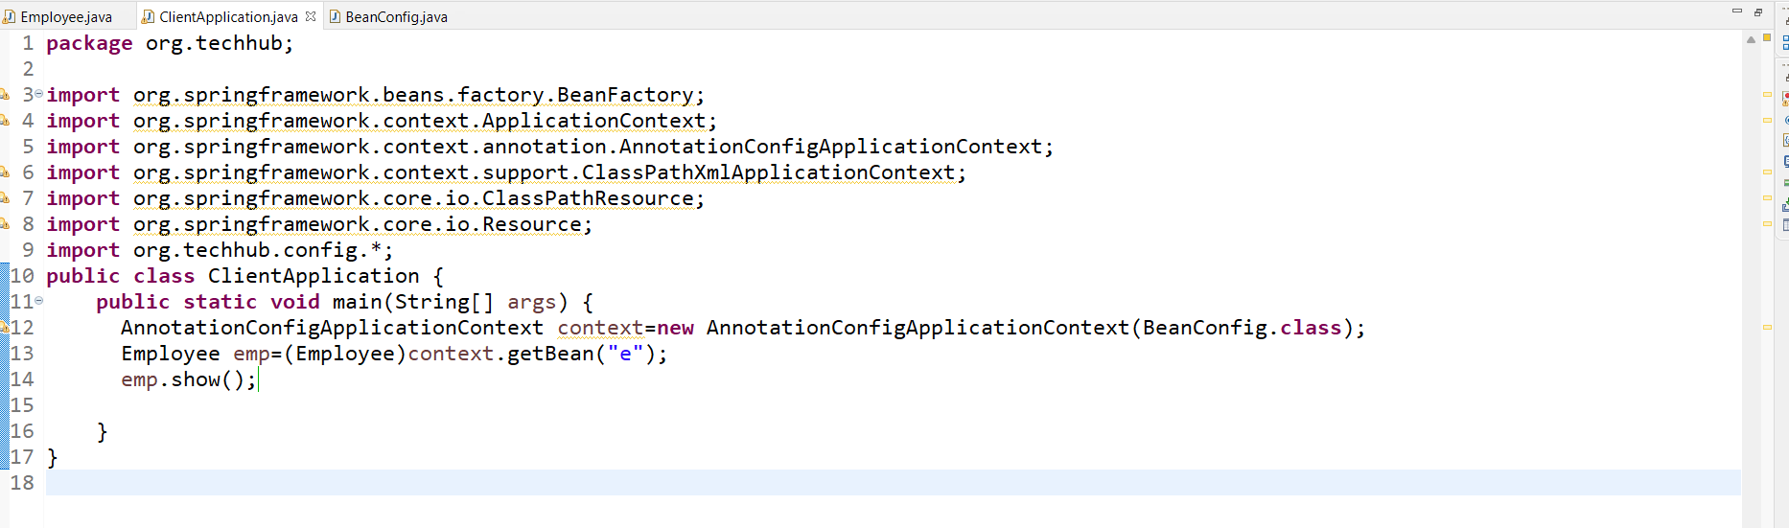
Constructor Injection
_________________________________________________________________
Constructor injection means when constructor call by spring container and pass parameter to constructor by spring container called as constructor injection
Note: If we have default constructor in class then we not need to implement constructor injection
Because when we call the getBean () method then spring container internally create object of bean class and call constructor.

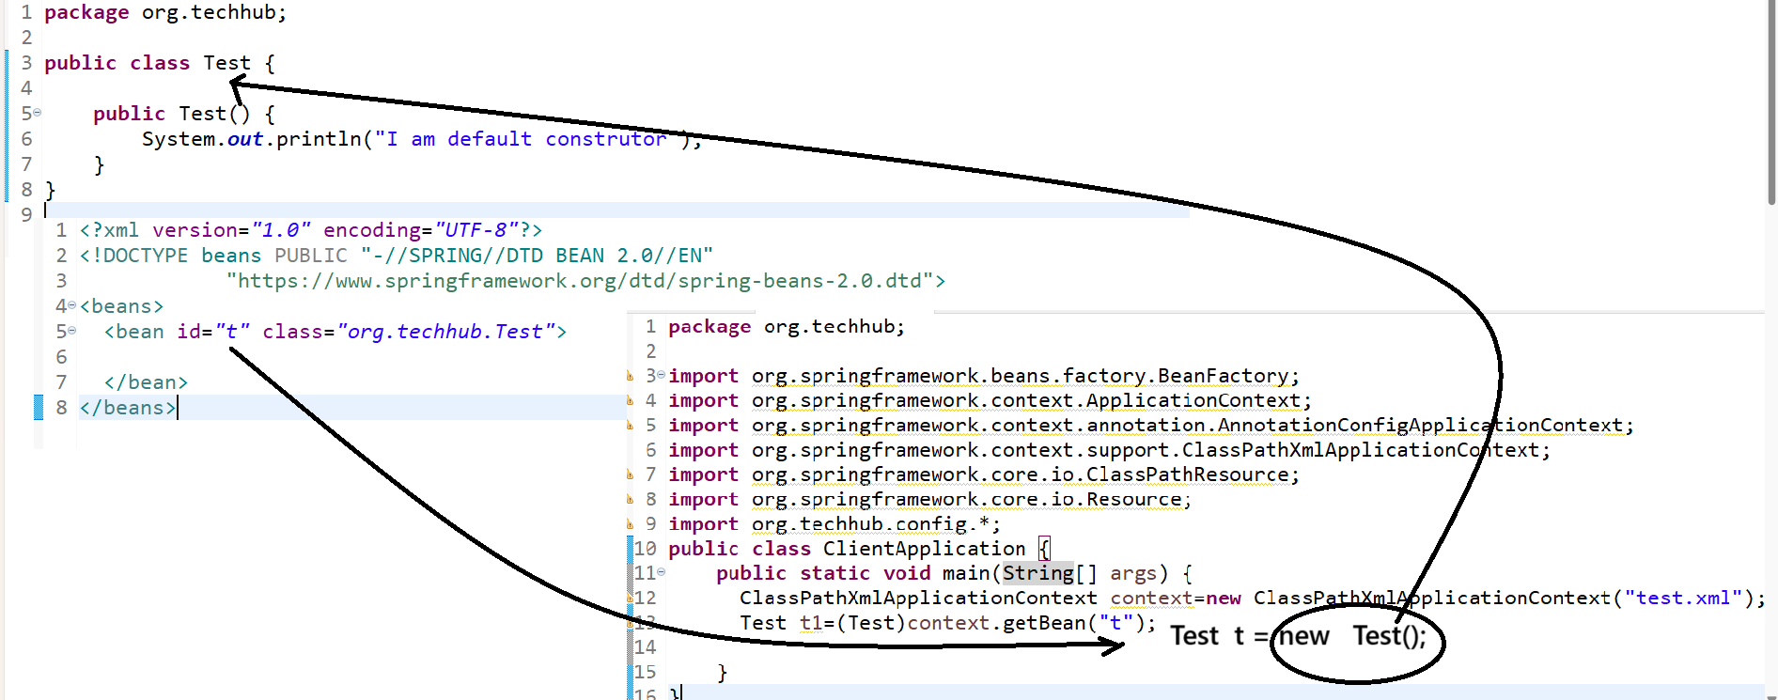

Note: when we have parameterized constructor then we need to perform constructor injection
Means need to parameter to constructor where we configure bean in XML and for that purpose we have
<constructor-arg value=”value” type=”typename” index=”parameterindex”/>
<constructor-arg>: this tag indicate we want to pass to constructor through the spring container at the of bean instantiation.
value: value is actual parameter data which we want to pass parameter
type: this attribute indicate type of data type
index: this attribute indicate parameter number
Note: normally index parameter recommend when we two parameter of same type.

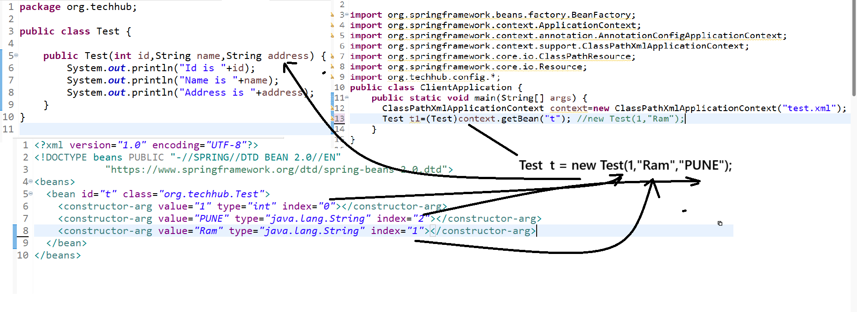
Object dependency and autowiring concept
_________________________________________________________________________________
If we particular object creation is dependent on another object creation called as object dependency
If we think about object dependency we have two terms
a) Target entity or class: target entity means which class object created by directly using spring container by getBean () method and which is responsible for create object of dependent class.
b) Dependent entity or class: A class which memory allocation is dependent on target class or parameter class called as dependent class.
Example: Suppose we have following class structure
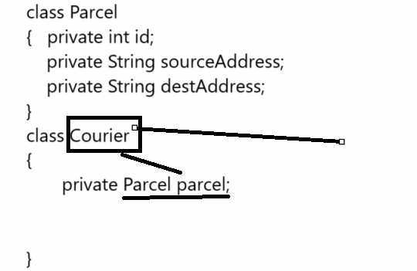
Note: if we think about above code we have two classes name as Courier and Parcel so here we can Courier is target entity and Parcel is dependent entity because Parcel object is dependent on Courier object means when we pass bean id of Courier to Spring container then internally Spring container can create object of Parcel automatically just we need to provide some configuration to spring container

How to implement Object dependency practically?
_____________________________________________________________________________
If we want to implement object dependency practically we have two ways
a) Using XML
b) Using Annotation

How to achieve object dependency with the help of XML
____________________________________________________________________________
<bean id=”dependent class id” class=”dependent classname”>
<property name=”propertyname” value=”value”/>
</bean>
<bean id=”target class id” class=”targetclassname”>
<property name=”propertyname” ref=”dependent class id”/>
</bean>

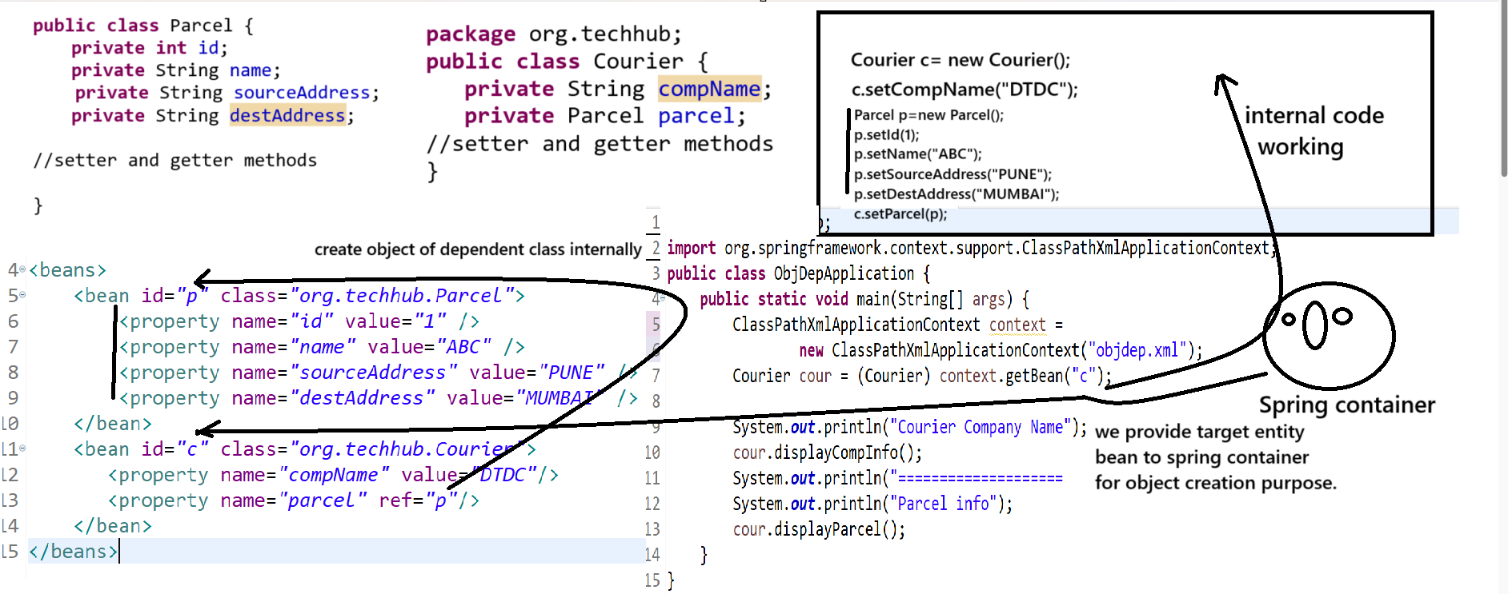

Example with source code
_____________________________________________________________________________
Courier.java
_________________________________________________________________________
package org.techhub;

public class Courier {
private String compName;

public Courier() {

}
public Courier(Parcel parcel) {
this.parcel=parcel;
}
public String getCompName() {
return compName;
}

public void setCompName(String compName) {
this.compName = compName;
}

public Parcel getParcel() {
return parcel;
}

public void setParcel(Parcel parcel) {
this.parcel = parcel;
}

public void displayParcel() {
System.out.println(parcel.getId() + "\t" + parcel.getName() + "\t" + parcel.getSourceAddress() + "\t"
+ parcel.getDestAddress());
}

public void displayCompInfo() {
System.out.println(compName);
}

private Parcel parcel;
}

Parcel.java
______________________________________________________________________
package org.techhub;

public class Parcel {
private int id;
private String name;
public int getId() {
return id;
}
public void setId(int id) {
this.id = id;
}
public String getName() {
return name;
}
public void setName(String name) {
this.name = name;
}
public String getSourceAddress() {
return sourceAddress;
}
public void setSourceAddress(String sourceAddress) {
this.sourceAddress = sourceAddress;
}
public String getDestAddress() {
return destAddress;
}
public void setDestAddress(String destAddress) {
this.destAddress = destAddress;
}
private String sourceAddress;
private String destAddress;
}
objdep.xml
<?xml version="1.0" encoding="UTF-8"?>
<!DOCTYPE beans PUBLIC "-//SPRING//DTD BEAN 2.0//EN"
"https://www.springframework.org/dtd/spring-beans-2.0.dtd">
<beans>
<bean id="p" class="org.techhub.Parcel">
<property name="id" value="1" />
<property name="name" value="ABC" />
<property name="sourceAddress" value="PUNE" />
<property name="destAddress" value="MUMBAI" />
</bean>
<bean id="c" class="org.techhub.Courier">
<property name="compName" value="DTDC"/>
<property name="parcel" ref="p"/>
</bean>
</beans>

ObjDepApplication.java
package org.techhub;
import org.springframework.context.ApplicationContext;
import org.springframework.context.support.ClassPathXmlApplicationContext;
public class ObjDepApplication {
public static void main(String[] args) {
ApplicationContext context =
new ClassPathXmlApplicationContext("objdep.xml");
Courier cour = (Courier) context.getBean("c");
Courier cour1 = (Courier) context.getBean("c");
Courier cour2 = (Courier) context.getBean("c");
System.out.println("Hashcode of cour "+System.identityHashCode(cour));
System.out.println("Hashcode of cour1 "+System.identityHashCode(cour1));
System.out.println("Hashcode of cour2 "+System.identityHashCode(cour2));

System.out.println("Courier Company Name");
cour.displayCompInfo();
System.out.println("====================================");
System.out.println("Parcel info");
cour.displayParcel();

System.out.println("Courier Company Name");
cour1.displayCompInfo();
System.out.println("====================================");
System.out.println("Parcel info");
cour1.displayParcel();
}
}
Now we want to auto writing concept
_________________________________________________________________________
Auto wiring concept only works with object dependency
If we use the auto wiring feature with object dependency then the benefit is programmer not need to provide dependent bean id manually in setter inject or in constructor injection it is taken care by spring container.
So if we want to use auto wiring we have following syntax
_____________________________________________________________________________
<bean id=”target id” class=”target classname” auto-wire=”type”>
</bean>

Types of auto wiring
________________________________________________________________
byName: when we use the byName auto writing then reference of dependent class declared in target class and bean id configured in XML file must be same.

Example with source code
_________________________________________________________________________
package org.techhub;
public class Courier {
private String compName;

public Courier() {

}
public Courier(Parcel parcel) {
this.parcel=parcel;
}
public String getCompName() {
return compName;
}

public void setCompName(String compName) {
this.compName = compName;
}

public Parcel getParcel() {
return parcel;
}

public void setParcel(Parcel parcel) {
this.parcel = parcel;
}

public void displayParcel() { //null.getId()
System.out.println(parcel.getId() + "\t" + parcel.getName() + "\t" + parcel.getSourceAddress() + "\t"
+ parcel.getDestAddress());
}

public void displayCompInfo() {
System.out.println(compName);
}

private Parcel parcel;//null
}

Parcel.java
package org.techhub;

public class Parcel {
private int id;
private String name;
public int getId() {
return id;
}
public void setId(int id) {
this.id = id;
}
public String getName() {
return name;
}
public void setName(String name) {
this.name = name;
}
public String getSourceAddress() {
return sourceAddress;
}
public void setSourceAddress(String sourceAddress) {
this.sourceAddress = sourceAddress;
}
public String getDestAddress() {
return destAddress;
}
public void setDestAddress(String destAddress) {
this.destAddress = destAddress;
}
private String sourceAddress;
private String destAddress;
}
objdep.xml
<?xml version="1.0" encoding="UTF-8"?>
<!DOCTYPE beans PUBLIC "-//SPRING//DTD BEAN 2.0//EN"
"https://www.springframework.org/dtd/spring-beans-2.0.dtd">
<beans>
<bean id="parcel" class="org.techhub.Parcel">
<property name="id" value="1" />
<property name="name" value="ABC" />
<property name="sourceAddress" value="PUNE" />
<property name="destAddress" value="MUMBAI" />
</bean>
<bean id="c" class="org.techhub.Courier" autowire="byName">
<property name="compName" value="DTDC"/>

</bean>
</beans>

ObjDepApplication.java
package org.techhub;
import org.springframework.context.ApplicationContext;
import org.springframework.context.support.ClassPathXmlApplicationContext;
public class ObjDepApplication {
public static void main(String[] args) {
ApplicationContext context =
new ClassPathXmlApplicationContext("objdep.xml");
Courier cour = (Courier) context.getBean("c");

System.out.println("Courier Company Name");
cour.displayCompInfo();

System.out.println("====================================");

System.out.println("Parcel info");
cour.displayParcel();

}
}

byType: byType auto wiring means spring container internal data type of bean configured in XML and dependent object member data type

Example with source code
_________________________________________________________________________
package org.techhub;
public class Courier {
private String compName;

public Courier() {

}
public Courier(Parcel parcel) {
this.parcel=parcel;
}
public String getCompName() {
return compName;
}

public void setCompName(String compName) {
this.compName = compName;
}

public Parcel getParcel() {
return parcel;
}

public void setParcel(Parcel parcel) {
this.parcel = parcel;
}

public void displayParcel() { //null.getId()
System.out.println(parcel.getId() + "\t" + parcel.getName() + "\t" + parcel.getSourceAddress() + "\t"
+ parcel.getDestAddress());
}

public void displayCompInfo() {
System.out.println(compName);
}

private Parcel parcel;//null
}

Parcel.java
package org.techhub;

public class Parcel {
private int id;
private String name;
public int getId() {
return id;
}
public void setId(int id) {
this.id = id;
}
public String getName() {
return name;
}
public void setName(String name) {
this.name = name;
}
public String getSourceAddress() {
return sourceAddress;
}
public void setSourceAddress(String sourceAddress) {
this.sourceAddress = sourceAddress;
}
public String getDestAddress() {
return destAddress;
}
public void setDestAddress(String destAddress) {
this.destAddress = destAddress;
}
private String sourceAddress;
private String destAddress;
}
objdep.xml
<?xml version="1.0" encoding="UTF-8"?>
<!DOCTYPE beans PUBLIC "-//SPRING//DTD BEAN 2.0//EN"
"https://www.springframework.org/dtd/spring-beans-2.0.dtd">
<beans>
<bean id="parcel" class="org.techhub.Parcel">
<property name="id" value="1" />
<property name="name" value="ABC" />
<property name="sourceAddress" value="PUNE" />
<property name="destAddress" value="MUMBAI" />
</bean>
<bean id="c" class="org.techhub.Courier" autowire="byType">
<property name="compName" value="DTDC"/>

</bean>
</beans>

ObjDepApplication.java
package org.techhub;
import org.springframework.context.ApplicationContext;
import org.springframework.context.support.ClassPathXmlApplicationContext;
public class ObjDepApplication {
public static void main(String[] args) {
ApplicationContext context =
new ClassPathXmlApplicationContext("objdep.xml");
Courier cour = (Courier) context.getBean("c");

System.out.println("Courier Company Name");
cour.displayCompInfo();

System.out.println("====================================");

System.out.println("Parcel info");
cour.displayParcel();

}
}

constructor: when we use the object dependency using constructor then we can use constructor auto wiring concept.

Example with source code
_________________________________________________________________________
package org.techhub;
public class Courier {
private String compName;

public Courier() {

}
public Courier(Parcel parcel) {
this.parcel=parcel;
}
public String getCompName() {
return compName;
}

public void setCompName(String compName) {
this.compName = compName;
}

public Parcel getParcel() {
return parcel;
}

public void setParcel(Parcel parcel) {
this.parcel = parcel;
}

public void displayParcel() { //null.getId()
System.out.println(parcel.getId() + "\t" + parcel.getName() + "\t" + parcel.getSourceAddress() + "\t"
+ parcel.getDestAddress());
}

public void displayCompInfo() {
System.out.println(compName);
}

private Parcel parcel;//null
}

Parcel.java
package org.techhub;

public class Parcel {
private int id;
private String name;
public int getId() {
return id;
}
public void setId(int id) {
this.id = id;
}
public String getName() {
return name;
}
public void setName(String name) {
this.name = name;
}
public String getSourceAddress() {
return sourceAddress;
}
public void setSourceAddress(String sourceAddress) {
this.sourceAddress = sourceAddress;
}
public String getDestAddress() {
return destAddress;
}
public void setDestAddress(String destAddress) {
this.destAddress = destAddress;
}
private String sourceAddress;
private String destAddress;
}
objdep.xml
<?xml version="1.0" encoding="UTF-8"?>
<!DOCTYPE beans PUBLIC "-//SPRING//DTD BEAN 2.0//EN"
"https://www.springframework.org/dtd/spring-beans-2.0.dtd">
<beans>
<bean id="parcel" class="org.techhub.Parcel">
<property name="id" value="1" />
<property name="name" value="ABC" />
<property name="sourceAddress" value="PUNE" />
<property name="destAddress" value="MUMBAI" />
</bean>
<bean id="c" class="org.techhub.Courier" autowire="byType">
<property name="compName" value="DTDC"/>

</bean>
</beans>

ObjDepApplication.java
package org.techhub;
import org.springframework.context.ApplicationContext;
import org.springframework.context.support.ClassPathXmlApplicationContext;
public class ObjDepApplication {
public static void main(String[] args) {
ApplicationContext context =
new ClassPathXmlApplicationContext("objdep.xml");
Courier cour = (Courier) context.getBean("c");

System.out.println("Courier Company Name");
cour.displayCompInfo();
System.out.println("====================================");
System.out.println("Parcel info");
cour.displayParcel();
}
}
autodetect: if we think about auto detect auto wiring then spring container internally check the default constructor in target class if default constructor found in target class then perform constructor injection and if default constructor not found in target class then perform byType auto writing

Example with source code
_________________________________________________________________________
package org.techhub;
public class Courier {
private String compName;

public Courier() {

}
public Courier(Parcel parcel) {
this.parcel=parcel;
}
public String getCompName() {
return compName;
}

public void setCompName(String compName) {
this.compName = compName;
}

public Parcel getParcel() {
return parcel;
}

public void setParcel(Parcel parcel) {
this.parcel = parcel;
}

public void displayParcel() { //null.getId()
System.out.println(parcel.getId() + "\t" + parcel.getName() + "\t" + parcel.getSourceAddress() + "\t"
+ parcel.getDestAddress());
}

public void displayCompInfo() {
System.out.println(compName);
}

private Parcel parcel;//null
}

Parcel.java
package org.techhub;

public class Parcel {
private int id;
private String name;
public int getId() {
return id;
}
public void setId(int id) {
this.id = id;
}
public String getName() {
return name;
}
public void setName(String name) {
this.name = name;
}
public String getSourceAddress() {
return sourceAddress;
}
public void setSourceAddress(String sourceAddress) {
this.sourceAddress = sourceAddress;
}
public String getDestAddress() {
return destAddress;
}
public void setDestAddress(String destAddress) {
this.destAddress = destAddress;
}
private String sourceAddress;
private String destAddress;
}
objdep.xml
<?xml version="1.0" encoding="UTF-8"?>
<!DOCTYPE beans PUBLIC "-//SPRING//DTD BEAN 2.0//EN"
"https://www.springframework.org/dtd/spring-beans-2.0.dtd">
<beans>
<bean id="parcel" class="org.techhub.Parcel">
<property name="id" value="1" />
<property name="name" value="ABC" />
<property name="sourceAddress" value="PUNE" />
<property name="destAddress" value="MUMBAI" />
</bean>
<bean id="c" class="org.techhub.Courier" autowire="byType">
<property name="compName" value="DTDC"/>

</bean>
</beans>

ObjDepApplication.java
package org.techhub;
import org.springframework.context.ApplicationContext;
import org.springframework.context.support.ClassPathXmlApplicationContext;
public class ObjDepApplication {
public static void main(String[] args) {
ApplicationContext context =
new ClassPathXmlApplicationContext("objdep.xml");
Courier cour = (Courier) context.getBean("c");

System.out.println("Courier Company Name");
cour.displayCompInfo();
System.out.println("====================================");
System.out.println("Parcel info");
cour.displayParcel();
}
}

default: default auto wiring perform byType auto wiring concept means when developer not set any auto wiring then spring container by default use the byType autowiring.
Bean Scope Concept in spring core
_________________________________________________________________________________
Bean scope means how bean should be instantiated by spring container and decide the life of bean called as bean scope.
Types of bean scope
_______________________________________________________________________
a) singleton: if we set the singleton scope of spring bean then spring container create object of bean only once in application and by default every bean has singleton scope.
b) prototype: prototype scope means bean can instantiate every time by spring container when we call getBean() method means prototype scope create normal java bean which create new memory every time when we call getBean()

Note: remaining scope we will discuss practically in Spring MVC
c) session: if we set session scope of spring bean then bean present whenever user session is live .
d) request: if we set the request scope of bean then bean can present only in request
e) application: if we set application scope for it is global scope for whole application means it is stored in ServletContext internally and accessible by all session objects and request object and till stored whenever application running on server
f) WebSocket: Scopes a single bean definition to the lifecycle of websocket only valid in context of web-aware spring.
etc

How to set the scope of bean using XML configuration
____________________________________________________________________________
<bean id=”idname” class=”classname” scope=”scopename”>
</bean>

Example:
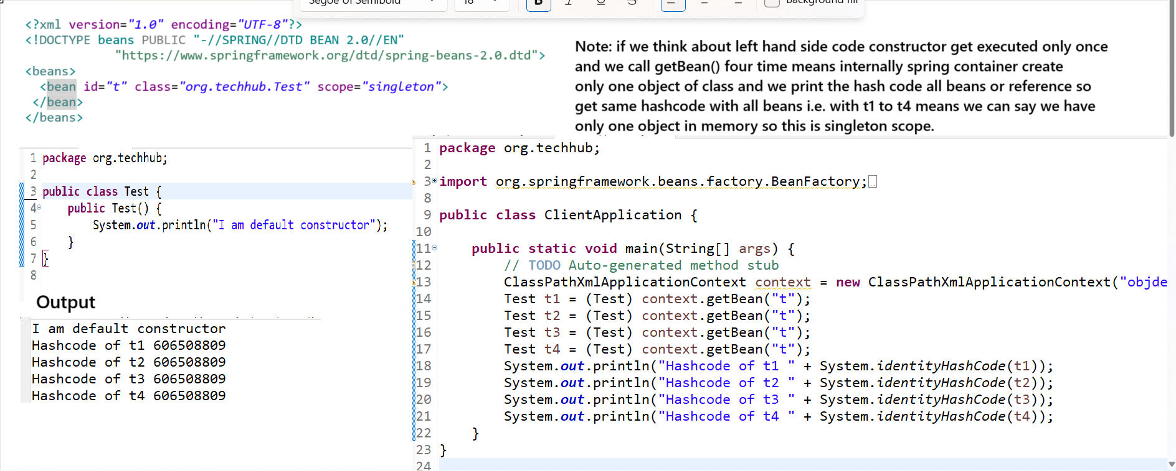
Proto type scope
__________________________________________________________________
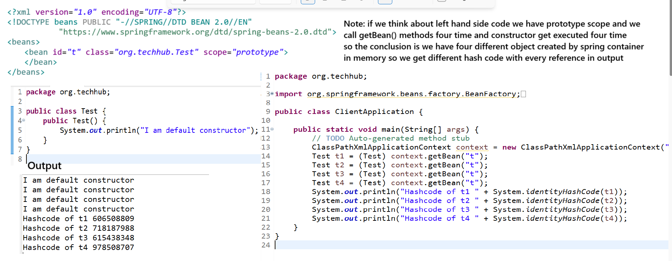

How to implement the Object dependency and Auto wiring concept with Annotations
_____________________________________________________________________________________
if we want to implement the object dependency using annotation we have to use following annotations
@Autowired
@Qualifier
Example using @Autowired annotation
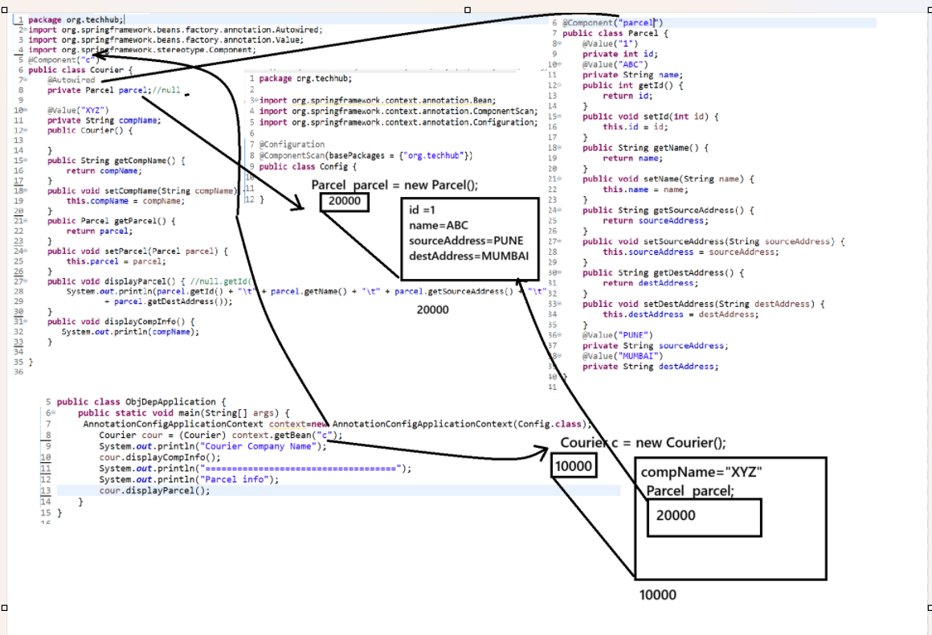
Example with source code
Courier.java
package org.techhub;
import org.springframework.beans.factory.annotation.Autowired;
import org.springframework.beans.factory.annotation.Value;
import org.springframework.stereotype.Component;
@Component("c")
public class Courier {
@Autowired
private Parcel parcel;//null

@Value("XYZ")
private String compName;
public Courier() {

}
public String getCompName() {
return compName;
}
public void setCompName(String compName) {
this.compName = compName;
}
public Parcel getParcel() {
return parcel;
}
public void setParcel(Parcel parcel) {
this.parcel = parcel;
}
public void displayParcel() { //null.getId()
System.out.println(parcel.getId() + "\t" + parcel.getName() + "\t" + parcel.getSourceAddress() + "\t"
+ parcel.getDestAddress());
}
public void displayCompInfo() {
System.out.println(compName);
}

}
Parcel.java
package org.techhub;

import org.springframework.beans.factory.annotation.Value;
import org.springframework.stereotype.Component;

@Component("parcel")
public class Parcel {
@Value("1")
private int id;
@Value("ABC")
private String name;
public int getId() {
return id;
}
public void setId(int id) {
this.id = id;
}
public String getName() {
return name;
}
public void setName(String name) {
this.name = name;
}
public String getSourceAddress() {
return sourceAddress;
}
public void setSourceAddress(String sourceAddress) {
this.sourceAddress = sourceAddress;
}
public String getDestAddress() {
return destAddress;
}
public void setDestAddress(String destAddress) {
this.destAddress = destAddress;
}
@Value("PUNE")
private String sourceAddress;
@Value("MUMBAI")
private String destAddress;
}

Config.java
package org.techhub;

import org.springframework.context.annotation.Bean;
import org.springframework.context.annotation.ComponentScan;
import org.springframework.context.annotation.Configuration;

@Configuration
@ComponentScan(basePackages = {"org.techhub"})
public class Config {

}
ClientApplication.java
package org.techhub;

import org.springframework.beans.factory.BeanFactory;
import org.springframework.beans.factory.xml.XmlBeanFactory;
import org.springframework.context.support.ClassPathXmlApplicationContext;
import org.springframework.core.io.ClassPathResource;
import org.springframework.core.io.Resource;

public class ClientApplication {

public static void main(String[] args) {
// TODO Auto-generated method stub
ClassPathXmlApplicationContext context = new ClassPathXmlApplicationContext("objdep.xml");
Test t1 = (Test) context.getBean("t");
Test t2 = (Test) context.getBean("t");
Test t3 = (Test) context.getBean("t");
Test t4 = (Test) context.getBean("t");
System.out.println("Hashcode of t1 " + System.identityHashCode(t1));
System.out.println("Hashcode of t2 " + System.identityHashCode(t2));
System.out.println("Hashcode of t3 " + System.identityHashCode(t3));
System.out.println("Hashcode of t4 " + System.identityHashCode(t4));
}
}

@Qualifier annotations
_________________________________________________________________________
It is used for achieve dynamic Polymorphism by using @Autowired annotations
Suppose consider if we have interface if we implement multiple implementer class and if we use the reference of interface with @Autowired annotation then using that reference which implementer object should be use decided by @Qualifier annotation so we required to pass implementer class bean id in @Qualifier annotations shown in following code.
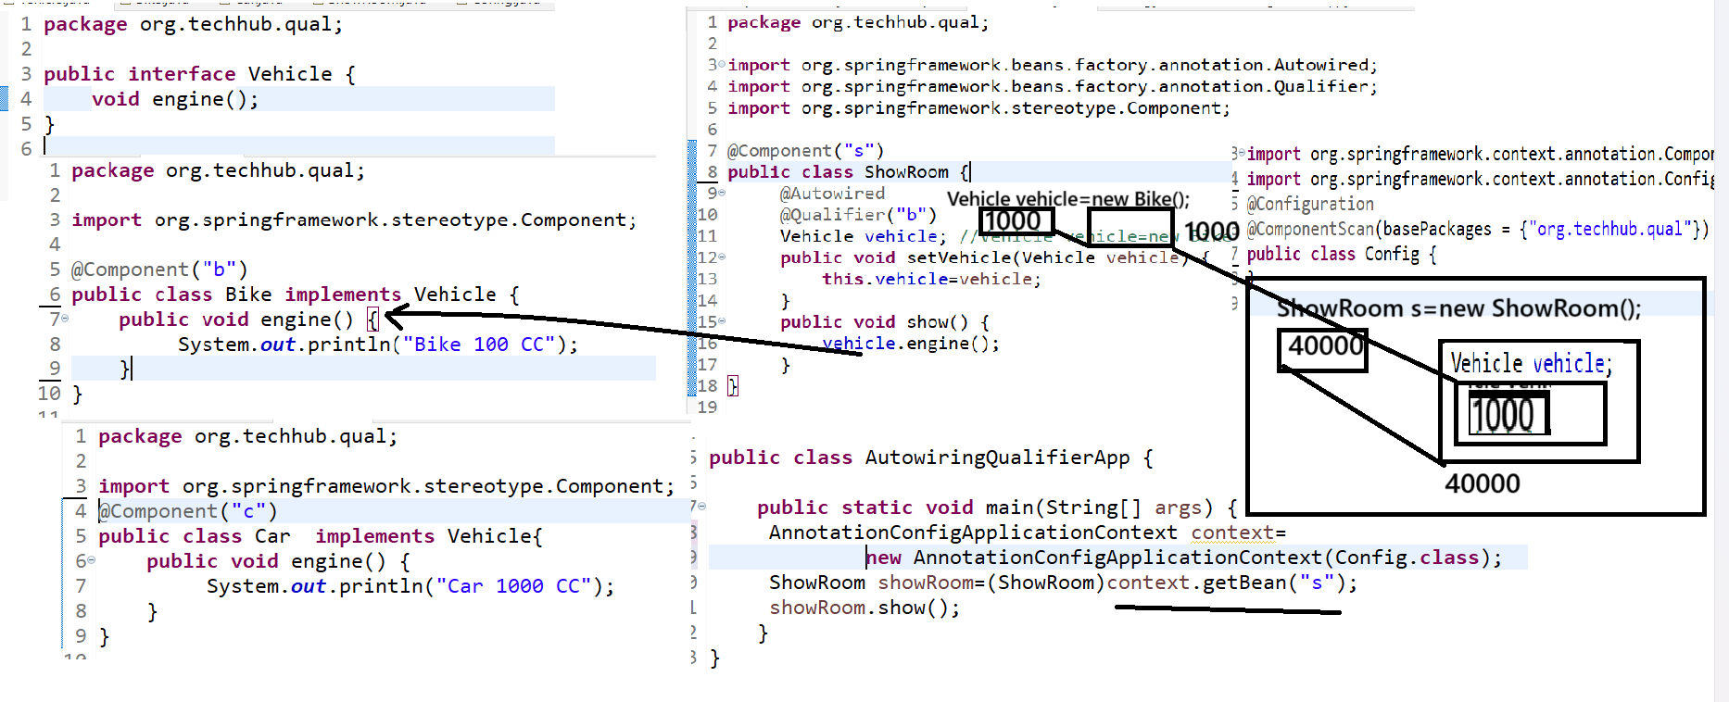
Example with source code

Vehicle.java
package org.techhub.qual;
public interface Vehicle {
void engine();
}
Bike.java
package org.techhub.qual;
import org.springframework.stereotype.Component;
@Component("b")
public class Bike implements Vehicle {
public void engine() {
System.out.println("Bike 100 CC");
}
}
Car.java
package org.techhub.qual;
import org.springframework.stereotype.Component;
@Component("c")
public class Car implements Vehicle{
public void engine() {
System.out.println("Car 1000 CC");
}
}
ShowRoom.java
package org.techhub.qual;

import org.springframework.beans.factory.annotation.Autowired;
import org.springframework.beans.factory.annotation.Qualifier;
import org.springframework.stereotype.Component;

@Component("s")
public class ShowRoom {
@Autowired
@Qualifier("b")
Vehicle vehicle; //Vehicle vehicle=new Bike();
public void setVehicle(Vehicle vehicle) {
this.vehicle=vehicle;
}
public void show() {
vehicle.engine();
}
}
Config.java

package org.techhub.qual;

import org.springframework.context.annotation.ComponentScan;
import org.springframework.context.annotation.Configuration;
@Configuration
@ComponentScan(basePackages = {"org.techhub.qual"})
public class Config {
}

ClientApplication
package org.techhub.qual;
import org.springframework.context.annotation.AnnotationConfigApplicationContext;
public class AutowiringQualifierApp {
public static void main(String[] args) {
AnnotationConfigApplicationContext context=
new AnnotationConfigApplicationContext(Config.class);
ShowRoom showRoom=(ShowRoom)context.getBean("s");
showRoom.show();
}
}

How to use the Scope with spring bean using annotation
___________________________________________________________________
we have annotation name as @Scope

Example with source code
package org.techhub.qual;
import org.springframework.beans.factory.annotation.Autowired;
import org.springframework.beans.factory.annotation.Qualifier;
import org.springframework.context.annotation.Scope;
import org.springframework.stereotype.Component;
@Component("s")
@Scope(scopeName = "prototype")
public class ShowRoom {
@Autowired
@Qualifier("b")
Vehicle vehicle; //Vehicle vehicle=new Bike();

public ShowRoom() {
System.out.println("I am show room constructor");
}
public void setVehicle(Vehicle vehicle) {
this.vehicle=vehicle;
}
public void show() {
vehicle.engine();
}
}

Spring bean life cycle
_______________________________________________________
Spring bean life cycle means to decide how bean object created by spring container and how bean object behave throughout the application and as well as how bean object destroy by spring container called as bean life cycle
If we think about bean life cycle it contains the following steps.
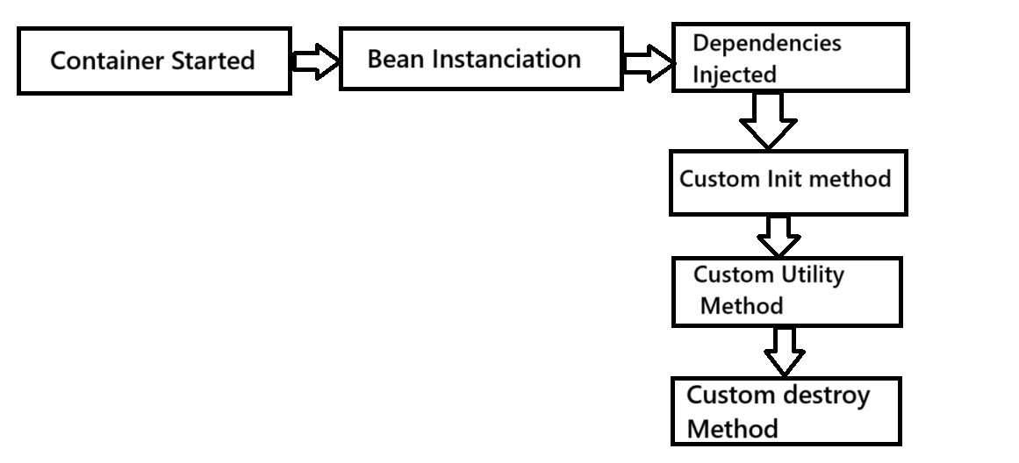
If we want to implement the spring bean life cycle practically in application we have three ways.
a) Using XML configuration
b) Using Annotation
C) Using Programming approach

Spring Bean Life cycle using XML
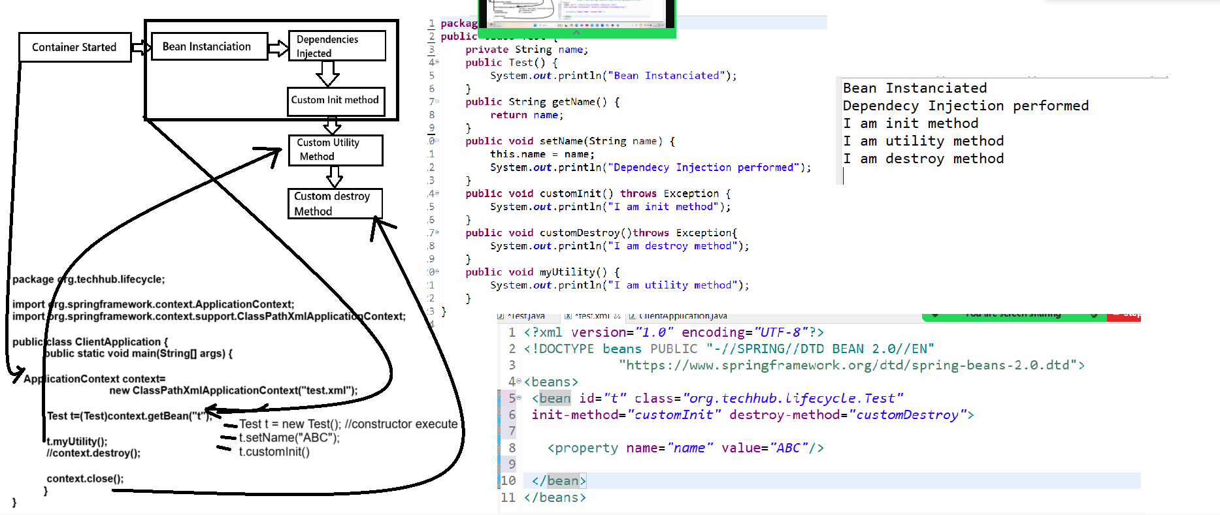

Test.java
package org.techhub.lifecycle;
public class Test {
private String name;
public Test() {
System.out.println("Bean Instanciated");
}
public String getName() {
return name;
}
public void setName(String name) {
this.name = name;
System.out.println("Dependecy Injection performed");
}
public void customInit() throws Exception {
System.out.println("I am init method");
}
public void customDestroy()throws Exception{
System.out.println("I am destroy method");
}
public void myUtility() {
System.out.println("I am utility method");
}
}
test.xml
<?xml version="1.0" encoding="UTF-8"?>
<!DOCTYPE beans PUBLIC "-//SPRING//DTD BEAN 2.0//EN"
"https://www.springframework.org/dtd/spring-beans-2.0.dtd">
<beans>
<bean id="t" class="org.techhub.lifecycle.Test"
init-method="customInit" destroy-method="customDestroy">
<property name="name" value="ABC"/>
</bean>
</beans>

ClientApplication.java
package org.techhub.lifecycle;
import org.springframework.context.ApplicationContext;
import org.springframework.context.support.ClassPathXmlApplicationContext;
public class ClientApplication {
public static void main(String[] args) {
ApplicationContext context=new ClassPathXmlApplicationContext("test.xml");
Test t=(Test)context.getBean("t");
t.myUtility();
context.close();
}
}

7. Execute the application

