PROJECT REPORT

PROJECT TITLE:
MEMS based Machine Vibration Monitoring and Management System.

TEAM – 6
Akshai U | 23BME007
Deenadhayalan B | 23BME016
Deepak Prasanna S M | 23BME017
Keerthin P | 23BME046
Mithrann S S | 23BME053
Naren K | 23BME055

ABSTRACT:
The Machine Vibration Monitoring System using ESP32 and Blynk App is an Internet of Things (IoT)-based solution that helps in continuously monitoring the vibration levels of industrial machines. Vibration is a key indicator of machine condition, and abnormal vibration often signals imbalance, misalignment, or wear in mechanical components. Detecting these variations early helps prevent unplanned downtime and costly repairs.
In this project, an ADXL345 accelerometer sensor is used to measure vibration in three axes (X, Y, Z). The vibration data is processed by an ESP32 microcontroller, which transmits the information to the Blynk Web Console and Mobile Application over Wi-Fi. The user can visualize the data in real-time through a live graph on the app. Additionally, if the vibration crosses a threshold value that is automatically set by the module, an alert message is sent through a GSM module and a push notification is triggered on the user’s device.
The system is compact, cost-effective, and designed with an in-built power supply to make it portable. It is especially suitable for small and medium-scale industries that cannot afford expensive vibration monitoring systems. By combining sensor technology with IoT communication, this project demonstrates how smart maintenance can enhance the reliability and lifespan of machines.
This project also emphasizes the importance of integrating electronics, software, and data analytics to create efficient monitoring systems. The system’s flexibility allows it to be adapted for different machines and environments. It provides a simple yet powerful tool for predictive maintenance, ensuring smoother industrial operation and reduced equipment downtime.

INRODUCTION:
In modern industries, machines are the backbone of production. Their continuous operation leads to mechanical stress, imbalance, and wear, causing vibration. Monitoring vibration helps detect early signs of mechanical failure such as bearing faults, shaft misalignment, or loosened bolts. When vibration levels rise beyond normal limits, it indicates that maintenance is required.
Traditional vibration monitoring systems are often complex and expensive, using wired sensors and data acquisition devices. These systems are not suitable for small-scale industries or remote equipment where accessibility is limited. To overcome these issues, the Machine Vibration Monitoring System using ESP32 and Blynk App provides a smart, wireless, and affordable alternative.
The ESP32 microcontroller serves as the central unit for data collection, processing, and communication. The ADXL345 accelerometer detects vibration in all three directions. The data is displayed on a 16x2 LCD screen for local monitoring and sent to the Blynk app for cloud-based visualization. The app displays real-time vibration graphs and sends instant alerts to the user if the machine exceeds its vibration threshold.
This project aims to provide a compact and efficient vibration detection system that can be easily integrated into any machine setup. Its IoT-based design eliminates the need for complex wiring and enables users to monitor vibration from anywhere in the world through the Blynk mobile interface.
The project’s goal is to improve predictive maintenance practices in industries by using affordable technology. This system reduces maintenance costs, improves equipment reliability, and ensures safer operations, making it a valuable tool in the era of Industry 4.0.

LITERATURE REVIEW:
Several research studies and practical implementations have been conducted to monitor vibration using both wired and wireless systems. Traditional systems relied on piezoelectric sensors connected to data loggers, requiring manual data collection and analysis. These methods, while accurate, are costly and time-consuming.
Modern approaches incorporate wireless communication and microcontrollers to transmit vibration data automatically. Researchers have explored using accelerometers such as MPU6050 and ADXL345 with microcontrollers like Arduino, Raspberry Pi, and ESP32 for data acquisition. Among these, the ADXL345 accelerometer stands out due to its high sensitivity, low noise, and I²C communication interface, which ensures accurate and stable measurements.
The ESP32 microcontroller, compared to Arduino Uno, provides greater processing power and built-in Wi-Fi/Bluetooth features, making it ideal for Internet of Things (IoT) applications. The Blynk platform is widely used in IoT projects due to its user-friendly interface and real-time data visualization capabilities.
Existing systems using Arduino and GSM have demonstrated reliable local monitoring but lacked cloud-based storage or mobile app integration. The combination of ESP32 + ADXL345 + GSM + Blynk provides a complete end-to-end solution, enabling both local display and remote monitoring.
Previous studies concluded that early fault detection through vibration measurement significantly increases machine life and reduces maintenance costs. Therefore, this project builds upon that foundation and integrates it with IoT to make the solution smarter, wireless, and more accessible for industrial use.

SYSTEM DESIGN:
The Machine Vibration Monitoring System using ESP32 and Blynk App is designed with both hardware and software modules working together to ensure real-time vibration analysis and alert generation. The system mainly consists of an ADXL345 accelerometer, an ESP32 microcontroller, a GSM module, a 16x2 LCD display, and a Blynk IoT interface. All these components are powered by an in-built power source to make the device portable and independent of external power.
The ADXL345 sensor continuously measures acceleration in the X, Y, and Z axes. These readings represent the vibration intensity of the machine. The sensor communicates with the ESP32 using the I²C communication protocol, allowing fast and accurate data transfer. The ESP32 acts as the brain of the system — it receives sensor data, calculates the vibration magnitude, and compares it against a predefined threshold value.
If the vibration level exceeds this threshold, the ESP32 triggers two responses:
- It sends an alert message to the user’s mobile through the GSM module.
- It sends a notification and graph update to the Blynk App through Wi-Fi.
Meanwhile, the 16x2 LCD display shows live vibration readings so that the operator near the machine can visually monitor its status. The Blynk app dashboard displays a real-time graph of vibration amplitude, providing clear insights into the machine’s condition.
The system’s design ensures accurate sensing, quick processing, and reliable communication. Each module is chosen for its efficiency and low power consumption, making the device suitable for continuous industrial operation.
HARDWARE IMPLEMENTATION:
The hardware implementation involves connecting and configuring all electronic components to function as one integrated vibration monitoring unit. The ESP32 microcontroller serves as the central controller that interfaces with the ADXL345 accelerometer, GSM module, and 16x2 LCD display.
The ADXL345 sensor is connected to the ESP32 using SDA and SCL pins via the I²C protocol, which ensures stable and fast data transfer. The GSM module (SIM800L or equivalent) connects through UART communication pins (TX and RX) for sending SMS alerts. The LCD display is interfaced through digital pins using the standard 4-bit mode, displaying live vibration data.
The power section includes a 5V regulated supply and a lithium-ion battery with a charging module, providing reliable and portable operation. The system is assembled on a PCB or breadboard for prototype testing, and all components are secured to minimize vibration interference.
Proper grounding and isolation techniques are used to ensure sensor accuracy. The hardware setup is enclosed in a small casing to protect components from dust and machine heat. During implementation, calibration is done to define the normal vibration range of the machine and set the threshold limit for abnormal vibration detection.
This hardware design ensures continuous and reliable performance, making it ideal for both industrial and educational environments. The simplicity of the circuit also allows easy maintenance and future upgrades such as adding multiple sensors or cloud storage modules.

RESULTS AND DISCUSSION:
After assembling the hardware and uploading the software, the system was tested under different vibration conditions. The tests were conducted on rotating machines such as fans, motors, and small pumps to observe the vibration levels during operation.
At normal operation, the vibration readings remained within the safe range, and the LCD displayed stable values. When the machine was intentionally imbalanced or run at higher speed, the sensor detected increased vibration values. The ESP32 immediately processed the data and sent alerts via GSM and Blynk. Users received instant SMS and app notifications indicating “High Vibration Detected.”
The Blynk App displayed a smooth real-time graph of vibration amplitude, accurately reflecting machine behavior. The results showed that the system responds rapidly (within milliseconds) and accurately detects even small variations in vibration. The data consistency proved that the ADXL345 sensor provides reliable output when properly calibrated.
During prolonged operation, the system remained stable and power-efficient. The portable design allowed easy attachment to different machines for testing. Comparisons with a commercial vibration meter showed minimal deviation, validating the system’s accuracy.
This project successfully demonstrates that an IoT-based wireless vibration monitoring system can replace traditional wired systems for many industrial applications. It provides an affordable and scalable way to improve predictive maintenance and ensure operational safety.

CONCLUSION AND FUTURE SCOPE:
The Machine Vibration Monitoring System using ESP32 and Blynk App effectively demonstrates how modern IoT technology can be used for industrial health monitoring. The system continuously measures vibration, displays readings locally on the LCD, and sends alerts via GSM and Blynk when the vibration exceeds safe limits. It ensures early fault detection, reduces downtime, and extends machine life.
The results confirm that the system is accurate, portable, and cost-effective compared to traditional vibration analyzers. Its use of the ADXL345 sensor and ESP32 microcontroller ensures reliability and efficiency, while the Blynk App provides an intuitive real-time visualization platform for users.
Future Scope:
- Integration of machine learning algorithms to predict failures based on vibration patterns.
- Development of cloud-based dashboards for long-term vibration data storage and trend analysis.
- Addition of temperature and sound sensors for comprehensive machine health diagnostics.
- Implementation of solar-powered operation for remote areas.
- Expansion into multi-sensor industrial networks for centralized monitoring.
This project serves as a solid foundation for future research and development in smart maintenance systems. By merging sensor technology, wireless communication, and IoT platforms, it represents an essential step toward smarter, safer, and more efficient industries.

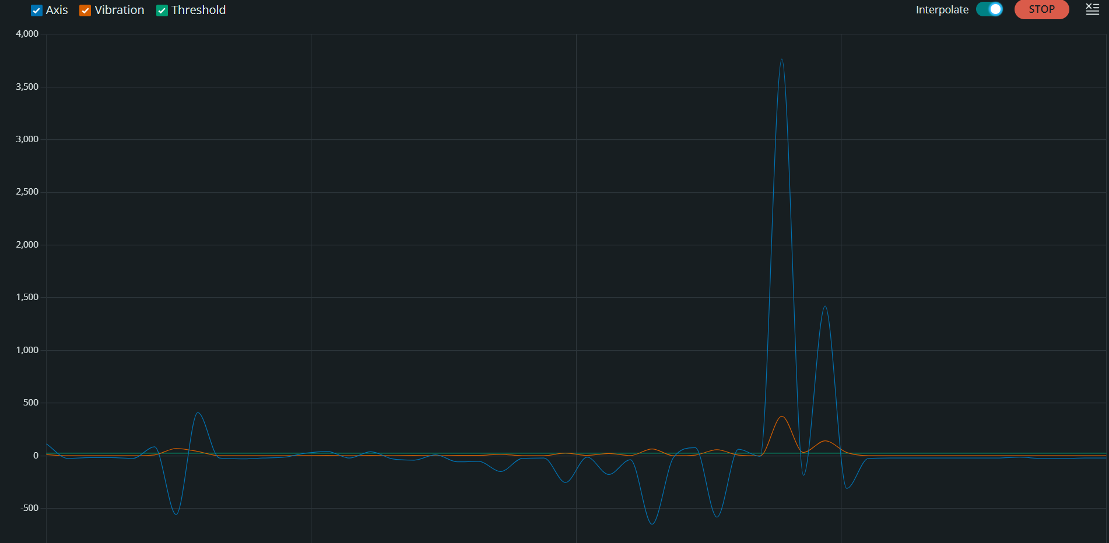
IMAGES FOR REFERENCE
REAL TIME REPRESENTATION OF AXIS, VALUES in Blynk Console along with Alarm on excessive vibrations being detected
Real time representation of axis, vibration and the threshold values in Arduino IDE serial monitor

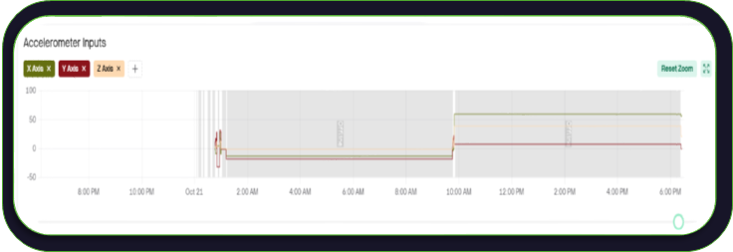
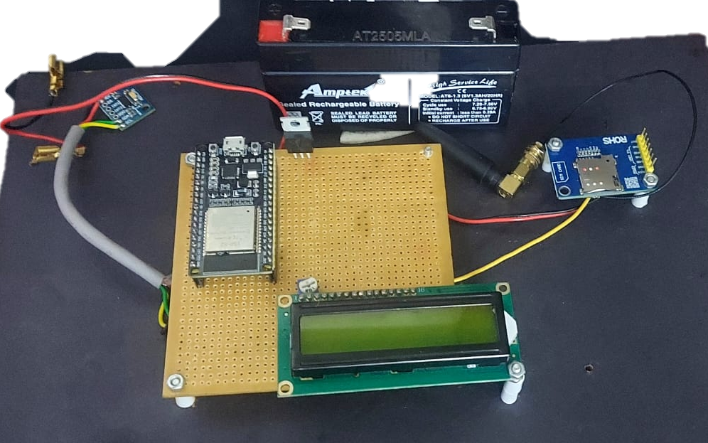
SMS alert received on the user’s device in time of excess vibration being detected
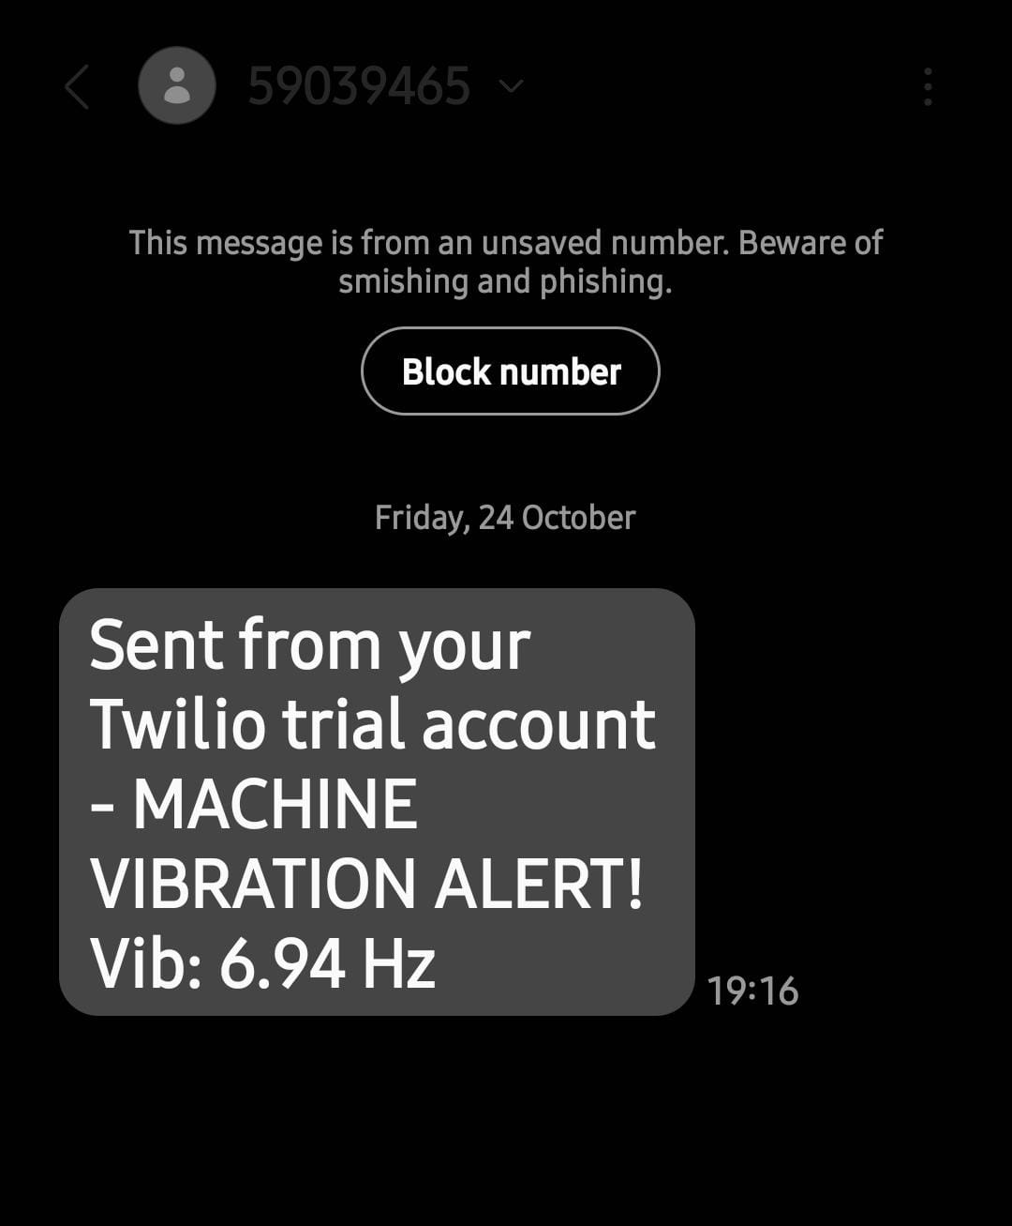

OUR SOLUTION PROTOTYPE

