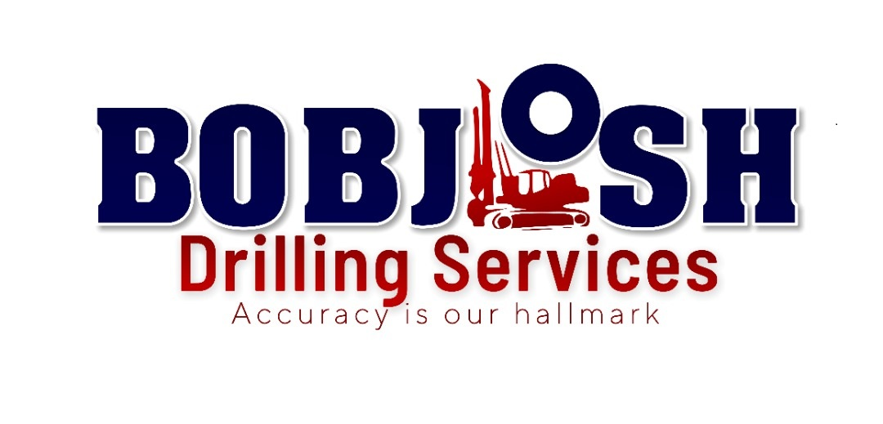

**Profile…………………………………………………………………………………………………**

**Mission………………………………………………………………………………………………**

**Vision………………………………………………………………………………………………..**

**Code of ethics……………………………………………………………………………………**

**Management Summary …………………………………………………………………………**

**Financial Plans ………………………………………………………………………………**

**Expenses………………………………………………………………………………………**

**Sustainability……………………………………………………………………………………**

**Equipment and services……………………………………………………………………………**

**Measuring performance……………………………………………………………………………**

**Health safety and environment…………………………………………………………………..**

**COMPANY PROFILE**

Our fleet of premium rigs are supported by a comprehensive fleet of all terrain crawlers, enabling access to Africa's most remote and challenging sites.

Managed by a team of motivated and experienced professionals, the company is well positioned and focused on diversifying our services within the drilling field and expanding the company’s capacity and geographical reach in a sustainable manner to achieve our goal of continuing to be a leading supplier of drilling services on the Ghana and beyond.

Bobjosh has a well-established footprint and proven track record of quality service delivery.

**Mission**

Deliver high quality drilling services in the local and international market of exploration drilling, through innovative solutions, professionalism and modern fleet of equipment.

**Vision**

Become a competitive leader among the exploration drilling companies, through comprehensive client service, unique solutions and care for the safety of the people and the environment.

Key Values of Bobjosh drilling service:

• Delivering comprehensive services in line with client expectations

• Knowledge and experience that guarantee success.

• Professional Staff and fully operable fleet of drilling rigs and well service equipment

• Respect for people and the environment

• High standards of project management

• Effective use of available technology

• The achievement of ambitious goals

• Expand activities into a sphere of CSR with particular emphasis on local content

• Provide the safest workplace and its environment

• Flexibility for clients’ needs

**Code of ethics**

Bobjosh drilling service is committed to the following Code of Ethics.

Wherever we operate we will:

Strictly stay compliance to and maintain our management systems for health, safety and the environment that are consistent with internationally recognised standards which enable us to:

• Identify, assess and manage risks to employees and the environment.

• Strive to achieve leading drilling industry practice.

• Meet and exceed applicable legal requirements.

• Set and achieve targets that include preventing incident.

• Develop our people and provide resources to meet our targets.

• Support the fundamental human rights of employees.

• Respect the traditional rights of indigenous peoples.

• Care for the environment and value cultural heritage.

Management team

Our executive management team has an enviable years of experience in drilling industry. Bobjosh Drilling is led by leaders who are committed to innovation, sustained growth and shared value. The team remains steadfast in the pursuit and implementation of the company’s strategy, underpinned by the continued development of new, ground-breaking technologies; the expansion of Bobjosh Drilling’s global footprint; and the nurturing of client and business relationships

The foundation of our strategy is the people who make it happen; our success depends on the skills and expertise that support our goals. Our people have specialized knowledge aligned with global best practice, which is then applied to ensure that sound, sustainable use is made of our assets, enhancing growth, productivity, and profitability

**Financial Plan**

Our model projects that we will be cash-flow positive by our first year of operation due to a strong strategic financial plans established. Our expenses will be driven mainly by equipment maintenance and drilling consumables costs, and will gradually

Grow from $300,000 in year one to $1,000,000 in two years as we double our contract efficiency to accommodate increased contract security. We will be financed mainly by the profit returns from our services. And will slowly introduce additional revenue streams including corporate partnership.

**Expenses**

Our largest expense is maintenance, logistics consumables and personnel salaries and benefits estimated to be around $100,000 during the first quarter alone. Note that throughout the year projection more than 50% of our expenses are related to maintenance, logistics personnel salaries and benefit, and miscellaneous costs are minimal.

**Sustainability**

Sustainability is a serious concern for any enterprise, and especially for those newly emerging companies. Through conservative planning, leveraging our partner relationships and exploiting revenue streams collateral to our core business, we hope to ensure this sustainability for Bobjosh drilling service.

Our financial projections show that we will be cash flow positive by three years of operation prior to contract consistency. Yet we recognize that without charging prices for our services, we are dependent on the funding from cooperate bodies to be sustainable at the first quarter of our operations. We plan to keep operating Costs Low operation targeting value for money.

Consistent with this disciplined model, we will generate strong cash, maintain our capital discipline, and improved our effective tax rate that will underpins our strong balance sheet.

“In light of some uncertain economic conditions, commodity prices remain strong and gold prices continue to surge bolstering the demand for drilling services. These positive market conditions are driving higher activity levels, increased drilling utilization rates and improved pricing and existing customers, is a reflection of the strong drilling environment.

We strive to maintain our growth strategy and are in the final stages of signing our first drilling contract. We remain confident in our strategic direction and continue to see positive trends as a result of our strategy in building a momentum of financial stability.

**SERVICES**

**Diamond coring drilling**

Bobjosh offers a complete surface diamond drilling service with a full range of sizes and capabilities. Our expertise are unsurpassed in West Africa and we have an enviable reputation for delivery in hard drilling situations.

**Reverse Circulation Drilling**

Our in-depth knowledge and experience of RC drilling is virtually unsurpassed in the industry. Using a RC drill pipe, the sample is returned uncontaminated though the inner pipe to the surface sampling equipment. By utilising this technique, Bobjosh however can maximise the geological sample recovery in adverse drilling conditions.

**Grade Control Drilling**

Grade control drilling is an effective tool in adding value to mineral exploration operations. This is achieved as grade control drilling is carried out in conjunction with ongoing surface and mining operations. It improves efficiencies, enhances the project management of operations and aids the verification that mined ores

Contain the minerals expected.

**Geotechnical Drilling**

This technique is utilised to determine soil and rock characteristics for a variety of purposes including construction and soil stabilisation.

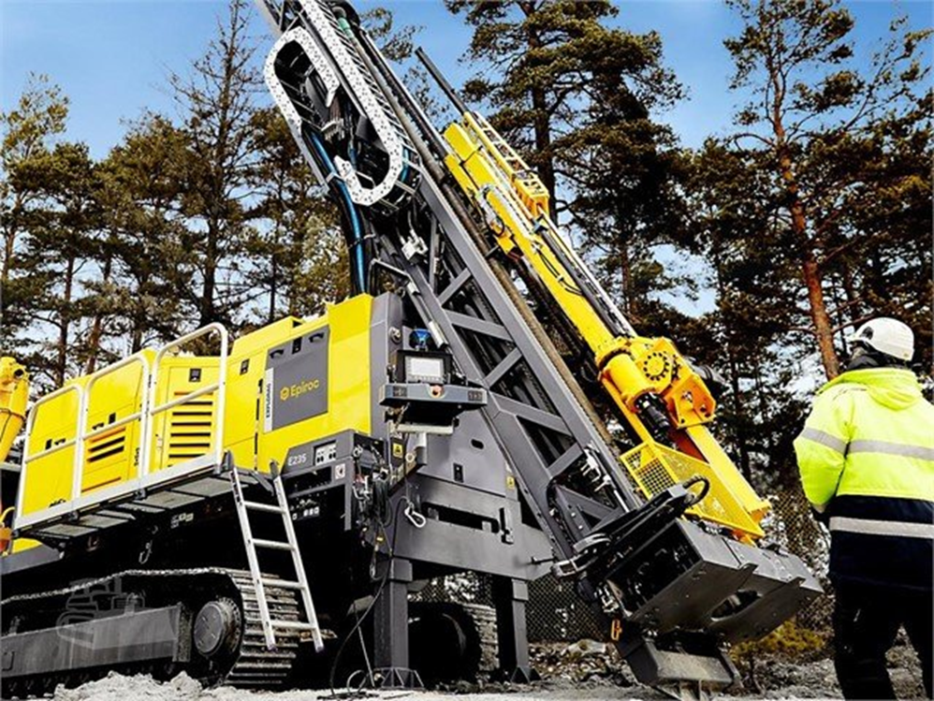EQUIPMENTS

**Explorac 235C:**

|  |  |
| --- | --- |
| Rod length | 6 m |
| Drilling depth capacity | 0 m - 450 m |
| Max. torque | 14 000 Nm |
| Feed type | Cylinder with chain |
| Feed force (restricted) | 75 kN |
| Pull force | 220 kN |
| Engine | Cat C18 522 kW, Tier 3 |
| Control system | RCS with radio remote |

**Measuring Performance**

To ensure high-quality, high-efficiency delivery of Bobjosh drilling services, we expect to track our progress in three critical target areas of performance

**Driving Operational Success for Our Client**

Securing contract is our fundamental goal of our organization. Leading indicators that will allow us to measure this success include the

Equipment efficiency on a project to meet client timelines.

Lagging indicators include the percentage client relationship prior to contract engagement and consistency.

The amount of dollar saved per meter drilled. Etc. we will track growth indicators such as quarterly and year to year growth.

**Providing High-Performing Platform Functionality**

To provide client services, we must have an operational platform that can handle a competitive market.

Bobjosh establishes Quality Control audits, and feedback from our client ensuring High Levels of Client Service. Our services are only effective if our stakeholders are satisfied with how our processes work to this end, we will regularly survey client engagement to gauge satisfaction and solicit their suggestions for continuous improvement Sustaining Success While Maintaining Cost-Efficiency

We believe we can deliver superior service at lower costs than other companies.

**Safety health and environment**

Our safety with the production system has been developed to exceed all applicable government and client standards. By partnering with industry leaders in behavioural safety, incident investigation, workers compensation, and OSHA standards, we have built a comprehensive integrated Health Safety and Environmental Management System.

This program utilizes the latest technology to ensure all branches have access to the most up-to-date standards and any information we gain is shared with the entire Company. Our crews are well-trained, dedicated employees who know Safety Cultures occur when every employee understands their rights and responsibility to work safely, be healthy, and to protect our environment every day.