**PR201 : Image Forgery Detection**

**Dataset (Size: 7.37GB)**

1. Authentic (78292 Images)
2. Tampered (76044 Images)

**Split dataset**:

1. Training (90% of Dataset)

1. Authentic (70462 Images)

2. Tampered (68439 Images)

1. Validation (5% of Dataset)
2. Authentic (3915 Images)
3. Tampered (3802 Images)
4. Testing (5% of Dataset)
5. Authentic (3915 Images)
6. Tampered (3803 Images)

**Epoch Based Dig:**

Total no. of epochs =50

Epoch results:

Epoch 1/50

8682/8682 [==============================] - 4941s 557ms/step - loss: 0.1569 - accuracy: 0.9290 - auc: 0.9847 - precision: 0.9282 - recall: 0.9276 - val_loss: 0.1734 - val_accuracy: 0.9285 - val_auc: 0.9887 - val_precision: 0.9578 - val_recall: 0.8943 - lr: 1.0000e-04

Epoch 2/50

8682/8682 [==============================] - 4888s 563ms/step - loss: 0.0734 - accuracy: 0.9681 - auc: 0.9964 - precision: 0.9622 - recall: 0.9735 - val_loss: 0.0489 - val_accuracy: 0.9788 - val_auc: 0.9985 - val_precision: 0.9703 - val_recall: 0.9871 - lr: 1.0000e-04

Epoch 3/50

8682/8682 [==============================] - 4814s 555ms/step - loss: 0.0585 - accuracy: 0.9752 - auc: 0.9975 - precision: 0.9680 - recall: 0.9822 - val_loss: 0.0508 - val_accuracy: 0.9775 - val_auc: 0.9983 - val_precision: 0.9741 - val_recall: 0.9803 - lr: 1.0000e-04

Epoch 4/50

8682/8682 [==============================] - 4816s 555ms/step - loss: 0.0495 - accuracy: 0.9791 - auc: 0.9982 - precision: 0.9727 - recall: 0.9852 - val_loss: 0.0445 - val_accuracy: 0.9830 - val_auc: 0.9990 - val_precision: 0.9756 - val_recall: 0.9903 - lr: 1.0000e-04

Epoch 5/50

8682/8682 [==============================] - 4817s 555ms/step - loss: 0.0434 - accuracy: 0.9821 - auc: 0.9985 - precision: 0.9756 - recall: 0.9884 - val_loss: 0.0400 - val_accuracy: 0.9820 - val_auc: 0.9992 - val_precision: 0.9654 - val_recall: 0.9992 - lr: 1.0000e-04

Epoch 6/50

8682/8682 [==============================] - 4815s 555ms/step - loss: 0.0393 - accuracy: 0.9835 - auc: 0.9988 - precision: 0.9780 - recall: 0.9888 - val_loss: 0.0361 - val_accuracy: 0.9842 - val_auc: 0.9992 - val_precision: 0.9711 - val_recall: 0.9976 - lr: 1.0000e-04

Epoch 7/50

8682/8682 [==============================] - 4816s 555ms/step - loss: 0.0361 - accuracy: 0.9843 - auc: 0.9990 - precision: 0.9784 - recall: 0.9900 - val_loss: 0.0435 - val_accuracy: 0.9807 - val_auc: 0.9991 - val_precision: 0.9661 - val_recall: 0.9958 - lr: 1.0000e-04

Epoch 8/50

8682/8682 [==============================] - ETA: 0s - loss: 0.0332 - accuracy: 0.9853 - auc: 0.9991 - precision: 0.9797 - recall: 0.9908

Epoch 8: ReduceLROnPlateau reducing learning rate to 2.9999999242136255e-05.

8682/8682 [==============================] - 4816s 555ms/step - loss: 0.0332 - accuracy: 0.9853 - auc: 0.9991 - precision: 0.9797 - recall: 0.9908 - val_loss: 0.0423 - val_accuracy: 0.9816 - val_auc: 0.9989 - val_precision: 0.9709 - val_recall: 0.9924 - lr: 1.0000e-04

Epoch 9/50

8682/8682 [==============================] - 4816s 555ms/step - loss: 0.0255 - accuracy: 0.9884 - auc: 0.9995 - precision: 0.9831 - recall: 0.9936 - val_loss: 0.0324 - val_accuracy: 0.9854 - val_auc: 0.9993 - val_precision: 0.9763 - val_recall: 0.9945 - lr: 3.0000e-05

Epoch 10/50

8682/8682 [==============================] - 4815s 555ms/step - loss: 0.0237 - accuracy: 0.9893 - auc: 0.9995 - precision: 0.9846 - recall: 0.9938 - val_loss: 0.0349 - val_accuracy: 0.9855 - val_auc: 0.9991 - val_precision: 0.9743 - val_recall: 0.9968 - lr: 3.0000e-05

Epoch 11/50

8682/8682 [==============================] - ETA: 0s - loss: 0.0223 - accuracy: 0.9898 - auc: 0.9996 - precision: 0.9851 - recall: 0.9943

Epoch 11: ReduceLROnPlateau reducing learning rate to 8.999999772640877e-06.

8682/8682 [==============================] - 4828s 556ms/step - loss: 0.0223 - accuracy: 0.9898 - auc: 0.9996 - precision: 0.9851 - recall: 0.9943 - val_loss: 0.0362 - val_accuracy: 0.9847 - val_auc: 0.9991 - val_precision: 0.9713 - val_recall: 0.9984 - lr: 3.0000e-05

Epoch 12/50

8682/8682 [==============================] - 4825s 556ms/step - loss: 0.0201 - accuracy: 0.9907 - auc: 0.9997 - precision: 0.9863 - recall: 0.9948 - val_loss: 0.0314 - val_accuracy: 0.9855 - val_auc: 0.9993 - val_precision: 0.9753 - val_recall: 0.9958 - lr: 9.0000e-06

Epoch 13/50

8682/8682 [==============================] - 4808s 554ms/step - loss: 0.0196 - accuracy: 0.9910 - auc: 0.9997 - precision: 0.9870 - recall: 0.9947 - val_loss: 0.0324 - val_accuracy: 0.9851 - val_auc: 0.9992 - val_precision: 0.9765 - val_recall: 0.9937 - lr: 9.0000e-06

Epoch 14/50

8682/8682 [==============================] - ETA: 0s - loss: 0.0192 - accuracy: 0.9909 - auc: 0.9997 - precision: 0.9869 - recall: 0.9947Restoring model weights from the end of the best epoch: 9.

Epoch 14: ReduceLROnPlateau reducing learning rate to 2.6999998226528985e-06.

8682/8682 [==============================] - 4808s 554ms/step - loss: 0.0192 - accuracy: 0.9909 - auc: 0.9997 - precision: 0.9869 - recall: 0.9947 - val_loss: 0.0314 - val_accuracy: 0.9860 - val_auc: 0.9990 - val_precision: 0.9788 - val_recall: 0.9932 - lr: 9.0000e-06

Epoch 14: early stopping

**Accuracy And Loss Graphs:**

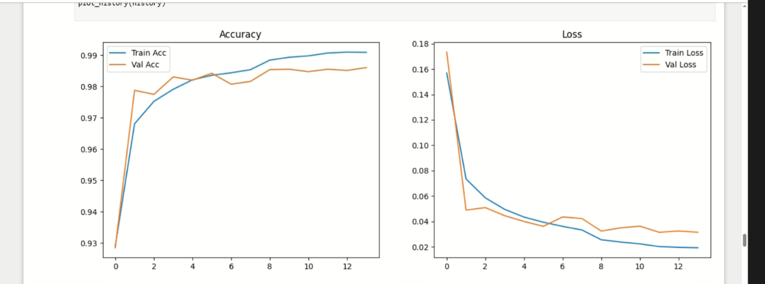

**Confusion Matrix:**

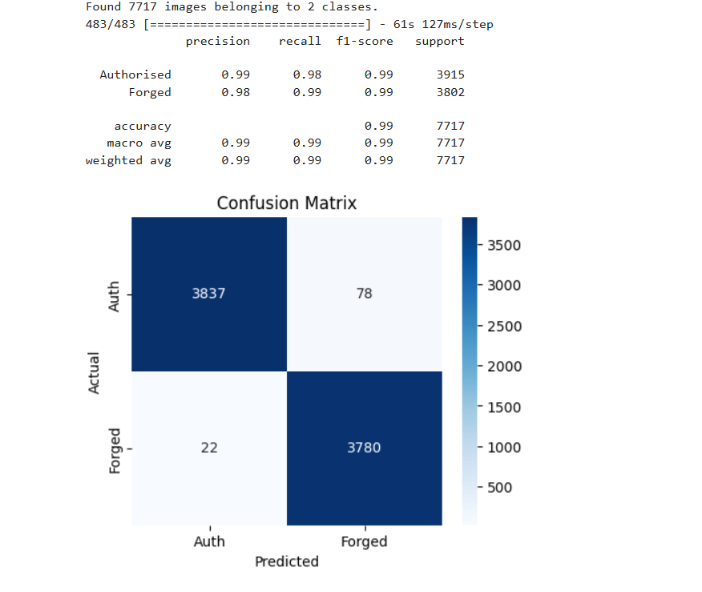

**Roc Curve:**

