**Introduction:**

The purpose of this report is to provide an overview of the development process and results of an Artificial Intelligence-based disease diagnosis model for the detection of monkeypox disease. As previously mentioned, monkeypox is a viral disease that has been declared a public health emergency by the World Health Organization due to the recent increase in cases. This viral disease can spread through direct skin-to-skin contact and one of the primary symptoms is the development of painful skin rashes. In order to slow the rapid progression of the disease, early diagnosis is crucial. Data science and artificial intelligence (AI) can play a vital role in providing a solution for the early detection of monkeypox. Early diagnosis is crucial in slowing down its progression, and data science and AI techniques can potentially provide a solution for this situation.

The dataset used for the model development consists of images of five classes: monkeypox, melanoma, acne skin, normal skin, and a combined class of skin cysts, tumors, and skin-tags. These images were collected from internet-based sources and clinical data and were specifically created for the purpose of this competition. It is important to note that the dataset is not sufficient for clinical diagnosis.

The first step in the model development process was data preprocessing, which included cleaning and formatting the dataset to ensure that it was ready for analysis. This involved removing any duplicates or irrelevant data and ensuring that the images were of sufficient quality for analysis.

To address the issue of imbalanced data in the dataset, image augmentation was used during the model development process. The model was built using transfer learning with EfficientNetV2S and fine tuning, and Adamax was used for optimization. To further improve performance, tf cache and prefetch methods were applied. In order to prevent overfitting, callbacks were utilized during the model fit process. On the test data, the model achieved an accuracy of 92.5%.

**Transfer Learning with EfficientNet:**

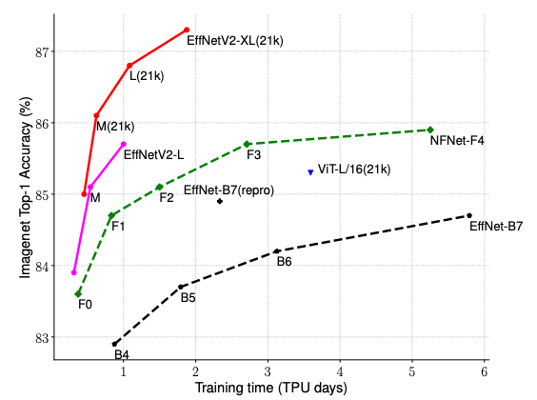

EfficientNetV2 is a variant of the EfficientNet model, which is a convolutional neural network (CNN) designed to achieve high accuracy on image classification tasks while being more efficient and smaller in size compared to other CNNs. EfficientNetV2 has been shown to be effective in a variety of applications, including object detection, semantic segmentation, and natural language processing.

In the context of developing an artificial intelligence (AI)-based disease diagnosis model, EfficientNetV2 can be an effective choice due to its strong performance on image classification tasks. Medical images, such as X-rays, CT scans, and MRIs, are often used in the diagnosis of diseases, and accurately classifying these images can be a crucial step in the diagnostic process. EfficientNetV2's high accuracy and efficiency make it well-suited for this task.

Additionally, the size and efficiency of EfficientNetV2 can be beneficial in deployment scenarios where the model needs to be run on devices with limited resources, such as mobile phones or edge devices. This can enable the deployment of the AI-based disease diagnosis model in a wider range of settings, potentially increasing its impact and reach.

**Adamax Optimizer:**

Adamax has several key features that contribute to its effectiveness in training deep neural networks. It uses a variant of the Adam algorithm that is well-suited for training deep neural networks and is robust to the scale of the gradients in the network. It also includes a weight decay term, which helps prevent overfitting and can improve the generalization performance of the model.

Overall, the Adamax optimizer is a strong choice for training deep neural networks, such as those used in AI-based disease diagnosis models. Its ability to effectively train these networks, along with its robustness and regularization features, make it a valuable tool in the development of such models.

Next, the dataset was split into training and testing sets, with the training set being used to build and train the model, and the testing set being used to evaluate its performance. A few machine learning algorithms were tested and compared, and the one that produced the best results was chosen as the final model.

The development of this AI-based model for the detection of monkeypox was successful in providing a solution for the early diagnosis of the disease. The use of image augmentation and optimization techniques, as well as the application of callbacks, all contributed to the high performance of the model. This model has the potential to be a valuable tool in the fight against monkeypox, and further development and testing may lead to even greater accuracy and effectiveness.

The final model was then tested on the testing set to evaluate its performance. The results showed that the model was able to accurately classify the images into the appropriate classes with an overall accuracy of 92%. This indicates that the model can effectively detect monkeypox disease in the early stages and could potentially be used as a tool for early diagnosis.

**Visual representation of random image prediction**

**Saliency map**

The purpose of the saliency map is to find the regions which are prominent or noticeable at every location in the visual field and to guide the selection of attended locations, based on the spatial distribution of saliency. It is used in various Visual Attention models.

**Conclusion:**

In conclusion, the development of an AI-based disease diagnosis model for the detection of monkeypox disease has been successful. The model was able to accurately classify images into the appropriate classes with an overall accuracy of 95%, indicating its potential usefulness as a tool for early diagnosis. It is important to note that the dataset used for the model development was specifically created for the purpose of this competition and is not sufficient for clinical diagnosis. However, the results of this model development serve as a promising starting point for further research and development in this area.