**The impact on hardware resources and network**

**performance when using network-based**

**applications**

Neil Sammut

Institute of Information & Communication Technology

Malta College or Arts, Science & Technology

Corradino Hill

Paola PLA 9032

neil.sammut.e21620@mcast.edu.mt

*Abstract*— In recent times, there has been a rise in the use of Cloud Computing due to the rising cost of on-site equipment and its maintenance. Cloud Service Providers offer end users the possibility to connect and use applications through their platform. Many popular network-based applications may feature social media, electronic mail, multiplayer online games, and streaming media services which demand high processing power and an efficient network performance. Many users rate their experience on the reliability and effectiveness of the services offered.

This research aims to test the impact on hardware resources and network performance when using different network-based applications individually or simultaneously. It is expected that with more network-based applications running concurrently, there will be an increase in the demands placed on the network and hardware resources which may possibly affect the speed and efficiency of the running applications. The network is monitored though a network monitoring tool while the demand for processing power will be assessed through a hardware resource monitor.

During testing, the results of each different monitoring tool were documented. The tests revealed that demands on the network and hardware are highly dependent on the type of applications run. Some features in applications require higher network and hardware processing power and if run together this may slow down the network and computer performance. For optimal network and hardware performance, when running several applications simultaneously, it was found that it would be better to use the minimum requirements for each application. Alternatively, to achieve the best performance of an application, it is recommended that other less important applications running in the background, should be turned off or kept to a minimum.

*Index Terms*—Cloud Computing, Network-based applications, Resource Monitoring, Network Performance.

1. INTRODUCTION

Cloud Service Providers offer end users the possibility to connect and use applications through their platform. Many popular network-based applications may feature social media, electronic mail, multiplayer online games, and streaming media services. [1]

Users rate their experience on using network-based applications according to the scalability, reliability and cost effectiveness of the services that they are using.

The motive behind this research arises out of the fact that users have their own preferences when using network-based applications, but everyone wishes to enjoy a high-performance network and quick processing power for their operational needs. My study aims to explore how different network-based applications, running both individually and concurrently, will affect the hardware resources and network performance. The intention is that by using the network monitoring tools and hardware resource monitors, I will measure and analyze the processing power and the network capacity for the smooth performance of the applications. This research will evaluate the difference between running one application at a time and running them concurrently and suggest ways on how to adjust the resource requirements of applications for a powerful hardware and network performance.

Section II of this paper will give a brief overview of how these applications running on the network will be monitored, while Section III will focus further on the monitoring of the network performance and hardware resources during testing. Any findings will be recorded in Section IV whilst Section V will be dedicated to outlining any further optimizations.

1. LITERATURE REVIEW

Cloud Computing is considered as the new generation of commercial computing models and network technology. The Open Network Environment allows users to avail themselves of a vast storage capability together with applications that can be customized according to a user’s requirements. Cloud computing applications offer a variety of possibilities which can allow for flexibility, reliability, and accessibility while reducing IT operational costs [2], but nonetheless, Cloud computing remains highly dependent on the internet connection.

The performance of an internet connection relies on the network latency, throughput, and bandwidth. These all play a crucial part in the efficient running of an online service application [2].

**Throughput:** is the average amount of data that is able to be transmitted and received within a specific time frame, along with measuring the average rate of messages that are transmitted successfully to the relevant destination. In this regard, by providing a practical measurement of the delivery of packets, throughput indicates the average output of data that is successfully transmitted to the intended destination.

**Bandwidth**: Bandwidth is the actual amount of data transmitted and received, within a specified timeframe, where the higher the bandwidth the more data is transmitted/received. The unit of measurement for bandwidth is bits per second (bps), However, even if high bandwidths are available, these may still suffer a delay in packet transmission due to packet loss, jitter, or latency.

**Latency**: refers to the amount of time taken for data to be able to reach its destination after being sent, commonly referred to as delay. Networks that experience very slow network speeds and less response times are expected to have high levels of latency, while on the other hand, networks that experience higher response times and faster network speeds are noted to have low levels of latency.

Studies conducted beforehand by Javed et al [6], Popescu et al [7] and Stantchev et al [4], all concentrate on the individual areas of network performance and hardware resources. On the other hand, studies effected by Khanghahi et al [5], Bali et al [2], and Sandooghi et al [3], were focused on the network and computing power of the Cloud in general rather than that of the applications based on the SaaS Platform of the Cloud. This research aims to form a comprehensive study of all areas whilst using network-based applications.

Javed et al’s [6] research provides an evaluation of cloud computing configurations ascertaining that cloud service providers assure a defined service level which is typically catered for the platform and not for a particular nonfunctional property, whose performance tends to change during runtime when there is extensive concurrent usage by numerous users or when failures happen.

Studies effected by Popescu et al [7] concentrated on how small network delays may lead to a significant performance degradation affecting both user and service provider. Their results show that different applications are affected by network latency to differing amounts.

Similarly, Stantchev et al [4] arrived at the same conclusion but the paper focused on evaluation of web services in cloud computing infrastructures. One of the highlighted insights concerned a relationship between web workloads which showed variability demands, resulting in variable CPU loads.

Popescu et al’s studies of network latency upon application performance for a set of cloud applications, ranged from a domain name server to machine learning workloads, running on Spark. They used NRG, a bespoke hardware appliance which evaluated different latency and variance magnitudes and distributions.

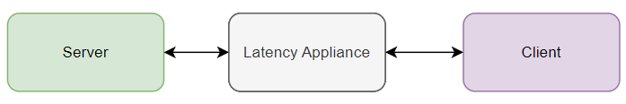

Figure 1 Tests undertaken by Popescu et al

Stantchev et al based their studies by evaluating the nonfunctional properties of a software system, which do not influence the functionality of a software or interfere with the principal task but is observed by end users during runtime since it includes response time, reliability, scalability, security attributes and transactional integrity.

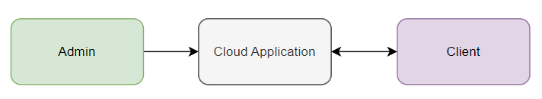

Figure 2 Tests undertaken by Stantchev et al

Javed et al concentrated their studies on the Quality-of-Service area which includes video applications, multimedia teleconferencing and voice over IP, all areas where a delay in the service would be detrimental to end users. They aimed to minimize latency by utilizing shorter and direct routes attempting various topologies to evaluate a new protocol.

III. RESEARCH METHODOLOGY

In today’s IT landscape, where costs to maintain onsite servers are increasing, many businesses are opting to use Cloud Computing Services

Cloud computing consists of three categories: SaaS (Software as a Service), PaaS (Platform as a Service) and IaaS (Infrastructure as a Service).

Figure IaaS, PaaS and SaaS in image representation

The SaaS platform offers software that is readily available for use, but end users seek scalability, reliability, and cost effectiveness in applications. Although Cloud Service Providers may offer end users the possibility to connect and use applications through their platform, it is imperative for users that these applications are customizable to cater for their individual needs and operate flawlessly during their connection with the internet. Users usually define their experience by how smooth and fast these applications are able to run both individually and concurrently.

My study aims to determine the impact on the network performance and hardware resources when applications are running both individually and concurrently. It is expected that the more operating applications there are, the more there will be a corresponding increase in the demands placed on network and hardware resources which may affect the smooth and fast operations of these applications. I also aim to explore the impact that customizable features found in applications may have on the network and hardware resources and suggest ways on how to optimize them in order to attain an efficient hardware and network performance.

The main focus of this research will be on the network performance and hardware resources required to run network-based applications. In order to test this, a Synology NAS server (a dedicated hardware server with inbuilt applications that is accessed through an online cloud portal) is used to simulate the cloud and its related applications. The objectives of this research will be to:

1. Evaluate the difference between running one application at a time and running applications concurrently, to measure the network performance and hardware resources required in the running of these inbuilt applications.
2. Determine which application features can be utilized by the end user to have a minimal impact on the network and hardware resources, with the ultimate aim of enhancing the user experience by attaining optimal performance.

These objectives aim to confirm whether there is a relationship between the features which can be opted for in applications, the hardware resources required and the network performance effect in their operations, together with finding the best features to adopt for flawless hardware and network operations.

Figure 04 shows a graphical representation of the conducted research.

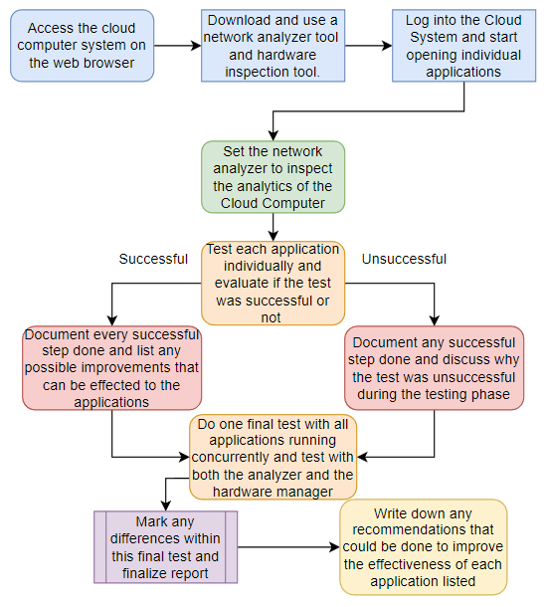

Figure 4 Research Pipeline

In order to test the network, the monitoring tool PRTG, developed by Paessler AG, was downloaded, and installed. On the other hand, to assess the hardware resources required for running each application the inbuilt Resource Monitor of the Synology NAS was used.

The applications assessed on the Synology NAS were a Web station, a Virtual Machine Manager, Audio Station for playing audio files and a Video Station for playing video files. All applications were run individually, but the Virtual Machine and the Video Station were also tested with varying options. Finally, all applications were run concurrently. In all instances the network performance was recorded, and the CPU and RAM usage were documented. The findings are being listed in Section IV below.

IV. FINDINGS & DISCUSSION OF RESULTS

A spike in the network was noticed on startup of the Synology NAS, but otherwise following this no other change occurred on the network thereafter. Subsequently the Web Station was accessed. A small spike in the network was noticed when accessing a website through the Web Server provided by the Web Station. Minimal spikes were also noted on using the Audio Station for playing music files, hence both the Web Station and the Audio Station have minimal effects on the network and as shown in Table I, the effect on Hardware Resources is negligible. On the other hand, running the Video Station and Virtual Machine had a significant impact both on the network performance and on the hardware resources. These applications contain features which can be adapted according to a user’s needs, like playing videos in high definition as opposed to standard definition format. For the purpose of this testing, these were varied, and their impact on performance was documented each time in order to have a clear picture of the outcome of each adaptable feature. It transpired that increasing the quality of the Videos demanded more performance both in terms of processing as well as bandwidth. As noted by Javed et al, the more the users request performance capacity, the more the demand, which may result in the clogging of the network and playback jittering or termination. Streaming high quality videos by various users would create a high demand which may result in network lag as deduced by Popescu et al and Stantchev et al. This can be further attested by the fact that having more than one application running at a time further creates demands on both the network and hardware resources as can be seen by Figure 5 below.

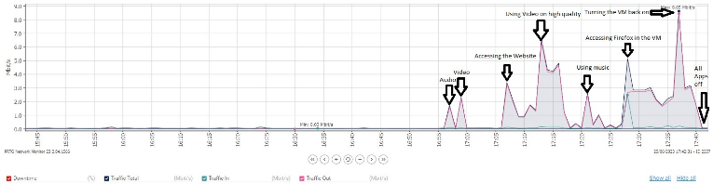

Figure Running all applications simultaneously

TABLE I

TESTING RESULTS

|  |  |  |  |  |
| --- | --- | --- | --- | --- |
| # | Application | Network Performance | Hardware CPU | Resources  RAM |
| 1 | No Application | Spike on startup. No further fluctuations | 2-9% | 31% |
| 2 | Web Station | Minimal spike on usage | No change | No change |
| 3 | Audio Station | Minimal spike on usage. Periodic spikes noted when music plays continuously | No change | No change |
| 4 | Video Station | Spike variates according to video quality | 24-29% | 32% |
| 5 | Virtual Machine | Massive spike noted after start up | 11-32% | 85-86% |
| 6 | All Applications Running | High spikes noted | 70% | 85% |
| 7 | All Applications Stopped | No spikes | 13% | 29% |
|  |  |  |  |  |

V. CONCLUSION

From the research that has been conducted, it transpired that there is indeed a relationship between the applications’ features and the impact that these have on network performance and utilization of hardware resources. The more advanced features used in applications, for example, higher screen resolutions like watching YouTube videos in High Definition, the greater the impact will be on the hardware resources such as CPU and memory utilization. The testing started with one user loading applications on the cloud and followed by a second and third user also using similar applications on the same infrastructure. As expected, the increase in users’ activity increased the demands on network bandwidth and hardware resources. To support the demands of many users, the cloud infrastructure needs to be scalable to ensure that it will continue to meet and ideally, exceed the demands.

Future studies may consider testing network-based applications whilst changing router parameters and performance (both wired or using WiFi connections) and increase RAM size.

REFERENCES

1. M. Miller, Cloud computing: Web-based applications that change the way you work and collaborate online. Indianapolis, In: Que, 2009.
2. M. S. Bali and S. Khurana, “Effect of latency on network and end user domains in Cloud Computing,” 2013 International Conference on Green Computing, Communication and Conservation of Energy (ICGCE), Dec. 2013, doi: <https://doi.org/10.1109/icgce.2013.6823539>
3. I. Sadooghi et al., “Understanding the Performance and Potential of Cloud Computing for Scientific Applications,” IEEE Transactions on Cloud Computing, vol. 5, no. 2, pp. 358–371, Apr. 2017, doi: https://doi.org/10.1109/tcc.2015.2404821
4. V. Stantchev, “Performance Evaluation of Cloud Computing Offerings,” 2009 Third International Conference on Advanced Engineering Computing and Applications in Sciences, Oct. 2009, doi: https://doi.org/10.1109/advcomp.2009.36.
5. N. Khanghahi and R. Ravanmehr, Cloud Computing Performance Evaluation: Issues and Challenges, 5th ed., vol. 3. ResearchGate, 2013. Accessed: Jun. 24, 2023. [Online]. Available: https://www.researchgate.net/publication/270157682_Cloud_Computing_Performance_Evaluation_Issues_and_Challenges.
6. U. Javed, M. Suchara, J. He, and J. Rexford, “Multipath protocol for delay-sensitive traffic,” IEEE Xplore, Jan. 01, 2009. https://ieeexplore.ieee.org/document/4808885 (accessed Jun. 24, 2023).
7. D. Popescu, N. Zilberman, and A. Moore, “Number 914 Characterizing the impact of network latency on cloud-based applications’ performance,” 2017. Accessed: Jun. 24, 2023. [Online]. Available: <https://www.cl.cam.ac.uk/techreports/UCAM-CL-TR-914.pdf> .