PA #2 Report
Python 5: Yuxiang Ding, Zhiyuan Chen
Calculation Method:
This programming assignment aims to simulate the motion of a robotic arm with two revolute joints moving along a planned trajectory. The schematic of the robotic arm is shown in Figure 1-1 (image taken from the lecture slides).
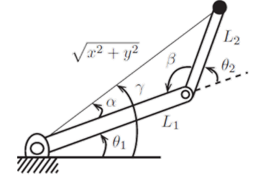
Figure 1 Two revolute joints robotic arm
For each point along the planned path, use the inverse kinematics method to calculate the angles θ₁ and θ₂, and then plot the corresponding position of the robotic arm. The formulas used for the calculations are shown as follows.
$$θ_{2}=180- \cos^{-1}\left(\frac{x^{2}+y^{2}-L_{1}^{2}-L_{2}^{2}}{2L_{1}L_{2}}\right)$$
$$α= \tan^{-1}\left(L_{2}*\sin{θ_{2}},L_{1}+L_{2}*\cos{θ_{2}}\right)$$
$$θ_{1}=\tan^{-1}\left(y, x\right)-α$$
In the implementation section, we referred to and utilized the code and library functions from https://github.com/AtsushiSakai/PythonRobotics.git to assist with plotting. For the detailed code implementation, please refer to twoJointArm.py.
Code: https://github.com/GoodgoodBoys/5463PA2.git
For teamwork:
For this assignment, we first discussed the approach to the problem together and reviewed the calculation methods of inverse kinematics. Zhiyuan Chen wanted to complete this assignment using ROS, but Yuxiang Ding was not familiar with ROS and therefore could not contribute to the ROS project. As a result, we eventually decided to work separately.
The code was managed and versioned using GitHub. First, we tested the sample code, in which the robotic arm moves to a clicked point on the screen. Then, I separated the arm-drawing function and removed the “gradual movement toward the target” logic, allowing the arm to move directly to the target position. And when it exceeds the boundary, the robotic arm moves to the position on the boundary that is closest to the target position. After that, I began writing the path-drawing part of the code, which stores all the points along the path and passes each point in a loop to the arm-drawing function.
Contribution:
Yuxiang Ding: Code, Report
Zhiyuan Chen: Please refer to the ROS section completed by our group.
Citation:
https://github.com/AtsushiSakai/PythonRobotics.git

