THE SKI CHALLENGE

At The Asia, we believe that the ability to create efficient algorithm and essential critical thinking skills are vital to our success and computing in general. In order to facilitate our evaluation process, we would like you to code up a solution to a small and fun problem, with a short analysis on your solution itself.

Being a software developer you can’t help but to value efficiency, so naturally you want to ski as long as possible and as fast as possible without having to ride back up on the ski lift.

In digital form the map looks like the number grid below. (The graph on the left is a graphical representation of the values on the right to help you visualize the mountain)

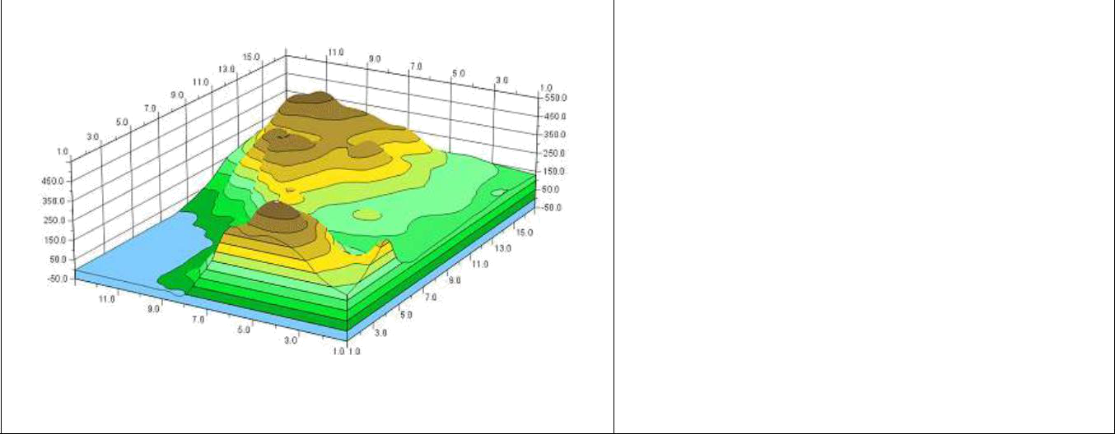

51 39 64 04 42 15 23 35
20 84 66 91 72 38 19 55
94 07 28 99 36 69 08 99
79 98 91 73 11 60 76 61
98 40 65 40 54 88 74 73
71 40 63 43 77 82 97 71
89 24 71 24 93 79 23 71
76 14 43 86 73 19 47 71
(The image does no depict the actual value on
the right)

In the 8x8 matrix, each value represents the elevation of that area of the mountain. From each area in the grid you can go north, south, east, and west - but only if the elevation of the area you are going into is less than the one you are in (You can’t ski uphill. Can you?)

Below is an example:

 | On this map, a possible path down the
51 39 64 04 42 15 23 35 | mountain is of length=4 and it is highlighted
20 84 66 91 72 38 19 55 | in red on the left: 98-91-73-40.
94 07 28 99 36 69 08 99
79 98 91 73 11 60 76 61
98 40 65 40 54 88 74 73
71 40 63 43 77 82 97 71
89 24 71 24 93 79 23 71
76 14 43 86 73 19 47 71


Your challenge is to write a program in Javascript (Nodejs) to find the longest (and then steepest) path. To save you some trouble, below is a JS code snippet to help you get started:

const map = [
[51,39,64,4,42,15,23,35],
[20,84,66,91,72,38,19,55],
[94,7,28,99,36,69,8,99],
[79,98,91,73,11,60,76,61],
[98,40,65,40,54,88,74,73],
[71,40,63,43,77,82,97,71],
[89,24,71,24,93,79,23,71],
[76,14,43,86,73,19,47,71],
];

Please add your code to github.com and send us repo link having readme file with instruction to run and test. Also please add comments to code.

Good luck and have fun!

