**INSTALLATION GUIDE**

**Hadoop**

Overview:

* Downloading and Installing Java (mandatory).
* Installing Hadoop (mandatory).

* **Downloading and Installing Java.**

If you don’t already have java, you can get it from this link,

Link : [https://www.oracle.com/java/technologies/javase/javase-jdk8downloads.html](https://www.oracle.com/java/technologies/javase/javase-jdk8-downloads.html)

Download the latest and compatible version (x64, x86)

for your computer.

After downloading, its installation is pretty basic, all you need to is run the setup and it’s done.

# Now, this is the IMPORTANT part,

You need to set environmental variable for JAVA.

Here’s how you do it,

• For windows 10,

* Go to Start, Search for Environmental Variables
* Select Edit the system Environmental Variables

You will have this screen popped up

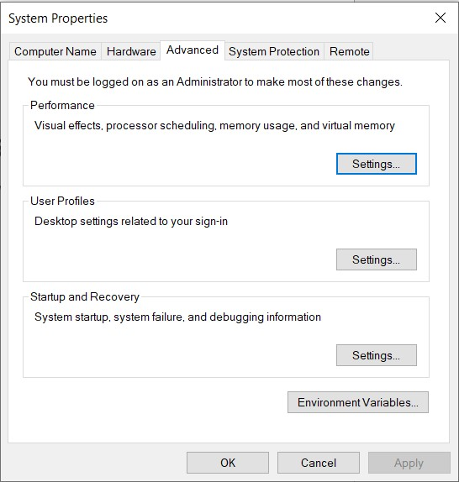

Click on Environmental variables and, you will have this pop up

Click on New in System variables

And set the variable name to JAVA_HOME and set the variable path to wherever your JAVA is installed. Like this,

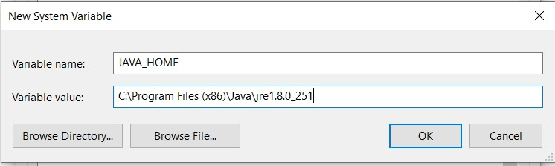

Click OK,

Now setting the path variable,

Navigate the path variable under system variables, click on edit.

You will see this popup,

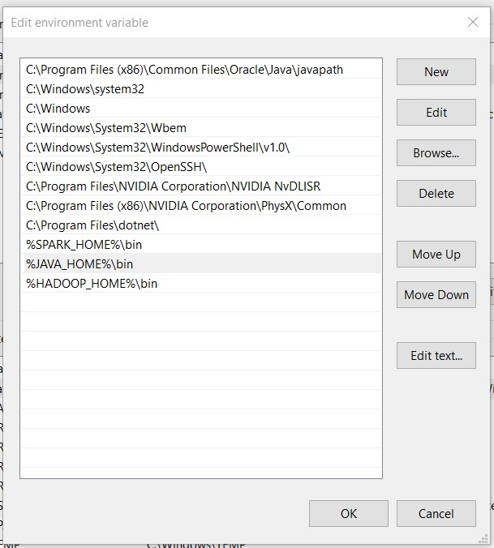

Click on new, and Type this,

## %JAVA_HOME%\bin

Like this,

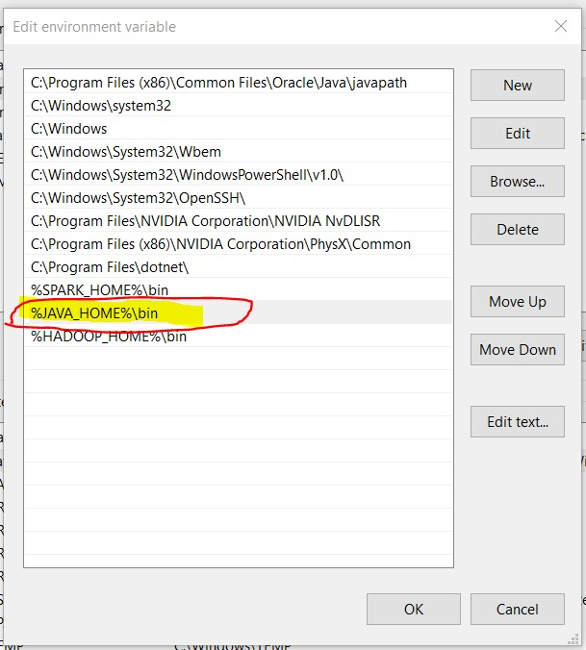

PRESS OK,

Now, to verify java installation, Open CMD and type this command java – version

You will see something like this

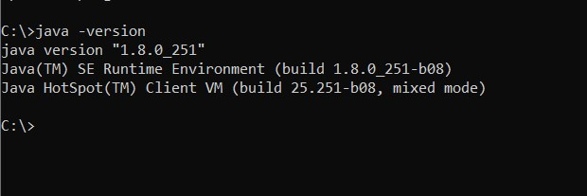

Java is Successfully Installed.

# INSTALLING HADOOP

Download Hadoop for here [Apache Download Mirrors](https://www.apache.org/dyn/closer.cgi/hadoop/common/hadoop-3.3.1/hadoop-3.3.1.tar.gz).

For windows you will be required some additional files so download bin folder from this github

<https://github.com/s911415/apache-hadoop-3.1.0-winutils>

And replace the bin folder from Hadoop with this bin folder.

Now, Set Environmental variable

HADOOP_HOME.

To do this,

Search Environmental variable in start.

Go to Environmental variables. Click new,

Set name to HADOOP_HOME,

Value will be the bin path from Hadoop i.e C:\Hadoop\bin

Download the config file from this link:

<https://drive.google.com/file/d/1ZTSjpPKx6d5O-vF-LQowxq9tbfOu_SYa/view?usp=sharing>

and place them in Hadoop\etc\hadoop folder

Also edit the Hadoop-env cmd file and set the JAVA_HOME to the location where your java is installed.

Use Hadoop version command to check if it is working.

Also run cmd in admin mode and run this command

hdfs namenode -format