A Narrative Report on the On-the-Job Training conducted at
Landbank of the Philippines Dipolog Branch and
DSAS Office of JRMSU-TC
Miputak, Dipolog City and ZNAC, Tampilisan

Presented to the faculty of
College of Computing Studies

In partial fulfillment of the requirements for the degree of
Bachelor of Science in Information System

Training Duration:
June 08 – September 21, 2026 (486 HRS)

Submitted by:
CYNTIA C. ROSWELL
BS in Information System – 3rd Year

Submitted to:
LORYMER L. JAUCULAN
Faculty OJT Coordinator

ACKNOWLEDGEMENT
Lorem ipsum dolor sit amet, consectetur adipiscing elit. Sed do eiusmod tempor incididunt ut labore et dolore magna aliqua. Ut enim ad minim veniam, quis nostrud exercitation ullamco laboris nisi ut aliquip ex ea commodo consequat. Duis aute irure dolor in reprehenderit in voluptate velit esse cillum dolore ad minim veniam, quis nostrud eu fugiat nulla pariatur.
Vestibulum ante ipsum primis in faucibus orci luctus et ultrices posuere cubilia curae; Praesent vitae justo eget felis facilisis fermentum. Integer euismod, lacus at tincidunt malesuada, sapien lorem interdum neque, vitae tincidunt erat nulla ac augue. Suspendisse potenti, donec feugiat magna vel libero consequat, ad minim veniam, quis nostrud vitae tincidunt sem volutpat.
Curabitur blandit tempus porttitor. Maecenas faucibus mollis interdum, morbi leo risus, porta ac consectetur ac, vestibulum at eros. Aenean lacinia bibendum nulla sed consectetur. Cras mattis consectetur purus sit amet fermentum, vivamus sagittis lacus vel augue laoreet rutrum faucibus dolor veniam, quis nostrud vitae tincidunt faucibus erat vitae tincidunt sem auctor.

TABLE OF CONTENTS
CONTENTS | PAGE
Acknowledgement ------------------------------------------------------------------------------- | i
Table of Contents -------------------------------------------------------------------------------- | ii
List of Table/Figures ----------------------------------------------------------------------------  I. LANDBANK OF THE PHILIPPINES DIPOLOG BRANCH | iii
Introduction --------------------------------------------------------------------------------------- | 1
- Background of the Organization
- Vision, Mission, And Objectives
- Organizational Structure
- The Products and Services Offered
Organization/Company Analysis --------------------------------------------------------------- | 4
- Strengths and Weaknesses of the Organization
- Opportunities and Threats of the Organization
- Recommendations for Improvement
Tasks and Duties --------------------------------------------------------------------------------- | 6
- Describe the Tasks and Responsibilities Assigned
- Duties and Procedures Conformed
Case Analysis ------------------------------------------------------------------------------------- | 7
- Identified Issues/Problems
- Strategies Undertaken
- Lesson Learned
Reflections ---------------------------------------------------------------------------------------- | 8
- Self-Evaluation
- Relevance to Course and Goals
II. DSAS OFFICE OF JRMSU-TC
Introduction --------------------------------------------------------------------------------------- | 9
- Background of the Organization
- Vision, Mission, And Objectives
- Organizational Structure
- The Products and Services Offered
Organization/Company Analysis --------------------------------------------------------------- | 12
- Strengths and Weaknesses of the Organization
- Opportunities and Threats of the Organization
- Recommendations for Improvement
Tasks and Duties --------------------------------------------------------------------------------- | 14
- Describe the Tasks and Responsibilities Assigned
- Duties and Procedures Conformed
Case Analysis ------------------------------------------------------------------------------------- | 15
- Identified Issues/Problems
- Strategies Undertaken
- Lesson Learned
Reflections ---------------------------------------------------------------------------------------- | 16
- Self-Evaluation
- Relevance to Course and Goals
Appendices ---------------------------------------------------------------------------------------- | 17
- Journal
- Certificate of Participation of Prime Seminar
- One-page narrative report of PRIME
- Resume And Application Letter
- Evaluation Of Grades from The Registrar
- Validated Enrollment Form
- Medical Certificate
- Parent’s Waiver
- Letter Of Acceptance
- Daily Time Record-Contains of Number of Hrs. Rendered
- Student’s Intern Rating Sheet
- Performance Evaluation
- Certificate Of Completion
- Memorandum of Agreement

LIST OF TABLES / FIGURES
LIST OF TABLES
Table 1: Journal Week 1
Table 2: Journal Week 2
Table 3: Journal Week 3

LIST OF FIGURES
Figure 1: Landbank Organizational Chart
Figure 2: DSAS Organizational Chart
Figure 3: Landbank Orientation
Figure 4: PRIME report photos

LANDBANK OF THE PHILIPPINES DIPOLOG BRANCH
INTRODUCTION
Background of the Organization:
Lorem ipsum dolor sit amet, consectetur adipiscing elit. Sed do eiusmod tempor incididunt ut labore et dolore magna aliqua. Ut enim ad minim veniam, quis nostrud exercitation ullamco laboris nisi ut aliquip ex ea commodo consequat. Duis aute irure dolor in reprehenderit in voluptate velit esse cillum dolore ad minim veniam, quis nostrud eu fugiat nulla pariatur.
Vestibulum ante ipsum primis in faucibus orci luctus et ultrices posuere cubilia curae; Praesent vitae justo eget felis facilisis fermentum. Integer euismod, lacus at tincidunt malesuada, sapien lorem interdum neque, vitae tincidunt erat nulla ac augue. Suspendisse potenti, donec feugiat magna vel libero consequat, ad minim veniam, quis nostrud vitae tincidunt sem volutpat.

Vision:
To be the premier financial institution that leads innovation in pursuit of development, inclusion and sustainability.

Mission:
We provide responsive financial solutions and services for all Filipinos, from countryside to countrywide.

Objectives:
- Expand credit access to farmers, fisherfolk, agrarian reform beneficiaries, and rural communities
- Support priority sectors such as micro, small, and medium enterprises, local government units, agriculture, and social services
- Ensure financial viability and sustainability so profits can be reinvested in development programs
- Promote financial inclusion by expanding accessible banking services, especially in underserved areas
- Drive digital transformation to deliver efficient, reliable, and inclusive financial services nationwide
Core Values:
L — Love for Country
E — Embody Excellence and Ethical Standards
A — Adopt Disruptive Innovations
D — Delight Customers

Products and Services Offered:
- Savings Accounts
- Checking or Current Accounts
- Time Deposit Accounts
- LANDBANK ATM and Debit Cards
- Agricultural and Fishery Loans
- Micro, Small, and Medium Enterprise Loans
- Housing and Salary Loans
- Local Government Unit Financing
- LANDBANK Mobile Banking Application
- LANDBANK iAccess Online Banking
- Bills Payment
- PESONet and InstaPay Fund Transfers
- Pension, Salary, and Government Benefits Disbursement

Organization Structure
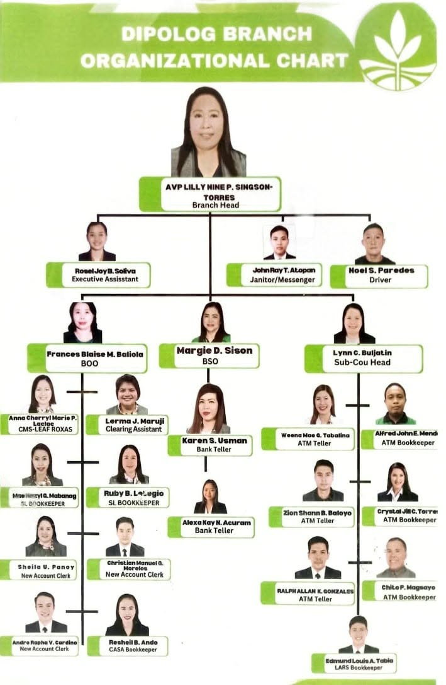
Figure 1: Landbank Organizational Chart

ORGANIZATION / COMPANY ANALYSIS
Strengths:
- Lorem ipsum dolor sit amet, consectetur adipiscing elit, sed do eiusmod tempor incididunt ut labore.
- Ut enim ad minim veniam, quis nostrud exercitation ullamco laboris nisi ut aliquip ex ea commodo.
- Duis aute irure dolor in reprehenderit in voluptate velit esse cillum dolore eu fugiat nulla pariatur.
- Curabitur blandit tempus porttitor, maecenas faucibus mollis interdum, vivamus sagittis lacus vel augue.

Weaknesses:
- Lorem ipsum dolor sit amet, consectetur adipiscing elit, sed do eiusmod tempor incididunt ut labore.
- Ut enim ad minim veniam, quis nostrud exercitation ullamco laboris nisi ut aliquip ex ea commodo.
- Duis aute irure dolor in reprehenderit in voluptate velit esse cillum dolore eu fugiat nulla pariatur.
- Curabitur blandit tempus porttitor, maecenas faucibus mollis interdum, vivamus sagittis lacus vel augue.

Opportunities:
- Lorem ipsum dolor sit amet, consectetur adipiscing elit, sed do eiusmod tempor incididunt ut labore.
- Ut enim ad minim veniam, quis nostrud exercitation ullamco laboris nisi ut aliquip ex ea commodo.
- Duis aute irure dolor in reprehenderit in voluptate velit esse cillum dolore eu fugiat nulla pariatur.
- Curabitur blandit tempus porttitor, maecenas faucibus mollis interdum, vivamus sagittis lacus vel augue.

Threats:
- Lorem ipsum dolor sit amet, consectetur adipiscing elit, sed do eiusmod tempor incididunt ut labore.
- Ut enim ad minim veniam, quis nostrud exercitation ullamco laboris nisi ut aliquip ex ea commodo.
- Duis aute irure dolor in reprehenderit in voluptate velit esse cillum dolore eu fugiat nulla pariatur.
- Curabitur blandit tempus porttitor, maecenas faucibus mollis interdum, vivamus sagittis lacus vel augue.

Recommendations for Improvement:
- Lorem ipsum dolor sit amet, consectetur adipiscing elit, sed do eiusmod tempor incididunt ut labore.
- Ut enim ad minim veniam, quis nostrud exercitation ullamco laboris nisi ut aliquip ex ea commodo.
- Duis aute irure dolor in reprehenderit in voluptate velit esse cillum dolore eu fugiat nulla pariatur.
- Curabitur blandit tempus porttitor, maecenas faucibus mollis interdum, vivamus sagittis lacus vel augue.

TASKS AND DUTIES
Assigned Tasks and Responsibilities:
- Vestibulum ante ipsum primis in faucibus orci luctus et ultrices posuere cubilia curae; Praesent vitae justo eget felis facilisis fermentum. Integer euismod, lacus at tincidunt malesuada, sapien lorem interdum neque, vitae tincidunt erat nulla ac augue. Suspendisse potenti, donec feugiat magna vel libero consequat, ad minim veniam, quis nostrud vitae tincidunt sem volutpat.

Duties and Procedures Conformed:
- Lorem ipsum dolor sit amet, consectetur adipiscing elit, sed do eiusmod tempor incididunt ut labore.
- Ut enim ad minim veniam, quis nostrud exercitation ullamco laboris nisi ut aliquip ex ea commodo.
- Duis aute irure dolor in reprehenderit in voluptate velit esse cillum dolore eu fugiat nulla pariatur.
- Curabitur blandit tempus porttitor, maecenas faucibus mollis interdum, vivamus sagittis lacus vel augue.

CASE ANALYSIS
Issue / Problem 1:
Duis aute irure dolor in reprehenderit in voluptate velit esse cillum dolore eu fugiat nulla pariatur.

Strategy/Action Undertaken for Problem 1:
Duis aute irure dolor in reprehenderit in voluptate velit esse cillum dolore eu fugiat nulla pariatur. Aute irure dolor in reprehenderit in voluptate velit esse cillum dolore eu fugiat nulla pariatur dolor in.

Issue / Problem 2:
Duis aute irure dolor in reprehenderit in voluptate velit esse cillum dolore eu fugiat nulla pariatur.

Strategy/Action Undertaken for Problem 2:
Duis aute irure dolor in reprehenderit in voluptate velit esse cillum dolore eu fugiat nulla pariatur.

Lessons Learned from the Situations:
Integer euismod, lacus at tincidunt malesuada, sapien lorem interdum neque, vitae tincidunt erat nulla ac augue. Suspendisse potenti, donec feugiat magna vel libero consequat, ad minim veniam, quis nostrud vitae tincidunt sem volutpat.

REFLECTIONS
Self-Evaluation:
Vestibulum ante ipsum primis in faucibus orci luctus et ultrices posuere cubilia curae; Praesent vitae justo eget felis facilisis fermentum. Integer euismod, lacus at tincidunt malesuada, sapien lorem interdum neque, vitae tincidunt erat nulla ac augue. Suspendisse potenti, donec feugiat magna vel libero consequat, ad minim veniam, quis nostrud vitae tincidunt sem volutpat.

Relevancy of the Organization:
Curabitur blandit tempus porttitor. Maecenas faucibus mollis interdum, morbi leo risus, porta ac consectetur ac, vestibulum at eros. Aenean lacinia bibendum nulla sed consectetur. Cras mattis consectetur purus sit amet fermentum, vivamus sagittis lacus vel augue laoreet rutrum faucibus dolor veniam, quis nostrud vitae tincidunt faucibus erat vitae tincidunt sem auctor. Maecenas faucibus mollis interdum, morbi leo risus, porta ac consectetur ac, vestibulum at eros.

DSAS OFFICE OF JRMSU-TC
INTRODUCTION
Background of the Organization:
Lorem ipsum dolor sit amet, consectetur adipiscing elit. Sed do eiusmod tempor incididunt ut labore et dolore magna aliqua. Ut enim ad minim veniam, quis nostrud exercitation ullamco laboris nisi ut aliquip ex ea commodo consequat. Duis aute irure dolor in reprehenderit in voluptate velit esse cillum dolore ad minim veniam, quis nostrud eu fugiat nulla pariatur.
Vestibulum ante ipsum primis in faucibus orci luctus et ultrices posuere cubilia curae; Praesent vitae justo eget felis facilisis fermentum. Integer euismod, lacus at tincidunt malesuada, sapien lorem interdum neque, vitae tincidunt erat nulla ac augue. Suspendisse potenti, donec feugiat magna vel libero consequat, ad minim veniam, quis nostrud vitae tincidunt sem volutpat.
Curabitur blandit tempus porttitor. Maecenas faucibus mollis interdum, morbi leo risus, porta ac consectetur ac, vestibulum at eros. Aenean lacinia bibendum nulla sed consectetur. Cras mattis consectetur purus sit amet fermentum, vivamus sagittis lacus vel augue laoreet rutrum faucibus dolor veniam, quis nostrud vitae tincidunt faucibus erat vitae tincidunt sem auctor.

Vision:
A Smart UniverCity, locally and globally, that inspires excellence, fosters innovation, and promotes sustainable development for the betterment of society.

Mission:
Jose Rizal Memorial State University pledges to deliver effective and efficient services along instruction, research, extension, and production.
It commits to provide a Smart UniverCity to foster adaptive learning with technology and innovation for student success, forge partnerships to tackle challenges and drive sustainable progress, and ensure academic excellence, ethics, and accountability in all operations.

Objectives:
- Lorem ipsum dolor sit amet, consectetur adipiscing elit, sed do eiusmod tempor incididunt ut labore.
- Ut enim ad minim veniam, quis nostrud exercitation ullamco laboris nisi ut aliquip ex ea commodo.
- Duis aute irure dolor in reprehenderit in voluptate velit esse cillum dolore eu fugiat nulla pariatur. Ut enim ad minim veniam, quis nostrud exercitation ullamco laboris nisi ut aliquip ex ea commodo.
- Ut enim ad minim veniam, quis nostrud exercitation ullamco laboris nisi ut aliquip ex ea commodo. Curabitur blandit tempus porttitor, maecenas faucibus mollis interdum, vivamus sagittis lacus vel augue.

Core Values:
R — Resilience
I — Integrity
Z — Zeal for Excellence
A — Altruism
L — Leadership

Products and Services Offered:
- Lorem ipsum dolor sit amet, consectetur adipiscing elit, sed do eiusmod tempor incididunt ut labore.
- Ut enim ad minim veniam, quis nostrud exercitation ullamco laboris nisi ut aliquip ex ea commodo.
- Duis aute irure dolor in reprehenderit in voluptate velit esse cillum dolore eu fugiat nulla pariatur.
- Curabitur blandit tempus porttitor, maecenas faucibus mollis interdum, vivamus sagittis lacus vel augue.

Organization Structure
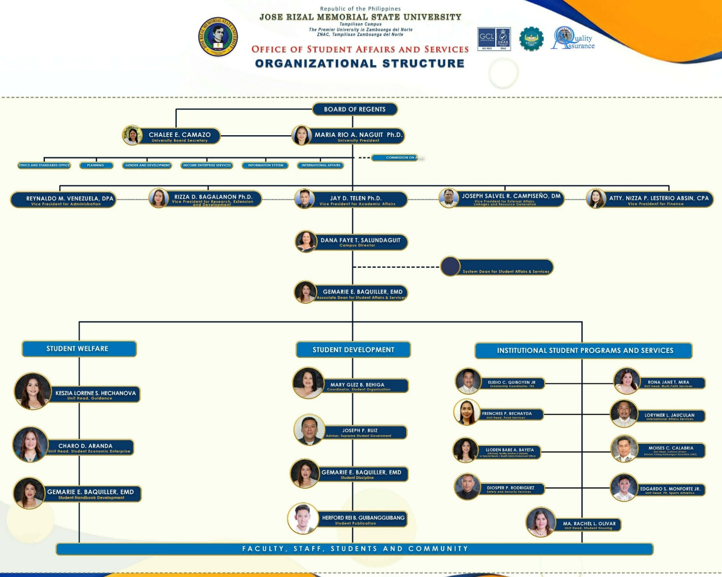
Figure 2: DSAS Organizational Chart

ORGANIZATION / COMPANY ANALYSIS
Strengths:
- Lorem ipsum dolor sit amet, consectetur adipiscing elit, sed do eiusmod tempor incididunt ut labore.
- Ut enim ad minim veniam, quis nostrud exercitation ullamco laboris nisi ut aliquip ex ea commodo.
- Duis aute irure dolor in reprehenderit in voluptate velit esse cillum dolore eu fugiat nulla pariatur.
- Curabitur blandit tempus porttitor, maecenas faucibus mollis interdum, vivamus sagittis lacus vel augue.

Weaknesses:
- Lorem ipsum dolor sit amet, consectetur adipiscing elit, sed do eiusmod tempor incididunt ut labore.
- Ut enim ad minim veniam, quis nostrud exercitation ullamco laboris nisi ut aliquip ex ea commodo.
- Duis aute irure dolor in reprehenderit in voluptate velit esse cillum dolore eu fugiat nulla pariatur.
- Curabitur blandit tempus porttitor, maecenas faucibus mollis interdum, vivamus sagittis lacus vel augue.

Opportunities:
- Lorem ipsum dolor sit amet, consectetur adipiscing elit, sed do eiusmod tempor incididunt ut labore.
- Ut enim ad minim veniam, quis nostrud exercitation ullamco laboris nisi ut aliquip ex ea commodo.
- Duis aute irure dolor in reprehenderit in voluptate velit esse cillum dolore eu fugiat nulla pariatur.
- Curabitur blandit tempus porttitor, maecenas faucibus mollis interdum, vivamus sagittis lacus vel augue.

Threats:
- Lorem ipsum dolor sit amet, consectetur adipiscing elit, sed do eiusmod tempor incididunt ut labore.
- Ut enim ad minim veniam, quis nostrud exercitation ullamco laboris nisi ut aliquip ex ea commodo.
- Duis aute irure dolor in reprehenderit in voluptate velit esse cillum dolore eu fugiat nulla pariatur.
- Curabitur blandit tempus porttitor, maecenas faucibus mollis interdum, vivamus sagittis lacus vel augue.

Recommendations for Improvement:
- Lorem ipsum dolor sit amet, consectetur adipiscing elit, sed do eiusmod tempor incididunt ut labore.
- Ut enim ad minim veniam, quis nostrud exercitation ullamco laboris nisi ut aliquip ex ea commodo.
- Duis aute irure dolor in reprehenderit in voluptate velit esse cillum dolore eu fugiat nulla pariatur.
- Curabitur blandit tempus porttitor, maecenas faucibus mollis interdum, vivamus sagittis lacus vel augue.

TASKS AND DUTIES
Assigned Tasks and Responsibilities:
- Lorem ipsum dolor sit amet, consectetur adipiscing elit. Sed do eiusmod tempor incididunt ut labore et dolore magna aliqua. Ut enim ad minim veniam, quis nostrud exercitation ullamco laboris nisi ut aliquip ex ea commodo consequat. Duis aute irure dolor in reprehenderit in voluptate velit esse cillum dolore ad minim veniam, quis nostrud eu fugiat nulla pariatur.

Duties and Procedures Conformed:
- Lorem ipsum dolor sit amet, consectetur adipiscing elit, sed do eiusmod tempor incididunt ut labore.
- Ut enim ad minim veniam, quis nostrud exercitation ullamco laboris nisi ut aliquip ex ea commodo.
- Duis aute irure dolor in reprehenderit in voluptate velit esse cillum dolore eu fugiat nulla pariatur.
- Curabitur blandit tempus porttitor, maecenas faucibus mollis interdum, vivamus sagittis lacus vel augue.

CASE ANALYSIS
Issue / Problem 1:
Lorem ipsum dolor sit amet, consectetur adipiscing elit. Sed do eiusmod tempor incididunt ut labore et dolore magna aliqua.

Strategy/Action Undertaken for Problem 1:
Ut enim ad minim veniam, quis nostrud exercitation ullamco laboris nisi ut aliquip ex ea commodo consequat. Duis aute irure dolor in reprehenderit in voluptate velit esse cillum dolore ad minim veniam, quis nostrud eu fugiat nulla pariatur.

Issue / Problem 2:
Lorem ipsum dolor sit amet, consectetur adipiscing elit. Sed do eiusmod tempor incididunt ut labore et dolore magna aliqua.

Strategy/Action Undertaken for Problem 2:
Ut enim ad minim veniam, quis nostrud exercitation ullamco laboris nisi ut aliquip ex ea commodo consequat. Duis aute irure dolor in reprehenderit in voluptate velit esse cillum dolore ad minim veniam, quis nostrud eu fugiat nulla pariatur.

Lessons Learned from the Situations:
Vestibulum ante ipsum primis in faucibus orci luctus et ultrices posuere cubilia curae; Praesent vitae justo eget felis facilisis fermentum. Integer euismod, lacus at tincidunt malesuada, sapien lorem interdum neque, vitae tincidunt erat nulla ac augue.

REFLECTIONS
Self-Evaluation:
Lorem ipsum dolor sit amet, consectetur adipiscing elit. Sed do eiusmod tempor incididunt ut labore et dolore magna aliqua. Ut enim ad minim veniam, quis nostrud exercitation ullamco laboris nisi ut aliquip ex ea commodo consequat. Duis aute irure dolor in reprehenderit in voluptate velit esse cillum dolore ad minim veniam, quis nostrud eu fugiat nulla pariatur.

Relevancy of the Organization:
Lorem ipsum dolor sit amet, consectetur adipiscing elit. Sed do eiusmod tempor incididunt ut labore et dolore magna aliqua. Ut enim ad minim veniam, quis nostrud exercitation ullamco laboris nisi ut aliquip ex ea commodo consequat. Duis aute irure dolor in reprehenderit in voluptate velit esse cillum dolore ad minim veniam, quis nostrud eu fugiat nulla pariatur. Praesent vitae justo eget felis facilisis fermentum. Integer euismod, lacus at tincidunt malesuada, sapien lorem interdum neque, vitae tincidunt erat nulla ac augue. Suspendisse potenti, donec feugiat magna vel libero consequat, ad minim veniam, quis nostrud vitae tincidunt sem volutpat

APPENDICES
JOURNAL
Week 1
DAY | DATE | ACCOMPLISHMENT | NO. OF WORKING HOURS
Day 1-4 | June 8 – 11 | - Lorem ipsum dolor sit amet, consectetur adipistempor incididunt ut labore.  - Ut enim ad minim veniam, quiso laboris nisi ut aliquip ex ea commodo.  - Duis aute irure dolor in reprehenderitdolore eu fugiat nulla pariatur.  - Curabitur blanmollis interdum, vivamus sagittis lacus vel augue. | 24
TOTAL NUMBER OF HOURS |  |  | 24
Table 1: Journal Week 1
Curabitur blandit tempus porttitor. Maecenas faucibus mollis interdum, morbi leo risus, porta ac consectetur ac, vestibulum at eros. Aenean lacinia bibendum nulla sed consectetur. Cras mattis consectetur purus sit amet fermentum, vivamus sagittis lacus vel augue laoreet rutrum faucibus dolor veniam, quis nostrud vitae tincidunt faucibus erat vitae tincidunt sem auctor.
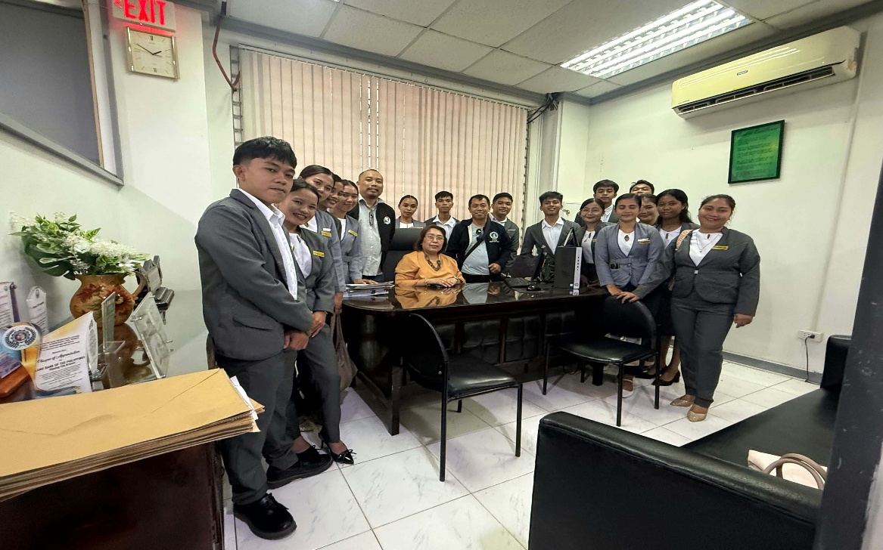
Figure 3: Landbank Orientation
Week 2
DAY | DATE | ACCOMPLISHMENT | NO. OF WORKING HOURS
Day 1-4 | June 15-19 | - Lorem ipsum dolor sit amet, consectetur adipistempor incididunt ut labore.  - Ut enim ad minim veniam, quiso laboris nisi ut aliquip ex ea commodo.  - Duis aute irure dolor in reprehenderitdolore eu fugiat nulla pariatur. | 32
TOTAL NUMBER OF HOURS |  |  | 32
Table 2: Journal Week 2
Aenean blandit tempus porttitor. Maecenas faucibus mollis interdum, morbi leo risus, porta ac consectetur ac, vestibulum at eros. Aenean lacinia bibendum nulla sed consectetur. Cras mattis consectetur purus sit amet fermentum, vivamus sagittis lacus vel augue laoreet rutrum faucibus dolor veniam, quis nostrud vitae tincidunt faucibus erat vitae tincidunt sem auctor.

Week 3
DAY | DATE | ACCOMPLISHMENT | NO. OF WORKING HOURS
Day 1-5 | June 22-26 | - Lorem ipsum dolor sit amet, consectetur adipistempor incididunt ut labore.  - Duis aute irure dolor in reprehenderitdolore eu fugiat nulla pariatur.  - Curabitur blanmollis interdum, vivamus sagittis lacus vel augue. | 40
TOTAL NUMBER OF HOURS |  |  | 40
Table 3: Journal Week 3
Cras mattis consectetur purus sit amet fermentum, vivamus sagittis lacus vel augueenean blandit tempus porttitor. Maecenas faucibus mollis interdum, morbi leo risus, porta ac consectetur ac, vestibulum at eros. Aenean lacinia bibendum nulla sed consectetur. Cras mattis consectetur purus sit amet fermentum, vivamus sagittis lacus vel augue

One page narrative report of PRIME
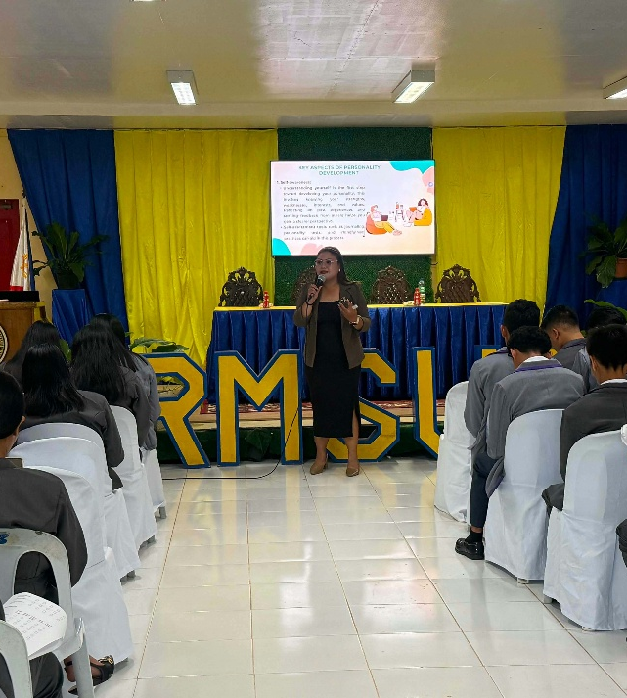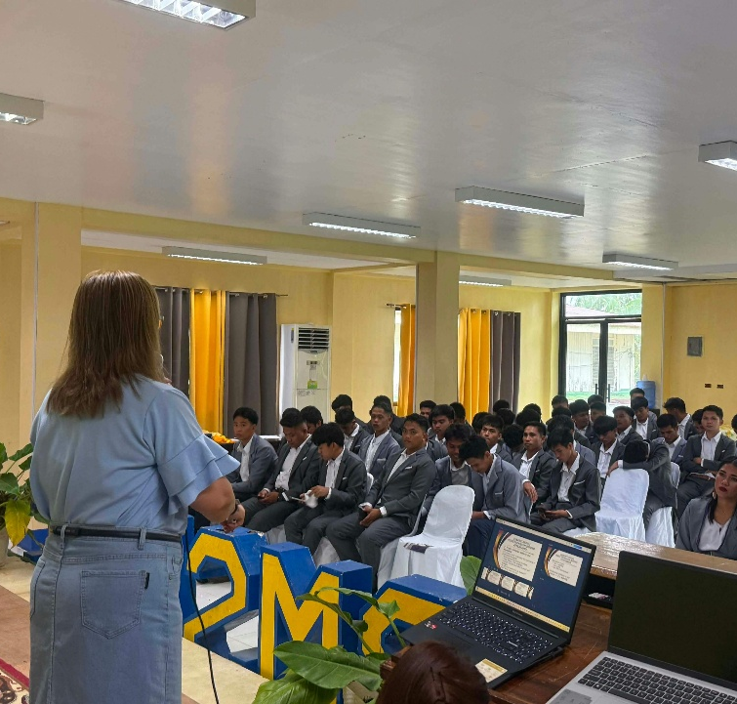
Figure 4: PRIME report photos
Lorem ipsum dolor sit amet, consectetur adipiscing elit. Sed do eiusmod tempor incididunt ut labore et dolore magna aliqua. Ut enim ad minim veniam, quis nostrud exercitation ullamco laboris nisi ut aliquip ex ea commodo consequat. Duis aute irure dolor in reprehenderit in voluptate velit esse cillum dolore ad minim veniam, quis nostrud eu fugiat nulla pariatur.
Vestibulum ante ipsum primis in faucibus orci luctus et ultrices posuere cubilia curae; Praesent vitae justo eget felis facilisis fermentum. Integer euismod, lacus at tincidunt malesuada, sapien lorem interdum neque, vitae tincidunt erat nulla ac augue. Suspendisse potenti, donec feugiat magna vel libero consequat, ad minim veniam, quis nostrud vitae tincidunt sem volutpat.
Curabitur blandit tempus porttitor. Maecenas faucibus mollis interdum, morbi leo risus, porta ac consectetur ac, vestibulum at eros. Aenean lacinia bibendum nulla sed consectetur. Cras mattis consectetur purus sit amet fermentum, vivamus sagittis lacus vel augue laoreet rutrum faucibus dolor veniam, quis nostrud vitae tincidunt faucibus erat vitae tincidunt sem auctor.

