Results
Descriptive Statistics
Descriptive Statistics
 | ANNUAL INCOME | HEIGHT
Valid | 30 | 30
Missing | 0 | 0
Mean | 209906.667
Std. Deviation | 171822.882
Minimum | 45000.000
Maximum | 780000.000
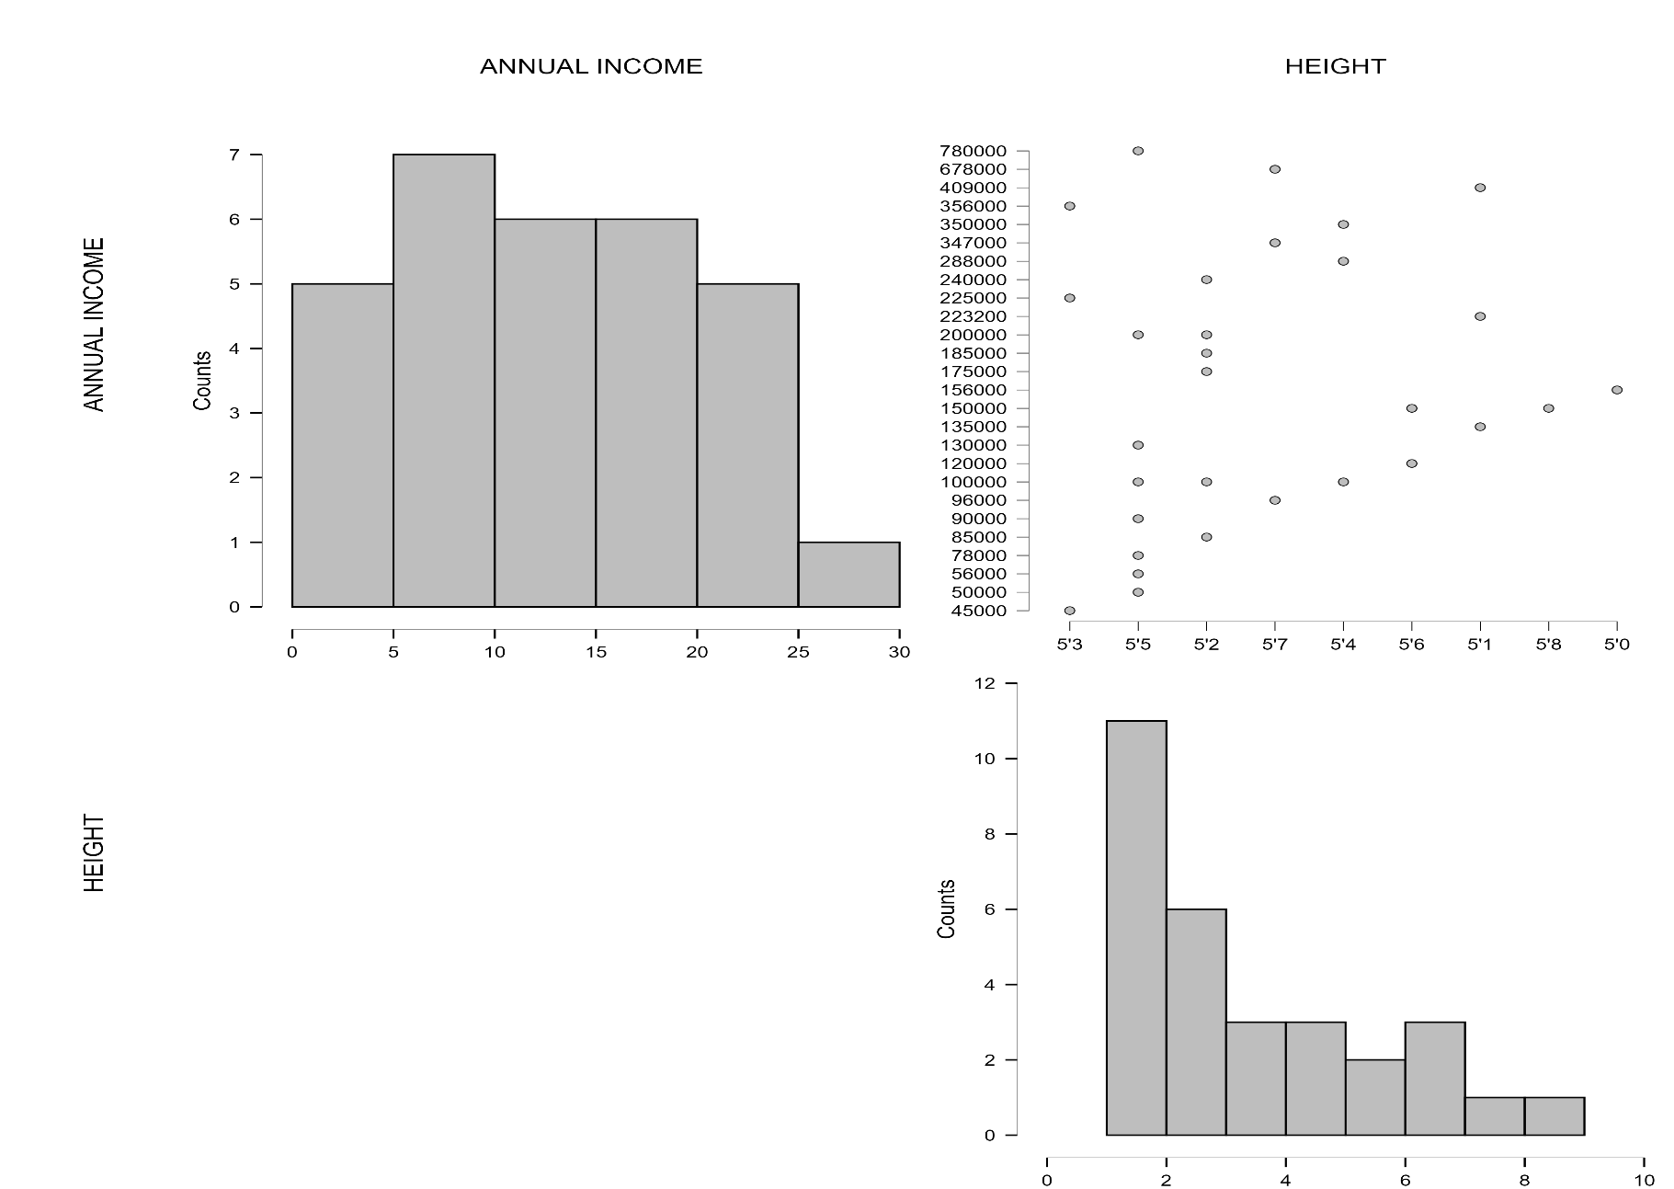
Correlation plot
Q-Q Plots ANNUAL INCOME
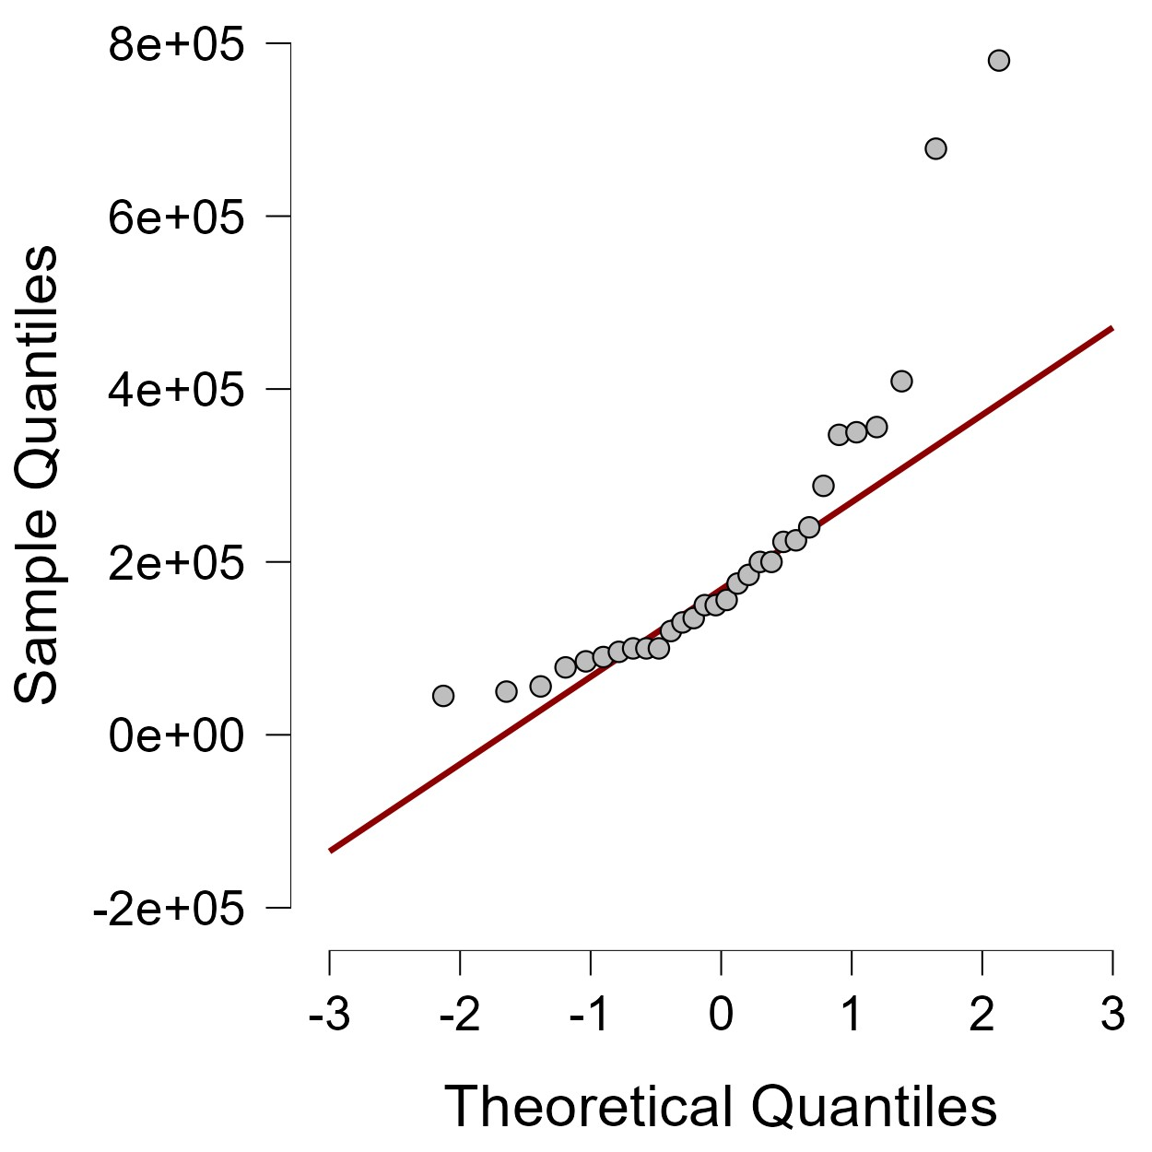

SUMMARY

In this data its shows the annual income and height of a person. The purpose of this data is to know the income and height is related to each other. When you look at the correlation plot between annual income and height it is shows that there no significant connection between the two variables.

