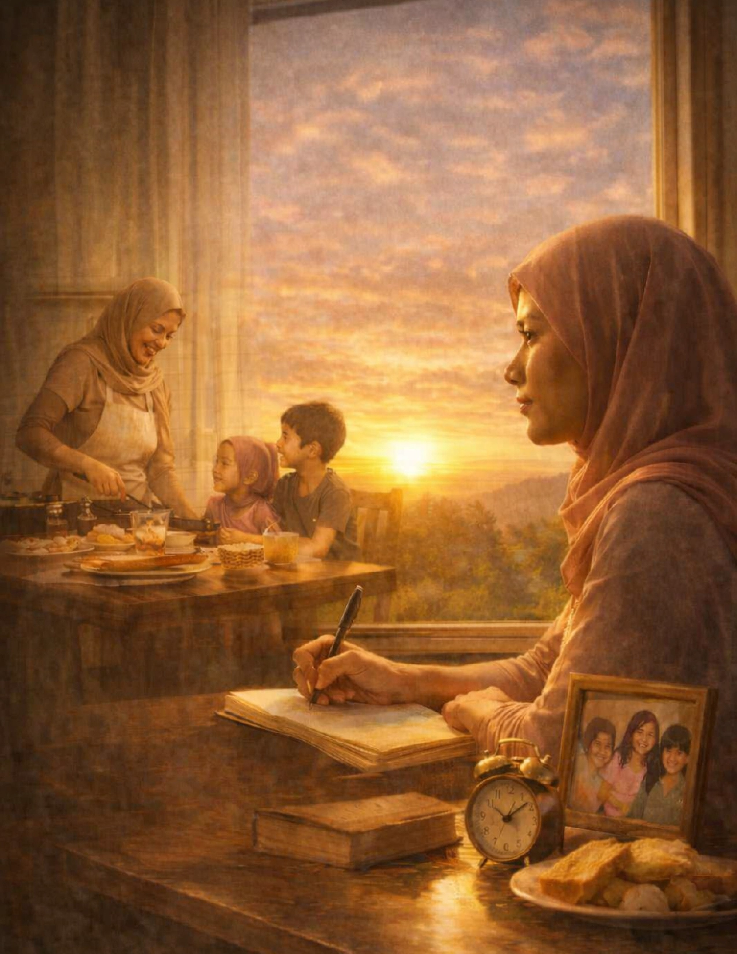
Laysa W. Cambia

Every time when the sun is out there's always a light and the
memories that I hold were priceless.

Memoir

Every time when the sun is out there's
always a light and the memories that I
hold were priceless. Every morning when
I woke up, I see my mom in the kitchen,
she's cooking for our breakfast,the
dining room is always ready. Every
morning there are different kind of
foods on the table. During breakfast my
mom always advise me and my
siblings, she always tell us that we need
to practice on how to cook different
foods. In front of the table, there is
always a lesson to be learned and
unforgettable memories that inspire
me every single day. Although life can
be very difficult, but we can overcome
anything, including all our problems,
because we all believe that every
problem has a solution.

New Faces New memories, and new opportunities that come into my life.

Every time when the sun is out there's always a light and the memories that I hold were priceless. Every morning when I woke up, I see my mom in the kitchen, she's cooking for our breakfast, the dining room is always ready. Every morning there are different kind of foods on the table. During breakfast my mom always advise me and my siblings, she always tell us that we need to practice on how to cook different foods. In front of the tablet Growing up, I always thought that destiny would favor me regarding my plans in life and what I pray for. Regarding my career, I am not afraid to face all the challenges and all the struggles in my life, because I want to be successful. I want to prove that I can handle everything. Although life is hard, and even though I am a poor kid, it does not mean I will stop chasing
my dream. It inspires me because of my situation. This kind of situation gives me the strength to build my dream. It also encourages me in every struggle I have faced when I feel lost and like a failure regarding my goals. here is always a lesson to be learned and unforgettable memories that inspire me every single day. Although life can be very difficult, but we can overcome anything, including all our problems, because we all believe that every problem has a solution.
#Dontgiveup
#Loveyourmomineverysingleday
#Sakabilangdilimmayliwanagnadarating
#Beyourself

