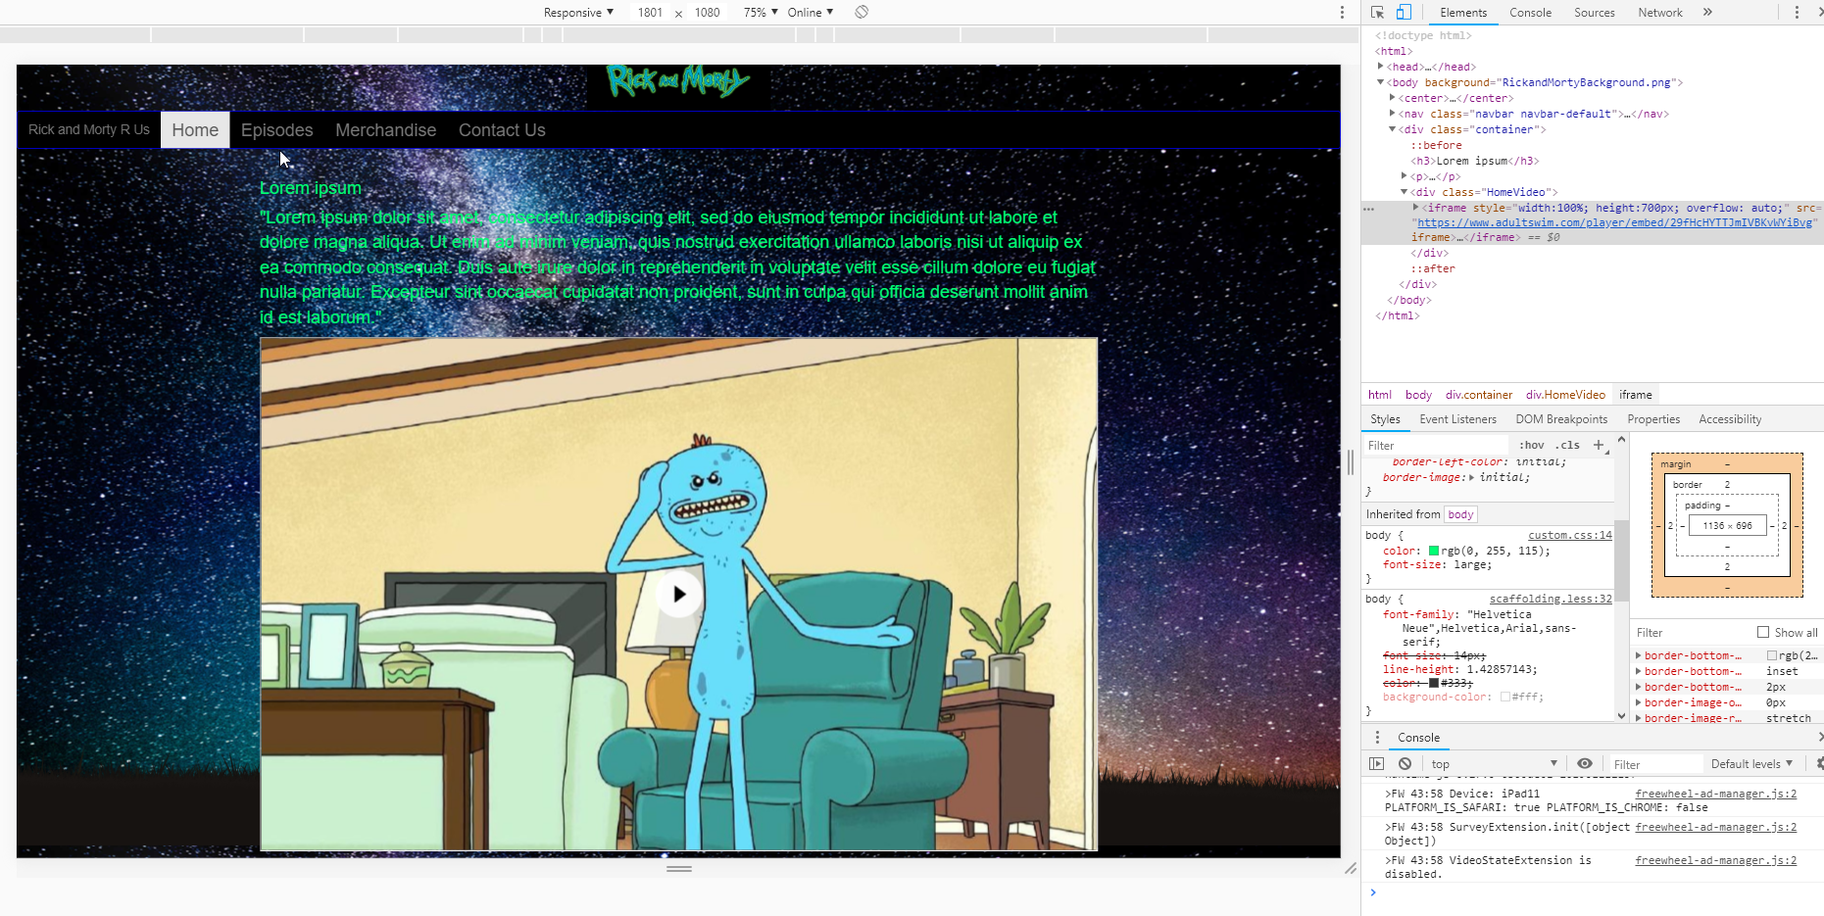

First CSS change was an easy one just changed text color to this RGB of green. I think this actually works better than red. I may still put a border and fill in color on the background of this so it doesn’t have to be green but it does make it much easier to read against the background. I also increased the font size and it makes it much easier to read as well. I will for sure be upping the size of the text and more than likely surrounding it in a box.

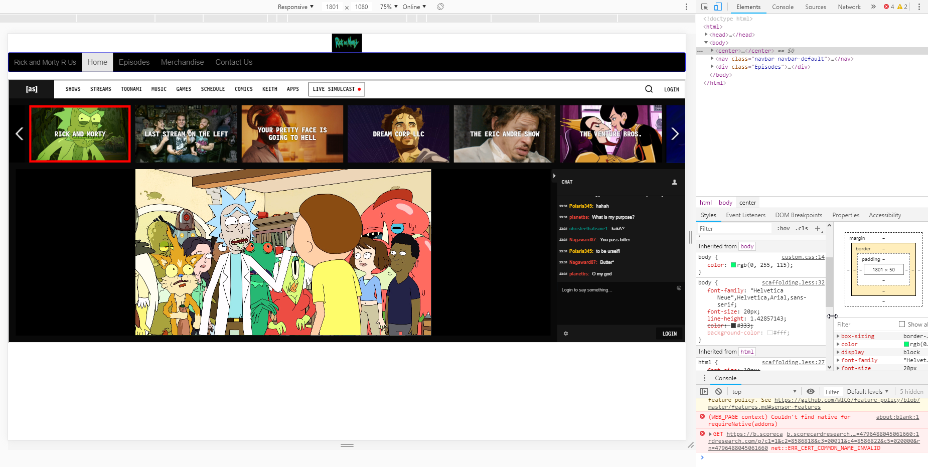

On my Episodes page upped the font size of the nav bar this looks much more aesthetically pleasing so am going to keep it this way.

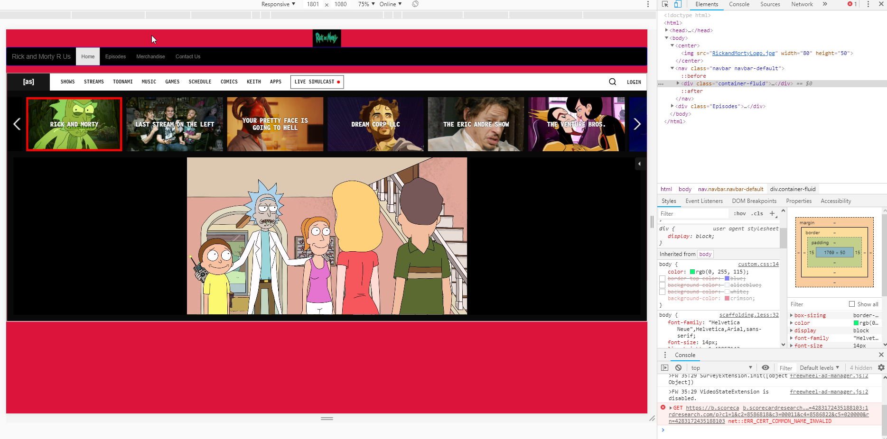

I tried changing the background color of the episodes page but this may be a little too bright of a color and it doesn’t really follow the theme of the main page. I may try to either use the same background or try another space background to keep the theme consistent.