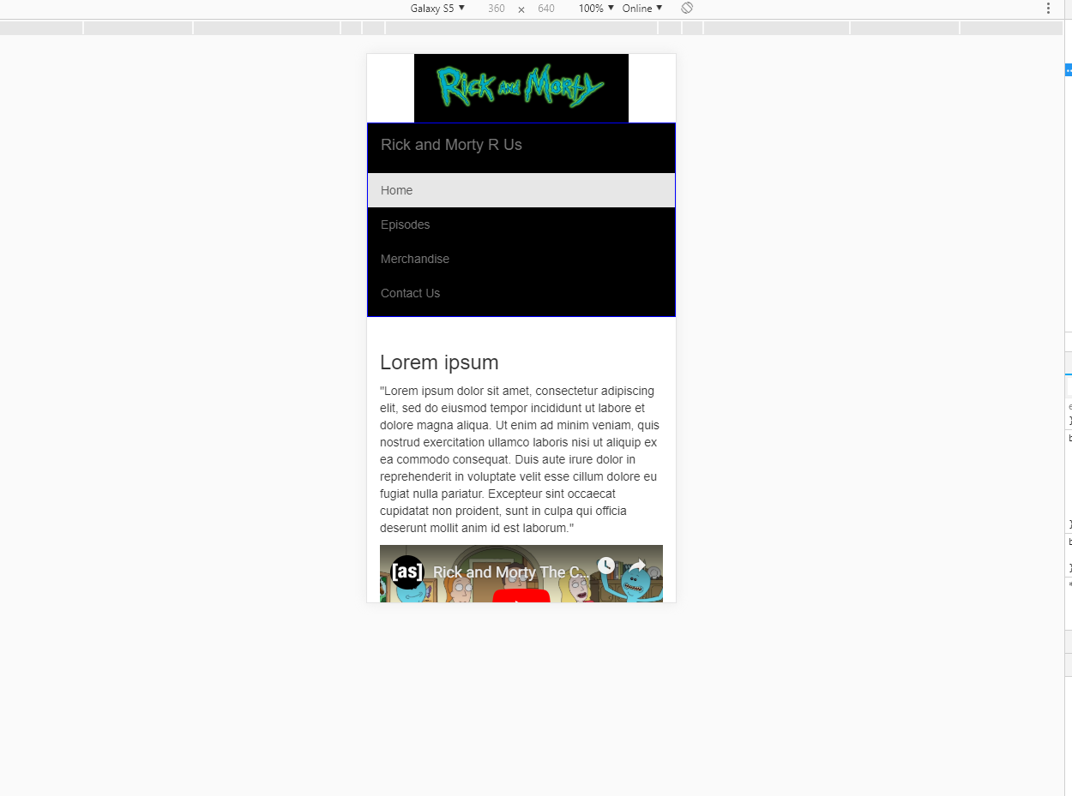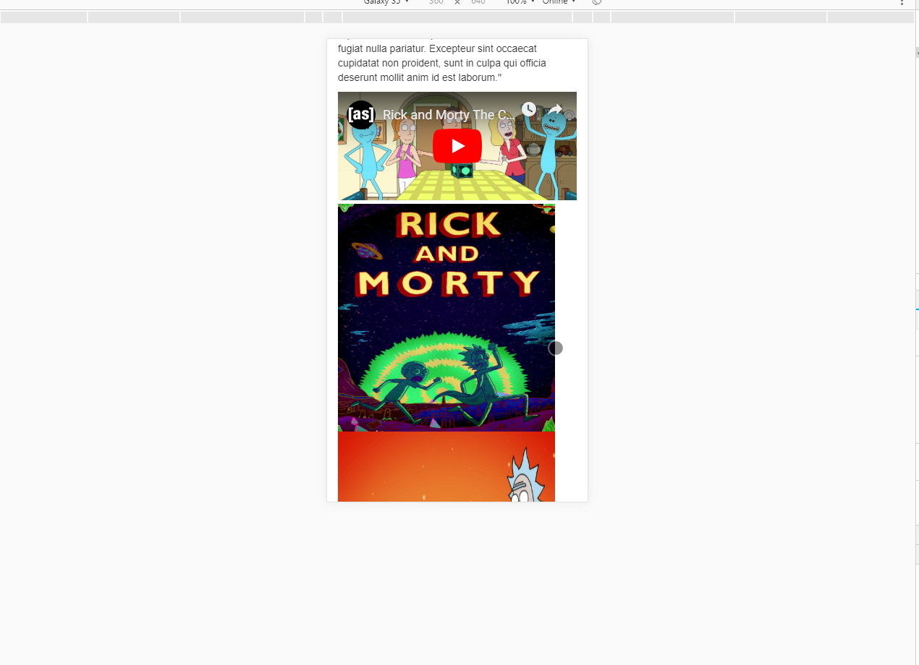

The first two are on a Galaxy S5 resolution is 360 x 640. I finally figured out the scaling issue for my YouTube video and will translate this onto my other pages as well as my one page will be all videos. The only thing I may try to change is how the pictures are scaling. I don’t like that they don’t fix the same size of the screen as the video.

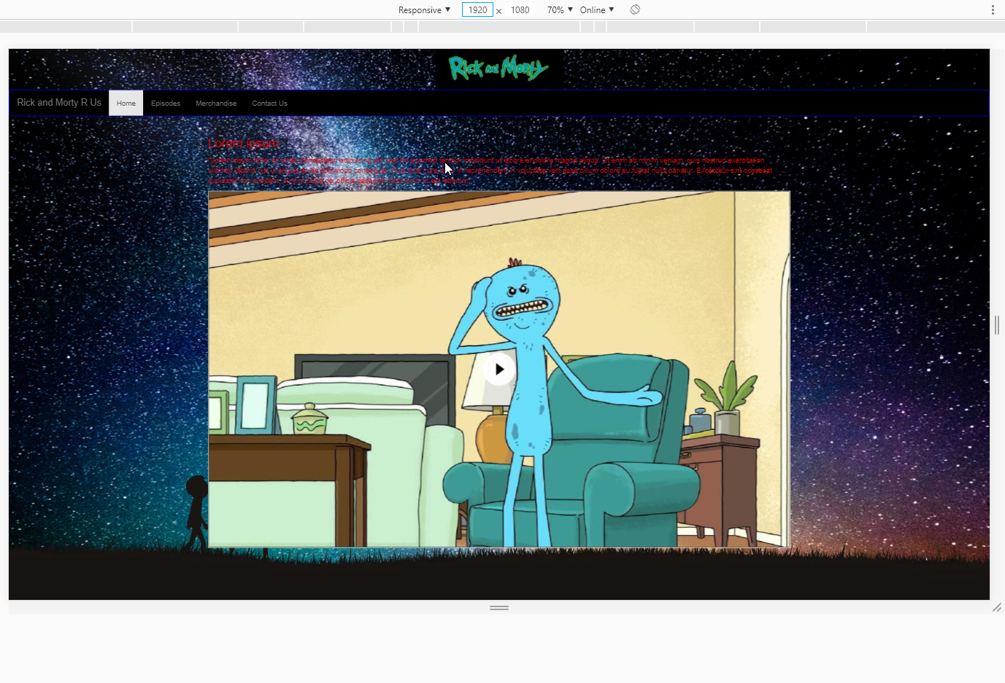This is a 1920 x 1080 same as most standard desktops nowadays. I am going to change the color of the navbar in my CSS as its too hard to read as it is now. I may also put the paragraph in a box with a solid background as its harder to read when its in the background its in. I may try to center the menu options as well. Not sure on that part but it will need to be cleaned up before turning in. I am still having an issue with my PHP and it seems to be my server install. I have tried changing some config files but to no avail. I have attached all code files. I also changed the font color to red after adding a background image as it was impossible to read before. I made these changes in dev tools in Opera my preferred browser of choice. This and research helped me figure out a way to remedy the video issue I was running into with it not scaling properly.

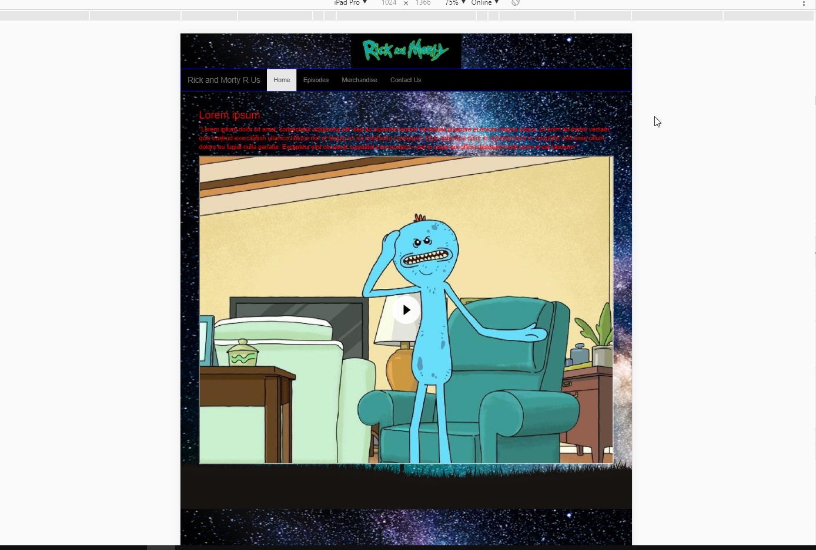

This is a iPad Pro resolution 1024 x 1366. The video looks good on all screen sizes now I still need to clean up color and also getting the website to look cleaner. I may need to scale the video down just a bit as well as I increased the starting height and it may need to be shrunk down just a little bit as the video is quite large at the moment.