**Practical No: 01**

Implement the Following:

## **A.Design a simple neural network model.**

Calculate the output of neural net where input X = 0.2, w = 0.3 and bias b 0.45.

*Given neural net:*

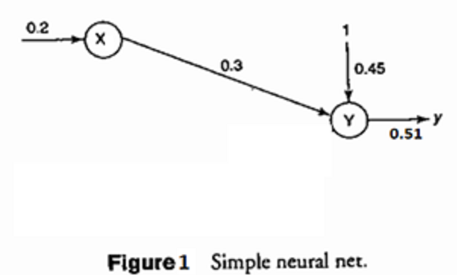

*Yin = wx + b = 0.3*0.2 + 0.45 = 0.51.*

*if (yin < 0), then output=y=0*

*else if (yin >1) then output=y=1*

*else output=y=yin*

**Code:**

inputs = float(input("Enter the input :"))

weights = float(input("Enter the weight :"))

bias = float(input("Enter bias :"))

yin = bias + (inputs * weights)

if yin < 0:

out = 0

elif yin > 1:

out= 1

else:

out = yin

print("Output is :",out)

**Output:**

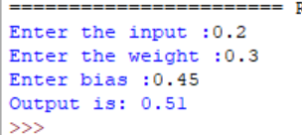

## **B.Calculate the output of neural net using both binary and bipolar sigmoidal function.**

**Code:**

import math

n = int(input("Enter no. of elements :"))

yin = 0

for i in range(0,n):

x=float(input("x= "))

w=float(input("w= "))

yin = yin + (x*w)

b = float(input("B= "))

yin = yin + b

print("Yin",yin)

binary_sigmoidal = (1/(1+(math.e**(-yin))))

print("Binary Sigmoidal= ",round(binary_sigmoidal,3))

bipolar_sigmoidal = (2/(1+(math.e**(-yin)))) - 1

print("Bipolar Sigmoidal= ",round(bipolar_sigmoidal,3))

**Output:**

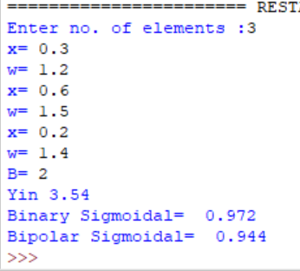

# 

# 

# 

# 

**Practical No: 02**

## **A:Generate AND/NOT function using McCulloch-Pitts neural net**.

**Code:**

import numpy as np

print("ANDNOT function using MP\n")

x1inputs = [1,1,0,0]

x2inputs = [1,0,1,0]

print("Considering all weights as excitatory");

w1 = [1,1,1,1]

w2 = [1,1,1,1]

yin = []

print("x1","x2","yin")

for i in range(0,4):

yin.append(x1inputs[i]*w1[i] + x2inputs[i]*w2[i])

print(x1inputs[i]," ",x2inputs[i]," ", yin[i])

print("Considering all weights as excitatory");

w1 = [1,1,1,1]

w2 = [-1,-1,-1,-1]

yin = []

print("x1","x2","yin")

for i in range(0,4):

yin.append(x1inputs[i]*w1[i] + x2inputs[i]*w2[i])

print(x1inputs[i]," ",x2inputs[i]," ", yin[i])

theta = 2*1-1

print("Threshold -Theta =",theta)

print("Applying Threshold ")

y = []

for i in range(0,4):

if(yin[i]>=theta):

value = 1

y.append(value)

else:

value = 0

y.append(value)

print("x1","x2","y")

for i in range(0,4):

print(x1inputs[i]," ",x2inputs[i]," ",y[i])

**Output:**  
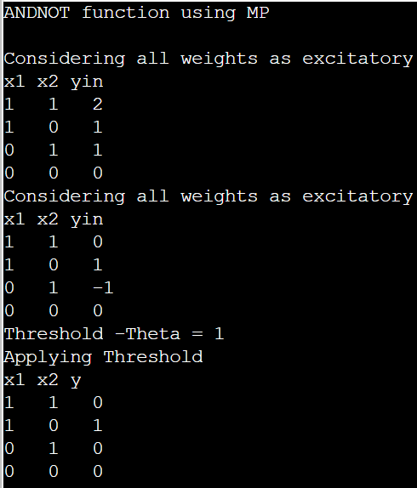

## **B:Generate XOR function using McCulloch-Pitts neural net.**

**Code:**

print("XOR function using McClloch-Pitts\n")

x1inputs = [1,1,0,0]

x2inputs = [1,0,1,0]

print("Calculating z1 = x1w11 + x2w12")

print("Considering one weight as exciatatory and other as inhibitory ")

w11 = [1,1,1,1]

w21 = [-1,-1,-1,-1]

print("x1","x2","z1")

z1 = []

for i in range(0,4):

z1.append(x1inputs[i]*w11[i] + x2inputs[i]*w21[i])

print(x1inputs[i]," ",x2inputs[i]," ",z1[i])

print("Calculating z1 = x1w21 + x2w22")

print("Considering one weight as exciatatory and other as inhibitory ")

w21 = [-1,-1,-1,-1]

w22 = [1,1,1,1]

print("x1","x2","z2")

z2 = []

for i in range(0,4):

z2.append(x1inputs[i]*w21[i] + x2inputs[i]*w22[i])

print(x1inputs[i]," ",x2inputs[i]," ",z2[i])

print("Applying Threshold = 1 for z1 and z2")

for i in range(0,4):

if(z1[i]>=1):

z1[i] = 1

else:

z1[i] = 0

if(z2[i]>=1):

z2[i]=1

else:

z2[i]=0

print("z1","z2")

for i in range(0,4):

print(z1[i]," ",z2[i]," ")

print("x1" , "x2" , "yin")

yin = []

v1 = 1

v2 = 1

for i in range(0,4):

yin.append(z1[i]*v1 + z2[i]*v2)

print(x1inputs[i]," ",x2inputs[i]," ",yin[i])

y=[]

for i in range(0,4):

if(yin[i]>=1):

y.append(1)

else:

y.append(0)

print("x1","x2","y")

for i in range(0,4):

print(x1inputs[i]," ",x2inputs[i]," ",y[i])

Output:

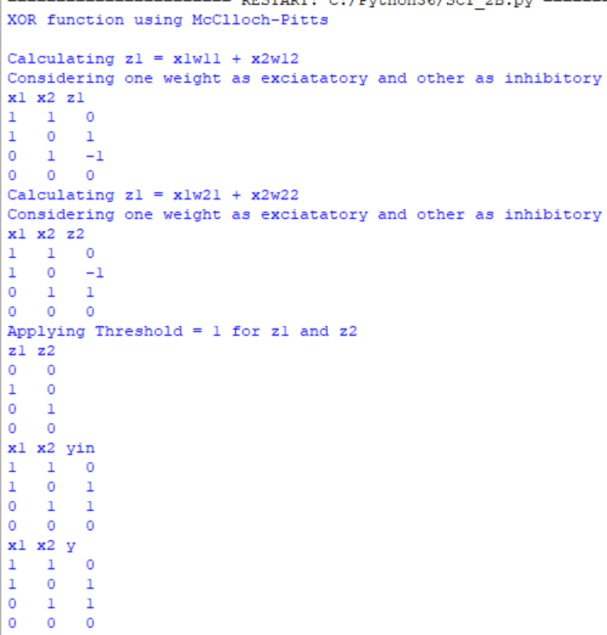

**Practical No: 03**

## **A:Write a program to implement Hebb’s rule.**

**Code:**

import numpy as np

x1 = np.array([1,-1,-1,1,-1,-1,1,1,1,1])

x2 = np.array([1,-1,1,1,-1,1,1,1,1,1])

y = np.array([1,-1])

b = 0

wtold = np.zeros((9,)).astype(int)

wtnew = np.zeros((9,)).astype(int)

print("--",wtold)

print("First input with target 1")

for i in range(0,9):

wtnew[i] = wtold[i] + x1[i]*y[0]

wtold = wtnew

b = b + y[0]

print("New Weights:",wtnew)

print("Bias Value:",b)

print("Second input with target -1")

for i in range(0,9):

wtnew[i] = wtold[i] + x2[i]*y[1]

b = b + y[1]

print("New Weights:",wtnew)

print("Bias Value:",b)

**Output:**

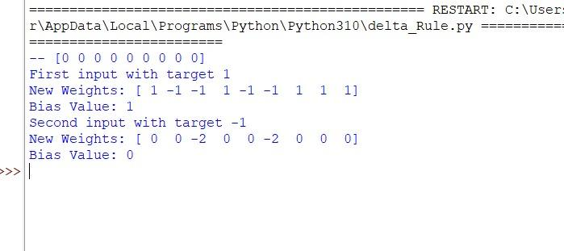

## **B:Write a program to implement delta rule.**

**Code:**

import numpy as np

import time

np.set_printoptions(precision = 2)

x = np.zeros((3,))

weights = np.zeros((3,))

desired = np.zeros((3,))

actual = np.zeros((3,))

for i in range(0,3):

x[i] = float(input("Initial Inputs:"))

for i in range(0,3):

weights[i] = float(input("Initial weights:"))

for i in range(0,3):

desired[i] = float(input("Initial Desired:"))

a = float(input("Enter learning rate:"))

print("Actual",actual)

print("Desired",desired)

while True:

if np.array_equal(desired,actual):

break

else:

for i in range(0,3):

weights[i] = weights[i] + a *(desired[i] - actual[i])

actual = x*weights

print("Weights:",weights)

Output:

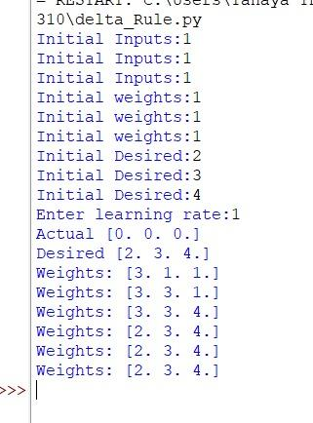

# 

# 

# 

# 

**Practical No: 04**

## **A:Write a program for BackPropagation Algorithm** .

**Code:**

import numpy as np

X=np.array(([2,9],[1,5],[3,6]),dtype=float)

Y=np.array(([92],[86],[89]),dtype=float)

#scale units

X=X/np.amax(X,axis=0)

Y=Y/100;

class NN(object):

def __init__(self):

self.inputsize=2

self.outputsize=1

self.hiddensize=3

self.W1=np.random.randn(self.inputsize,self.hiddensize)

self.W2=np.random.randn(self.hiddensize,self.outputsize)

def forward(self,X):

self.z=np.dot(X,self.W1)

self.z2=self.sigmoidal(self.z)

self.z3=np.dot(self.z2,self.W2)

op=self.sigmoidal(self.z3)

return op;

def sigmoidal(self,s):

return 1/(1+np.exp(-s))

obj=NN()

op=obj.forward(X)

print("actual output\n"+str(op))

print("expected output\n"+str(Y))

**Output:**

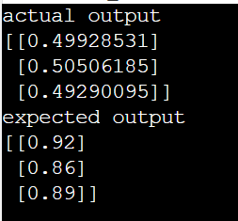

## **B:Write a program for Error BackPropagation Algorithm .**

**Code:**

import numpy as np

X=np.array(([2,9],[1,5],[3,6]),dtype=float)

Y=np.array(([92],[86],[89]),dtype=float)

X=X/np.amax(X,axis=0)

Y=Y/100;

class NN(object):

def __init__(self):

self.inputsize=2

self.outputsize=1

self.hiddensize=3

self.W1=np.random.randn(self.inputsize,self.hiddensize)

self.W2=np.random.randn(self.hiddensize,self.outputsize)

def forward(self,X):

self.z=np.dot(X,self.W1)

self.z2=self.sigmoidal(self.z)

self.z3=np.dot(self.z2,self.W2)

op=self.sigmoidal(self.z3)

return op;

def sigmoidal(self,s):

return 1/(1+np.exp(-s))

def sigmoidalprime(self,s):

return s* (1-s)

def backward(self,X,Y,o):

self.o_error=Y-o

self.o_delta=self.o_error * self.sigmoidalprime(o)

self.z2_error=self.o_delta.dot(self.W2.T)

self.z2_delta=self.z2_error * self.sigmoidalprime(self.z2)

self.W1 = self.W1 + X.T.dot(self.z2_delta)

self.W2= self.W2+ self.z2.T.dot(self.o_delta)

def train(self,X,Y):

o=self.forward(X)

self.backward(X,Y,o)

obj=NN()

for i in range(2000):

print("input"+str(X))

print("Actual output"+str(Y))

print("Predicted output"+str(obj.forward(X)))

print("loss"+str(np.mean(np.square(Y-obj.forward(X)))))

obj.train(X,Y)

**Output:**

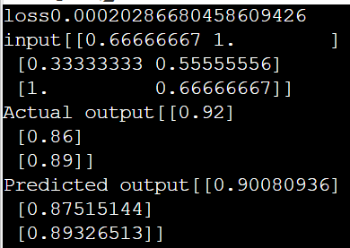

# 

# 

# 

# 

# 

# **Practical No: 05**

## **A:Write a program for Hopfield Network .**

**Code:**

import numpy as np

def compute_next_state(state,weight):

next_state = np.where(weight @ state>= 0, +1, -1)

return next_state

def compute_final_state(initial_state,weight,max_iter=1000):

previous_state = initial_state

next_state =compute_next_state(previous_state,weight)

is_stable = np.all(previous_state == next_state)

n_iter = 0

while(not is_stable) and (n_iter <= max_iter):

previous_state = next_state;

next_state = compute_next_state(previous_state,weight)

is_stable = np.all(previous_state==next_state)

n_iter +=1

return previous_state, is_stable,n_iter

initial_state = np.array([+1,-1,-1,-1])

weight = np.array([

[0, -1, -1, +1],

[-1, 0, +1, -1],

[-1,+1, 0, -1],

[+1,-1, -1, 0]])

final_state, is_stable, n_iter = compute_final_state(initial_state,weight)

print("Final state",final_state)

print("is_Stable",is_stable)

**Output:**

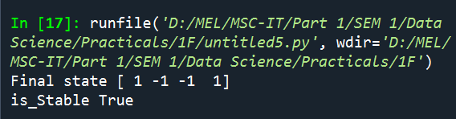

## **B:Write a program for Radial Basis function .**

**Code:** R Compiler

D <- matrix(c(-3,1,4), ncol=1)

N <- length(D)

rbf.gauss <- function(gamma=1.0) {

function(x){

exp(-gamma * norm(as.matrix(x),"F")^2)

}

}

xlim <- c(-5,7)

print(N)

print(xlim)

plot(NULL,xlim=xlim,ylim=c(0,1.25), type = "n")

points(D,rep(0,length(D)), col= 1:N,pch=19)

x.coord = seq(-7,7,length=250)

gamma <- 1.5

for (i in 1:N){

points(x.coord, lapply(x.coord - D[i,],rbf.gauss(gamma)),type="l",col=i)

}

**Output:**

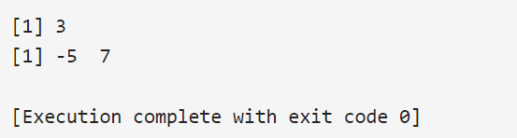

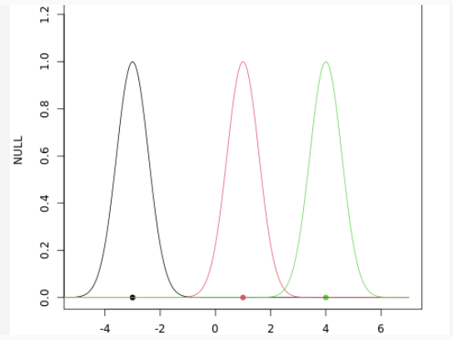

# **Practical No: 06**

## **A:Kohonen Self organizing map .**

**Code:**

!pip install minisom

import minisom

from minisom import MiniSom

import matplotlib.pyplot as plt

data = [[ 0.80, 0.55, 0.22, 0.03],

[ 0.82, 0.50, 0.23, 0.03],

[ 0.80, 0.54, 0.22, 0.03],

[ 0.80, 0.53, 0.26, 0.03],

[ 0.79, 0.56, 0.22, 0.03],

[ 0.75, 0.60, 0.25, 0.03],

[ 0.77, 0.59, 0.22, 0.03]]

som = MiniSom(6, 6, 4, sigma=0.3, learning_rate=0.5) # initialization of 6x6 SOM

som.train_random(data, 100) # trains the SOM with 100 iterations

plt.imshow(som.distance_map())

**Output:**

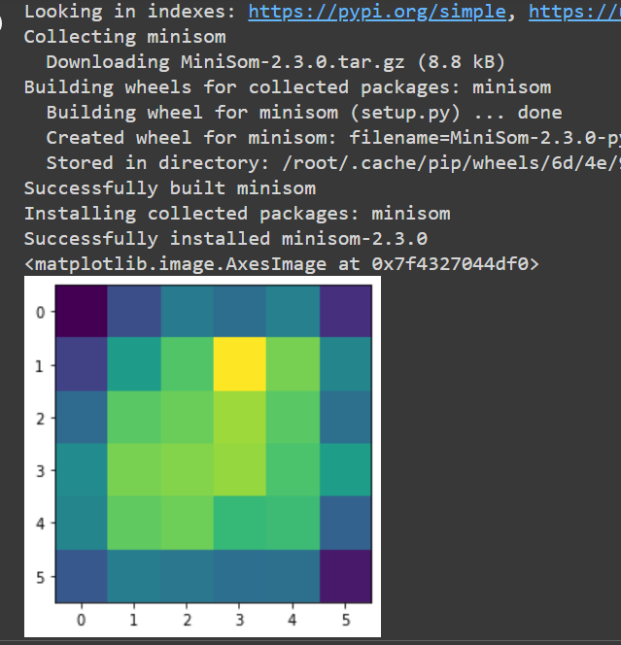

## **B:Adaptive Resonanace Theory .**

**Code:**

from __future__ import print_function

from __future__ import division

import numpy as np

class ART:

def __init__(self, n=5, m=10, rho=.5):

self.F1 = np.ones(n)

self.F2 = np.ones(m)

self.Wf = np.random.random((m,n))

self.Wb = np.random.random((n,m))

self.rho = rho

self.active = 0

def learn(self, X):

self.F2[...] = np.dot(self.Wf, X)

I = np.argsort(self.F2[:self.active].ravel())[::-1]

for i in I:

d = (self.Wb[:,i]*X).sum()/X.sum()

if d >= self.rho:

self.Wb[:,i] *= X

self.Wf[i,:] = self.Wb[:,i]/(0.5+self.Wb[:,i].sum())

return self.Wb[:,i], i

if self.active < self.F2.size:

i = self.active

self.Wb[:,i] *= X

self.Wf[i,:] = self.Wb[:,i]/(0.5+self.Wb[:,i].sum())

self.active += 1

return self.Wb[:,i], i

return None,None

if __name__ == '__main__':

np.random.seed(1)

network = ART( 5, 10, rho=0.5)

data = [" O ",

" O O",

" O",

" O O",

" O",

" O O",

" O",

" OO O",

" OO ",

" OO O",

" OO ",

"OOO ",

"OO ",

"O ",

"OO ",

"OOO ",

"OOOO ",

"OOOOO",

"O ",

" O ",

" O ",

" O ",

" O",

" O O",

" OO O",

" OO ",

"OOO ",

"OO ",

"OOOO ",

"OOOOO"]

X = np.zeros(len(data[0]))

for i in range(len(data)):

for j in range(len(data[i])):

X[j] = (data[i][j] == 'O')

Z, k = network.learn(X)

print("|%s|"%data[i],"-> class", k)

**Output:**

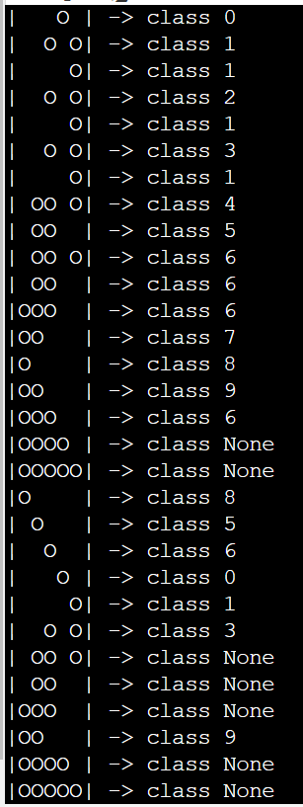

# **Practical No: 07**

## **A:Write a program for Linear Separation .**

**Code:**

import numpy as np

import matplotlib.pyplot as plt

def create_distance_function(a, b, c):

""" 0 = ax + by + c """

def distance(x, y):

""" returns tuple (d, pos)

d is the distance

If pos == -1 point is below the line,

0 on the line and +1 if above the line

"""

nom = a * x + b * y + c

if nom == 0:

pos = 0

elif (nom<0 and b<0) or (nom>0 and b>0):

pos = -1

else:

pos = 1

return (np.absolute(nom) / np.sqrt( a ** 2 + b ** 2), pos)

return distance

points = [ (3.5, 1.8), (1.1, 3.9) ]

fig, ax = plt.subplots()

ax.set_xlabel("Sweet")

ax.set_ylabel("Sour")

ax.set_xlim([-1, 6])

ax.set_ylim([-1, 8])

X = np.arange(-0.5, 5, 0.1)

colors = ["r", ""] # for the samples

size = 10

for (index, (x, y)) in enumerate(points):

if index== 0:

ax.plot(x, y, "o",

color="darkorange",

markersize=size)

else:

ax.plot(x, y, "oy",

markersize=size)

step = 0.05

for x in np.arange(0, 1+step, step):

slope = np.tan(np.arccos(x))

dist4line1 = create_distance_function(slope, -1, 0)

#print("x: ", x, "slope: ", slope)

Y = slope * X

results = []

for point in points:

results.append(dist4line1(*point))

#print(slope, results)

if (results[0][1] != results[1][1]):

ax.plot(X, Y, "g-")

else:

ax.plot(X, Y, "r-")

plt.show()

print('53004220035')

**Output:**

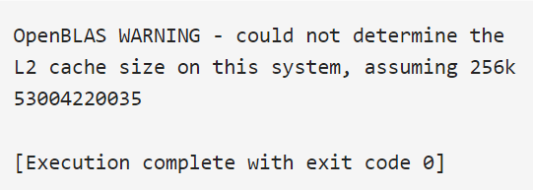

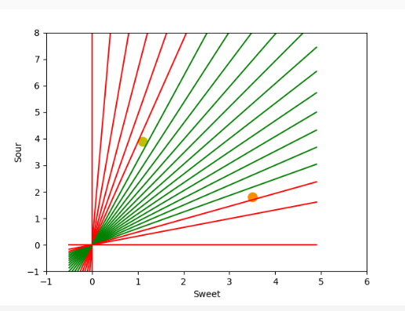

## **B:Write a program for Hopfield Network model for associative memory .**

**Code:**

!pip install neurodynex

from neurodynex.hopfield_network import network, pattern_tools, plot_tools

import matplotlib.pyplot as plt

pattern_size = 5

# create an instance of the class HopfieldNetwork

hopfield_net = network.HopfieldNetwork(nr_neurons= pattern_size**2)

# instantiate a pattern factory

factory = pattern_tools.PatternFactory(pattern_size, pattern_size)

# create a checkerboard pattern and add it to the pattern list

checkerboard = factory.create_checkerboard()

pattern_list = [checkerboard]

# add random patterns to the list

pattern_list.extend(factory.create_random_pattern_list(nr_patterns=3, on_probability=0.5))

plot_tools.plot_pattern_list(pattern_list)

# how similar are the random patterns and the checkerboard? Check the overlaps

overlap_matrix = pattern_tools.compute_overlap_matrix(pattern_list)

plot_tools.plot_overlap_matrix(overlap_matrix)

# let the hopfield network "learn" the patterns. Note: they are not stored

# explicitly but only network weights are updated !

hopfield_net.store_patterns(pattern_list)

# create a noisy version of a pattern and use that to initialize the network

noisy_init_state = pattern_tools.flip_n(checkerboard, nr_of_flips=4)

hopfield_net.set_state_from_pattern(noisy_init_state)

# from this initial state, let the network dynamics evolve.

states = hopfield_net.run_with_monitoring(nr_steps=4)

# each network state is a vector. reshape it to the same shape used to create the patterns.

states_as_patterns = factory.reshape_patterns(states)

# plot the states of the network

plot_tools.plot_state_sequence_and_overlap(states_as_patterns, pattern_list,

reference_idx=0, suptitle="Network dynamics")

**Output:**

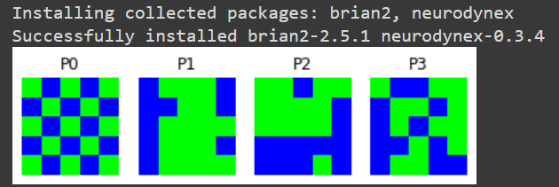

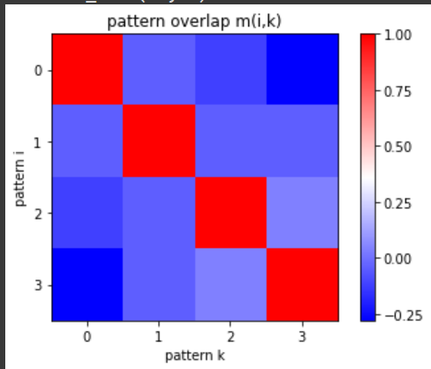

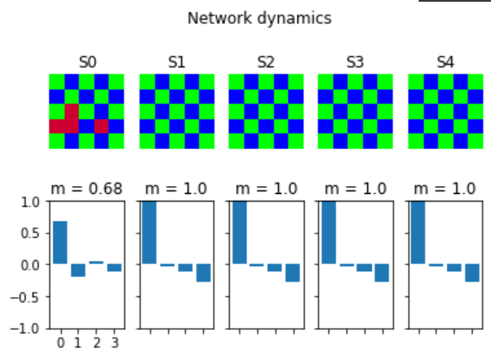

**Practical No: 08**

## **A:Membership and Identity Operators | in, not in** .

**Code:**

**1- In Operator**

list1=[]

print("Enter 5 numbers")

for i in range(0,5):

v=int(input())

list1.append(v)

list2=[]

print("Enter 5 numbers")

for i in range(0,5):

v=int(input())

list2.append(v)

flag=0

for i in list1:

if i in list2:

flag=1

if(flag==1):

print("The Lists Overlap")

else:

print("The Lists do Not overlap")

**Output:**

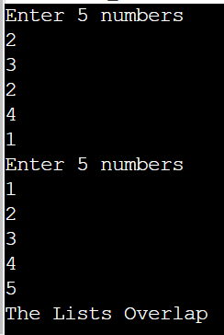 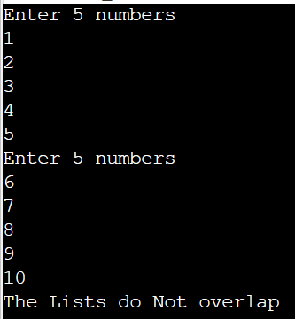

**2- not In Operator**

# Aim: Not in operator in python

list1=[]

c=int(input("Enter the number of elements that you want to insert in List 1:"))

for i in range(0,c):

ele = int(input("Enter the element :"))

list1.append(ele)

a = int(input("enter the number that you want to find in List 1:"))

if a not in list1:

print( "The list does not contain ", a )

else:

print( "The list contains", a )

**Output:**

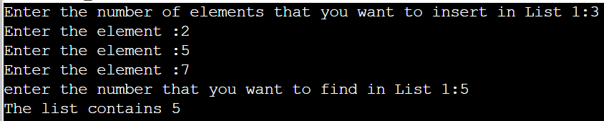

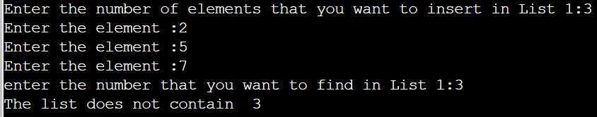

## **B:Membership and Identity Operators | is, is not**.

**Code:**

**1: Implement Membership and Identity Operators is.**

details =[]

name=input("Enter your name : ")

details.append(name)

age=float(input("Enter your exact age : "))

details.append(age)

roll_no=int(input("Enter your roll no : "))

details.append(roll_no)

for i in details:

print(i)

print("Int = ",type(i) is int)

print("Float = ",type(i) is float)

print("String = ",type(i) is str)

print()

**Output:**

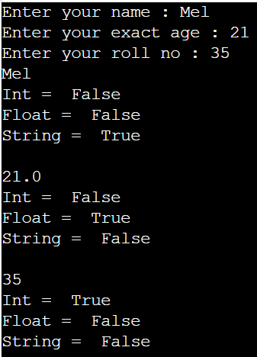

**2: Implement Membership and Identity Operators is not.**

details =[]

name=input("Enter your name : ")

details.append(name)

age=float(input("Enter your exact age : "))

details.append(age)

roll_no=int(input("Enter your roll no : "))

details.append(roll_no)

print()

for i in details:

print(i)

print("Not Int = ",type(i) is not int)

print("Not Float = ",type(i) is not float)

print("Not String = ",type(i) is not str)

print()

**Output:**

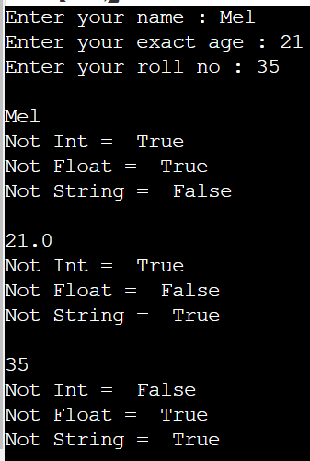

**Practical No: 09**

## **A:Find ratios using Fuzzy logic** .

**Code:**

!pip install fuzzywuzzy

from fuzzywuzzy import fuzz

from fuzzywuzzy import process

s1 = "I love fuzzysforfuzzys"

s2 = "I am loving fuzzysforfuzzys"

print ("FuzzyWuzzy Ratio:", fuzz.ratio(s1, s2))

print ("FuzzyWuzzy PartialRatio: ", fuzz.partial_ratio(s1, s2))

print ("FuzzyWuzzy TokenSortRatio: ", fuzz.token_sort_ratio(s1, s2))

print ("FuzzyWuzzy TokenSetRatio: ", fuzz.token_set_ratio(s1, s2))

print ("FuzzyWuzzy WRatio: ", fuzz.WRatio(s1, s2),'\n\n')

# for process library,

query = 'fuzzys for fuzzys'

choices = ['fuzzy for fuzzy', 'fuzzy fuzzy', 'g. for fuzzys']

print ("List of ratios: ")

print (process.extract(query, choices), '\n')

print ("Best among the above list: ",process.extractOne(query, choices))

**Output:**

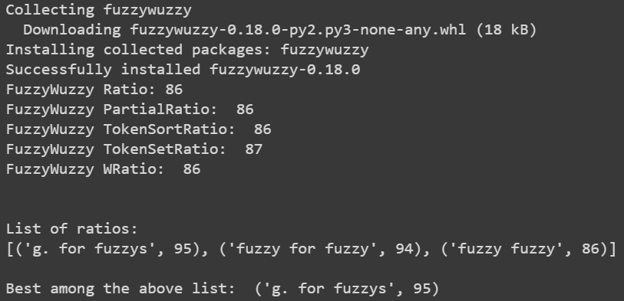

## **B:Solve Tipping problem using Fuzzy logic**.

**Code:**

!pip install fuzzywuzzy

!pip install -U scikit-fuzzy

import skfuzzy as fuzz

from skfuzzy import control as ctrl

import numpy as np

quality = ctrl.Antecedent(np.arange(0, 11, 1), 'quality')

service = ctrl.Antecedent(np.arange(0, 11, 1), 'service')

tip = ctrl.Consequent(np.arange(0, 26, 1), 'tip')

quality.automf(3)

service.automf(3)

tip['low'] = fuzz.trimf(tip.universe, [0, 0, 13])

tip['medium'] = fuzz.trimf(tip.universe, [0, 13, 25])

tip['high'] = fuzz.trimf(tip.universe, [13, 25, 25])

quality['average'].view()

service.view()

tip.view()

rule1 = ctrl.Rule(quality['poor'] | service['poor'], tip['low'])

rule2 = ctrl.Rule(service['average'], tip['medium'])

rule3 = ctrl.Rule(service['good'] | quality['good'], tip['high'])

rule1.view()

tipping_ctrl = ctrl.ControlSystem([rule1, rule2, rule3])

tipping = ctrl.ControlSystemSimulation(tipping_ctrl)

tipping.input['quality'] = 6.5

tipping.input['service'] = 9.8

tipping.compute()

print (tipping.output['tip'])

tip.view(sim=tipping)

**Output:**

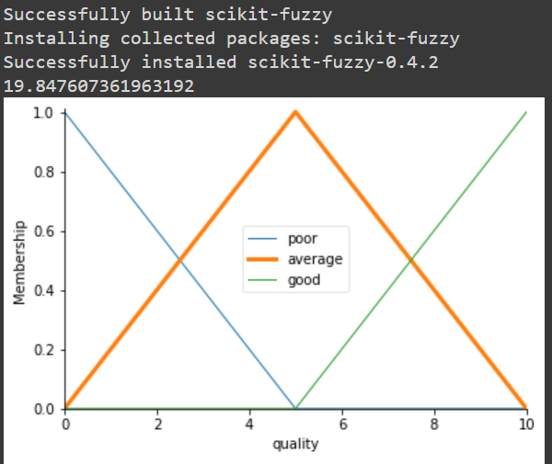 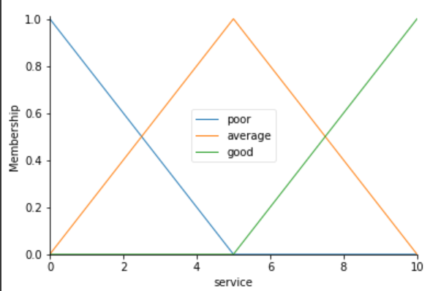

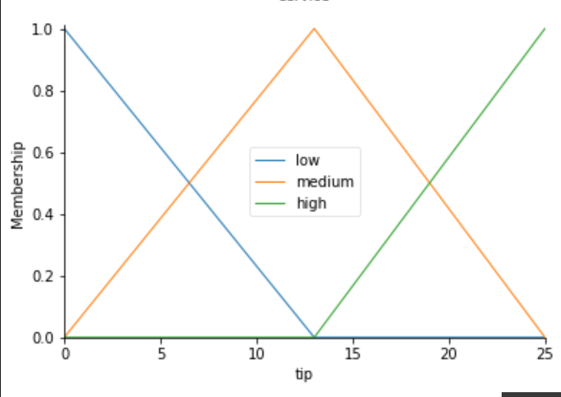 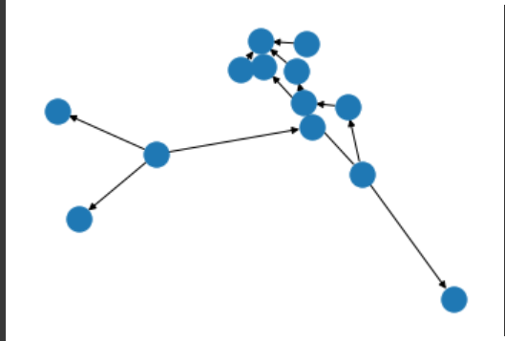

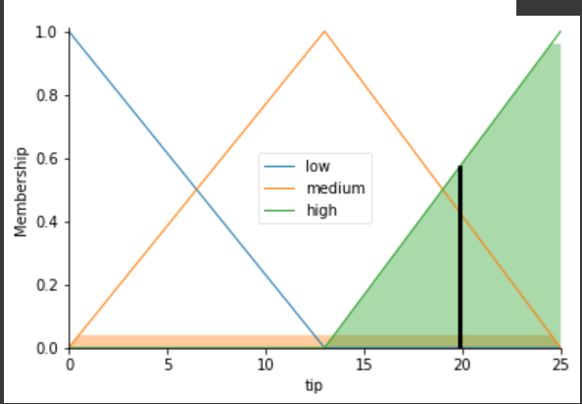

# 

# **Practical No: 10**

# **A:Implementation of Simple Genetic Algorithm .**

**Code:**

import random

# Number of individuals in each generation

POPULATION_SIZE = 100

# Valid genes

GENES = '''abcdefghijklmnopqrstuvwxyzABCDEFGHIJKLMNOP

QRSTUVWXYZ 1234567890, .-;:_!"#%&/()=?@${[]}'''

# Target string to be generated

TARGET = "UPG College Student "

class Individual(object):

'''

Class representing individual in population

'''

def __init__(self, chromosome):

self.chromosome = chromosome

self.fitness = self.cal_fitness()

@classmethod

def mutated_genes(self):

'''

create random genes for mutation

'''

global GENES

gene = random.choice(GENES)

return gene

@classmethod

def create_gnome(self):

'''

create chromosome or string of genes

'''

global TARGET

gnome_len = len(TARGET)

return [self.mutated_genes() for _ in range(gnome_len)]

def mate(self, par2):

'''

Perform mating and produce new offspring

'''

# chromosome for offspring

child_chromosome = []

for gp1, gp2 in zip(self.chromosome, par2.chromosome):

# random probability

prob = random.random()

# if prob is less than 0.45, insert gene

# from parent 1

if prob < 0.45:

child_chromosome.append(gp1)

# if prob is between 0.45 and 0.90, insert

# gene from parent 2

elif prob < 0.90:

child_chromosome.append(gp2)

# otherwise insert random gene(mutate),

# for maintaining diversity

else:

child_chromosome.append(self.mutated_genes())

# create new Individual(offspring) using

# generated chromosome for offspring

return Individual(child_chromosome)

def cal_fitness(self):

'''

Calculate fittness score, it is the number of

characters in string which differ from target

string.

'''

global TARGET

fitness = 0

for gs, gt in zip(self.chromosome, TARGET):

if gs != gt: fitness+= 1

return fitness

# Driver code

def main():

global POPULATION_SIZE

#current generation

generation = 1

found = False

population = []

# create initial population

for _ in range(POPULATION_SIZE):

gnome = Individual.create_gnome()

population.append(Individual(gnome))

while not found:

# sort the population in increasing order of fitness score

population = sorted(population, key = lambda x:x.fitness)

# if the individual having lowest fitness score ie.

# 0 then we know that we have reached to the target

# and break the loop

if population[0].fitness <= 0:

found = True

break

# Otherwise generate new offsprings for new generation

new_generation = []

# Perform Elitism, that mean 10% of fittest population

# goes to the next generation

s = int((10*POPULATION_SIZE)/100)

new_generation.extend(population[:s])

# From 50% of fittest population, Individuals

# will mate to produce offspring

s = int((90*POPULATION_SIZE)/100)

for _ in range(s):

parent1 = random.choice(population[:50])

parent2 = random.choice(population[:50])

child = parent1.mate(parent2)

new_generation.append(child)

population = new_generation

print("Generation: {}\tString: {}\tFitness: {}".\

format(generation,

"".join(population[0].chromosome),

population[0].fitness))

generation += 1

print("Generation: {}\tString: {}\tFitness: {}".\

format(generation,

"".join(population[0].chromosome),

population[0].fitness))

if __name__ == '__main__':

main()

**Output:**

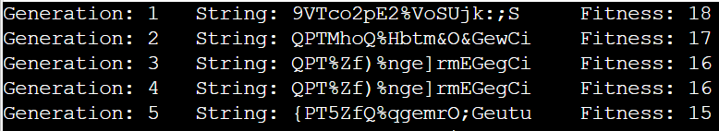

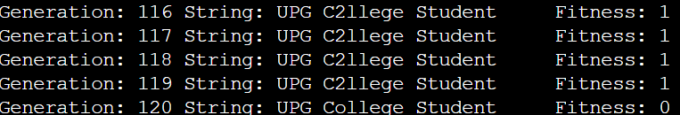

## **B:Create two classes: City and Fitness using Genetic Algorithm .**

**Code:**

import numpy as np, random, operator, pandas as pd, matplotlib.pyplot as plt

from tkinter import Tk, Canvas, Frame, BOTH, Text

import math

class City:

def __init__(self, x, y):

self.x = x

self.y = y

def distance(self, city):

xDis = abs(self.x - city.x)

yDis = abs(self.y - city.y)

distance = np.sqrt((xDis ** 2) + (yDis ** 2))

return distance

def __repr__(self):

return "(" + str(self.x) + "," + str(self.y) + ")"

class Fitness:

def __init__(self, route):

self.route = route

self.distance = 0

self.fitness= 0.0

def routeDistance(self):

if self.distance ==0:

pathDistance = 0

for i in range(0, len(self.route)):

fromCity = self.route[i]

toCity = None

if i + 1 < len(self.route):

toCity = self.route[i + 1]

else:

toCity = self.route[0]

pathDistance += fromCity.distance(toCity)

self.distance = pathDistance

return self.distance

def routeFitness(self):

if self.fitness == 0:

self.fitness = 1 / float(self.routeDistance())

return self.fitness

def createRoute(cityList):

route = random.sample(cityList, len(cityList))

return route

def initialPopulation(popSize, cityList):

population = []

for i in range(0, popSize):

population.append(createRoute(cityList))

return population

def rankRoutes(population):

fitnessResults = {}

for i in range(0,len(population)):

fitnessResults[i] = Fitness(population[i]).routeFitness()

return sorted(fitnessResults.items(), key = operator.itemgetter(1), reverse = True)

def selection(popRanked, eliteSize):

selectionResults = []

df = pd.DataFrame(np.array(popRanked), columns=["Index","Fitness"])

df['cum_sum'] = df.Fitness.cumsum()

df['cum_perc'] = 100*df.cum_sum/df.Fitness.sum()

for i in range(0, eliteSize):

selectionResults.append(popRanked[i][0])

for i in range(0, len(popRanked) - eliteSize):

pick = 100*random.random()

for i in range(0, len(popRanked)):

if pick <= df.iat[i,3]:

selectionResults.append(popRanked[i][0])

break

return selectionResults

def matingPool(population, selectionResults):

matingpool = []

for i in range(0, len(selectionResults)):

index = selectionResults[i]

matingpool.append(population[index])

return matingpool

def breed(parent1, parent2):

child = []

childP1 = []

childP2 = []

geneA = int(random.random() * len(parent1))

geneB = int(random.random() * len(parent1))

startGene = min(geneA, geneB)

endGene = max(geneA, geneB)

for i in range(startGene, endGene):

childP1.append(parent1[i])

childP2 = [item for item in parent2 if item not in childP1]

child = childP1 + childP2

return child

def breedPopulation(matingpool, eliteSize):

children = []

length = len(matingpool) - eliteSize

pool = random.sample(matingpool, len(matingpool))

for i in range(0,eliteSize):

children.append(matingpool[i])

for i in range(0, length):

child = breed(pool[i], pool[len(matingpool)-i-1])

children.append(child)

return children

def mutate(individual, mutationRate):

for swapped in range(len(individual)):

if(random.random() < mutationRate):

swapWith = int(random.random() * len(individual))

city1 = individual[swapped]

city2 = individual[swapWith]

individual[swapped] = city2

individual[swapWith] = city1

return individual

def mutatePopulation(population, mutationRate):

mutatedPop = []

for ind in range(0, len(population)):

mutatedInd = mutate(population[ind], mutationRate)

mutatedPop.append(mutatedInd)

return mutatedPop

def nextGeneration(currentGen, eliteSize, mutationRate):

popRanked = rankRoutes(currentGen)

selectionResults = selection(popRanked, eliteSize)

matingpool = matingPool(currentGen, selectionResults)

children = breedPopulation(matingpool, eliteSize)

nextGeneration = mutatePopulation(children, mutationRate)

return nextGeneration

def geneticAlgorithm(population, popSize, eliteSize, mutationRate, generations):

pop = initialPopulation(popSize, population)

print("Initial distance: " + str(1 / rankRoutes(pop)[0][1]))

for i in range(0, generations):

pop = nextGeneration(pop, eliteSize, mutationRate)

print("Final distance: " + str(1 / rankRoutes(pop)[0][1]))

bestRouteIndex = rankRoutes(pop)[0][0]

bestRoute = pop[bestRouteIndex]

return bestRoute

def geneticAlgorithmPlot(population, popSize, eliteSize, mutationRate, generations):

pop = initialPopulation(popSize, population)

progress = []

progress.append(1 / rankRoutes(pop)[0][1])

for i in range(0, generations):

pop = nextGeneration(pop, eliteSize, mutationRate)

progress.append(1 / rankRoutes(pop)[0][1])

plt.plot(progress)

plt.ylabel('Distance')

plt.xlabel('Generation')

plt.show()

def main():

cityList = []

for i in range(0,25):

cityList.append(City(x=int(random.random() * 200), y=int(random.random() * 200)))

geneticAlgorithmPlot(population=cityList, popSize=100, eliteSize=20, mutationRate=0.01, generations=500)

main()

**Output:**

