<html>
<head>
<link rel="stylesheet" href="estilo.css">
<script language="javascript">
function vd()
{ if((document.fo.nom.value=="")||(document.fo.apep.value=="")||(document.fo.apem.value=="")||(document.fo.ci.value==""))
{
alert("llenar todos los espacios");
}
else if(isNaN(document.fo.ci.value))
{
alert("solo numeros en campo ci");
}
else
document.fo.submit();
}
</script>
</head>
<body>
<form id="fo"action="insertar1.php" method="POST" name="fo">
<table>
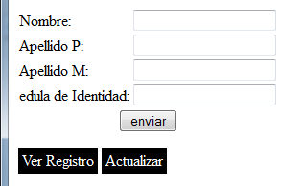
<tr>
<td>Nombre:</td>
<td><input type="text" name="nom" ></td>

</tr>
<tr> <td>Apellido P:</td>
<td><input type="text" name="apep"></td>

</tr>
<tr>
<td>Apellido M:</td>
<td><input type="text" name="apem"></td>

</tr>
<tr>
<td>edula de Identidad:</td>
<td><input type="text" name="ci"></td>
</tr>
<tr><td colspan="2" align="center"><input name="Submit" type="button" value="enviar" onClick="vd()"></td></tr>
</table>
</form>
<table cellpadding="0" cellspacing="0">
<tr>
<td ><a href="select.php" class="botonmenu"> Ver Registro</a></td>
<td ><a href="update.php" class="botonmenu">Actualizar</a></td>
</tr>
</table>
</body>
</html>

Coneccion php
<?php
function conectar()
{
if(!($cn=mysql_connect("localhost","root","")))
{ echo'error';
exit();
}
if(!mysql_select_db("prueba"))
{ echo'error';
exit();
}

return $cn;

}

?>
Insertar

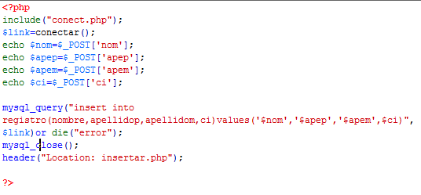

Sleccionar
<html>
<head>
<link rel="stylesheet" href="estilo.css">
</head>
<body>
<?php
include("conect.php");
$cn=conectar();
$sql=("select * from registro");
$sql1=mysql_query($sql,$cn);
echo'<table align="center">
</tr ><td bgcolor="#FF9">ci</td><td bgcolor="#FF9">Nombre</td><td bgcolor="#FF9">Apellidop</td><td bgcolor="#FF9">Apellidom</td>';
while($f=mysql_fetch_array($sql1))
{
echo'
<tr>
<td>'.$f['ci'].'</td>
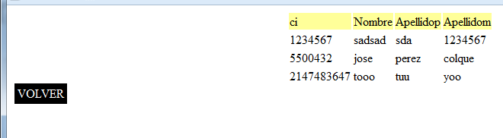
<td>'.$f['nombre'].'</td>
<td>'.$f['apellidop'].'</td>
<td>'.$f['apellidom'].'</td>

</tr>';
}
echo'</table>';
echo'<table">';
echo'<tr>';
echo'<td>';
echo'<a href="insertar.php" class="botonmenu">VOLVER</a>';
echo'<td>';
echo'</tr>';
echo'</table>'
?>
</body>
</html>
actualizar
<?php
include ("conect.php");
$cn=conectar();
echo'<form action="update.php" method="post">';
echo'<input type="text" name="bus">';
echo'<input type="submit" name="buscar">';
echo'</form>';
$sql=("select * from registro");
$sql1=mysql_query($sql,$cn);

echo'<table>
</tr ><td bgcolor="#FF9">ci</td><td bgcolor="#FF9">Nombre</td><td bgcolor="#FF9">Apellidop</td><td bgcolor="#FF9">Apellidom</td>';
while($f=mysql_fetch_array($sql1))
{ echo"<form action='actualizar.php?ci=".$f['ci']."'method='post'>";
echo'<tr>';
echo'<td><input type="text" name="ci" value="'.$f['ci'].'"</td>';
echo'<td><input type="text" name="nom" value="'.$f['nombre'].'"</td>';
echo'<td><input type="text" name="apep" value="'.$f['apellidop'].'"</td>';
echo'<td><input type="text" name="apem" value="'.$f['apellidom'].'"</td>';

echo"<td><button>update</button></td>";

echo'</form>';
echo'<td><a href="delete.php?ci='.$f['ci'].'"><button>delete</button></a></td>';echo'</tr>';

}
echo'<table>';
echo'<a href="insertar.php">VOLVER<a>';

?>

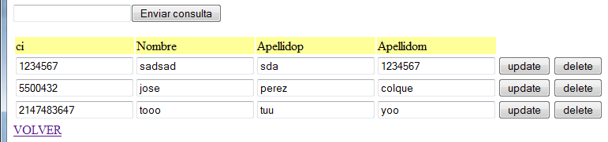

<?php
include("conect.php");
$cn=conectar();
echo $c=$_POST['ci'];
echo $nom=$_POST['nom'];
echo $apep=$_POST['apep'];
echo $apem=$_POST['apem'];
$sql=("UPDATE registro SET nombre='$nom',apellidop='$apep',apellidom='$apem',ci='$c' WHERE ci='$c.'")or die("error");
mysql_query($sql,$cn);
header("location: update.php");
?>
Borrar
<?php
include("conect.php");
$cn=conectar();
echo $c=$_REQUEST['ci'];

$sql=("delete from registro WHERE ci='$c.'")or die("error");
mysql_query($sql,$cn);
header("location: update.php");
?>

Archive css
@charset "utf-8";
/* CSS Document */

.botonmenu{
margin:2px;
padding:4px;
background:#000;
color:#FFF;
border-radius:3xp;
text-decoration:none;

}

Csssssssssss
body{
font-family:arial;
background:rgb(200,200,200);
margin:0px;padding:0px;
}
#contenedor{
width:800px;
margin:auto;
box-shadow:0px 10px 15px rgba(0,0,0,0.3);
background:white;padding:15px;
}
#contienecarrito{
position:absolute;
margin-left:470px;
top:10px;
clear:both;
width:300px;
float:right;
padding:15px;
border-radius:5px;
box-shadow:0px 5px 10px rgba(0,0,0,0.2) inset;
background:rgb(200,200,200);
}
h1,h2,header a{
width:50%;
}
h1,h2,h3,p{
margin:0px;
padding:0px;
}
h1{
font-size:48px;
}
h2{
font-size:14px;
font-weight:normal;
}
header a{
text-decoration:none;
color:black;
}
#contienecarrito table tr td{
text-align:right;
padding:4px;
}
#contienecarrito table{
width:100%;
border-spacing:0;
border-collapse:collapse;
}
#contienecarrito table tr:last-child{
background:white;
}
article a{
color:black;
text-decoration:none;
}
header{
margin-bottom:15px;
}
article{
border-top:1px dashed rgb(200,200,200);
padding-top:15px;
padding-bottom:15px;}
#carrito{
background:white;}
article img{
margin-right:10px;
border:5px solid white;
float:left;
box-shadow:0px 10px 15px rgba(0,0,0,0.4);}
article{clear:both;}
footer{text-align:center;}

