Computer-Vision---Project-2-Visual-traffic-monitoring-at-a-road-intersection

Ariton Cosmin

# Task1

This task is handled by using background subtraction, choosing the regions of interests and then computing the mean “activation” of the region of interest. If the mean “activation” is higher than a preset threshold, then a car is detected in that lane, otherwise it is flagged as not detected.

The background is not readily available, but can be approximated by creating the mean image of all the frames in the corresponding context video. This is a technique that based on the theory that the background appears more often than the foreground. So, naturally, the background will have a higher weight if we take an average. Although some artefacts still appear, they can be filtered out by setting the threshold high enough when doing background subtraction.

The regions of interest are selected apriori, with the assumption that they don’t change.

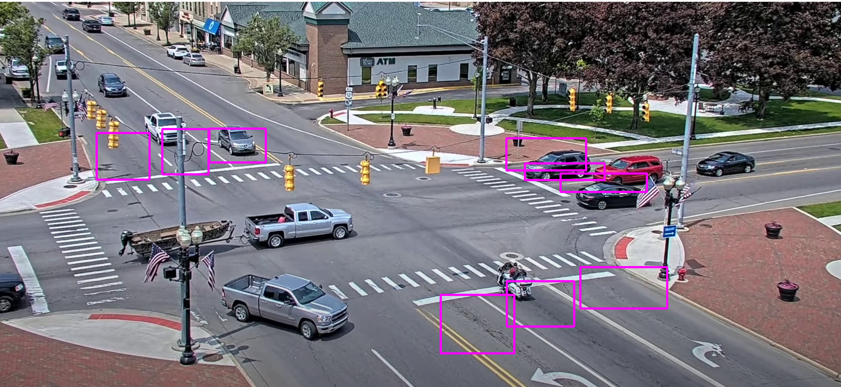

## Image with the classifier at work

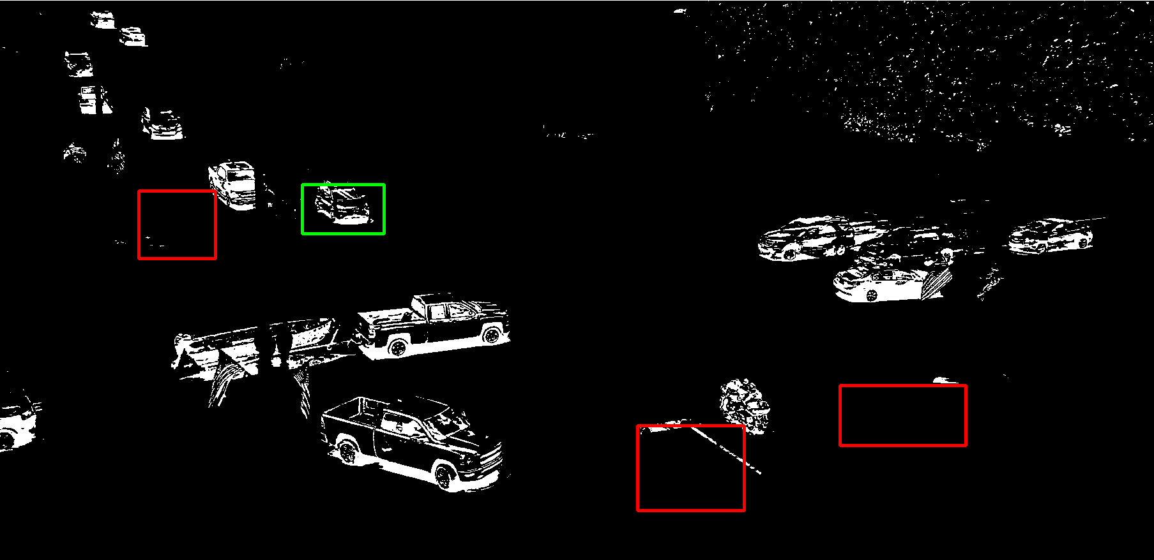

# Task2

For this task grabcut was used for the initial segmentation of the car. This segmentation is used to create a histogram with the pixels present on the car which will be used as a target for every following frame.

We will confine our search in a neighborhood of 20px by 20px around the last known position of the car and we will add a weighted gradient that acts like a momentum from the previous 8 frames. The main idea is that the new position should be near the last one and should be going in the same general direction.

If the past gradients suggest a motion in the general direction of the end of the screen and we have an out of bounds situation, then the tracking is stopped as it is considered that the subject exited the camera view.

The apparent size of the subjects change with respects to their position in the camera view. With that in mind, the width and height is of bounding box is resized with respect to the gradient.

## Example of an initial foreground using grabcut



## Example of the histogram of the selected foreground

