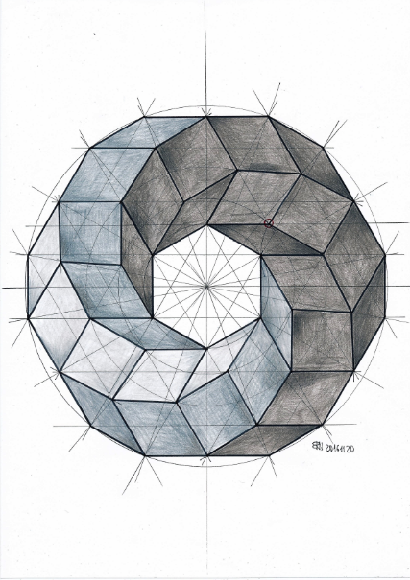

**APPLICATION OF CALCULUS IN**

**REAL LIEF**

**DIFFERENTIAL EQUATIONS:**

**ESTIMATING THE TIME OF DEATH**

Let's suppose that you are a crime investigator and you've found a dead body (it could be anything from a fish to a human being or anything else that comprises of atoms). You are asked to tell the estimated time of death. If you made your calculus and physics homeworks you should already know that Newton's law of cooling should come in rescue:

***The rate of heat loss of a body is proportional to the temperature difference between the body and its surroundings.***

We can solve this problem if we measure the initial temperature of the body T at the time we found it then if we let it to emit/radiate some heat for a short period of time (t) then we measure again it's final temperature (f) such that we can determine the rate of heat loss by that body. [Knowing](https://en.wikipedia.org/wiki/Knowing" \t "http://mynixworld.info/2014/06/06/differential-equations-estimating-time-death/_blank) that it's normal temperature was 37C we determine how long time (t) it took to cool down till (T) degrees Celsius.

Let's call the rate of heat loss of a body with IMG_256 where *dT* is the change of temperature with respect to time and *dt* is the change of time.

temperature of the dead body IMG_257 and the temperature of the surrounding IMG_258. Note that the difference between the body and its surroundings will be IMG_259 where Ts is just a constant.

Because each type of body (eq. fish body vs. human body) has a specific heat capacity, also the capacity to absorb and/or to emit the heat from/to surroundings, the rate of heat loss must also depend on that. Let me explain what I mean: each body absorbs/emits heat at different rate because each body is composed of different elements in different ratio. For instance, did you know that the human body contains 65% oxygen (O), 18.5% carbon (C), 9.5% hydrogen (H), 3.2% nitrogen (N), 1% phosphor (P),...., and less the 0.1% are small traces of boron (B), copper (Cu), fluorine(F),iodine(I), iron (Fe),manganese (Mn), tin (Sn) and zinc (Zn)? Because each of these elements have different number of electrons and orbitals they absorb/emit different amount of energy (like heat). When the heat is absorbed the atom's electrons jump to a higher energy level and when they emit the heat back to surroundings they jump back to the their ground energy level (the energy absorbed earlier is released back as a photon, which we can call it light; light is a wide spectrum, it can be visible for our eyes or invisible: for instance heat which is just infrared light; there is also UV-light, microwaves, radio waves, x-rays, gamma-rays; also light is just a electromagnetic wave that transports energy, it oscillates at different rate and has different wave length depending on its 'colour').

Let's name that property (which is a constant) that depends on the body composition with IMG_256.

****Summary****

IMG_257

where:

* dT/dt is the rate of heat loss of a body
* Ts is the surrounding temperature
* T is the body temperature
* k is a proportionality constant that depends on the body