Fernando Guerrero Nuez
M1 – Montaje y mantenimiento de equipos
Arduino 2
Display

Contenido
1.1 conectar el display 7 segmentos y que encienda. 2
1.2 Hacer una cuenta atrás de 9 al 0. 4
1.3 Añadir un boton con el cual sumemos 1 a la cantidad que este en el display. 7

1.1 conectar el display 7 segmentos y que encienda.
Circuito:
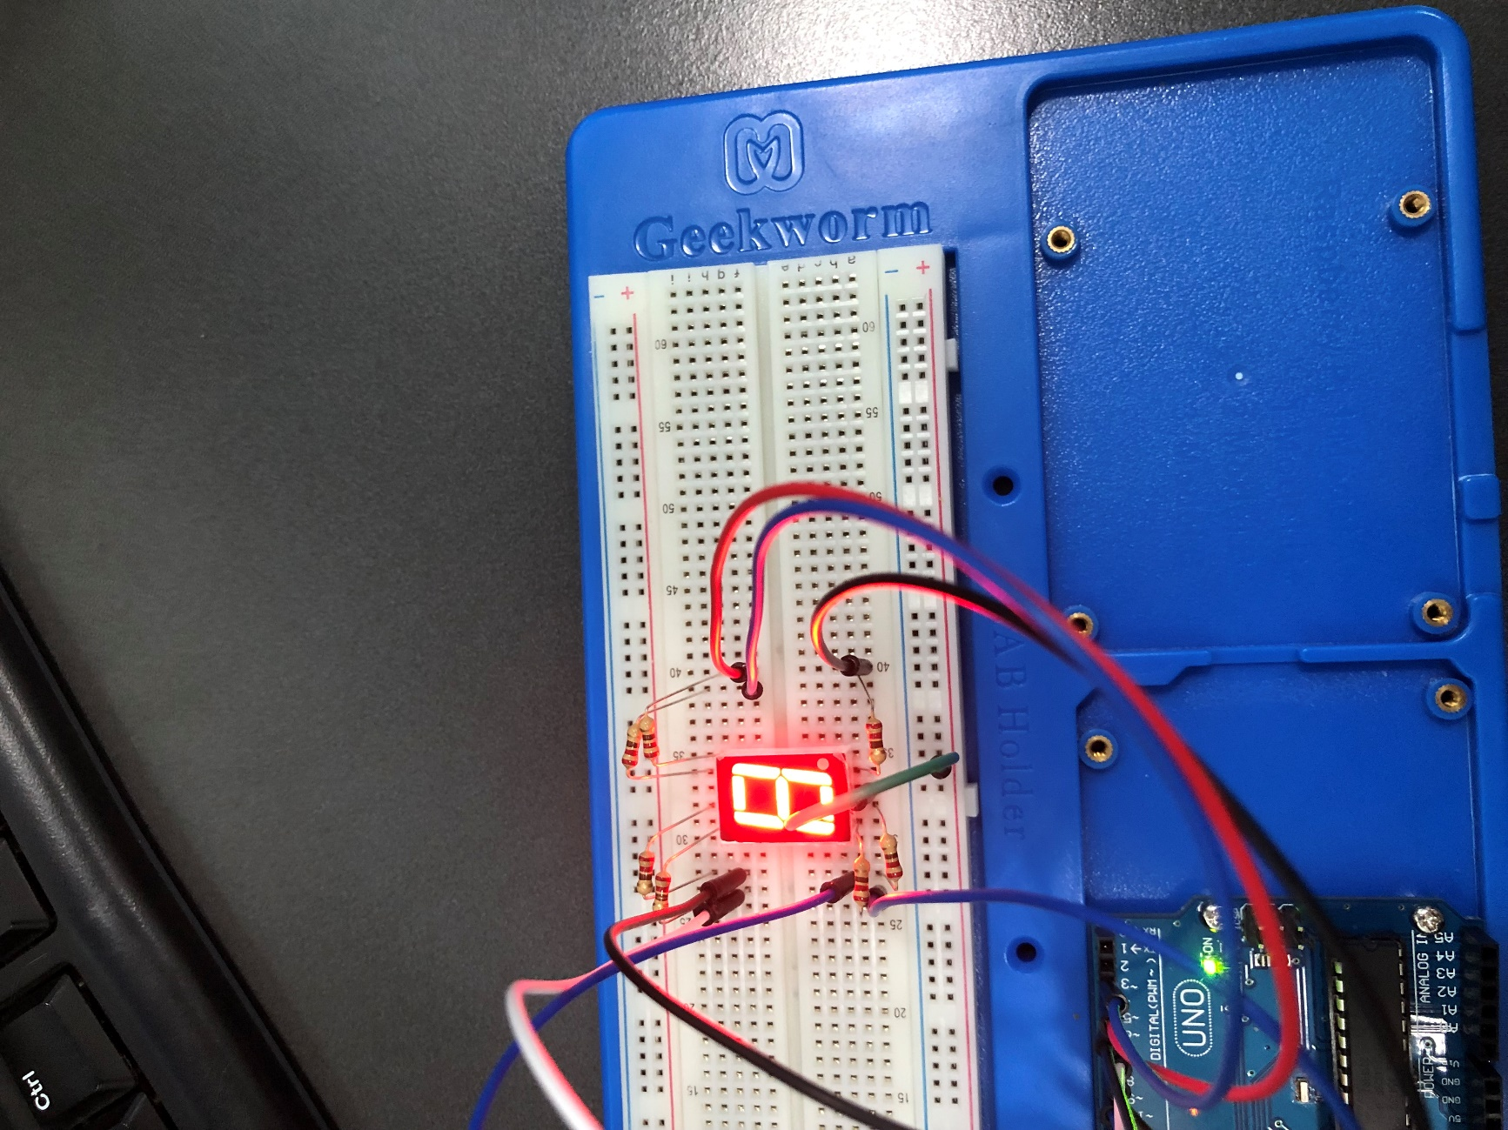
Código:
int a = 2;
int b = 3;
int c = 6;
int d = 7;
int e = 8;
int f = 4;
int g = 5;

void setup() {
pinMode(a, OUTPUT);
pinMode(b, OUTPUT);
pinMode(c, OUTPUT);
pinMode(d, OUTPUT);
pinMode(e, OUTPUT);
pinMode(f, OUTPUT);
pinMode(g, OUTPUT);
}

void loop() {
digitalWrite(a, LOW);
digitalWrite(b, LOW);
digitalWrite(c, LOW);
digitalWrite(d, LOW);
digitalWrite(e, LOW);
digitalWrite(f, LOW);
digitalWrite(g, LOW);
}

1.2 Hacer una cuenta atrás de 9 al 0.
Circuito:
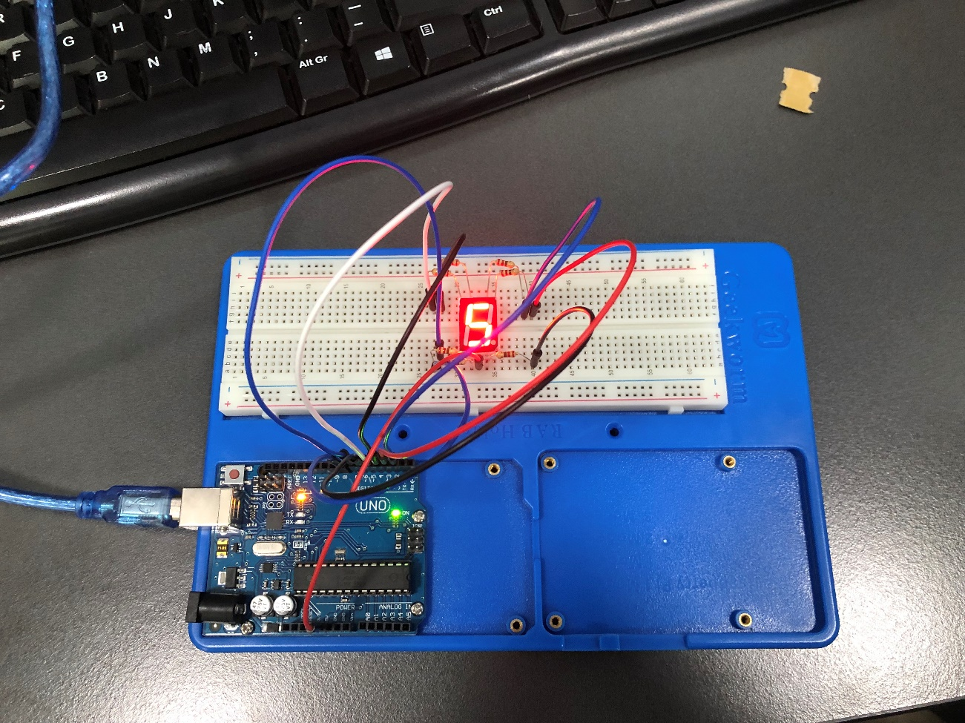
Código:
int a = 2;
int b = 3;
int c = 6;
int d = 7;
int e = 8;
int f = 4;
int g = 5;

void setup() {
pinMode(a, OUTPUT);
pinMode(b, OUTPUT);
pinMode(c, OUTPUT);
pinMode(d, OUTPUT);
pinMode(e, OUTPUT);
pinMode(f, OUTPUT);
pinMode(g, OUTPUT);
}

void loop() {
digitalWrite(a, LOW);
digitalWrite(b, LOW);
digitalWrite(c, LOW);
digitalWrite(d, HIGH);
digitalWrite(e, HIGH);
digitalWrite(f, LOW);
digitalWrite(g, LOW);
delay(500);
digitalWrite(a, LOW);
digitalWrite(b, LOW);
digitalWrite(c, LOW);
digitalWrite(d, LOW);
digitalWrite(e, LOW);
digitalWrite(f, LOW);
digitalWrite(g, LOW);
delay(500);
digitalWrite(a, LOW);
digitalWrite(b, LOW);
digitalWrite(c, LOW);
digitalWrite(d, HIGH);
digitalWrite(e, HIGH);
digitalWrite(f, HIGH);
digitalWrite(g, HIGH);
delay(500);
digitalWrite(a, LOW);
digitalWrite(b, HIGH);
digitalWrite(c, LOW);
digitalWrite(d, LOW);
digitalWrite(e, LOW);
digitalWrite(f, LOW);
digitalWrite(g, LOW);
delay(500);
digitalWrite(a, LOW);
digitalWrite(b, HIGH);
digitalWrite(c, LOW);
digitalWrite(d, LOW);
digitalWrite(e, HIGH);
digitalWrite(f, LOW);
digitalWrite(g, LOW);
delay(500);
digitalWrite(a, HIGH);
digitalWrite(b, LOW);
digitalWrite(c, LOW);
digitalWrite(d, HIGH);
digitalWrite(e, HIGH);
digitalWrite(f, LOW);
digitalWrite(g, LOW);
delay(500);
digitalWrite(a, LOW);
digitalWrite(b, LOW);
digitalWrite(c, LOW);
digitalWrite(d, LOW);
digitalWrite(e, HIGH);
digitalWrite(f, HIGH);
digitalWrite(g, LOW);
delay(500);
digitalWrite(a, LOW);
digitalWrite(b, LOW);
digitalWrite(c, HIGH);
digitalWrite(d, LOW);
digitalWrite(e, LOW);
digitalWrite(f, HIGH);
digitalWrite(g, LOW);
delay(500);
digitalWrite(a, HIGH);
digitalWrite(b, LOW);
digitalWrite(c, LOW);
digitalWrite(d, HIGH);
digitalWrite(e, HIGH);
digitalWrite(f, HIGH);
digitalWrite(g, HIGH);
delay(500);
digitalWrite(a, LOW);
digitalWrite(b, LOW);
digitalWrite(c, LOW);
digitalWrite(d, LOW);
digitalWrite(e, LOW);
digitalWrite(f, LOW);
digitalWrite(g, HIGH);
delay(500);
}

1.3 Añadir un boton con el cual sumemos 1 a la cantidad que este en el display.

Circuito:
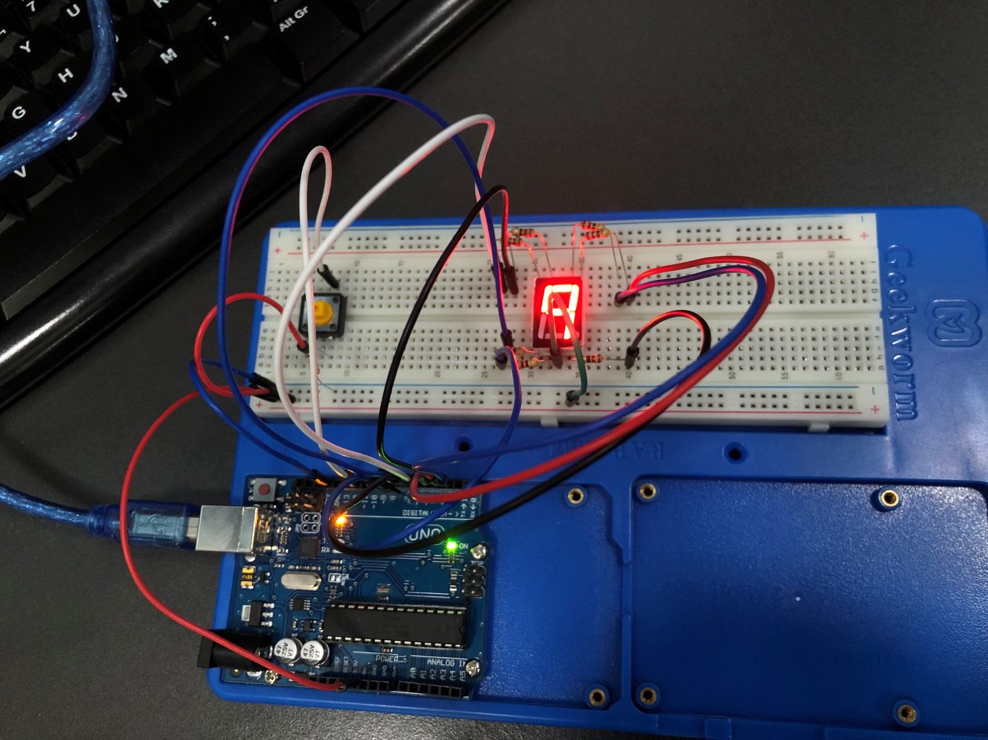

Código:
int status = 9;
int a = 2;
int b = 3;
int c = 6;
int d = 7;
int e = 8;
int f = 4;
int g = 5;
int button = 11;

void setup() {
pinMode(a, OUTPUT);
pinMode(b, OUTPUT);
pinMode(c, OUTPUT);
pinMode(d, OUTPUT);
pinMode(e, OUTPUT);
pinMode(f, OUTPUT);
pinMode(g, OUTPUT);
pinMode(button, INPUT);
}

void loop() {
if (status == 9){
if (digitalRead(11) == HIGH){
delay (200);
status = (status - 1);
}//0
digitalWrite(a, LOW);
digitalWrite(b, LOW);
digitalWrite(c, LOW);
digitalWrite(d, LOW);
digitalWrite(e, LOW);
digitalWrite(f, LOW);
digitalWrite(g, HIGH);
}else{
if (status == 8){
if (digitalRead(11) == HIGH){
delay (200);
status = (status - 1);
}//1
digitalWrite(a, HIGH);
digitalWrite(b, LOW);
digitalWrite(c, LOW);
digitalWrite(d, HIGH);
digitalWrite(e, HIGH);
digitalWrite(f, HIGH);
digitalWrite(g, HIGH);
}else{
if (status == 7){
if (digitalRead(11) == HIGH){
delay (200);
status = (status - 1);
}//2
digitalWrite(a, LOW);
digitalWrite(b, LOW);
digitalWrite(c, HIGH);
digitalWrite(d, LOW);
digitalWrite(e, LOW);
digitalWrite(f, HIGH);
digitalWrite(g, LOW);
}else{
if (status == 6){
if (digitalRead(11) == HIGH){
delay (200);
status = (status - 1);
}//3
digitalWrite(a, LOW);
digitalWrite(b, LOW);
digitalWrite(c, LOW);
digitalWrite(d, LOW);
digitalWrite(e, HIGH);
digitalWrite(f, HIGH);
digitalWrite(g, LOW);
}else{
if (status == 5){
if (digitalRead(11) == HIGH){
delay (200);
status = (status - 1);
}//4
digitalWrite(a, HIGH);
digitalWrite(b, LOW);
digitalWrite(c, LOW);
digitalWrite(d, HIGH);
digitalWrite(e, HIGH);
digitalWrite(f, LOW);
digitalWrite(g, LOW);
}else{
if (status == 4){
if (digitalRead(11) == HIGH){
delay (200);
status = (status - 1);
}//5
digitalWrite(a, LOW);
digitalWrite(b, HIGH);
digitalWrite(c, LOW);
digitalWrite(d, LOW);
digitalWrite(e, HIGH);
digitalWrite(f, LOW);
digitalWrite(g, LOW);
}else{
if (status == 3){
if (digitalRead(11) == HIGH){
delay (200);
status = (status - 1);
}//6
digitalWrite(a, LOW);
digitalWrite(b, HIGH);
digitalWrite(c, LOW);
digitalWrite(d, LOW);
digitalWrite(e, LOW);
digitalWrite(f, LOW);
digitalWrite(g, LOW);
}else{
if (status == 2){
if (digitalRead(11) == HIGH){
delay (200);
status = (status - 1);
}//7
digitalWrite(a, LOW);
digitalWrite(b, LOW);
digitalWrite(c, LOW);
digitalWrite(d, HIGH);
digitalWrite(e, HIGH);
digitalWrite(f, HIGH);
digitalWrite(g, HIGH);
}else{
if (status == 1){
if (digitalRead(11) == HIGH){
delay (200);
status = (status - 1);
}//8
digitalWrite(a, LOW);
digitalWrite(b, LOW);
digitalWrite(c, LOW);
digitalWrite(d, LOW);
digitalWrite(e, LOW);
digitalWrite(f, LOW);
digitalWrite(g, LOW);
}else{
if (status == 0){
if (digitalRead(11) == HIGH){
delay (200);
status = (status - 1);
}//9
digitalWrite(a, LOW);
digitalWrite(b, LOW);
digitalWrite(c, LOW);
digitalWrite(d, HIGH);
digitalWrite(e, HIGH);
digitalWrite(f, LOW);
digitalWrite(g, LOW);
}
}
}
}
}
}
}
}
}
}
}

