Fernando Guerrero Nuez
M1 – Montaje y mantenimiento de equipos
Arduino 7
Videojuegos

“Dinosaurio”
Código:
const int kPinBtn = 8; // Push Button - Pin 7
#include <LiquidCrystal.h>
#include <Wire.h>

LiquidCrystal lcd(12, 11, 5, 4, 3, 2);

byte patlama[] = {
B00000,
B00000,
B10101,
B01110,
B01110,
B10101,
B00000,
B00000
};

byte s1[] = {
B11110,
B10010,
B11110,
B11110,
B11110,
B10010,
B10011,
B11000
};

byte s2[] = {
B11110,
B10010,
B11110,
B11110,
B11110,
B10010,
B11010,
B00011
};

byte c1[] = {
B00000,
B00000,
B00110,
B00110,
B10110,
B11110,
B00110,
B00110
};

bool spriteBool = false;
float jump = 0;
int cactiRng = 20;
int cacti[16] = {0,0,0,0,0,0,0,0,0,0,0,0,0,0,0,0};
int skor=0;
int hskor=0;
bool isDed = false;
bool d1 = false;
int db=0;

void setup()
{
Serial.begin(9600);
pinMode(kPinBtn, INPUT_PULLUP); // Push Button as INPUT wiith pullup

lcd.createChar(0, s1);
lcd.createChar(1, s2);
lcd.createChar(2, c1);
lcd.createChar(3, patlama);

lcd.setCursor(0,0);
}

void loop()
{
if(isDed==false)
{
delay(500);
//
cactiRng-=random(4, 12);
if(cactiRng<=0){
db--;
cactiRng = 40;//lover the number is more the more cactus will spawn
if(skor>250){cactiRng=35;}//lover the number is more the more cactus will spawn
if(skor>500){cactiRng=30;}//lover the number is more the more cactus will spawn
if(skor>750){cactiRng=25;}//lover the number is more the more cactus will spawn
cacti[15]=1;
if(random(0,6)==3&&db<=0){cactiRng=0;
db=2;
}
}
//
for(int i = 0; i < 15; i++)
{
if(i==15)
{
cacti[i]=0;
}else{
cacti[i]=cacti[i+1];
cacti[i+1] = 0;
}
}
for(int i = 0; i < 15; i++){
lcd.setCursor(i,1);
if(cacti[i]==1)
{
lcd.write(2);
}else{
if(!(jump==0&&i==1))
{
lcd.print(" ");
}
}
}
//
if(digitalRead(kPinBtn) == LOW&&jump<=0) // When Push Button is pressed
{
jump=2;
}
if(jump>0)
{
jump-=0.5;
}
if(jump>0)
{
lcd.setCursor(1,1);
if(cacti[1]==0){ lcd.print(" ");}
lcd.setCursor(1,0);
}else{
lcd.setCursor(1,0);
lcd.print(" ");
lcd.setCursor(1,1);
}
if(spriteBool==true)
{

spriteBool=false;
}else{
lcd.write(1);
spriteBool=true;
}
//
if(cacti[1]&&jump==0)
{
lcd.setCursor(1,1);
lcd.write(3);
delay(2000);
isDed=true;
lcd.clear();
Serial.print("you died");
}else{
skor+=5;
lcd.setCursor(12,0);
lcd.print(skor);
}
//
}else {
//öyou died
if(d1==false){
lcd.setCursor(0,0);
lcd.print("Score "+String(skor));
if(skor>hskor){hskor=skor;}

lcd.setCursor(0,1);
lcd.print("HghScore "+String(hskor));
d1=true;
}
if(digitalRead(kPinBtn) == LOW){
d1=false;
isDed=false;
skor=0;
for(int i=0; i<15;i++){cacti[i]=0;}
cactiRng=40;
lcd.clear();
}
}
}

Montaje:
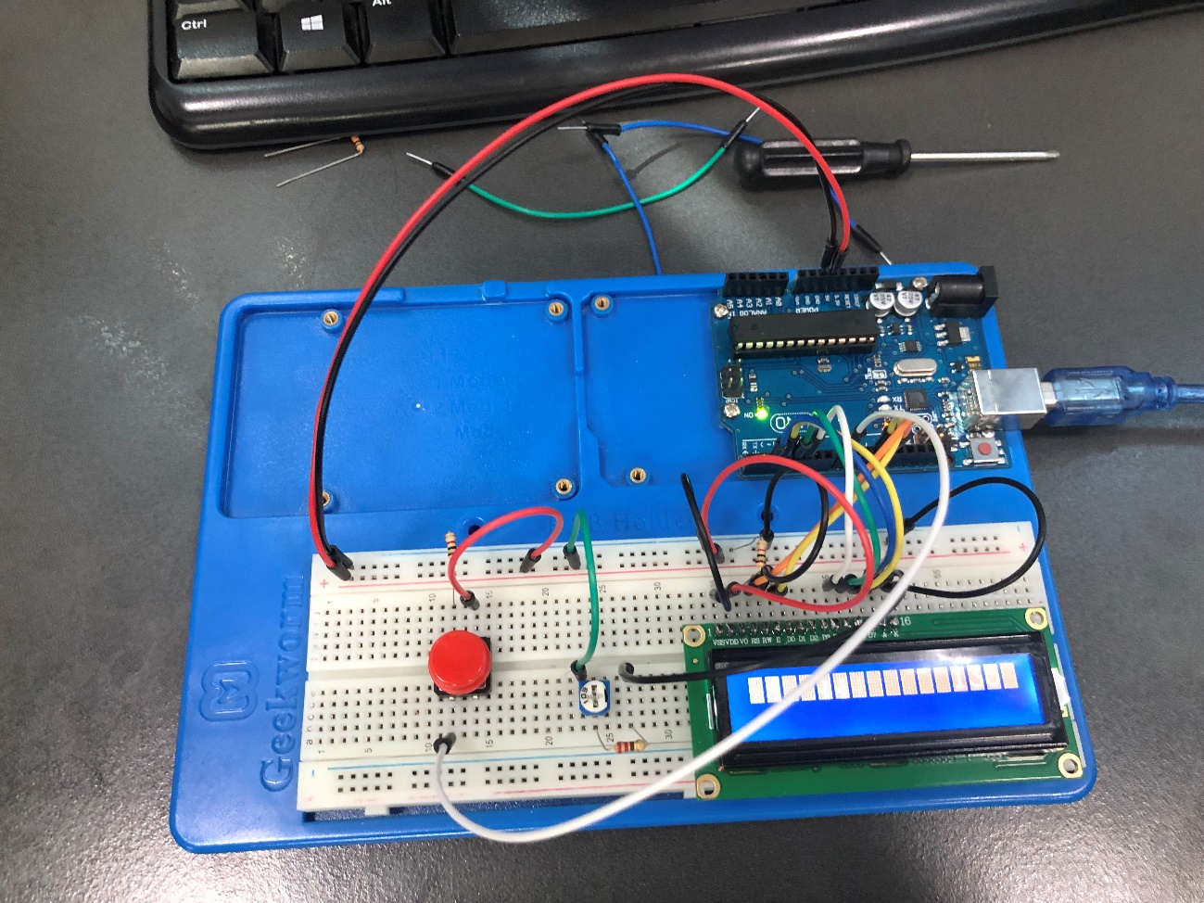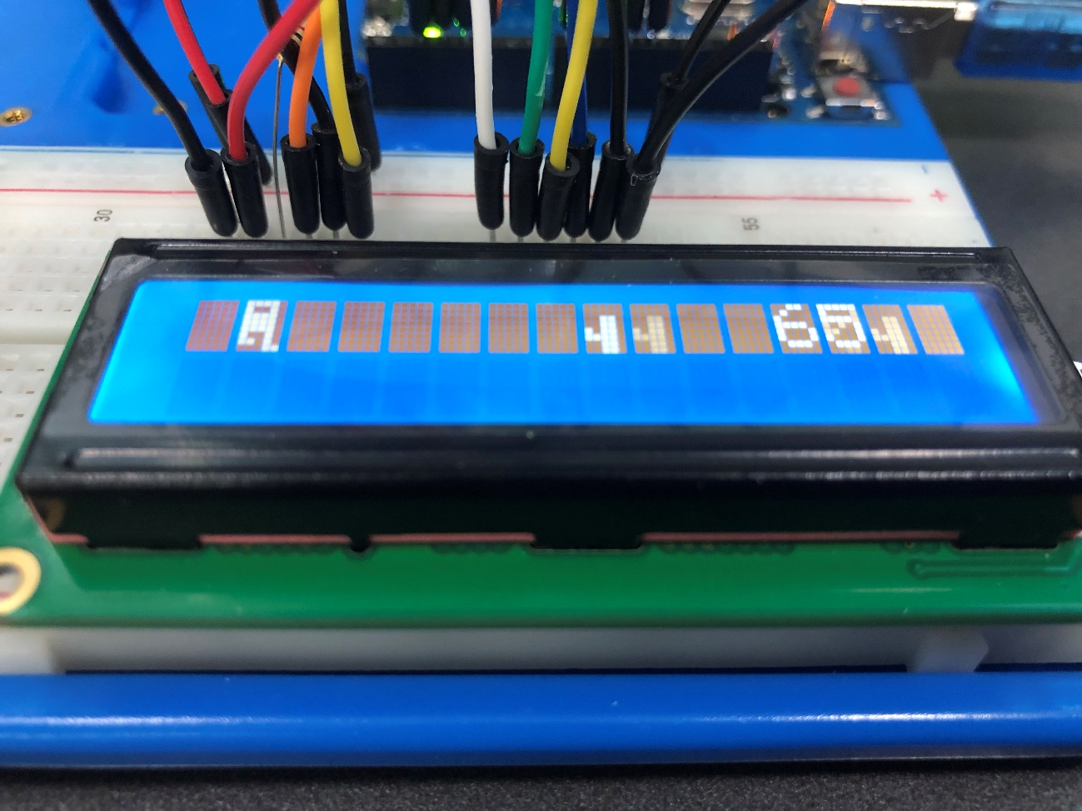

Tetris:
Código:
/**
* @brief Tetris game for Arduino
*
* This code implements a simplified version of the classic game Tetris, using
* an Arduino board and a 16x2 LCD display. The game includes a simple intro
* screen, a scoring system, and the standard Tetris gameplay mechanics of
* falling tetrominoes and clearing lines.
*
* @author Hubert Marczak (hkktr)
*/

#include <EEPROM.h>
#include <LiquidCrystal.h>

/* Settings */
constexpr unsigned long kIntroDelay{1000}; // default: 1000
constexpr unsigned long kGameOverDelay{3000}; // default: 3000
constexpr unsigned long kActionTimeDelay{150}; // default: 150
constexpr unsigned long kMoveTimeDelay{350}; // default: 350
constexpr unsigned long kRapidFallLineDelay{20}; // default: 20
constexpr unsigned long kClearedLineScoreBonus{5}; // default: 5

/* Pins */
constexpr int kLeftButtonPin{4};
constexpr int kRightButtonPin{3};
constexpr int kRotateButtonPin{5};
constexpr int kRapidFallButtonPin{2};
constexpr int kLcdRsPin{8};
constexpr int kLcdEnablePin{9};
constexpr int kLcdD4Pin{10};
constexpr int kLcdD5Pin{11};
constexpr int kLcdD6Pin{12};
constexpr int kLcdD7Pin{13};

/* Constants */
constexpr int kFigures[7][4]{{0, 2, 4, 6}, {2, 4, 5, 7}, {3, 5, 4, 6},
{3, 5, 4, 7}, {2, 3, 5, 7}, {3, 5, 7, 6},
{2, 3, 4, 5}};
constexpr int kFiguresSize{sizeof(kFigures) / sizeof(kFigures[0])};
constexpr int kFigureSize{sizeof(kFigures[0]) / sizeof(kFigures[0][0])};

/**
* The Board class is used to store and manage the state of the game board.
*/
class Board {
public:
/**
* @param x The x-coordinate of the position
* @param y The y-coordinate of the position
*
* @returns The boolean value of the board at the specified position.
*/
bool At(const int x, const int y) const;
/**
* Sets the value of the board at the specified position to the
* specified boolean value.
*
* @param x The x-coordinate of the position
* @param y The y-coordinate of the position
* @param value The new value at specified position
*/
void Set(const int x, const int y, const bool value);
/**
* Checks for full lines on the board and clears them, moving any lines above
* them down if necessary.
*
* @returns The number of lines cleared.
*/
int ClearLines();
/**
* Clears the game board by setting all values in the board array to false.
*/
void Clear();

static constexpr int Width() { return kWidth; }
static constexpr int Height() { return kHeight; }
static constexpr int BlockWidth() { return kBlockWidth; }
static constexpr int BlockHeight() { return kBlockHeight; }
static constexpr int Columns() { return kWidth / kBlockWidth; }
static constexpr int Rows() { return kHeight / kBlockHeight; }

private:
static constexpr int kWidth{16};
static constexpr int kHeight{20};
static constexpr int kBlockWidth{8};
static constexpr int kBlockHeight{5};

/**
* Moves all the lines with y lower than the provided value down by one
* block on the board. This method is used to update the board after clearing
* lines.
*
* @param max_y The y-coordinate value below which lines should be moved down
*/
void MoveLines(const int max_y);

bool board_[kWidth][kHeight];
};

bool Board::At(const int x, const int y) const { return board_[x][y]; }

void Board::Set(const int x, const int y, const bool value) {
board_[x][y] = value;
}

int Board::ClearLines() {
int cleared_lines{0};

int y{Board::Height() - 1};
while (y >= 0) {
int quantity{0};
for (int x{0}; x < Board::Width(); ++x) {
if (At(x, y)) ++quantity;
}

if (quantity == 0) {
break;
} else if (quantity == Board::Width()) {
for (int x{0}; x < Board::Width(); ++x) {
Set(x, y, false);
}

MoveLines(y);
++cleared_lines;
} else {
--y;
}
}

return cleared_lines;
}

void Board::Clear() {
for (int x{0}; x < Board::Width(); ++x) {
for (int y{0}; y < Board::Height(); ++y) {
Set(x, y, false);
}
}
}

void Board::MoveLines(const int max_y) {
for (int y{max_y}; y > 0; --y) {
for (int x{0}; x < Board::Width(); ++x) {
Set(x, y, At(x, y - 1));
}
}
}

/**
* The Tetromino class is responsible for creating and manipulating Tetromino
* objects, which represent the various shapes used in the game of Tetris. A
* Tetromino object is composed of four blocks arranged in a specific shape,
* such as a straight line or a square. The Tetromino class provides functions
* for moving and rotating these shapes on a game board.
*/
class Tetromino {
public:
/**
* The Direction enum is used to indicate the direction to move the tetromino
* horizontally. It has two possible values, kLeft and kRight, which
* respectively represent moving the tetromino to the left or to the right.
*
* The Direction enum is used in conjunction with the Move method,
* which moves the tetromino horizontally based on the specified direction.
*/
enum class Direction {
kLeft = -1,
kRight = 1,
};

/**
* The Tetromino class constructor creates a new Tetromino object of a random
* figure from the set of pre-defined figures.
*/
Tetromino();

/**
* Checks if the tetromino collides with any other blocks on the game board.
*
* @param board The board to check for collisions with the tetromino
*
* @returns True if there was a collision, false otherwise.
*/
bool Collide(const Board& board) const;
/**
* Moves the current tetromino left or right by one column, if possible.
*
* @param board The board to check for collisions with the tetromino after
* move in specified direction
* @param direction The direction to move the tetromino, either
* `Direction::kLeft`
*
* @returns True if the move occured, false otherwise.
*/
bool Move(const Board& board, const Direction direction);
/**
* Rotates the tetromino by 90 degrees, if possible.
*
* @param board The board to check for collisions with the tetromino after
* rotation
*
* @returns True if the rotation occured, false otherwise.
*/
bool Rotate(const Board& board);
/**
* Moves the tetromino down by one row, if possible.
*
* @param board The board to check for collisions with the tetromino after
* moving it down
*
* @returns True if the tetromino is at the bottom, false otherwise.
*/
bool MoveDown(const Board& board);
/**
* Adds or removes a tetromino from the game board, depending on the value
* of the passed-in argument.
*
* @param board The board to draw or remove the tetromino blocks from
* @param value The boolean value, where true indicates that the tetromino
* should be drawn on the board, and false indicates that it should be removed
* from the board
*/
void Draw(Board& board, const bool value) const;

private:
/**
* The Block struct represents a single block of a tetromino. It consists of
* two fields, x and y, which represent the x and y coordinates of the block,
* respectively.
*/
struct Block {
int x;
int y;
};

Block shape_[kFigureSize];
};

Tetromino::Tetromino() {
constexpr int x{Board::Width() / 2};
constexpr int y{0};

const int figure{random(kFiguresSize)};
for (int i{0}; i < kFigureSize; ++i) {
shape_[i].x = x + kFigures[figure][i] % 2;
shape_[i].y = y + kFigures[figure][i] / 2;
}
}

bool Tetromino::Collide(const Board& board) const {
for (int i{0}; i < kFigureSize; ++i) {
const Block& block{shape_[i]};
if (board.At(block.x, block.y)) return true;
}
return false;
}

bool Tetromino::Move(const Board& board, const Direction direction) {
const int offset{static_cast<int>(direction)};

for (int i{0}; i < kFigureSize; ++i) {
const int new_x{shape_[i].x + offset};
if (new_x < 0 || new_x >= Board::Width()) return false;
if (board.At(new_x, shape_[i].y)) return false;
}

for (int i{0}; i < kFigureSize; ++i) {
shape_[i].x += offset;
}
return true;
}

bool Tetromino::Rotate(const Board& board) {
// Disables square rotation
if (abs(shape_[3].x - shape_[0].x) == 1 &&
abs(shape_[3].y - shape_[0].y) == 1)
return false;

const Block& center = shape_[2];
Block rotated[kFigureSize];

for (int i{0}; i < kFigureSize; ++i) {
const int x{shape_[i].y - center.y};
const int y{shape_[i].x - center.x};
rotated[i].x = center.x - x;
rotated[i].y = center.y + y;

if (rotated[i].x < 0 || rotated[i].x >= Board::Width()) return false;
if (rotated[i].y < 0 || rotated[i].x >= Board::Height()) return false;
if (board.At(rotated[i].x, rotated[i].y)) return false;
}

for (int i{0}; i < kFigureSize; ++i) {
shape_[i].x = rotated[i].x;
shape_[i].y = rotated[i].y;
}
return true;
}

bool Tetromino::MoveDown(const Board& board) {
for (int i{0}; i < kFigureSize; ++i) {
if (shape_[i].y >= Board::Height() - 1) return true;
if (board.At(shape_[i].x, shape_[i].y + 1)) return true;
}

for (int i{0}; i < kFigureSize; ++i) {
++shape_[i].y;
}
return false;
}

void Tetromino::Draw(Board& board, const bool value) const {
for (int i{0}; i < kFigureSize; ++i) {
const Block& block = shape_[i];
board.Set(block.x, block.y, value);
}
}

/**
* The Display class is responsible for managing the display of the game on an
* LCD screen. It provides methods for printing various messages, drawing the
* game board, tetromino shapes, and score information on the screen.
*/
class Display {
public:
/**
* The constructor takes six arguments, which are the pin numbers for the LCD
* screen. It creates a LiquidCrystal object underneath to interface with the
* LCD screen.
*
* @param rs
* @param enable
* @param d4
* @param d5
* @param d6
* @param d7
*/
Display(int rs, int enable, int d4, int d5, int d6, int d7)
: display_{rs, enable, d4, d5, d6, d7} {}

/**
* Draws the game board on the display, including the current tetromino, if
* available.
*
* @param board The game board
* @param tetromino The current tetromino (optional)
**/
void DrawBoard(Board& board, const Tetromino* const tetromino);
/**
* Updates the game score on the display.
*
* @param score The new score to display
*/
void PrintScore(const int score);

/**
* Displays an introductory message that includes the game title and author.
*/
void Intro();
/**
* Clears the game display and prints the game score, starting with a score of
* 0.
*/
void Start();
/**
* Displays the player's current score and high score on the game screen.
*
* @param score The current score of the game
* @param high_score The highest score achieved in all previous games
*/
void GameOver(const int score, const int high_score);
/**
* Displays the "game over" message and provides instructions for restarting
* the game.
*/
void Restart();

private:
/**
* Updates the character for specific segment of the board.
*
* @param column The number of column on the display
* @param row The number of row on the display
* @param board The game board
*
* @returns True if any changes were made, false otherwise.
*/
bool UpdateCharacter(const int column, const int row, const Board& board);

LiquidCrystal display_;
uint8_t characters_[Board::Columns()][Board::Rows()][Board::BlockWidth()];
};

void Display::DrawBoard(Board& board, const Tetromino* const tetromino) {
if (tetromino) tetromino->Draw(board, true);

for (int column{0}; column < Board::Columns(); ++column) {
for (int row{0}; row < Board::Rows(); ++row) {
if (UpdateCharacter(column, row, board)) {
const int index{column * Board::Rows() + row};
display_.createChar(index, characters_[column][row]);
display_.setCursor(row, column);
display_.write(uint8_t(index));
}
}
}

if (tetromino) tetromino->Draw(board, false);
}

void Display::PrintScore(const int score) {
display_.setCursor(9, 1);
display_.print(min(score, 999));
}

void Display::Intro() {
uint8_t block_character[] = {0b11111, 0b11111, 0b11111, 0b11111,
0b11111, 0b11111, 0b11111, 0b11111};
display_.createChar(0, block_character);
display_.begin(16, 2);

display_.setCursor(0, 0);
display_.print("TET ");
display_.write(uint8_t(0));
display_.print(" Author:");

display_.setCursor(0, 1);
display_.print("RIS ");
display_.write(uint8_t(0));
display_.print(" hkktr (HM)");
}

void Display::Start() {
for (int column{0}; column < Board::Columns(); ++column) {
for (int row{0}; row < Board::Rows(); ++row) {
for (int y{0}; y < Board::BlockWidth(); ++y) {
characters_[column][row][y] = 0b00000;
}
}
}

display_.clear();
display_.setCursor(4, 0);
display_.print("XXXX Score:");

display_.setCursor(4, 1);
display_.print("XXXX");
PrintScore(0);
}

void Display::GameOver(const int score, const int high_score) {
uint8_t crown_character[] = {0b00000, 0b00000, 0b00000, 0b10101,
0b11111, 0b11111, 0b11111, 0b00000};
display_.createChar(0, crown_character);
display_.clear();

display_.setCursor(0, 0);
display_.print("Your score: ");
display_.print(score);
if (score >= high_score) display_.write(uint8_t(0));

display_.setCursor(0, 1);
display_.print("High score: ");
display_.print(high_score);
if (score <= high_score) display_.write(uint8_t(0));
}

void Display::Restart() {
display_.clear();
display_.setCursor(0, 0);
display_.print("Game over! Press");
display_.setCursor(0, 1);
display_.print("rotate to play.");
}

bool Display::UpdateCharacter(const int column, const int row,
const Board& board) {
const int x{column * Board::BlockWidth()};
const int y{(Board::Rows() - row - 1) * Board::BlockHeight()};

uint8_t character[8];
constexpr uint8_t kPowers[]{1, 2, 4, 8, 16};

for (int i{0}; i < Board::BlockWidth(); ++i) {
uint8_t value{0};
for (int j{0}; j < Board::BlockHeight(); ++j) {
value += board.At(x + i, y + j) * kPowers[j];
}
character[i] = value;
}

bool changes{false};
for (int i{0}; i < Board::BlockWidth(); ++i) {
if (characters_[column][row][i] != character[i]) {
characters_[column][row][i] = character[i];
changes = true;
}
}

return changes;
}

/**
* Responsible for initializing and managing the state of the game. It also
* handles user input and updates the game state accordingly.
*/
class Game {
public:
/**
* Deallocates the memory used by the display and tetromino objects.
*/
~Game();

/**
* Initializes the pins for input, sets up the EEPROM
* for reading and writing high score data, initializes the display for
* output, and starts the intro sequence.
*/
void Setup();
/**
* Performs an update on the game state every tick, which includes
* updating the tetromino position, checking for completed lines,
* and handling user input.
*/
void Update();

private:
static constexpr int kMemoryHighScoreAddress{0};

/**
* Handles a rapid tetromino fall if the user chooses to do so. If the user
* presses the "drop" key, the method immediately moves the current tetromino
* to the bottom of the board, then clears any completed lines and updates
* score.
*
* @returns True if rapid fall occured, false otherwise.
*/
bool HandleRapidFall();
/**
* Checks user input and updates the tetromino if possible.
*
* @param time The elapsed time in milliseconds
*
* @returns True if resulted in any changes to the board, false otherwise.
*/
bool HandleUserInput(const unsigned long time);
/**
* Moves the current tetromino down by one cell if the delta time
* since the last move down is greater than a constant value.
*
* @param time The elapsed time in milliseconds
*
* @returns True if resulted in any changes to the board, false otherwise.
*/
bool HandleTetrominoMoveDown(const unsigned long time);
/**
* Removes the current tetromino from the board and updates the score.
*/
void RemoveTetromino();

/**
* Displays the game's intro sequence, which includes showing the game
* title and author. Once the intro is complete, the method starts the game.
*/
void Intro();
/**
* Resets the game state and starts the game. This includes resetting
* the score, deleting the tetromino, and clearing the game board.
*/
void Start();
/**
* Displays the "game over" message and waits for the player to restart the
* game. If the player has achieved a new high score, the method saves it to
* the EEPROM memory.
*/
void GameOver();

Board board_;
Display* display_;
Tetromino* tetromino_;

int score_{0};
unsigned long last_action_time_{0};
unsigned long last_move_time_{0};
};

Game::~Game() {
delete display_;
delete tetromino_;
}

void Game::Setup() {
pinMode(kLeftButtonPin, INPUT_PULLUP);
pinMode(kRightButtonPin, INPUT_PULLUP);
pinMode(kRotateButtonPin, INPUT_PULLUP);
pinMode(kRapidFallButtonPin, INPUT_PULLUP);

randomSeed(analogRead(0));

if (!EEPROM.read(kMemoryHighScoreAddress)) {
EEPROM.write(kMemoryHighScoreAddress, 0);
}

display_ = new Display(kLcdRsPin, kLcdEnablePin, kLcdD4Pin, kLcdD5Pin,
kLcdD6Pin, kLcdD7Pin);

Intro();
}

void Game::Update() {
bool changes{false};

if (!tetromino_) {
tetromino_ = new Tetromino();
changes = true;

if (tetromino_->Collide(board_)) return GameOver();
}

const unsigned long time{millis()};
if (HandleRapidFall()) return;
if (HandleUserInput(time)) changes = true;
if (HandleTetrominoMoveDown(time)) changes = true;

if (changes) display_->DrawBoard(board_, tetromino_);
}

bool Game::HandleRapidFall() {
if (digitalRead(kRapidFallButtonPin) == LOW) {
while (!tetromino_->MoveDown(board_)) {
display_->DrawBoard(board_, tetromino_);
delay(kRapidFallLineDelay);
}

RemoveTetromino();
return true;
}

return false;
}

bool Game::HandleUserInput(const unsigned long time) {
const unsigned long last_action_delta{time - last_action_time_};

if (last_action_delta >= kActionTimeDelay) {
bool action{false};

if (digitalRead(kLeftButtonPin) == LOW) {
action = tetromino_->Move(board_, Tetromino::Direction::kLeft);
} else if (digitalRead(kRightButtonPin) == LOW) {
action = tetromino_->Move(board_, Tetromino::Direction::kRight);
} else if (digitalRead(kRotateButtonPin) == LOW) {
action = tetromino_->Rotate(board_);
}

if (action) {
last_action_time_ = time;
return true;
}
}

return false;
}

bool Game::HandleTetrominoMoveDown(const unsigned long time) {
const unsigned long last_move_delta{time - last_move_time_};

if (last_move_delta >= kMoveTimeDelay) {
if (tetromino_->MoveDown(board_)) RemoveTetromino();
last_move_time_ = time;
return true;
}

return false;
}

void Game::RemoveTetromino() {
tetromino_->Draw(board_, true);
delete tetromino_;
tetromino_ = nullptr;

++score_;
score_ += board_.ClearLines() * kClearedLineScoreBonus;

display_->PrintScore(score_);
}

void Game::Intro() {
display_->Intro();
delay(kIntroDelay);
Start();
}

void Game::Start() {
delete tetromino_;
tetromino_ = nullptr;

score_ = 0;
last_action_time_ = millis();
last_move_time_ = millis();

board_.Clear();
display_->Start();
}

void Game::GameOver() {
const int high_score{EEPROM.read(0)};

display_->GameOver(score_, high_score);
if (score_ > high_score) EEPROM.update(0, score_);
delay(kGameOverDelay);

display_->Restart();
while (digitalRead(kRotateButtonPin) == HIGH) {
}
Start();
}

Game game;

void setup() { game.Setup(); }

void loop() { game.Update(); }

Circuito:
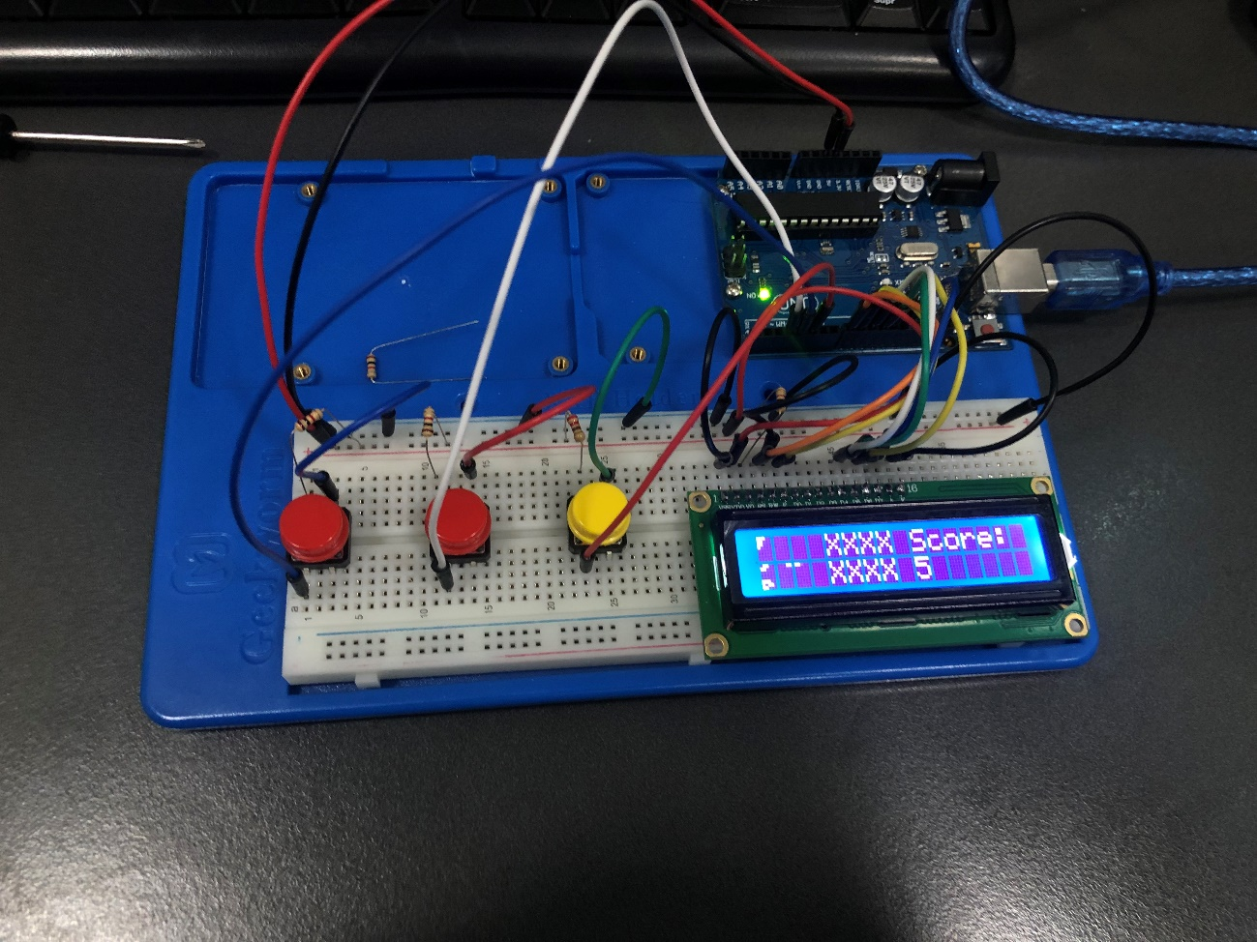
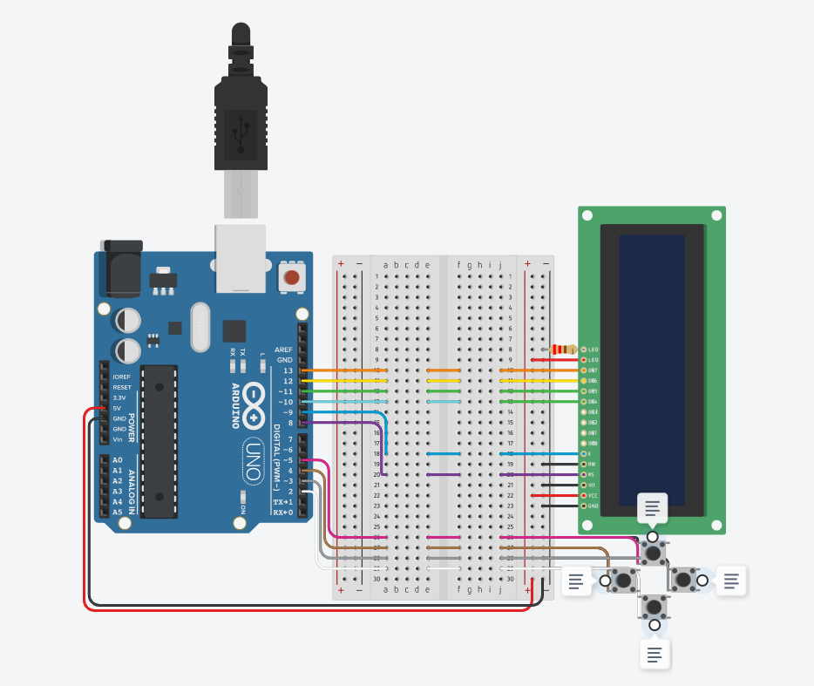
Créditos: Tetris (tinkercad.com)

