What to do
You need to create a constraint layout similar to this image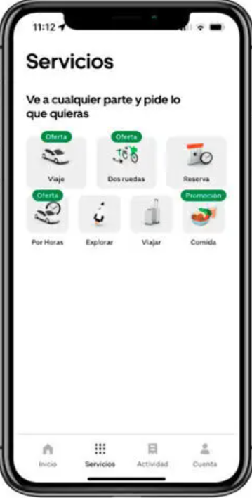

What must be delivered
- APK. Build the project or generate apk and search the apk in app\build\outputs\apk\debug
- Main folder in a zip (app\src\main)
- Video in English explaining
  - Main Android Studio sections
  - All the different types of logs (compilations, debug, run, ….)
  - Different types of layout
  - How did you created the constraint layout and all the constraints you created
  - Show the app running

What will be evaluated
- English 1 point
- Video explanation 3 points
- Layout achieved 6 points. Responsive, well structure, well documented, …

