Hybrid app
For 2020-21: https://openwebinars.net/academia/aprende/ionic/2075/

Theory:

Definiciones
- Native vs Hybrid application: https://blog.techmagic.co/native-vs-hybrid-apps/
- Single Page Application (SPA): aplicación web que se comporta como una aplicación de escritorio. Para ello carga toda la aplicación/web de una sola vez evitando tener que consultar la página al servidor cada vez que se cambia de opción del menú. Tarda más en cargarse la primera vez, pero mejora el rendimiento en las próximas consultas
- PWA Aplicación Web Progresiva. Son una mezcla de aplicación web y nativa. Mediante los llamados “Service Workers” una aplicación web progresiva puede seguir trabajando aunque el navegador Web ya no esté activo (es decir, estará en segundo plano). Están disponibles para Chrome, Edge, Firefox y Safari
- Native widgets: Small native applications

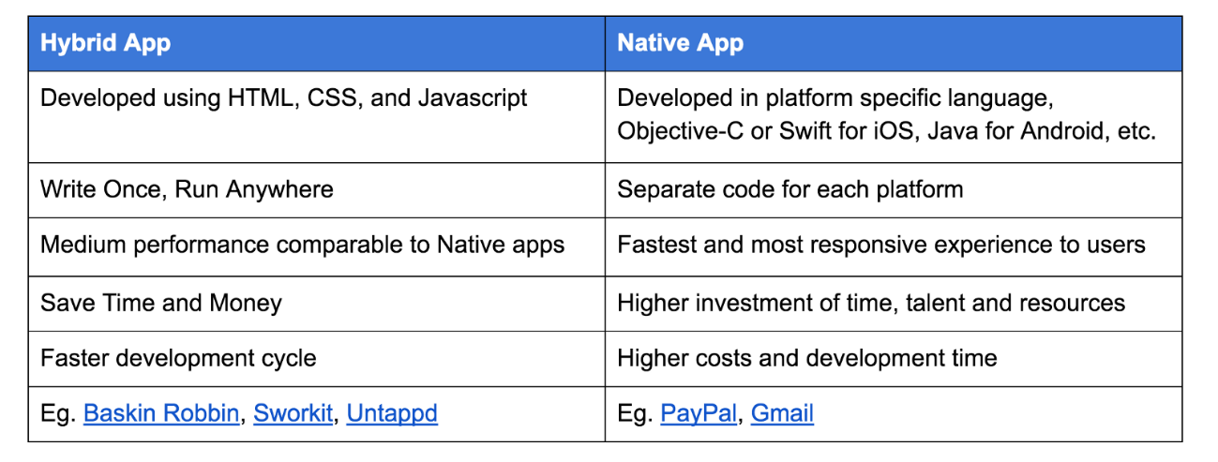

Dev Tool / Framworks
- Flutter vs Ionic: https://www.syntonize.com/flutter-o-ionic/
- Xamarin vs Ionic vs React Native: https://cruxlab.com/blog/reactnative-vs-xamarin/
- PhoneGap vs Apache Cordova: https://www.campusmvp.es/recursos/post/PhoneGap-o-Apache-Cordova-que-diferencia-hay.aspx
Utility | Code | Dev Tool | Main function | Dependency | Use Native Widgets | Inconvenients
IOS | Swift | XCode | Native | None | Yes
Android | Java or Kodlin | Android Studio | Native | None | Yes
Windows Phone | C#+XAML or HTML5+WinJS |  | Native | None | Yes
Xamarin | C# |  | Close to native |  | Yes
Apache Cordova |  |  | Native Wrapper | Java 8 JDK, Apache ant, Android SDK | Yes
PhoneGap |  |  | Native Wrapper. is a distribution of Apache Cordova |  | Yes
Tigger.io |  |  | Native Wrapper |  | N/A
Ionic | TypeScript |  |  | Angular and Cordova | No | Networking, permissions, … cannot be generic
Vue Native | Javascript |  |  |  | Yes
React Native | Javascript

A la hora de realizar aplicaciones para móviles tenemos tres opciones:
- Crear una versión para cada plataforma, usando sus herramientas nativas.
- Utilizar algún framework intermedio, como Xamarin, que funcione en todas ellas y que nos permita reutilizar la lógica y solo desarrollar la interfaz en cada caso.
- Utilizar HTML+CSS+JavaScript y algún host multiplataforma, como PhoneGap o Apache Cordova, que nos permita compilar la aplicación para todas las plataformas

https://cruxlab.com/blog/reactnative-vs-xamarin/
Tanto C# como JavaScript no se compilan directamente en la CPU. C# se compila en bytecode y JavaScript es interpretado por el navegador. Eso implica que no es del todo eficiente.
Existen dos formas de mejorar el rendimiento
- Compilación JIT (Just in Time) compilan el bytecode o el código fuente en código nativo la primera vez que se ejecuta, pero el resto de ejecuciones ya no es necesario.
- Compilación AOT (Ahead-of-Time). Idem que el anterior, pero se convierte a código nativo en el momento de compilación en lugar del momento de ejecución

La lógica nos indica que AOT debería ser mejor que JIT ya que se convierte a nativo antes de ejecutarlo, pero al ser JavaScript un lenguaje que nos permite ser dinámico el JIT es la mejor opción en ese caso.
En iOS la protección es mayor y el JIT no está permitido ya que realiza modificaciones en tiempo de ejecución.
Usar 64 bits es más eficiente

 | Nativas | Xamarin | React Native | Ionic
Running the code | iOS | AOT | Interpreter | Interpreter  JIT with plugin
 | Android | JIT/AOT | JIT | JIT
64-bit support | iOS | YES | ? | Yes
 | Android | Yes | No | ?
GUI | iOS and Android | Native widgets (directly or under the hood) | Native widgets under the hood | HTML

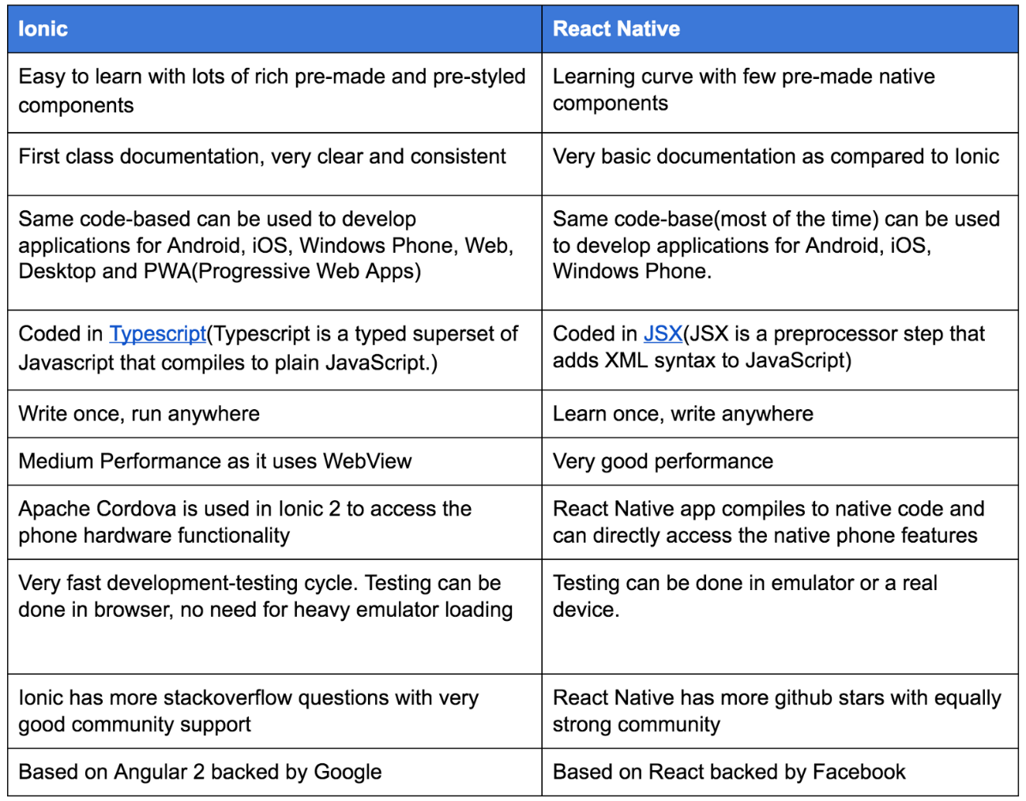
Flutter vs Ionic
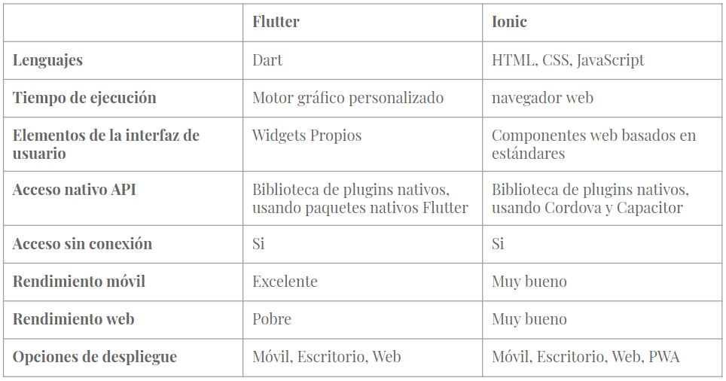

First Ionic app: https://ionicframework.com/docs/v1/guide/preface.html

Pizarra
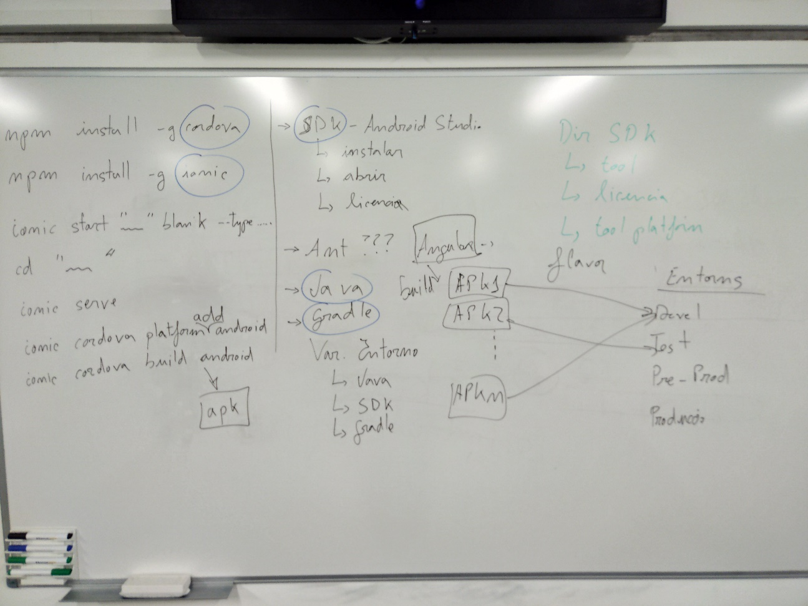

Instalar con npm y variables de entorno

Instalo cordova
npm install -g cordova

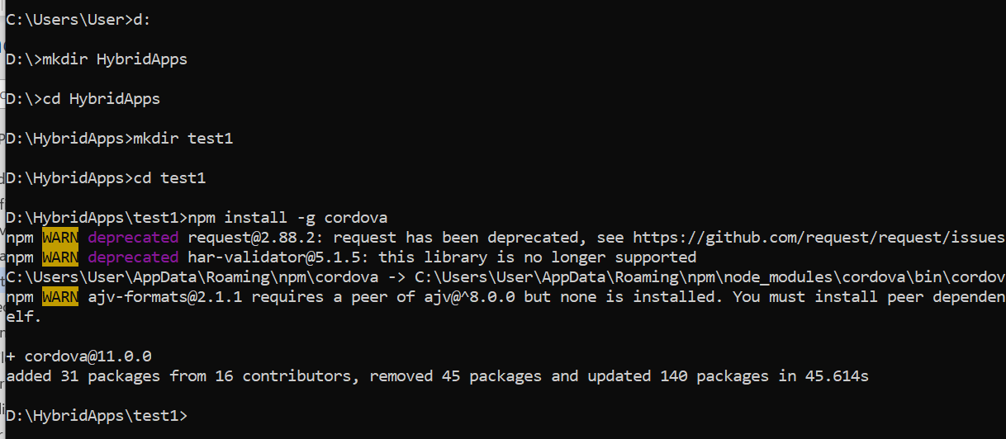
Java JDK
Install the most recent Java 8 JDK (NOT just the JRE), JDK 9 is NOT currently (2017.12) supported by Cordova.
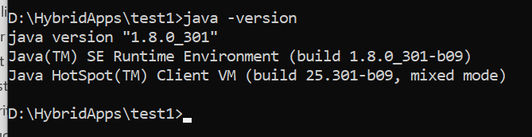
Next, create an environment variable for JAVA_HOME pointing to the root folder where the Java JDK was installed. So, if you installed the JDK into C:\Program Files\Java\jdk7, set JAVA_HOME to be this path. After that, add the JDK's bin directory to the PATH variable as well. Following the previous assumption, this should be either %JAVA_HOME%\bin or the full path C:\Program Files\Java\jdk7\bin
Apache Ant
To install Ant, download a zip from here, extract it, move the first folder in the zip to a safe place, and update your PATH to include the bin folder in that folder. For example, if you moved the Ant folder to c:/, you'd want to add this to your PATH: C:\apache-ant-1.9.2\bin.
Android SDK
Installing the Android SDK is also necessary. The Android SDK provides you the API libraries and developer tools necessary to build, test, and debug apps for Android.
Cordova requires the ANDROID_HOME environment variable to be set. This should point to the [ANDROID_SDK_DIR]\android-sdk directory (for example c:\android\android-sdk).
Next, update your PATH to include the tools/ and platform-tools/ folder in that folder. So, using ANDROID_HOME, you would add both %ANDROID_HOME%\tools and %ANDROID_HOME%\platform-tools
Also include %ANDROID_HOME%\emulator
Despues de instalar el android studio el SDK se instala al abrir el programa en el directorio C:\Users\User\AppData\Local\Android\Sdk

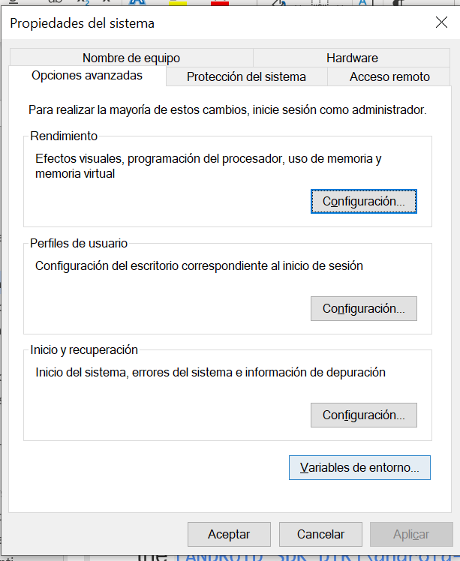
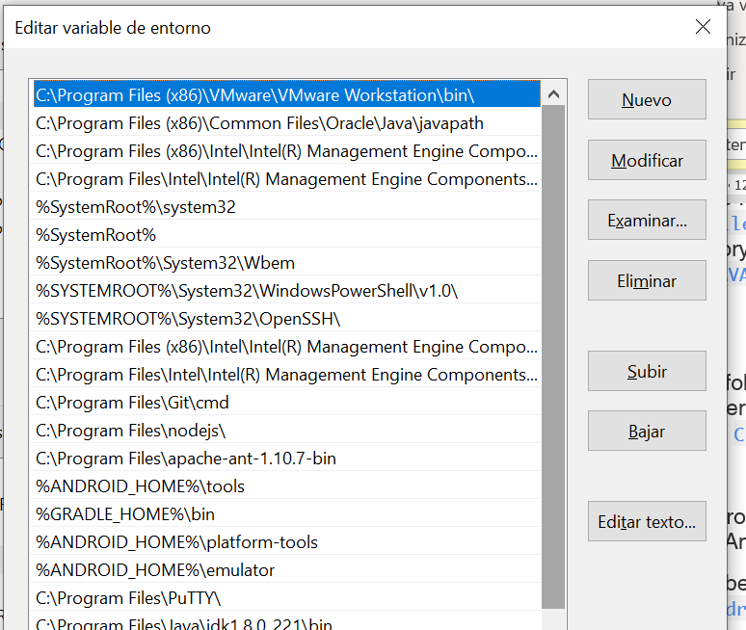

Instalo ionic
npm install -g ionic

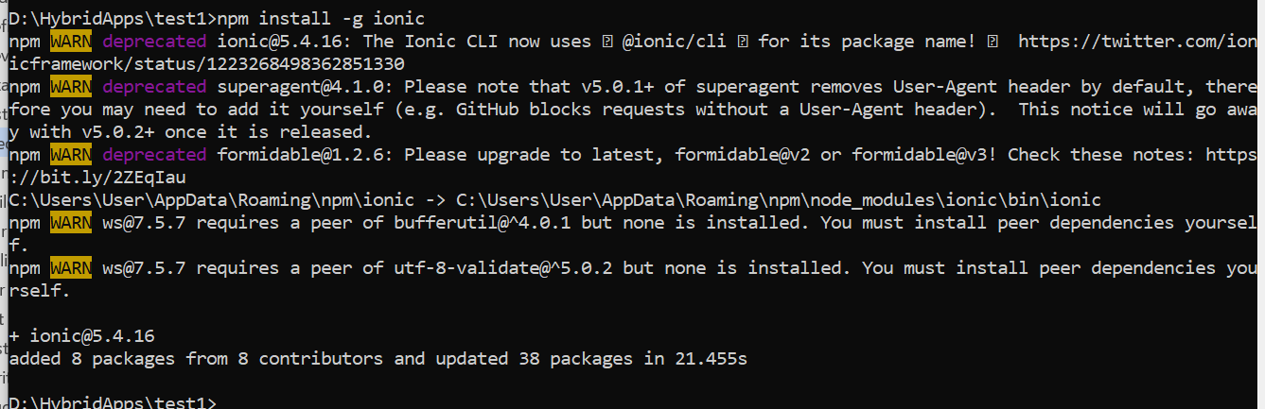

Instalo gradle

https://gradle.org/install/

Lo instalamos manualmente.
Nos bajamos solo los binarios

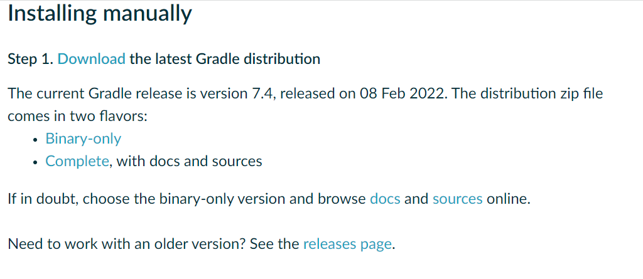
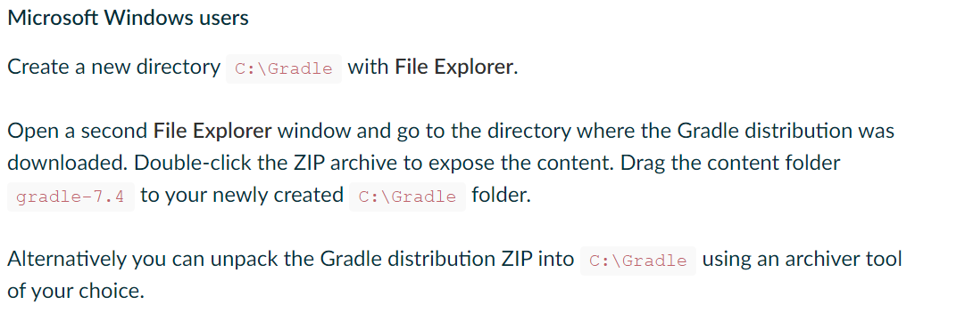
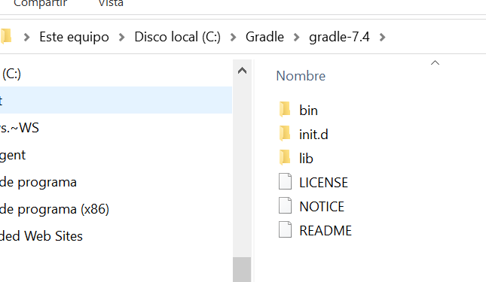

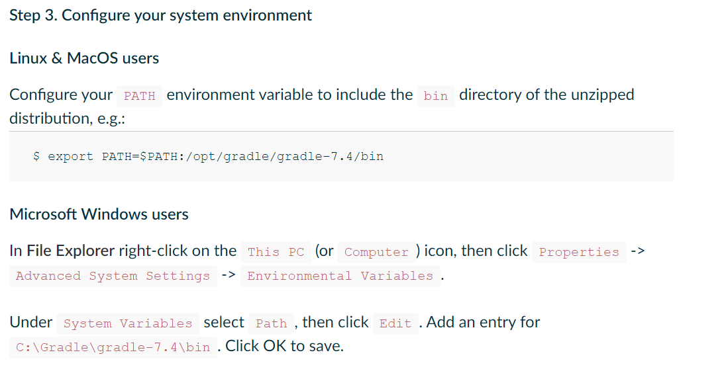

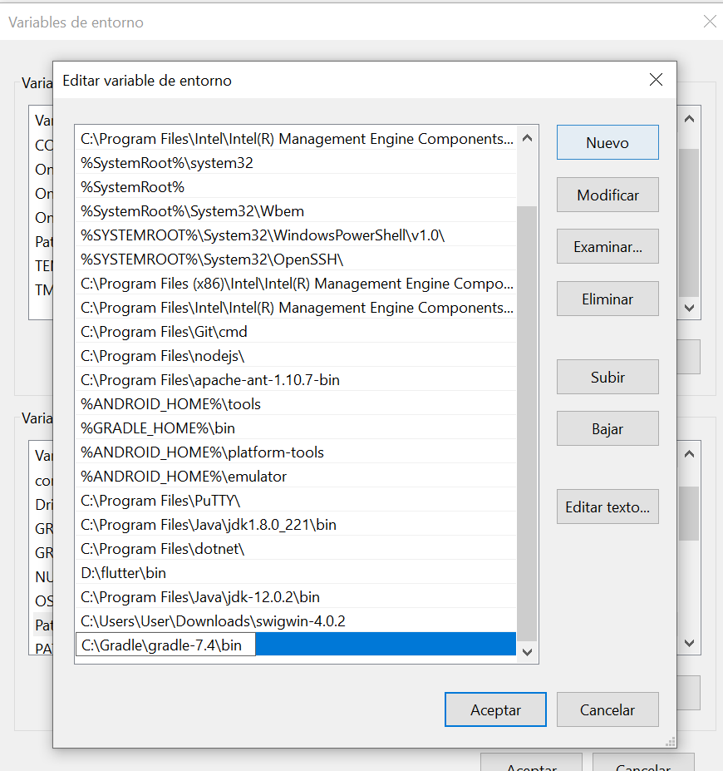

Abrimos nuevo terminal y comprobamos que está instalado

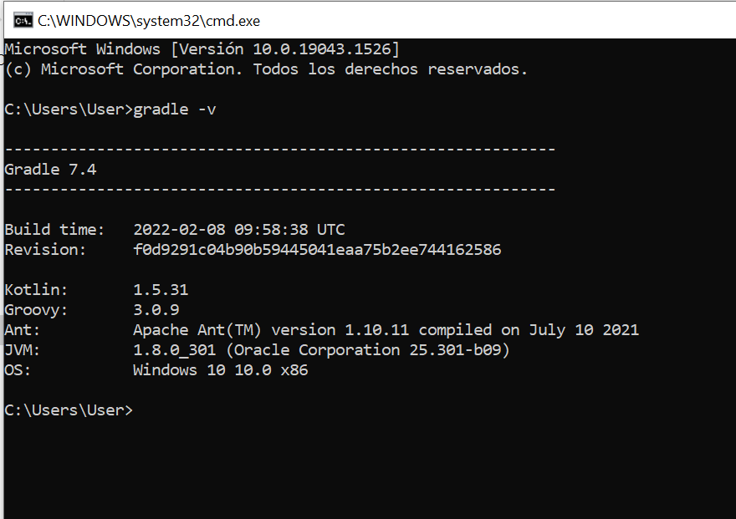

Creo Proyecto “todo” y pruebo la web

ionic start todo blank --type ionic1
o
ionic start todo blank --type angular
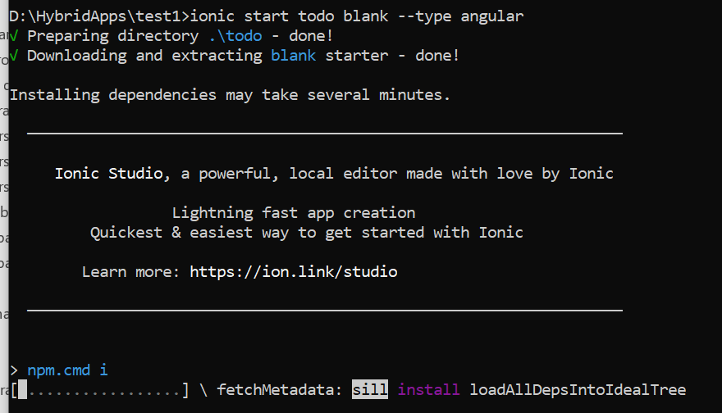
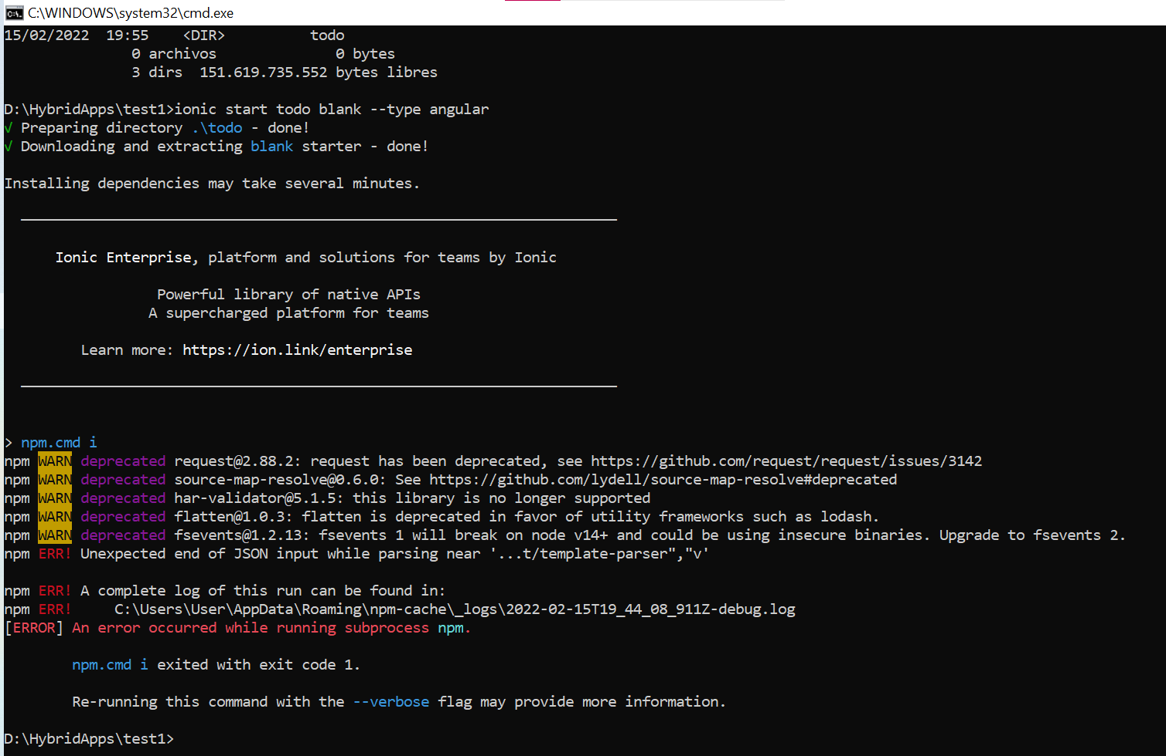

Si da ese error, limpio la cache del npm
npm cache clean –force
Y vuelvo a lanzarlo
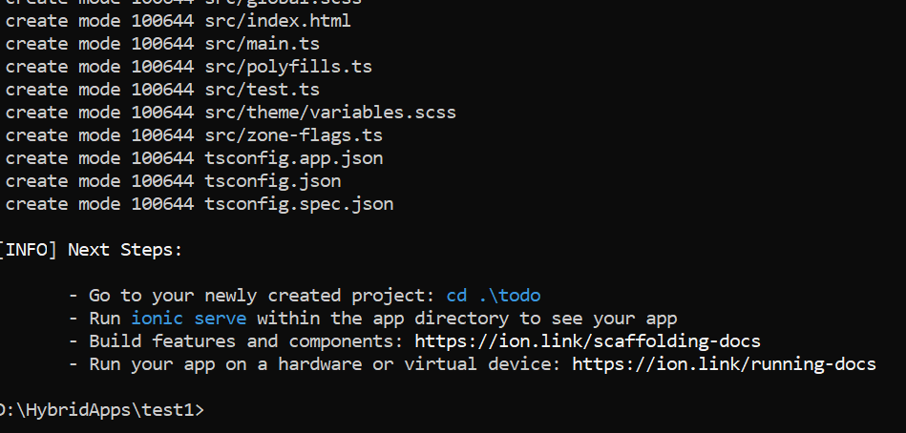

En el directorio del Proyecto lo arranco
cd todo
ionic serve

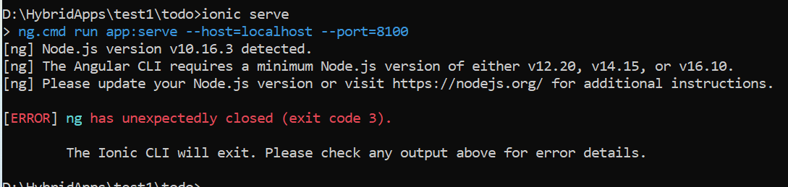

Actualizo la version de nodejs
https://nodejs.org/es/download/
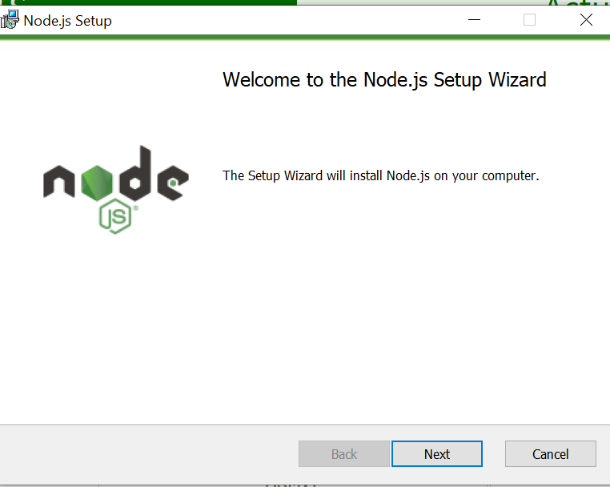
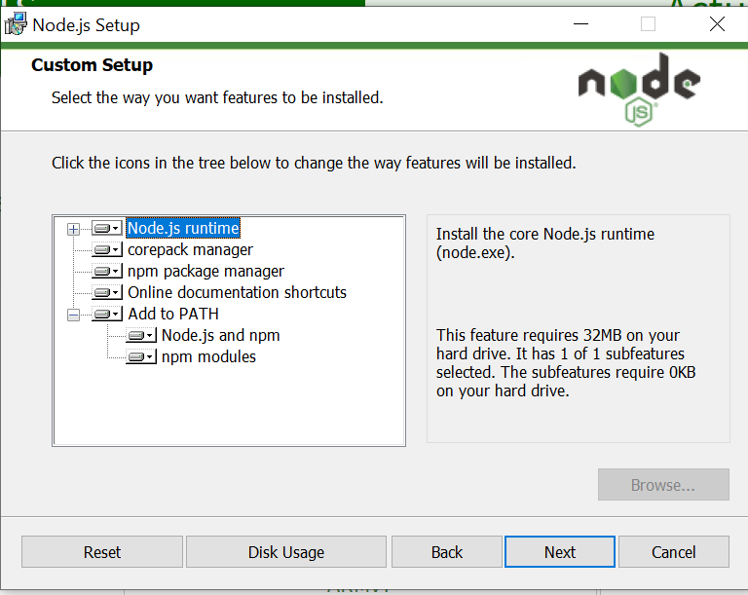
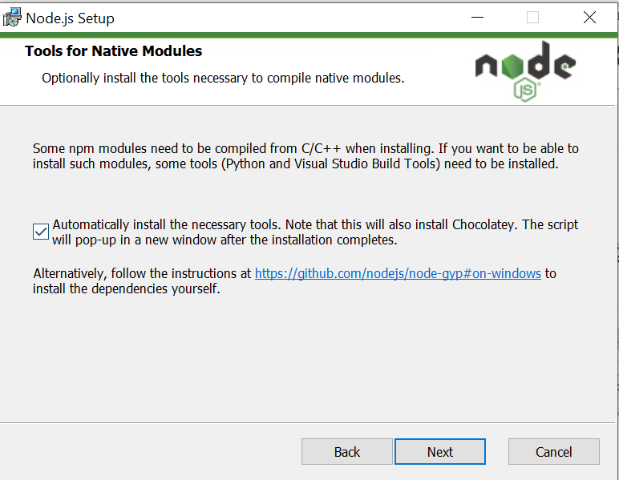
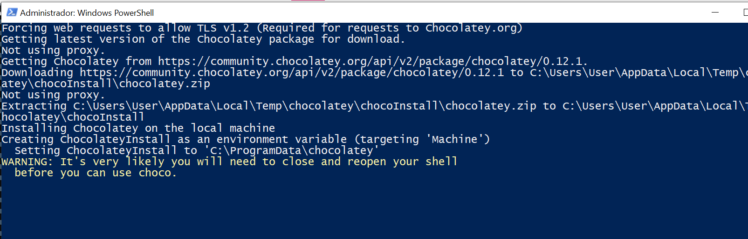
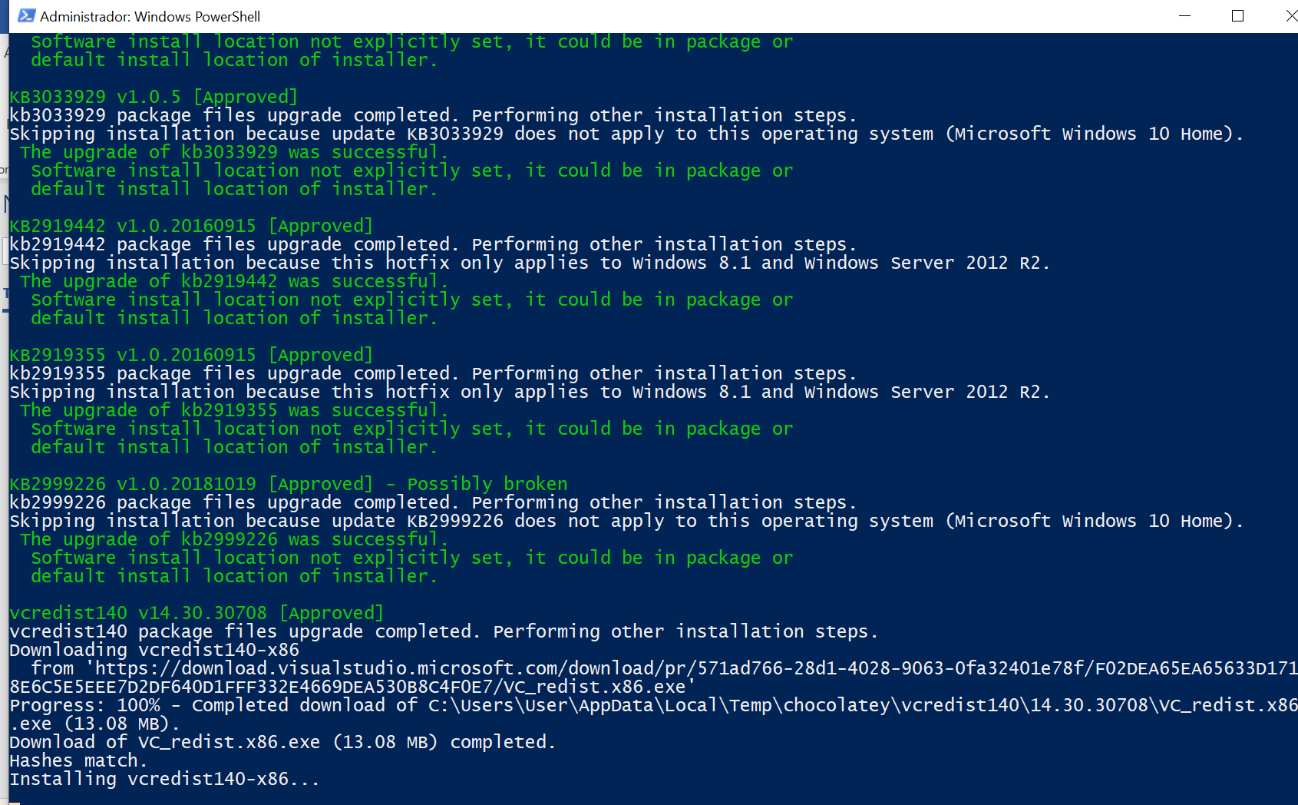
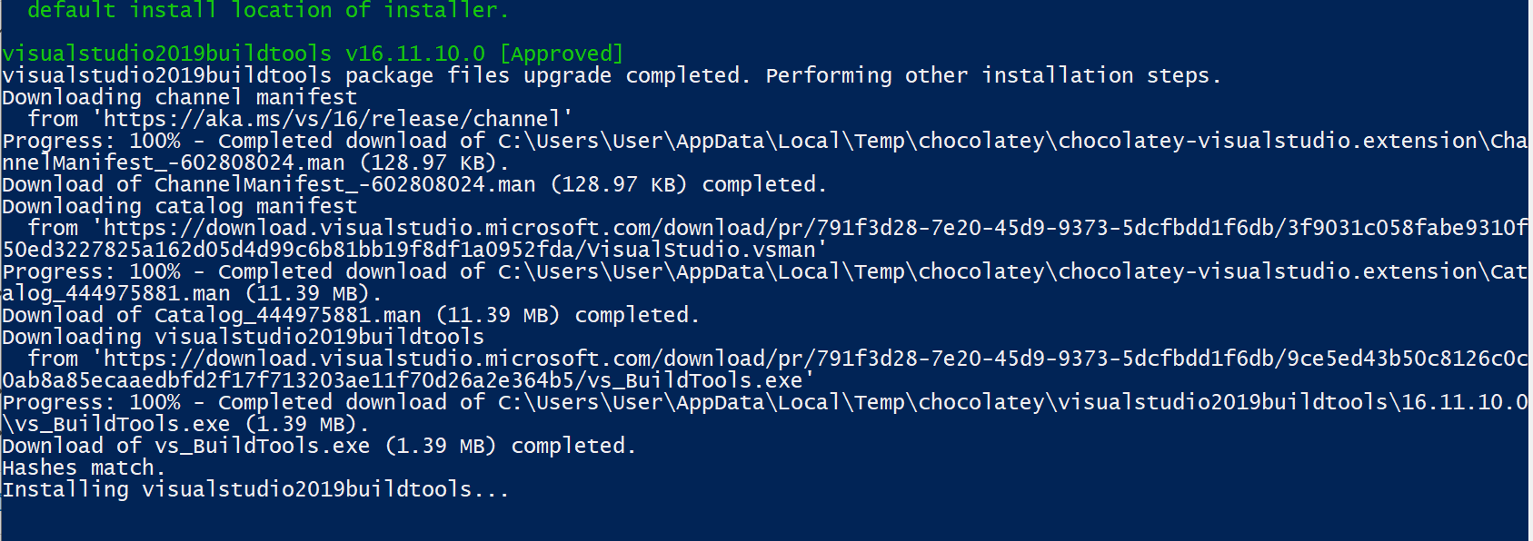
Volvemos a intentar levantar el “ionic serve”
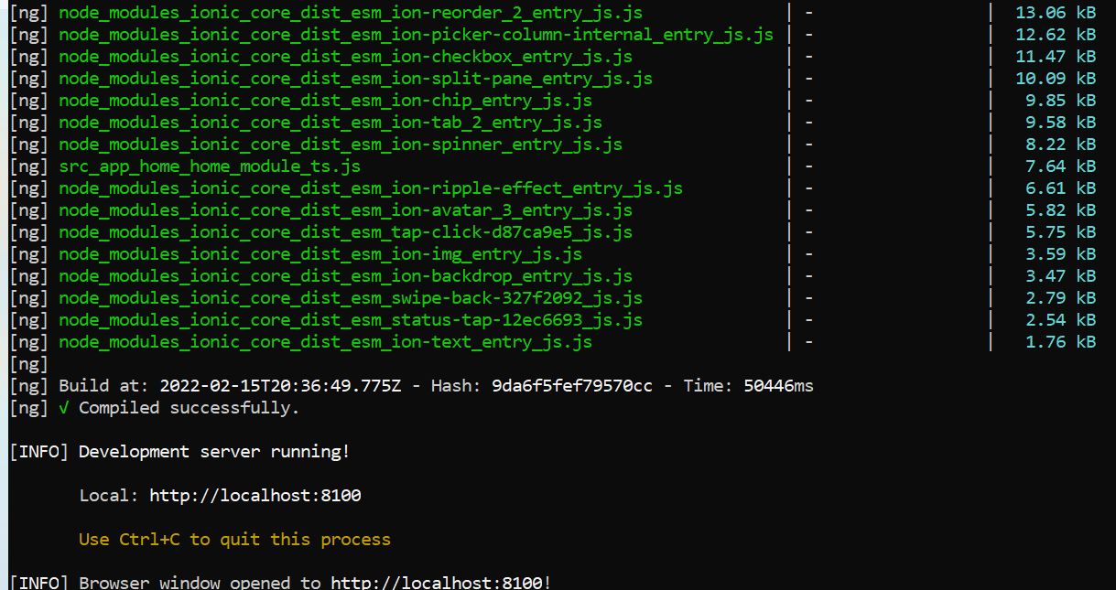
Y vemos la aplicación Angular activa
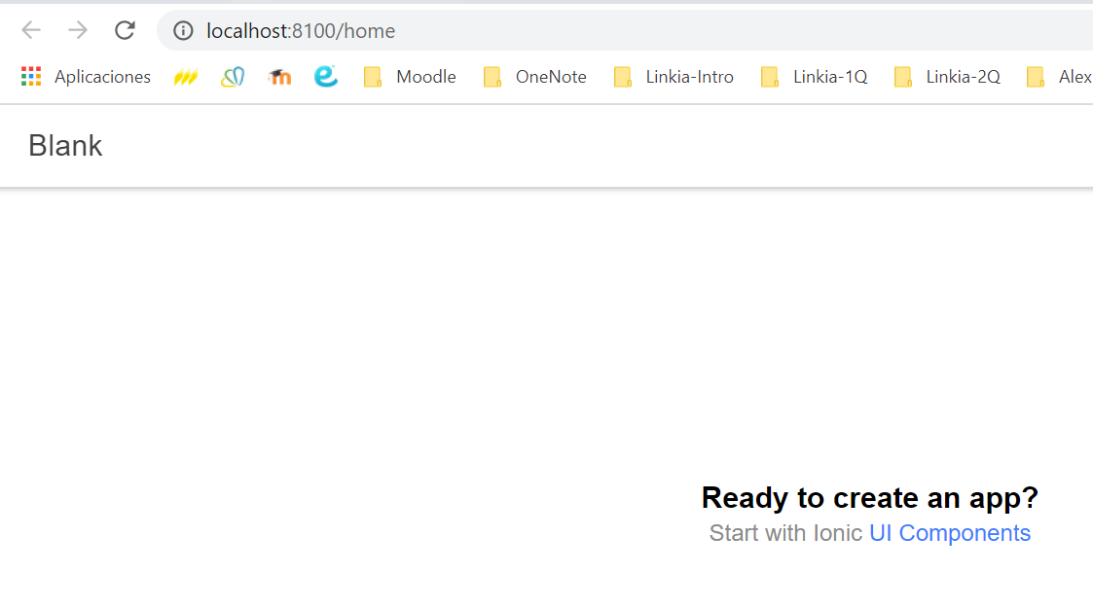

Modifico el “D:\HybridApps\test1\todo\src\app\home\home.page.html”

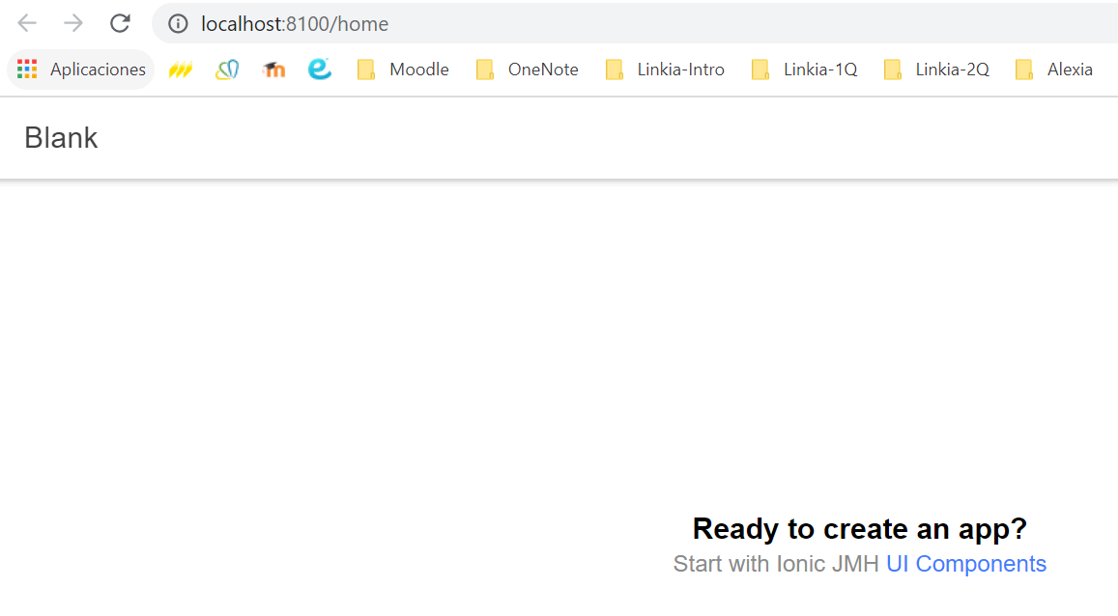

Configure Platforms de iOS y Android

Now, we need to tell ionic that we want to enable the iOS and Android platforms. Note: unless you are on MacOS, leave out the iOS platform:
$ ionic cordova platform add ios
$ ionic cordova platform add android

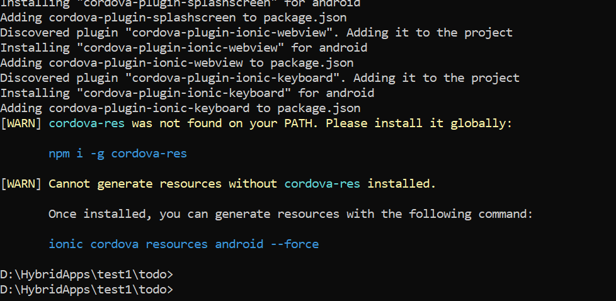

Build
Just to make sure the default project worked, try building and running the project (substitute ios for android to build for Android instead):
$ ionic cordova build android

Error: Cannot find module '@angular-devkit/build-angular/src/angular-cli-files/models/webpack-configs/utils
Solución
npm i @ionic/angular-toolkit@latest

Otro Error:
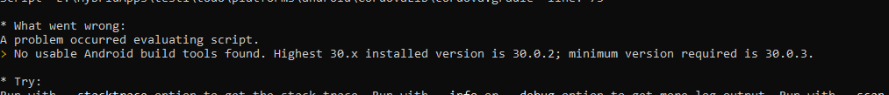
Solución
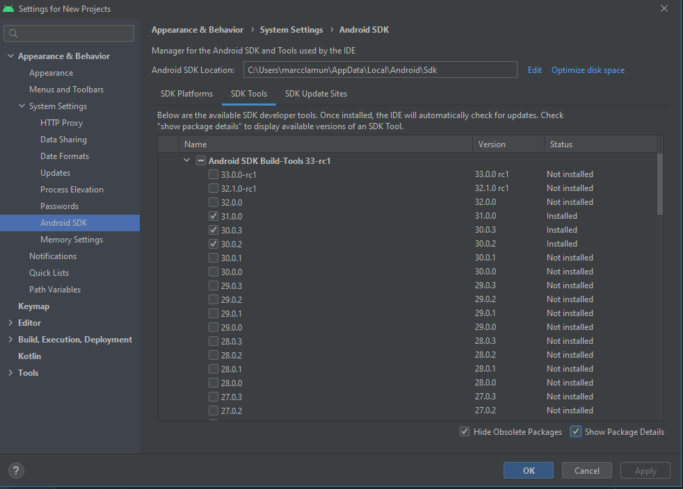
Al final tiene que aparecer el apk
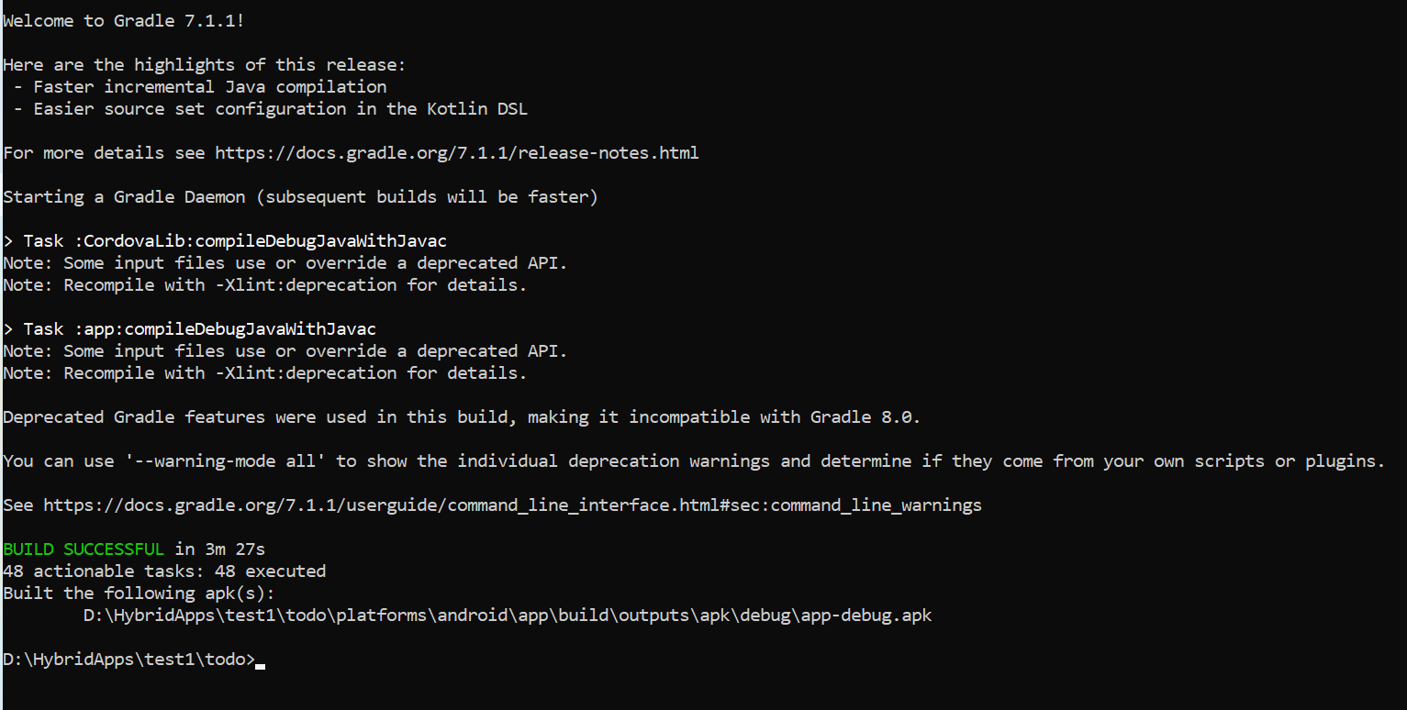
Built the following apk(s):
C:\Users\User\OneDrive - Centre d'Estudis Monlau\DAM-WEB-Mobile\todo\platforms\android\app\build\outputs\apk\debug\app-debug.apk

Lo pruebo en el NOX y me funciona

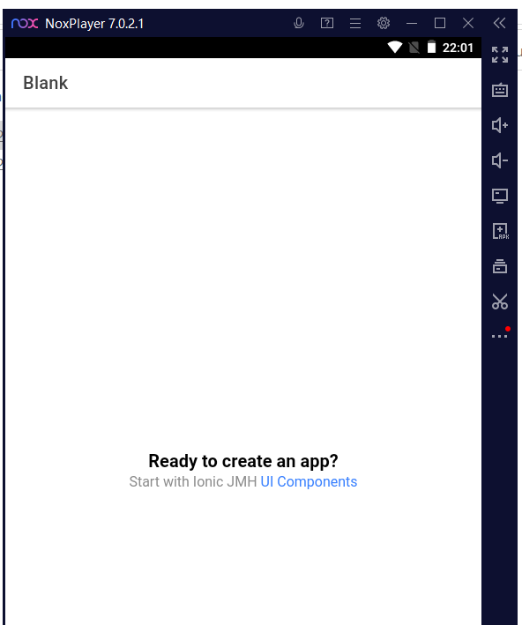

Flutter

https://www.youtube.com/watch?v=CoPnDnJjVSk&list=PLl_hIu4u7P677H9f6zPOHiOz2izkvQq2E (Curso Introducción a Flutter - [01] - Introducción)

- SDK abierto de Google
- Build rápido
- UI bellas
- Rendimiento nativo. Se compila con código nativo
- Dart
  - Just in time. Se testea rápido
  - Buen Garbage collector. Limpia la cache rápidamente
  - Lenguaje descriptivo
  - Caso éxito: Alibaba
  - Sustituto Android Studio: Fuchsia OS

Instalación: https://flutter.dev/docs/get-started/install/windows

- Download and unzip. Do not unzip in “Programm files”
- Incluirlo en el PATH
- CMD y ejecutar “flutter doctor” (tarda un poco)

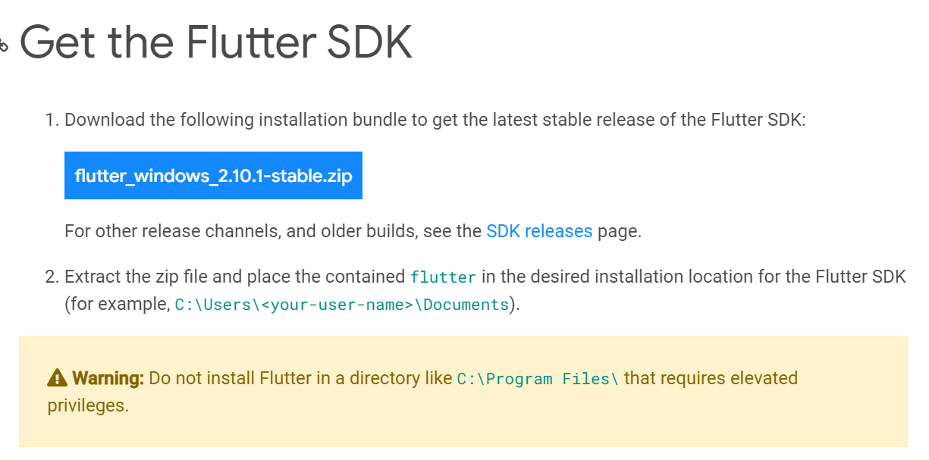

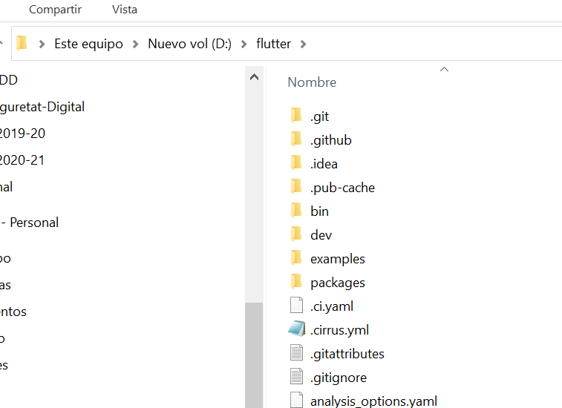

Añadimos en el path

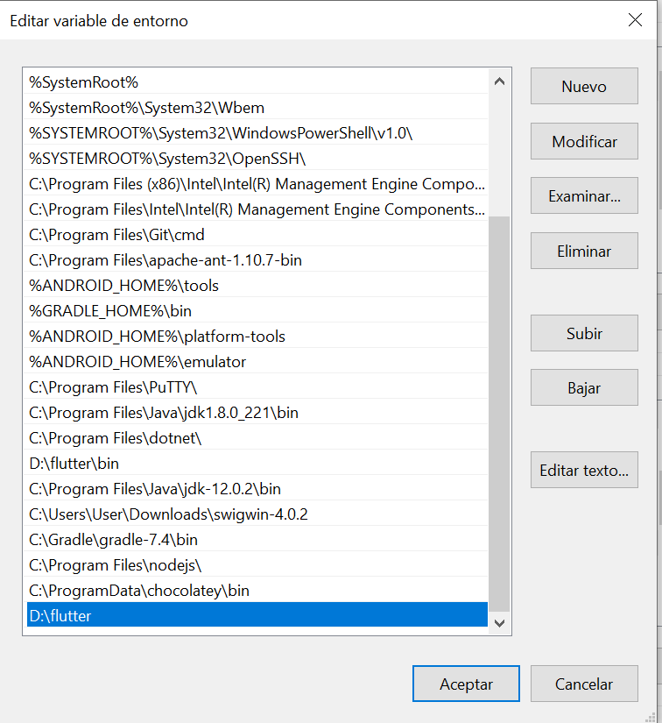

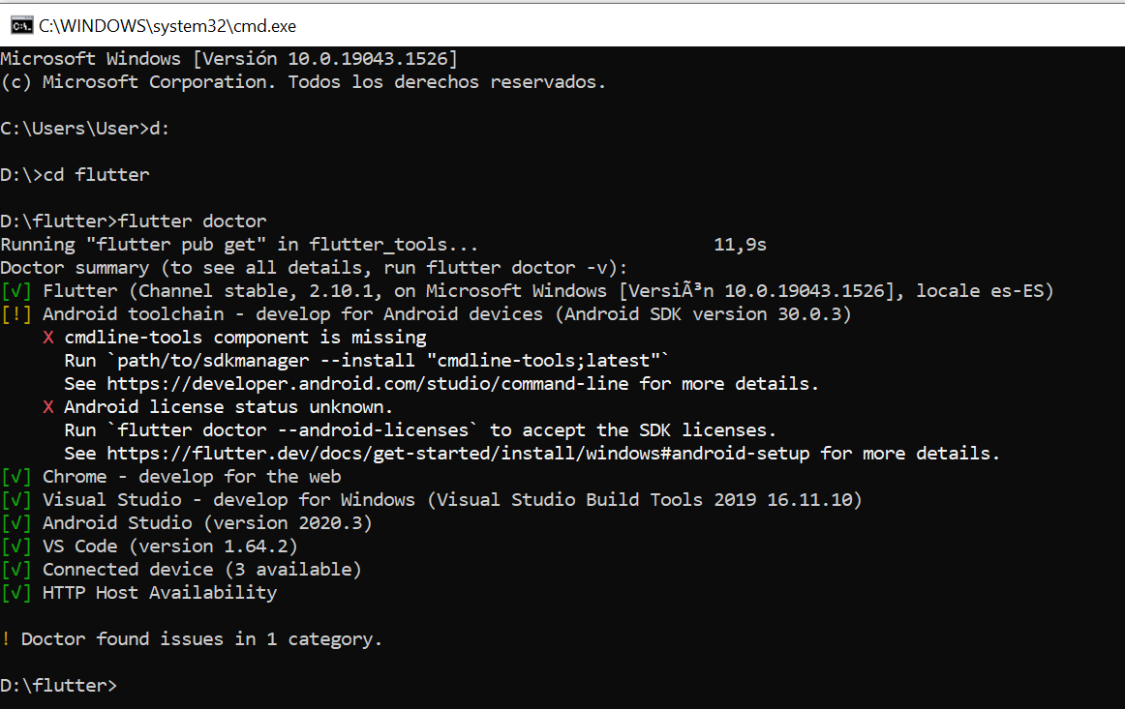

Instalo las dos dependencias que me faltan
C:\Users\User\AppData\Local\Android\Sdk\tools\bin\sdkmanager --install "cmdline-tools;latest"
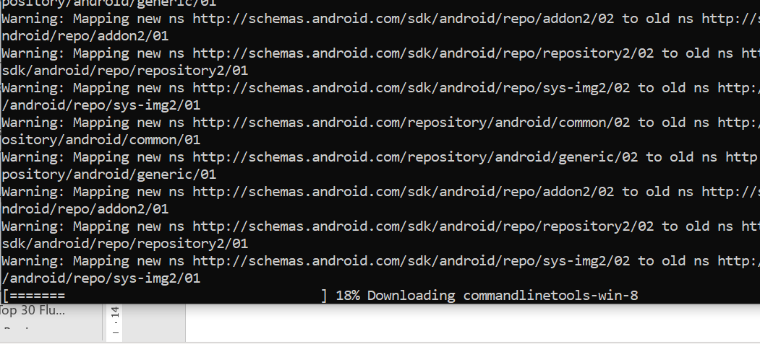
Instala las commandlinetools

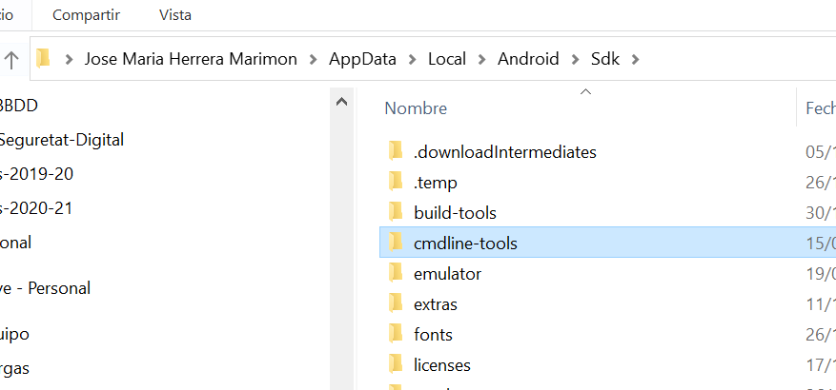
Para aceptar licencias:
flutter doctor --android-licenses
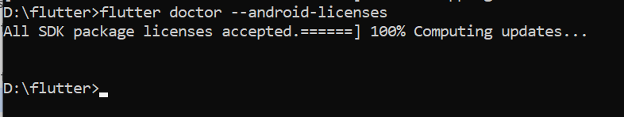

Volvemos a realizar un check del doctor

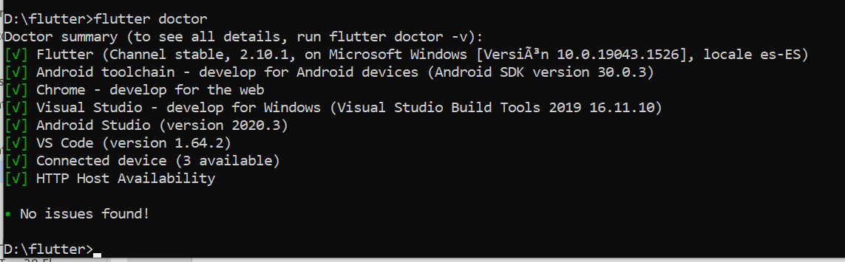

Todo ok
Actualizo plugin de Dark y de Flutter en el Android Studio

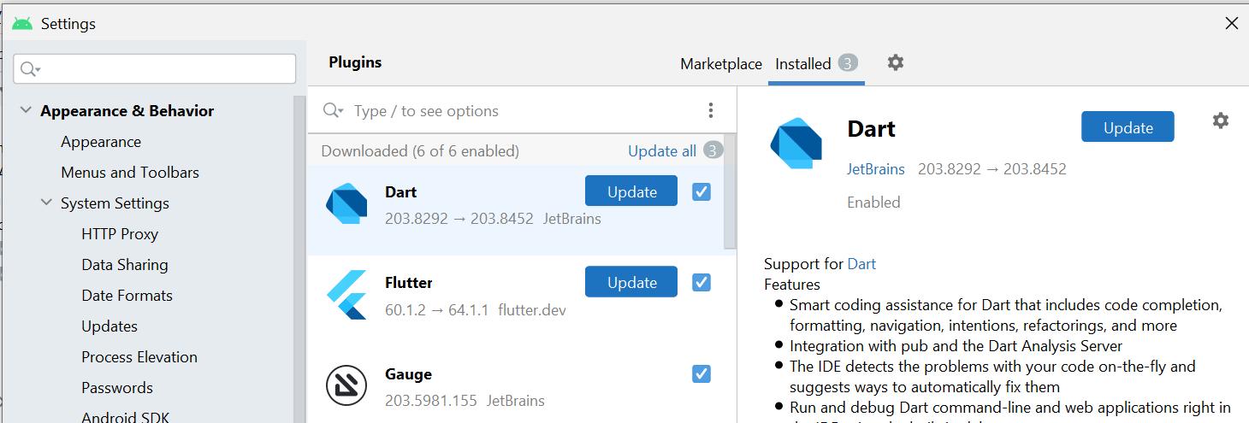

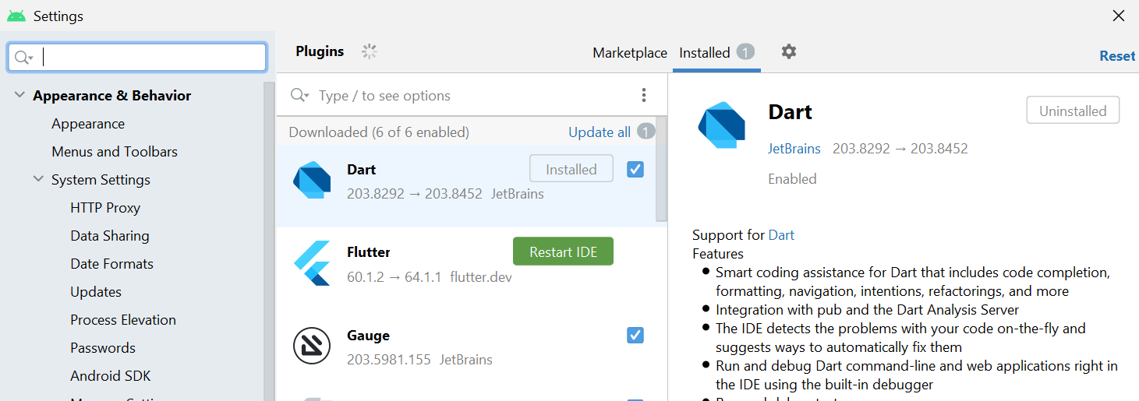
Reiniciamos IDE

En el Android Studio nos aparece una nueva icona para crear aplicaciones de Flutter

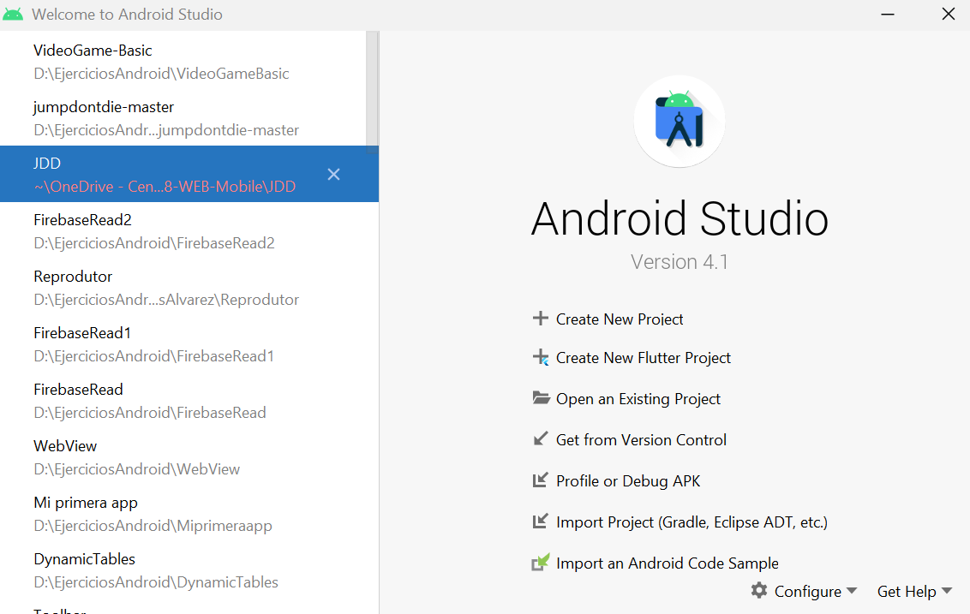

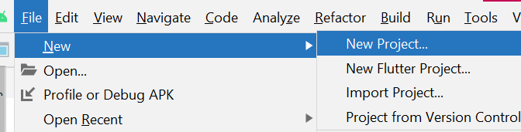
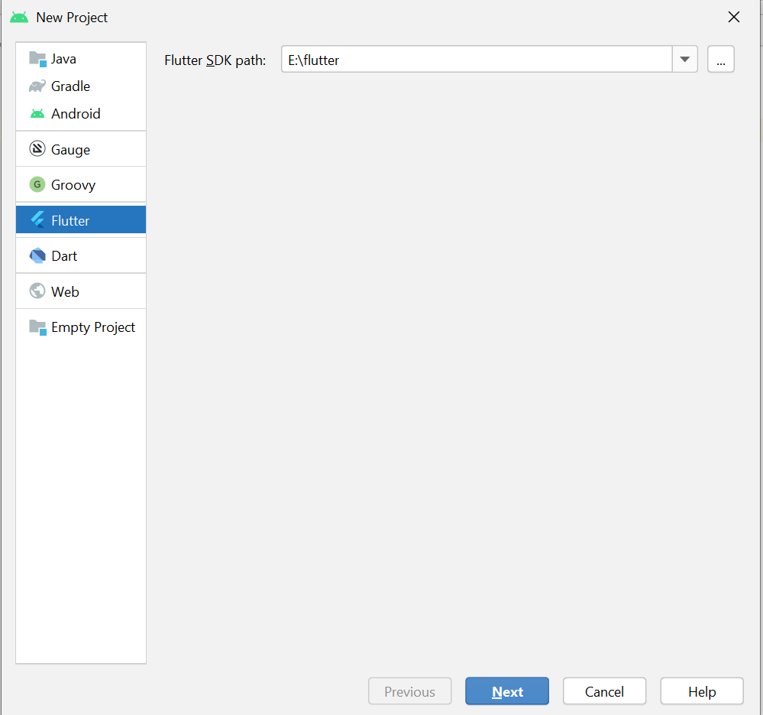
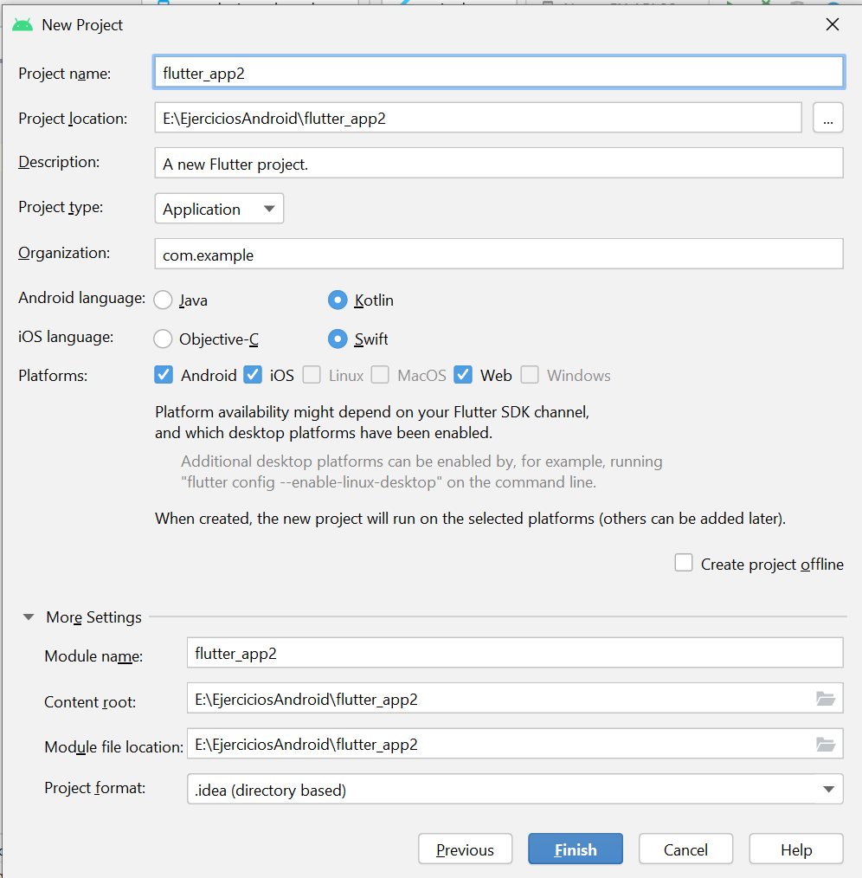

Set up an editor
https://flutter.dev/docs/get-started/editor?tab=androidstudio

Test drive
https://flutter.dev/docs/get-started/test-drive?tab=androidstudio

Con el “reload enable” podemos ejecutar los cambios de una aplicación que está ya abierta de forma mucho más rápida.
OJO: Si está en modo debug no se puede usar el “reload enable”
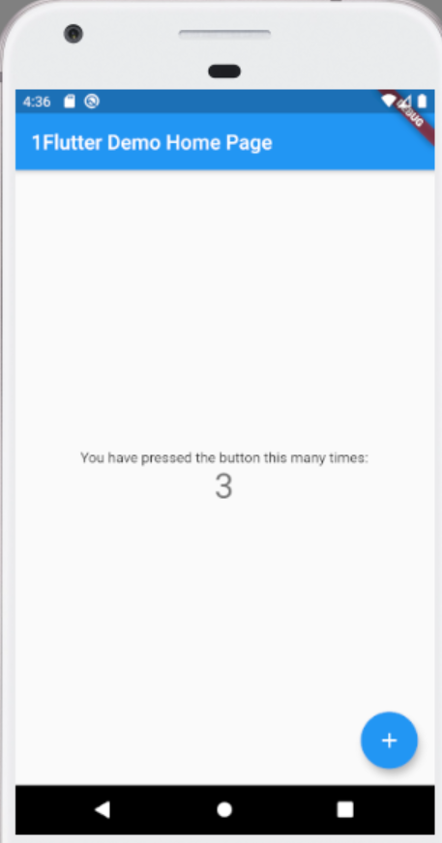

Write your first Flutter app, part 1

App name: “flutter_app”
https://flutter.dev/docs/get-started/codelab

Execute on Web

Para poder ejecutar el flutter como una aplicación web tenemos que configurarlo de la siguiente forma:
flutter channel beta
flutter upgrade
flutter config --enable-web

La página web inicial se vería de esta forma
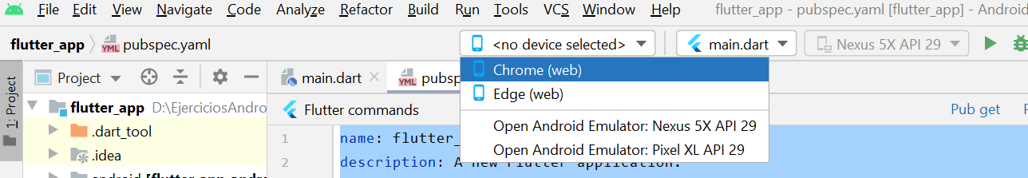
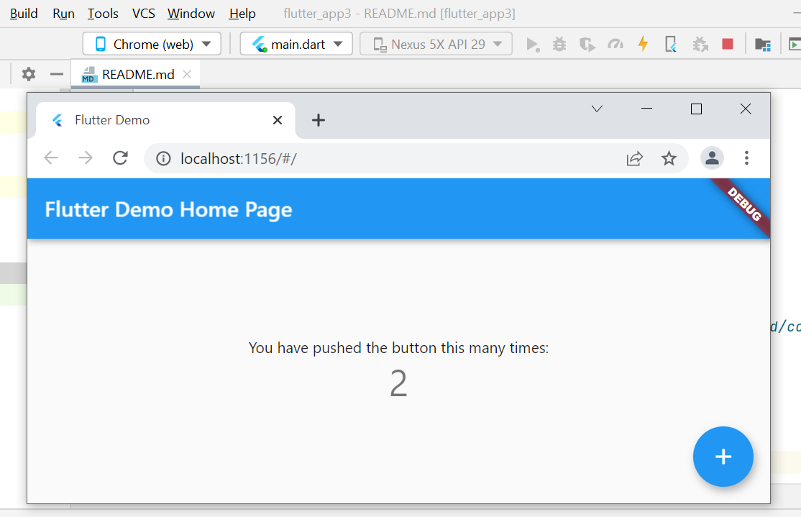

La página web

Use Pub get
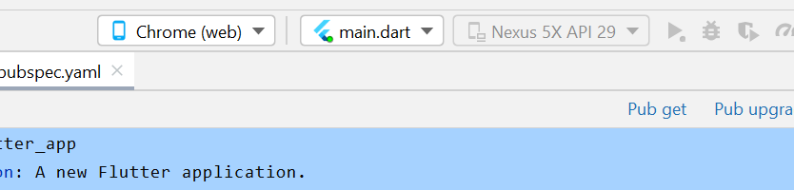
Ejecutándolo en el browser:

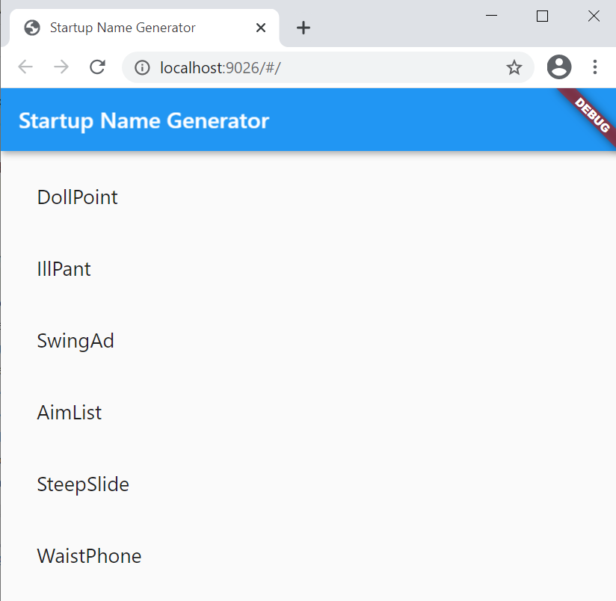

main.dark

// Copyright 2018 The Flutter team. All rights reserved.
// Use of this source code is governed by a BSD-style license that can be
// found in the LICENSE file.
import 'package:flutter/material.dart';
import 'package:english_words/english_words.dart';
void main() => runApp(MyApp());
class MyApp extends StatelessWidget {
@override
Widget build(BuildContext context) {
return MaterialApp(
title: 'Startup Name Generator',
home: RandomWords(),
);
}
}
class RandomWords extends StatefulWidget {
@override
_RandomWordsState createState() => _RandomWordsState();
}
class _RandomWordsState extends State<RandomWords> {
final _suggestions = <WordPair>[];
final _biggerFont = TextStyle(fontSize: 18.0);
@override
Widget build(BuildContext context) {
return Scaffold(
appBar: AppBar(
title: Text('Startup Name Generator'),
),
body: _buildSuggestions(),
);
}
Widget _buildSuggestions() {
return ListView.builder(
padding: EdgeInsets.all(16.0),
itemBuilder: /*1*/ (context, i) {
if (i.isOdd) return Divider(); /*2*/
final index = i ~/ 2; /*3*/
if (index >= _suggestions.length) {
_suggestions.addAll(generateWordPairs().take(10)); /*4*/
}
return _buildRow(_suggestions[index]);
});
}
Widget _buildRow(WordPair pair) {
return ListTile(
title: Text(
pair.asPascalCase,
style: _biggerFont,
),
);
}
}

pubspec.yaml

name: flutter_app
description: A new Flutter application.
# The following line prevents the package from being accidentally published to
# pub.dev using `pub publish`. This is preferred for private packages.
publish_to: 'none' # Remove this line if you wish to publish to pub.dev
# The following defines the version and build number for your application.
# A version number is three numbers separated by dots, like 1.2.43
# followed by an optional build number separated by a +.
# Both the version and the builder number may be overridden in flutter
# build by specifying --build-name and --build-number, respectively.
# In Android, build-name is used as versionName while build-number used as versionCode.
# Read more about Android versioning at https://developer.android.com/studio/publish/versioning
# In iOS, build-name is used as CFBundleShortVersionString while build-number used as CFBundleVersion.
# Read more about iOS versioning at
# https://developer.apple.com/library/archive/documentation/General/Reference/InfoPlistKeyReference/Articles/CoreFoundationKeys.html
version: 1.0.0+1
environment:
sdk: ">=2.7.0 <3.0.0"
dependencies:
flutter:
sdk: flutter
# The following adds the Cupertino Icons font to your application.
# Use with the CupertinoIcons class for iOS style icons.
cupertino_icons: ^1.0.0
english_words: ^3.1.5
dev_dependencies:
flutter_test:
sdk: flutter
# For information on the generic Dart part of this file, see the
# following page: https://dart.dev/tools/pub/pubspec
# The following section is specific to Flutter.
flutter:
# The following line ensures that the Material Icons font is
# included with your application, so that you can use the icons in
# the material Icons class.
uses-material-design: true
# To add assets to your application, add an assets section, like this:
# assets:
# - images/a_dot_burr.jpeg
# - images/a_dot_ham.jpeg
# An image asset can refer to one or more resolution-specific "variants", see
# https://flutter.dev/assets-and-images/#resolution-aware.
# For details regarding adding assets from package dependencies, see
# https://flutter.dev/assets-and-images/#from-packages
# To add custom fonts to your application, add a fonts section here,
# in this "flutter" section. Each entry in this list should have a
# "family" key with the font family name, and a "fonts" key with a
# list giving the asset and other descriptors for the font. For
# example:
# fonts:
# - family: Schyler
# fonts:
# - asset: fonts/Schyler-Regular.ttf
# - asset: fonts/Schyler-Italic.ttf
# style: italic
# - family: Trajan Pro
# fonts:
# - asset: fonts/TrajanPro.ttf
# - asset: fonts/TrajanPro_Bold.ttf
# weight: 700
#
# For details regarding fonts from package dependencies,
# see https://flutter.dev/custom-fonts/#from-packages

Trucos de flutter (Top 30 Flutter Tips and Tricks)

https://youtu.be/5vDq5DXXxss

Flutter Tutorial for Beginners 2021 | Flutter 2.0

https://www.youtube.com/watch?v=RkGvqjYESPg&t=1184s

Flutter Authentication and Authorization with Auth0, Part 1: Adding Authentication to an App

https://auth0.com/blog/flutter-authentication-authorization-with-auth0-part-1-adding-authentication-to-an-app/

Flutter samples

https://flutter.github.io/samples/#

