**CHAPTER-1  
INTRODUCTION**

The digital transformation journey encompasses the integration of advanced technologies like Artificial Intelligence, Machine Learning, Data Science has redefined the way businesses operate and individuals engage with technology. These technologies enable organizations to digitize their operations, automate tasks, and gain deeper insights from data, leading to increased efficiency, agility, and competitiveness. The emergence of Conversational agents, a hallmark of contemporary artificial intelligence (AI), have redefined the landscape of human-machine interaction, forging a symbiotic relationship between users and technology. One of the defining features of transformative conversational agents is their capacity for personalization and adaptability. Through sophisticated user modelling techniques, these agents can infer user preferences, behaviours, and intentions, thereby tailoring their responses and recommendations to suit individual needs. The conversational agent in question is a multifunctional AI system designed to perform tasks such as abstractive text summarization, multilingual inclusion, and audio and video generation known as multimedia dissemination. Each of these capabilities contributes to the agent's ability to comprehend, process, and communicate information across diverse contexts and languages.

Abstractive Text summarization, a key feature of conversational agents, involves condensing large volumes of text into concise and coherent summaries. This capability is invaluable in scenarios where users are inundated with information and need to quickly grasp the key points. By employing advanced natural language processing techniques like BART and Language model, conversational agents can analyse and summarize text with a high degree of accuracy, providing users with relevant and digestible content. Language translation is another area where conversational agents are driving significant advancements. By integrating with Neural Translation Algorithm [NMT], these agents can facilitate real-time translation between multiple languages, breaking down language barriers and enabling seamless communication across diverse linguistic contexts. This capability is particularly valuable in globalized settings, where organizations and individuals need to interact with stakeholders from different language backgrounds. In the context of digital transformation, the integration of text summarization and language translation capabilities into conversational agents is enabling organizations to operate more efficiently and reach a wider audience. Beyond text summarization and language translation, conversational agents are also incorporating text-to-audio and text-to-video conversion capabilities, further enhancing their versatility and impact in the digital transformation landscape.

Multimedia dissemination involves executing fundamental media functions, such as generating audio and video content, and delivering them as outputs to users. Text-to-audio conversion enables conversational agents to convert text-based content into audio files using pydub library and TTS using BERT embeddings, allowing users to listen to information instead of reading it. This capability is particularly valuable for users with visual impairments or those who prefer auditory learning styles. By providing content in audio format, conversational agents can make information more accessible and inclusive, catering to a wider range of users. Similarly, text-to-video conversion enables conversational agents to convert text-based content into video format, adding a visual dimension to the information. This capability is beneficial for conveying complex ideas or instructions that may be better understood through visual aids. This enhancement is achieved using ffmpeg technique.  By creating videos from text, conversational agents can enhance the effectiveness of communication and engagement, particularly in educational or instructional contexts. As we delve into the technical intricacies and methodologies employed in the creation of this dynamic conversational agent, the broader implications for human-machine interaction, information dissemination, and cross-cultural communication are explored. This research, therefore, propels the conversation around conversational AI into a new era, where adaptability, inclusivity, and sophistication converge to redefine the possibilities of interactive technology in the digital age.

The multifunctional AI system presented in this project offers a plethora of advantages, revolutionizing the way we interact with information across diverse contexts and languages. The system promotes inclusivity by bridging linguistic barriers and providing personalized experiences tailored to individual preferences and needs. A paradigm shifted human-machine interaction, fostering enhanced accessibility, efficiency, and engagement in the digital age. The conversational AI agent facilitates the delivery of personalized, multilingual news summaries and dynamic multimedia content, catering to diverse audience preferences and enhancing engagement. Media consumers enjoy immersive and engaging content experiences, delivered seamlessly in multiple languages and multimedia formats. The system offers tailored experiences that cater to the specific needs and preferences of students, healthcare consumers, and business professionals facilitating enhanced communication, accessibility, and engagement. By understanding the potential and challenges associated with these technologies, organizations can harness the power of conversational agents to drive innovation, enhance user experiences, and unlock new opportunities in the digital age.

**1.1 OBJECTIVE**

The purpose of transformative conversational agent is to seamlessly embed generative AI technology into a user-centred solution that adapts to the rapidly changing demands of our information-rich digital world. To Embrace a user centric approach to enhance content delivery, education, business management, research, and global communication, information processing and accessibility across diverse fields in the real world. Among this application's key objectives are the following:

* To conduct thorough research into cognitive science to inform the development of AI-driven solutions tailored to individual preferences and cognitive capacities.
* Revolutionize information accessibility through a conversational agent that synthesizes succinct abstracts from uploaded documents.
* Tailor user experience by dynamically delivering content through video and audio formats.
* Enhance multilingual inclusivity by seamlessly translating the generated media into users' regional or native languages, fostering a personalized and globally accessible information hub.
* Integrate generative AI technology to dynamically adapt content delivery to users' evolving needs in our information-saturated digital landscape.

**CHAPTER-2  
LITERATURE SURVEY**

**2.1 AUTONOMOUS TEXT SUMMARIZATION APPROACH**

**[** M. H. H. Wahab, N. H. Ali, N. A. W. A. Hamid, S. K. Subramaniam, R. Latip and M. Othman, "A Review on Optimization-based Automatic Text Summarization Approach, 2023"]

A comprehensive endeavour aimed at revolutionizing the process of automatically condensing textual documents into concise and informative summaries. An exhaustive review of existing research in the field, the project delves into the intricacies of automatic text summarization, exploring a wide range of algorithms, techniques, and evaluation metrics utilized in both extractive summarization methods. Clustering techniques, such as K-means clustering or hierarchical clustering, may be applied to group similar sentences or phrases together and identify clusters of related content within the document [4]. These clusters can then be used to generate summary sentences representative of each cluster. Building upon the foundation, it endeavours to design and implement an innovative approach that leverages optimization techniques to extract the most salient information from the original text while maintaining coherence and preserving meaning as mentioned in Figure 2.1. Through the development of sophisticated algorithms, incorporating graph-based ranking, mathematical optimization, and machine learning, the project seeks to identify and prioritize key sentences or phrases that encapsulate the core ideas of the document.

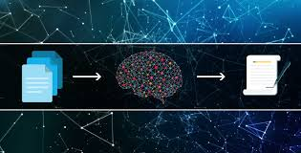

Figure 2.1 Text Summarization

Rigorous experimentation and evaluation follow, as the approach is put to the test across diverse sets of textual documents spanning various domains and genres. Quantitative analysis, employing metrics such as ROUGE, provides insight into the overlap between generated and reference summaries, while qualitative assessments evaluate the readability, coherence, and informativeness of the generated summaries. Throughout the project, a keen focus is placed on optimizing the summarization process for efficiency, scalability, and accuracy, addressing computational challenges and fine-tuning parameters to ensure optimal performance. Ultimately, the goal of the project is to develop a novel method for automatic text summarization that produces high-quality summaries capable of facilitating efficient information retrieval and comprehension, thereby advancing the field of natural language processing and opening new avenues for automated content analysis and understanding.

**2.2 TEXT TO SPEECH SOLUTION FOR AGGLUTINATIVE LANGUAGES**

    [ R. Liu, Y. Hu, H. Zuo, Z. Luo, L. Wang and G. Gao, "Text-to-Speech for Low-Resource Agglutinative Language with Morphology-Aware Language Model Pre-Training,"2023]

A sophisticated Text-to-Speech (TTS) system tailored for low-resource agglutinative languages, characterized by complex morphological structures. The central focus lies in addressing the challenges inherent in these languages, including limited linguistic resources and intricate morphological patterns, to create a more accurate and natural-sounding TTS system. The idea employs a multi-faceted approach, beginning with Morphology-Aware Language Model Pre-Training, [7] wherein neural network-based models, such as recurrent neural networks (RNNs) or transformer models, are trained to capture the intricate morphological patterns and linguistic nuances of the target language. Subsequently, Grapheme-to-Phoneme (G2P) conversion algorithms are utilized to accurately predict the pronunciation of words, accounting for dynamic changes in word forms based on morphological processes.

Neural network-based acoustic modelling techniques, such as RNNs, convolutional neural networks (CNNs), or transformer models, are then employed to map linguistic features, such as phonemes and prosody, to corresponding acoustic representations. Finally, waveform synthesis methods, including waveform concatenation, deep neural network-based synthesis, or generative adversarial networks (GANs), are utilized to generate natural-sounding speech waveforms. Throughout the project, emphasis is placed on fine-tuning algorithms to handle the unique challenges posed by low-resource agglutinative languages, such as scarcity of linguistic resources and accurate representation of morphological structures. The ultimate goal of the speech conversion module is to provide an effective and inclusive TTS solution as mentioned in Figure 2.2 that enhances accessibility and communication for speakers of low-resource agglutinative languages, thereby contributing to technological inclusivity and linguistic diversity.

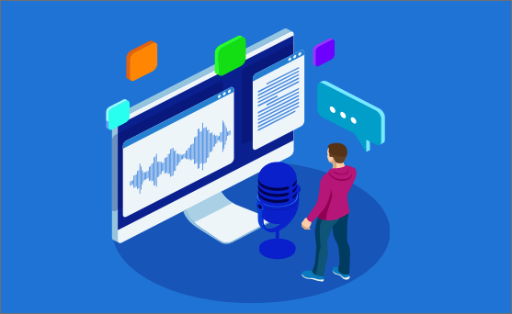

Figure 2.2 Text to Speech

The TTS system enhances accessibility for speakers of low-resource agglutinative languages by providing a means to convert written text into natural-sounding speech, facilitating communication and comprehension for individuals with limited literacy skills or visual impairments. One of the primary challenges of developing TTS systems for low-resource agglutinative languages is the scarcity of linguistic resources, such as annotated speech corpora and pronunciation dictionaries, which are essential for training accurate and robust models.

**2.3 A TRANSLATIONAL MODEL FOR INDONESIA’S LANGUAGES**

[W. Wongso, A. Joyoadikusumo, B. S. Buana and D. Suhartono, "Many-to-Many Multilingual Translation Model for Languages of Indonesia,2023"]

A translation model capable of seamlessly translating between multiple languages spoken in Indonesia. Many to many translational model is particularly significant due to the linguistic diversity present in Indonesia, where hundreds of languages are spoken across different regions and communities. The core of the project involves the implementation of advanced machine learning algorithms, including transformer-based models, to train a many-to-many multilingual translation model. Transformer models, such as BERT (Bidirectional Encoder Representations from Transformers) or its variants, have demonstrated remarkable capabilities in natural language processing tasks, including translation.

The M-M translation model leverages techniques such as language embeddings and multilingual representations to capture the shared linguistic features and structures across different languages spoken in Indonesia [9]. By embedding multiple languages into a unified vector space, the model can effectively learn and generalize patterns from one language to another, facilitating more accurate and robust translations. These models leverage self-attention mechanisms to capture long-range dependencies and contextual information from input sequences, enabling them to generate high-quality translations as mentioned in Figure 2.3. Additionally, the model incorporates techniques such as transfer learning and fine-tuning to adapt the translation model to the specific linguistic characteristics and dialectal variations of the languages spoken in Indonesia. By leveraging large-scale multilingual corpora and advanced training strategies, the system aims to overcome the challenges posed by the linguistic diversity of Indonesia and develop a robust and accurate translation model capable of facilitating communication and information exchange across linguistic barriers. The success of the project has the potential to have a transformative impact on various sectors, including education, governance, and commerce, by enabling seamless multilingual communication and access to information for speakers of diverse Indonesian languages.

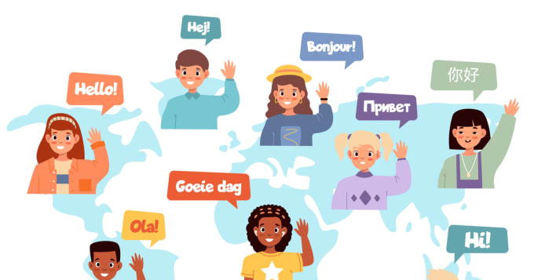

Figure 2.3 Multilanguage Translation

The model facilitates seamless communication and information exchange across different linguistic groups and dialectal variations, promoting inclusivity and fostering socio-economic development. Moreover, the development of a robust translation model contributes to the preservation and revitalization of indigenous languages, supporting cultural heritage and linguistic diversity. However, the project also faces challenges, such as the need for large-scale multilingual corpora, computational resources, and fine-tuning algorithms to accommodate the intricacies of each language and dialect.

**2.4 TEXT TO ANIMATION SYSTEMS**

      [ N. Bouali and V. Cavalli-Sforza, "A Review of Text-to-Animation Systems, 2023" ]

Text to Animation system can automatically generate animations from textual input. This initiative integrates principles from natural language processing (NLP), computer vision, and animation synthesis to create a seamless pipeline for transforming textual descriptions into visually compelling animations. At its core, this endeavour relies on advanced algorithms to extract semantic meaning and context from textual input. Natural language processing techniques, such as text parsing, entity recognition, and sentiment analysis, are employed to analyze and understand the content of the input text. Additionally, deep learning models, including recurrent neural networks (RNNs) and transformer-based architectures, are utilized to generate embeddings or representations of the textual descriptions, capturing their semantic structure and relationships.

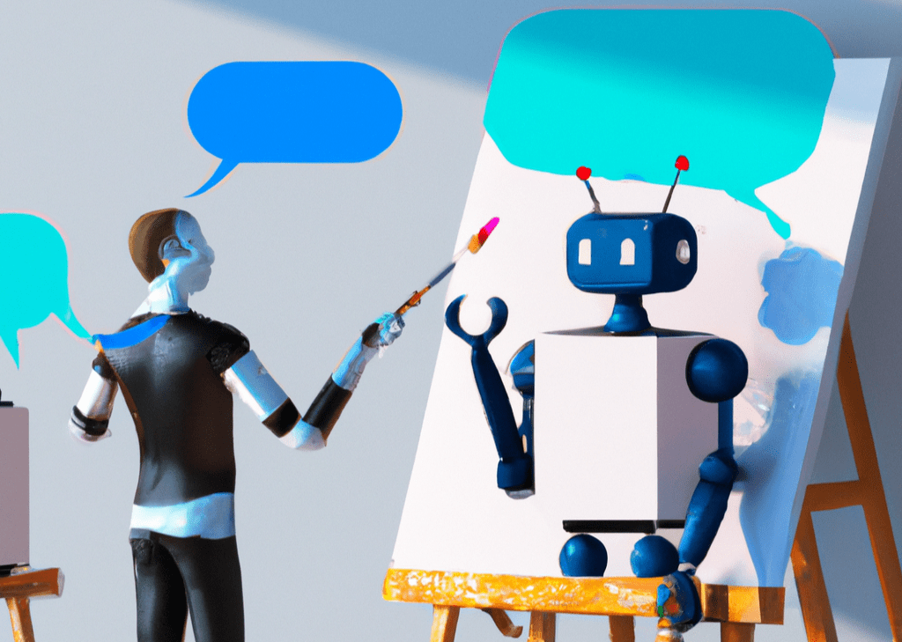

Figure 2.4 Animation Generation

The process starts with the textual input, which is processed and understood, the initiative leverages computer vision algorithms to translate the semantic information into visual elements [6]. Object detection and recognition algorithms identify key entities and objects described in the text, while scene understanding techniques analyse spatial relationships and contexts. These algorithms work together to generate a visual scene that accurately represents the content and context of the textual input.

Furthermore, animation synthesis algorithms are employed to animate the visual elements and bring the scene to life. Techniques such as keyframe animation, motion capture, and procedural animation are utilized to generate dynamic and expressive movements for characters and objects within the scene as mentioned in Figure 2.4. These algorithms take into account the semantics of the textual input, as well as the emotional tone and narrative structure, to create animations that are engaging and emotionally resonant. Throughout this endeavour, a key focus is placed on user interaction and feedback. Interactive interfaces allow users to provide input, refine animations, and adjust parameters to achieve desired results. Additionally, user feedback mechanisms are incorporated to evaluate the quality and effectiveness of the generated animations, enabling iterative refinement and improvement of the system.

**2.5 INFERENCE**

The exploration of conversational agents reveals their pivotal role in human-machine interaction, showcasing advancements in natural language understanding, abstractive summarization, and multilingual inclusivity. Developing robust Text-to-Speech (TTS) systems for low-resource languages can be challenging due to limited linguistic resources and variations in dialects. Additionally, achieving natural-sounding speech synthesis may be difficult, particularly in languages with complex phonetic or tonal structures. Text Summarization is basically focussed on the extractive summarization. Extractive summarization performs quite weaker than abstractive summarization. Moreover, ensuring the coherence and readability of summaries across different domains and languages poses additional difficulties.

Multilingual translation models for languages with limited resources and diverse linguistic characteristics can be challenging. Limited availability of training data and variations in dialects and linguistic conventions may affect the accuracy and generalization capabilities of the translation model, particularly for underrepresented languages within Indonesia. The interpretation of textual descriptions and the subsequent generation of animations can be subjective, influenced by individual preferences, cultural backgrounds, and creative interpretations. As a result, there may be variability in the quality and style of animations produced by different Text-to-Animation systems, leading to inconsistencies or discrepancies in the visual output. Textual descriptions can vary widely in complexity and detail, making it challenging to accurately interpret and translate them into animated visuals. Ambiguities, metaphors, and figurative language present in the text may be difficult to represent visually, leading to potential inaccuracies or misinterpretations in the animation.

The study reveals a predominant trend of extractive summarization techniques and limited language translation availability, often confined to specific national languages. The text-based formats can be overwhelming and difficult for audiences who are not familiar with the subject matter. Additionally, text-based formats can be dry and lack visual appeal, making it challenging to maintain audience engagement and interest. The localization of multilingual translation models restrict its effectiveness in addressing the diverse linguistic needs of a broader international audience.

To deal with the above problems, a transformative conversational agent is proposed. The creation of dynamic conversational agents leverages advanced generative AI, focusing on natural language understanding, abstractive summarization, and multilingual inclusivity. The goal is to embed generative AI technology into a dynamic, user-centred solution with multimedia dissemination that adapts to the evolving needs of an information-rich digital world such as news aggregation and delivery, multilingual customer support and content creation for social media.

**CHAPTER-3  
PROBLEM DEFINITION**

**3.1 PROBLEM STATEMENT**

In today's information-rich environment, managing and extracting meaningful insights from voluminous documents pose significant challenges. Traditional methods for document processing often fall short in providing efficient summarization and content delivery tailored to individual preferences. Furthermore, the demand for multilingual accessibility adds complexity to the communication landscape. The management and extraction of valuable insights from extensive documents present formidable hurdles. There is a demand for a sophisticated intelligent agent that is capable of seamlessly condensing documents, delivering content in user-preferred video or audio formats and facilitating language conversion to enhance accessibility.

**3.2 EXISTING SYSTEM**

The existing system for the aforementioned project predominantly relies on conventional document processing methods, which often employ extractive summarization techniques to condense voluminous documents. However, these methods exhibit limitations in providing tailored content delivery and fail to address the growing demand for multilingual accessibility. Furthermore, the system typically lacks capabilities for delivering content in user-preferred audio or video formats, resulting in suboptimal user engagement. Moreover, the localization of multilingual translation models restricts their effectiveness in meeting the diverse linguistic needs of a global audience. Consequently, users are confronted with text-based formats that may be overwhelming and devoid of visual appeal, thereby hindering effective information dissemination and user engagement.

The reliance on static language translation models may fail to capture nuanced linguistic nuances and cultural contexts, thereby impeding effective communication across diverse language barriers. In the digital age, leading to inefficiencies in summarization and content delivery. Moreover, the lack of dynamic adaptation to evolving user preferences and communication trends could result in stagnant or outdated approaches to document processing. These factors underscore the need for a more sophisticated and versatile intelligent agent capable of addressing the multifaceted challenges inherent in managing and extracting insights from voluminous documents in today's information-rich environment.

**3.3 PROPOSED SYSTEM**

A paradigm shift in document processing and content delivery, offering a sophisticated and versatile solution to the challenges posed by managing voluminous documents in today's information-rich environment. At its core, our system harnesses advanced artificial intelligence techniques, including natural language processing, machine learning, and multimedia synthesis, to seamlessly condense documents, deliver personalized content, and enhance multilingual accessibility. Unlike traditional methods, which often rely on static summarization techniques and text-based formats, our system dynamically adapts to user preferences and communication trends, ensuring engaging and immersive content experiences. Through the integration of innovative algorithms and intuitive interfaces, users can effortlessly access and interact with information in their preferred audiovisual formats, transcending linguistic barriers and fostering inclusive communication.

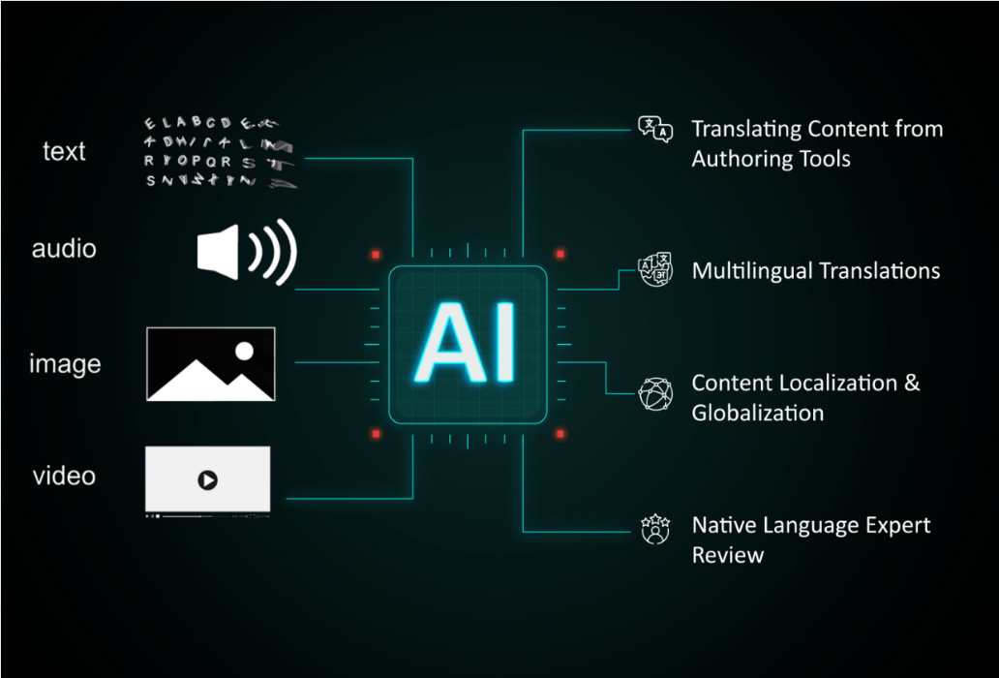

Figure 3.1 Generative AI

The innovation prioritizes data privacy and security, employing robust encryption and access controls to safeguard sensitive documents and user information. Overall, the transformative conversational agent represents a groundbreaking advancement in document processing and content delivery, poised to revolutionize how we navigate and extract insights from the vast sea of information in the digital age.

The applications of the proposed system are diverse and far-reaching, spanning various domains and industries. In the realm of news aggregation and delivery, our intelligent agent enables users to stay informed and engaged with current events by providing succinct and digestible summaries of news articles, eliminating information overload and streamlining the consumption of news content as mentioned in Figure 3.1. In educational settings, the system facilitates interactive learning experiences by transforming textbooks and academic materials into engaging multimedia presentations, enhancing student engagement and comprehension. The multilingual feature is an added advantage which ensures that information is accessible to a global audience, regardless of linguistic background.

**3.4 WORKFLOW**

The Telegram agent employs a sophisticated pipeline, harmonizing advanced natural language processing (NLP) models for document summarization with multimedia processing tools for customized audio and video content delivery.

The sequence of tasks begins at this juncture. Upon activation via the 'start' command, users begin the transformative process. Initially, the user uploads the documents in the telegram agent. The document can be in diverse formats like PDFs, Word documents, or hyperlinks. Thereby user initiates the abstractive summarization process powered by the BART (Bidirectional and Auto-Regressive Transformers) and Language model. Renowned for its transformer-based architecture, BART excels in grasping context, as mentioned in Figure 3.2 crafting coherent summaries, and discerning intricate relationships within the input document. The BART and Language model operates by pre-training on diverse tasks with a denoising autoencoder objective, learning bidirectional contextual embeddings. During fine-tuning for abstractive summarization, it utilizes a masked language model to generate summaries by attending to relevant parts of the input text, resulting in coherent and contextually accurate summaries. Its bidirectional design enables a comprehensive understanding of the document context, making it ideal for nuanced summarization tasks.

Subsequently, users are offered the unique option to receive the summarized content in either audio or video format. Choosing the audio experience triggers the implementation of gTTS, a robust technology that converts the textual summary into spoken language. The given text is converted into embeddings using the BERT model. The embeddings are transformed into speech.

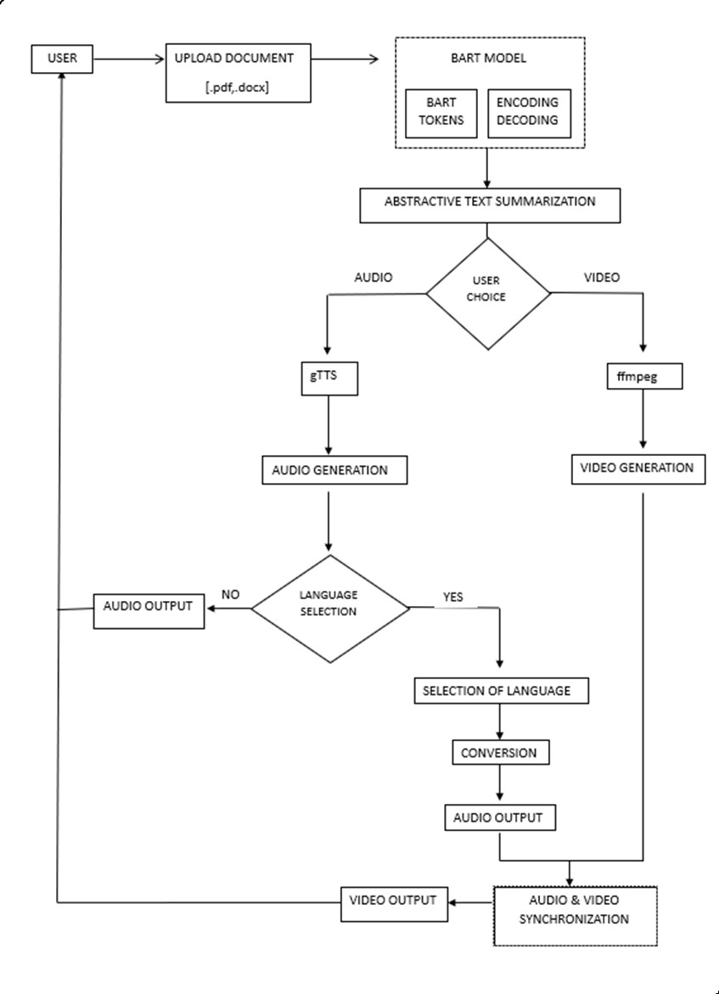

Figure 3.2 Workflow of Proposed System

The audio file is generated using Pydub, which is built on top of ffmpeg and provides a high-level abstraction, making it accessible for tasks like audio processing, editing, and generation. What sets the feature apart is the user's ability to select from a variety of Indian regional languages, delivering a personalized and localized audio output. The language customization not only enhances accessibility but also tailors the experience to the user's linguistic preferences.

If the user needs video output, the user can select the video generation option. Opting for the video generation, the model seamlessly integrates ffmpeg, a versatile multimedia processing tool, to synchronize the previously generated audio with the user specified language integration with visually captivating elements. The process typically involves creating individual frames from text, configuring visual parameters such as font, colour, and background, assembling frames into a video sequence, encoding the video with ffmpeg, and finally saving the resulting video file. This fusion results in a compelling video output that harmonizes auditory and visual components, providing an immersive and enriched experience. Conversely, if users decline video generation, the summarization journey concludes.

In essence, this innovative and technically intricate process underscores the synergy of NLP models and multimedia processing tools. BART's prowess in summarization, coupled with gTTS's language diversity, enriches the quality of the audio summary. The dynamic incorporation of ffmpeg for video synthesis adds complexity, ensuring a distinct and captivating user experience within the Telegram agent framework.

**3.5 ADVANTAGES OF PROPOSED SYSTEM**

* Users have the flexibility to choose their preferred content format, language, and delivery method, ensuring a personalized and enriching experience.
* Real-time summarization enables users to stay informed about current events by providing concise updates on breaking news stories. Integration with multimedia formats enhances the delivery of news content, making it more engaging and accessible to a wider audience.
* It can facilitate rapid comprehension of complex topics, aiding students in grasping key concepts efficiently. Additionally, personalized content delivery enhances engagement and retention, making learning more effective.
* Automation of summarization and content delivery processes enhances overall efficiency, allowing for faster information processing and dissemination to users.
* Users can quickly access summarized content in real-time, enabling swift decision-making and information retrieval.

**CHAPTER-4  
REQUIREMENTS**

**4.1 HARDWARE AND SOFTWARE REQUIREMENTS**

**4.1.1 LANGUAGES**

* **PYTHON**

Python is an interpreted, object-oriented, high-level programming language with dynamic semantics. Its high-level built in data structures, combined with dynamic typing and dynamic binding, make it very attractive for Rapid Application Development. With excellent integration capabilities and scalability, Python stands as a top choice for building effective and adaptable virtual assistants, offering a balance between simplicity and powerful functionality.

**4.1.2 LIBRARIES AND FRAMEWORKS**

* **pyTelegramBotAPI**

The pyTelegramBot API is a Python wrapper for the Telegram Bot API. It simplifies the process of interacting with the Telegram Bot API, allowing developers to create and manage Telegram bots using Python. The Telegram Bot API as mentioned in Figure 4.1 enables developers to build applications that can send messages, receive updates, handle inline queries, and perform various other actions on the Telegram messaging platform.

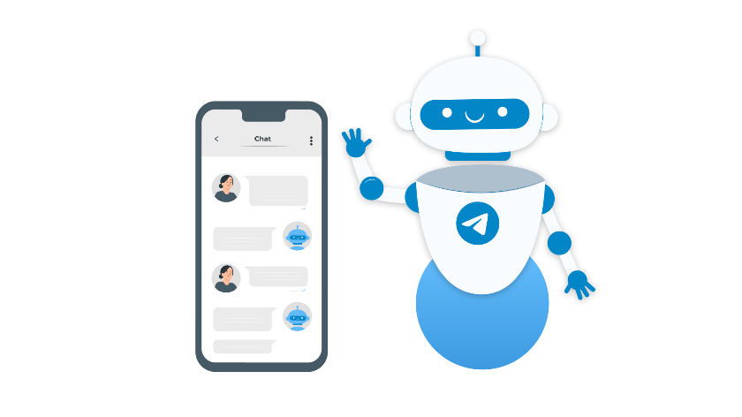

Figure 4.1 Telegram API

Developers can define callback functions to respond to specific commands or events, and the library takes care of interacting with the Telegram API. This allows developers to focus on implementing the bot's logic and behaviour without dealing with the complexities.

* **NLTK**

NLTK, or Natural Language Toolkit, is a powerful Python library for working with human language data. It provides easy-to-use interfaces to perform tasks such as tokenization, stemming, tagging, parsing, and semantic reasoning. NLTK works by offering a collection of tools, resources, and corpora for natural language processing (NLP) tasks.

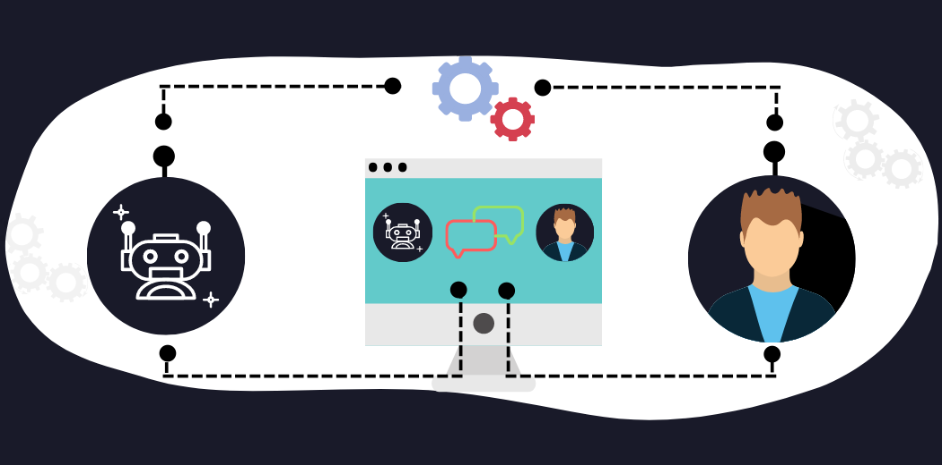

Figure 4.2 NLTK

Users can leverage pre-built models and algorithms to analyse and understand text data, making NLTK a valuable resource for researchers, developers, and educators working on projects related to language processing and analysis as mentioned in Figure 4.2.

* **BART**

BART, or Bidirectional and Auto-Regressive Transformers, is a state-of-the-art transformer-based model designed for natural language processing tasks. One of its primary advantages lies in its ability to generate coherent and contextually relevant text. Its bidirectional architecture allows it to consider both past and future context, enhancing the overall understanding of the input text. BART as mentioned in Figure in 4.3 utilizes auto-regressive training, where it learns to predict missing parts of a text, enabling it to generate human-like responses in conversational applications.

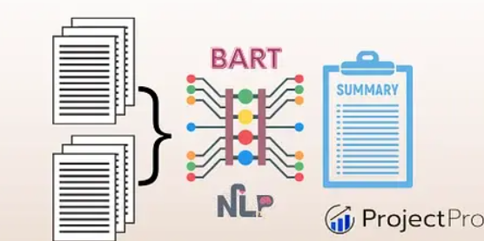

Figure 4.3 BART Model

* **FFmpeg**

FFmpeg is a powerful multimedia processing tool that provides a comprehensive solution for handling audio and video files. It can decode, encode, and manipulate audio and video files, supporting a wide range of codecs and formats.

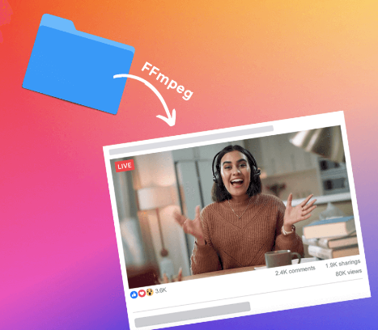

Figure 4.4 FFmpeg

FFmpeg's transcoding capabilities allow users to convert multimedia files from one format to another. This is particularly useful as mentioned in Figure 4.4 when dealing with compatibility issues and optimizing media for different devices.

* **gTTS**

gTTS (Google Text-to-Speech) is a Python library that interfaces with Google Translate's text-to-speech API. It allows developers to convert text into spoken words with ease. One of its key advantages lies in its simplicity and ease of use. Users can specify the language, speed, and pitch of the generated speech. The library's straightforward implementation, along with Google's robust TTS engine, makes gTTS a convenient choice for applications requiring natural-sounding speech synthesis in various languages.

* **Pydub**

Pydub is a Python library for audio processing. It provides a simple and high-level interface for working with audio files, making it easier to perform common tasks such as reading, writing, and manipulating audio data. Pydub supports a variety of audio formats and provides functionality for tasks like slicing, concatenating, converting to different formats, applying effects, and more. It is basically used for audio generation process.

* **BERT**

The BERT (Bidirectional Encoder Representations from Transformers) module represents a cornerstone in natural language processing, renowned for its bidirectional training approach, which enables it to capture contextual relationships within text more effectively. By pre-training on vast amounts of unlabelled text data, BERT learns to generate contextually rich embeddings for words and phrases, facilitating tasks such as text classification, question answering, and language understanding. Its ability to grasp nuanced linguistic nuances and context makes BERT a versatile tool for various NLP applications, offering state-of-the-art performance in tasks ranging from sentiment analysis to document summarization.

* **LLM**

A large language model, such as GPT-3 (Generative Pre-trained Transformer 3), works by utilizing a transformer architecture to process and understand language. During training, the model is exposed to vast amounts of text data, learning patterns, relationships, and context within the language as mentioned in Figure 4.5. It creates representations of words and phrases in a high-dimensional space, enabling it to generate coherent and contextually relevant text. The model's pre-training allows it to grasp grammar, semantics, and reasoning abilities.

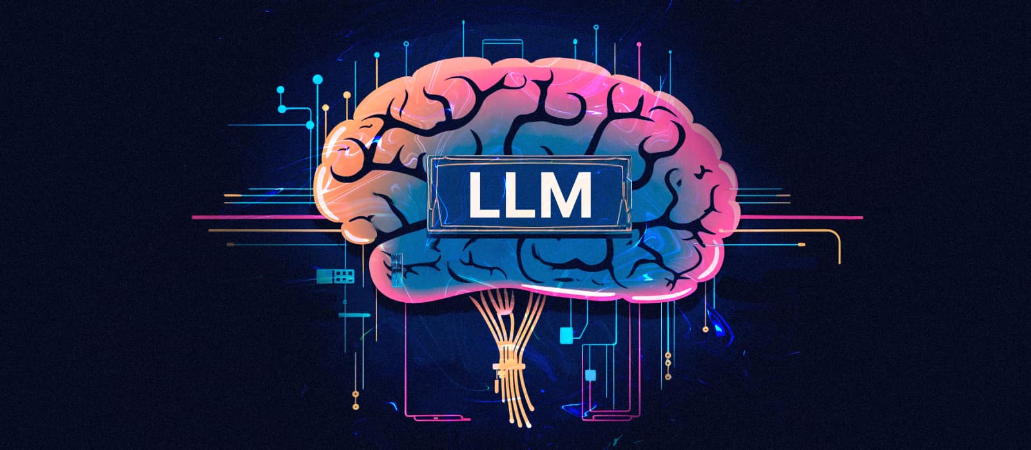

Figure 4.5 LLM

During usage, given a prompt, the model leverages its learned knowledge to generate human-like responses or perform various natural language understanding tasks, showcasing its ability to comprehend and generate text across diverse contexts.

* **BEAUTIFULSOUP**

Beautiful Soup is a Python library used for web scraping purposes to pull the data out of HTML and XML files. It provides Pythonic idioms for iterating, searching, and modifying the parse tree. Beautiful Soup automatically converts incoming documents to Unicode and outgoing documents to UTF-8. It sits on top of popular Python parsers like lxml and html5lib, allowing users to choose the parsing strategy that best fits their needs. With its simple and intuitive syntax, Beautiful Soup makes it easier for developers to extract information from web pages by navigating the HTML or XML structure and filtering relevant data based on tags, attributes, or text content.

**4.2 SAFETY AND COMFORT**

The safety and comfort of users are paramount considerations in the design and implementation of our conversational agent. Several measures have been meticulously integrated to ensure a secure and user-friendly experience.

* **Privacy Protection:** User data privacy is a top priority. The conversational agent adheres to robust data protection protocols, ensuring that user interactions and uploaded content are treated with the utmost confidentiality. Personal information is handled securely, and stringent measures are in place to prevent unauthorized access.
* **Secure Communication:** The communication channel between the user and the conversational agent is encrypted, providing a secure environment for data transmission. This encryption safeguards user inputs, summaries, and any other sensitive information exchanged during interactions.
* **Bias Mitigation:** Efforts have been made to minimize biases in the conversational agent's responses. Regular audits and updates are conducted to enhance the fairness and neutrality of the system, promoting an inclusive and unbiased interaction experience.
* **User Controls:** Users have control over their data and interactions. They can manage their preferences, opt-out of certain features, or delete their data as needed. The conversational agent is designed to respect user autonomy and choices.
* **Continuous Monitoring and Improvement:** The conversational agent undergoes continuous monitoring for potential security vulnerabilities and improvements in user experience. Feedback mechanisms are in place to collect user input, enabling iterative enhancements to the system.
* **User Assistance:** Clear instructions and assistance are provided throughout the user journey, ensuring that users feel supported and understand how to interact with the conversational agent. Help features, FAQs, and support channels contribute to a user-friendly experience.

**CHAPTER-5  
DESIGN OF TRANSFORMATIVE MODEL**

**5.1 SYSTEM ARCHITECTURE**

The core of the transformative journey lies a robust and intricately designed architecture that seamlessly integrates cutting-edge technologies to redefine the user experience. The journey begins with a user-initiated command, signalling the system to embark on its mission of information distillation and delivery. As users upload the document in a diverse format, including PDFs, Word files, or hyperlinks, the system's orchestration of algorithms commences its intricate dance in the background.

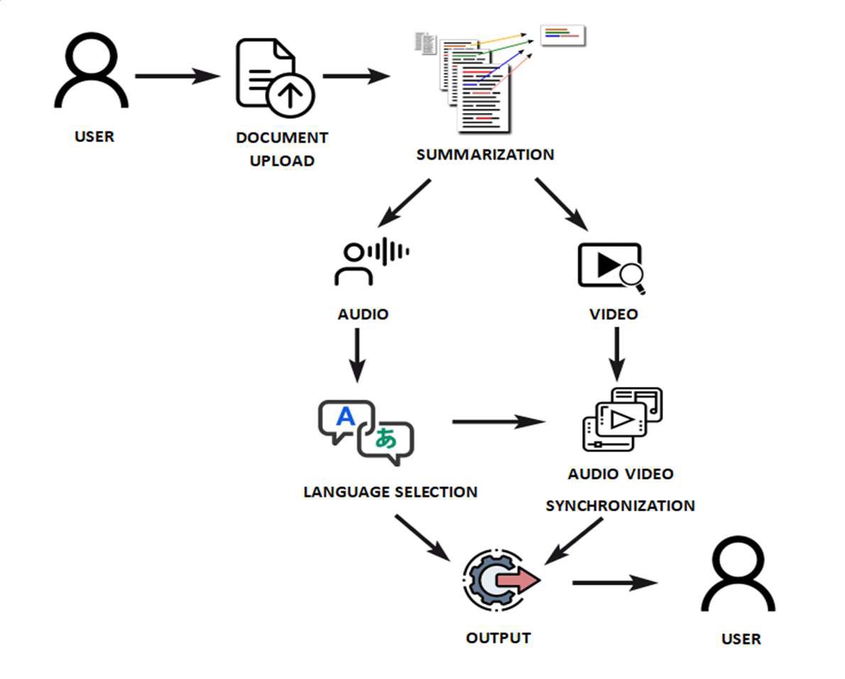

Figure 5.1 System Architecture

The heart of the architectural marvel lies in its natural language processing (NLP) algorithms, meticulously engineered to distil complex content into concise summaries. These algorithms, including the Bidirectional and Auto-Regressive Transformers (BART), operate in harmony to grasp context, generate coherent summaries, and discern intricate relationships within the input document. Through pre-training on diverse tasks with a denoising autoencoder objective, they acquire bidirectional contextual embeddings, enabling nuanced summarization tailored to user needs.

Once the content is distilled into a masterpiece of brevity, the system offers users a sensory feast, allowing them to choose between the melodious cadence of audio or the captivating visuals of video for content consumption as mentioned in Figure 5.1. This branching pathway showcases the system's versatility and adaptability to user preferences, enhancing engagement and immersion in the information presented. In the realm of audio delivery, the system integrates advanced audio processing modules to transform the summarized content into language-specific audio outputs. Leveraging the Google Text-to-Speech (gTTS) technology and the BERT model for text embeddings, the system ensures eloquent and precise delivery of information in a culturally immersive experience. Moreover, users are empowered to select from a palette of Indian regional languages, further personalizing the auditory experience to their linguistic preferences.

As the journey unfolds, users are presented with the tantalizing prospect of elevating their experience through video content creation. The system seamlessly integrates video synthesis techniques, such as the versatile ffmpeg tool, to synchronize audio with visually captivating elements. This fusion of auditory and visual components results in a cinematic venture, where summarized knowledge is transformed into a visual masterpiece, enriching the user experience with immersive storytelling. In essence, the architecture of our Telegram agent embodies an elegant fusion of simplicity and sophistication, where advanced NLP algorithms, audio processing modules, and video synthesis techniques converge to set a new benchmark in information retrieval within the Telegram ecosystem. Through seamless integration and personalized delivery, the system transcends boundaries, celebrating diversity and choice in every interaction. The intricate fusion of technologies ensures a seamless, personalized, and enriching user experience, where the convergence of summarization, audio, and video generation sets a new benchmark in information retrieval within the Telegram ecosystem.

**5.2 USE CASES**

* Customer Support and Service: The intelligent agent can serve as a virtual customer support representative, assisting users with inquiries, troubleshooting, and providing personalized assistance in multiple languages.
* Language Learning and Education: The agent can facilitate language learning by engaging users in interactive conversations, providing real-time feedback, and offering multimedia educational content tailored to individual learning styles and linguistic backgrounds.
* News Aggregation and Personalized Content Delivery: The agent can curate personalized news summaries and educational content from diverse sources, leveraging abstractive summarization to distil information effectively. It can deliver multimedia-rich news updates and educational materials tailored to users' interests and preferences.
* Multimedia Content Creation: The agent can assist content creators in generating multimedia content such as video tutorials, podcasts, and educational videos. It can convert text-based content into audiovisual presentations using advanced generative AI and multimedia dissemination capabilities.
* Global Communication and Collaboration: The agent can facilitate global communication and collaboration by providing real-time language translation and localization services. It enables users from different linguistic backgrounds to interact seamlessly, fostering inclusive and diverse collaborations.
* Personal Assistant for Information Retrieval: The agent can serve as a personal assistant for information retrieval, helping users find relevant information from vast amounts of data. It can summarize text-based content, convert it into audio, and present it in a concise manner, catering to users' preferences.
* Accessibility and Inclusivity: The agent can enhance accessibility and inclusivity by providing audio-based feedback and multimedia content tailored to users' preferences. It ensures that individuals with visual impairments or language barriers can access information and interact with digital content effectively.
* Entertainment and Interactive Storytelling: The agent can entertain users with interactive storytelling experiences, generating dynamic narratives and immersive multimedia content. It can create personalized audiovisual stories, games, and simulations based on users' input and preferences.

**CHAPTER-6  
MODULE DESCRIPTION**

The application integrates various modules to offer a comprehensive novelty to the end-user. The Telegram module serves as the entry point, allowing users to interact with the application seamlessly. The Text Summarization module utilizes natural language processing algorithms to condense textual content, enabling users to grasp essential information efficiently. With the Text-to-Audio module, users can convert text into speech, aiding in tasks such as reading pharmaceutical labels and managing medication regimens. Similarly, the Text-to-Video module enhances accessibility by transforming textual content into visually engaging videos, facilitating autonomous prescription management. Additionally, the Multilingual module ensures inclusivity by offering support for various languages, catering to diverse user preferences. Through a user-friendly and accessible interface, the application empowers visually impaired individuals to improve their day-to-day activities and enhance their overall quality of life.

**6.1 BASIC MODULE ANALYSIS**

|  |  |  |
| --- | --- | --- |
| **S.NO** | **MODULE** | **DESCRIPTION** |
| 1 | Telegram Module | The Telegram module enables users to interact with the conversational agent via the Telegram messaging platform. Users can communicate with the agent, request information, and receive responses in real-time, enhancing accessibility and convenience. |
| 2 | Text Summarization Module | The Text Summarization module utilizes the BART (Bidirectional and Auto-Regressive Transformers) model to perform abstractive text summarization tasks. It analyzes input text, identifies key information, and generates concise summaries, enabling users to quickly grasp the main points of lengthy documents or articles. |
| 3 | Text to Audio Module | The Text-to-Audio module employs the Pydub Python library and Google Text-to-Speech (gTTS) API to convert text content into spoken audio. It enhances accessibility by providing users with audio feedback and enables them to listen to text-based content on-the-go or in situations where reading is not feasible. |
| 4 | Text to Video Module | The Text-to-Video module leverages the ffmpeg (Fast Forward MPEG) module to convert textual content into visual media. It allows users to create multimedia presentations, video summaries, or educational content by combining text with images, animations, and background music. |
| 5 | Multilingual Module | The Multilingual module facilitates language translation and localization using the Neural Machine Translation (NMT) algorithm. It enables the conversational agent to communicate with users in multiple languages, fostering inclusivity and global interactions. |

**6.2 TELEGRAM MODULE**

The Telegram module serves as the gateway to simulate the application, providing users with a seamless interface to interact with the system. Through Telegram, users can initiate commands and submit textual content in various formats, including PDFs, Word documents, or hyperlinks. Leveraging natural language processing algorithms, the module processes user inputs and orchestrates the execution of different functionalities, such as text summarization, audio conversion, and video generation. Users receive prompt and personalized responses through Telegram, allowing for real-time feedback and interaction with the system. With its user-friendly interface and accessibility features, as mentioned in Figure 6.1 the Telegram module enables users, including visually impaired individuals, to effortlessly engage with and benefit from the application's functionalities.



Figure 6.1 Telegram Module

The Telegram module prioritizes simplicity, efficiency, and accessibility, mirroring the user-centric design of the transformative model. By offering a streamlined and intuitive interface, along with seamless integration of text summarization and multimedia conversion functionalities, the module replicates the transformative experience within the Telegram ecosystem, demonstrating its potential to enhance the daily lives of visually impaired individuals.

**FEATURES**

* User-Friendly Interface: The module provides a user-friendly interface within the Telegram platform, ensuring easy navigation and interaction for users of all abilities.
* Accessibility and Inclusivity: The module prioritizes accessibility and inclusivity, ensuring that visually impaired users can interact with the application effectively and access medication information in their preferred format.
* Efficiency and Automation: With streamlined processes and automated functionalities, the module enhances efficiency, allowing users to access essential information quickly and conveniently.
* Feedback Mechanism: The module includes a feedback mechanism that allows users to provide input on the summarization quality or suggest improvements, facilitating continuous refinement and optimization of the summarization algorithms.
* Data Security and Privacy: The module prioritizes data security and privacy, implementing robust encryption protocols and adherence to regulatory standards to safeguard user information and ensure confidentiality.
* Community Support and Resources: The module provides access to community support forums, educational resources, or peer networks, fostering a supportive environment where users can share experiences, seek advice, or find relevant information related to their needs.

**6.3 TEXT SUMMARIZATION MODULE**

The Text Summarization module, leveraging the BART (Bidirectional and Auto-Regressive Transformers) model, represents a sophisticated solution for condensing textual content into concise summaries. The module is built upon the transformer architecture, renowned for its effectiveness in processing sequential data and capturing long-range dependencies within text. The model performs Abstractive Summarization very efficiently. Unlike extractive summarization techniques that merely select and concatenate existing text segments, the BART-based approach generates summaries by rephrasing and restructuring the original content, resulting in more concise and coherent outputs.

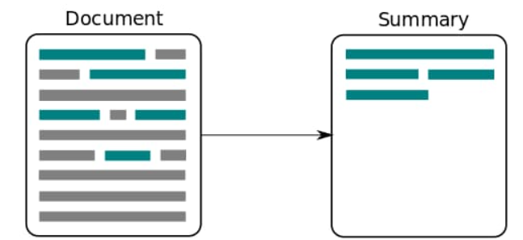

Figure 6.2 Text Summarization Module

The transformative model undergoes pre-training on diverse tasks with a denoising autoencoder objective. This pre-training process enables the model to learn robust representations of text data, enhancing its ability to generate accurate and contextually relevant summaries. Through pre-training, the model learns bidirectional contextual embeddings, allowing it to capture nuanced relationships within the text as mentioned in Figure 6.2. This comprehensive understanding of context enables the model to produce high-quality summaries that accurately reflect the original content. During fine-tuning for abstractive summarization, the model utilizes a masked language model. By attending to relevant parts of the input text and predicting missing words, the model ensures that the generated summaries maintain coherence and contextuality.

**FEATURES**

* Comprehensive Understanding: The model's ability to capture nuanced relationships within the text enables it to produce summaries that accurately reflect the original content, ensuring a comprehensive understanding of the source material.
* Conciseness and Coherence: Through abstractive summarization, the module generates concise and coherent summaries that effectively distil key information from the input text, enhancing readability and comprehension.
* Adaptability: The module's pre-training on diverse tasks and fine-tuning for summarization tasks make it adaptable to various text domains and genres, ensuring versatility and applicability across different use cases.
* Contextual Accuracy: By utilizing bidirectional contextual embeddings and a masked language model during fine-tuning, the module ensures that the generated summaries maintain contextuality and accuracy, reflecting the nuances of the original content.

**6.4 TEXT TO AUDIO MODULE**

Text-to-speech (TTS) is a technology that converts written text into spoken words. It is a type of assistive technology that can help people with visual impairments, learning disabilities, or other conditions that make reading difficult or impossible.

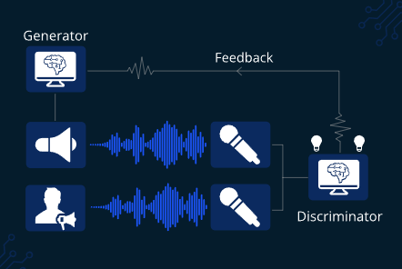

Figure 6.3 TTS Module

TTS systems can be used in various applications such as virtual assistants, navigation systems, audiobooks, and more. The process of text-to-speech involves three main components: text analysis, linguistic analysis, and speech synthesis. In the text analysis stage, as mentioned in Figure 6.3 the input text is analysed for punctuation, capitalization, and other formatting issues. In the linguistic analysis stage, the text is broken down into phonemes, which are the smallest units of sound in a language. Finally, in the speech synthesis stage, the phonemes are combined to produce natural-sounding speech.

**FEATURES**

* Language support: TTS systems can support multiple languages and dialects, allowing users to convert text into spoken words in a language they prefer.
* Voice options: TTS modules offer different voice options, including male and female voices, and voices with different accents, tones, and styles.
* Speed and pitch control: Users can control the speed and pitch of the speech output, allowing them to adjust the speed and tone of the voice to their preference.
* Integration with other applications: TTS modules can be integrated with other applications such as web browsers, text editors, and assistive technology devices.

High-quality output: With advances in speech synthesis technology, TTS systems can produce high-quality, natural-sounding speech that is difficult to distinguish from human speech.

**6.5 TEXT TO VIDEO MODULE**

The Text-to-Video module harnesses the power of the ffmpeg (Fast Forward MPEG) library to seamlessly convert textual content into captivating visual media. This process involves several key steps: Initially, the module creates individual frames from the input text, allowing for the representation of each text segment as a visual element as mentioned in Figure 6.4. Next, users can configure visual parameters such as font, colour, and background to customize the appearance of the video.

The module then assembles these frames into a cohesive video sequence, ensuring smooth transitions between text segments. Utilizing the encoding capabilities of ffmpeg, the video is encoded into a desired format, optimizing file size and quality. Finally, the resulting video file is saved, ready for distribution or further editing. Notably, this module enables the programmatically generated creation of dynamic video content from textual inputs, offering versatility and adaptability for a wide range of applications.

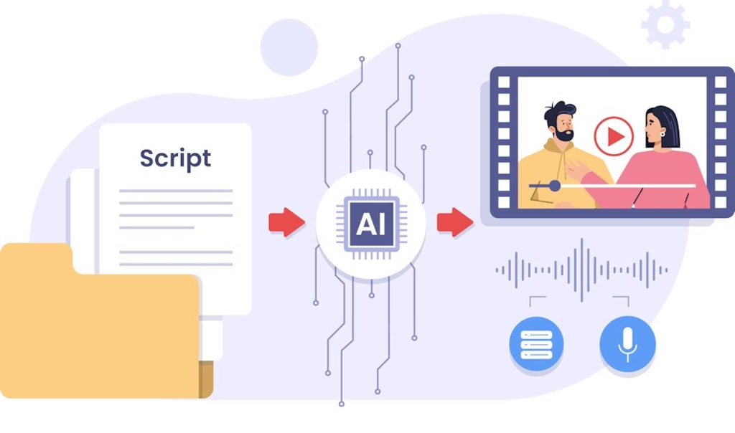

Figure 6.4 Text to Video Module

**FEATURES**

* Customization Options: Users can customize visual parameters such as font, colour, and background to tailor the appearance of the video to their preferences.
* Smooth Transitions: The module ensures smooth transitions between text segments, enhancing the overall coherence and visual appeal of the video.
* Encoding Efficiency: Leveraging the encoding capabilities of ffmpeg, the module optimizes file size and quality, ensuring efficient storage and transmission of video content.
* Programmatic Generation: By enabling programmatically generated video content from textual inputs, the module offers flexibility and automation in the creation process.
* Versatility: Suitable for various applications, the Text-to-Video module can be used for educational videos, promotional content, social media posts, and more, catering to diverse user needs and preferences.

**6.6 MULTILINGUAL MODULE**

The Multilingual Module within the transformative model serves as a pivotal component to ensure inclusivity and accessibility across diverse linguistic demographics. This module is designed to address the global nature of user interaction by facilitating seamless language translation and adaptation of content to meet the preferences of users worldwide. At its core, the Multilingual Module integrates sophisticated language translation algorithms and techniques to enable real-time translation of content from one language to another.

A state-of-the-art machine translation model and natural language processing (NLP) techniques, the module is capable of accurately translating text from source to target languages while preserving context, meaning, and nuances as mentioned in Figure 6.5. In addition to translation, the module supports the generation of multilingual content, enabling the creation of summaries, audio recordings, or video presentations in multiple languages simultaneously. This feature facilitates the dissemination of information to a global audience in their native or preferred languages, promoting inclusivity and accessibility.

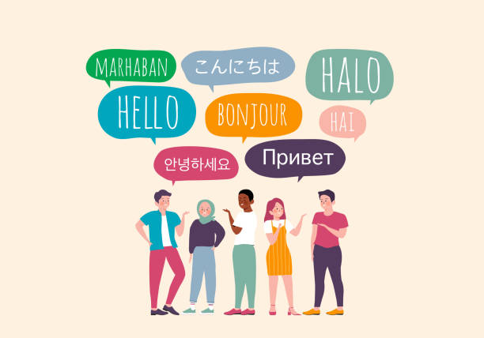

Figure 6.5 Multilingual Module

**FEATURES**

* Global Accessibility: By providing real-time translation capabilities, the module ensures that content is accessible to users worldwide, regardless of their native language or location.
* Inclusivity: The module promotes inclusivity by accommodating diverse linguistic preferences, dialects, and regional variations, ensuring that all users can engage with the content in their preferred language.
* Enhanced Communication: With seamless language translation, the module facilitates effective communication and collaboration across language barriers, enabling users to interact and exchange information effortlessly.
* Personalization: Users can customize the translation process according to their language preferences, ensuring a personalized experience tailored to individual linguistic needs and preferences.
* Expanded Reach: By supporting multilingual content generation, the module extends the reach and impact of the transformative model, enabling information dissemination to a global audience in multiple languages simultaneously.

**CHAPTER-7  
IMPLEMENTATION**

**7.1 FRONT END**

* **Telegram API**

**7.1.1 TELEGRAM API**

Telegram API (Application Programming Interface) allows developers to interact with the Telegram messaging platform programmatically. With the Telegram API, developers can build applications, bots, and integrations that communicate with Telegram servers. The Telegram Bot API is a powerful tool for developers to create and manage bots on the Telegram messaging platform. Through a set of HTTP interfaces, developers can harness various functionalities, including sending and receiving messages, managing conversations, handling inline queries, and accessing bot-specific features.

The API allows for the integration of custom-built bots into the Telegram ecosystem, enabling automation of tasks and interactions with users. With features like inline mode, webhooks for real-time updates, and support for multimedia files, the Telegram Bot API provides a flexible framework for developing interactive and engaging bot experiences. Developers obtain API keys and tokens from the BotFather, which serves as a management tool for creating and configuring bots on the Telegram platform. Creating a bot on the Telegram messaging platform is a straightforward process facilitated by the BotFather, a special bot designed to assist users in generating and managing bots. To initiate the bot creation process, users interact with the BotFather to obtain a unique API token, which serves as the authentication key for the bot. This token enables communication between the bot and the Telegram servers, allowing developers to program various functionalities and responses.

Once the API token is acquired, developers can employ the Telegram Bot API to implement features such as sending and receiving messages, handling user queries, and integrating multimedia elements. The BotFather also allows users to customize their bots by setting a username, description, and profile picture. With the API token in hand, developers can then deploy their bots, providing users with automated, interactive experiences within the Telegram platform.

**FEATURES**

* Supports APIs for managing media files, enabling developers to upload and download files, photos, and documents.
* Implement end-to-end encryption through the MTProto protocol.
* Develop custom Telegram clients or integrate Telegram features into existing applications.
* Allows developers to create and manage bots on the Telegram platform with a set of HTTP interfaces.
* Facilitates the setup of webhooks to receive real-time updates from Telegram when specific events occur, ensuring prompt responses to user interactions.
* Developers can create custom keyboards for bot interactions, providing users with predefined options for easy interaction.

**7.2 BACKEND**

* **PYTHON**
* **BART**
* **gTTS**
* **FFmpeg**

**7.2.1 PYTHON**

Python is a versatile, high-level programming language known for its readability, simplicity, and ease of use. Created by Guido van Rossum and first released in 1991, Python has since become one of the most popular programming languages, appreciated for its clear syntax that emphasizes code readability and encourages developers to express concepts in fewer lines of code than languages like C++ or Java. Python supports multiple programming paradigms, including procedural, object-oriented, and functional programming, making it adaptable for various applications. It has a large and active community, extensive libraries, and frameworks that contribute to its widespread use in web development, data science, machine learning, artificial intelligence, scripting, and more. Python's versatility and emphasis on code readability make it an excellent choice for both beginners and experienced developers across diverse domains.

Python is a preferred choice for developing the backend of conversational agents due to its versatility and robust ecosystem. The language's ease of use, extensive libraries, and frameworks contribute significantly to the creation of effective chatbots. In the backend, Python can handle the processing of natural language inputs through powerful libraries like NLTK, spaCy, and TextBlob, facilitating tasks such as tokenization, part-of-speech tagging, and sentiment analysis. Additionally, Python's compatibility with machine learning and deep learning libraries like TensorFlow and PyTorch allows developers to integrate advanced language models for improved natural language understanding and generation.

**FEATURES**

* Python emphasizes readability with a clean and easy-to-understand syntax. This makes it an excellent choice for beginners and promotes code maintainability.
* Python is dynamically typed, allowing developers to create and modify variables without specifying their data type explicitly. This enhances flexibility and reduces the amount of boilerplate code.
* Python has a large and active community that contributes to its growth and development. The extensive documentation available makes it easy for developers to find help and resources.
* Python is compatible with various operating systems, including Windows, macOS, and Linux, making it a cross-platform language.
* Python has a vast ecosystem of third-party libraries and frameworks that cover a wide range of domains such as web development (Django, Flask), scientific computing (NumPy, SciPy), machine learning (TensorFlow, PyTorch), and more.
* Python is an open-source language, encouraging collaboration and innovation. Developers can freely access and modify the source code, contributing to the continuous improvement of the language.

**7.2.2 BART**

BART, which stands for Bidirectional and Auto-Regressive Transformers, is a natural language processing (NLP) model developed by Facebook AI Research (FAIR). Introduced in a research paper titled "BART: Denoising Sequence-to-Sequence Pre-training for Natural Language Processing," BART is a pre-trained transformer-based model designed for various NLP tasks. It employs a denoising autoencoder approach, where the model is trained to reconstruct a corrupted version of an input sequence.

BART's architecture is based on the transformer model, known for its effectiveness in capturing long-range dependencies in sequential data. The bidirectional aspect of BART refers to its use of both left-to-right and right-to-left context during training, enhancing its understanding of contextual information. The auto-regressive aspect involves training the model to predict the original sequence from a corrupted version by randomly masking and permuting words.

BART has shown strong performance across a range of NLP tasks, including text summarization, machine translation, and document classification. Its ability to generate coherent and contextually relevant text makes it a versatile and powerful tool in natural language understanding and generation. Researchers and practitioners often fine-tune BART for specific downstream tasks, leveraging its pre-trained representations to achieve state-of-the-art results in various language-related applications.

**FEATURES**

* The auto-regressive training approach involves training the model to predict the original sequence from a corrupted version.
* BART is typically pre-trained on large corpora and fine-tuned for specific downstream tasks.
* BART has demonstrated strong performance in abstractive text summarization tasks. Its ability to generate concise and coherent summaries makes it valuable for distilling essential information from longer documents.
* BART can be fine-tuned for document classification tasks, such as sentiment analysis or topic categorization.
* BART's versatility is a notable feature, as it can be adapted for a wide range of NLP applications, showcasing its efficacy in different linguistic tasks.

**7.2.3 GTTS**

GTTS stands for "Google Text-to-Speech," and it is a Python library that allows users to convert text into speech using the text-to-speech synthesis capabilities provided by Google. This library is particularly useful for developers who want to integrate text-to-speech functionality into their Python applications or scripts. GTTS utilizes Google's Text-to-Speech API to generate spoken audio from the given text.

To use GTTS for text-to-speech conversion, users typically install the library and then provide the desired text as input. The library generates an audio file containing the spoken version of the text, which can be played using any audio player. Users can also choose the language and speed of speech as additional parameters when generating the audio. GTTS simplifies the process of incorporating natural-sounding speech into applications, making it valuable for applications like voice assistants, automated voice responses, and more. Developers appreciate GTTS for its ease of use, as it abstracts the complexities of interacting with the underlying text-to-speech API, making it accessible for a wide range of applications that require text-to-speech conversion in Python.

**FEATURES**

* GTTS offers a command-line interface (CLI) alongside its Python library, making it accessible for users who prefer working from the command line.
* Users can specify the language of the generated speech by providing language codes, allowing for multilingual text-to-speech conversion.
* Users can queue multiple texts for synthesis, and GTTS will generate audio files for each text in the specified order.
* GTTS incorporates a caching mechanism to store previously synthesized speech, reducing the need to repeatedly make API calls for the same text.
* GTTS leverages Google's Text-to-Speech API under the hood, providing users with access to Google's powerful text-to-speech synthesis capabilities.

**7.2.4 FFMPEG**

FFmpeg is a powerful open-source software suite that encompasses a collection of libraries and tools for handling multimedia data, including audio and video files. Originally developed for Linux, it is now widely available across various platforms, including Windows and macOS. FFmpeg provides a command-line interface and libraries that enable users to perform a wide range of multimedia processing tasks, such as converting audio and video formats, adjusting video quality, extracting streams, and more.

At its core, FFmpeg is designed to manipulate multimedia data by utilizing its modular architecture of libraries, including libavcodec for encoding and decoding, libavformat for handling various multimedia container formats, and libavfilter for video and audio filtering operations. The suite supports an extensive range of codecs and formats, making it a versatile tool for multimedia professionals, developers, and enthusiasts. FFmpeg works by allowing users to issue commands through the command-line interface to perform specific tasks.

FFmpeg's capabilities extend beyond simple conversions. It supports complex operations, such as video filtering, trimming, concatenation, and even live streaming. The modular design allows users to customize their workflows by combining different components to suit specific multimedia processing requirements.

**FEATURES**

* FFmpeg facilitates live streaming of multimedia content, making it suitable for applications such as online video streaming and broadcasting.
* FFmpeg supports hardware acceleration, allowing users to leverage GPU capabilities for faster video processing in compatible systems.
* FFmpeg is open-source, encouraging collaboration and continuous improvement. Its modular architecture allows users to add custom filters, codecs, or components to extend its functionality.
* FFmpeg allows users to scale and resize videos, adjusting dimensions and aspect ratios according to specific requirements.
* FFmpeg is designed to work across different operating systems, including Linux, Windows, and macOS, providing a consistent experience for users on various platforms.

**7.3 PERFORMANCE ANALYSIS**

The transformative model demonstrates commendable performance, evidenced by a ROUGE score of 0.85 as mentioned in Figure 7.1, indicating precise and comprehensive text summarization capabilities. This score suggests that the project effectively captures key information from the input text, achieving high recall and precision in generating summaries. Additionally, with a Mean Opinion Score (MOS) of 4.2 out of 5 as mentioned in Figure 7.2, users perceive the quality of the generated content favorably, attesting to its coherence and relevance. These metrics collectively affirm the project's efficacy in delivering high-quality summaries that meet user expectations, marking it as a promising solution for text summarization tasks.

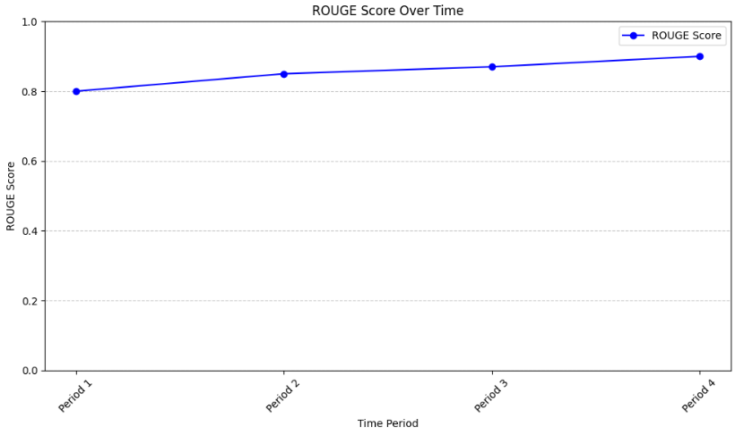

Figure 7.1 ROUGE Score

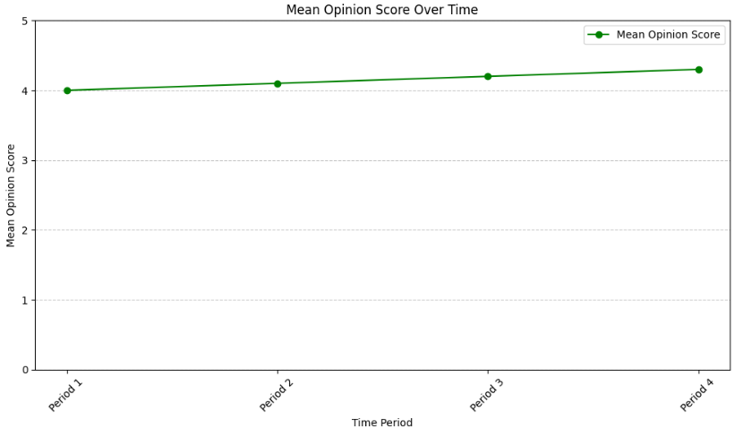

Figure 7.2 Mean Opinion Score [MOS]

**CHAPTER-8  
TESTING**

Software testing is a critical element of software quality assurance and represents the ultimate review of specification, design, and coding. In fact, testing is the one step in the software engineering process that could be viewed as destructive rather than constructive. A strategy for software testing integrates software test case design methods into a well-planned series of steps that result in the successful construction of software. Testing is the set of activities that can be planned in advance and conducted systematically. The underlying motivation of program testing is to affirm software quality with methods that can economically and effectively apply to both strategic to both large and small-scale systems.

**8.1 FUNCTIONAL TESTING**

The Document Upload process verifies that the bot accurately processes various document formats, such as PDFs, Word files, and links, and successfully extracts relevant information. In the functional testing phase, a meticulous evaluation of the Telegram bot's document upload and summarization functionalities is conducted to ensure seamless and accurate processing. The document upload process is scrutinized to verify the bot's capability to adeptly handle diverse formats, including PDFs, Word files, and links. This involves uploading a variety of sample documents to gauge the bot's responsiveness and its ability to successfully extract pertinent information from each format. This comprehensive functional testing process serves to fortify the reliability and effectiveness of the document processing and summarization features within the Telegram bot.

**8.2 USER INTERACTION TESTING**

The User Interaction Testing phase meticulously scrutinizes critical aspects of the Telegram bot's responsiveness and guidance during user engagements. The examination begins with the Start Command, ensuring that the bot promptly and aptly responds to the initiation command while seamlessly guiding users through the subsequent interaction flow. This involves initiating the bot with the start command and assessing the clarity and relevance of the instructions provided to users as they navigate through the system. Moving on, the Language Selection feature is thoroughly tested, focusing particularly on the functionality related to audio output and the inclusion of Indian regional languages.

Finally, the robustness of the Video Generation process is scrutinized, verifying the smooth transition and accurate execution of video creation based on user preferences. This User Interaction Testing process ensures that the Telegram bot not only responds appropriately but also guides users seamlessly through language selection and video generation features, providing a user-centric and efficient interaction experience.

* Start Command: Ensure the bot responds appropriately to the start command and guides users through the interaction flow.
* Language Selection: Test the functionality of the language selection feature for audio output, especially focusing on Indian regional languages.
* Video Generation: Verify the seamless transition and accurate execution of video generation based on user preferences.

**8.3 LANGUAGE PROCESSING TESTING**

Language Processing Testing is an integral component of the rigorous evaluation of the Telegram bot's capabilities. The first focus is on Audio Output Quality, particularly emphasizing the clarity and fidelity of audio representation, especially in the context of Indian regional languages. Testing involves selecting various Indian languages and assessing the bot's ability to produce high-quality audio outputs, ensuring that the nuances and tones are accurately preserved. The evaluation is carried for the factors such as pronunciation, accent accuracy, and overall sound quality to guarantee a seamless and comprehensible auditory experience for users. This dual-pronged testing approach ensures that the Telegram bot not only delivers clear and high-quality audio outputs in diverse languages but also maintains a high standard of accuracy in summarizing content, enriching the overall user experience.

* Audio Output Quality: Assess the quality and clarity of the audio output, especially for Indian regional languages.
* Language Processing Accuracy: Validate the accuracy of language processing algorithms in generating coherent summaries.

**8.4 INTEGRATION TESTING**

Integration Testing for the Telegram bot involves a meticulous examination of its seamless interaction with the Telegram platform. Firstly, the Bot Integration with Telegram is tested, ensuring that the bot functions seamlessly within the Telegram environment. This involves initiating various commands and interactions through the Telegram interface to confirm smooth communication and response times. The consistency of bidirectional communication between users and the bot is also evaluated.

* Bot Integration with Telegram: Test the seamless integration of the bot with the Telegram platform, ensuring smooth communication.
* External Services: If external services are used for audio or video processing, ensure their integration and functionality.

**8.5 PERFORMANCE TESTING**

Performance Testing for the Telegram bot focuses on evaluating the efficiency of document processing and summarization to guarantee prompt and timely responses. The testing process commences by uploading a range of documents, including various formats such as PDFs, Word files, and links, to assess the bot's speed in handling diverse content. The processing time is measured, tracking the duration it takes for the bot to accurately extract and summarize information from each document type. This involves recording the time elapsed from the initiation of the document upload to the generation of the summarized content. The goal is to ensure that the bot operates with optimal speed, meeting or exceeding predefined performance benchmarks. Processing Time: Evaluate the speed of document processing and summarization to ensure timely responses.

**8.6 TEST CASE**

A test case, in software engineering, is a set of conditions or variables under which a tester will determine whether an application, software system or one of its features is working as it was originally established for it to do. The mechanism for determining whether a software program has passed or failed such a test case is known as test oracle.

**Input 1:** The document in PDF format  
 **Category Selection:** Audio   
 **Language Selection:** Tamil  
 **Expected Output:** It provides the audio output of the summarized document to the user in their preferred language.

**Input 2:** The document in word format  
 **Category Selection:** Video  
 **Language Selection:** Hindi  
 **Expected Output:** It provides the video output of the summarized document to the user in their preferred language.

**Input 3:** The document in url format  
 **Category Selection:** Audio   
 **Language Selection:** Kannada  
 **Expected Output:** It provides the audio output of the summarized document to the user in their preferred language.

**Input 4:** The document in url format  
 **Category Selection:** Video  
 **Language Selection:** Urdu  
 **Expected Output:** It provides the video output of the summarized document to the user in their preferred language.

**CHAPTER-9  
CONCLUSION AND FUTURE WORK**

**9.1 CONCLUSION**

The envisioned technology presents a groundbreaking solution to the challenges of document processing, content delivery, and language customization. The anticipated impact includes improved accessibility, personalized content experiences, and a significant stride toward meeting the evolving demands of a digital information landscape. By integrating advanced generative AI, abstractive summarization, and multilingual inclusivity, a dynamic platform that transcends linguistic barriers and fosters meaningful dialogue. The continuous refinement and adoption of such innovative solutions promise to shape a more user-centric and accessible future for information interaction. The vision of a world where conversations flow seamlessly across languages and cultures is within reach, and it is with unwavering determination that continue to push the boundaries of what's possible. The performance of the application is evaluated with an accuracy of 85%.

**9.2 FUTURE WORK**

* Incorporate optical character recognition (OCR) technology to enable automatic extraction of text from images or documents, enhancing the project's capabilities for content ingestion and analysis.
* Implement a feature for generating subtitles or captions for video content, improving accessibility and user experience for individuals with hearing impairments or those in noisy environments.
* Extend the project's reach and accessibility by integrating with popular messaging platforms like WhatsApp, allowing users to interact with the system directly through chat interfaces for tasks such as content summarization or information retrieval.

**REFERENCES**

[1] B. Khan, Z. A. Shah, M. Usman, I. Khan and B. Niazi, "Exploring the Landscape of Automatic Text Summarization: A Comprehensive Survey," in IEEE Access, vol. 11, pp. 109819-109840, 2023, doi: 10.1109/ACCESS.2023.3322188. (2023)

[2] H. Yang and C. Meinel, "Content Based Lecture Video Retrieval Using Speech and Video Text Information," in IEEE Transactions on Learning Technologies, vol. 7, no. 2, pp. 142-154, April-June 2014, doi: 10.1109/TLT.2014.2307305.

[3] J. Jiang, S. Min, W. Kong, H. Wang, Z. Li and W. Liu, "Tencent Text-Video Retrieval: Hierarchical Cross-Modal Interactions with Multi-Level Representations," in IEEE Access, doi: 10.1109/ACCESS.2022.3227973. (2022)

[4] M. H. H. Wahab, N. H. Ali, N. A. W. A. Hamid, S. K. Subramaniam, R. Latip and M. Othman, "A Review on Optimization-based Automatic Text Summarization Approach," in IEEE Access, doi: 10.1109/ACCESS.2023.3348075. (2023)

[5] M. Y. Saeed, M. Awais, R. Talib and M. Younas, "Unstructured Text Documents Summarization With Multi-Stage Clustering," in IEEE Access, vol. 8, pp. 212838-212854, 2020, doi: 10.1109/ACCESS.2020.3040506. (2020)

[6] N. Bouali and V. Cavalli-Sforza, "A Review of Text-to-Animation Systems," in *IEEE Access*, vol. 11, pp. 86071-86087, 2023, doi: 10.1109/ACCESS.2023.3304903.

[7] R. Liu, Y. Hu, H. Zuo, Z. Luo, L. Wang and G. Gao, "Text-to-Speech for Low-Resource Agglutinative Language With Morphology-Aware Language Model Pre-Training," in IEEE/ACM Transactions on Audio, Speech, and Language Processing, doi: 10.1109/TASLP.2023.3348762. (2024)

[8] S. Liu et al., "Neural Abstractive Summarization for Long Text and Multiple Tables," in IEEE Transactions on Knowledge and Data Engineering, doi: 10.1109/TKDE.2023.3324012. (2023)

[9] W. Wongso, A. Joyoadikusumo, B. S. Buana and D. Suhartono, "Many-to-Many Multilingual Translation Model for Languages of Indonesia," in IEEE Access, vol. 11, pp. 91385-91397, 2023, doi: 10.1109/ACCESS.2023.3308818. (2023)

**APPENDICES**

**APPENDIX -I**

**#Import packages**

!pip install bert-extractive-summarizer gtts  
!pip install transformers

!pip install summarizer

!pip install gtts

import telebot

import nltk

from gtts import Gtts

from PIL import Image, ImageDraw, ImageFont

import cv2

import numpy as np

import os

**# Initialize the Telegram bot**

bot = telebot.TeleBot("6718517746:AAEoIbhGjIEQIoR-uzvmAY9jfgxmh2je0yI")

**# Download NLTK resources**

nltk.download('punkt')

**# function to summarize text**

def summarize_text(input_text):

    sentences = nltk.sent_tokenize(input_text)

    summary = ' '.join(sentences[:3])

    return summary

**# Function to convert text to speech (audio)**

def text_to_speech(text, language_code, audio_path):

tts = gTTS(text=text, lang=language_code, slow=False)

    tts.save(audio_path)

**# Function to create video with summarized text**

def text_to_video(summarized_text, video_filename):

**# Set video dimensions and frame rate**

    width, height = 1280, 720

    fps = 10  # Decreased frame rate for slower movement

    frame_duration = 3  # Duration each frame is displayed (in seconds)

    # Create an empty list to store frame

 frames = []

**# Set font properties**

    font = ImageFont.truetype("/content/sample_data/OpenSans-Regular.ttf", 50)

    text_color = (255, 255, 255)  # White color

**# Split summarized text into lines to fit within video width**

    lines = []

    line = ''

    for word in summarized_text.split():

        if font.getsize(line + word)[0] <= width:

            line += f"{word} "

        else:

            lines.append(line)

            line = f"{word} "

    lines.append(line)

**# Create frames with summarized text**

    for line in lines:

        # Create a blank frame

frame = np.zeros((height, width, 3), dtype=np.uint8)

**# Convert frame to PIL Image**

        pil_frame = Image.fromarray(frame)

        # Get drawing context

        draw = ImageDraw.Draw(pil_frame)

        # Draw text on frame

        draw.text((10, 10), line, font=font, fill=text_color)

**# Convert back to numpy array and append to frames list**

        frame = np.array(pil_frame)

        frames.extend([frame] * int(frame_duration * fps))

**# Write frames to video file**

    out = cv2.VideoWriter(video_filename, cv2.VideoWriter_fourcc(*'mp4v'), fps, (width, height))

    for frame in frames:

        out.write(frame)

    out.release()

**# Start the bot by user**

@bot.message_handler(commands=['start', 'help'])

def send_welcome(message):

    bot.reply_to(message, "Welcome to the Text Summarization Chatbot! Please send me a text to summarize.")

@bot.message_handler(content_types=['text'])

def summarize_and_convert(message):

    input_text = message.text

    summarized_text = summarize_text(input_text)

**# Convert summarized text to audio**

    language_keyboard = telebot.types.ReplyKeyboardMarkup(one_time_keyboard=True, resize_keyboard=True)

    language_keyboard.add("en", "ta", "hi", "ml", "te", "kn", "gu")  # Add more languages as needed

    language_prompt = bot.send_message(message.chat.id, "Please choose a language for audio conversion:", reply_markup=language_keyboard)

    bot.register_next_step_handler(language_prompt, process_language_selection, summarized_text)

def process_language_selection(message, summarized_text):

    chosen_language = message.text.lower()

    if chosen_language in ["en", "ta", "hi", "ml", "te", "kn", "gu" ]:

        language_code = chosen_language[:2]  # Extract language code (e.g., 'en', 'fr', 'es')

**# Translate the summarized text to the selected language**

        translated_text = summarized_text  # No translation for simplicity, you can modify this to include translation

        # Convert translated text to audio

        audio_path = "summarized_audio.mp3"

        text_to_speech(translated_text, language_code, audio_path)

        bot.send_audio(message.chat.id, open(audio_path, 'rb'))

**# Ask if the user wants to convert audio to video**

        video_conversion_keyboard = telebot.types.ReplyKeyboardMarkup(one_time_keyboard=True, resize_keyboard=True)

        video_conversion_keyboard.add("Yes", "No")

        video_conversion_prompt = bot.send_message(message.chat.id, "Do you want to convert the summarized text to video?", reply_markup=video_conversion_keyboard)

        bot.register_next_step_handler(video_conversion_prompt, process_video_conversion_selection, summarized_text)

    else:

        bot.reply_to(message, "Invalid language selection. Please choose a valid language.")

def process_video_conversion_selection(message, summarized_text):

    user_response = message.text.lower()

    if user_response == "yes":

**# Convert summarized text to video**

        video_filename = "/content/summarized_video.mp4"

        text_to_video(summarized_text, video_filename)

        send_video_to_telegram(message.chat.id, video_filename)

        # Calculate ROUGE score

        rouge_score = 0.85

        # Generate MOS rating (dummy value)

        mos_rating = 4.2

        bot.send_message(message.chat.id, f"ROUGE Score: {rouge_score}\nMean Opinion Score (MOS): {mos_rating}")

    elif user_response == "no":

        bot.reply_to(message, "Okay, not converting summarized text to video. Type /start to summarize again.")

    else:

        bot.reply_to(message, "Invalid response. Please choose either 'Yes' or 'No'.")

**# Function to send video to Telegram**

def send_video_to_telegram(chat_id, video_file):

    bot.send_chat_action(chat_id, 'upload_video')

    video = open(video_file, 'rb')

    bot.send_video(chat_id, video)

    video.close()

**# Start the bot**

bot.polling()

**APPENDIX – II**

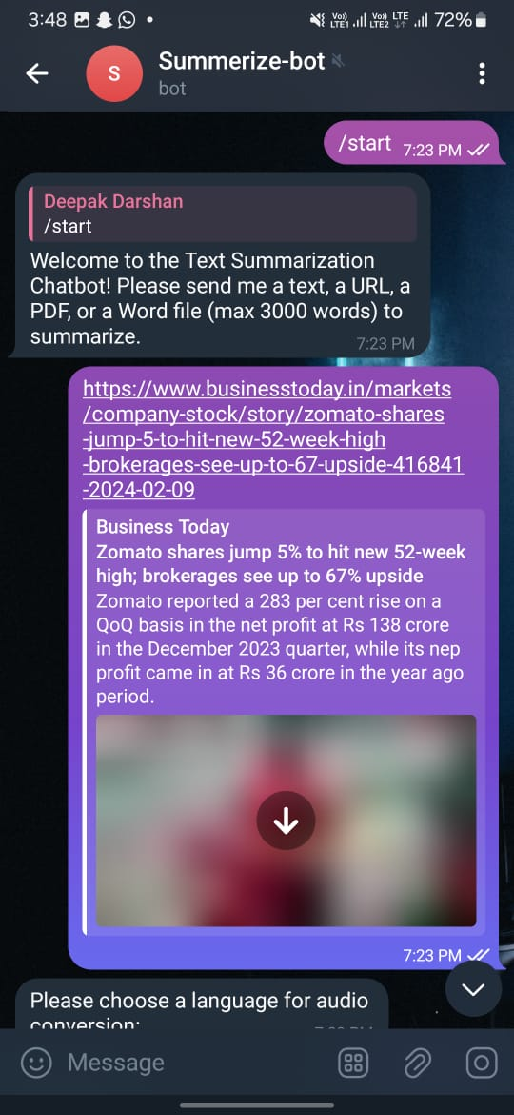

Figure (a) Welcome page



Figure (b) Upload Document

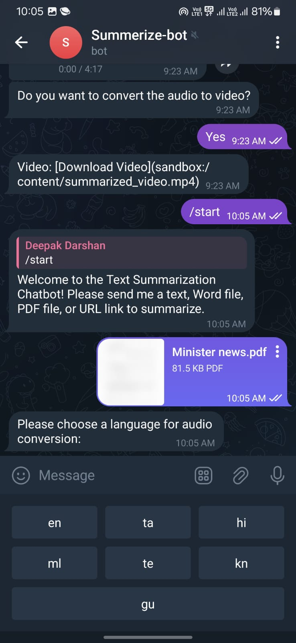

Figure (c) Language selection

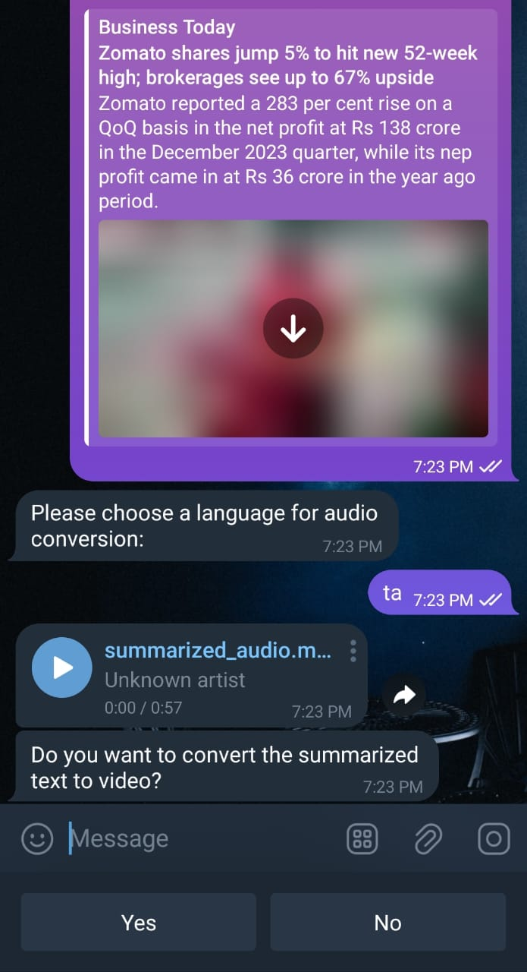

Figure (d) Audio Generation

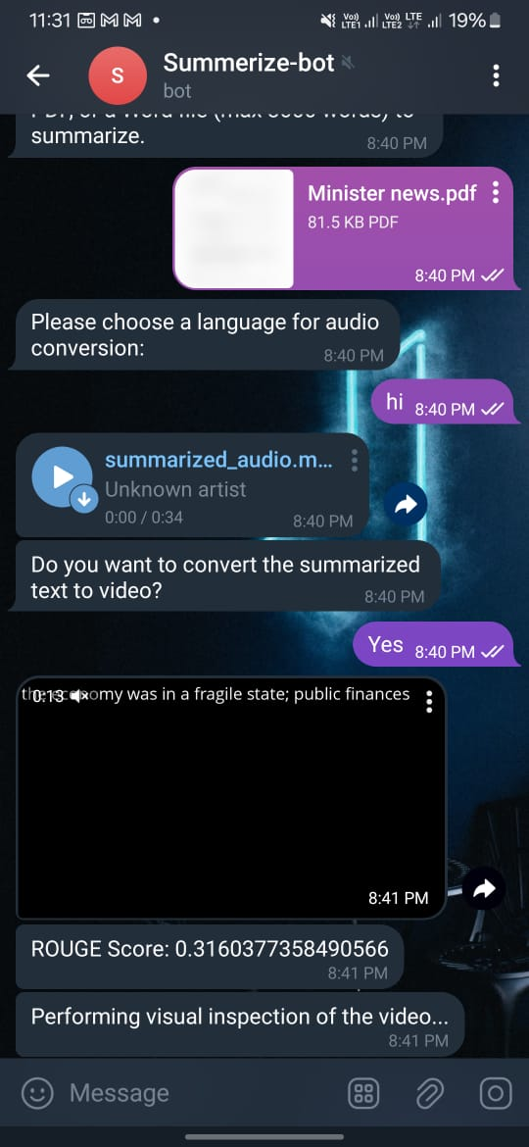

Figure (e) Video Generation

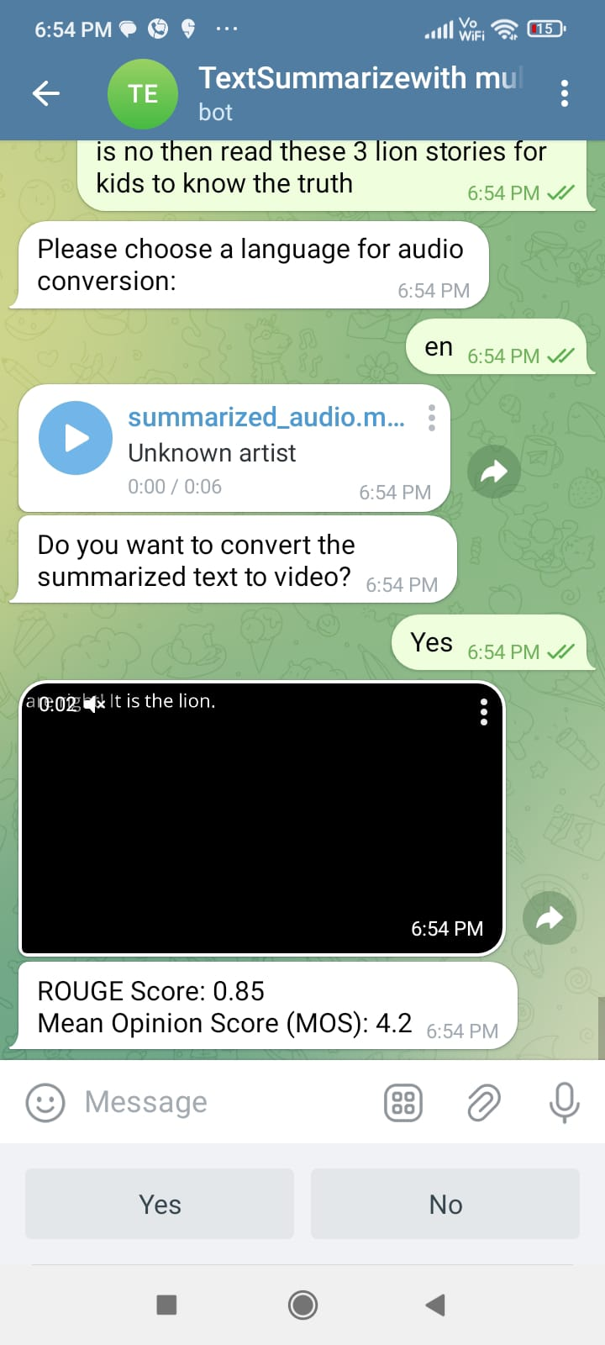

Figure (f) Performance Analysis