FOOTPRINTING
Who-is info

Domain Name: TESLA.COM
Registry Domain ID: 187902_DOMAIN_COM-VRSN
Registrar WHOIS Server: whois.markmonitor.com
Registrar URL: http://www.markmonitor.com
Updated Date: 2022-10-02T09:36:05Z
Creation Date: 1992-11-04T05:00:00Z
Registry Expiry Date: 2024-11-03T06:00:00Z
Registrar: MarkMonitor Inc.
Registrar IANA ID: 292
Registrar Abuse Contact Email: abusecomplaints@markmonitor.com
Registrar Abuse Contact Phone: +1.2086851750
Domain Status: clientDeleteProhibited https://icann.org/epp#clientDeleteProhibited
Domain Status: clientTransferProhibited https://icann.org/epp#clientTransferProhibited
Domain Status: clientUpdateProhibited https://icann.org/epp#clientUpdateProhibited
Domain Status: serverDeleteProhibited https://icann.org/epp#serverDeleteProhibited
Domain Status: serverTransferProhibited https://icann.org/epp#serverTransferProhibited
Domain Status: serverUpdateProhibited https://icann.org/epp#serverUpdateProhibited
Name Server: A1-12.AKAM.NET
Name Server: A10-67.AKAM.NET
Name Server: A12-64.AKAM.NET
Name Server: A28-65.AKAM.NET
Name Server: A7-66.AKAM.NET
Name Server: A9-67.AKAM.NET
Name Server: EDNS69.ULTRADNS.BIZ
Name Server: EDNS69.ULTRADNS.COM
Name Server: EDNS69.ULTRADNS.NET
Name Server: EDNS69.ULTRADNS.ORG
DNSSEC: unsigned
URL of the ICANN Whois Inaccuracy Complaint Form: https://www.icann.org/wicf/
>>> Last update of whois database: 2024-06-27T13:06:57Z <<<

For more information on Whois status codes, please visit https://icann.org/epp

NOTICE: The expiration date displayed in this record is the date the
registrar's sponsorship of the domain name registration in the registry is
currently set to expire. This date does not necessarily reflect the expiration
date of the domain name registrant's agreement with the sponsoring
registrar. Users may consult the sponsoring registrar's Whois database to
view the registrar's reported date of expiration for this registration.

TERMS OF USE: You are not authorized to access or query our Whois
database through the use of electronic processes that are high-volume and
automated except as reasonably necessary to register domain names or
modify existing registrations; the Data in VeriSign Global Registry
Services' ("VeriSign") Whois database is provided by VeriSign for
information purposes only, and to assist persons in obtaining information
about or related to a domain name registration record. VeriSign does not
guarantee its accuracy. By submitting a Whois query, you agree to abide
by the following terms of use: You agree that you may use this Data only
for lawful purposes and that under no circumstances will you use this Data
to: (1) allow, enable, or otherwise support the transmission of mass
unsolicited, commercial advertising or solicitations via e-mail, telephone,
or facsimile; or (2) enable high volume, automated, electronic processes
that apply to VeriSign (or its computer systems). The compilation,
repackaging, dissemination or other use of this Data is expressly
prohibited without the prior written consent of VeriSign. You agree not to
use electronic processes that are automated and high-volume to access or
query the Whois database except as reasonably necessary to register
domain names or modify existing registrations. VeriSign reserves the right
to restrict your access to the Whois database in its sole discretion to ensure
operational stability. VeriSign may restrict or terminate your access to the
Whois database for failure to abide by these terms of use. VeriSign
reserves the right to modify these terms at any time.

The Registry database contains ONLY .COM, .NET, .EDU domains and
Registrars.
Domain Name: tesla.com
Registry Domain ID: 187902_DOMAIN_COM-VRSN
Registrar WHOIS Server: whois.markmonitor.com
Registrar URL: http://www.markmonitor.com
Updated Date: 2022-10-02T09:36:05+0000
Creation Date: 1992-11-04T05:00:00+0000
Registrar Registration Expiration Date: 2024-11-03T00:00:00+0000
Registrar: MarkMonitor, Inc.
Registrar IANA ID: 292
Registrar Abuse Contact Email: abusecomplaints@markmonitor.com
Registrar Abuse Contact Phone: +1.2086851750
Domain Status: clientUpdateProhibited (https://www.icann.org/epp#clientUpdateProhibited)
Domain Status: clientTransferProhibited (https://www.icann.org/epp#clientTransferProhibited)
Domain Status: clientDeleteProhibited (https://www.icann.org/epp#clientDeleteProhibited)
Domain Status: serverUpdateProhibited (https://www.icann.org/epp#serverUpdateProhibited)
Domain Status: serverTransferProhibited (https://www.icann.org/epp#serverTransferProhibited)
Domain Status: serverDeleteProhibited (https://www.icann.org/epp#serverDeleteProhibited)
Registry Registrant ID:
Registrant Name: Domain Administrator
Registrant Organization: DNStination Inc.
Registrant Street: 3450 Sacramento Street, Suite 405
Registrant City: San Francisco
Registrant State/Province: CA
Registrant Postal Code: 94118
Registrant Country: US
Registrant Phone: +1.4155319335
Registrant Phone Ext:
Registrant Fax: +1.4155319336
Registrant Fax Ext:
Registrant Email: admin@dnstinations.com
Registry Admin ID:
Admin Name: Domain Administrator
Admin Organization: DNStination Inc.
Admin Street: 3450 Sacramento Street, Suite 405
Admin City: San Francisco
Admin State/Province: CA
Admin Postal Code: 94118
Admin Country: US
Admin Phone: +1.4155319335
Admin Phone Ext:
Admin Fax: +1.4155319336
Admin Fax Ext:
Admin Email: admin@dnstinations.com
Registry Tech ID:
Tech Name: Domain Administrator
Tech Organization: DNStination Inc.
Tech Street: 3450 Sacramento Street, Suite 405
Tech City: San Francisco
Tech State/Province: CA
Tech Postal Code: 94118
Tech Country: US
Tech Phone: +1.4155319335
Tech Phone Ext:
Tech Fax: +1.4155319336
Tech Fax Ext:
Tech Email: admin@dnstinations.com
Name Server: a9-67.akam.net
Name Server: edns69.ultradns.biz
Name Server: edns69.ultradns.org
Name Server: a12-64.akam.net
Name Server: edns69.ultradns.net
Name Server: a1-12.akam.net
Name Server: edns69.ultradns.com
Name Server: a10-67.akam.net
Name Server: a7-66.akam.net
Name Server: a28-65.akam.net
DNSSEC: unsigned
URL of the ICANN WHOIS Data Problem Reporting System: http://wdprs.internic.net/
>>> Last update of WHOIS database: 2024-06-27T13:06:50+0000 <<<

For more information on WHOIS status codes, please visit:
https://www.icann.org/resources/pages/epp-status-codes

If you wish to contact this domain’s Registrant, Administrative, or Technical
contact, and such email address is not visible above, you may do so via our web
form, pursuant to ICANN’s Temporary Specification. To verify that you are not a
robot, please enter your email address to receive a link to a page that
facilitates email communication with the relevant contact(s).

Web-based WHOIS:
https://domains.markmonitor.com/whois

If you have a legitimate interest in viewing the non-public WHOIS details, send
your request and the reasons for your request to whoisrequest@markmonitor.com
and specify the domain name in the subject line. We will review that request and
may ask for supporting documentation and explanation.

The data in MarkMonitor’s WHOIS database is provided for information purposes,
and to assist persons in obtaining information about or related to a domain
name’s registration record. While MarkMonitor believes the data to be accurate,
the data is provided "as is" with no guarantee or warranties regarding its
accuracy.

By submitting a WHOIS query, you agree that you will use this data only for
lawful purposes and that, under no circumstances will you use this data to:
(1) allow, enable, or otherwise support the transmission by email, telephone,
or facsimile of mass, unsolicited, commercial advertising, or spam; or
(2) enable high volume, automated, or electronic processes that send queries,
data, or email to MarkMonitor (or its systems) or the domain name contacts (or
its systems).

MarkMonitor reserves the right to modify these terms at any time.

By submitting this query, you agree to abide by this policy.

MarkMonitor Domain Management(TM)
Protecting companies and consumers in a digital world.

Visit MarkMonitor at https://www.markmonitor.com
Contact us at +1.8007459229
In Europe, at +44.02032062220
----

Traceroute information

traceroute to tesla.com (2.18.54.207), 30 hops max, 60 byte packets
1 192.168.191.2 (192.168.191.2) 1.996 ms 1.873 ms 1.655 ms
2 * * *
3 * * *
4 * * *
5 * * *
6 * * *

Google Dorks

https://github.com/Darkstar69/CEH-Labs/blob/main/tesla/dorks/github-dorking.html
https://github.com/Darkstar69/CEH-Labs/blob/main/tesla/dorks/google-dorking.html
https://github.com/Darkstar69/CEH-Labs/blob/main/tesla/dorks/shodan-dorking.html
https://github.com/Darkstar69/CEH-Labs/blob/main/tesla/dorks/vendorking.html

Meta Data (youtube)
{
"title": "Tesla",
"description": "Electric vehicles, giant batteries & solar, AI & robotics. Tesla’s mission is to accelerate the world’s transition to sustainable energy.",
"customUrl": "@tesla",
"publishedAt": "2006-12-08T05:50:26Z",
"thumbnails": {
"default": {
"url": "https://yt3.ggpht.com/p89RToB7j2iu9BYhK2Zn6vLkxJXYC9cAbxfJ0eMvUd4jrsyRQtuYIvinn8N2H6utyeBKcrvlhSE=s88-c-k-c0x00ffffff-no-rj",
"width": 88,
"height": 88
},
"medium": {
"url": "https://yt3.ggpht.com/p89RToB7j2iu9BYhK2Zn6vLkxJXYC9cAbxfJ0eMvUd4jrsyRQtuYIvinn8N2H6utyeBKcrvlhSE=s240-c-k-c0x00ffffff-no-rj",
"width": 240,
"height": 240
},
"high": {
"url": "https://yt3.ggpht.com/p89RToB7j2iu9BYhK2Zn6vLkxJXYC9cAbxfJ0eMvUd4jrsyRQtuYIvinn8N2H6utyeBKcrvlhSE=s800-c-k-c0x00ffffff-no-rj",
"width": 800,
"height": 800
}
},
"localized": {
"title": "Tesla",
"description": "Electric vehicles, giant batteries & solar, AI & robotics. Tesla’s mission is to accelerate the world’s transition to sustainable energy."
},
"country": "US"
}
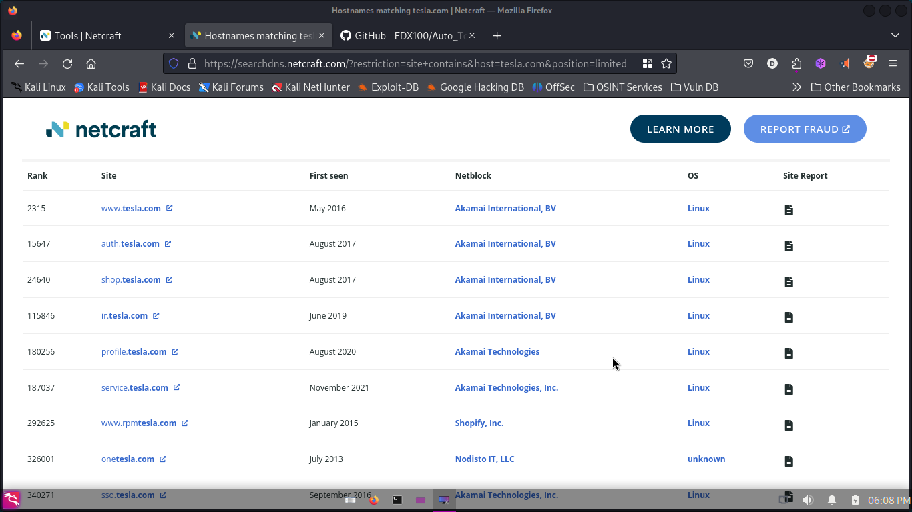

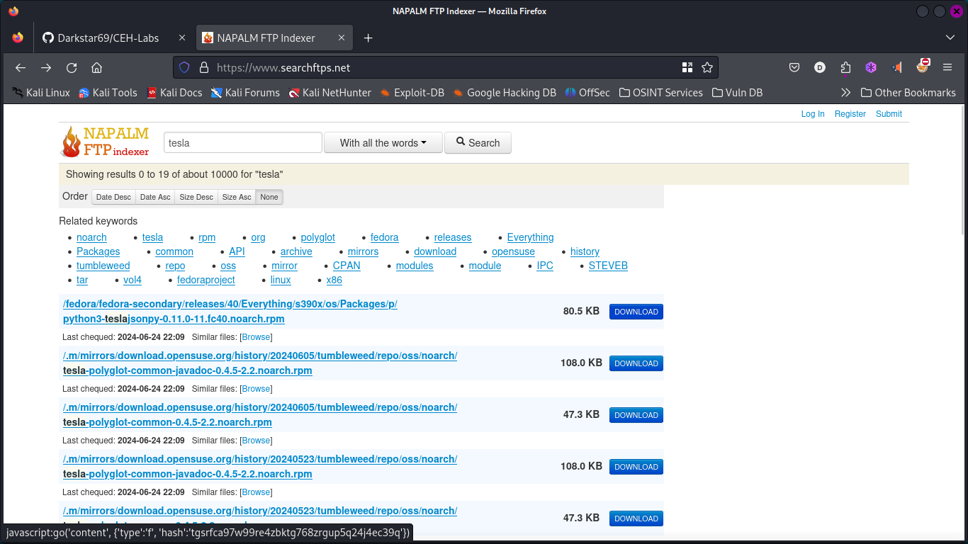

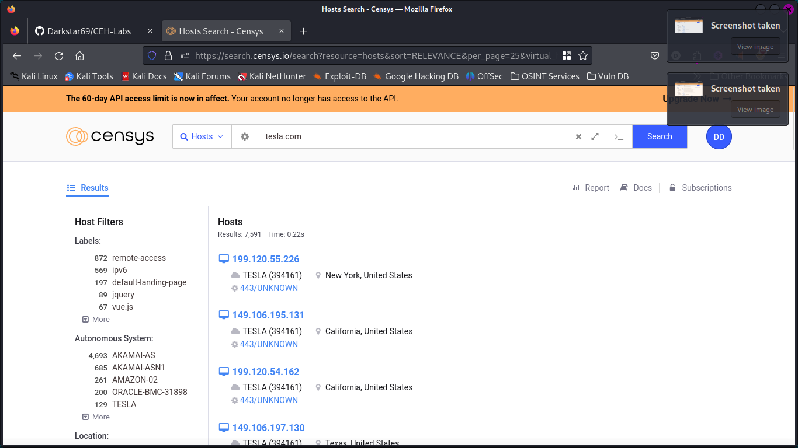

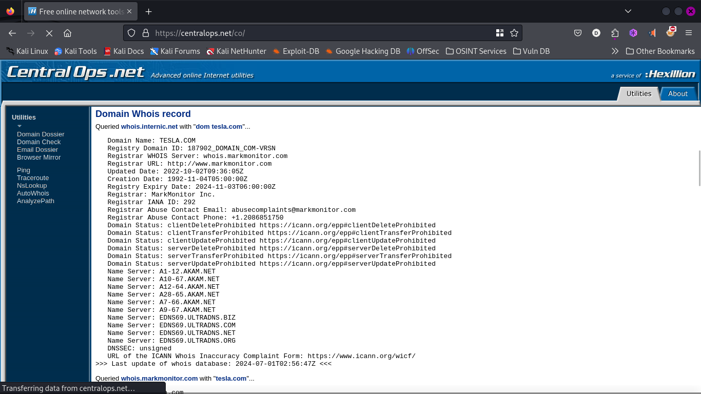

NSLOOKUP

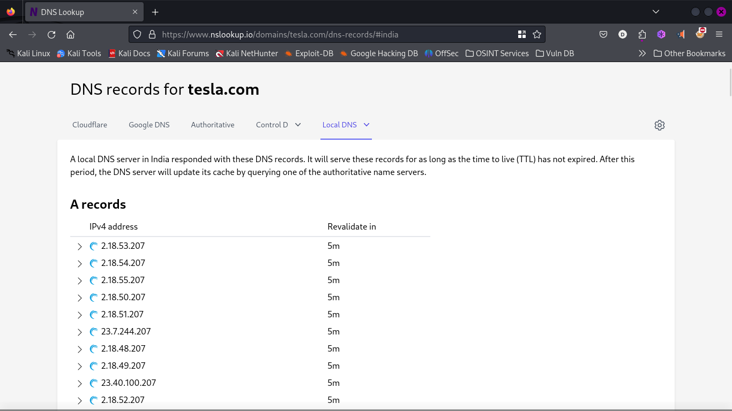

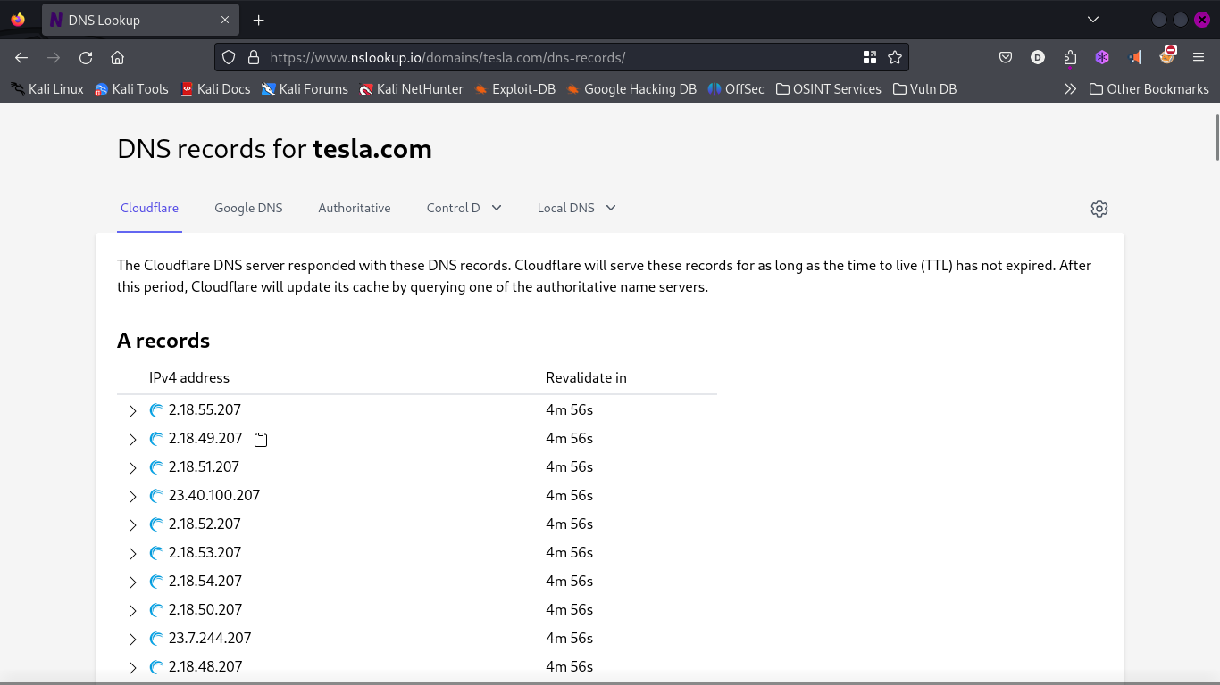

Security Trails Result

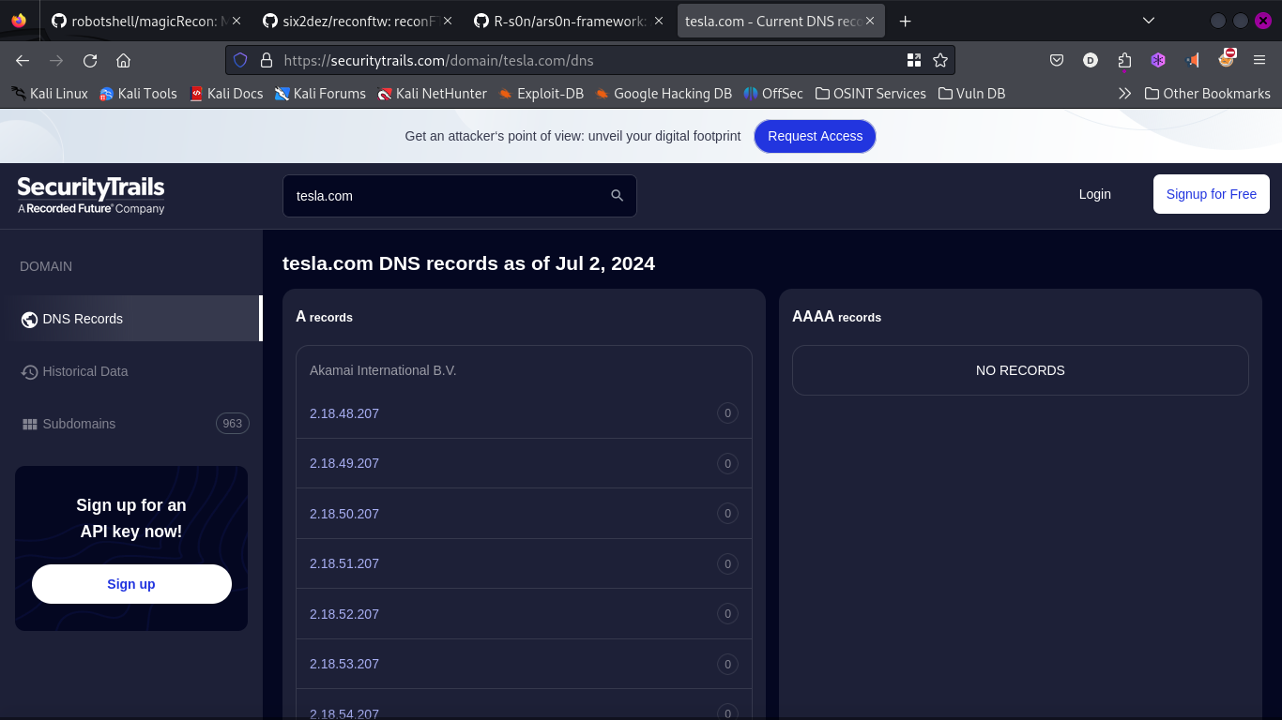

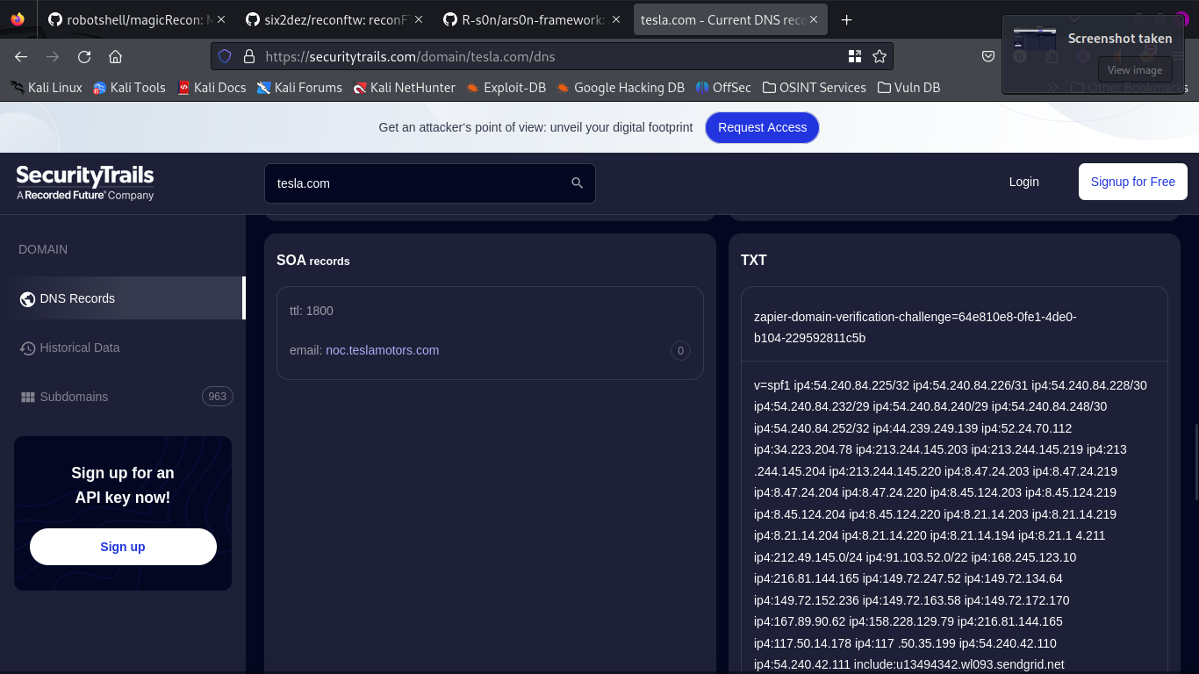

Billcipher outputs :
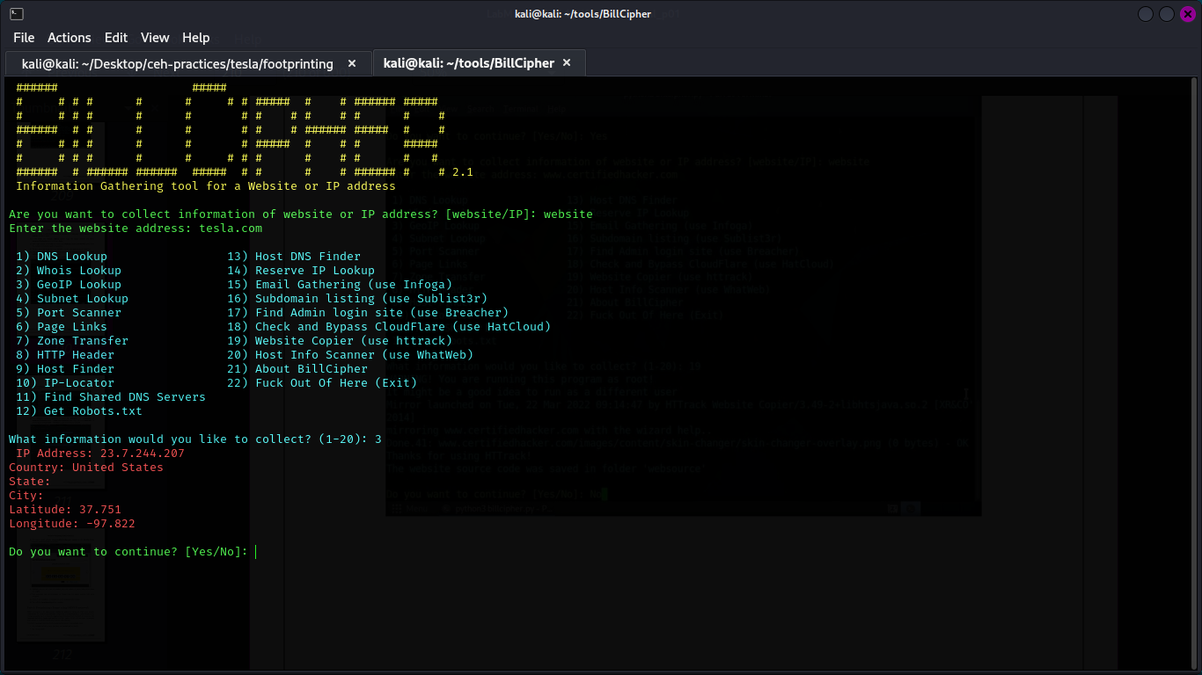

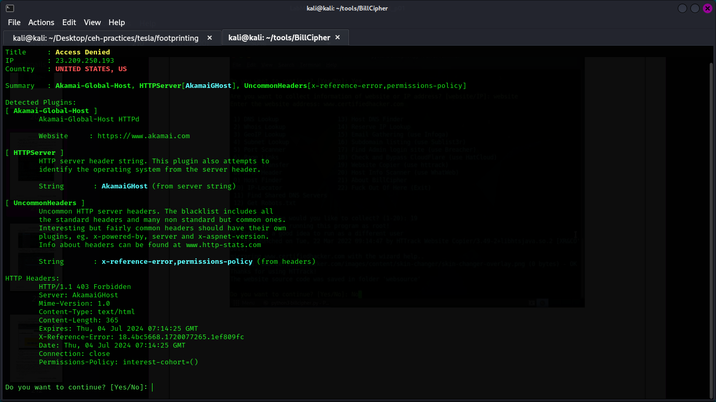
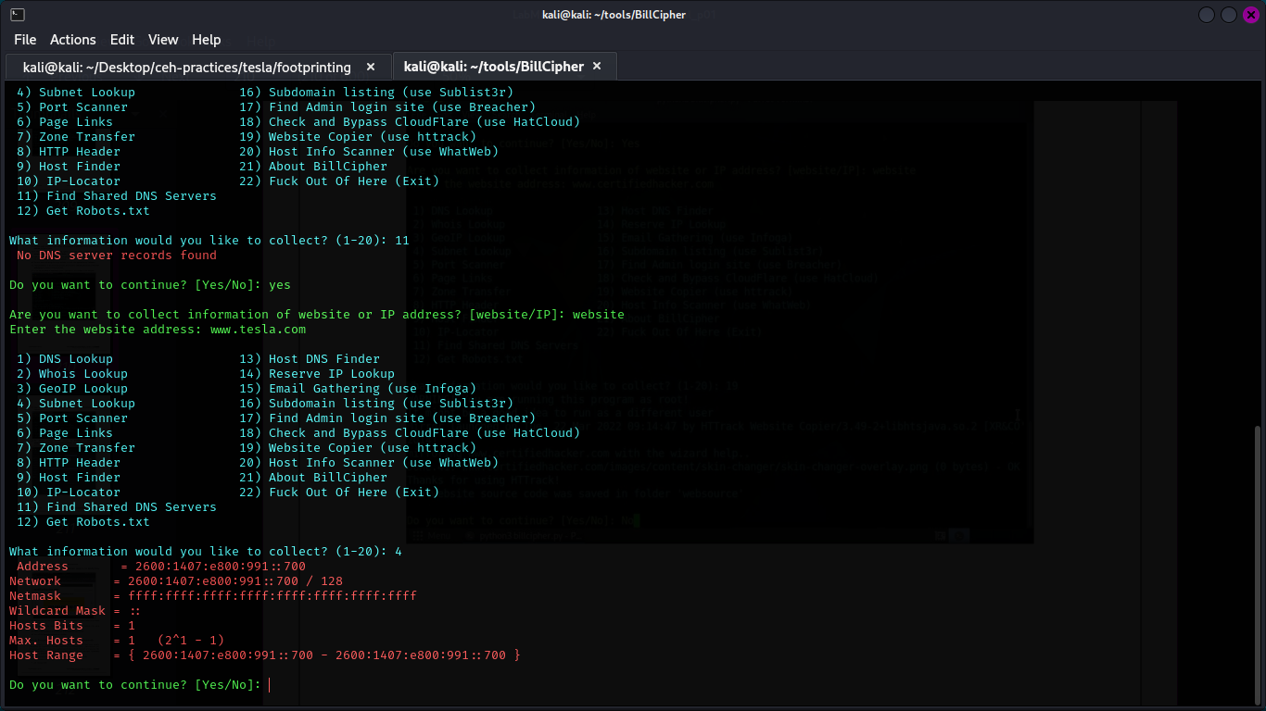

Namechk :

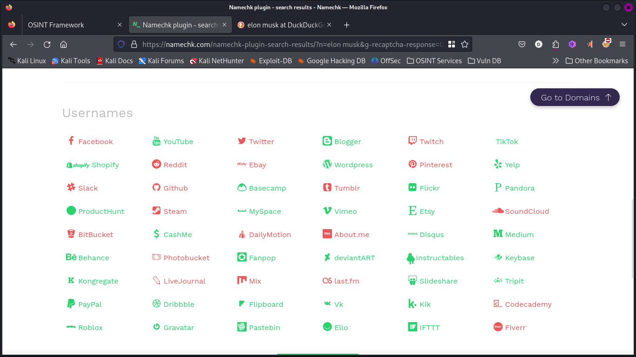

Scanning Networks

Host Discovery:

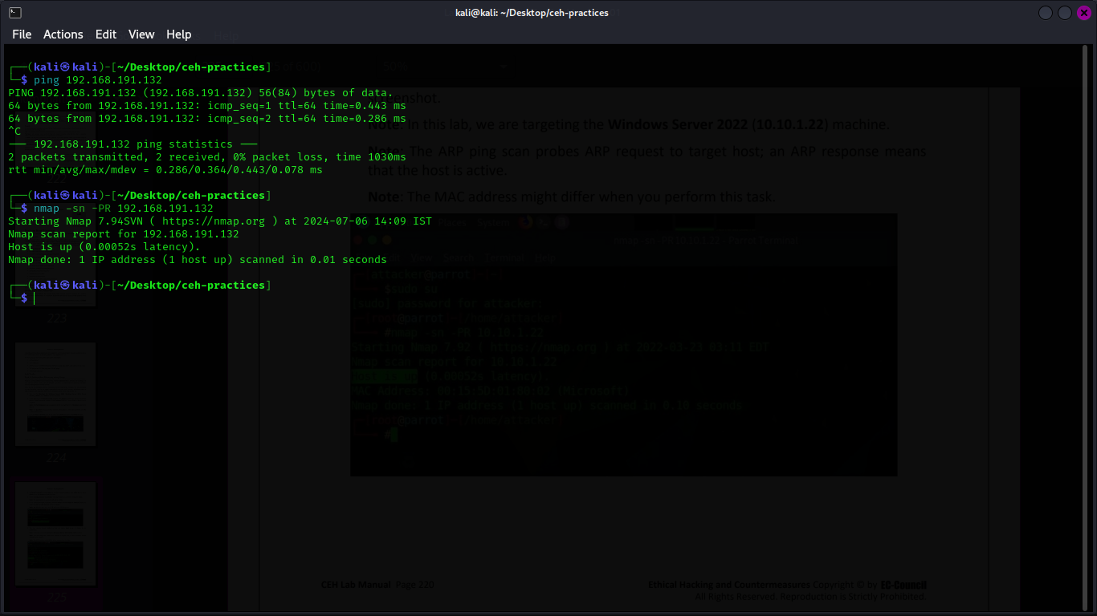
ARP ping
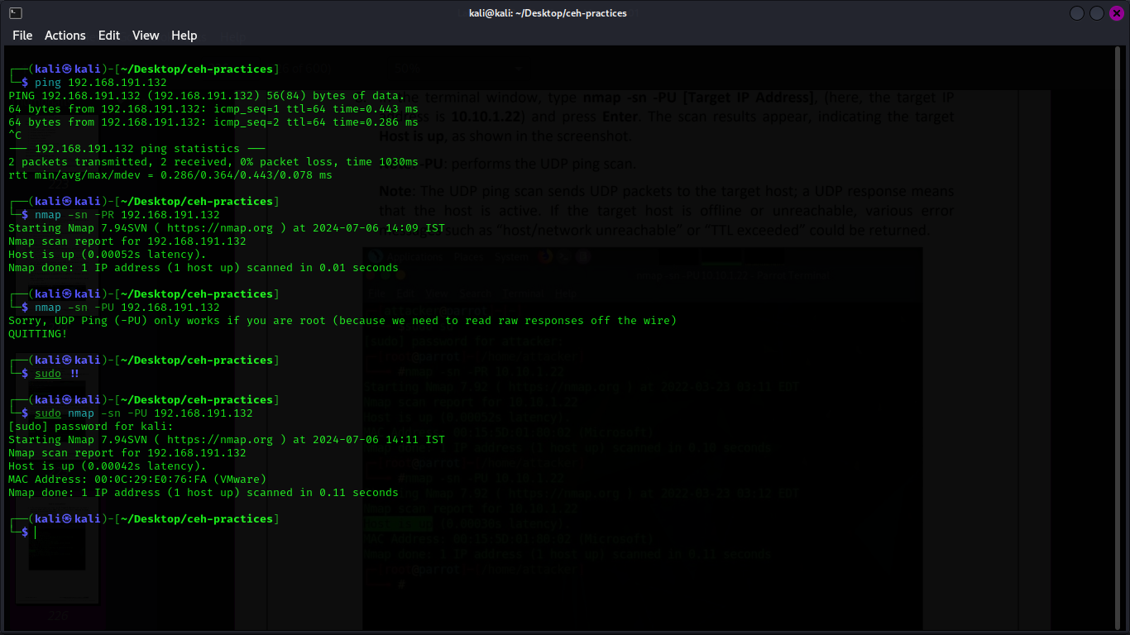
UDP ping

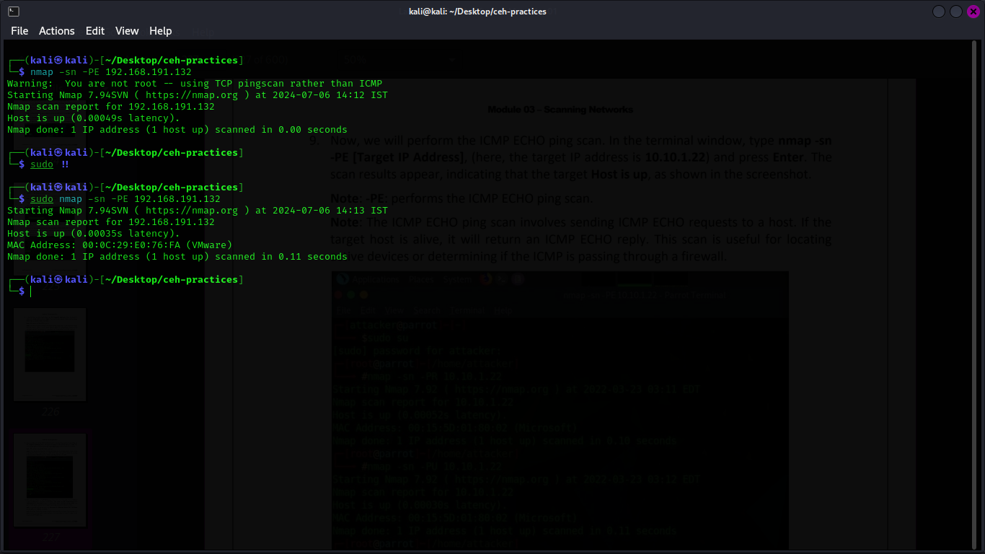
ICMP Echo ping

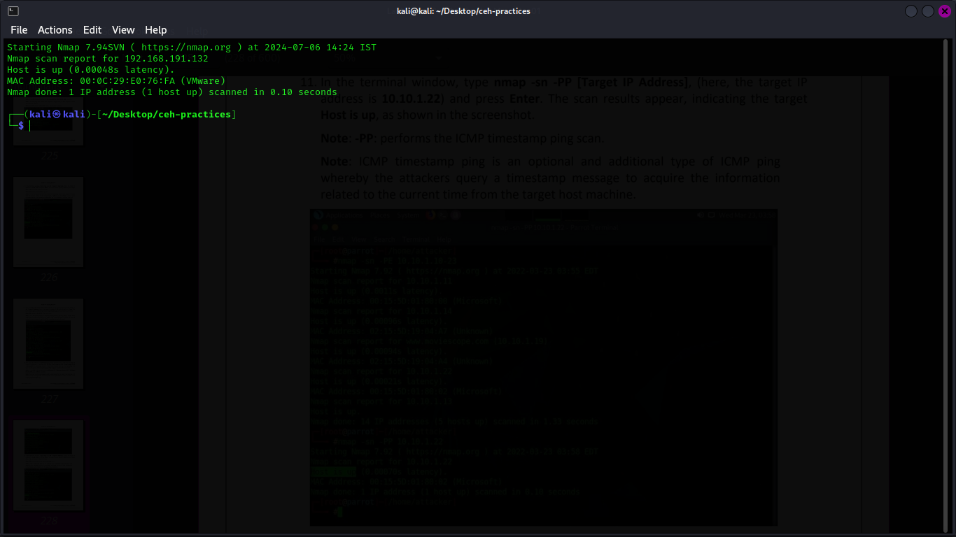
ICMP timestamp ping

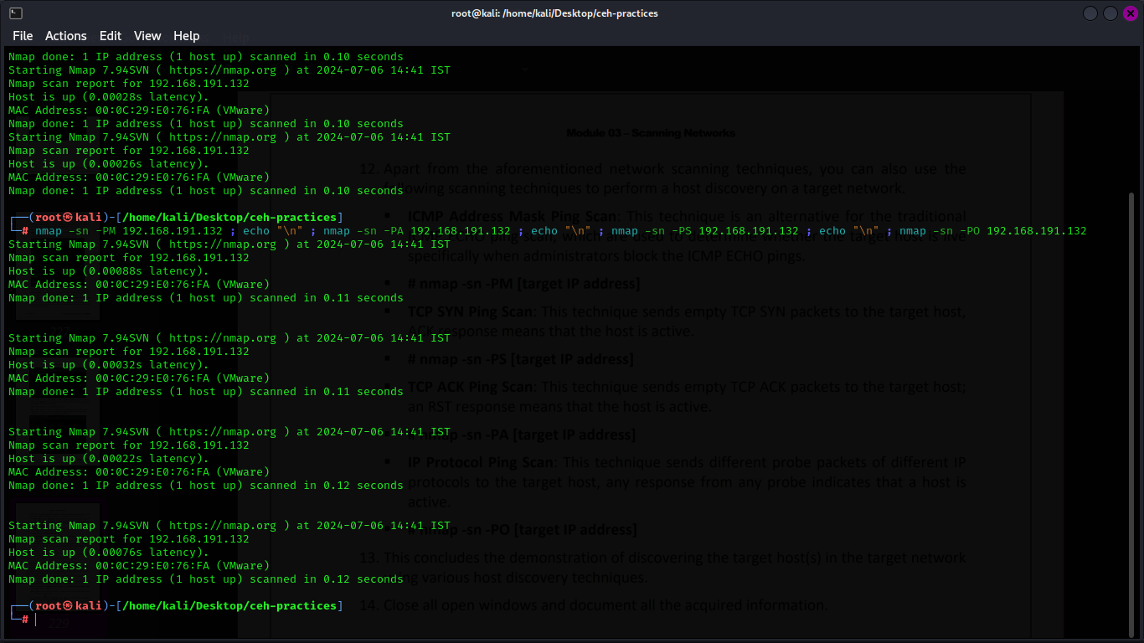
TCP SYN ping scan & TCP ACK ping scan & IP Protocol ping scan

