PROJECT REPORT
CyberSOC Intelligence Platform
An AI-Assisted Security Operations Center Dashboard
Built with Python · Streamlit · MySQL · Google Gemini AI
Repository
github.com/OfficialSubhayan/CyberSOC-Intelligence-Platform
Prepared for project documentation and review
License: MIT

Table of Contents
1. Executive Summary 3
2. Project Overview 3
3. System Architecture 3
4. Project Structure 4
5. Core Features 5
6. Technology Stack 5
7. Database Design 5
8. AI Module 7
9. Analyst Workflow 7
10. Installation and Setup 8
11. Team Contributions 8
12. Learning Objectives 9
13. Future Enhancements 9
14. Conclusion 9

1. Executive Summary
The CyberSOC Intelligence Platform is a Python-based Security Operations Center (SOC) application that pairs traditional incident management with artificial intelligence. It gives security analysts a single dashboard to view, store, and investigate security incidents, while Google's Gemini AI provides on-demand explanations, summaries, and threat analysis alongside the raw incident data.
The platform was built to demonstrate how AI can be layered onto a conventional SOC workflow without replacing it — incidents still live in a structured MySQL database, but analysts gain an AI assistant that can be queried directly from the same interface where they triage and manage cases.

Key Outcomes
- A working Streamlit dashboard for incident visibility and management.
- A MySQL-backed data layer for structured, queryable incident storage.
- A Gemini AI integration that answers security questions and analyzes incidents in context.
- A modular codebase (app, database, AI layers) that is straightforward to extend.

2. Project Overview
Security Operations Centers handle a steady, often high, volume of alerts and incidents that must be triaged, investigated, and resolved. Manual investigation is time-consuming, and analysts frequently need to pull together context from several sources before they can act. The CyberSOC Intelligence Platform addresses this by combining incident storage and management with an AI layer that can be asked to explain, summarize, or analyze an incident in plain language.
The platform enables analysts to:
- View and manage security incidents through an interactive dashboard.
- Store and retrieve incident records from a MySQL database.
- Run AI-assisted analysis on incidents as they are reviewed.
- Ask free-form cybersecurity questions using Google Gemini.
- Monitor incident status and history from a single screen.

3. System Architecture
The application follows a layered architecture. The analyst interacts with a Streamlit-based dashboard (app.py), which sits above two supporting layers: a database layer (db.py) that reads from and writes to MySQL, and an AI layer (ai_helper.py) that sends requests to the Google Gemini API. Configuration and credentials — database connection details and the Gemini API key — are supplied through environment variables rather than hard-coded into the application.
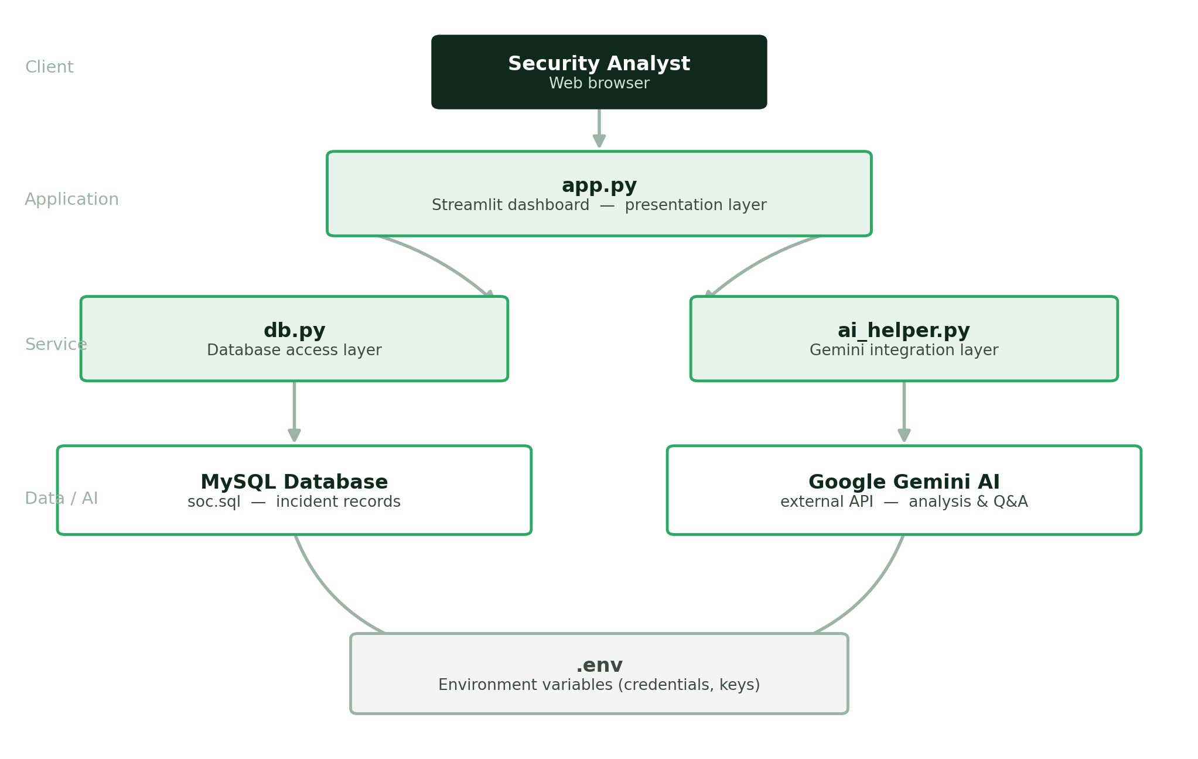
Figure 1. High-level system architecture of the CyberSOC Intelligence Platform.

Layer Responsibilities
- Client — the analyst's browser, used to access the Streamlit dashboard.
- Application — app.py renders the dashboard and coordinates the other layers.
- Service — db.py and ai_helper.py isolate database access and AI calls from the UI code.
- Data / AI — MySQL stores incident records; Gemini provides the analysis and Q&A capability.

4. Project Structure
The repository is organized around a small number of focused files, keeping the presentation, data, and AI logic separate:
File | Purpose
app.py | Main Streamlit application and dashboard entry point
db.py | Database connection and query logic
ai_helper.py | Google Gemini AI integration
soc.sql | MySQL database schema
requirements.txt | Python dependency list
.env | Environment variables (not included in the repository)
README.md | Project documentation

5. Core Features
- Interactive SOC dashboard for reviewing and managing incidents.
- Google Gemini AI integration for analyst-facing explanations and analysis.
- MySQL database connectivity for structured incident storage.
- AI-assisted incident analysis triggered directly from the dashboard.
- Structured incident management, including status tracking.
- Real-time database read and write operations.
- Environment-variable-based configuration, keeping secrets out of source control.
- Built entirely in Python, keeping the stack simple and consistent.

6. Technology Stack
The platform is intentionally built on a small, well-understood set of technologies:
Technology | Purpose
Python | Backend development
Streamlit | Dashboard interface
MySQL | Database
Google Gemini AI | AI-powered analysis
Python Dotenv | Environment variable management
Pandas | Data processing

7. Database Design
Incident information is stored in MySQL, defined by the soc.sql schema. Each incident record captures the information an analyst needs to triage and track a case from detection through resolution.
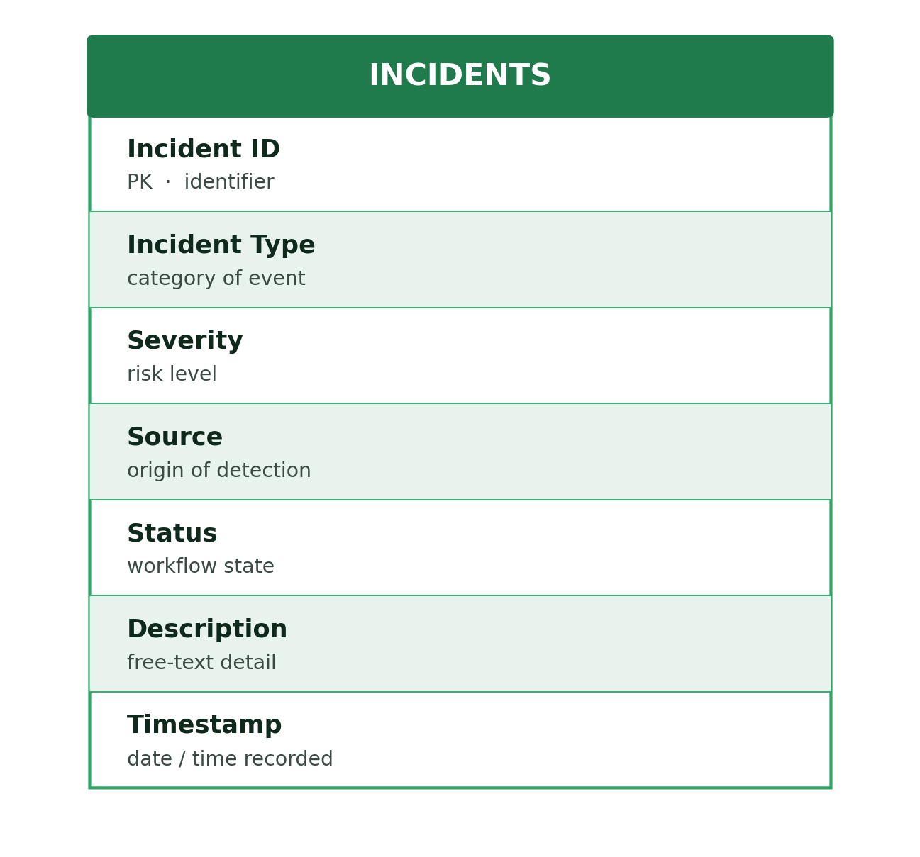
Figure 2. Core fields captured for each incident record.
Field | Description
Incident ID | Unique identifier for the record
Incident Type | Category of the security event
Severity | Risk level assigned to the incident
Source | Origin of the detection
Status | Current stage in the response workflow
Description | Free-text detail of what occurred
Timestamp | Date and time the incident was recorded

8. AI Module
The AI layer, implemented in ai_helper.py, integrates Google's Gemini model to support the analyst during investigation. Rather than replacing the analyst's judgment, it is designed to accelerate the early stages of triage by turning raw incident data into a plain-language explanation.
The AI module assists analysts by:
- Explaining what a security incident means in plain language.
- Summarizing alerts so analysts can triage faster.
- Providing threat analysis based on the incident's details.
- Answering general cybersecurity questions posed by the analyst.
- Reducing the manual research needed during investigation, improving analyst productivity.

9. Analyst Workflow
From the analyst's point of view, using the platform to investigate an incident follows a consistent, repeatable sequence — from opening the dashboard to receiving an AI-assisted summary.
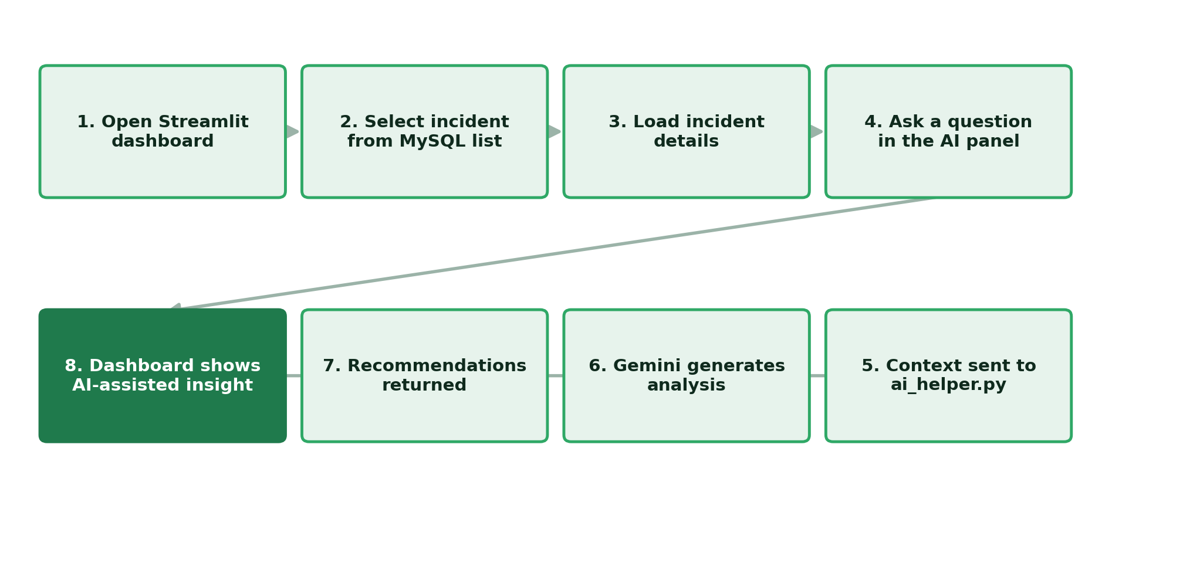
Figure 3. End-to-end analyst workflow, from dashboard to AI-assisted insight.
- Analyst opens the Streamlit dashboard.
- An incident is selected from the MySQL-backed incident list.
- Incident details — type, severity, source — are loaded from the database.
- Analyst asks a question or requests analysis through the AI panel.
- The query and incident context are passed to ai_helper.py.
- Google Gemini generates an analysis based on that context.
- A summary, explanation, and any recommendations are returned to the dashboard.
- The dashboard displays the AI-assisted insight alongside the incident record.

10. Installation and Setup

10.1 Clone the Repository
git clone https://github.com/OfficialSubhayan/CyberSOC-Intelligence-Platform.git

10.2 Create and Activate a Virtual Environment
python -m venv .venv
Windows: .venv\Scripts\activate Linux / Mac: source .venv/bin/activate

10.3 Install Dependencies
pip install -r requirements.txt

10.4 Set Up the Database
- Create a MySQL database.
- Import the schema: source soc.sql;

10.5 Configure Environment Variables
Create a .env file in the project root with the following keys:
- DB_HOST, DB_PORT, DB_NAME, DB_USER, DB_PASSWORD — MySQL connection details.
- GOOGLE_API_KEY — API key for Google Gemini.

10.6 Run the Application
streamlit run app.py
The dashboard opens automatically in the default browser.

11. Team Contributions
The platform was built by a four-person team, each responsible for a distinct part of the system:
Team Member | Contribution
Sarthak Mukherjee | Database design and SQL development
Surojit Jana | Streamlit dashboard development
Sayar Sekhar Ghosh | AI integration and testing
Subhayan Mitra | Backend development, database connectivity, project integration and GitHub management

12. Learning Objectives
Beyond the working product, the project was designed to build practical experience with:
- Python programming
- SQL database management
- AI integration
- Environment variable management
- Streamlit dashboard development
- Security Operations Center (SOC) concepts
- Incident management

13. Future Enhancements
Several extensions are identified as natural next steps for the platform:
- SIEM integration
- Threat intelligence API integration
- User authentication
- Alert correlation
- MITRE ATT&CK mapping
- Incident timeline visualization
- PDF report generation
- Role-based access control
- A broader SOC analytics dashboard

14. Conclusion
The CyberSOC Intelligence Platform shows a practical, working pattern for bringing AI into an SOC analyst's day-to-day workflow: keep incident data structured and queryable in a conventional database, and layer an AI assistant on top that can be asked to explain, summarize, and analyze that data on demand. The result is a compact, Python-based system that is easy to extend — the roadmap of SIEM integration, threat intelligence feeds, and MITRE ATT&CK mapping points toward a fuller SOC analytics platform built on the same foundation.
Project repository: github.com/OfficialSubhayan/CyberSOC-Intelligence-Platform · Licensed under MIT.

