COUNTIF:

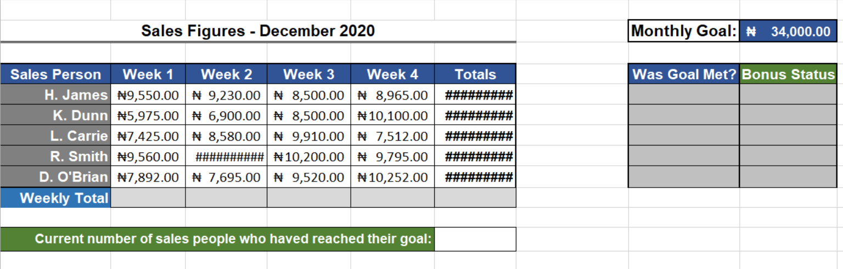

Current number of sales-people who have reached their goal: =COUNTIF(F5:F9,">=34000")

Was Goal met? = with IF function = IF(F5>$I$2,"Yes","No")

Bonus Status = with IF function = IF(H5="Yes","Bonus","No Bonus")

