IF()_FUNCTION:

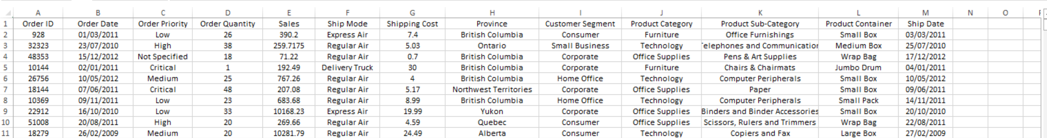

Priority: =IF([@[Order Priority]]="Critical", "Urgent", "Not Urgent")

Priority Star : =IF([@[Order Priority]]="Critical","***",IF([@[Order Priority]]="High","**","*"))

Price Classification: =IF([@Sales]>5000,"Expensive","Cheap")

