IF_ERROR:

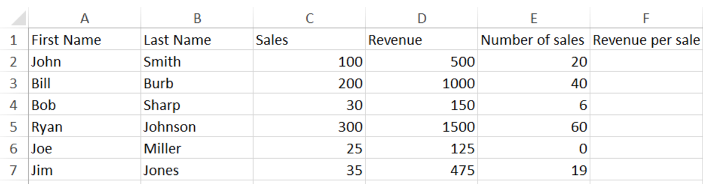

IFERROR: = IFERROR([@Revenue]/[@[Number of sales]], "No Sales yet")

