SUMIF:

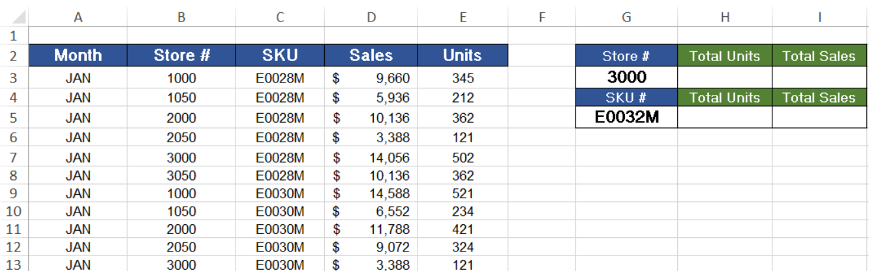

Total Units (Store): =SUMIF(MyStoreTable[Store '#], "=3000", MyStoreTable[Units])

Total Units (SKU): =SUMIF(MyStoreTable[SKU], "=E0032M", MyStoreTable[Units])

Total Sales (Store): =SUMIF(MyStoreTable[Store '#], "=3000", MyStoreTable[Sales])

Total Sales (SKU): =SUMIF(MyStoreTable[SKU], "=E0032M", MyStoreTable[Sales])

