VLOOKUP:

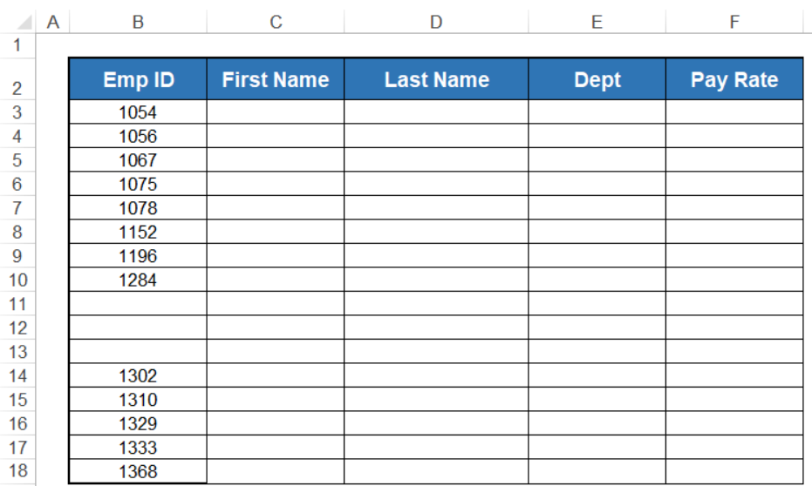 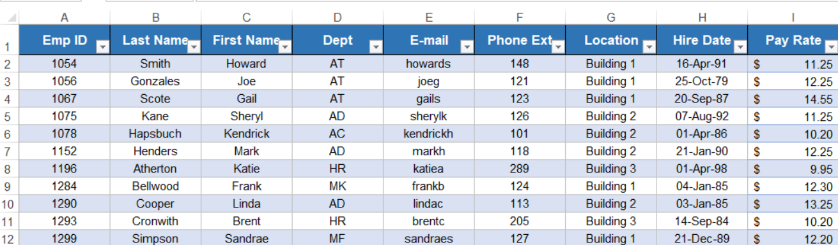

FirstName= =IFERROR(VLOOKUP([@[Emp ID]],MasterList,3,FALSE),"No Matching ID")

LastName=IFERROR(VLOOKUP([@[Emp ID]],MasterList,2,FALSE),"No Matching ID")

Department =IFERROR(VLOOKUP([@[Emp ID]],MasterList,4,FALSE),"No Matching ID")

Pay Rate =IFERROR(VLOOKUP([@[Emp ID]],MasterList,9,FALSE),"No Matching ID")

