JENGABANK PAYMENTS
Application Blue Proposal, Version 2
JengaSec 2026 | APP04, Payment Processing Service | 13 October 2026
AI-use statement

With the organisers' permission, given the time constraints, the team used an AI assistant (Claude, by Anthropic) for planning, README documentation, and generating boilerplate code. The team reviewed and validated the relevant outputs before submission.
Declared by: Darlene Wendy, Build Lead
Date: 13 October 2026

Team and roles

Role | Name | Responsibilities
Build Lead | Darlene Wendy | Database schema and migrations, double-entry ledger, atomic transfers, idempotency, reversals, frontend, Docker and CI, code review
Developer, Identity and Visibility | Christopher Mbuthia | Login, sessions and tokens, lockout, roles, account endpoints, structured request and security logging
Developer, Transaction Controls | Lucy Njenga | Limits, fraud engine, maker-checker approvals, audit trail endpoints, end-of-day reconciliation
Security Lead | Phenny Mwaisaka | Threat model, security objectives, attacking every release, frontend security review, live defence coordination

1. Problem statement
A payment service is where money is actually created, moved and recorded. If it fails, the damage is direct: money is stolen, created out of nothing, paid twice, or moved without the approvals the bank requires. Worse, a weak service lets an attacker or a dishonest insider hide what happened by editing the records.
Typical payment systems fail in predictable ways:
- A balance is stored as a number that code updates, so one bug or one injected query changes it with no trace.
- Two requests that arrive at the same moment both pass the balance check and overspend the account.
- A retried request, after a dropped connection, posts the payment a second time.
- Limits and fraud checks run in the client or can be skipped, and approval rules are enforced only in application code.
- History can be edited or deleted, so tampering cannot be proven.
APP04 asks for a service that closes every one of these gaps: a double-entry ledger with derived balances, atomic transfers that are safe under concurrency, idempotency, server-side limits, fraud allow, review or block decisions, maker-checker above a threshold, reversals as new entries, and an append-only log that reconciles at end of day.

2. Proposed solution
JengaBank Payments makes one promise: money is never created, destroyed, spent twice, or moved without the right people agreeing, and every attempt to do otherwise leaves a trace.
We keep that promise in two layers. The application enforces the business rules: ownership, limits, fraud decisions, maker-checker and idempotency. Underneath it, the database enforces the accounting rules on its own, so even a bug in our code or a successful injection cannot unbalance the books, overdraw an account or rewrite history.

2.1 Architecture
Layer | Choice | Why
API | Java 21, Spring Boot 3.5, Spring Security | Our team's strongest language; mature, well-patched security framework
Data access | Plain SQL through JdbcTemplate | Exact control over locking and transactions; every query is reviewable
Database | PostgreSQL 16 (provided by JengaSec) | Transactional integrity, row locks, constraint triggers
Schema changes | Flyway migrations | The database builds itself identically on every start
Frontend | React PWA, served by the same image | One container, one port; no third-party scripts or CDNs
Logs | JSON lines to stdout | One line per request plus one per security decision

Request flow. Every request passes through the same steps: a request ID is assigned, the token is authenticated, the role is checked and the input validated, the service runs inside one database transaction, an audit row is written, and the JSON response and log line are produced.
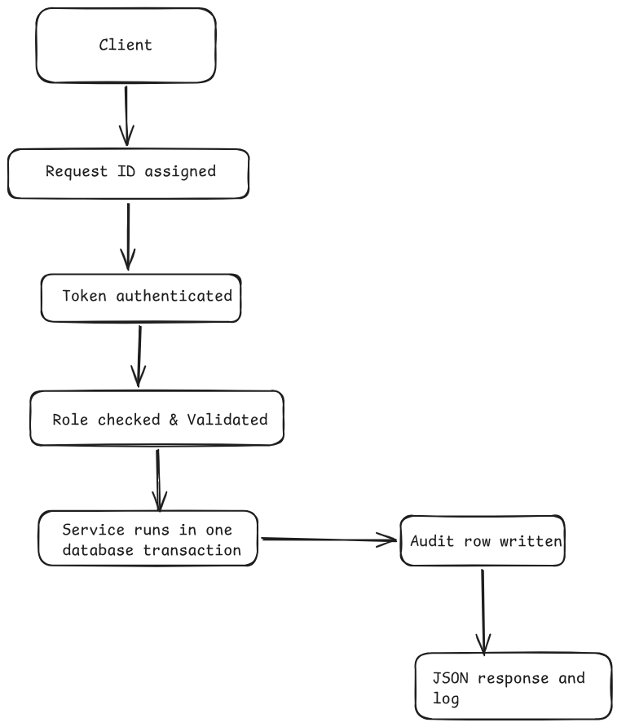

2.2 Double-entry ledger; balance derived, never a mutable field

Every money movement is a journal with at least two entries, a debit and a credit. There is no balance column anywhere in the schema. A balance is always the sum of an account's entries, calculated on read. Opening balances are also journals, posted from the bank's internal funding account, so even seed data obeys the rules. A deferred constraint trigger checks at commit that every journal's debits equal its credits. An unbalanced journal cannot be committed, whatever the application does.

2.3 Atomic transfers, provably safe under concurrent requests
A transfer runs in a single transaction: lock both accounts in a fixed order (which prevents deadlocks), check limits and fraud, insert the journal, entries, transfer record and audit row, then commit. Any failure rolls back everything. As a second line of defence, a commit-time trigger re-locks the debited account and rejects any entry that would take a customer account below zero.

2.4 Idempotency
Every money-changing request (transfer, approval, rejection, reversal) requires an Idempotency-Key header. We store the key with the caller, a SHA-256 hash of the request and the response:
- Same key, same request: the original response is returned; nothing is posted again.
- Same key, different request: 409 Conflict, logged as idempotency.conflict.
- Missing key: 400.
The frontend generates one key per transfer attempt and reuses it on retry, so a dropped connection or a double tap can never pay twice.

2.5 Server-side limits and fraud allow, review or block
The server enforces limits; nothing from the client is trusted except who to pay and how much. Limits: KES 1,000,000 per transfer, KES 2,000,000 per customer per day, and 5 transfers per minute per user.
The fraud engine runs synchronously, inside the transaction, before the transfer row is written. Rules include a large amount to a new payee, velocity spikes, repeated failed attempts and unusual hours. Each rule returns a decision with human-readable reasons:

Decision | Result
ALLOW | Posted immediately; status COMPLETED
REVIEW | Held, no money moves; status PENDING_APPROVAL
BLOCK | Refused and recorded, no money moves; status BLOCKED

The decision and reasons are stored with the transfer and are immutable; a database trigger rejects any attempt to change them, so a REVIEW can never be flipped to ALLOW to skip the checker.

2.6 Maker-checker above a threshold; reversals as new entries
Transfers of KES 250,000 or more, and anything fraud marks REVIEW, wait for a CHECKER. The database itself rejects an approval by the person who created the transfer (a CHECK constraint, not just application code). Status can only move forward: pending to completed or rejected, and completed to reversed.
A reversal never edits or deletes the original. It posts a new journal with the entries swapped, linked to the original. A unique constraint means a journal can be reversed only once, and large reversals also go through a checker.

2.7 Append-only log that reconciles at end of day
Journals, ledger entries, the audit log and reconciliation results reject UPDATE, DELETE and TRUNCATE at the database level. The audit log is hash-chained: the database assigns each record's sequence number and stores the SHA-256 of the previous record inside the next, under a lock so concurrent writers cannot fork the chain. Changing any past record breaks every hash after it.
Reconciliation runs every day at 23:00 EAT and on demand, and verifies:
- Every journal balances.
- Every account's balance matches its entries.
- No customer account is below zero.
- The audit chain is intact.
Results are stored (append-only) and logged as reconciliation.passed or reconciliation.failed.

2.8 Identity and access
- Tokens: 32 random bytes; only the SHA-256 is stored, so a database leak yields no working sessions. 30-minute expiry; logout revokes server-side.
- Passwords: BCrypt, cost 12.
- Brute force: account lockout after 5 failures (15 minutes) plus a per-IP limit of 10 attempts per minute.
- No user enumeration: unknown usernames take the same time and get the same error as wrong passwords.
- Roles: CUSTOMER, MAKER, CHECKER, enforced centrally per endpoint. Identity comes only from the token, never from the request body.
- Ownership: the owner is part of every account query. Another customer's account returns 404, not 403, so attackers cannot learn what exists, and the attempt is logged.
- Input: unknown JSON fields rejected, field lengths enforced, money only as whole cents (integers), 16 KB request limit. Errors never contain stack traces, SQL or internal details.

3. Data model
PostgreSQL 16, built by Flyway migrations V1 to V5. All money is stored as BIGINT cents in KES. All identifiers are server-generated UUIDs.

Table | Purpose | Key protections
users | Customers and staff, one role each | Username format check; role limited to CUSTOMER, MAKER or CHECKER; BCrypt hash only; failed-login counter and lock time
sessions | One row per issued token | Stores SHA-256 of the token, never the token; expiry and revocation
accounts | Customer and internal bank accounts | No balance column; only the internal funding account may go negative; customer accounts must have an owner
journals | One business event (opening, transfer, reversal) | Append-only; a reversal must link to the journal it reverses, and only once
ledger_entries | Debit and credit lines | Append-only; amount must be positive; journal must balance at commit; customer accounts cannot go below zero
account_balances (view) | Balance per account | Always SUM of entries; read-only
transfers | Requested movements and their decisions | Never deleted; amounts, accounts, creator and fraud decision immutable; status only moves forward; approver must differ from creator
reversals | Reversal requests | Reason required; one live reversal per transfer; approver must differ from requester
idempotency_keys | Replay protection | Primary key (user, key); stores request hash and response
audit_log | Hash-chained record of every action | Append-only; database sets sequence, time and hashes; audit_verify() checks the whole chain
reconciliation_runs | End-of-day results | Append-only; stores every check and its outcome

4. API contract compliance
All endpoints follow one written contract, kept in the repository as docs/api.md and published by the running service at /openapi.json, generated from the code so it cannot drift.

4.1 Conventions
Area | Rule
Paths | Under /api/v1; plural lowercase nouns; actions as sub-resources
JSON | camelCase; unknown fields rejected; 16 KB maximum body
Money | amountMinor as a whole number of cents plus currency: KES; no floating point
Identity | From the bearer token only; never userId or role in a request
Idempotency | Idempotency-Key required on every money-changing POST
Errors | One shape: code, message, requestId; no internal details
Status codes | 200, 201, 202 (pending approval), 400, 401, 403, 404 (not found or not yours), 409, 422 (business rule), 423 (locked), 429, 500
Lists | Cursor pagination returning items and nextCursor; limit 50 by default, 100 maximum
Tracing | X-Request-Id accepted or generated, returned in the response and every log line
Time | UTC, ISO 8601

4.2 Endpoints
Method | Path | Access | Idempotency
GET | /healthz, /readyz, /openapi.json | Public | No
POST | /api/v1/auth/login | Public | No
POST | /api/v1/auth/logout | Signed in | No
GET | /api/v1/me | Signed in | No
GET | /api/v1/accounts, /api/v1/accounts/{id}, /api/v1/accounts/{id}/entries | CUSTOMER, own only | No
POST | /api/v1/transfers | CUSTOMER | Required
GET | /api/v1/transfers, /api/v1/transfers/{id} | Own; staff see all | No
POST | /api/v1/transfers/{id}/reversals | MAKER | Required
GET | /api/v1/approvals | CHECKER | No
POST | /api/v1/approvals/{id}/approve, /api/v1/approvals/{id}/reject | CHECKER | Required
POST | /api/v1/reconciliation/runs | CHECKER | No
GET | /api/v1/reconciliation/runs/latest, /api/v1/audit, /api/v1/audit/verify | MAKER, CHECKER | No

How compliance is checked: roles are enforced centrally per path in the security configuration; integration tests assert status codes, error shape and role denials; the frontend uses a typed copy of the contract, so any mismatch fails its build.

5. Deployment configuration
Item | Configuration
Image | Multi-stage build: React build, Maven build, Java 21 JRE on Alpine runtime
Platform | linux/amd64
User | Non-root, UID 10001; no shell login
Port | 8080, single port; frontend and API served together
Health | /healthz (process up) and /readyz (database reachable and migrations applied)
Resources | Fits 2 CPU and 3 GB shared with PostgreSQL; JVM heap capped at 50% of memory; exits cleanly on out-of-memory
Database | PostgreSQL 16 provided by JengaSec; connection details from environment variables; schema created by Flyway on start
Secrets | None in the image or repository; all configuration from environment variables
Network | No outbound internet needed at runtime; fonts and scripts are bundled
Logs | JSON lines to stdout
Registry | Private GitHub Container Registry; read-only token shared with JengaSec; a new tag for every release (v1, v2, v3), never latest
CI | On every push: backend tests against a real PostgreSQL container and frontend build. On a version tag: build, Trivy scan (fails on critical vulnerabilities), push
Headers | Content-Security-Policy, X-Frame-Options DENY, no referrer, nosniff, restricted Permissions-Policy

6. Threat model

6.1 Assets and trust boundaries
Asset | Why it matters
Ledger (journals and entries) | It is the money. Every balance is derived from it
Transfers and their decisions | Who moved what, and who approved it
Credentials and sessions | Control of accounts
Audit trail | Our evidence; worthless if it can be edited

Trust boundaries: network to API (everything untrusted); customer to staff (makers and checkers have powers customers do not); API to database (the database trusts no one, including our own API).

6.2 Threats and controls
# | Threat | Attacker | Impact | Controls
T1 | Pay from someone else's account (IDOR) | Customer | Theft | Owner in every query; 404; authz.access.denied logged
T2 | Double spend with parallel requests | Customer | Overdraft, money created | Ordered row locks; commit-time overdraft trigger
T3 | Replay a transfer request | Network attacker or flaky client | Duplicate payment | Mandatory idempotency key with request hash
T4 | Negative, zero or huge amounts | Customer | Money created | Validation; database check that amount is above zero; limits
T5 | Bypass fraud review | Insider or injection | Unchecked large transfer | Decision set before insert; immutable by trigger
T6 | Approve own transfer | Insider | Maker-checker defeated | Database check that approver is not the creator
T7 | Rewrite or delete history | Insider or injection | Fraud hidden | Append-only triggers; hash chain; reconciliation
T8 | Unbalance the ledger | Bug or injection | Books wrong | Deferred balanced-journal trigger
T9 | Reverse a transfer twice | Insider | Money created | Unique reversal link; one live reversal per transfer
T10 | Password guessing | External | Account takeover | Lockout, IP rate limit, BCrypt, no enumeration
T11 | Stolen token | External | Account takeover | Short expiry, server-side revocation, hashed storage
T12 | Role escalation via request body | Customer | Staff powers | Unknown fields rejected; role only from token
T13 | Information leakage from errors | External | Reconnaissance | Single safe error shape; no stack traces

7. Security objectives
- No caller can move or view money in an account they do not own.
- The sum of all ledger entries is always zero, and every journal balances.
- No customer balance can go below zero, even under concurrent requests.
- The same request can never post money twice.
- No transfer at or above KES 250,000, or marked REVIEW, moves without a different person's approval.
- No financial or audit record can be changed or deleted, and any tampering is detectable.
- Every security decision produces a log line that identifies the actor, action and outcome.

8. Logging and live defence
Every request writes one JSON line with ts, src_ip, method, path, status, user and action, plus a request ID that also appears in every error response. Every security decision writes its own named event.
Signal | Likely attack | Our response
Burst of auth.login.failed, then auth.account.locked | Password guessing | Report source IP and targeted accounts
Repeated authz.access.denied on accounts | IDOR or enumeration | Report actor and account IDs probed
idempotency.conflict | Replay or tampered retry | Report actor and key
fraud.block or limit.exceeded spikes | Automated draining | Report pattern and amounts
approval.self_approval_denied | Insider abuse | Escalate
db.guard_triggered | Injection or logic bypass reached the database | Escalate immediately
reconciliation.failed or audit.chain.broken | Integrity compromise | Run verification, report affected records

During the event one person watches authentication and access logs, one watches money movement, and the Security Lead triages and files reports.

9. Testing
Automated tests run in CI against a real PostgreSQL container and cover authentication, lockout, enumeration resistance, ownership, role enforcement, token revocation and request validation. Concurrency and idempotency tests run parallel transfers against the full API.
Our Security Lead attacks every version we release before it is submitted.

10. Implementation plan
Phase | Work | Owner | Done when
1. Foundation | Schema and migrations, health endpoints, configuration, Dockerfile, CI, error handling, JSON logging | Build Lead | Image v1 reaches Healthy
2. Identity | Login, sessions, lockout, roles, account and entry endpoints | Identity Developer | Auth and ownership tests pass
3. Money core | Ledger service, atomic transfers, idempotency, concurrency tests | Build Lead | Parallel transfer test cannot overspend
4. Controls | Limits, fraud engine, maker-checker, audit endpoints, reconciliation | Transaction Controls Developer | Controls tests pass; reconciliation passes
5. Reversals and frontend | Reversal flow; React frontend wired to the API | Build Lead | End-to-end flows work in the image
6. Hardening | Security Lead attacks each release; fixes; final scan | Whole team | No open critical findings; final image Healthy

Every pull request is reviewed by the Build Lead against a checklist: money as integer cents, ownership on every query, no updates or deletes on ledger or audit rows, a log line for every security decision, safe errors, validated input, and security tests alongside the code.

11. Timeline
When (EAT) | Milestone
Mon 12 Oct | Team formed and roles set; schema, infrastructure, frontend and identity built; profiles and IDs completed by 23:59
Tue 13 Oct, 09:00 | Proposal version 2 submitted
Tue 13 Oct, morning | Money core, controls and reversals completed; Security Lead attacks each release
Tue 13 Oct, 12:00 | Code freeze; bug fixes only
Tue 13 Oct, 13:00 | Final image submitted and Healthy
Tue 13 Oct, 14:00 | Official build freeze
Wed 14 to Fri 16 Oct | Live defence at Strathmore: log monitoring, detection and reporting

12. Risks and mitigations
Risk | Likelihood | Mitigation
Core features not finished before the freeze | Medium | Build in priority order; ship a Healthy image early and improve it with new tags; cut scope rather than break Healthy
Image fails Healthy (platform, user, scan) | Medium | amd64 build, non-root user, slim patched base image, Trivy in CI before every push
Concurrency bug in transfer code | Low | Ordered row locks in the application, plus a commit-time overdraft trigger in the database as a backstop
Logic bypass or injection reaches the database | Low | Parameterised SQL only; database triggers and constraints reject illegal changes and raise db.guard_triggered
JVM and database exceed the shared 3 GB | Low | Heap capped at 50%; small connection pool; tested with the same limits locally
Login rate limiter is in memory | Accepted | Fine for one instance; account lockout still applies per user
Fraud rules are heuristics with fixed thresholds | Accepted | Decisions carry reasons and borderline cases go to REVIEW, so a person decides
Internal funding account may go negative by design | Accepted | Excluded from customer overdraft checks; covered by reconciliation
No TLS termination inside our container | Accepted | Traffic stays on the provided range network; tokens are short-lived and revocable
A team member becomes unavailable | Low | Shared written contract and folder ownership; any developer can pick up another's area

13. References
- JengaSec 2026 Briefing, Application Blue Track, and the APP04 Payment Processing Service brief.
- OWASP Application Security Verification Standard (ASVS) 4.0.3. https://owasp.org/www-project-application-security-verification-standard/
- OWASP API Security Top 10, 2023 edition. https://owasp.org/API-Security/
- NIST SP 800-63B, Digital Identity Guidelines: Authentication and Lifecycle Management. https://pages.nist.gov/800-63-3/sp800-63b.html
- PostgreSQL 16 Documentation: Explicit Locking, and CREATE TRIGGER (constraint triggers). https://www.postgresql.org/docs/16/
- IETF HTTPAPI Working Group, The Idempotency-Key HTTP Header Field (Internet-Draft). https://datatracker.ietf.org/doc/draft-ietf-httpapi-idempotency-key-header/
- RFC 9110, HTTP Semantics. https://www.rfc-editor.org/rfc/rfc9110
- Spring Security Reference Documentation. https://docs.spring.io/spring-security/reference/
- CIS Docker Benchmark. https://www.cisecurity.org/benchmark/docker

