Fr. Conceicao Rodrigues College Of Engineering
Bandra
Computer Department
SEM-V



Web Technology Project
QUIZZER

Group Members:
Simran Dsouza (8335)
Elita Menezes (8346)
Darlene Nazareth (8353)
Guide: Mr. Mahendra Mehra
Project Code: https://github.com/Darlene-Naz/Quizzer.git
Table of Contents
Table of Contents iii
Revision History iv
1. Introduction 1
1.1 Purpose 1
1.2 Project & Product Overviews 1
1.3 How It Benefits AStudent and Teacher 2
2. Overall Description 1
2.1 Product Perspective Error! Bookmark not defined.
3. Functional Requirements 4
4. Non-fucntional Requirements Error! Bookmark not defined.
Appendix A: Glossary 5
Appendix B: Analysis Models 9

Introduction
This is a quiz Webpage which gives information about the students academic progress. Firstly, every teacher must login using a unique ID and a password. With this, the student is also supposed to login using the roll no provided to them and a unique password.
The teacher will then input her branch and year that she is currently teaching. She can create subjects and topics related to the subject. She can then create a quiz by inputting questions and answers. Every student gets 4 options of which every correct answer to the question is awarded points which will be stored in the database.
From the teacher’s perspective, a teacher has access to the database wherein he/she can see which students are attempting the quiz. The teacher can also see the student’s progress in a tabular format after each quiz.

Purpose
To create the application, we had to research on various drawbacks of quizzes that were online as well as offline.
The drawbacks of online quizzes were that there was constant need to login after exiting the page. In terms of Security, online quizzes were more prone to getting affected.
The issues faced with Offline quizzes are that time is wasted on a considerably larger margin in terms of distributing and grading papers. The chances of cheating during an examination is very high.
To overcome these downsides, we came up with the creation of the Quiz App to provide efficiency as well as complete protection of information.

Project & Product Overviews
Quizzer replaces the already existing quiz feature on moodle. Quizzer provides a better and much more interesting look to make learning more fun. In addition to this, it helps to focus on improving
The Logical Reasoning aspect of the curriculum. Although quizzer is at a small scale, it helps them to improve their skills in terms of preparing for future competitive exams.

How It Benefits a Teacher and Student
- A teacher need not take the trouble of assigning a time, distribute the papers, collect the papers and correct each one of them manually.
- It helps creating a flexible environment for the examination.
- The records are stored and hence the teacher doesn’t need to manually write them down.
- It skips the orthodox pen paper methodology and provides a much more interesting and fun approach to exams.

Overall Description
Time Saving: Since the teacher doesn’t have to correct each quiz it helps saving time. Also the manual process of entering the scores of the student can be avoided. It creates the quizzes on the go.

No Complication: It has a simple UI which provides a smooth user experience for both teachers and students.

Cost Effective: It’s cheaper as no paper is purchased during this process.

Security: Online systems are just as secure. Your data is stored on servers that feature online security.

Product Perspective
The system is developed using the following technologies:
Front End:
- HTML5
HTML5 is a software solution stack that defines the properties and behaviors of web page content by implementing a markup based pattern to it.

- CSS3
Cascading Style Sheets (CSS) is a style sheet language used for describing the presentation of a document written in a markup language like HTML.

- Bootstrap4
Bootstrap is a free and open-source CSS framework directed at responsive, mobile-first front-end web development. It contains CSS- and (optionally) JavaScript-based design templates for typography, forms, buttons, navigation and other interface components.

- jQuery
jQuery is a JavaScript library designed to simplify HTML DOM tree traversal and manipulation, as well as event handling, CSS animation, and Ajax.

- Embedded JavaScript
JavaScript often abbreviated as JS, is a high-level, interpreted scripting language that conforms to the ECMAScript specification. JavaScript has curly-bracket syntax, dynamic typing, prototype-based object-orientation, and first-class functions.

Back End:
- Node.JS
Node.js is an open-source, cross-platform, JavaScript runtime environment that executes JavaScript code outside of a browser.

- Express.JS
Express.js, or simply Express, is a web application framework for Node.js, designed for building web applications and APIs.

- MongoDB
MongoDB is a cross-platform document-oriented database program. Classified as a NoSQL database program, MongoDB uses JSON-like documents with schema.

Others:

- Passport.JS
Passport is authentication middleware for Node.js. Extremely flexible and modular, Passport can be unobtrusively dropped in to any Express-based web application. A comprehensive set of strategies support authentication using a username and password, Facebook, Twitter, and more.

- MongoDB Atlas
Flexible and scalable document database.

- Robo 3T
The GUI for MongoDB. Visually explore your data. Run ad hoc queries in seconds. Interact with your data with full CRUD functionality. View and optimize your query performance.

- Google reCaptcha (v2) API
reCAPTCHA is a free service that protects you against spam and other types of automated abuse.
It uses advanced risk analysis techniques to tell humans and bots apart.

- EJS template engine
EJS is a simple templating language that lets you generate HTML markup with plain JavaScript. No religiousness about how to organize things. No reinvention of iteration and control-flow. It's just plain JavaScript.

3 FUNCTIONAL REQUIREMENTS
Registration

- System will allow the teacher and student to add themselves on the system
- The system will provide the teachers with a unique ID which is used as a username and a unique password which is entered by the teachers.
- The student have to register using their roll no and unique password

Login

- Sign In: The teacher/student first needs to sign in to the system with the username
And password he/she have provided with. The system need to check for that username and password and then only allow him/her to access the system.

Report Generation

- Student Information: The system shall generate reports based on how they have performed in the quiz.

4 NON FUNCTIONAL REQUIREMENTS

Performance Criteria:

- Time: The elapsed time between the submission of order process between the customer and cashier in a canteen should be as minimum as possible.

- User-friendly: It should be users friendly. The user interface should be kept simple and uncluttered. Since different type of people interact with this process, it should be very easy for them to understand.

- Flexibility: It should be so flexible that whenever we want to make changes in it, it can be done very easily.

DATABASE (MONGODB)

What is MongoDB?
MongoDB is a document database with the scalability and flexibility the querying and indexing.
- Each database contains collections which in turn contains documents. Each document can be different with a varying number of fields. The size and content of each document can be different from each other.
- The document structure is more in line with how developers construct their classes and objects in their respective programming languages. Developers will often say that their classes are not rows and columns but have a clear structure with key-value pairs.
- As seen in the introduction with NoSQL databases, the rows (or documents as called in MongoDB) doesn't need to have a schema defined beforehand. Instead, the fields can be created on the fly.
- The data model available within MongoDB allows you to represent hierarchical relationships, to store arrays, and other more complex structures more easily.

Why NoSQL over SQL?
Today, the advantages of NoSQL databases are no secret, especially when cloud computing has gained wide adoption.
NoSQL databases were created in response to the limitations of traditional relational database technology. When compared against relational databases, NoSQL databases are more scalable and provide superior performance, and their data model addresses several shortcomings of the relational model.
The advantages of NoSQL include being able to handle:
- Large volumes of structured, semi-structured, and unstructured data
- Agile sprints, quick iteration, and frequent code pushes
- Object-oriented programming that is easy to use and flexible
- Efficient, scale-out architecture instead of expensive, monolithic architecture
Today, companies leverage NoSQL databases for a growing number of use cases. NoSQL databases also tend to be open-source and that means a relatively low-cost way of developing, implementing and sharing software.

Why we chose MongoDB over MySQL?
- MongoDB is schema free, allowing you to create documents without having to define the structure of the document first. These documents can be easily changed by adding or deleting fields.
- In MongoDB, data is stored in JSON-like documents that can have varied structures. To improve query speed, MongoDB can store related data together, which can accessed using the MongoDB query language.
- Using the MongoDB data model, we can represent hierarchical relationships, data arrays, and other complex structures in the database. Also in many cases, MongoDB performance is improved over MySQL because MongoDB does not use joins to connect data, improving performance.
- Since MongoDB has no clear schema definition- There are several instances where MongoDB can be a good choice when dealing with databases with no clear schema definition.

Application User Interface

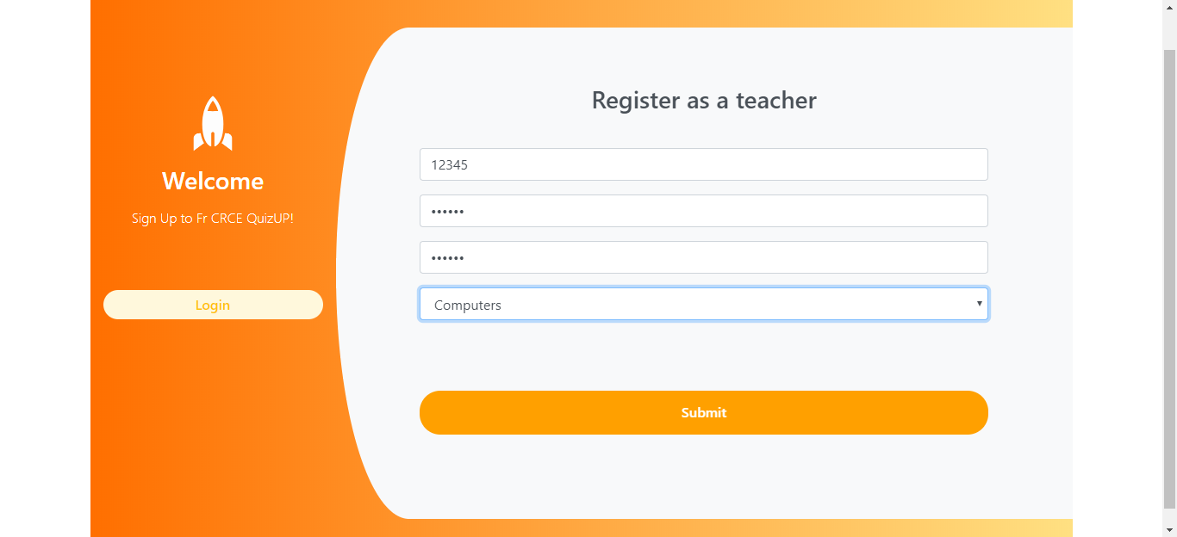
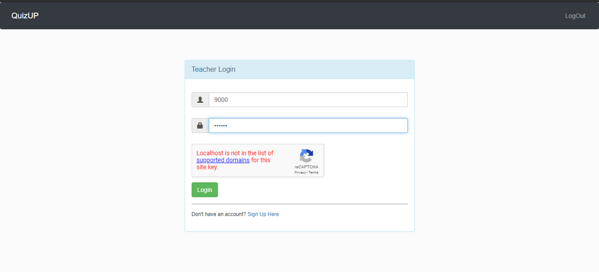
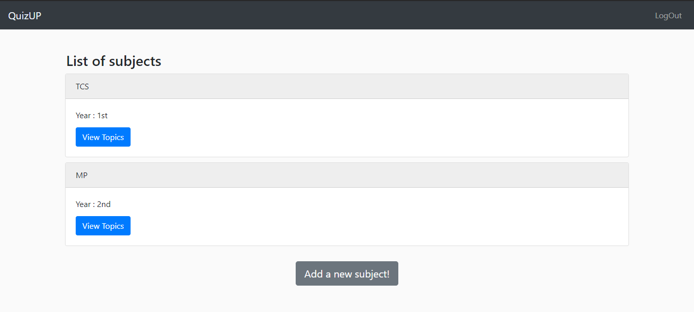
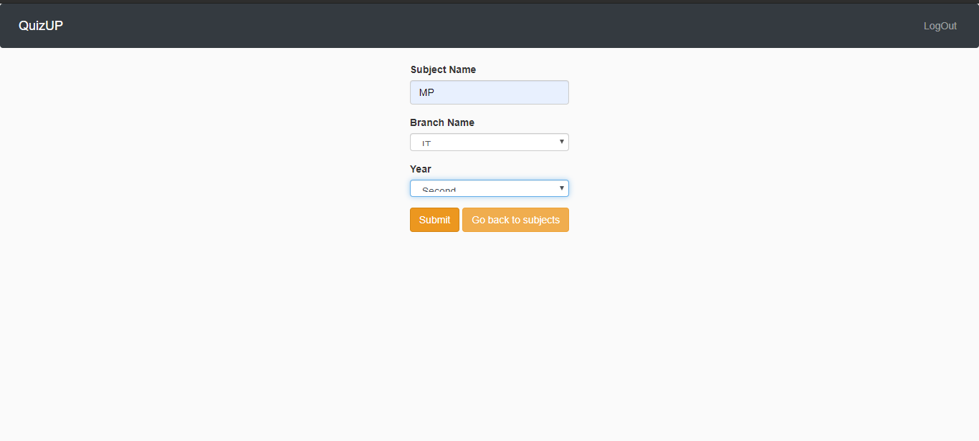
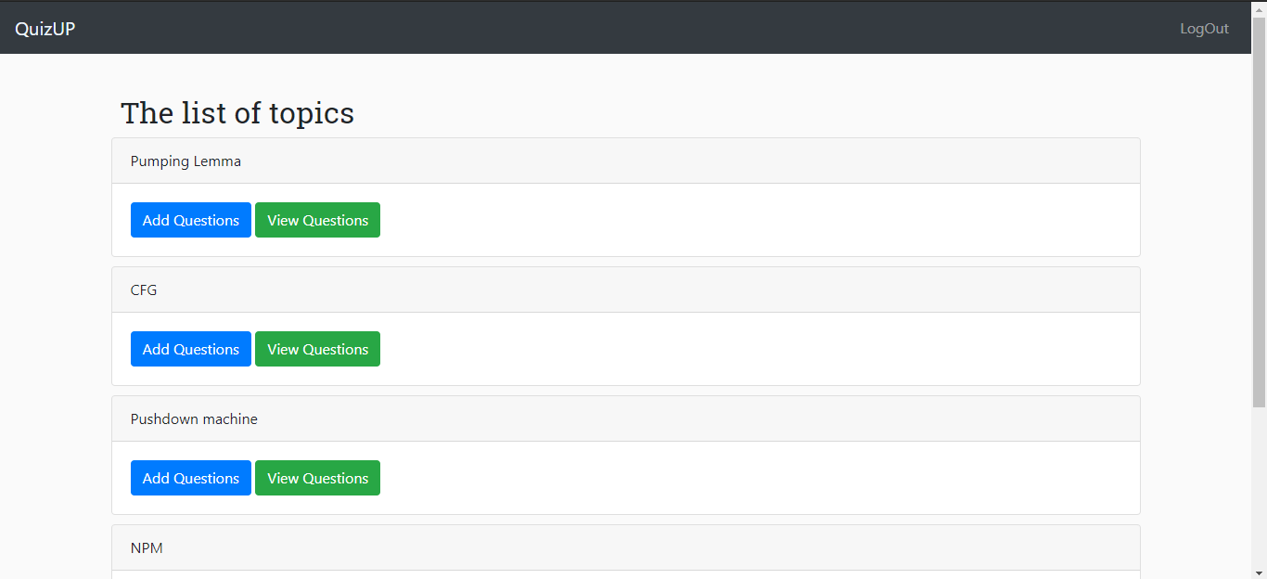
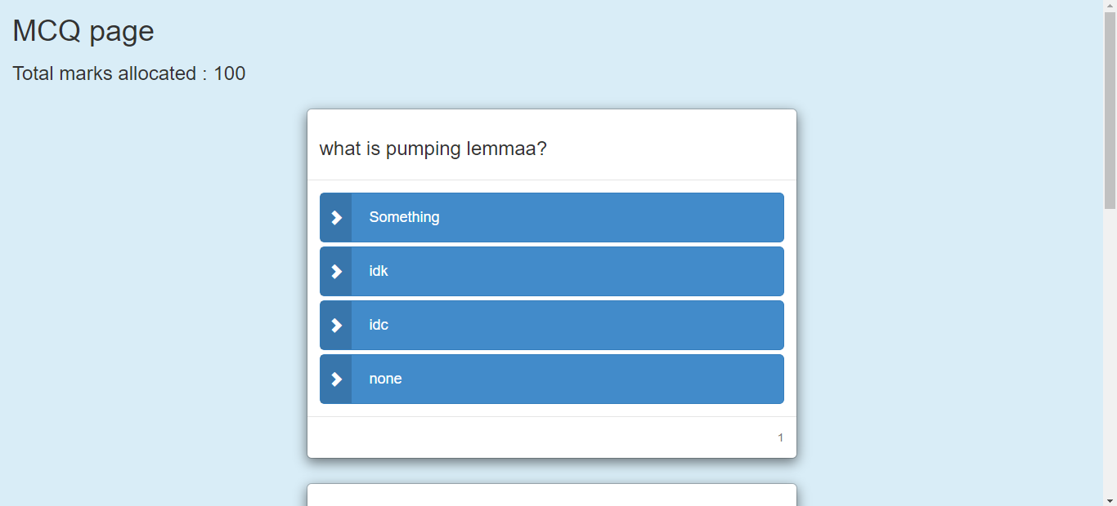
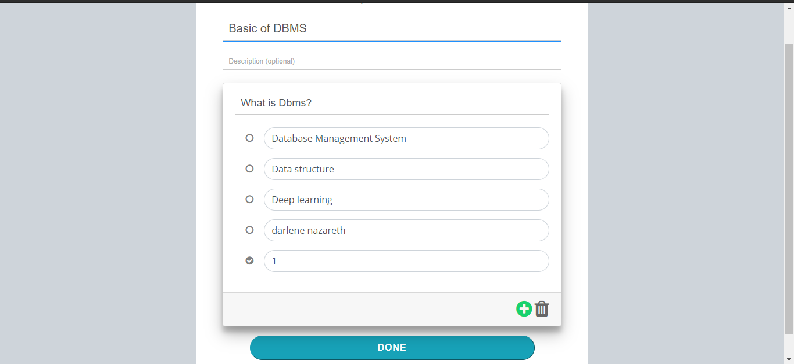
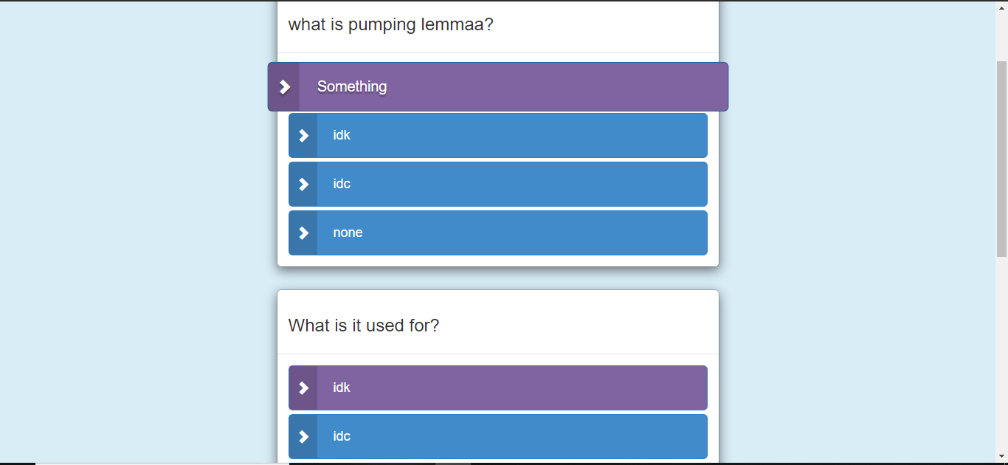

Conclusion
Due to increased manual work, the available system becomes time consuming. Therefore, with the creation of the quiz application the workload reduces a considerable amount since it is a faster method by digitalizing the offline quiz approach.
It provides students with proper practice in terms of giving competitive examinations.
Appendix A: User Schema
MCQ Schema
var mcqSchema = new mongoose.Schema({
question : String,
optionA : String,
optionB : String,
optionC : String,
optionD : String,
answer : String,
});
Topic Schema
var topicSchema = new mongoose.Schema({
topicName : String,
marks : Number,
mcqs : [
{
type : mongoose.Schema.Types.ObjectId,
ref : 'MCQ'
}
]
});
Subject Schema
var subjectSchema = new mongoose.Schema({
subjectName : String,
branch : String,
year : String,
topics : [
{
type : mongoose.Schema.Types.ObjectId,
ref : 'Topic'
}
]
});
User Schema
var userSchema = new mongoose.Schema({
username : {
type : String,
required : true,
trim : true
},
password : {
type : String,
minlength : 4,
trim : true,
},
branch : {
type : String,
required : true,
},
subject : [
{
type : mongoose.Schema.Types.ObjectId,
ref : 'Subject'
}
],
year : String,
type : String,

});
Appendix B: Use Case Diagram
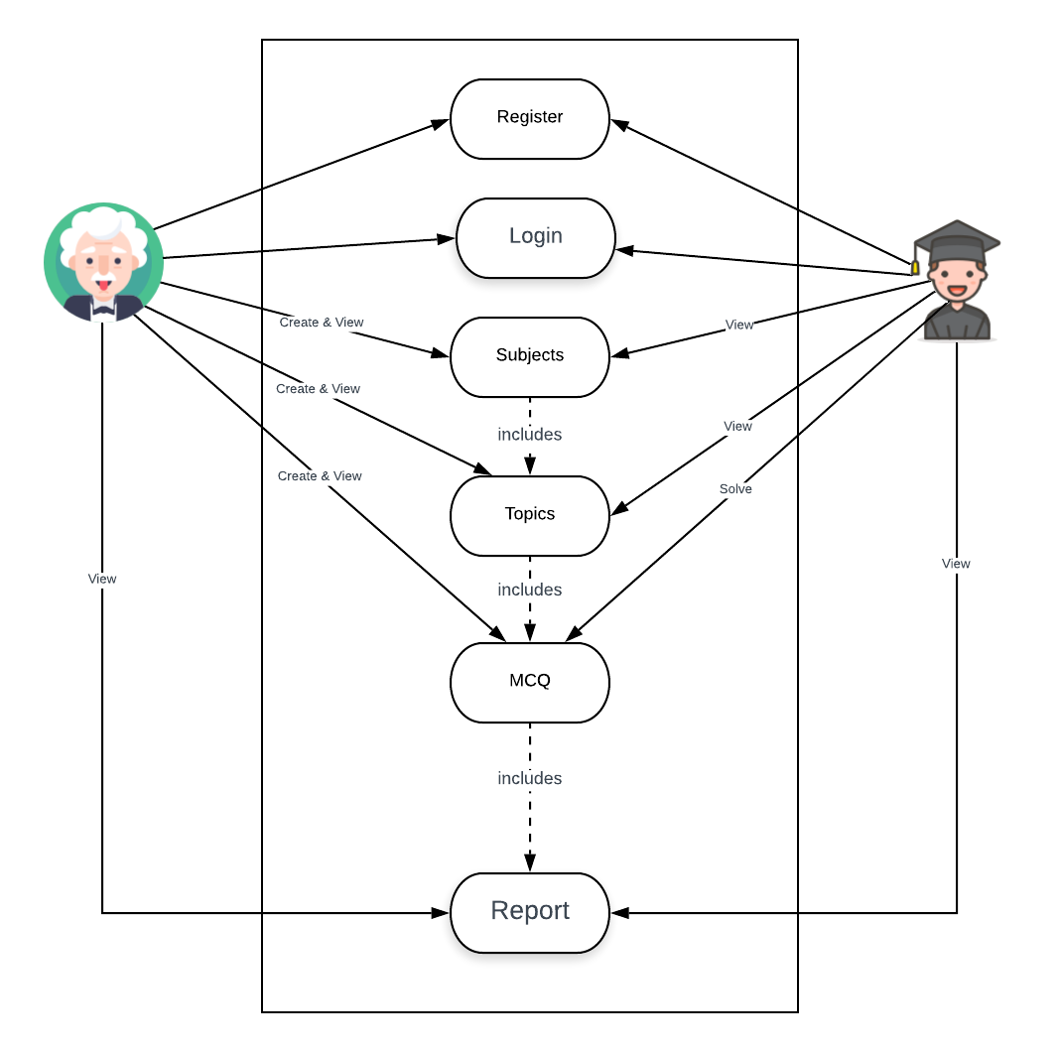

Reference
https://docs.mongodb.com/
https://nodejs.org/en/docs/
https://www.udemy.com/course/the-web-developer-bootcamp/
www.vdocuments.mx.com
www.academia.edu.com
https://krazytech.com/projects/sample-software-requirements-specificationsrs-report-airline-database

