1.
;Purpose-Program of moving data to register and display it
.MODEL SMALL ; In the SMALL model all code is placed in one physical segment and all data in another physical segment.

.STACK 100H ; stack 100h reserves 100h bytes for stack.
org 100h sets the current address to 100h, that is the address the assembler is assuming.
.DATA ;

.CODE
main1 PROC

mov dx,65
mov ah,2
int 21h
mov ah,4ch
int 21h
main1 endp; end of procedure

end ;end of file

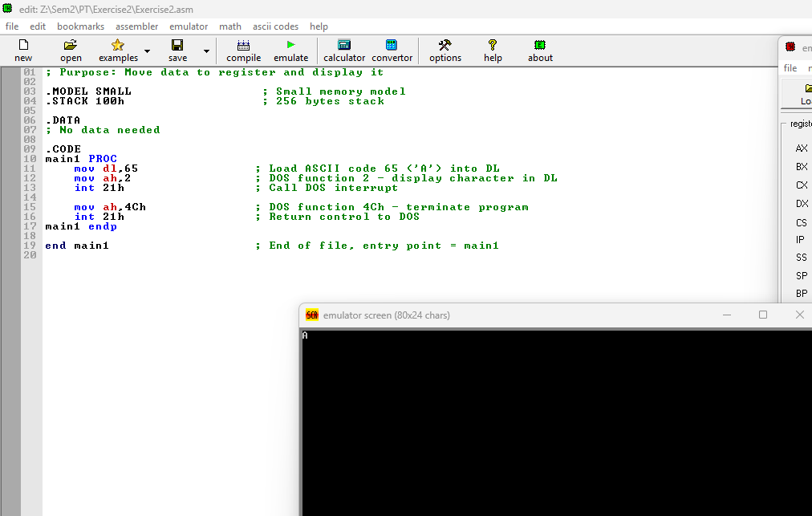
----------------------
2.
; Program to display string on the screen “hello world message”
.MODEL SMALL
.STACK 100H

.DATA
MSG DB 'HELLO world!$'
msg2 DB 'MSCIT$'
.CODE
MAIN PROC
MOV AX,@DATA
MOV DS,AX
LEA DX,MSG
MOV AH,9
INT 21h
MOV AH,4CH
INT 21h
MAIN ENDP
END MAIN

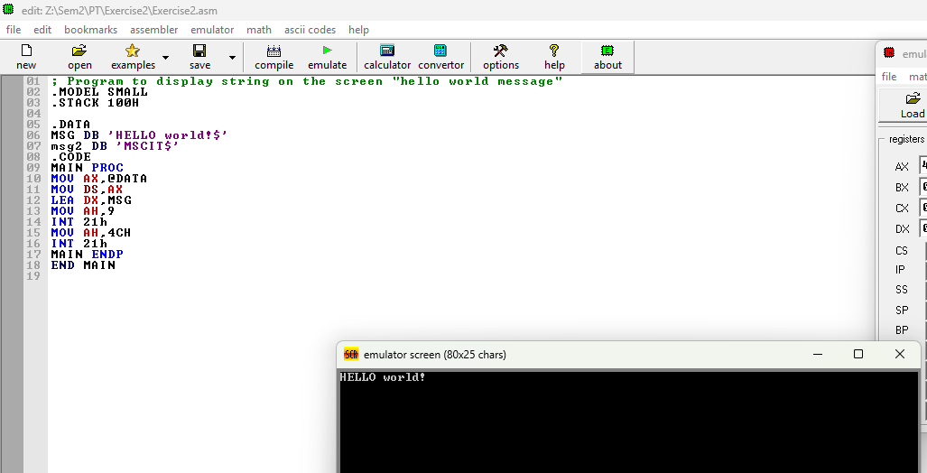
------

3.

;program for using ascii chars to display data on screen
.MODEL SMALL
.data

main2 PROC
mov dl,10
mov ah,2
int 21h
mov dl,10
mov ah,2
int 21h
mov dl,10
mov ah,2
int 21h
mov dl,10
mov ah,2
int 21h
mov dl,13
mov ah,2
int 21h
mov bl,02
mov cl,03 ;regiser to register transfer
add bl,cl
add bl,48
mov dl,bl
mov ah,2
int 21h
main2 endp; end of procedure
end ;end of file

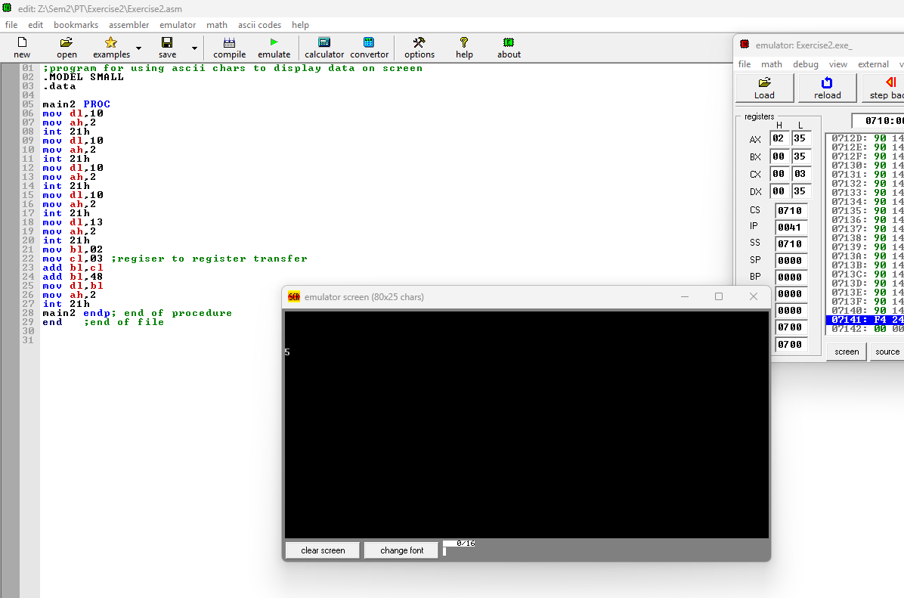

4.
.MODEL SMALL ; In the SMALL model all code is placed in one physical segment and all data in another physical segment.

.STACK 100H ; stack 100h reserves 100h bytes for stack. org 100h sets the current address to 100h, that is the address the assembler is assuming.
.DATA ;

.CODE
main1 PROC

mov dx,101
mov ah,2
int 21h
main1 endp; end of procedure
end ;end of file
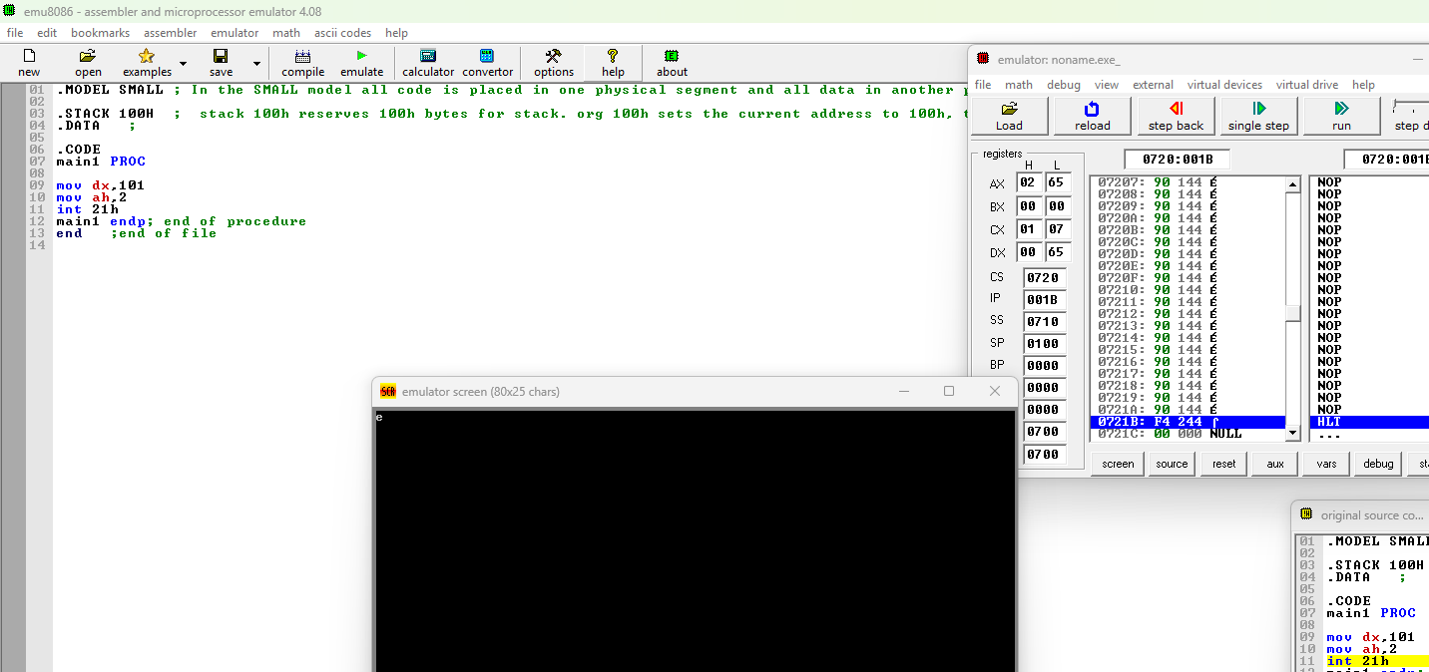

5.
;program showing register to register data transfer
.MODEL SMALL ; In the SMALL model all code is placed in one physical segment and all data in another physical segment.

.STACK 100H ; stack 100h reserves 100h bytes for stack. org 100h sets the current address to 100h, that is the address the assembler is assuming.
.DATA ;

.CODE
main1 PROC

mov dx,48
mov ah,2
int 21h
main1 endp; end of procedure

main2 PROC
mov bl,02
mov cl,03 ;regiser to register transfer
add bl,cl
add bl,48
mov dl,bl
mov ah,2
int 21h
main2 endp; end of procedure

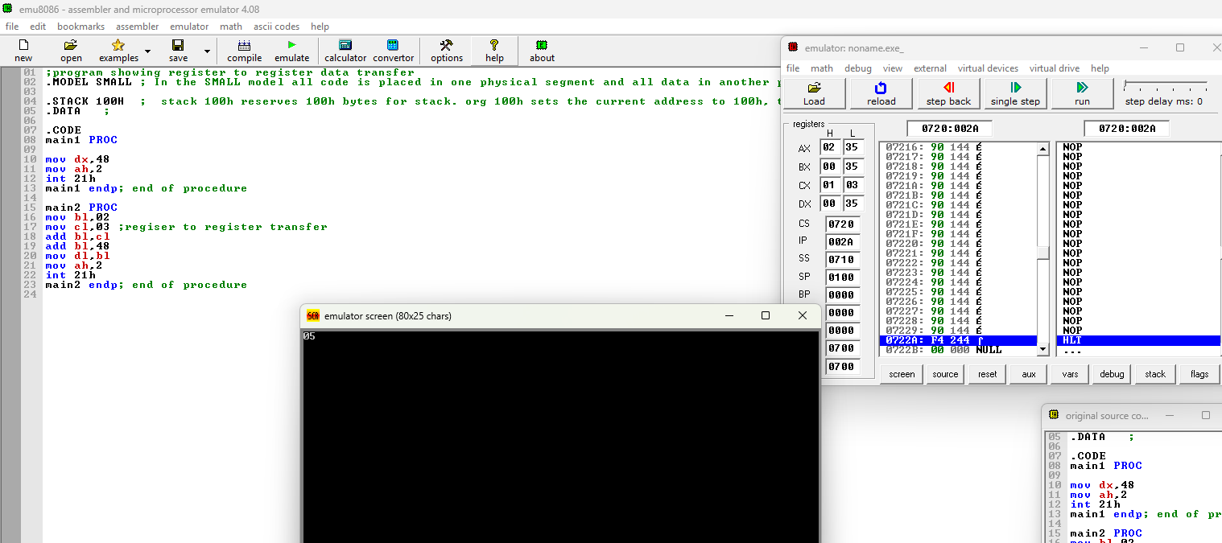

7.

.MODEL SMALL ; In the SMALL model all code is placed in one physical segment and all data in another physical segment.

.STACK 100H ; stack 100h reserves 100h bytes for stack. org 100h sets the current address to 100h, that is the address the assembler is assuming.
.DATA ;
var1 db ?
var2 db ?

.CODE
main1 PROC

mov dx,48
mov ah,2
int 21h
main1 endp; end of procedure

main2 PROC

mov ah,01
int 21h
mov dl,al; character is stored in al
mov ah,02
int 21h

main2 endp; end of procedure

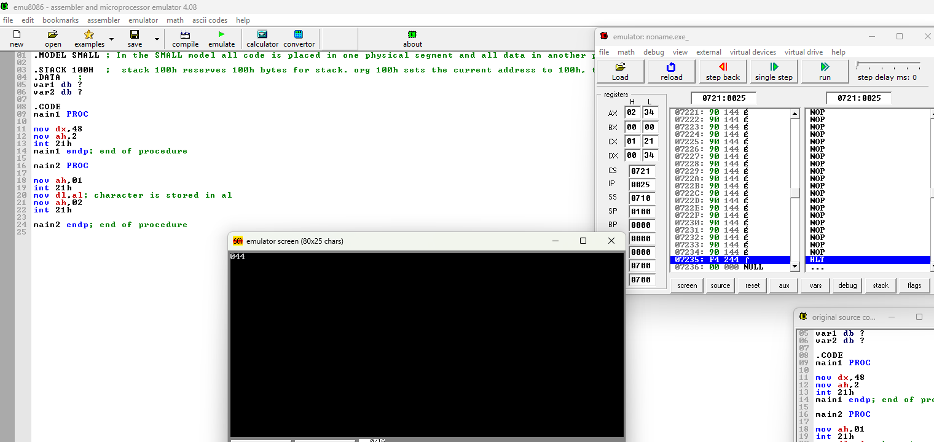

8. Develop program (code) to initilaize variable with the value and display it on Screen.
