Exercise 2
Note: In all the programs commentng of each line is compulsory in which you have to describe the meaning of each line.
1. Write a program in assembly language to print hello world string.
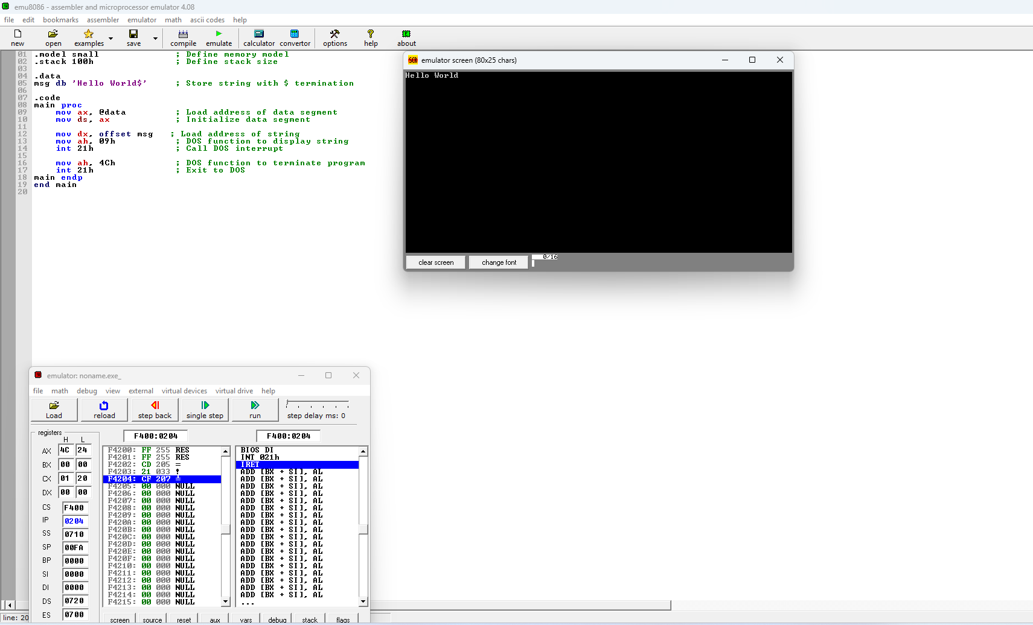
2. Write a program in assembly language to add two single digit numbers whose sum would be less then 10.
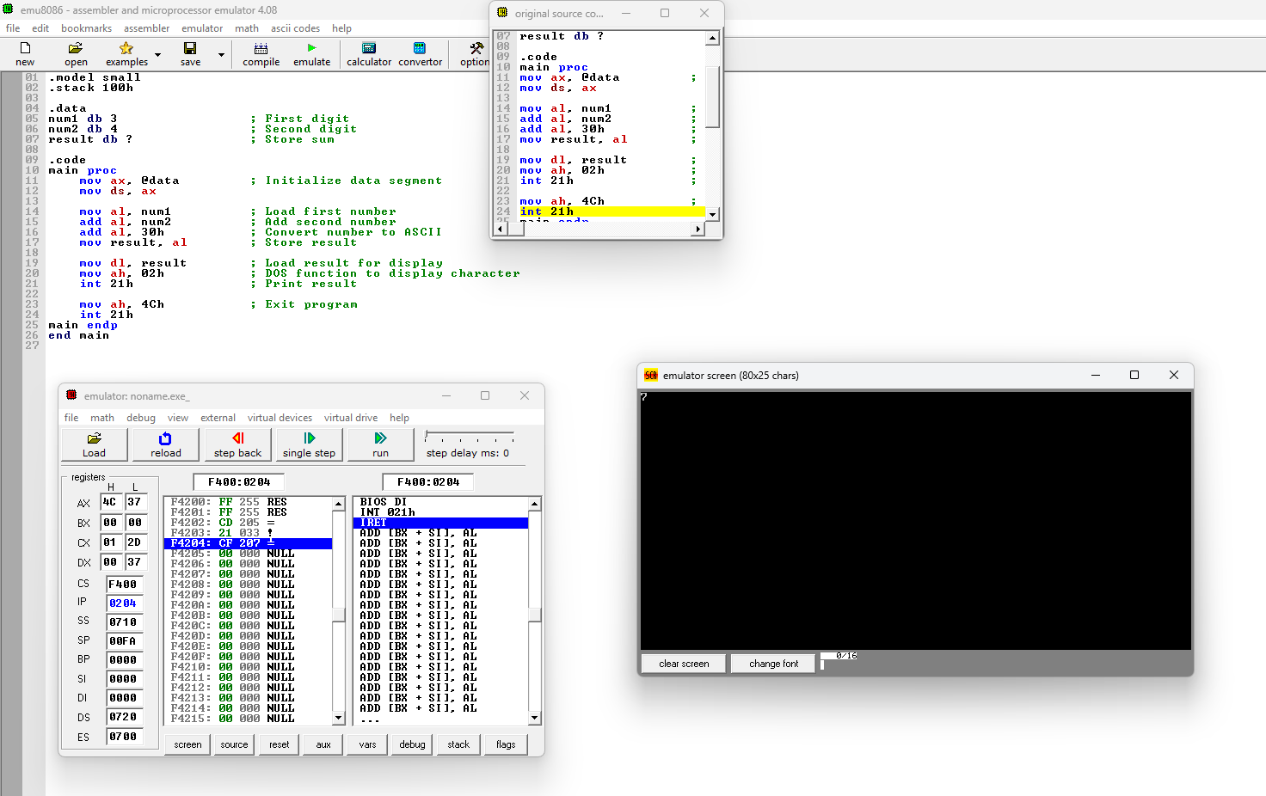
3. Write a program in assembly language to display digits from 1 to 9 .
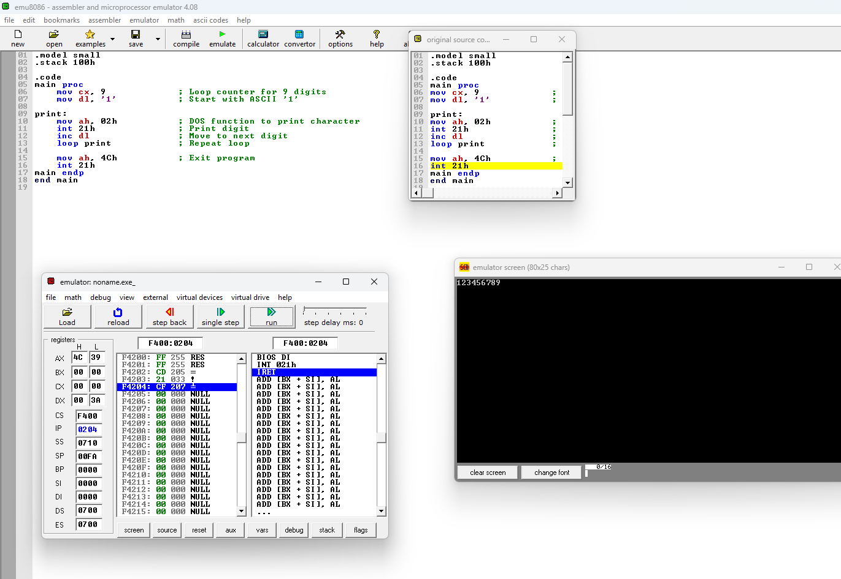
4. Write a program in assembly language to print data as per ascii value on the console.
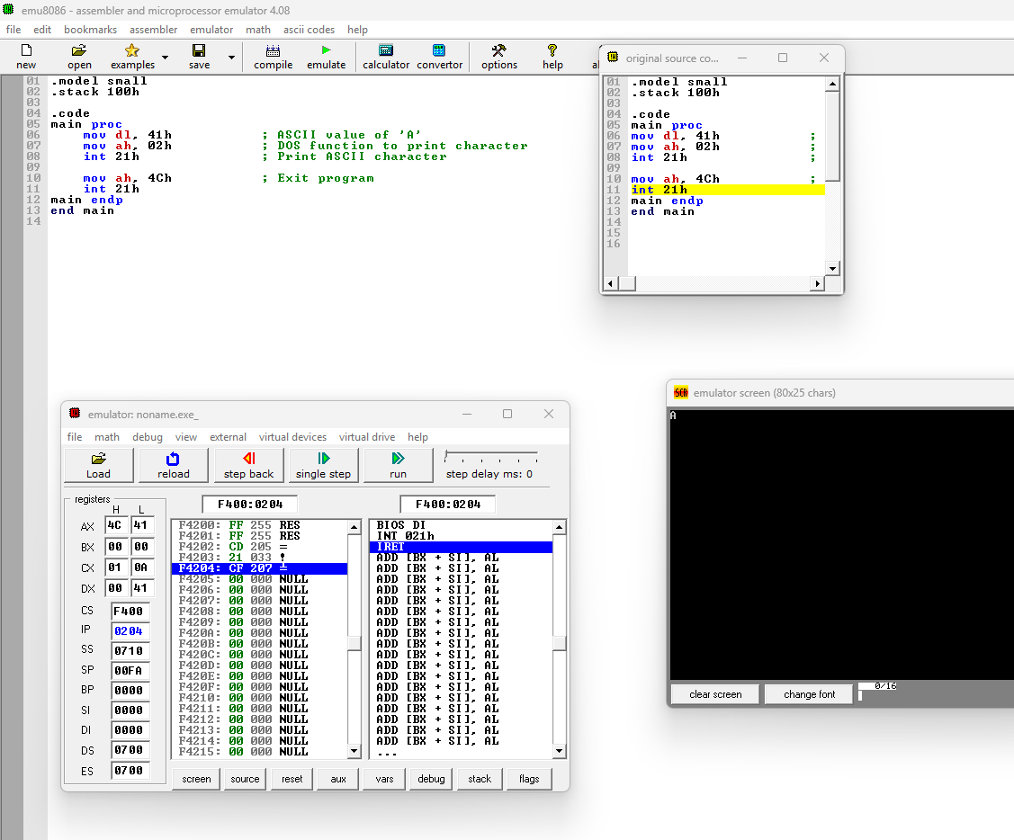
5. Write a program in assembly language to print data as follows hello world
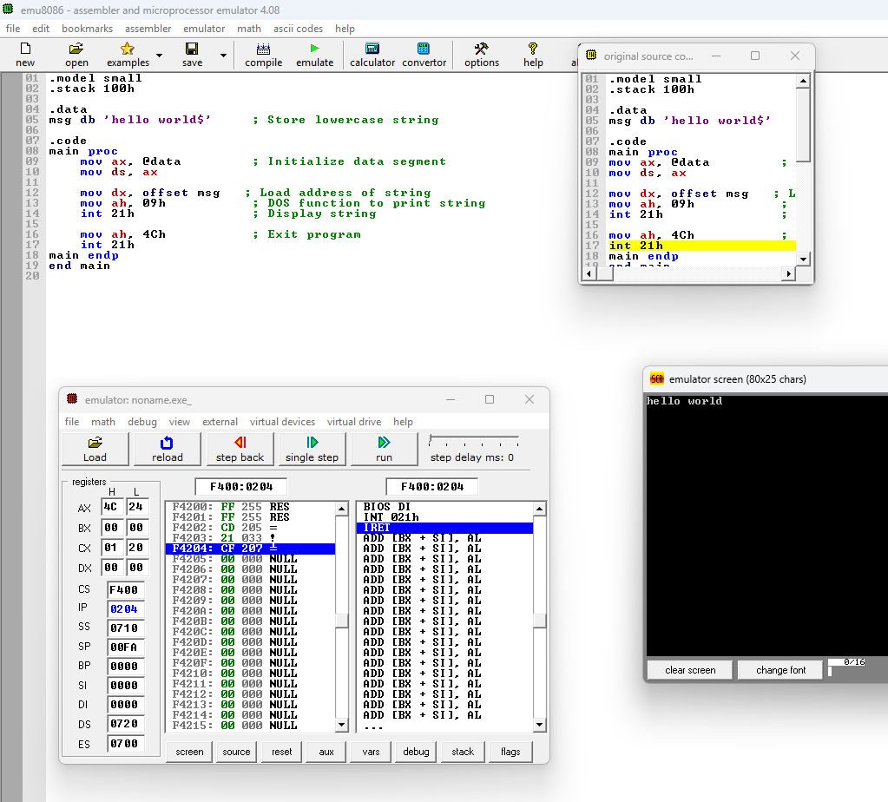
6. Write a program in assembly language to subtract two single digit
numbers whose result less then 10.
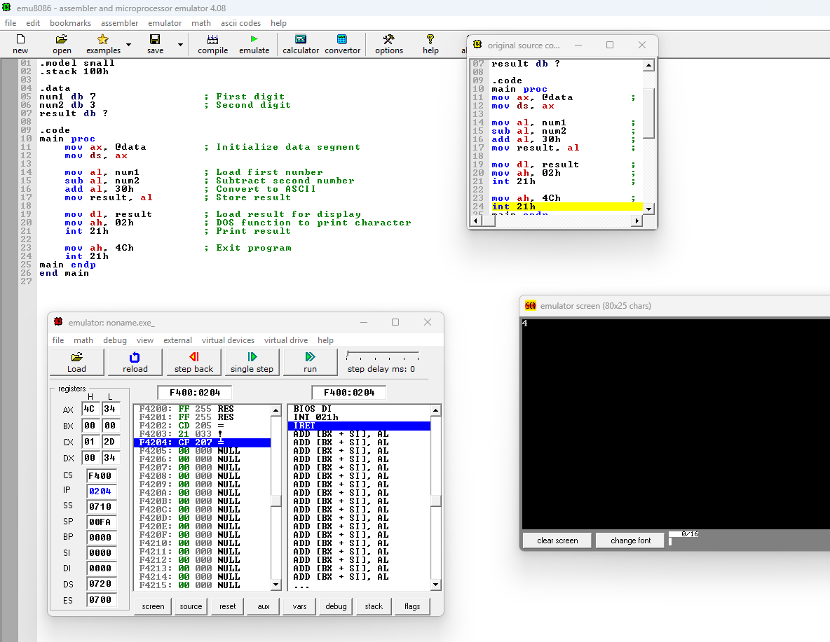
7. Write an assembly language program to print following output.
*
**
***
****
*****
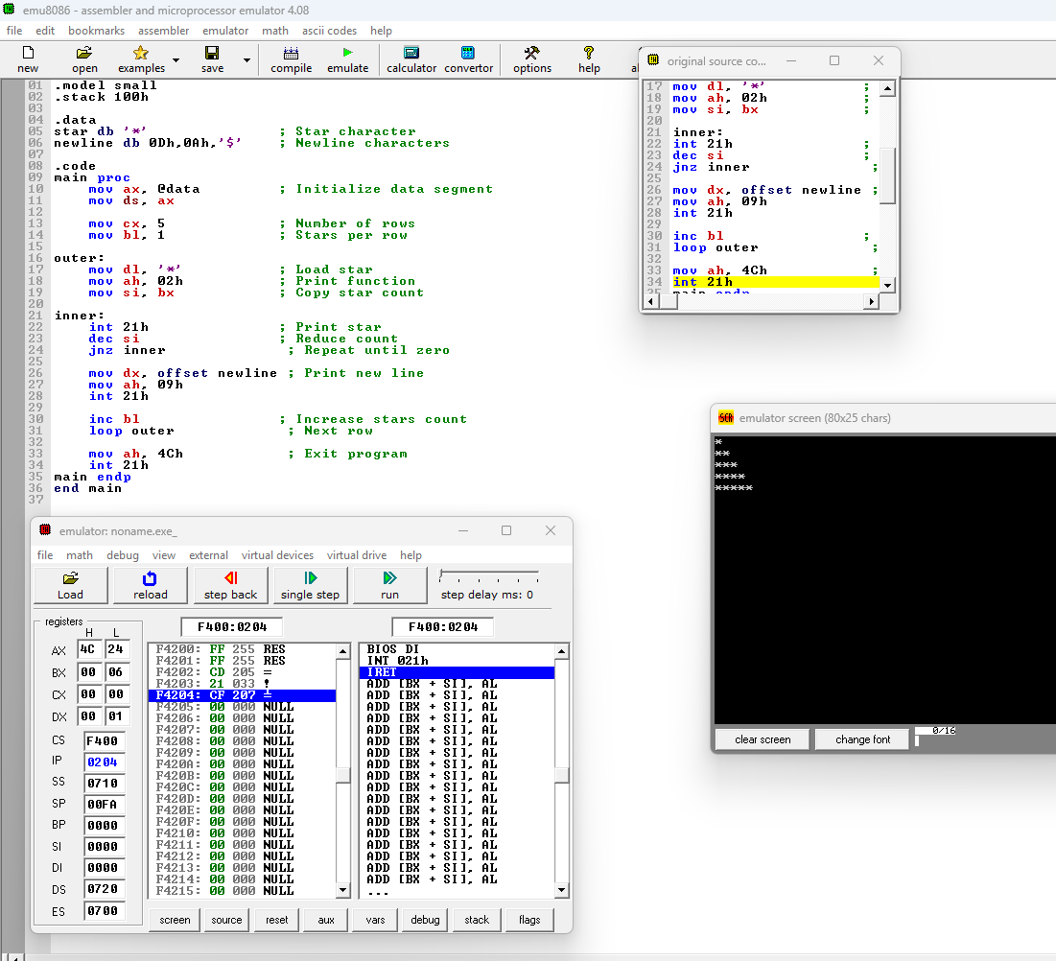
8. Write an assembly language program to add two two digit number and print it on the screen
