Exercise 3
Note: In all the programs commentng of each line is compulsory in which you have to describe the meaning of each line.

1. Assembly language program in 8086 to add two 8 bit numbers taking variables and print it without using mask.
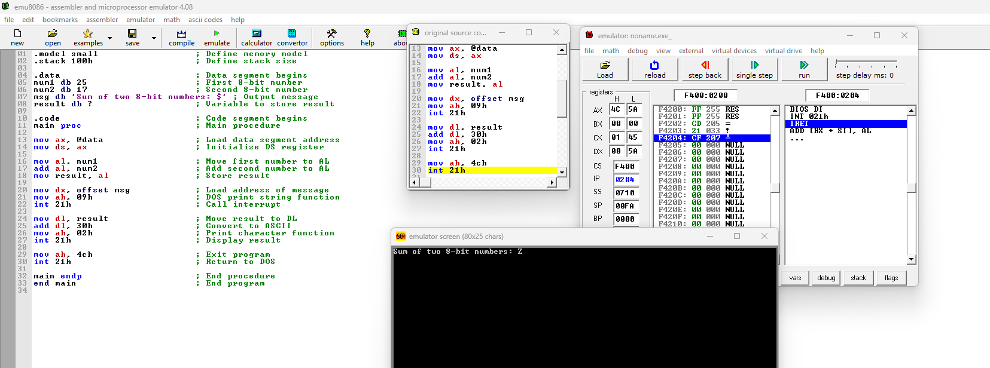
2. Assembly language program in 8086 to Add two 16-bit numbers and print it without using mask
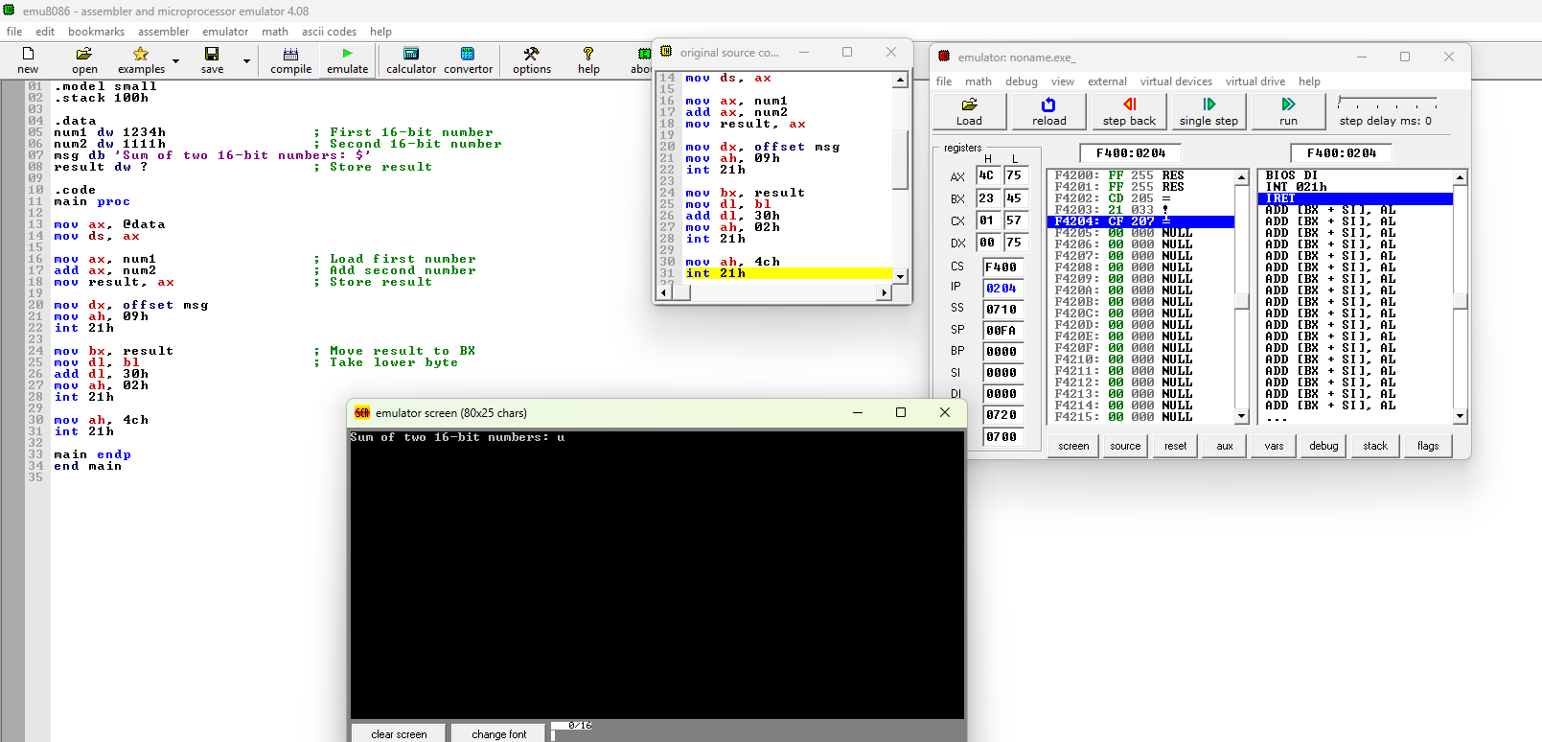
3. Assembly language program in 8086 to Subtract two single digit numbers and print it without using mask
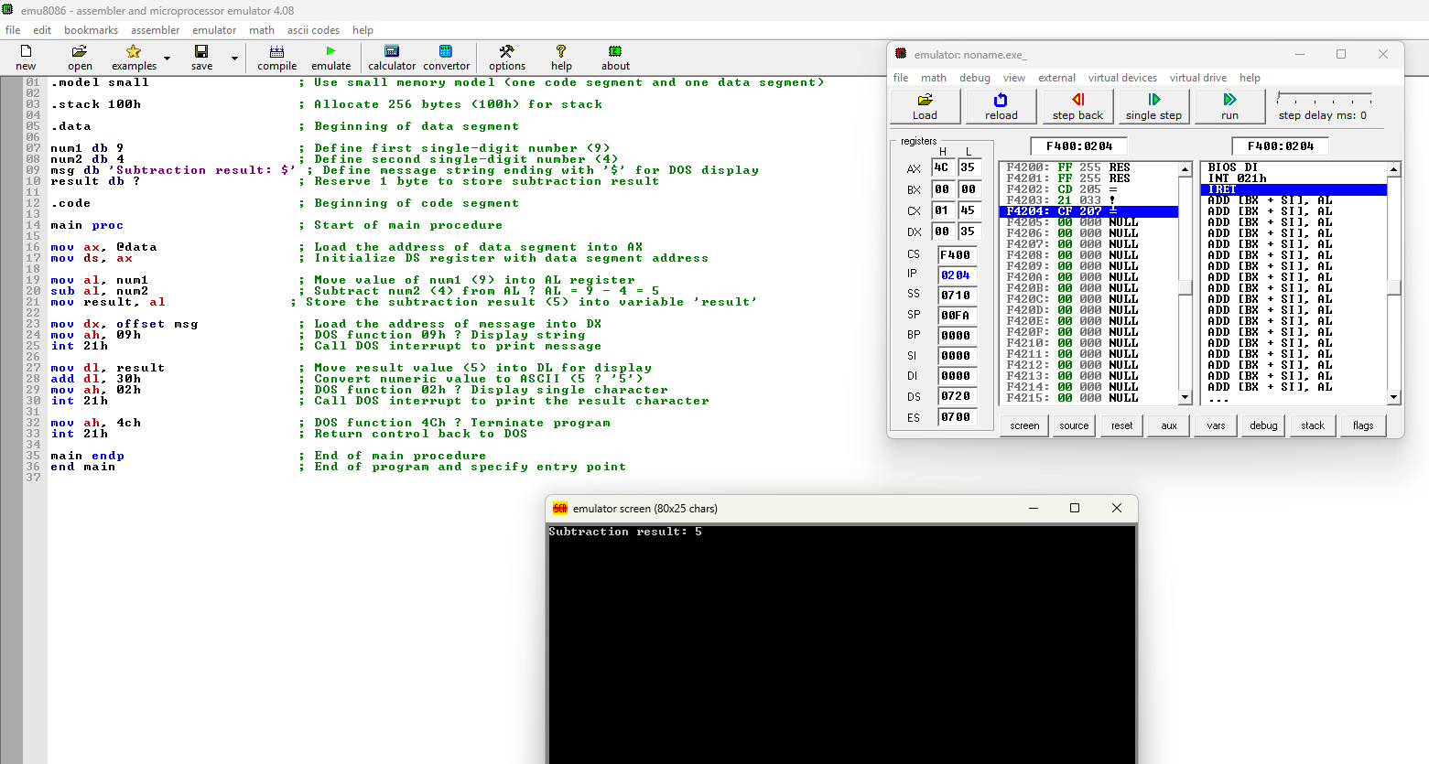
4. Assembly language program in 8086 to Find largest of two single digit numbers using flags
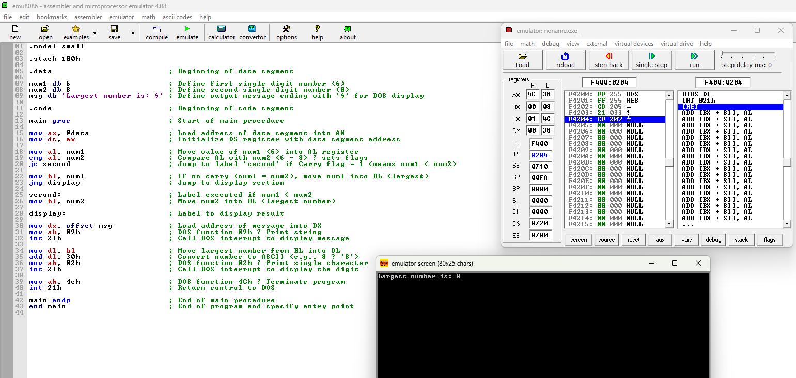

5. Assembly language program in 8086 to Find smallest of two single digit numbers using flags
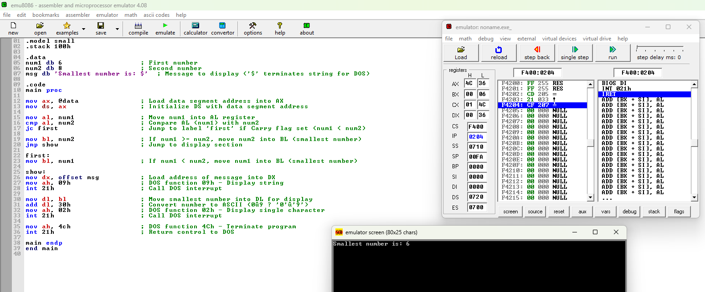
6. Assembly language program in 8086 to Swap two single digit numbers and print their values before and after swapping.
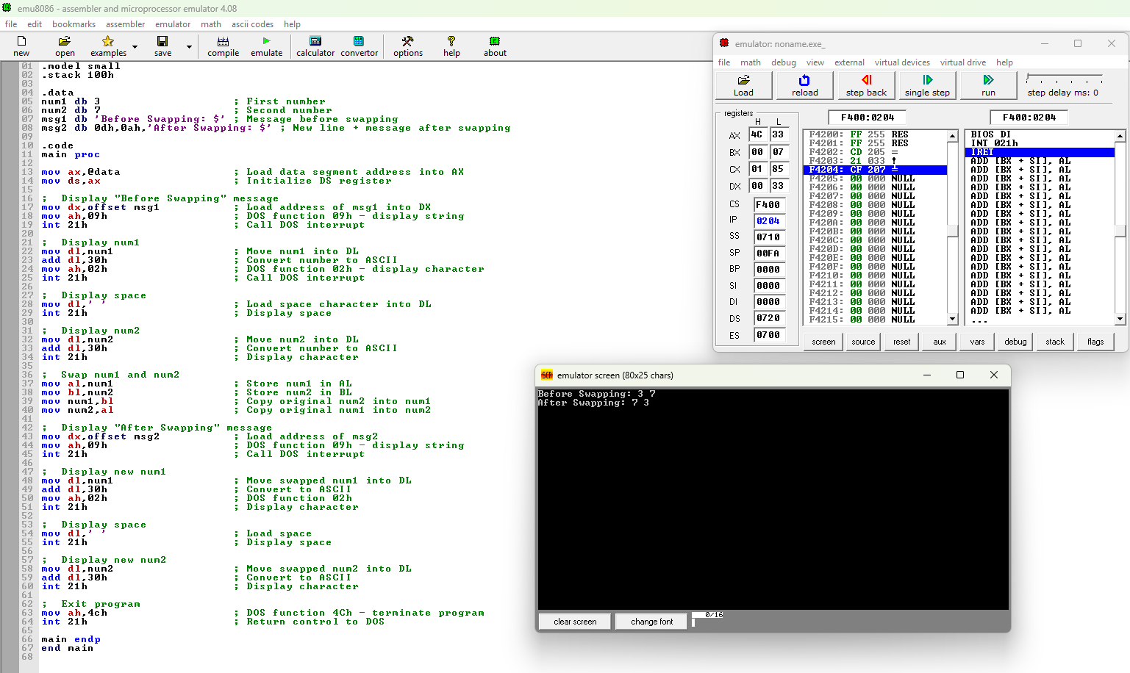
7. Assembly language program in 8086 to Generate multiplication table of 2
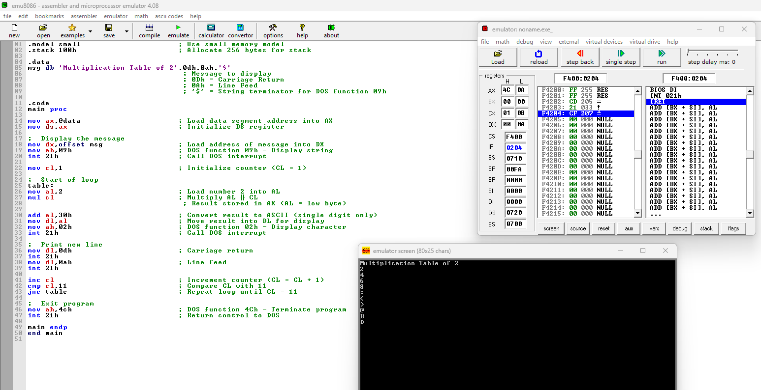
8. Assembly language program in 8086 to Check if number(single digit) is even or odd
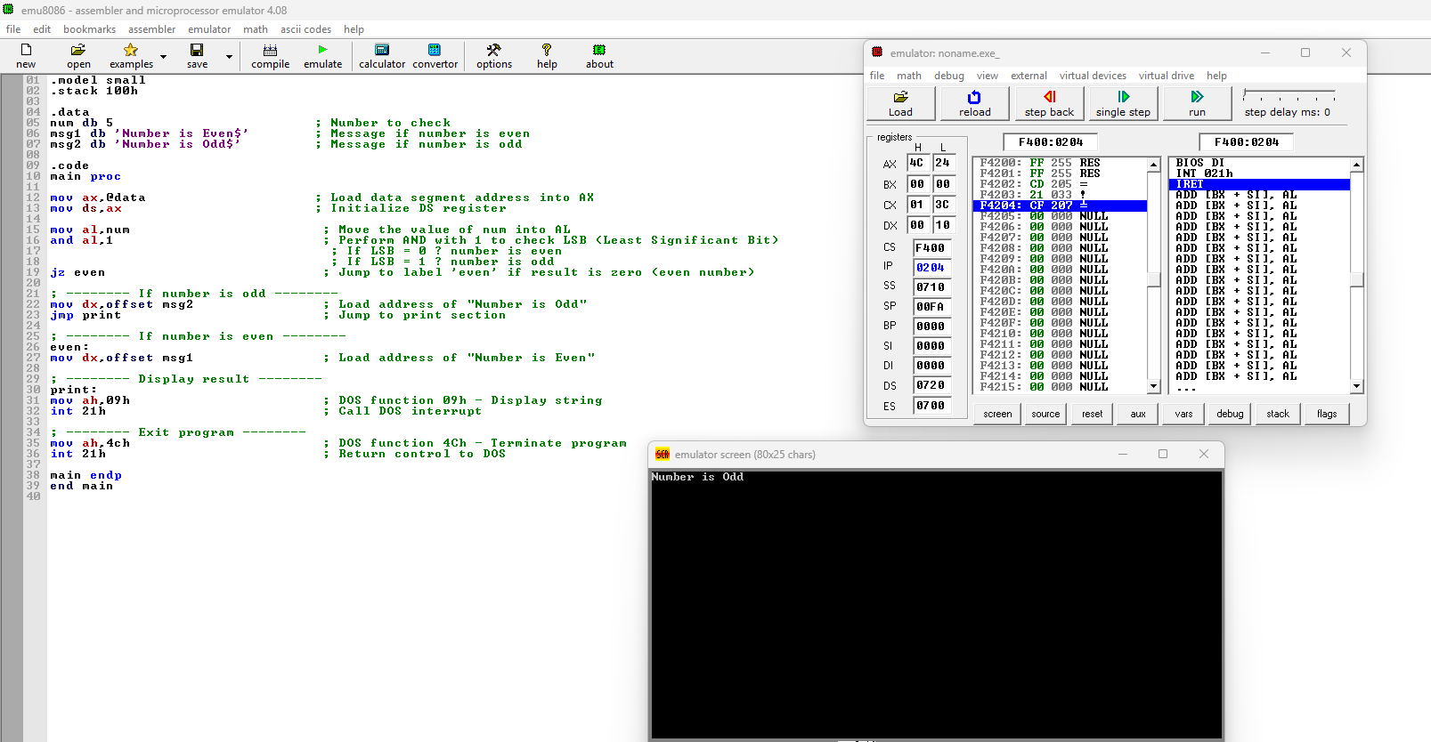
9. Assembly language program in 8086 to find Sum of 3 single digit numbers inputting from keyboard and print the sum.
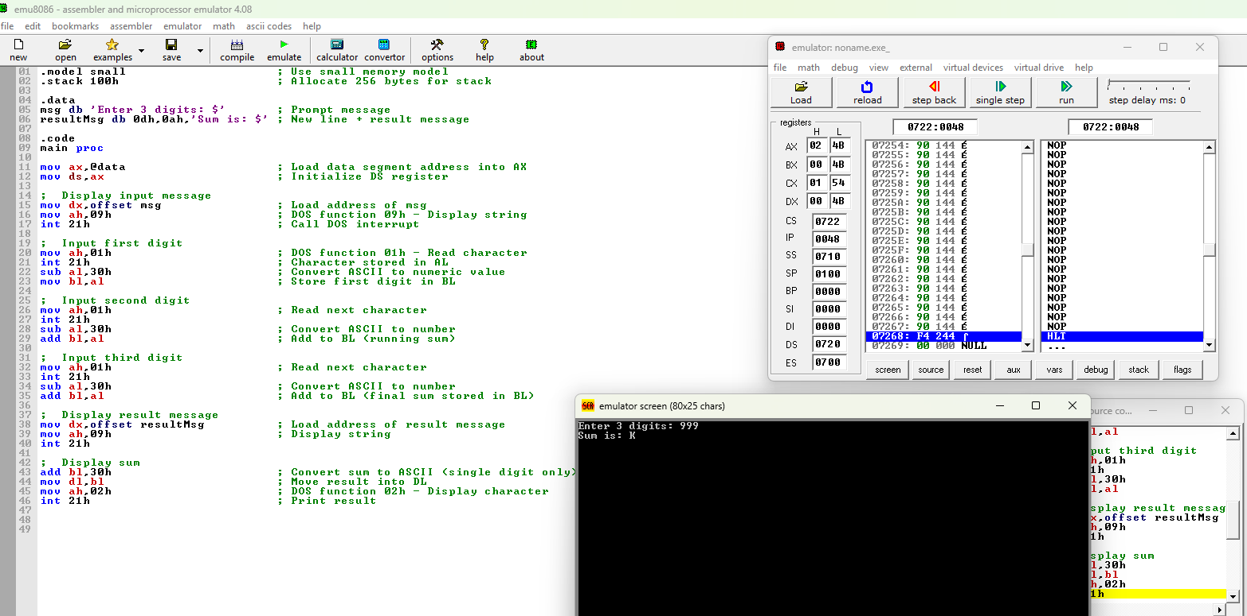
10. Assembly language program in 8086 to Multiply two single digit 8-bit numbers
