This is a test of headings

And of images (of bold bees)
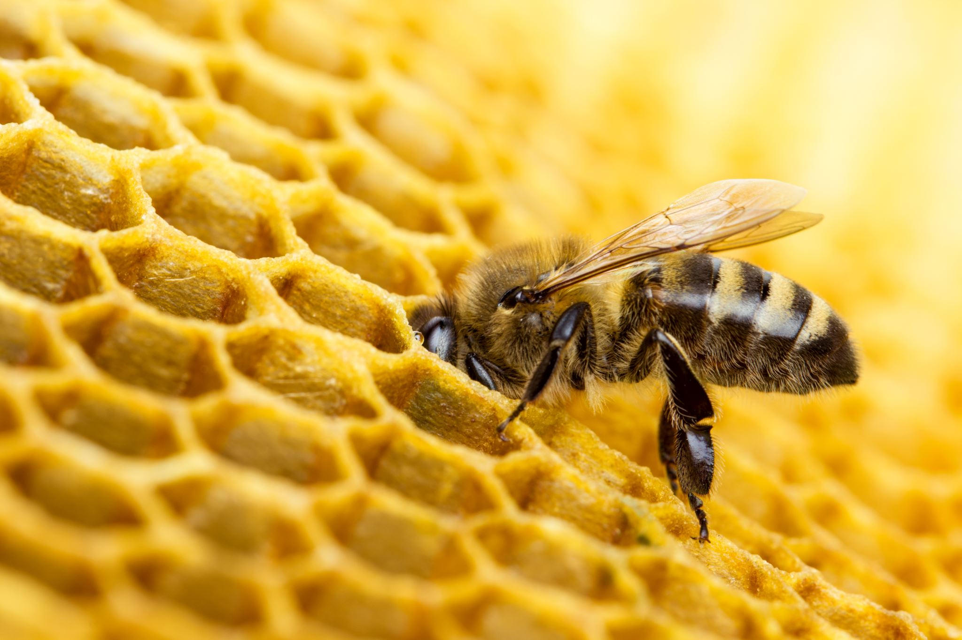

With slightly larger fonts

