CHAPTER 1
INTRODUCTION
Project Context
Today's healthcare industry because of the rapidly increasing demand for high-quality, prompt delivery of, clinics need to establish an effective and well-designed clinic management should be in place. As a whole, using a non-paper process in the clinic is not only inefficient, but it can also create unnecessary time delays, and a wide variety of potential errors. To address these inefficiencies, Northlens has developed the Northlens Appointment System to provide clinics with a fully-integrated, comprehensive digital platform that includes registration of patients, appointment scheduling, and storage and administration of clinical records.
Although technology has improved, most clinics still use the old way of keeping patient records on paper. This can create numerous difficulties for clinics and patients, such as inaccurate patient information, missing patient files, poor communication between clinics and patients concerning appointment information, and minimal interaction between patients.
The Northlens Appointment System has been created to replace the use of paper with digital solutions, automating these manual processes. The objective of the Northlens Appointment System was to successfully and easily receive patient appointments and information, create an admin page to help manage all aspects of patient services and appointment-management, and generate reports as needed to support clinic operations/monitoring activities.
Purpose and Description
The purpose of the Northlens Appointment System is to automate healthcare administration, enhance patient care quality, and improve operational efficiency. Clinics can streamline paperwork, minimize errors, and provide a hassle-free health experience by digitizing processes like appointment management, medical record management, and patient communication. The system aims to improve accessibility for both patients and medical staff, ensuring secure data handling.
The Northlens Appointment System is an integrated digital system designed to automate clinical and administrative work. Through implementing a web-based clinic management system, healthcare providers can offer more efficient, transparent, and patient-friendly services. This study will explore the impact, benefits, and challenges of adopting such a system.
Objectives
Generally, the study aims to develop the Northlens Appointment System.
Specifically, it aims the following:
- To accept user information and appointment schedule.
- To develop an admin page that manages patient services and appointments; and
- To generate necessary reports

Scope and Limitations
The Northlens Appointment System aims to improve healthcare operations by digitizing necessary administrative and clinical processes. The system's scope includes patient management to facilitate online patient registration, appointment scheduling, medical history tracking, and communication with healthcare providers; electronic health records allow authorized personnel to securely store and access patient records for better treatment and diagnosis; and analytics and reporting offer insights into clinic performance, patient demographics, and operational improvements.
The Northlens Appointment System brings several advantages, but it also carries limitations, such as internet dependency this web-based system needs a stable internet connectivity, which may limit its use for practices in areas that have unreliable internet access; data privacy challenges it include cybersecurity breaches of patient records and unauthorized access to sensitive patient information; user adaptability not all healthcare providers and patients are adaptable enough to move to digital processes that require additional training and access; and hardware and infrastructure costs by implementing the Northlens Appointment System initial setup may require investments in servers, security systems, and training programs.

CHAPTER 2
REVIEW AND RELATED LITERATURE/SYSTEMS
The review of related literature explores existing research, theories, and studies that support the development of appointment systems. It provides a foundation for understanding key technologies, challenges, and innovations in healthcare management.
Web-Based healthcare solutions various studies highlight the benefits of digital systems in improving accessibility, reducing administrative burdens, and enhancing patient outcomes. Electronic health records research discussed the impact of EHR systems on data accuracy, security, and interoperability among healthcare providers. And cloud-based clinic appointments, academic discussions assess the advantages of cloud computing for scalability, real-time data access, and cost-effectiveness.
The first objective focuses on accepting user information and appointment schedules. Shifting from manual to digital processes will allow the clinic to manage patient information and appointments more efficiently. This transition reduces paperwork, reduces human error, and allows patients to register and book appointments more conveniently. In earlier studies, Ampuan and Delena (2022), evaluated a web-based appointment system which was implemented at a university and illustrated the effectiveness of a web-based system. The system was found to improve the process of patient registration and appointment scheduling. Automating the processes decreased the administrative burden, which
enabled staff to concentrate more on patient interaction. Similarly, Dela Fuente et al. (2023) developed a cross-platform scheduling system, showing potential for automating appointment booking across multiple devices. Allowing patients to potentially book their appointments each time they are anywhere they might have a phone, tablet, or computer. The benefit of the cross-platform design provides both patients and medical staff with up-to-the-minute scheduling information, allowing for a reduction in double bookings or more appropriate control of multiple bookings and a better management of time.
Communication too emerges as a central theme, According to Ele et al. (2020) the use of SMS notifications for appointment reminders in the study offers a straightforward strategy for improved communication with patients in areas with unreliable internet. For Northlens, by incorporating SMS notifications, the patients are constantly reminded of their appointment and it will reduce the amounts of no-shows, which also helps improve appointment adherence.
The core of the patient-facing system relies on timelines. Raj Kumar et al. (2024) investigates how a web appointment management system could support real-time updates and automatic scheduling of appointments. The real-time scheduling is fundamental to achieving Northlens goals in reduced patient wait times and enhanced overall clinic performance. Patients, clinic process, and flow can all benefit from real-time scheduling but all of these benefits rely on the appointment scheduling system working to reduce scheduling conflict and notifying patients right away about scheduling information changing, which was critical for managing patient expectations. Furthermore Khan et al. (2021) reviewed
optimization techniques in patient appointment scheduling, demonstrating how algorithmic approaches can reduce scheduling conflicts and improve clinic workflow, which is crucial for Northlens real-time scheduling to reduce wait times and maximize efficiency.
Although functionality was important, user acceptance remains essential. Khalil and Serhier (2023) conducted a systematic literature review focusing on user acceptance of medical e-appointment systems in mental healthcare. The study emphasized the importance of user-friendly interfaces and addressing privacy concerns to enhance adoption rates, while Atherton et al. (2024) explored patient use and experience of online appointment booking in primary care. The mixed methods study revealed that while online booking systems offer flexibility, their adoption was influenced by factors such as age, socioeconomic status, and digital literacy.
According to Lim and Teo (2023) highlighted that implementing digital platforms for appointment scheduling improves operational efficiency by automating booking processes, reducing human error, and balancing workloads across service units. For Northlens, incorporating a digital platform ensures that patient information and appointment schedules are systematically stored, accessible, and that delays are minimized. The significant role of digital health tools in managing chronic diseases by improving patient engagement and facilitating better communication between patients and healthcare professionals Alanzi (2020). This supports Northlens goal of enhancing patient interaction through digital platforms.
The second objective is to develop an admin page that manages patient services and appointments. With a centralized system, optometrists and clinic staff will have the ability to access patient vision records, prescription history, and appointment schedules. Centralized access will assist the clinic in better coordinating tasks, reducing waiting time for patients, and ensuring that optical services such as eye examinations, prescription updates, and eyewear orders are delivered smoothly and accurately.
Kyambille and Kalegele (2016) emphasized the potential of using technology to manage patient appointments and schedules, streamlining communication and workflow for medical staff. By utilizing a system in which medical employees receive real-time scheduling updates on the palm of their hand, medical staff are empowered to make faster decisions in regards to patient care. In a system for scheduling via technology, medical staff can receive notifications for urgent changes or updates, alleviating bottlenecks and significantly improving the efficiency of a clinic or practice. In addition, Akhtar et al. (2021) developed "PATDOC," an online appointment management system that facilitates seamless scheduling between patients and doctors. The system includes an administrative interface that allows for efficient management of appointments and patient data. Ayobami (2024) designed and implemented a hospital appointment management system that features an admin dashboard for managing patient services and appointments. The system improved operational efficiency by streamlining the appointment scheduling process.
Marbela et al. (2024), the researchers developed a web-based hospital management software that included modules for patient schedule handling, reservation, medical records, reminders, and other “medical action” modules. Its relevance to Northlens is that it shows a modern web-based patient management system can centralize patient registration, appointment scheduling, and records, exactly what an admin page should handle.
In modern healthcare systems, efficient management of resources and patient data is essential. Adopting scalable and secure technological solutions allows healthcare providers to improve services while maintaining data integrity and accessibility. The system relies on scalability and security. Musa and Alhassan (2019) analyzed cloud computing adoption in healthcare, highlighting its benefits such as scalability, enhanced data security, and cost-effectiveness. These align with Northlens use of cloud technology to enable real-time data access and efficient resource management for patient services.
Modern healthcare management increasingly relies on data-driven approaches to optimize operations and improve services. Analytical tools can streamline administrative tasks into actionable insights, enhancing efficiency and resource allocation. Mišić and Perakis (2019) illustrated how analytics can help streamline workflow effectively across various sectors, including business and healthcare. In the case of Northlens, if they use data analytics in the clinic appointment system, it may provide insights into workflow patterns of medical staff by looking at appointment types, history of patient visits, and resource availability. By analyzing appointment patterns, medical staff can focus on urgent issues, manage their day effectively, and apply resources where they are most needed.
In addition, Liang, Xue, and Wang (2022) demonstrated how data analytics could improve hospital performance by analyzing patient flow and appointment schedules, supporting the integration of analytics in Northlens to enhance resource allocation and workflow efficiency. Furthermore, Zhai et al. (2023) examined the benefits of data analytics and precision medicine. With data to better define patient needs and patterns for booked appointments, Northlens may be able to automate some of the routine processes like triaging a patient, accepting a request for an appointment, or collecting documents, thus enabling the medical staff to spend more time focusing directly on a patient. Advanced data and analytics could also better identify inefficiencies in the workflow, allowing the clinic to modify and continuously improve the workflow, thus ensuring resources are meaningfully allocated.
According to Kyambille, G. G., & Kalegele, K. (2016). This study presented a mobile-based application scheduling system aimed at managing patient appointments in specialty care clinics. The system addressed challenges such as service interval inconsistencies and the timely availability of doctors. By leveraging mobile technology, the application enhances appointment scheduling efficiency, ensuring patients can access appropriate specialist care when needed. The study presented a model that balances service quality and fairness, aiding in the generation of comprehensive reports for decision-making.
According to Abel et al. (2015) developed an Android-based electronic medical records system for outpatient clinics. The system included an administrative component where clinic staff can manage patient profiles, appointments, and notifications. Their implementation illustrates how mobile and open-source technologies can be leveraged to build low-cost yet efficient systems for healthcare management, which aligns well with the goals of developing a modern admin page for an optical clinic.
The third objective emphasizes generating necessary reports. The system can provide summaries and information regarding clinic activities, visits, and resource use through automated data collection and report generation. This allows management to be well-informed, assess performance, and identify opportunities for improvement.
Data-driven insights are increasingly essential in healthcare management, enabling clinics to optimize operations, improve patient experience, and allocate resources efficiently. Generating detailed report from patient data and Integrating analytics into appointment systems allows organizations to monitor patient and make informed strategic decisions. Fosso Wamba et al. (2017) discussed the integration of big data analytics to improve firm performance, which can be adapted to healthcare environments by providing valuable information on patient behaviors, appointment trends, and clinic performance. If Northlens utilizes analytics, the data may generate comprehensive reports on patient demographics, booking patterns, and service use reports. These reports can help an organization make data-based decisions to improve clinic functioning such as peak hours and strategizing staffing. Cao et al. (2017) reported that implementing a web-based appointment system reduced average waiting times significantly in a Chinese hospital. The system's ability to generate detailed reports contributed to better resource allocation and strategic planning.
Zhao et al. (2017) provided a systematic review of web-based appointment systems, suggesting some advantages that would minimize administrative responsibilities, improve efficiency, and ensure timely reporting. These implications are significant for Northlens as they would allow for better, more strategic resource management, time management, and patient care. Automated reporting is an element of some web-based appointment systems and is able to provide a comprehensive suite of performance evaluation indicators, measure patient satisfaction, and assess the need for improvement. This capability could allow Northlens to monitor and improve operations continuously resulting in a greater clinic performance and improved patient outcomes.
Naeem et al. (2014), the development and implementation of a hospital information system (HIS) in a tertiary hospital resulted in improvements in quality, return on investment, and resource utilization when switching from paper-based to digital systems. This underlined that having a fully digital versus paper-based system enables efficient data compilation and reporting, which was essential if Northlens aims to offer necessary reports.
Anuyah et al. (2024) explored predictive modeling and deep learning in improving clinical trials, and highlights a potentially useful method of investigating patient data at Northlens. By utilizing similar predictive models, Northlens could be able to predict no-shows for patients, forecast appointment patterns, and better anticipate demand. Having access to such forecasts could provide Northlens with insight to prepare for high times of demand and to allocate resources appropriately.
Recent developments in healthcare management systems demonstrated the growing importance of digital solutions in improving administrative efficiency and decision-making. Comparing existing systems helps highlight the unique features and advantages of more advanced platforms, such as the Northlens Appointment System. Dizon and Mariano (2021) developed a desktop-based dental clinic management system with automated reporting features, similar in purpose to the Northlens Appointment System. While both aim to enhance administrative efficiency through reduced manual documentation and faster data access, Northlens offers broader functionality covering appointment trends, service analytics, and real-time performance insights along with cloud hosting and cross-platform support for greater scalability and flexibility.
In addition, Reyes and Villanueva (2022) created a modular medical records system for local clinics in Batangas City, featuring report generation based on patient intake and physician workload. This aligns with the Northlens Appointment System’s goal of delivering customizable summaries and performance data. However, while Reyes and Villanueva’s system was tailored for local government use with limited modularity, Northlens offers a more advanced, scalable, web-based platform with real-time analytics, cloud integration, cross-platform support, and automated alerts for enhanced clinic management.
Traditional paper-based systems has a inefficiencies such as slow data retrieval, human errors, and difficulty in maintaining records which led to the adoption of digital solutions. Standalone software-based systems early clinic management programs offered automation but lacked remote accessibility and cloud integration. Modern web-based clinic management systems a comprehensive solution now integrate EHR, billing, telemedicine, and analytics for enhanced efficiency and open-source vs. proprietary systems, studies compare the adaptability and security aspects of open-source clinic management platforms versus proprietary healthcare software.
In this study, the Northlens Web-Based Clinic Appointment System was initiated to improve clinical processes by transitioning from paper-based to digitized records. The goal was to enhance operational efficiency, reduce administrative burdens, and support better decision-making in clinical settings. (Alsulame et al., 2021) highlighted the use of web-based systems has gained traction for providing improved accessibility and streamlined communication between patients and healthcare providers, while Alamo et al. (2020), key considerations in the design of healthcare systems include data protection and usability, which guided the development of the Northlens system. In our study, we prioritized these elements to foster trust among users, both patients and clinicians, ensuring intuitive navigation and strong security protocols
In addition to operational efficiency and patient engagement. Studies have shown that mobile phone reminders significantly enhance patient attendance rates in healthcare settings. In line with these findings, Gurol-Urganci et al. (2022) confirmed that SMS-based reminders effectively increase appointment adherence. These insights influenced our decision to integrate real-time scheduling and automated SMS reminders in the Northlens system to minimize no-shows and increase patient engagement. Secure messaging functionalities inspired by Ratwani et al. (2021), who emphasized that such features improve coordination and workflow in clinical environments. The Northlens platform enhances time management by allowing staff and patients to communicate efficiently while maintaining organized and updated schedules
The system also benefits from advanced analytics and reporting. Ala et al. (2021) addressed the optimization of appointment scheduling in healthcare systems using the Whale Optimization Algorithm (WOA) and NSGA-II. The study presented a model that balances service quality and fairness, aiding in the generation of comprehensive reports for decision-making. Similarly, Mahfouz et al. (2023) evaluated patient satisfaction with the web-based medical appointment system "Mawid" in Saudi Arabia. The study found high satisfaction levels and highlighted the system's effectiveness in reducing clinic crowding and improving registration processes. These findings alongside, Patel and Burke (2018) conducted a meta-analysis confirming that SMS reminders effectively reduce patient no-shows in outpatient clinics. This justifies Northlens’ incorporation of SMS notifications to improve appointment adherence and reduce missed visits.
Centralized and accurate record-keeping remains another core advantage. Nguyen et al. (2019) highlighted the benefits of centralized and accurate electronic health records in reducing documentation errors and improving provider satisfaction. Our investigation supports these findings. The Northlens system centralizes patient records, promotes accurate data entry, and streamlines access to clinical information for better healthcare delivery.
In conclusion, the review of related systems examines existing healthcare management platforms, comparing their features, strengths, and limitations. Also highlights the adoption from paper-based to digital healthcare system to improve efficiency, reduce errors and enhance patient monitoring. Features such as automated scheduling, SMS reminders, centralized records, and analytics effective in optimizing clinic operations and patient engagement. By adopting this Northlens aims to streamline appointment management, improve communication, and support data-driven decision making for web-based clinic management systems.

CHAPTER 3
TECHNICAL BACKGROUND
The Northlens Appointment System is built upon various technological frameworks that support its functionality, security, and efficiency. This section provides an overview of the underlying technologies that enable the system to operate effectively.
Software Requirements
The appointment system requires various software components to ensure functionality, security, and performance. Below are the essential software requirements categorized into different aspects:
TABLE 1
Software Requirements for the Development of Northlens Appointment System
Software | Descriptions
Operating System
Server-Side: | Windows 10 or Windows 11 Pro Server for hosting the application.
Client-Side: | Compatible with Windows, macOS, and mobile platforms (iOS and Android).
Database Management System (DBMS)

Relational Databases: | MySQL Server for structured data storage.
Web Server & Hosting Web Server | InfinityFree
Programming Languages & Frameworks
Frontend: | HTML, CSS, JavaScript (React.js).
Backend: | PHP, MySQL

Table 1 shows the software requirements for a web-based appointment system. First, the operating systems Linux (Ubuntu/CentOS) or Windows 11 Pro for hosting are compatible with iOS and Android for client use. The second software requirement is a database management system (MySQL) for structured data. Web Servers (InfinityFree) for handling HTTP requests. Lastly, the programming languages include HTML, CSS, JavaScript, and React.js for the frontend and PHP for the backend. These technologies ensure scalability, efficiency, and user accessibility across devices.
Hardware Requirements
The Northlens Appointment System requires reliable hardware infrastructure to ensure smooth operation, scalability, and security. These hardware components ensure the optimal performance and security of the system. Below are the essential hardware requirements categorized into different components:

TABLE 2
Hardware Requirements for the Development of Northlens Appointment System
Hardware | Descriptions
Server Hardware
Processor: | Multi-core processor (Intel Xeon or AMD Ryzen) for efficient data processing.
Memory (RAM): | Minimum 16GB RAM for smooth server performance.
Storage: | SSD-based storage (at least 500GB) for fast data access and backup.
Network Interface: | A Gigabit Ethernet card for stable connectivity.
Client Side-Hardware
Desktop/Laptop: | Intel Core i5/i7 or AMD Ryzen 5/7 with at least 8GB RAM.
Mobile Devices: | Smartphones and tablets are compatible with web-based access.
Input Devices: | Keyboard and mouse for desktop users.
Networking Equipment
Internet Connection: | High-speed broadband or fiber-optic internet.
Router and Switch: | Enterprise-grade router and network switches for stable connections.
Peripheral Devices
Printers: | Required for document management.

Table 2 shows the hardware requirements that will help the system run. For server hardware: multi-core processors (Intel Xeon/AMD Ryzen) provide efficient data processing, SSD-based storage enables fast data access and backup, a gigabit Ethernet card ensures high-speed connectivity, and an uninterruptible power supply maintains stable and continuous operations. Additionally, networking equipment with high-speed internet and enterprise-grade routers/switches is required for connectivity and security. Peripheral devices included printers for document and inventory management.
These hardware components ensure optimal performance to support efficient, secure, user-friendly operations of the web-based clinic management system.
Human Resources Requirements
The successful implementation and operation of the Northlens Appointment System require a skilled and dedicated team. Below are the key human resource roles necessary for the system's development, deployment, and ongoing management.
TABLE 3
Human Resources for the Development of Northlens Appointment System

Human Resource | Role
System Development Team
Software Developers | Responsible for coding, designing, and maintaining the system.
Database Administrator | Ensure secure and efficient data management.
UI/UX Designer | Focus on creating a user-friendly interface for both patients and healthcare providers.
Healthcare Personnel
Doctors | Use the system for patient records, appointments, and consultations.
Technical Support & IT Teams
System Administrators | Manage software updates, backups, and troubleshooting.
Technical Support Specialists | Assist healthcare staff and patients using the system.
Administrative & Management Team
Clinic Staff | Supervise daily operations and ensure smooth workflows.
Training & Implementation Team
Training Coordinators | Educate healthcare staff on system usage.
Implementation Specialists | Assist with system deployment and initial setup.

Table 3 showed the human resources that are needed to manage the system for development, updating, and sustaining the day-to-day progress of the system. These resources are essential to maintain and operate the system according to the needs of the clinic’s processes.
The System Development Team represents the core of the project. Software Developers perform the core coding functions, translating the system's specifications into functional features. The Database Administrator is responsible for the secure and efficient management of all patient data, scheduling appointments, and maintaining system records. Additionally, the UI/UX Designer develops an intuitive interface for both patients and healthcare professionals to enhance the overall user experience.
Healthcare Personnel, particularly doctors, are the primary users of the system for consultations, accessing patient records, scheduling appointments, and more. This user group provides valuable input on improving the system’s usability based on their own experience in real clinical settings.
The Technical Support & IT Team ensures that the system continues to function after deployment in the production environment. System Administrators take care of backups, system updates, and security, while Technical Support Specialists assist users (both staff and patients) who encounter problems using the system.
The Administrative & Management Team assists in overseeing the clinic’s daily operations. Their responsibilities include responding to patient inquiries, verifying appointments, and coordinating with providers to prevent double bookings.
Lastly, the Training & Implementation Team prepares healthcare staff for successful system implementation. Training Coordinators provide orientation and training to enable users to become proficient with the system, while Implementation Specialists manage the initial setup and deployment. Their efforts ensure a smooth and effective transition from manual to digital workflows.
Technical Requirements
The Technical Requirements define the minimum hardware and software requirements for developing and implementing the Northlens Appointment System. The requirements will ensure that the system is efficient, secure, and reliable on both local and online platforms.
TABLE 4
Technical Requirements for the Implementation of Northlens Appointment System

Technical Requirements | Specifications | Descriptions
Operating System | Windows 10 / 11 | Used for system development, testing, and deployment processes.
Web Hosting Platform | InfinityFree | Hosts the Northlens Appointment System online and provides free, reliable, and scalable web hosting for PHP-based applications.
Database Server | MySQL / XAMPP | Stores appointment, patient, and physician data securely and efficiently.
Programming Environment | PHP, HTML, CSS, JavaScript | Provides the main environment for developing both frontend and backend functionalities of the system.
Development Browser | Google Chrome | Used for debugging, testing, and previewing the web application during development.
Security and Authentication | PHP Sessions / Encrypted Passwords | Ensures data privacy through secure logins and encryption mechanisms.

Table 4 shows that the objective of this section is to recognize the most important tools, platforms, and environments involved in the development and hosting of the system. It illustrates the OS, hosting platform, database server, programming environment, browser, and security measures that collectively support the seamless functionality and performance of the web-based appointment system for Northlens Optical Clinic.
Gantt Chart
This section presents the Gantt Chart for Northlens Appointment System with booking concerning planning and requirements gathering, and design during 2025. The chart defines the beginning and ending for each phase in such a way as to ensure that the project is sustainable, and key milestones are fulfilled within the time limits set.
As shown in Figure 1, the researchers developed the system construction phase, which delivers the system design over four months (beginning in June and ending early in October). This is an intensive period of development and represents the start-to-finish development of the entire system, moving from the technical setup to UI development and implementing functional code.

During this phase, the developers first set up the infrastructure for the Development Environment, Database, and System Base (i.e., Core Framework). The developers spend three weeks in June creating what is called the 'technological prerequisites' for the system. This process includes configuring the IDE, creating the core database structure based on the requirements, and implementing the selected software development framework to provide a stable foundation for the application.
The development of the final user interface is the largest single activity of this phase, taking up almost four months from the last week of June until the second week of September. It takes the highest fidelity mock-ups, developed by the UI Designer, and translates them into functional, interactive front-end code. The primary focus of this task is to develop the three primary components of the application: the client-facing appointment interface and the internal admin panel for staff.
The final stages of UI coding conclude, and the next process, which includes building and testing all the various parts and functions, occurs over four weeks from mid-September to the beginning of October. During this phase, the team builds out all the necessary components that reside on the back end of the application, including the appointment validation system and notifications, security, and connectivity between the interface and the database (from front-end to back-end). The most important activity at this stage is testing the application using unit testing and integration testing to ensure that each of the built components performs in accordance with the defined specifications prior to deploying the complete system for use in a live environment.
As technical construction nears completion, this final part of the process occurs during the month of October and consists of approximately three weeks' worth of activities. This document becomes an essential deliverable for future review and research of the completed system.
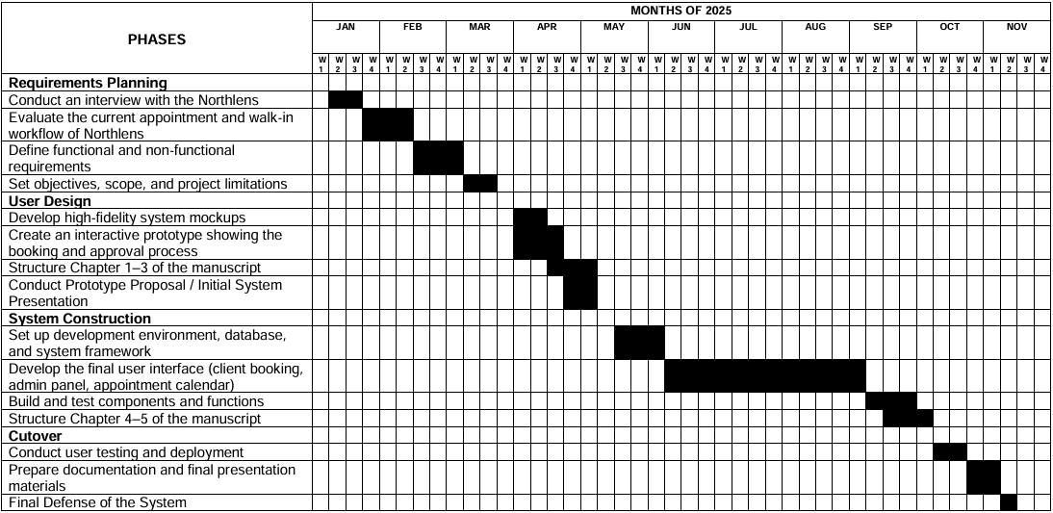
Figure 1. Gantt chart for the Development of Northlens Appointment System
CHAPTER 4
METHODOLOGY, RESULTS, AND DISCUSSION
To develop the Northlens Appointment System, the researchers applied the System Development Life Cycle (SDLC) through the Waterfall Model. The researchers decided to implement the Waterfall Model, possibly because of the nature of the majority of the development, specifically with it being a system that books patient appointments. The Waterfall Model provides for a systematic and linear development process, permitting the researchers to maintain organization.
The study was designed to address challenges experienced by the clinic in managing appointments. The proposed system aimed to make appointment scheduling faster, lessen manual work, and improve overall service for patients.
During the design phase, the researchers produced several diagrams: the Entity-Relationship Diagram (ERD), the Data Flow Diagram (DFD), and the Context Diagram. Each diagram provided a framework for what the database ecosystem would look like, how information would be shared/flow with use, and how staff would engage in providing service in the system. Several diagrams also guided a service user interface that was easy to navigate and would be used by the staff to manage patient appointments.
As for the implementation phase, the system was developed using PHP and MySQL effectively, and an interface is established, which is user-friendly and allows patients to book their appointments online at their convenience. The system included features such as adding, updating, and canceling appointments and
patient records, while enabling admin to manage the appointment schedule and alter appointments as needed, and the ability to login securely for admin.
During testing, the researchers verified that each component of the system is operational and met specifications. This included unit testing of individual modules, integration testing to guarantee successful integration of the database and system. The clinic staff is trained in using the system to manage the reliable long-term operation of the system.
Requirements Analysis
This section identifies the process used to determine the needs and expectations of the users of the system. The Northlens Appointment System aims to streamline the process of booking appointments at the Northlens Optical Clinic. The system can be used by the Admin and by the Patient. The Admin manages patients' records in addition to managing the overall scheduling process for appointments and clinical operations, while the Patient uses the system to schedule appointments for themselves. The functional requirements specify what each user must be able to do for the system to function. For example, the Admin must be able to log into the system in a secure manner, manage patient records, manage appointments, including approving, rescheduling, and canceling appointments, and generate reports for patients regarding their appointments. The Patient must be able to register for an account on the site, log in to the appointment scheduling site securely, view available appointments, schedule and reschedule appointments, and receive email notifications. In addition to functional requirements, the system will also have a set of non-functional requirements. A few important non-functional requirements include being user-friendly, fast, and secure so that patients can book an appointment without feeling lost or confused, or delay caused by assurance of fast service. Security will be indicated in the requirements for the system through features, including password encryption or role-based access to protect sensitive patient data.
In addition, the system should be constantly available on the web, able to scale for multiple users, and reliable enough to avoid double-booking, among other issues. But the system also has limitations, including being web-based and requiring a stable connection to operate effectively.
Requirements Documentation
This section serves as a record of all the needs, wants, and constraints addressed by the project. It elaborates on the software needed to build the system, as well as the detailed analysis of the software's implementation in Northlens Optical Clinic. This aims to propose a solution to satisfy user requirements and document whether the steps taken so far have given a reasonable expectation of success in integrating the functionalities into the clinic's operations.
Table 4 presents the functional requirements for the Northlens Appointment System, developed to facilitate patient-clinic interactions in the areas of appointment scheduling, record keeping, and overall efficiency in that process with the clinic. The features for administrators will allow them to manage patient records (add/edit/delete), appointments (confirm/reschedule/cancel appointments), and generate reports of their activities. The features for the patients will allow them to create an account, log in, book available time slots, update/cancel their appointments, and receive email notifications. There will also be required inputs into the system, which will include details about the patients (name, contact information & email address), appointment details (date, time, type of service, and appointment status), and secure login credentials for both patients and administrators.
Functional Requirements
The Northlens Appointment System, patients can make accounts, schedule an appointment, and confirm appointments via email. Patients can see all their appointments information on the web. Administrators can handle patient information, approve appointment requests and analyze clinic statistical data.
Table 5
Functional Requirements of Northlens Appointments Systems
Functionalities | Description
Registration | This function allows the user to save their information to access the main page.  Input: Full Name, Email Address, Password, and User Information.  Output: Registered successfully.
Email Notification | This function sends a reminder to the patient when the appointment request is approved.
Login/Logout | This function allows the user to log in and out of the system securely. After logging in, patients can book appointments and view their records.  Input: Email Address and Password.  Output: User Interface.
Book Appointment | This function allows the user to select the service date and time.  Input: Services, Date, and Time.  Output: Approved appointment request.
Manage Patient and Appointment requests | This function allows the Admin to manage patients and check availability, view appointment requests and approve them, edit records, and save any changes made.
View Dashboard | This function allows the Admin to view important statistics around the number of patients admitted daily and the activity of appointments.

The Northlens Appointment System's functional requirements, identified in Table 5 that provide support to both patients and administrators in the management of appointments. The system starts with the Registration function, which facilitates an account for a patient by providing the patient's record details. The system automates notifications when an appointment request is approved, so patients receive notifications on time. The system provides secure access to the Login/Logout function by allowing patients to book an appointment and view their records after sign-in. The Book Appointment option will facilitate the patient to choose a desired service, date, and time for their scheduled appointment. On the administrator side, the Manage Patient and Appointment Request function allows the administrator to view the patient's record, check availability for the appointment, process patient appointment requests, approve patients' requests, make edits to requested details, and keep record of updated details. The View Dashboard will provide the admin with a summary overview of selected statistics, such as total daily counted patients, and the status of all appointment activity to view and make decisions. Each function can promote each other effectively, allowing the office to run smoothly, increase patient engagement, and allow for better clinic management.
Non-Functional Requirements
The non-functional requirements of a product/service indicate some of its characteristics, or qualities, that would guarantee that the product/service will operate efficiently and fulfill the requirements, expectations, and desires of users in addition to just being functional. The non-functional requirements for the Northlens Appointment System will address numerous important areas within the system, such as portability, security, reliability, and performance. The requirements will also provide a method for assessing the system's ability to deliver a satisfactory experience for both patients and staff.

Table 6
Non-Functional Requirements of Northlens Appointments Systems
Functionalities | Description
Portability | The system was created to be portable, as it operates well on a variety of devices and web browsers.
Security | The system emphasized security to protect sensitive information for patients and doctors. Protected login information, secure medical records, and encrypted appointment details, prevent breaches and unauthorized usage.
Maintainability | The system was designed with maintainability in mind, so any updates, debugging, or future improvements can be made simply without disrupting activity.
Reliability | The system is built to operate consistently under regular usage, allowing reliable ability to access main functions of creating an account, scheduling an appointment, and handling records.
Scalability | The design allows the system to continue to support increasing numbers of users and appointment increases.
Performance | Optimizations were used to enable fast actions for registering, logging in, and appointment scheduling without latency.
Reusability | The system was designed using reusable modules with the registration module in mind, so it may be modified and reused for future development or additional functionality.
Flexibility | The system was designed with flexibility in mind so new requirements can be easily incorporated, such as modifying doctors' schedules or new patient appointment requirements, making sure the system keeps pace with practice requirements as it grows.

Table 6 the Northlens Appointment System non-functional requirements are explicitly defined to emphasize portability, security, and reliability, among others. Portability ensured the system could successfully operate on a wide variety of devices and web browsers, thus making it available to a wider range of users. Security was critical for safeguarding sensitive information such as login credentials for users, patient records, and appointment details, to prevent unauthorized access from other users. A requirement for maintainability which would allow easier updates, debugging, and improvements to the system, without disrupting services was included, as well as a requirement for reliability to ensure accuracy and consistency of the core functions of account creation, booking and managing user records. Scalability would also be a requirement, to ensure a rapidly growing number of users and appointment opportunities could be accommodated. A non-functional requirement for optimized performance was important to guarantee that response times to registering, logging in, and booking patients were fast. Reusability meant that modules could be repurposed for other expansions to the system that would occur later, while flexibility meant the system could add new features or incorporate changes (such as new schedules for doctors or meeting new patient needs). The non-functional requirements worked together as a whole to ensure efficiency, adaptability, and patient experience.
Design of Software, Systems, Product, and/or Process
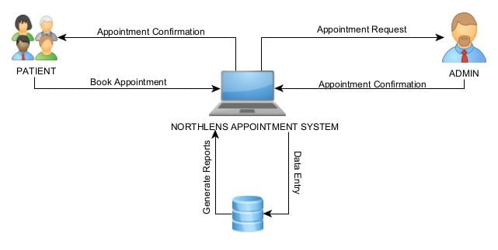
System Architecture

Figure 2: System Architecture of Northlens Appointment System
Figure 2 illustrated the detailed process of how the Northlens Appointment System operates. Patients are able to login, register, and request appointments. Admins manage users, handle walk-ins, and approve appointments. Appointment information data is stored in the system's user and appointment records so it can be accessed to view scheduling, appointment history, and reporting. This diagram shows a visual representation of the step-by-step process that patients, admins, and data have as part of the interaction.
Process model
The Appointment System at Northlens is the centralized procedure to manage appointment-related activities between patients, admins, and the database. A patient would interact with the system by signing in, registering, booking appointments, and receiving confirmations. Admins would use the system to manage the users' details, walk-in patients, and approve or cancel appointments. The system also provides the admin with scheduling, a history of appointments, and reports that have been generated for tracking appointments. The database manages all user information, the records of appointments, and appointment history at the back end and supplies the system with information for generating reports. This process model allows patients, admins, and the appointment record system to ensure appointments happen smoothly through one central system.

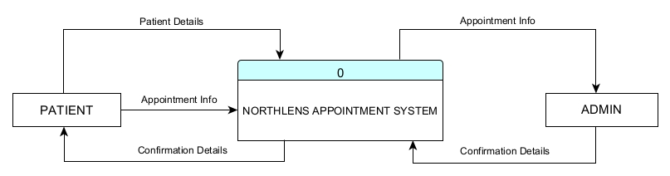
Context Diagram

Figure 3: Context Diagram of Northlens Appointment System

Figure 3 illustrated the high-level context of the Northlens Appointment System and its interactions with various external entities. Patients provide appointment and customer information to the system when scheduling appointments, while the system returns confirmation details such as appointment status and schedule. Meanwhile, the Admin receives appointment and customer information from the system to manage, verify, and confirm bookings, sending back confirmation details that are then relayed to the patient. This diagram shows the overall data flow, emphasizing how the system efficiently connects patients and administrators to streamline the appointment process at Northlens Optical Clinic.

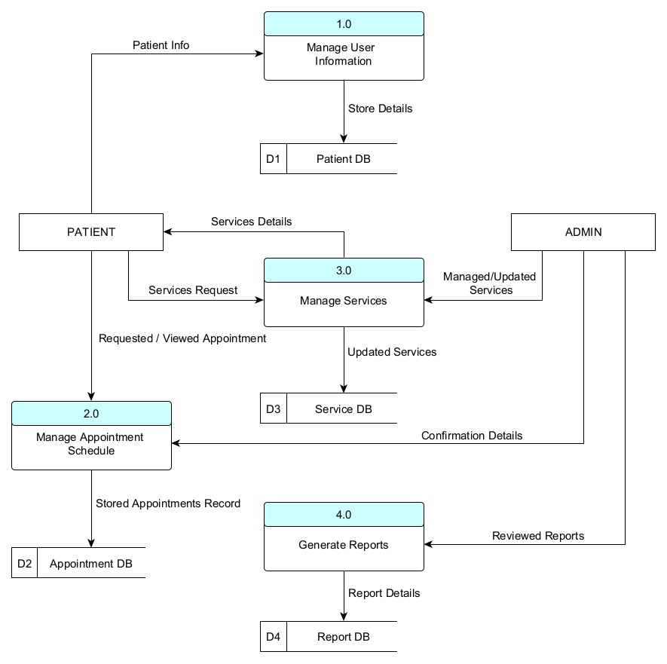
Data Flow Diagram

Figure 4: Data Flow Diagram of Northlens Appointment System
Figure 4 illustrated a Level 0 Data Flow Diagram for the Northlens Appointment System and shows how inputs and outputs are controlled. The patient is able to take actions in the system, such as logging in or signing up, booking appointments, and receiving confirmation messages. The admin enters information such as login name and password, user information, and walk-in appointment information. The admin can change the appointment schedule within the system by cancelling or approving a walk-in appointment. The admin can also view appointment schedules, appointment history, and reports for monitoring and decision-making. This level 0 diagram illustrates the overall capability of the appointment system, highlighting its functionality for the patient and the admin to access a centralized appointment system that manages the appointment process.
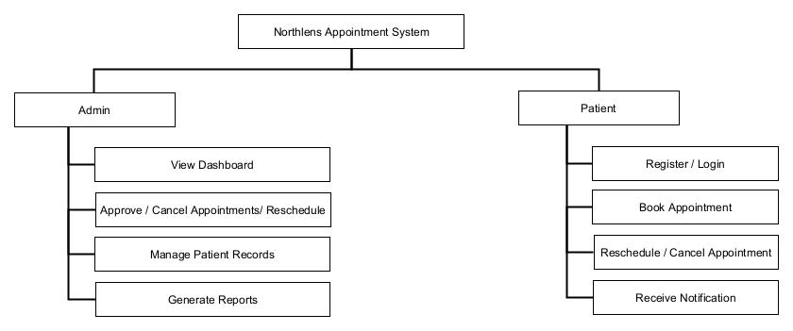
Functional Decomposition Diagram

Figure 5: Functional Decomposition Diagram of Northlens Appointment System
Figure 5 showed the Functional Decomposition Diagram (FDD) of the Northlens Appointment System, identifying the key functional components and interactions with both types of users: admins and patients. The admin has functions of administering patient records, approving/rejecting/reschedule appointment requests, reviewing dashboard information in real time, and running reports for monitoring and documenting performance. The patients have functions of registering or logging on, booking appointments, rescheduling and cancelling appointments, and receiving notifications for their appointments in real time. The overall insights from the figure reflect that both admins and patients are connected to the system in an organized function to effectively schedule, administer, and communicate the patient appointment functionalities.

Data Model
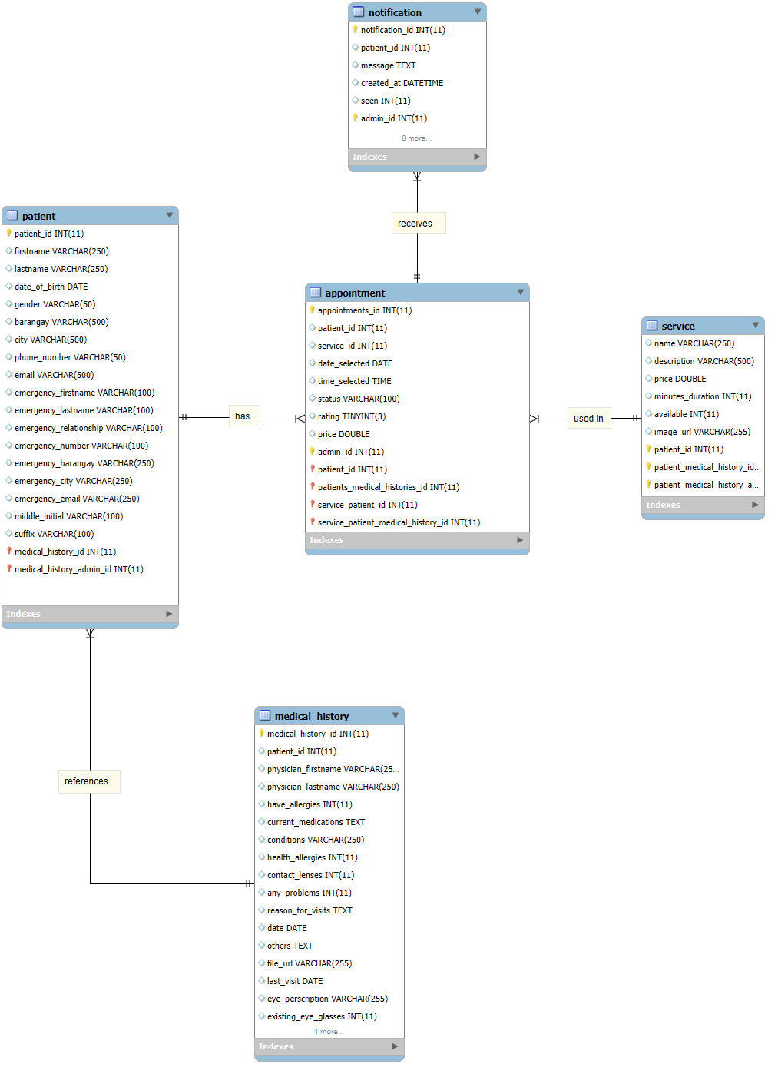
Entity-Relationship Diagram

Figure 6: Entity Relationship Diagram of Northlens Appointment System
Figure 6 illustrated the database structure for the Northlens Appointment System. It consists of five core entities: patient, appointment, service, medical_history, and notification.
The patient table serves as the foundation for the entire application. The patient is used to store complete patient information such as patient demographics, contact information, address, and emergency contacts. Each patient will be directly connected to their appointment records, medical history, and notification records, to allow the appointment system to associate all processes related to the scheduling, medical history, and communication with the correct patient. The patient's table acts as the primary source of data for identifying, tracking, and managing all patients in the system.
The appointment table is responsible for tracking all appointments made by a patient at a particular clinic. The appointments contain the essential fields, including: A Patient_Id, a Service_Id, the date and time of the appointment, the appointment status, the price of the service, and the rating for the appointment. The appointment will also include a reference to the admin who created or managed the appointment. The appointment connects the patient to the services they have scheduled, provide a pathway for tracking the flow of appointments, ensure accurate scheduling, and support clinic operations.
The service table contains detailed information about the services that Northlens Optical Clinic offers. Each service contains the following information: The service name, service description, the service price, an image of the service, and whether the service is available. This connects to the appointment table to indicate what services the patient has chosen for each appointment date. This ensures that all services are identified and referred to consistently throughout the system.
The medical_history table provides detailed medical-related information for every patient, including physician information, allergies, medications, health conditions, reasons for visits, use of contact lenses, eye prescription, and any uploaded files associated with the patient's medical record. Each medical history record has a relationship with both the patient and the administrator responsible for the record, allowing for accountability and tracking of the patient's medical data.
The notification table manages the messages sent to patients regarding appointment reminders, changes to their appointments, appointment confirmations or any other type of notification generated by the system. This entity includes information pertaining to the notification message content, created date, whether or not the patient has viewed the message, where the patient was from, and the administrator's identification number. This provides a way to communicate with patients on time, which helps to increase patient engagement and ensure that patients keep their appointments.
Data Dictionary
The Northlens Appointment Systems data dictionary specifies the structure and organization of its database tables to enable correct data storage and facilitate efficient operation of the system. The Admin table holds the administrator accounts, which include username, password, and email, and serves, in effect, as the main point of control for the system. The Patient table includes personal and contact information (names, birthdate, gender, phone, and address) and serves as the basis for all transactions about patients. The Service table allows the system to outline the different medical services that are provided, naming the service, describing the service, and specifying the service fee. The Appointment table is the central link between patients, admins, and services and records the date, time, and status of the appointment. Lastly, the Medical History table specifies the patient's record of diagnosis and treatment and documents visit dates, which allows continuity of care. The tables clearly define relationships, such as one admin can manage multiple appointments, one patient can schedule multiple services, and one patient can hold multiple histories. Each specific piece serves to support the input of data and the integrity of the database, while facilitating scheduling, record-keeping, and communication within the Northlens Appointment System.
Table 7
Table of tbl_Appointment
Field Name | Data Type | Key | Length | Description | FK reference table
APPOINTMENT_ID | INT | Primary | 11 | Unique appointment ID
PATIENT_ID | INT | Foreign | 11 | ID of the patient who booked the appointment | Patients
SERVICE_ID | INT | Foreign | 11 | ID of the service selected for the appointment | Services
DATE_SELECTED | DATE |  |  | Appointment date chosen by the patient
TIME_SELECTED | TIME |  |  | Appointment time chosen by the patient
STATUS | VARCHAR |  | 100 | Appointment status
RATING | TINYINT |  | 3 | Rating, NULL if not rated
PRICE | DOUBLE |  |  | Service fee or appointment cost

Table 7 records all appointment transactions within the system, linking patients and services to specific booking details. It includes essential information such as the patient ID, service ID, selected date and time, appointment status (e.g., pending, approved, or cancelled), and service price. Additionally, it stores a rating field that allows patients to provide feedback after their appointment, helping assess service satisfaction. This table serves as the core of the scheduling process, ensuring that each booking is properly tracked, billed, and reviewed.
The tbl_Appointment table utilizes two key foreign keys that link it to other tables in the database. The first is the PATIENT_ID field, a foreign key that points to the tbl_Patient table's ID field. Referential integrity is ensured, and appointments cannot be scheduled without a patient created in the system since a patient must be present in the tbl_Patient table in order for an appointment to be active. Every appointment will have a service referenced to it as the service being rendered because the SERVICE_ID field is a foreign key field that references the ID field in tbl_Service. This is a very important foreign key in that it is used to ensure appointment records are valid, look good and have enough information to prevent role tracking between dependencies of appointments tables.
Table of 8
Table of tbl_Medical_History
Field Name | Data Type | Key | Length | Description | FK reference table
MEDICAL_HISTORY_ID | INT | Primary | 11 | Unique record identifier.
PATIENT_ID | INT | Foreign | 11 | Linked patient ID from the patients table. | Patients
PHYSICIAN_FIRSTNAME | VARCHAR |  | 250 | Physician’s first name.
PHYSICIAN_LASTNAME | VARCHAR |  | 250 | Physician’s last name.
HAVE_ALLERGIES | INT |  | 11 | Indicates if the patient has allergies.
CURREN_MEDICATIONS | TEXT |  |  | Current medications of the patient.
CONDITIONS | VARCHAR |  | 250 | Patient’s existing conditions.
HEALTH_ALLERGIES | INT |  | 11 | Indicates health-related allergies.
CONTACT_LENSES | INT |  | 11 | If the patient uses contact lenses.
ANY_PROBLEMS | INT |  | 11 | If the patient has eye problems.
REASON_FOR_VISIT | TEXT |  |  | Reason for the clinic visit.
DATE | DATE |  |  | Date of consultation or record.
OTHERS | TEXT |  |  | Additional notes or remarks.
FILE_URL | VARCHAR |  | 255 | Link to uploaded medical files.
LAST_VISIT | DATE |  |  | Patient’s last clinic visit.
EYE_PRESCRIPTION | VARCHAR |  | 255 | Patient’s eye prescription.
EXISITNG_EYE_GLASSES | INT |  | 11 | Indicates if the patient has eyeglasses.

Table 8 stored the comprehensive medical background of each patient, including physician details, allergies, medications, and eye conditions. It helps the clinic maintain accurate health records by recording consultation dates, reasons for visits, and other relevant notes or files. This table also includes prescription details and the patient’s history of eyeglass use, which are crucial for providing proper eye care. By linking each record to a specific patient, this table allows physicians to review previous diagnoses and treatments, ensuring continuity and accuracy in healthcare services.
The table includes a foreign Key called the PATIENT_ID, which is used to attach each record of medical history to the record in the patients table. The foreign key ensures that every medical entry corresponds to an existing and approved patient within the database, thereby avoiding orphaned or incorrect data entry. This enhances the integrity of data so that the system knows how to trace a patient's profile with a medical history when a relationship is established. In this way, the clinic can easily retrieve a full record for each patient, which enables the efficient organization of data, correct tracking of previous consultations, and leads to better management of health information.
Table 9
Table of tbl_Patient
Field Name | Data Type | Key | Length | Description | FK reference table
PATIEN_ID | INT | Primary | 11 | Unique patient ID
USER_ID | INT | Foreign | 11 | References the associated user account | Users
FIRSTNAME | VARCHAR |  | 250 | Patient’s first name
LASTNAME | VARCHAR |  | 250 | Patient’s last name
DATE_OF_BIRTH | DATE |  |  | Patient’s date of birth
GENDER | VARCHAR |  | 50 | Patient’s gender
BARANGAY | VARCHAR |  | 500 | Patient’s barangay or local address
CITY | VARCHAR |  | 500 | Patient’s city of residence
PHONE_NUMBER | VARCHAR |  | 50 | Patient’s contact number
EMAIL | VARCHAR |  | 500 | Patient’s email address
EMERGENCY_FIRSTNAME | VARCHAR |  | 100 | Emergency contact’s first name
EMERGENCY_LASTNAME | VARCHAR |  | 100 | Emergency contact’s last name
EMERGENCY_RELATION  SHIP | VARCHAR |  | 100 | Relationship to patient
EMERGENCY_NUMBER | VARCHAR |  | 100 | Emergency contact’s phone number
EMERGENCY_BARANGAY | VARCHAR |  | 250 | Emergency contact’s barangay or local address
EMERGENCY_CITY | VARCHAR |  | 250 | Emergency contact’s city
EMERGENCY_EMAIL | VARCHAR |  | 250 | Emergency contact’s email address
MIDDLE_INITIAL | VARCHAR |  | 100 | Patient’s middle initial
SUFFIX | VARCHAR |  | 100 | Patient’s suffix

Table 9 contained all personal, demographic, and emergency information of individuals registered in the system. It holds each patient’s full name, date of birth, gender, address, contact details, and email, ensuring easy identification and communication. The table also stores emergency contact information, including the contact’s name, relationship, address, and phone number, which is vital during urgent situations. Each patient is linked to a corresponding user account to ensure secure and personalized access to services. This table serves as the foundation for managing patient records and ensuring reliable clinic-patient communication.
The USER_ID field references the foreign key to the Users table. This linking of a patient to a user account allows for secure and individualize access to the system. It is the foreign key (FK) that enforces data integrity by ensuring that any record associated with a patient must be associated with a user account. This provides consistency in the authentication, authorization, and management of services associated with a patient.
Table 10
Table of tbl_Notification
Field Name | Data Type | Key | Length | Description | FK reference table
NOTIFICATION_ID | INT | Primary | 11 | Unique message ID
PATIEN_ID | INT | Foreign | 11 | References the patient who sent or received the message | Patients
MESSAGE | TEXT |  |  | Message content
CREATED_AT | DATETIME |  |  | Date and time when the message is created
SEEN | INT |  | 11 | Indicates if the message has been seen

Table 10 managed the messages and notifications exchanged between patients and the clinic. It includes the sender’s patient ID, message content, timestamp, and seen status to determine whether the message has been read. This table plays an important role in improving communication and transparency between patients and administrators, ensuring that updates such as appointment confirmations, reschedules, and service announcements are delivered efficiently.
The PATIENT_ID field is an FK that references the ID field in the tbl_Patient table to create a link between each Notification or Message (sent/received by patients) and the corresponding patient who sent/received it. This link helps to ensure that a message is accurately mapped to the correct patient record, maintaining data integrity and facilitating the efficient retrieval of patient-specific notifications.

Table 11
Table of tbl_Service
Field Name | Data Type | Key | Length | Description | FK reference table
SERVICE_ID | INT | Primary | 11 | Unique service ID
NAME | VARCHAR |  | 250 | Name of the service offered
DESCRIPTION | VARCHAR |  | 500 | Description or details about the service
PRICE | DOUBLE |  |  | Cost of the service
AVAILABLE | INT |  | 11 | Availability status
IMAGE_URL | VARCHAR |  | 255 | Optional image or icon URL for the service

Table 11 stored details about all services offered by the clinic. It includes the service name, description, price, and availability status. Optional image URLs may also be included for easier service identification. This table ensures that patients and administrators have accurate information about available services, enabling efficient booking and management of clinic operations.

Table 12
Table of tbl_Admin

Field Name | Data Type | Key | Length | Description | FK reference table
ADMIN_ID | INT | Primary | 11 | Unique admin ID
EMAIL | VARCHAR |  | 1000 | Admin email address
PASSWORD | VARCHAR |  | 1000 | Admin password

Table 12 holds data on system administrators, including their unique ID, email, and password, providing secure access control to manage appointments, services, and patient data effectively.
Implementation Results
This section outlines the results of implementing the Northlens Appointment System, focusing on its main features integrated into the site. To guarantee the system performed as expected, was dependable and robust, and could effectively support the clinic's operations. In summary, this study program showed, the system successfully achieved its aim to improve patient registration, make online booking convenient and secure, and enable secure access for users. This study demonstrated the overall operational efficiency of the system and met the original aim of the study.
1. The first objective is “To accept user information and appointment schedule”.
The system was successfully developed to manage patient registration and appointment scheduling efficiently. Patients can enter their personal details, such as full name, contact number, and preferred appointment date and time, through a user-friendly interface. The module ensures that all required fields are properly validated before submission, and all information is securely stored in the database. Additionally, the appointment scheduling feature allows patients to view available slots in real time, minimizing conflicts and helping the clinic maintain an organized scheduling process. As shown in Figure 7, the interface is designed to be simple and accessible, ensuring that patients can easily register and schedule their appointments without assistance.
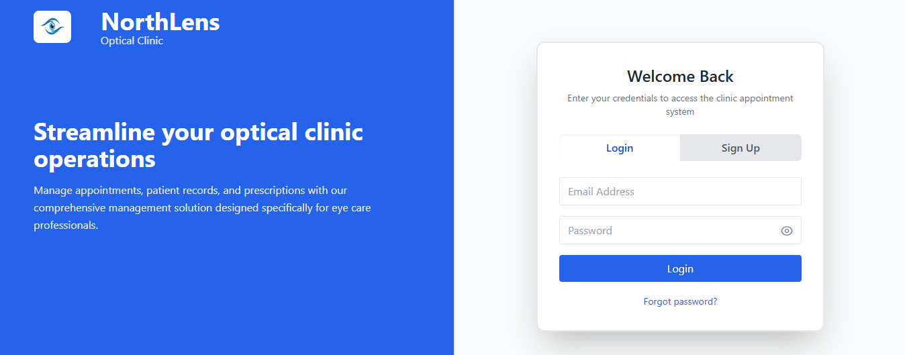

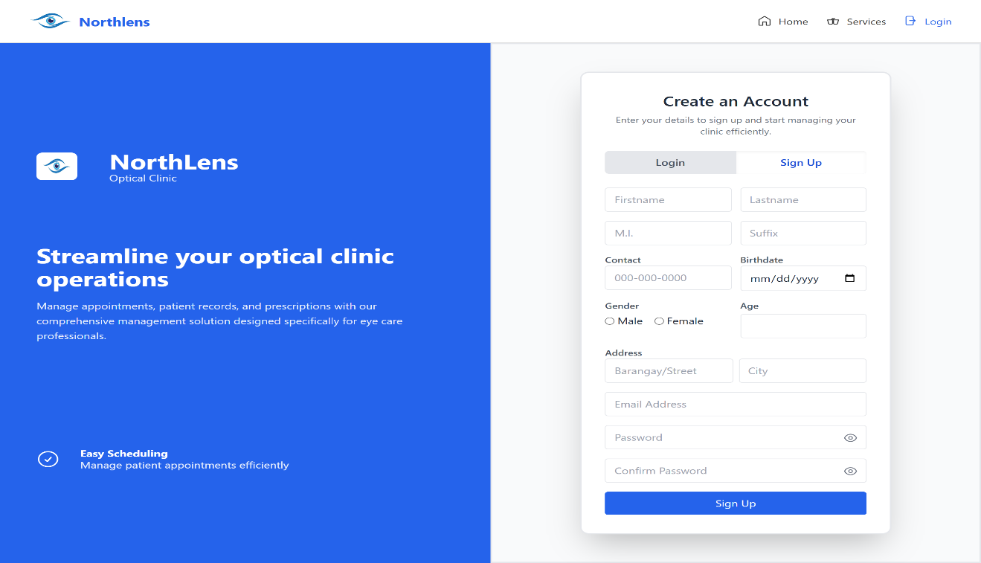

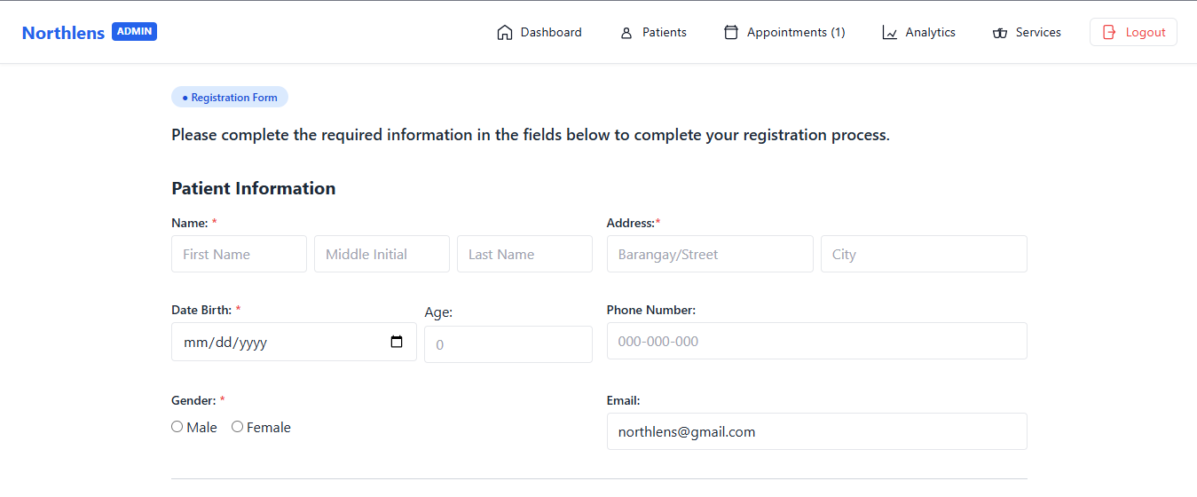

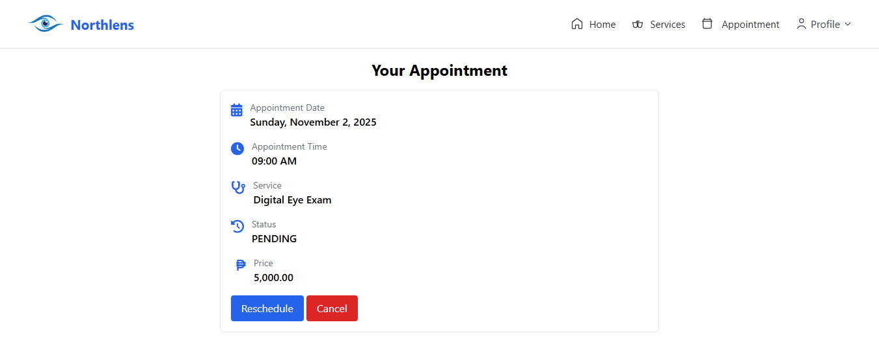

Figure 7. User Information and Appointment Scheduling Page
2. The second objective is “To develop an admin page that manages patient services and appointments”;
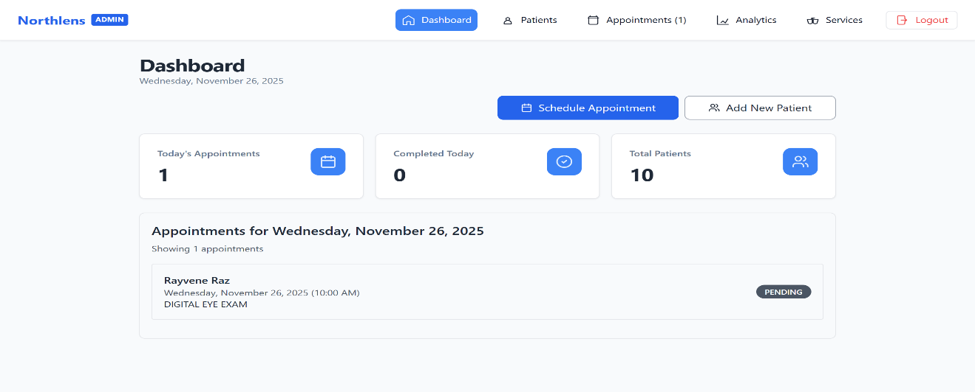
An admin dashboard was implemented to give clinic personnel the ability to efficiently manage patient data and appointment schedules. Through this page, administrators can view a complete list of patient records, update or modify information, approve or reschedule appointments, and manage service offerings. The system provides real-time access to data, allowing staff to monitor daily operations and ensure that each appointment is properly recorded. As shown in Figure 8, the admin page presents a clean and organized layout, making it easier for staff to navigate, track appointment status, and maintain accurate records for each patient.

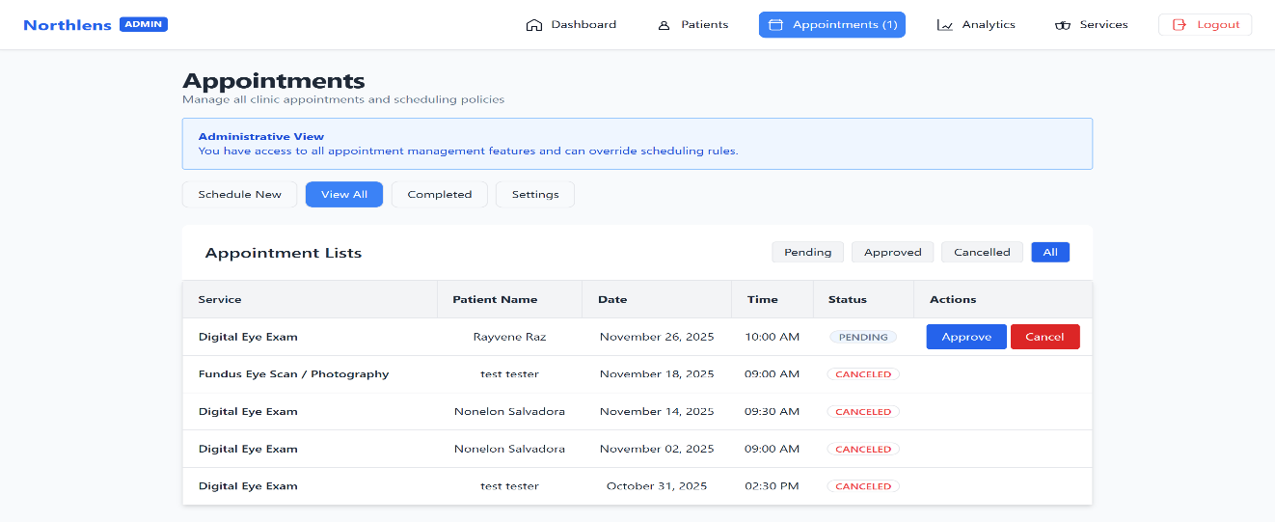

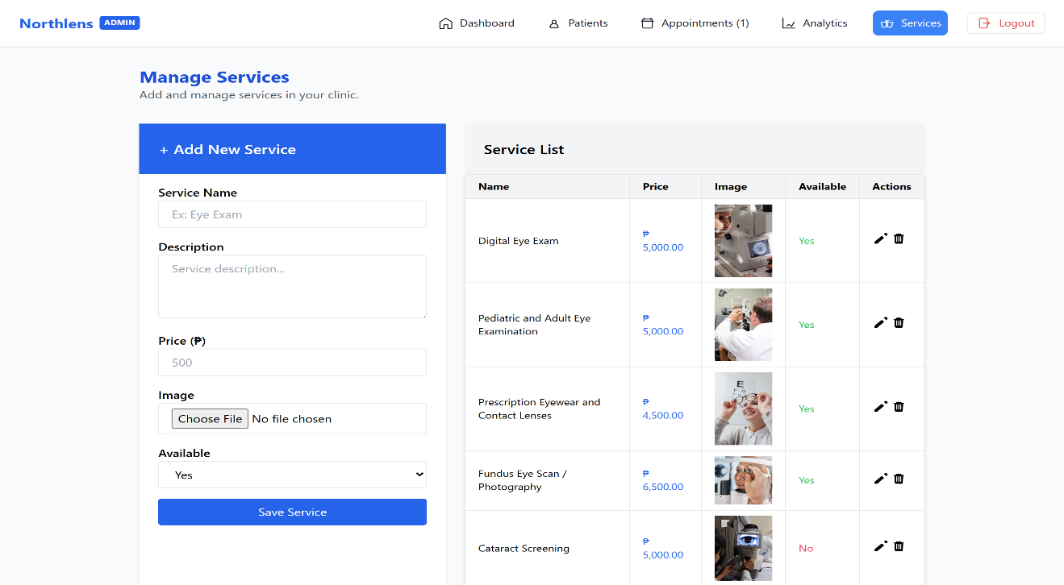

Figure 8. Admin Page for Managing Patient Services and Appointments

3. To generate necessary reports.
The system included a reporting module capable of generating accurate and comprehensive reports based on patient and appointment data. These reports can be produced daily, weekly, or monthly, depending on administrative needs. The generated reports provide valuable insights into clinic performance, patient volume, and service trends. This feature supports data-driven decision-making and improves overall operational monitoring. As shown in Figure 9, the reporting interface allows administrators to easily access and print reports, ensuring that the clinic has a reliable reference for recordkeeping and planning.

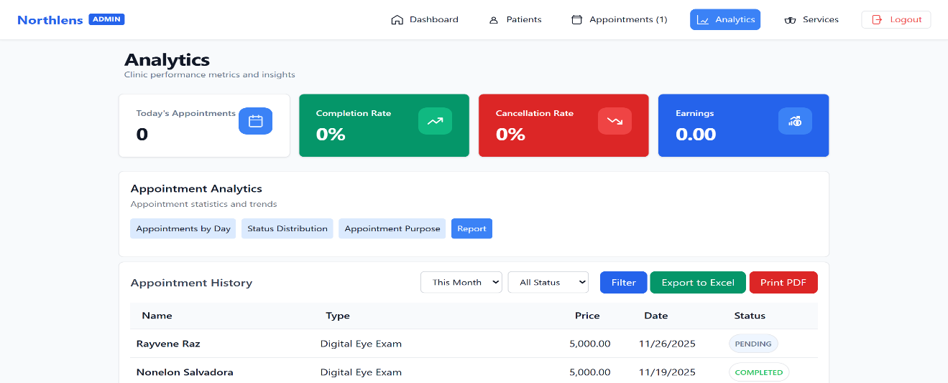

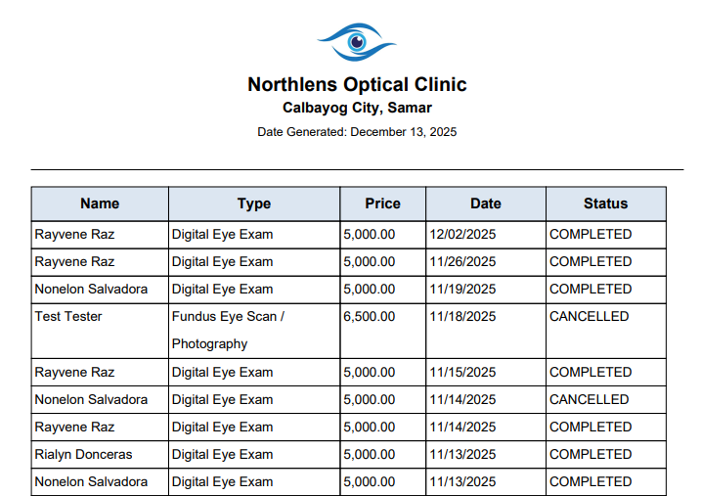

Figure 9. Report Generation Page
CHAPTER 5
RECOMMENDATIONS
To continue enhancing the Northlens Optical Clinic Appointment System, the researchers recommend the following areas of enhancement related to security, data protection, and facilitation of online transactions. These enhancements aim to increase user trust, improve financial management, and strengthen the system’s digital frameworks.
It is recommended that the Northlens Appointment System increase its security and data privacy measures to better protect the accounts of both administrators and patients. Implementing two-factor authentication (2FA) for all users would add an extra layer of verification, thereby enhancing account security. Upon deployment, the system should comply with basic data privacy and security standards, such as encryption, secure data backup, and role-based access control to safeguard sensitive patient information.
It is also recommended to develop and integrate an online payment and billing capability within the system. By integrating secure, reliable payment platforms such as GCash, PayMaya, or credit/debit card options, patients would have a more convenient and efficient way to pay consultation fees, reservation charges, and product purchases. Additionally, the system should automatically generate digital receipts for every transaction, enabling patients to download or view them through their accounts for better record management and transparency.

Future enhancements to the Northlens Appointment System could include AI-powered features such as chatbots, appointment recommendations, and personalized reminders. The inclusion of these features would enhance the overall user experience, reduce the likelihood of no-shows, and contribute to more efficient clinic operations.

REFERENCES
Abel, D., Gavidi, B., Rollings, N., & Chandra, R. (2015). Development of an Android application for an electronic medical record system in an outpatient environment for healthcare in Fiji. https://arxiv.org/abs/1503.00810
Akhter, A. R., Chamarthi, V., Gk, K., & Jain, M. (2021). PATDOC - An Online Appointment Management System. ResearchGate. https://www.researchgate.net/publication/353019876_PATDOC_-_An_Online_Appointment_Management_System
Ala, A., Alsaadi, F. E., Ahmadi, M., & Mirjalili, S. (2021). Optimization of an Appointment Scheduling Problem for Healthcare Systems Based on the Quality of Fairness Service Using Whale Optimization Algorithm and NSGA-II. Scientific Reports, 11, 19816. https://www.nature.com/articles/s41598-021-98851-7
Alanzi, T. (2020). The role of digital health in diabetes management: Patient and healthcare professional perspectives. Healthcare, 8(3), 243. https://doi.org/10.3390/healthcare8030243
Alsulame, K., Khalifa, M., & Househ, M. (2021). The impact of e-health on the quality and safety of healthcare: A systematic review. Studies in Health Technology and Informatics, 281, 82–86. https://doi.org/10.3233/SHTI210115
Ampuan, A., & Delena, R. (2022). An implementation and evaluation of a web-based appointment system for the Mindanao State University – Main Campus. Journal of Information Systems and Informatics, 4(4), 922–937. https://journal-isi.org/index.php/isi/article/view/379
Anuyah, S., Singh, M. K., & Nyavor, H. (2024). Advancing clinical trial outcomes using deep learning and predictive modelling: Bridging precision medicine and patient-centered care. arXiv preprint arXiv:2412.07050. https://arxiv.org/abs/2412.07050
Atherton, H., Brant, H., Ziebland, S., Bikker, A., Campbell, J. L., Gibson, A., ... & Salisbury, C. (2024). Investigating Patient Use and Experience of Online Appointment Booking in Primary Care: Mixed Methods Study. Journal of Medical Internet Research, 26, e51931. https://www.jmir.org/2024/1/e51931/
Ayobami, M. (2024). Design and Implementation of Hospital Appointment Management System. Caleb University Projects. https://www.projects.calebuniversity.edu.ng/caleb_uploads/2024/04/1-Michael-Ayobami.pdf
Cao, W., et al. (2017). Web-Based Medical Appointment Systems: A Systematic Review. Journal of Medical Internet Research, 19(4), e134. https://www.jmir.org/2017/4/e134/
Dela Fuente, M. A. M., Facunla, J. A., De Guzman, H. N. F., Jacinto, E. F., Hilario, J. B., Olipas, C. N. P., & Cunanan, A. I. (2023). Project Clinik: A cross-platform scheduling and appointment reservation system. Formosa Journal of Computer and Information Science, 2(1), 13–24. https://journal.formosapublisher.org/index.php/fjcis/article/view/4077
Dizon, M., & Mariano, J. (2021). Dental Clinic Management System. International Research Journal of Modernization in Engineering Technology and Science, 7(4). https://www.irjmets.com/uploadedfiles/paper//issue_4_april_2025/73704/final/fin_irjmets1746457161.pdf

Ele, B., Odey, J. A., Frank, N. E., & Ekinya, I. M. (2020). A web-based medical appointment scheduling with SMS alert notification system. Transactions on Engineering and Computing Sciences, 8(6), 1–9. https://journals.scholarpublishing.org/index.php/TMLAI/article/view/9098
Fosso Wamba, S., Gunasekaran, A., Akter, S., Ren, S. J., & Dubey, R. (2017). Big data analytics and firm performance: Effects of dynamic capabilities. Journal of Business Research, 70, 356–365. https://doi.org/10.1016/j.jbusres.2016.08.009
Gurol-Urganci, I., de Jongh, T., Vodopivec-Jamsek, V., Atun, R., & Car, J. (2022). Mobile phone messaging reminders for attendance at healthcare appointments: A systematic review and meta-analysis. Journal of Medical Internet Research, 24(6), e35606. https://doi.org/10.2196/35606
Khalil, L., & Serhier, Z. (2023). Exploring User Acceptance of Medical E-Appointment Systems for Mental Healthcare: A Systematic Literature Review. SHS Web of Conferences, 175, 01018. https://www.shs-conferences.org/articles/shsconf/abs/2023/24/shsconf_mh2s2023_01018/shsconf_mh2s2023_01018.html
Khan, I., Ahmad, A., Mahmood, A., & Maqbool, B. (2021). Patient appointment scheduling in healthcare: A systematic review of optimization models and techniques. Computers & Industrial Engineering, 152, 107018. https://doi.org/10.1016/j.cie.2020.107018
Kyambille, G. G., & Kalegele, K. (2016). Enhancing patient appointments scheduling that uses mobile technology. arXiv preprint arXiv:1602.03337. https://arxiv.org/abs/1602.03337
Liang, H., Xue, Y., & Wang, L. (2022). Data analytics for improving hospital performance: A case study on patient flow and appointment scheduling. Journal of Biomedical Informatics, 127, 103993. https://doi.org/10.1016/j.jbi.2022.103993
Lim, Y. H., & Teo, P. C. (2024). An implementation of digital platform to enhance the appointment scheduling system. International Journal of Academic Research in Business and Social Sciences, 14(2), 402–416. https://doi.org/10.6007/IJARBSS/v14-i2/20635
Mahfouz, M. S., et al. (2023). Evaluation of Patient Satisfaction with the New Web-Based Medical Appointment Systems "Mawid" at Primary Health Care Level in Southwest Saudi Arabia: A Cross-Sectional Study. PubMed. https://pubmed.ncbi.nlm.nih.gov/36814746/
Marbella, H. N., Akbar, I. A., Setiawan, B., & others. (2024). Design and development of a web‑based patient management information system. Procedia Computer Science, 234, 1799–1806. https://doi.org/10.1016/j.procs.2024.03.188
Mišić, V. V., & Perakis, G. (2019). Data analytics in operations management: A review. Manufacturing & Service Operations Management, 21(4), 689–701. https://pubsonline.informs.org/doi/abs/10.1287/msom.2019.0805
Musa, H., & Alhassan, S. (2019). Cloud computing adoption in healthcare: Benefits and challenges. International Journal of Medical Informatics, 129, 52–59. https://doi.org/10.1016/j.ijmedinf.2019.06.004
Naeem, A. et al. (2014). Development of an in-house hospital information system in a hospital in Pakistan. International Journal of Medical Informatics, 83(3), 180–188. https://doi.org/10.1016/j.ijmedinf.2013.12.004
Nguyen, L., Bellucci, E., & Nguyen, L. T. (2019). Electronic health records implementation: An evaluation of information system impact and contingency factors. International Journal of Medical Informatics, 130, 104033. https://doi.org/10.1016/j.ijmedinf.2019.104033
Patel, V., & Burke, T. (2018). Evaluating the effectiveness of SMS reminders to reduce patient no-shows in outpatient clinics: A meta-analysis. Telemedicine and e-Health, 24(12), 927–934. https://doi.org/10.1089/tmj.2017.0298
Raj Kumar, S., Shadheem, S., & Surya, S. (2024). Web-based application for doctor-patient appointment management system. Journal of ISMAC, 6(3), 261–270. https://irojournals.com/iroismac/article/view/6/3/6
Ratwani, R. M., Savage, E., Will, A., Fong, A., Karavite, D., Muthu, N., & Miller, K. (2021). A usability and safety analysis of electronic health records: A multi-center study. Journal of the American Medical Informatics Association, 28(2), 258–263. https://doi.org/10.1093/jamia/ocaa264
Reyes, C., & Villanueva, M. (2022). Web-Based Health Monitoring System for the Municipality of Sta. Cruz Health Centers. SSRN. https://www.scribd.com/document/576588045/SSRN-id3779341
Zhai, K., Yousef, M. S., Mohammed, S., Al-Dewik, N. I., & Qoronfleh, M. W. (2023). Optimizing clinical workflow using precision medicine and advanced data analytics. Processes, 11(3), 939. https://www.mdpi.com/2227-9717/11/3/939
Zhao, P., Yoo, I., Lavoie, J., Lavoie, B. J., & Simoes, E. (2017). Web-based medical appointment systems: A systematic review. Journal of Medical Internet Research, 19(4), e134. https://www.jmir.org/2017/4/e134/

APPENDICES

Appendix A
Relevant Source Code

Login and Signup
const form = document.getElementById('login-form');
const username = document.getElementById('username');
const password = document.getElementById('password');
if (form) {
document.getElementById('login-form').addEventListener('submit', function (e) {
const username = document.getElementById('username');
const password = document.getElementById('password');
let valid = true;
if (!username.value.trim()) {
username.classList.add('ring-2', 'ring-red-500');
valid = false;
} else {
username.classList.remove('ring-2', 'ring-red-500');
}
if (!password.value.trim()) {
password.classList.add('ring-2', 'ring-red-500');
valid = false;
} else {
password.classList.remove('ring-2', 'ring-red-500');
}
if (!valid) {
e.preventDefault(); // stop form submission
}
});
}
const emailInput = document.getElementById("email");
const emailWarning = document.getElementById("emailWarning");
const signupBtn = document.querySelector("#signup-form button");
if (emailInput) {
emailInput.addEventListener("keyup", function () {
const email = emailInput.value.trim();
if (!email) return;
fetch("crud/checkEmail.php?email=" + encodeURIComponent(email))
.then(res => res.text())
.then(result => {
if (result === "exists") {
emailWarning.textContent = "⚠️ This email is already registered.";
emailWarning.classList.remove("hidden");
signupBtn.disabled = true;
signupBtn.classList.add("opacity-50", "cursor-not-allowed");
} else {
emailWarning.textContent = "";
emailWarning.classList.add("hidden");
signupBtn.disabled = false;
signupBtn.classList.remove("opacity-50", "cursor-not-allowed");
}
})
.catch(err => console.error("Error checking email:", err));
});
}
const signform = document.getElementById("signup-form");
const signpassword = document.getElementById("password");
const confirmPassword = document.getElementById("confirm_password");
const warning = document.getElementById("passwordWarning");
if (confirmPassword) {
confirmPassword.addEventListener("keyup", function (e) {
if (signpassword.value !== confirmPassword.value) {
warning.textContent = "⚠️ Passwords do not match!";
warning.classList.remove("hidden");
signupBtn.disabled = true;
signupBtn.classList.add("opacity-50", "cursor-not-allowed");
} else {
warning.textContent = "";
warning.classList.add("hidden");
signupBtn.disabled = false;
signupBtn.classList.remove("opacity-50", "cursor-not-allowed");
}
});
}
function togglePassword() {
const passwordInput = document.getElementById('password');
const eyeIcon = document.getElementById('eyeIcon');
const isHidden = passwordInput.type === 'password';
passwordInput.type = isHidden ? 'text' : 'password';
// Toggle eye icon (switch between open and closed)
eyeIcon.outerHTML = isHidden
? `<svg id="eyeIcon" xmlns="http://www.w3.org/2000/svg" fill="none"
viewBox="0 0 24 24" stroke-width="1.5" stroke="currentColor"
class="w-5 h-5">
<path stroke-linecap="round" stroke-linejoin="round"
d="M3.98 8.223A10.477 10.477 0 001.5 12c1.5 4.5 5.25 7.5 10.5 7.5
3.042 0 5.79-1.224 7.77-3.223M6.228 6.228A9.715 9.715 0 0112 4.5c4.5 0 8.25 3
9.75 7.5a10.478 10.478 0 01-1.272 2.707M6.228 6.228L3 3m0 0l18 18" />
</svg>`
: `<svg id="eyeIcon" xmlns="http://www.w3.org/2000/svg" fill="none"
viewBox="0 0 24 24" stroke-width="1.5" stroke="currentColor"
class="w-5 h-5">
<path stroke-linecap="round" stroke-linejoin="round"
d="M2.25 12C3.75 7.5 7.5 4.5 12 4.5s8.25 3 9.75 7.5
c-1.5 4.5-5.25 7.5-9.75 7.5S3.75 16.5 2.25 12z" />
<circle cx="12" cy="12" r="3" />
</svg>`;
}
function toggleCPassword() {
const passwordInput = document.getElementById('cpassword');
const eyeIcon = document.getElementById('ceyeIcon');
const isHidden = passwordInput.type === 'password';

passwordInput.type = isHidden ? 'text' : 'password';
// Toggle eye icon (switch between open and closed)
eyeIcon.outerHTML = isHidden
? `<svg id="eyeIcon" xmlns="http://www.w3.org/2000/svg" fill="none"
viewBox="0 0 24 24" stroke-width="1.5" stroke="currentColor"
class="w-5 h-5">
: `<svg id="eyeIcon" xmlns="http://www.w3.org/2000/svg" fill="none"
viewBox="0 0 24 24" stroke-width="1.5" stroke="currentColor"
class="w-5 h-5">
<path stroke-linecap="round" stroke-linejoin="round"
d="M2.25 12C3.75 7.5 7.5 4.5 12 4.5s8.25 3 9.75 7.5
c-1.5 4.5-5.25 7.5-9.75 7.5S3.75 16.5 2.25 12z" />
<circle cx="12" cy="12" r="3" />
</svg>`;
}
const dob = document.getElementById('dob');
if (dob) {
document.getElementById('dob').addEventListener('change', function() {
const dob = new Date(this.value);
const today = new Date();
if (!isNaN(dob.getTime())) { // valid date check
let age = today.getFullYear() - dob.getFullYear();
const m = today.getMonth() - dob.getMonth();
// Adjust if birthday hasn't happened yet this year
if (m < 0 || (m === 0 && today.getDate() < dob.getDate())) {
age--;
}
document.getElementById('age').value = age >= 0 ? age : 0;
} else {
document.getElementById('age').value = '';
}
});
}
Patient Appointment
<?php
session_start();
$appointment = null;
// Database config
include 'db/db.php';
$dateofappointment = '';
$timeofappointment = '';
$service = '';
$status = '';
$price = 0;
$patientInfo = null;
if (isset($_SESSION['patient_id'])) {
$stmt = $conn->prepare("SELECT * FROM appointments WHERE patient_id = ? AND date_selected >= CURDATE() AND (status <> 'COMPLETED' && status <> 'CANCELED')");
$stmt->bind_param("i", $_SESSION['patient_id']);
$stmt->execute();
$resultpatient = $stmt->get_result();
$appointment = $resultpatient->fetch_assoc();
$stmt = $conn->prepare('SELECT * FROM patients WHERE id = ?');
$stmt->bind_param("i", $_SESSION['patient_id']);
$stmt->execute();
$resultpatient = $stmt->get_result();
$patient = $resultpatient->fetch_assoc();
if ( $patient) {
$patientInfo = $patient;
}
if ($appointment) {
$dateofappointment = date('l, F j, Y', strtotime($appointment['date_selected']));
$timeofappointment = date('h:i A', strtotime($appointment['time_selected']));
$status = $appointment['status'];
$price = $appointment['price'];
$appointmentId = $appointment['id'];
$stmtservice = $conn->prepare("SELECT * FROM services WHERE id = ?");
$stmtservice->bind_param("i", $appointment['service_id']);
$stmtservice->execute();
$res = $stmtservice->get_result();
$serviceres = $res->fetch_assoc();
if ($serviceres) {
$service = $serviceres['name'];
}
}
} ?>
<?php
$stmt = $conn->prepare("SELECT appointments.*, services.name FROM appointments inner join services on services.id = appointments.service_id WHERE patient_id = ? AND (status = 'COMPLETED' OR status = 'CANCELED') ");
$stmt->bind_param("i", $_SESSION['patient_id']);
$stmt->execute();
$resultpatient = $stmt->get_result();
$appointments = $resultpatient->fetch_all(MYSQLI_ASSOC);
foreach ($appointments as $appointment) {
?>
<tr data-id="<?= $appointment['id'] ?>">
<td class="text-center"><?php echo $appointment['name'] ?></td>
<td class="text-center"><?php echo $appointment['date_selected'] ?></td>
<td class="text-center"><?php echo $appointment['time_selected'] ?></td>
<td class="text-center"><?php echo $appointment['status'] == 'CANCELED' ? 'CANCELLED' : $appointment['status'] ?></td>
<td class="text-center cursor-pointer flex">
<?php if ($appointment['status'] != 'CANCELED') {
?>
<?php if (($appointment['rating'] != null)): ?>
<?php for ($i = 1; $i <= 5; $i++): ?>
<i class="fa fa-star <?= $i <= $appointment['rating'] ? 'text-red-500' : '' ?>"></i>
<?php endfor; ?>
<?php else: ?>
<?php for ($i = 1; $i <= 5; $i++): ?>
<i class="fa fa-star star <?= $i <= $appointment['rating'] ? 'text-red-500' : '' ?>" data-value="<?= $i ?>"></i>
<?php endfor; ?>
<?php endif; ?>
<?PHP
} ?>
Admin Dashboard
<?php include 'header/header.php'; ?>
<?php
if (isset($_SESSION['user_id']) && isset($_SESSION['role']) && $_SESSION['role'] == 'admin') {
$todaysAppointmentCount = 0;
$completedtoday = 0;
$totalpatient = 0;
$tcompleted = 0;
$todaysAppointments = [];
include 'db/db.php';
$stmt = $conn->prepare("SELECT * FROM patients");
$stmt->execute();
$result = $stmt->get_result();
$totalpatient = $result->num_rows;
$stmt = $conn->prepare("SELECT * FROM appointments WHERE date_selected = CURDATE() AND status = 'COMPLETED'");
$stmt->execute();
$result = $stmt->get_result();
$completedtoday = $result->num_rows;
$stmt = $conn->prepare("SELECT patients.firstname, patients.lastname, appointments.date_selected as date,time_selected as time, services.name as service_name, appointments.status FROM appointments inner join patients on appointments.patient_id=patients.id inner join services on appointments.service_id=services.id WHERE date_selected = CURDATE() order by time_selected asc");
$stmt->execute();
$result = $stmt->get_result();
$todaysAppointments = $result->fetch_all(MYSQLI_ASSOC);
$todaysAppointmentCount = $result->num_rows;
?>
<!-- Dashboard Content -->
<main class="p-6 md:w-full lg:w-3/4 mx-auto">
<!-- Header -->
<div class="mb-4">
<h1 class="text-3xl font-bold tracking-tight text-foreground">Dashboard</h1>
<p class="text-sm text-slate-500">
<?php echo date('l, F j, Y'); ?>
</p> </div>
Services
<?php
session_start();
if (isset($_SESSION['user_id']) && !(isset($_SESSION['role']) && $_SESSION['role'] == 'admin')) {
return;
}
$listsofservices = [];
include 'db/db.php';
$stmt = $conn->prepare("SELECT * FROM services");
$stmt->execute();
$result = $stmt->get_result();
$listsofservices = $result->fetch_all(MYSQLI_ASSOC);
$stmt->close();
$conn->close();
?>
<?php
foreach ($listsofservices as $service) { ?>
<tr class="hover:bg-gray-50">
<td class="px-4 py-2 border"><?php echo htmlspecialchars($service['name']); ?></td>
<td class="px-4 py-2 border text-blue-600">₱ <?php echo number_format(htmlspecialchars($service['price']), 2); ?></td>
<td class="px-4 py-2 border">
<img width="100" src="<?php echo $service['image_url'] ?>" alt=""></td>
<td class="px-4 py-2 border <?php echo $service['available'] ? 'text-green-500' : 'text-red-500'; ?> "><?php echo $service['available'] ? 'Yes' : 'No'; ?></td>
<td class="px-4 py-2 border ">
<button onclick="openEditModal(<?php echo $service['id']; ?>)" class="text-black hover:underline">
<svg xmlns="http://www.w3.org/2000/svg" viewBox="0 0 24 24"
fill="currentColor" class="w-5 h-5">
<path d="M21.731 2.269a2.625 2.625 0 00-3.712 0l-1.086 1.086 3.712 3.712 1.086-1.086a2.625 2.625 0 000-3.712zM3 17.25V21h3.75l10.606-10.606-3.712-3.712L3 17.25z" />
</svg>
</button>
<button onclick="openDeleteModal(<?php echo $service['id']; ?>)" class="text-black hover:underline">
<svg xmlns="http://www.w3.org/2000/svg" viewBox="0 0 24 24"
fill="currentColor" class="w-5 h-5">
<path fill-rule="evenodd"
clip-rule="evenodd" />
</svg>
</button>
</td>
</tr>
<!-- Edit Modal -->
<div id="editModal<?php echo $service['id']; ?>" class="hidden fixed inset-0 bg-black bg-opacity-40 flex items-center justify-center z-50">
<div class="bg-white w-full max-w-md p-6 rounded shadow-lg">
<h3 class="text-lg font-semibold mb-4">Edit Service</h3>
<form method="POST" action="crud/updateService.php" enctype="multipart/form-data">
<div class="space-y-3">
<input type="hidden" name="id" value="<?php echo htmlspecialchars($service['id']); ?>" />
<input required type="text" name="name" value="<?php echo htmlspecialchars($service['name']); ?>" class="w-full px-4 py-2 border rounded" placeholder="Service Name" />
<textarea class="w-full px-4 py-2 border rounded h-20" name="description" placeholder="Description"><?php echo htmlspecialchars($service['description']); ?></textarea>
<div class="flex gap-2">
<input required type="number" name="price" class="w-full px-4 py-2 border rounded" value="<?php echo htmlspecialchars($service['price']); ?>" placeholder="Price" />
</div>
<div >
<label class="block font-medium">Image</label>
<input type="file" class="w-full border px-4 py-2 rounded" accept=".jpg,.jpeg,.png" name="imageUrl" placeholder="500" />
</div>
<select class="w-full px-4 py-2 border rounded" name="available">
<option value="1" <?php echo $service['available'] ? 'selected' : ''; ?>>Available</option>
<option value="0" <?php echo !$service['available'] ? 'selected' : ''; ?>>Not Available</option>
</select>
</div>
<div class="mt-6 flex justify-end gap-3">
<button type="button" onclick="closeEditModal(<?php echo $service['id']; ?>)" class="text-gray-600">Cancel</button>
<button type="submit" class="bg-blue-600 text-white px-4 py-2 rounded">Update</button>
</div>
</form>
</div>
</div>
<!-- Delete Modal -->
<div id="deleteModal<?php echo $service['id']; ?>" class="hidden fixed inset-0 bg-black bg-opacity-40 flex items-center justify-center z-50">
<div class="bg-white w-full max-w-sm p-6 rounded shadow-lg text-center">
<h3 class="text-lg font-semibold mb-4 text-red-600">Delete Service?</h3>
<p class="mb-4 text-gray-700">Are you sure you want to delete this service? This action cannot be undone.</p>
<div class="flex justify-center gap-4">
<button type="button" onclick="closeDeleteModal(<?php echo $service['id']; ?>)" class="px-4 py-2 border rounded text-gray-700">Cancel</button>
<a href="crud/deleteService.php?id=<?php echo $service['id']; ?>" class="px-4 py-2 bg-red-600 text-white rounded">Delete</a>
</div>
</div>
</div>
<?php } ?>
Manage Appointment
<?php
include 'header/header.php';
if (isset($_SESSION['role']) && ($_SESSION['role'] == 'admin')) {
?>
<!-- Main Content -->
<main class="p-6 md:w-full lg:w-3/4 mx-auto">
<!-- Header -->
<div class="mb-4">
<h2 class="text-3xl font-bold tracking-tight">Appointments</h2>
<p class="text-sm text-slate-500">Manage all clinic appointments and scheduling policies</p>
</div>
<!-- Admin Info -->
<div class="border border-blue-300 bg-blue-50 text-blue-700 p-4 rounded mb-4 text-sm">
<strong>Administrative View</strong><br />
You have access to all appointment management features and can override scheduling rules.
</div>
<!-- Action Buttons -->
<div class="flex gap-2 mb-6">
<a href="?" class="border px-4 py-2 rounded-lg hover:bg-gray-100 text-sm <?php if (!isset($_GET['viewall']) && !isset($_GET['settings']) && !isset($_GET['completed'])) { echo 'bg-blue-500 text-white hover:bg-blue-500'; } ?>">Schedule New</a>
<a href="?viewall" class="border px-4 py-2 rounded-lg hover:bg-gray-100 text-sm <?php if (isset($_GET['viewall'])) { echo 'bg-blue-500 text-white hover:bg-blue-500'; } ?>">View All</a>
<a href="?completed" class="border px-4 py-2 rounded-lg hover:bg-gray-100 text-sm <?php if (isset($_GET['completed'])) { echo 'bg-blue-500 text-white hover:bg-blue-500'; } ?>">Completed</a>
<a href="?settings" class="border px-4 py-2 rounded-lg hover:bg-gray-100 text-sm <?php if (isset($_GET['settings'])) { echo 'bg-blue-500 text-white hover:bg-blue-500'; } ?>">Settings</a>
</div>
<?php
if (isset($_GET['viewall'])) {
include 'admin/listofappointments.php';
} else if (isset($_GET['settings'])) {
include 'admin/settings.php';
} else if (isset($_GET['completed'])) {
include 'admin/completedlists.php';
} else {
include 'admin/schedule.php';
}
?>
</main>
<?php
} else {
echo 'PAGE NOT FOUND';
}
?>
Generate Reports
<?php
session_start();
if (isset($_SESSION['user_id']) && !(isset($_SESSION['role']) && $_SESSION['role'] == 'admin')) {
return;
}
?>
<?php include 'header/header.php' ?>
<?php
$todaysAppointmentCount = 0;
$completedtoday = 0;
$totalpatient = 0;
$tcompleted = 0;
$earnings = 0;
$todaysAppointments = [];
include 'db/db.php';
$stmt = $conn->prepare("SELECT * FROM patients");
$stmt->execute();
$result = $stmt->get_result();
$totalpatient = $result->num_rows;
$stmt = $conn->prepare("SELECT * FROM appointments WHERE date_selected = CURDATE() AND status = 'COMPLETED'");
$stmt->execute();
$result = $stmt->get_result();
$completedtoday = $result->num_rows;
$stmt = $conn->prepare("SELECT * FROM appointments");
$stmt->execute();
$result = $stmt->get_result();
$totalAppointment = $result->num_rows;
$stmt = $conn->prepare("SELECT SUM(price) AS total_price FROM appointments WHERE date_selected = CURDATE() AND status = 'COMPLETED'");
$stmt->execute();
$result = $stmt->get_result();
$row = $result->fetch_assoc();
$earnings = $row['total_price'] ?? 0;
$stmt = $conn->prepare("SELECT * FROM appointments WHERE date_selected = CURDATE() AND status = 'COMPLETED'");
$stmt->execute();
$result = $stmt->get_result();
$row = $result->fetch_assoc();
$totalCompleteedAppointment = $result->num_rows;
$stmt = $conn->prepare("SELECT * FROM appointments WHERE date_selected = CURDATE() AND status = 'CANCELED'");
$stmt->execute();
$result = $stmt->get_result();
$totalCcancelAppointment = $result->num_rows;
$completePercentage = 0;
$cancelPercentage = 0;
if ($totalAppointment != 0) {
$completePercentage = ($totalCompleteedAppointment / $totalAppointment) * 100;
$cancelPercentage = $totalCcancelAppointment / $totalAppointment * 100;
}
<?php
if (!isset($_GET['status']) && !isset($_GET['purpose']) && !isset($_GET['report'])) {
include 'analytics/appointmentbyday.php';
} else if ( isset($_GET['status'])) {
include 'analytics/appointmentbystatus.php';
} else if ( isset($_GET['purpose'])) {
include 'analytics/appointmentpurpose.php';
} else if ( isset($_GET['report'])) {
include 'analytics/report.php';
}

Appendix B
User’s Guide

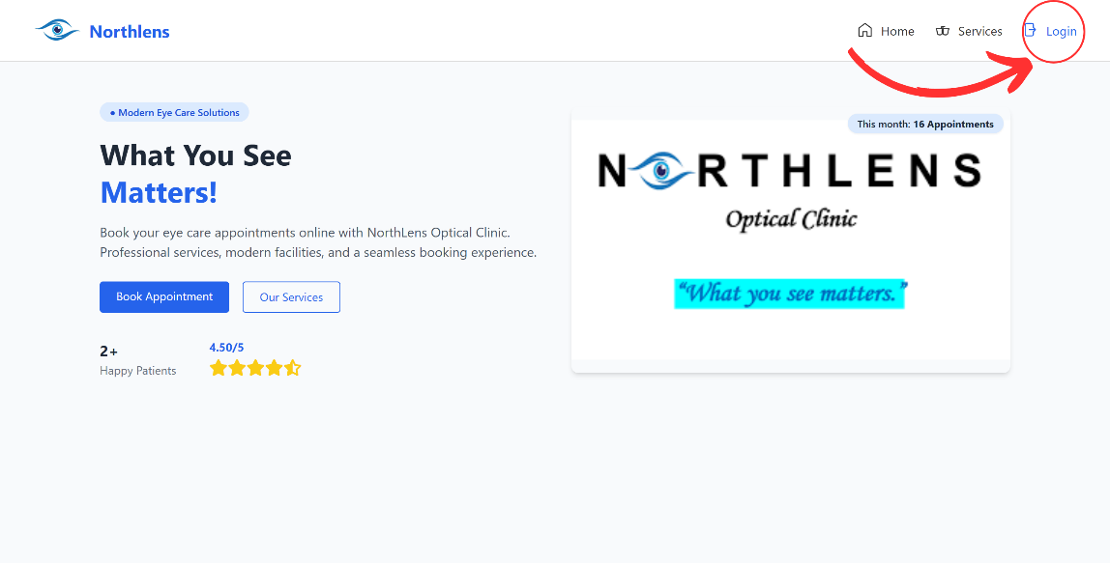
A. How to Login?

Figure 10.1. LandingPage
- Search the link of the system ( https://northlens.free.nf/ )
- Click Login → to login or signup an account.
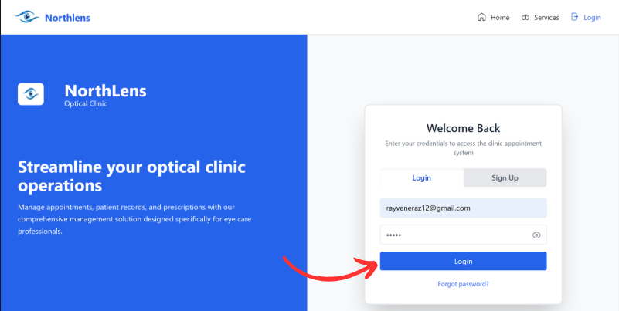

Figure 10.2. Login as Patient
- Enter the patient credentials:
  - Username: rayvene@gmail.com
  - Password: reben
- Click Login → redirected to LandingPage
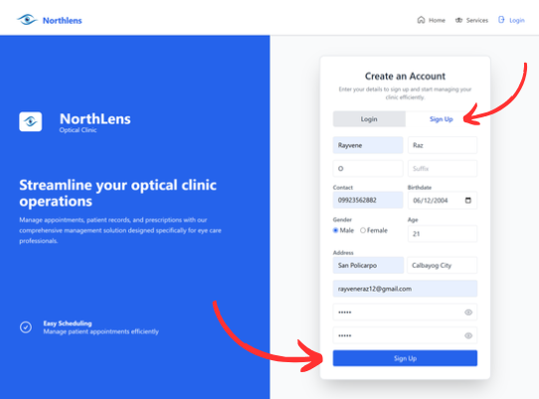

Figure 10.3. Signup for creating account
- Click SignUp → for creating account.
- Enter Patient Credentials:
- Enter FirstName / LastName / Middle I. / Suffix
- Enter Contact Number
- Enter Birthdate
- Choose Gender
- Enter Address
- Enter Email Address
- Enter Password / Confirm Password
- Click SignUp → redirected to LandingPage

B. How to Book your Services?
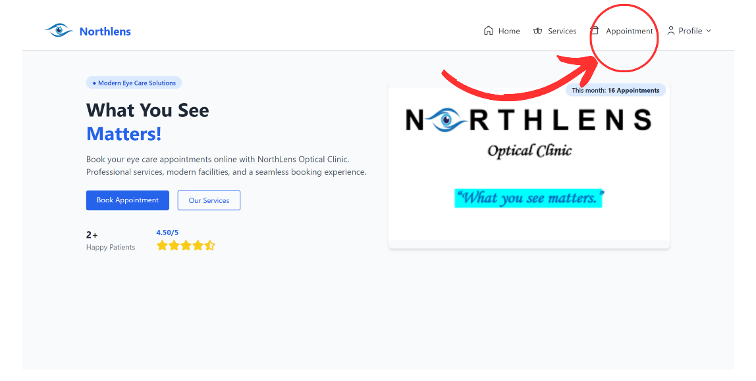

Figure 11.1. Appointment
- Click Appointment
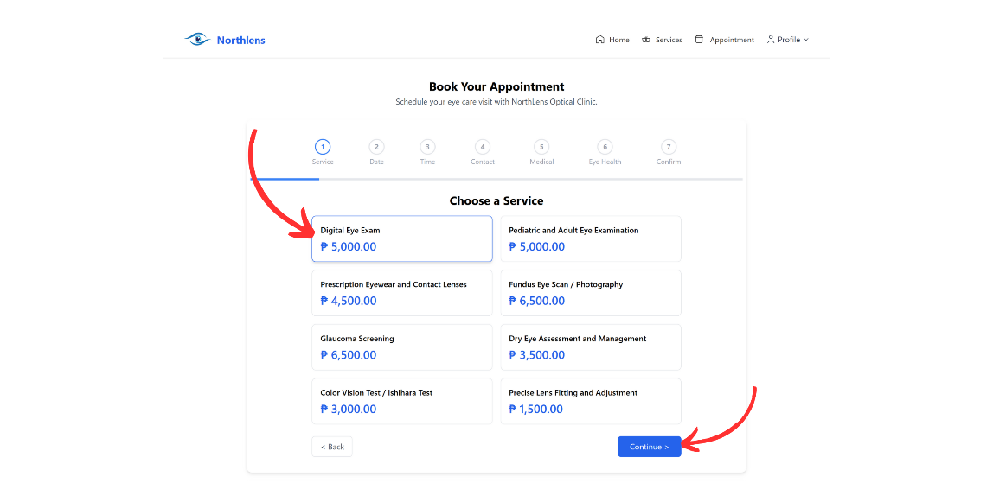

Figure 11.2. Choose Services
- Click to Choose Services
- Click Continue

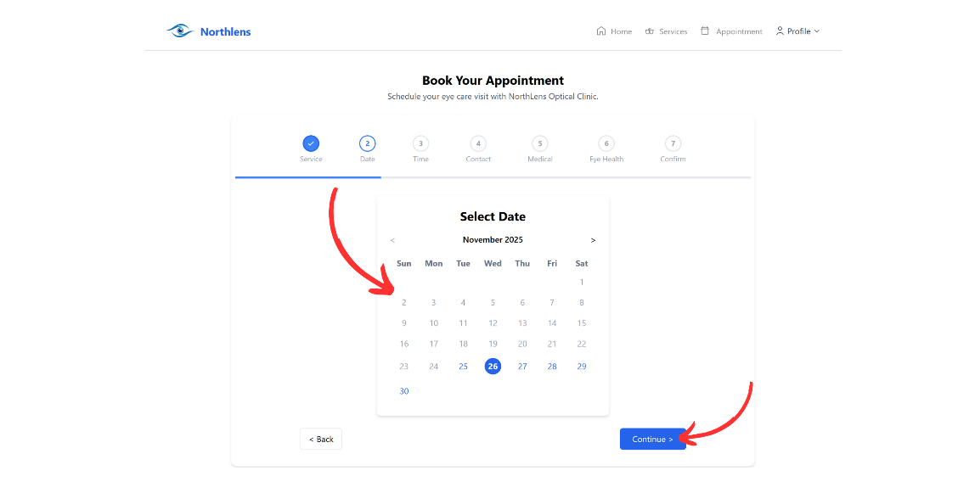

Figure 11.3. Choose Date
- Click to Choose Date
- Click Continue
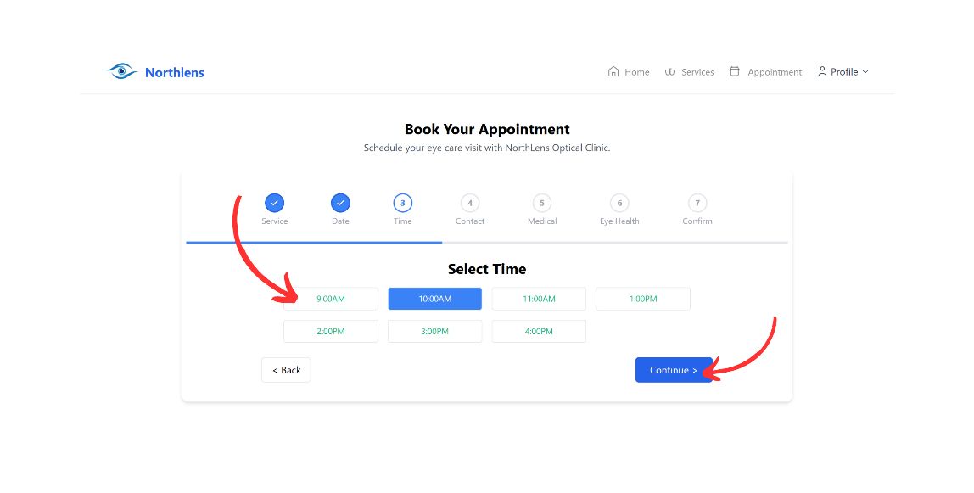

Figure 11.4. Choose Time
- Click to Choose Time
- Click Continue

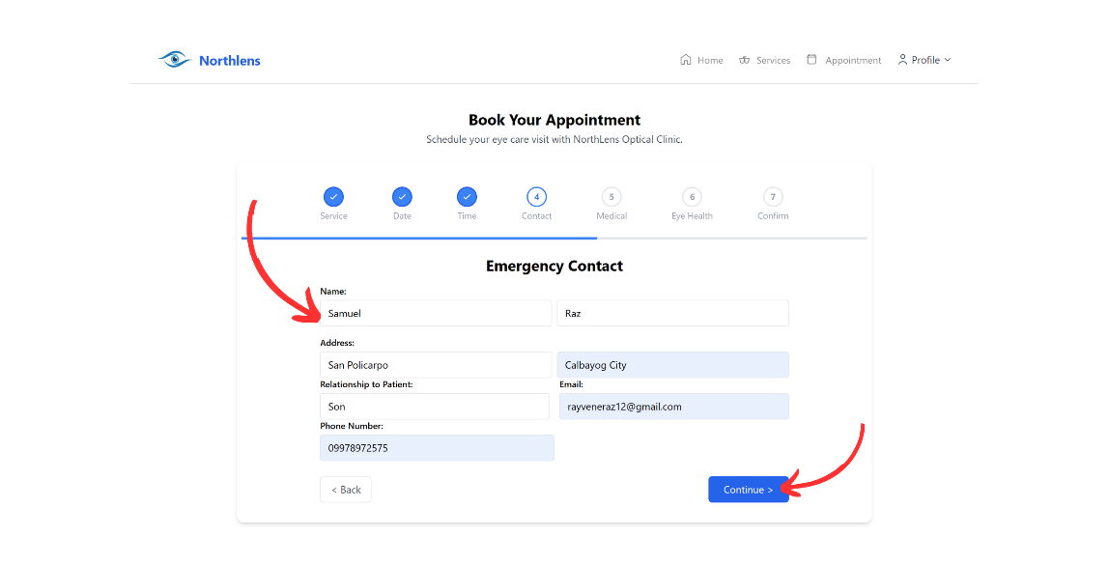

Figure 11.5. Emergency Contact
- Enter FirstName / LastName
- Enter Address
- Enter Relationship to Patient
- Enter Email
- Enter Phone Number
- Click Continue
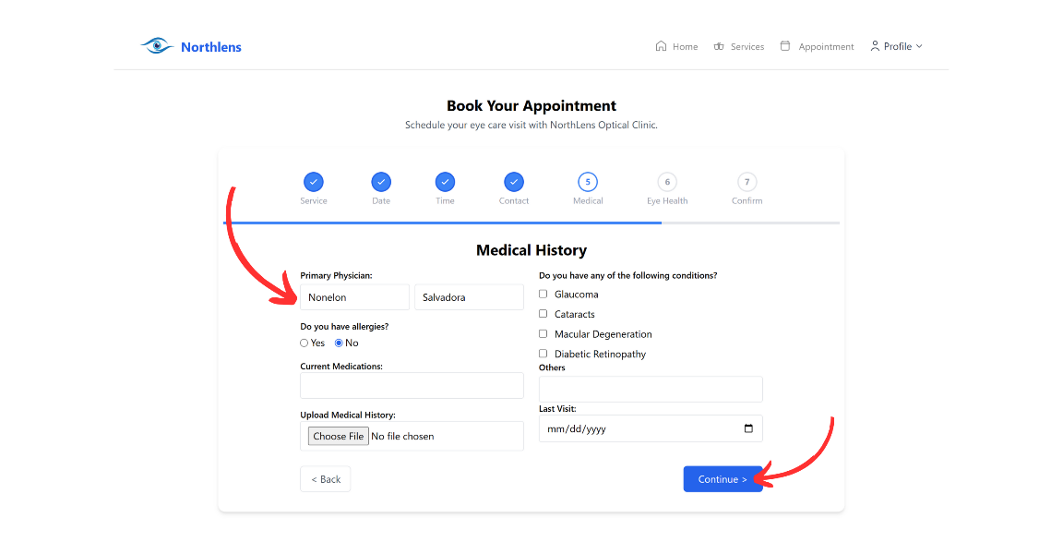

Figure 11.6. Medical History
- Enter Primary Physician
- Choose If you have Allergies
- Enter Current Medications
- Upload Medical History
- Choose If you have any Conditions
- Enter Others
- Select Date → Last Visit
- Click Continue
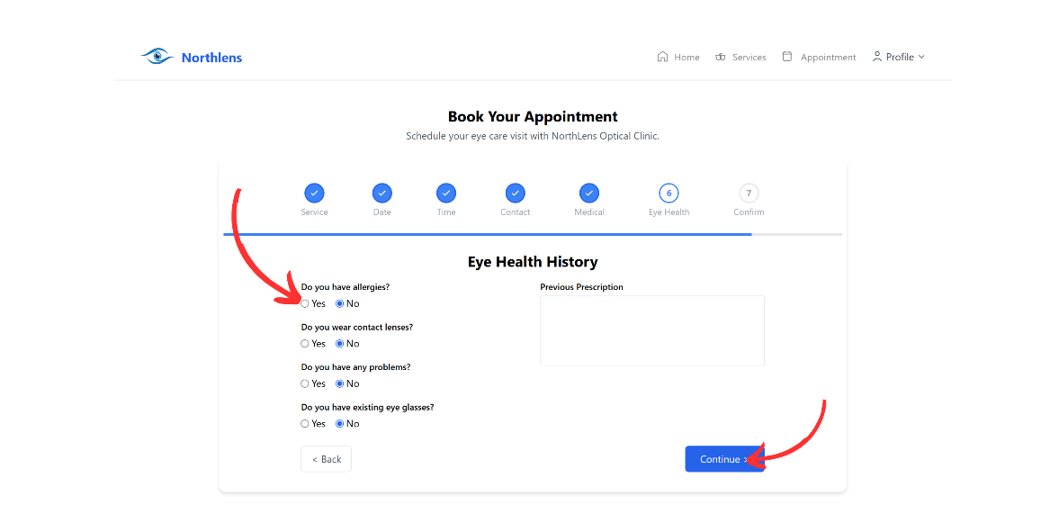

Figure 11.7. Eye Health History
- Choose If you have Allergies
- Choose If you wear Contact Lenses
- Choose If you have any Problems
- Choose If you have Existing Glasses
- Enter Previous Prescription
- Click Continue

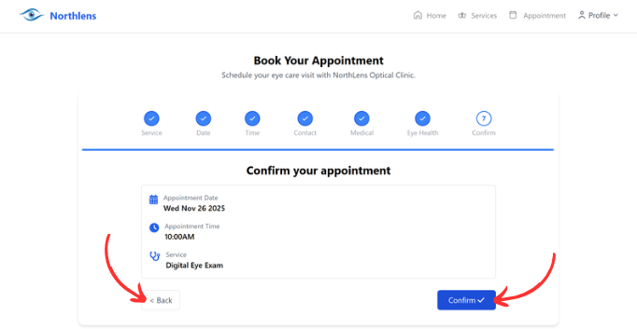

Figure 11.8. Confirmation of Appointment
- Click Back → if you have changes
- Click Confirm
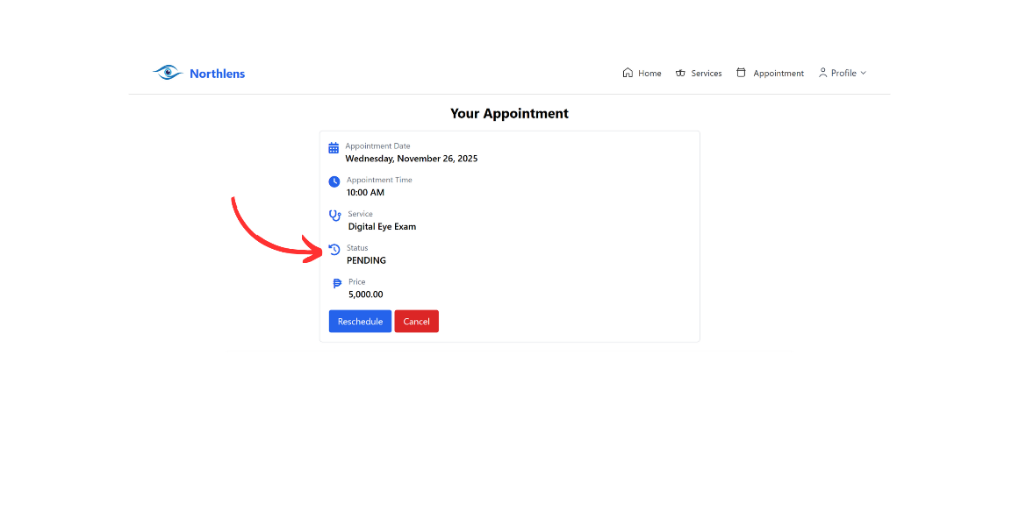
C. How to see your appointment was approved?

Figure 12.1. Pending Status

- See Status
- Click Reschedule → if you want to reschedule your appointment
- Click Cancel → if you want to cancel your appointment
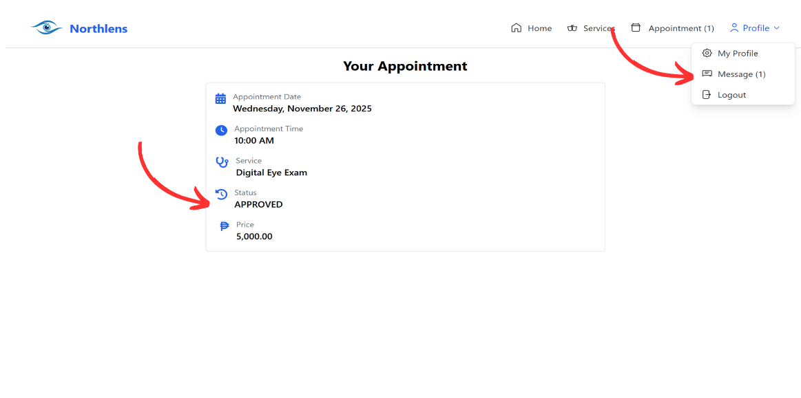

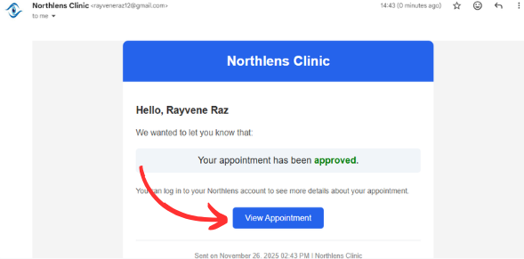

Figure 12.2. Approved Status
- See Status
- Click Message → to see message for approved / cancelled
- Click View Appointment → return to appointment

D. Admin Login
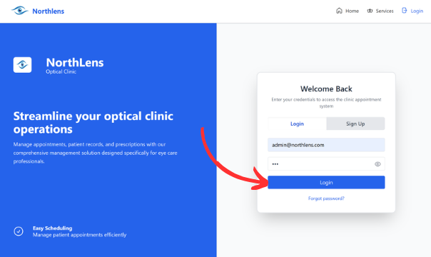

Figure 13. Login as Admin
- Enter Admin Credentials
- Username: admin@northlens.com
- Password: 123
- Click Login → redirected to admin page
E. Admin Page
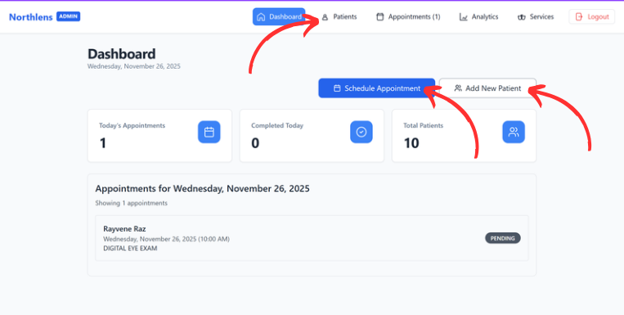

Figure 14.1. Admin Dashboard
- Click Schedule Appointment → to schedule new appointment for patient
- Click Add New Patient → to add new patient
- Click Patient → to see all patients information
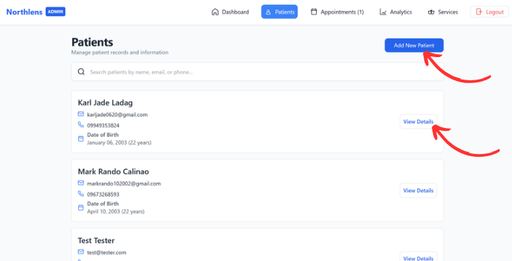

Figure 14.2. Details of Patients
- Click Add New Patient → to add new patient
- Click View Details → to view patient information
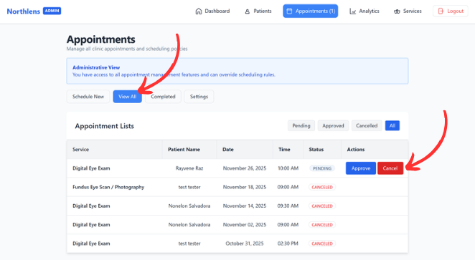

Figure 14.3. Actions for Appointment

- Click Schedule New → to schedule new appointments
- Click View All → to view all appointments
- Click Approve or Cancel → to approve or cancel appointments
- Click Completed → to see all completed appointments
- Click Settings → to change admin personal information

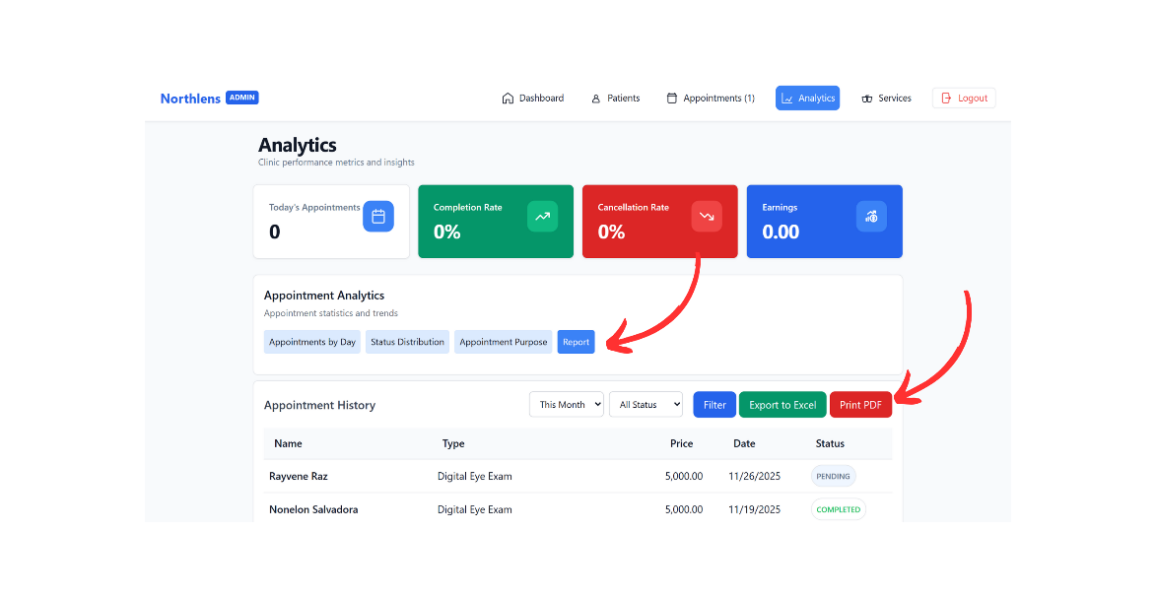

Figure 14.4. Analytics
- Click Reports → to view all reports in appointments
- Click Print PDF → to print all reports

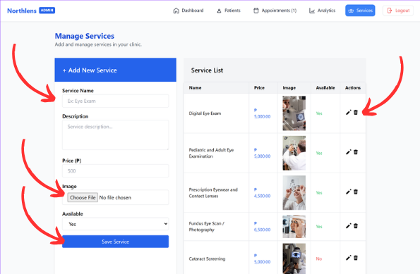

Figure 14.5. Manage Services

- Enter Service Name / Description / Price
- Click Choose File → to choose picture for the service
- Click Available → to choose if yes or not available
- Click Save Service → to save services
- Click Edit or Delete → to make changes for service

Appendix C
Certificate of Proofreading



Appendix D
Certificate of Originality



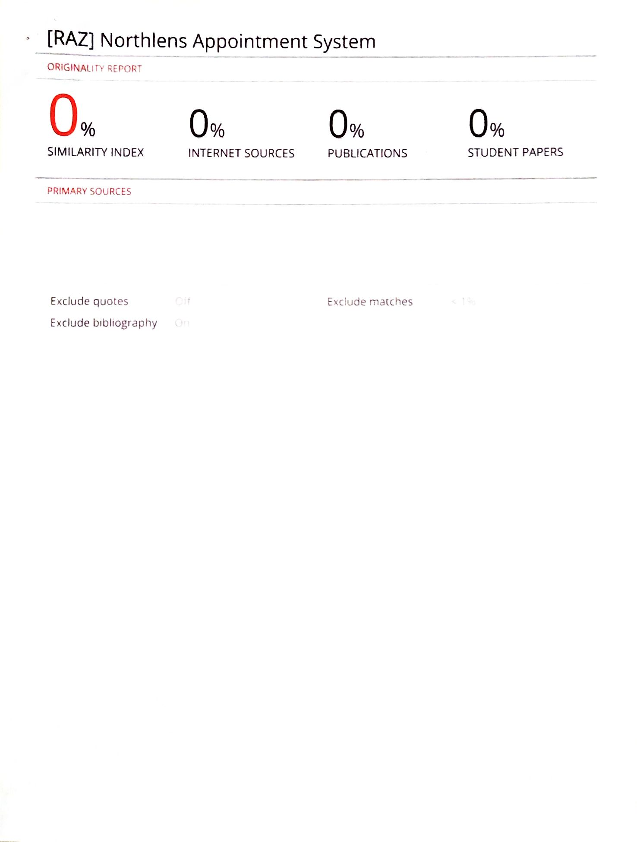

Appendix E
Certificate of Acceptance

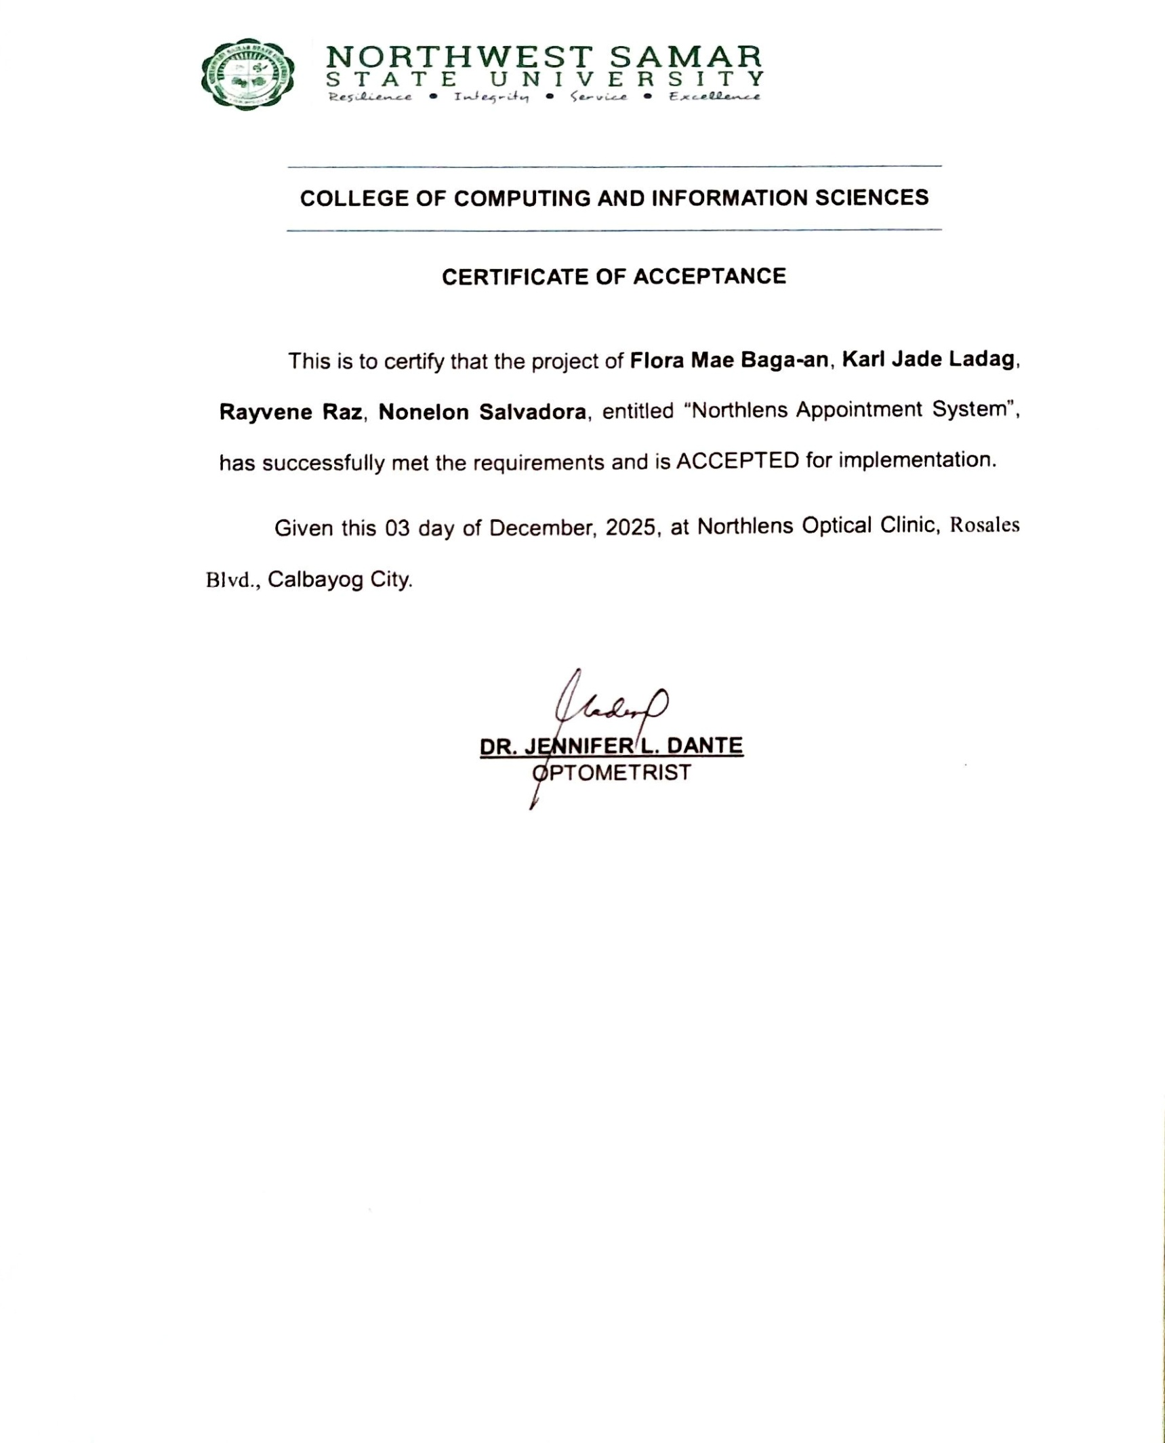

Appendix F
Curriculum Vitae

 | RAYVENE O. RAZ  SYSTEM DESIGNER AND PROGRAMMER
PERSONAL DATA:
Date of Birth:  Place of Birth:  Address:  Religion:  Contact Number:  Email: | June 12, 2004  San Policarpo, Calbayog City, Samar  Purok 10, Rubante St., San Policarpo, Calbayog City  Roman Catholic  09923562882  rayveneraz12@gmail.com
EDUCATIONAL BACKGROUND:
Primary:  Secondary:  Junior High School:  Senior High School:  Tertiary:  BASIC SKILLS: | San Policarpo Central Elementary School  San Policarpo National High School  San Policarpo National High School  Northwest Samar State University
Web Design and UI/UX Principles
Programming Language (HTML, CSS, JavaScript, MySQL)
Computer Service System

 | NONELON C. SALVADORA  SYSTEM ANALYST AND RESEARCHER
PERSONAL DATA:
Date of Birth:  Place of Birth:  Address:  Religion:  Contact Number:  Email: | September 9, 2004  Marcatubig, Calbayog City, Samar  Purok 4, Brgy. Marcatubig, Calbayog City  Born Again  09355981846  nonelonsalvadora0916@gmail.com
EDUCATIONAL BACKGROUND:
Primary:  Secondary:  Junior High School:  Senior High School:  Tertiary: | Marcatubig Elementary School  Rafael Lentejas Memorial School of Fisheries  San Policarpo National High School  Northwest Samar State University
BASIC SKILLS:
Computer Literate
Basic Troubleshooting
Microsoft Office (Word, Excel, PowerPoint)

 | KARL JADE LADAG  SYSTEM ANALYST AND RESEARCHER
PERSONAL DATA:
Date of Birth:  Place of Birth:  Address:  Religion:  Contact Number:  Email: | January 6, 2003  Calbayog City, Samar  Purok 6, Brgy. Carayman, Calbayog City  Roman Catholic  09755920737  karljad0620@gmail.com
EDUCATIONAL BACKGROUND:
Primary:  Secondary:  Junior High School:  Senior High School:  Tertiary:  BASIC SKILLS: | Carayman Elementary School  Sta. Margarita National High School  Sta. Margarita National High School  Northwest Samar State University
Computer Literate
Microsoft Office (Word, Excel, PowerPoint)

 | FLORA MAE P.  BAGA-AN  PROJECT MANAGER AND RESEARCHER
PERSONAL DATA:
Date of Birth:  Place of Birth:  Address:  Religion:  Contact Number:  Email: | November 2, 2003  San Policarpo, Calbayog City, Samar  Brgy. Cahumpan, Calbayog City  Roman Catholic  09945347535  floramaebagaan@gmail.com
EDUCATIONAL BACKGROUND:
Primary:  Secondary:  Junior High School:  Senior High School:  Tertiary:  BASIC SKILLS: | Cahumpan Elementary School  Trinidad National High School  Trinidad National High School  Northwest Samar State University
Computer Literate
Microsoft Office (Word, Excel, PowerPoint)

