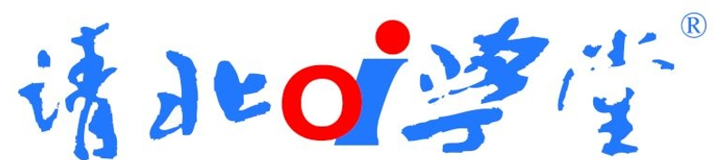

**版权声明：本次课程直播及回放版权属北京清北学堂教育科技有限公司所有**。

**课程回放操作说明**

1. 回放时间安排：购买之日起观看时限不超过2个月，回放功能自动关闭。

2. 账号密码：账号：姓名；密码：手机号。清北学员课后交流答疑群72716362（每周固定时间教研老师答疑，详见群公告）；遇到考试、作业等的请依照视频文件》《题库如何注册机领取权限》在题库noip.ac直接题库自行建立虚拟考试进行考试以及做练习题。

步骤一：PC端（建议使用chrome浏览器）复制下方对应课程日期的链接。若手机端用手机扫描二维码，跳转至登录页面

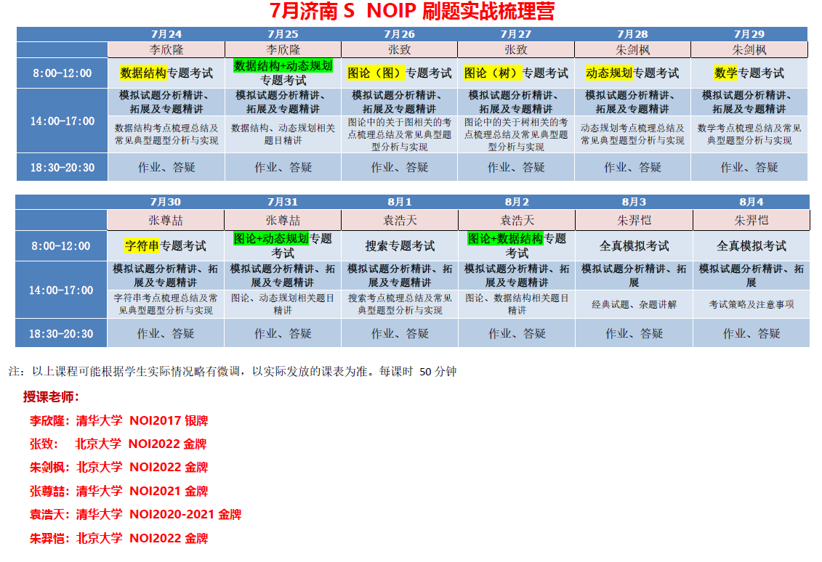

步骤二：.输入直播课程的账号密码，登录即可观看

注意：如学生看不清教师头像，或**老师写代码时**，可移动鼠标至摄像头或右下方，点击右下角放大，切换至全屏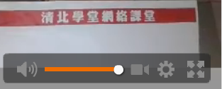

3、回放网址及二维码

|  |  |
| --- | --- |
| **日期内容** | **对应课程日期的链接** |
| 2023-07-24 13:42:18 2023-07-24 17:01:07 | https://view.csslcloud.net/api/view/callback?roomid=AE9DA033D054CC0D9C33DC5901307461&userid=068A5B0B59D5CDBC&recordid=1EB10F9438E910199C33DC5901307461&liveid=012BE50C4D18C93A9C33DC5901307461 |
| 2023-07-25 13:52:12 2023-07-25 17:04:15 | https://view.csslcloud.net/api/view/callback?roomid=AE9DA033D054CC0D9C33DC5901307461&userid=068A5B0B59D5CDBC&recordid=331D9053D17EE5339C33DC5901307461&liveid=B2F6003E8F88054A9C33DC5901307461 |
| 2023-07-26 13:50:48 2023-07-26 16:53:12 | https://view.csslcloud.net/api/view/callback?roomid=AE9DA033D054CC0D9C33DC5901307461&userid=068A5B0B59D5CDBC&recordid=9B068166A046B6F69C33DC5901307461&liveid=1EE14C2F7DBECE969C33DC5901307461 |
| 2023-07-26 16:55:18 2023-07-26 17:00:13 | https://view.csslcloud.net/api/view/callback?roomid=AE9DA033D054CC0D9C33DC5901307461&userid=068A5B0B59D5CDBC&recordid=06C4F82E8581574C9C33DC5901307461&liveid=1276BC95CAF57FDE9C33DC5901307461 |
| 2023-07-27 13:53:26 2023-07-27 17:02:16 | https://view.csslcloud.net/api/view/callback?roomid=AE9DA033D054CC0D9C33DC5901307461&userid=068A5B0B59D5CDBC&recordid=CB709AB6626CDD6D9C33DC5901307461&liveid=6E739F43DF8001609C33DC5901307461 |
| 2023-07-28 13:50:28 2023-07-28 17:04:18 | https://view.csslcloud.net/api/view/callback?roomid=AE9DA033D054CC0D9C33DC5901307461&userid=068A5B0B59D5CDBC&recordid=A2006FA69AAFD9549C33DC5901307461&liveid=6131B325C63ACCE39C33DC5901307461 |
| 2023-07-29 13:50:20 2023-07-29 17:03:54 | https://view.csslcloud.net/api/view/callback?roomid=AE9DA033D054CC0D9C33DC5901307461&userid=068A5B0B59D5CDBC&recordid=B5FC77AEAE46F3969C33DC5901307461&liveid=8C13D02F648EEA9B9C33DC5901307461 |
| 2023-07-30 13:50:36 2023-07-30 17:05:05 | https://view.csslcloud.net/api/view/callback?roomid=AE9DA033D054CC0D9C33DC5901307461&userid=068A5B0B59D5CDBC&recordid=08F7DA752BDBCF7E9C33DC5901307461&liveid=71396FC9C38485BD9C33DC5901307461 |
| 2023-07-30 18:21:45 2023-07-30 19:39:08 | https://view.csslcloud.net/api/view/callback?roomid=AE9DA033D054CC0D9C33DC5901307461&userid=068A5B0B59D5CDBC&recordid=4D0400A77A30EA749C33DC5901307461&liveid=05210B62ECB36DE69C33DC5901307461 |
| 2023-07-31 14:45:21 2023-07-31 17:06:36 | https://view.csslcloud.net/api/view/callback?roomid=AE9DA033D054CC0D9C33DC5901307461&userid=068A5B0B59D5CDBC&recordid=484C568CB19938A09C33DC5901307461&liveid=0DD9DBFE145042009C33DC5901307461 |
| 2023-07-31 18:22:11 2023-07-31 19:44:32 | https://view.csslcloud.net/api/view/callback?roomid=AE9DA033D054CC0D9C33DC5901307461&userid=068A5B0B59D5CDBC&recordid=399B9CF547BB28549C33DC5901307461&liveid=EC5F4AE486A41B679C33DC5901307461 |
| 2023-08-01 13:50:13 2023-08-01 17:00:06 | https://view.csslcloud.net/api/view/callback?roomid=AE9DA033D054CC0D9C33DC5901307461&userid=068A5B0B59D5CDBC&recordid=38DDF5F1C34CADF99C33DC5901307461&liveid=997F3275E9275D3A9C33DC5901307461 |
| 2023-08-02 13:47:45 2023-08-02 17:02:20 | https://view.csslcloud.net/api/view/callback?roomid=AE9DA033D054CC0D9C33DC5901307461&userid=068A5B0B59D5CDBC&recordid=D9FCA111F50D712A9C33DC5901307461&liveid=FFC92CB0CB230A8C9C33DC5901307461 |
| 2023-08-03 13:47:48 2023-08-03 17:04:11 | https://view.csslcloud.net/api/view/callback?roomid=AE9DA033D054CC0D9C33DC5901307461&userid=068A5B0B59D5CDBC&recordid=30C05464918BFB0E9C33DC5901307461&liveid=DC4819E0EB69FA839C33DC5901307461 |
| 2023-08-03 18:18:29 2023-08-03 18:50:13 | https://view.csslcloud.net/api/view/callback?roomid=AE9DA033D054CC0D9C33DC5901307461&userid=068A5B0B59D5CDBC&recordid=298683F0BB6B61FD9C33DC5901307461&liveid=AB0A2F0E1C06AC409C33DC5901307461 |
| 2023-08-04 12:50:41 2023-08-04 16:00:43 | https://view.csslcloud.net/api/view/callback?roomid=AE9DA033D054CC0D9C33DC5901307461&userid=068A5B0B59D5CDBC&recordid=572E709C4BF4873E9C33DC5901307461&liveid=070E7EA8AF3F1B3C9C33DC5901307461 |
|  |  |
|  |  |
|  |  |
|  |  |
|  |  |
|  |  |