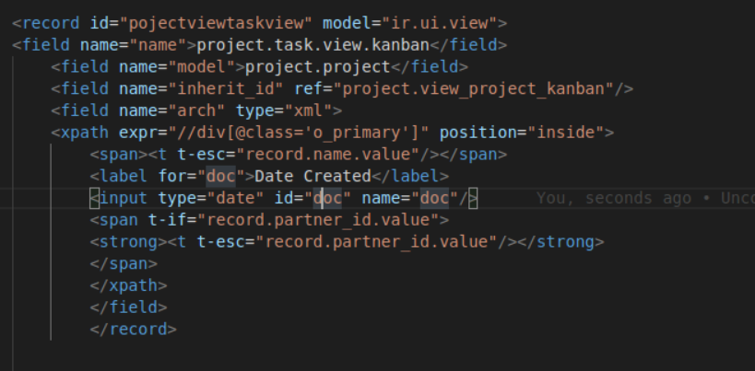

Record id must be unique .. model from were u are taking .. name can be anything .. in xpath from were u are taking it will come .. and then write what u want to see

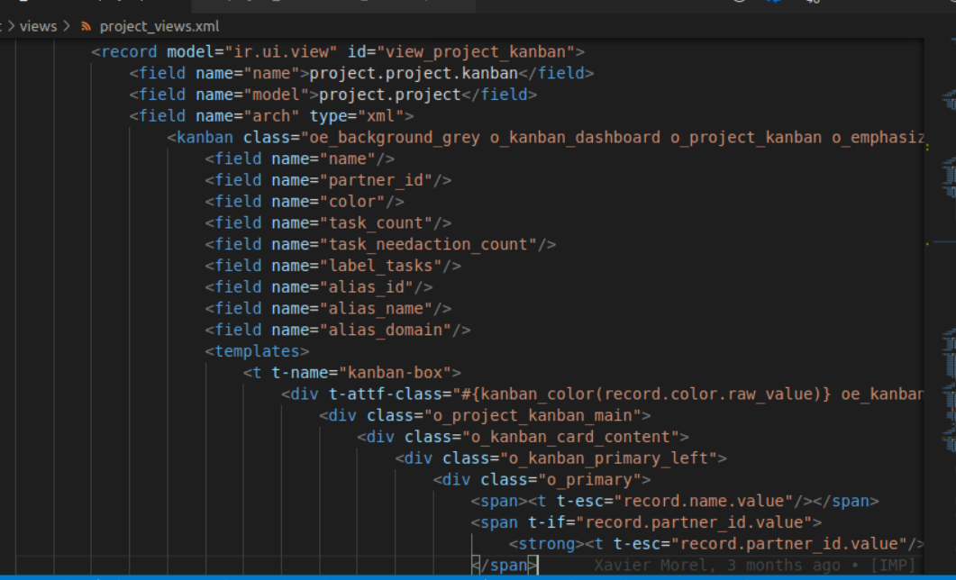

For reference can see both image