import pandas as pd
import numpy as np
import seaborn as sns
import matplotlib.pyplot as plt
import warnings
warnings.filterwarnings(action="ignore")
from sklearn.model_selection import train_test_split
from sklearn.neighbors import KNeighborsClassifier
from sklearn.metrics import accuracy_score, classification_report
from sklearn.model_selection import RepeatedStratifiedKFold, StratifiedKFold
from imblearn.over_sampling import SMOTE
from imblearn.over_sampling import ADASYN
from sklearn.metrics import roc_curve, auc
from sklearn.metrics import ConfusionMatrixDisplay
from sklearn import metrics
from sklearn.metrics import confusion_matrix
from sklearn.metrics import ConfusionMatrixDisplay
from sklearn.datasets import make_classification
from sklearn.metrics import accuracy_score, precision_score, recall_score, f1_score
#importing data from the dataset
df = pd.read_csv(r"C:\Users\agarw\OneDrive\Desktop\Dissertation\data.csv")
#checking for bankrupt companies 0 is non-bankrupt and 1 is bankrupt
bankrupt_data = df['Bankrupt?'].value_counts()
bankrupt_data
Bankrupt?
0 6599
1 220
Name: count, dtype: int64
#Distribution representation
plt.figure(figsize = (10,5))
colors = ["#3498db", "#e74c3c"]
ax = sns.countplot(x=df['Bankrupt?'], data=df,palette=colors)
for p in ax.patches:
ax.annotate(f'{p.get_height()}', (p.get_x() + p.get_width() / 2., p.get_height()),
ha='center', va='center', xytext=(0, 10), textcoords='offset points')
# Add labels and title
plt.xlabel('Bankrupt')
plt.ylabel('Count')
plt.title('Distribution of Bankrupt')
# Show the plot
plt.show()
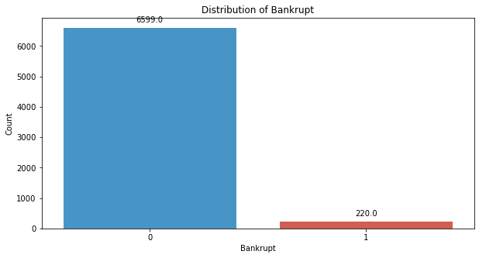
# seperate the Bankrupt label from the dataset
y = df['Bankrupt?']
X = df.drop(['Bankrupt?'], axis = 1)
# divinding our dataset into training dataset
X_train, X_temp, y_train, y_temp = train_test_split(X, y, test_size=0.3, random_state=42)
#Distribution representation
plt.figure(figsize = (10,5))
colors = ["#3498db", "#e74c3c"]
ax = sns.countplot(x=y_train, data=df,palette=colors)
for p in ax.patches:
ax.annotate(f'{p.get_height()}', (p.get_x() + p.get_width() / 2., p.get_height()),
ha='center', va='center', xytext=(0, 10), textcoords='offset points')
# Add labels and title
plt.xlabel('Bankrupt')
plt.ylabel('Count')
plt.title('Distribution of Bankrupt')
# Show the plot
plt.show()
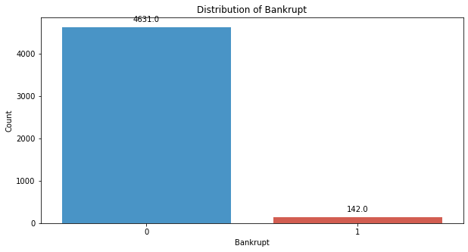
# divinding our dataset into testing and validation
X_val, X_test, y_val, y_test = train_test_split(X_temp, y_temp, test_size=0.5, random_state=42)
k_values = range(1, 10)
# Initialize lists to store accuracy scores for each K
f1_scores = []
# Iterate through different values of K
for k in k_values:
knn_classifier = KNeighborsClassifier(n_neighbors=k)
knn_classifier.fit(X_train, y_train)
y_val_pred = knn_classifier.predict(X_val)
f1_value = f1_score(y_val, y_val_pred)
f1_scores.append(f1_value)
# Plot the results to find the "elbow"
plt.figure(figsize=(10, 6))
plt.plot(k_values, f1_scores, marker='o', linestyle='-')
plt.title("K-NN Accuracy vs. Number of Neighbors (K)")
plt.xlabel("Number of Neighbors (K)")
plt.ylabel("F1 Score")
plt.grid(True)
plt.show()
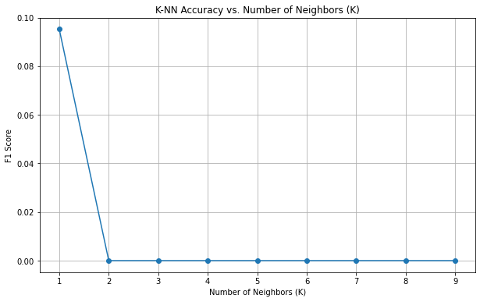
k = 1
knn_classifier = KNeighborsClassifier(n_neighbors=k)
# Step 4: Train the classifier on the training data
knn_classifier.fit(X_train, y_train)
KNeighborsClassifier(n_neighbors=1)
# Step 5: Predict on the validation data
y_val_pred = knn_classifier.predict(X_val)
# Step 6: Evaluate the model on the validation data
validation_accuracy = accuracy_score(y_val, y_val_pred)
print("Validation Accuracy:", validation_accuracy)
Validation Accuracy: 0.9442815249266863
conf_matrix_validation = confusion_matrix(y_val, y_val_pred)
print("Confusion matrix")
print(conf_matrix_validation)
Confusion matrix
[[963 21]
[ 36 3]]
TN, FP, FN, TP = conf_matrix_validation.ravel()
accuracy = (TP + TN) / (TP + TN + FP + FN)
precision = TP / (TP + FP)
recall = TP / (TP + FN)
f1_score = 2 * (precision * recall) / (precision + recall)
# Display other metrics
print(f"Accuracy: {accuracy:.2f}")
print(f"Precision: {precision:.2f}")
print(f"Recall: {recall:.2f}")
print(f"F1 Score: {f1_score:.2f}")
Accuracy: 0.94
Precision: 0.12
Recall: 0.08
F1 Score: 0.10
# Step 7: Predict on the testing data
y_test_pred = knn_classifier.predict(X_test)
# Step 8: Evaluate the model on the testing data
test_accuracy = accuracy_score(y_test, y_test_pred)
print("Testing Accuracy:", test_accuracy)
Testing Accuracy: 0.9423264907135875
conf_matrix_testing = confusion_matrix(y_test, y_test_pred)
print("Confusion matrix")
print(conf_matrix_testing)
Confusion matrix
[[961 23]
[ 36 3]]
TN, FP, FN, TP = conf_matrix_testing.ravel()
accuracy = (TP + TN) / (TP + TN + FP + FN)
precision = TP / (TP + FP)
recall = TP / (TP + FN)
f1_score = 2 * (precision * recall) / (precision + recall)
# Display other metrics
print(f"Accuracy: {accuracy:.2f}")
print(f"Precision: {precision:.2f}")
print(f"Recall: {recall:.2f}")
print(f"F1 Score: {f1_score:.2f}")
Accuracy: 0.94
Precision: 0.12
Recall: 0.08
F1 Score: 0.09
# Compute ROC curve and ROC area for each class
fpr_val, tpr_val, _ = roc_curve(y_val, y_val_pred)
roc_auc_val = auc(fpr_val, tpr_val)
fpr_test, tpr_test, _ = roc_curve(y_test, y_test_pred)
roc_auc_test = auc(fpr_test, tpr_test)
# Plot ROC curve
plt.figure(figsize=(8, 8))
plt.plot(fpr_val, tpr_val, color='darkorange', lw=2, label=f'Validation ROC curve (area = {roc_auc_val:.2f})')
plt.plot(fpr_test, tpr_test, color='green', lw=2, label=f'Test ROC curve (area = {roc_auc_test:.2f})')
plt.plot([0, 1], [0, 1], color='navy', lw=2, linestyle='--')
plt.xlim([0.0, 1.0])
plt.ylim([0.0, 1.05])
plt.xlabel('False Positive Rate')
plt.ylabel('True Positive Rate')
plt.title('Receiver Operating Characteristic (ROC) Curve')
plt.legend(loc="lower right")
plt.show()
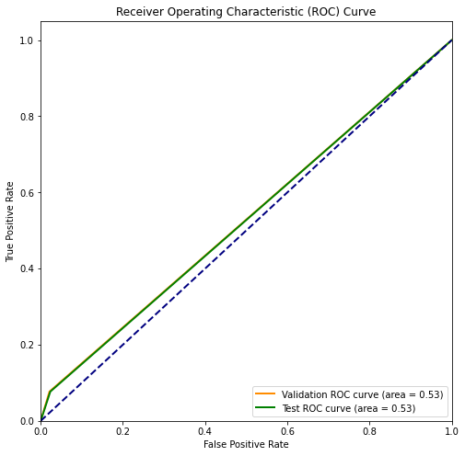
# divinding our dataset into training dataset
X_train_smote, X_temp_smote, y_train_smote, y_temp_smote = train_test_split(X, y, test_size=0.3, random_state=42)
X_val_smote, X_test_smote, y_val_smote, y_test_smote = train_test_split(X_temp_smote, y_temp_smote, test_size=0.5, random_state=42)
smote = SMOTE(sampling_strategy=1, random_state=42)
X_resampled_smote, y_resampled_smote = smote.fit_resample(X_train_smote, y_train_smote)
#Distribution representation
plt.figure(figsize = (10,5))
colors = ["#3498db", "#e74c3c"]
ax = sns.countplot(x=y_resampled_smote, data=df,palette=colors)
for p in ax.patches:
ax.annotate(f'{p.get_height()}', (p.get_x() + p.get_width() / 2., p.get_height()),
ha='center', va='center', xytext=(0, 10), textcoords='offset points')
# Add labels and title
plt.xlabel('Bankrupt')
plt.ylabel('Count')
plt.title('Distribution of Bankrupt')
# Show the plot
plt.show()
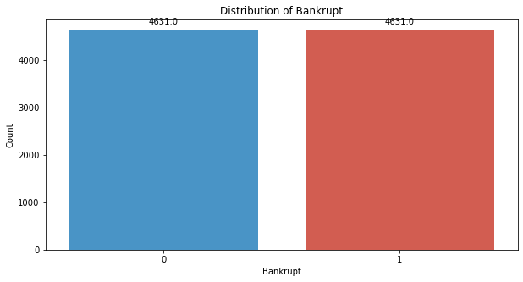
k_values = range(1, 18)
# Initialize lists to store accuracy scores for each K
f1_scores = []
# Iterate through different values of K
for k in k_values:
knn_classifier = KNeighborsClassifier(n_neighbors=k)
knn_classifier.fit(X_resampled_smote, y_resampled_smote)
y_val_pred_smote = knn_classifier.predict(X_val_smote)
f1_value = metrics.f1_score(y_val_smote, y_val_pred_smote)
f1_scores.append(f1_value)
# Plot the results to find the "elbow"
plt.figure(figsize=(10, 6))
plt.plot(k_values, f1_scores, marker='o', linestyle='-')
plt.title("K-NN F1 score vs. Number of Neighbors (K)")
plt.xlabel("Number of Neighbors (K)")
plt.ylabel("F1 Score")
plt.grid(True)
plt.show()
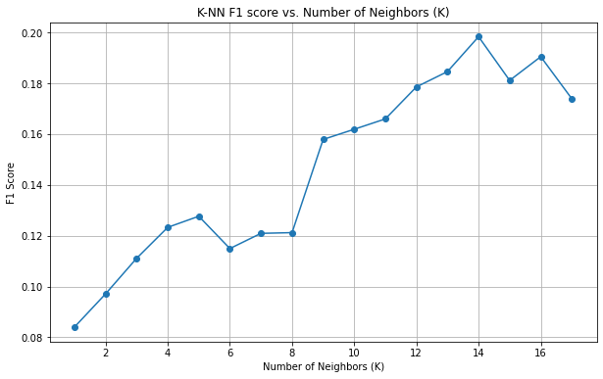
k = 14
knn_classifier_smote = KNeighborsClassifier(n_neighbors=k)
knn_classifier_smote.fit(X_resampled_smote, y_resampled_smote)
KNeighborsClassifier(n_neighbors=14)
y_val_pred_smote = knn_classifier_smote.predict(X_val_smote)
validation_accuracy = accuracy_score(y_val_smote, y_val_pred_smote)
print("Validation Accuracy:", validation_accuracy)
Validation Accuracy: 0.8103616813294232
conf_matrix_validation = confusion_matrix(y_val_smote, y_val_pred_smote)
print("Confusion matrix")
print(conf_matrix_validation)
Confusion matrix
[[805 179]
[ 15 24]]
TN, FP, FN, TP = conf_matrix_validation.ravel()
accuracy = (TP + TN) / (TP + TN + FP + FN)
precision = TP / (TP + FP)
recall = TP / (TP + FN)
f1_score = 2 * (precision * recall) / (precision + recall)
# Display other metrics
print(f"Accuracy: {accuracy:.2f}")
print(f"Precision: {precision:.2f}")
print(f"Recall: {recall:.2f}")
print(f"F1 Score: {f1_score:.2f}")
Accuracy: 0.81
Precision: 0.12
Recall: 0.62
F1 Score: 0.20
y_test_pred_smote = knn_classifier_smote.predict(X_test_smote)
test_accuracy = accuracy_score(y_test_smote, y_test_pred_smote)
print("Testing Accuracy:", test_accuracy)
Testing Accuracy: 0.8015640273704789
conf_matrix_testing = confusion_matrix(y_test_smote, y_test_pred_smote)
print("Confusion matrix")
print(conf_matrix_testing)
Confusion matrix
[[803 181]
[ 22 17]]
TN, FP, FN, TP = conf_matrix_testing.ravel()
accuracy = (TP + TN) / (TP + TN + FP + FN)
precision = TP / (TP + FP)
recall = TP / (TP + FN)
f1_score = 2 * (precision * recall) / (precision + recall)
# Display other metrics
print(f"Accuracy: {accuracy:.2f}")
print(f"Precision: {precision:.2f}")
print(f"Recall: {recall:.2f}")
print(f"F1 Score: {f1_score:.2f}")
Accuracy: 0.80
Precision: 0.09
Recall: 0.44
F1 Score: 0.14
# Compute ROC curve and ROC area for each class
fpr_val, tpr_val, _ = roc_curve(y_val_smote, y_val_pred_smote)
roc_auc_val = auc(fpr_val, tpr_val)
fpr_test, tpr_test, _ = roc_curve(y_test_smote, y_test_pred_smote)
roc_auc_test = auc(fpr_test, tpr_test)
# Plot ROC curve
plt.figure(figsize=(8, 8))
plt.plot(fpr_val, tpr_val, color='darkorange', lw=2, label=f'Validation ROC curve (area = {roc_auc_val:.2f})')
plt.plot(fpr_test, tpr_test, color='green', lw=2, label=f'Test ROC curve (area = {roc_auc_test:.2f})')
plt.plot([0, 1], [0, 1], color='navy', lw=2, linestyle='--')
plt.xlim([0.0, 1.0])
plt.ylim([0.0, 1.05])
plt.xlabel('False Positive Rate')
plt.ylabel('True Positive Rate')
plt.title('Receiver Operating Characteristic (ROC) Curve')
plt.legend(loc="lower right")
plt.show()
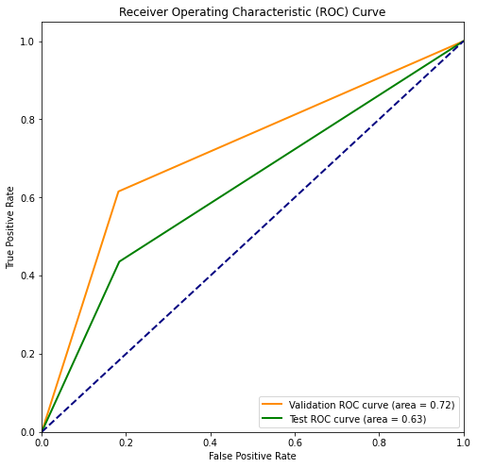
# divinding our dataset into training dataset
X_train_smote, X_temp_smote, y_train_smote, y_temp_smote = train_test_split(X, y, test_size=0.3, random_state=42)
X_val_smote, X_test_smote, y_val_smote, y_test_smote = train_test_split(X_temp_smote, y_temp_smote, test_size=0.5, random_state=42)
smote = SMOTE(sampling_strategy=0.5, random_state=42)
X_resampled_smote, y_resampled_smote = smote.fit_resample(X_train_smote, y_train_smote)
#Distribution representation
plt.figure(figsize = (10,5))
colors = ["#3498db", "#e74c3c"]
ax = sns.countplot(x=y_resampled_smote, data=df,palette=colors)
for p in ax.patches:
ax.annotate(f'{p.get_height()}', (p.get_x() + p.get_width() / 2., p.get_height()),
ha='center', va='center', xytext=(0, 10), textcoords='offset points')
# Add labels and title
plt.xlabel('Bankrupt')
plt.ylabel('Count')
plt.title('Distribution of Bankrupt')
# Show the plot
plt.show()
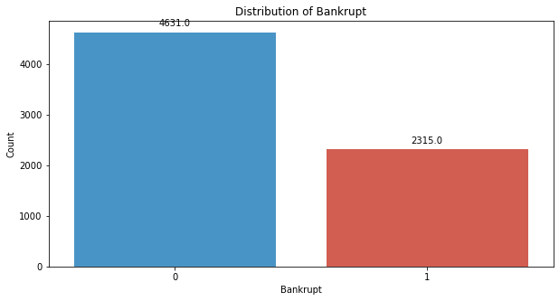
k_values = range(1, 18)
# Initialize lists to store accuracy scores for each K
f1_scores = []
# Iterate through different values of K
for k in k_values:
knn_classifier = KNeighborsClassifier(n_neighbors=k)
knn_classifier.fit(X_resampled_smote, y_resampled_smote)
y_val_pred_smote = knn_classifier.predict(X_val_smote)
f1_value = metrics.f1_score(y_val_smote, y_val_pred_smote)
f1_scores.append(f1_value)
# Plot the results to find the "elbow"
plt.figure(figsize=(10, 6))
plt.plot(k_values, f1_scores, marker='o', linestyle='-')
plt.title("K-NN F1 Score vs. Number of Neighbors (K)")
plt.xlabel("Number of Neighbors (K)")
plt.ylabel("F1 Score")
plt.grid(True)
plt.show()
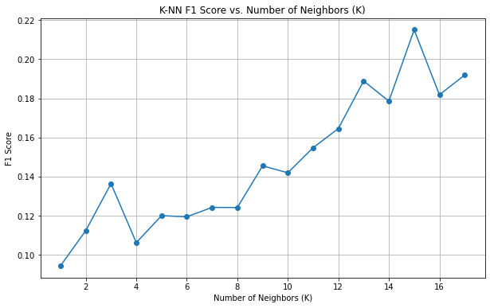
k = 15
knn_classifier_smote = KNeighborsClassifier(n_neighbors=k)
knn_classifier_smote.fit(X_resampled_smote, y_resampled_smote)
KNeighborsClassifier(n_neighbors=15)
y_val_pred_smote = knn_classifier_smote.predict(X_val_smote)
validation_accuracy = accuracy_score(y_val_smote, y_val_pred_smote)
print("Validation Accuracy:", validation_accuracy)
Validation Accuracy: 0.8572825024437928
conf_matrix_validation = confusion_matrix(y_val_smote, y_val_pred_smote)
print("Confusion matrix")
print(conf_matrix_validation)
Confusion matrix
[[857 127]
[ 19 20]]
TN, FP, FN, TP = conf_matrix_validation.ravel()
accuracy = (TP + TN) / (TP + TN + FP + FN)
precision = TP / (TP + FP)
recall = TP / (TP + FN)
f1_score = 2 * (precision * recall) / (precision + recall)
# Display other metrics
print(f"Accuracy: {accuracy:.2f}")
print(f"Precision: {precision:.2f}")
print(f"Recall: {recall:.2f}")
print(f"F1 Score: {f1_score:.2f}")
Accuracy: 0.86
Precision: 0.14
Recall: 0.51
F1 Score: 0.22
y_test_pred_smote = knn_classifier_smote.predict(X_test_smote)
test_accuracy = accuracy_score(y_test_smote, y_test_pred_smote)
print("Testing Accuracy:", test_accuracy)
Testing Accuracy: 0.855327468230694
conf_matrix_testing = confusion_matrix(y_test_smote, y_test_pred_smote)
print("Confusion matrix")
print(conf_matrix_testing)
Confusion matrix
[[863 121]
[ 27 12]]
TN, FP, FN, TP = conf_matrix_testing.ravel()
accuracy = (TP + TN) / (TP + TN + FP + FN)
precision = TP / (TP + FP)
recall = TP / (TP + FN)
f1_score = 2 * (precision * recall) / (precision + recall)
# Display other metrics
print(f"Accuracy: {accuracy:.2f}")
print(f"Precision: {precision:.2f}")
print(f"Recall: {recall:.2f}")
print(f"F1 Score: {f1_score:.2f}")
Accuracy: 0.86
Precision: 0.09
Recall: 0.31
F1 Score: 0.14
# Compute ROC curve and ROC area for each class
fpr_val, tpr_val, _ = roc_curve(y_val_smote, y_val_pred_smote)
roc_auc_val = auc(fpr_val, tpr_val)
fpr_test, tpr_test, _ = roc_curve(y_test_smote, y_test_pred_smote)
roc_auc_test = auc(fpr_test, tpr_test)
# Plot ROC curve
plt.figure(figsize=(8, 8))
plt.plot(fpr_val, tpr_val, color='darkorange', lw=2, label=f'Validation ROC curve (area = {roc_auc_val:.2f})')
plt.plot(fpr_test, tpr_test, color='green', lw=2, label=f'Test ROC curve (area = {roc_auc_test:.2f})')
plt.plot([0, 1], [0, 1], color='navy', lw=2, linestyle='--')
plt.xlim([0.0, 1.0])
plt.ylim([0.0, 1.05])
plt.xlabel('False Positive Rate')
plt.ylabel('True Positive Rate')
plt.title('Receiver Operating Characteristic (ROC) Curve')
plt.legend(loc="lower right")
plt.show()
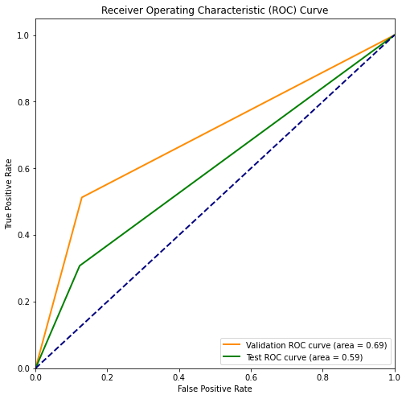
# divinding our dataset into training dataset
X_train_smote, X_temp_smote, y_train_smote, y_temp_smote = train_test_split(X, y, test_size=0.3, random_state=42)
X_val_smote, X_test_smote, y_val_smote, y_test_smote = train_test_split(X_temp_smote, y_temp_smote, test_size=0.5, random_state=42)
smote = SMOTE(sampling_strategy=0.25, random_state=42)
X_resampled_smote, y_resampled_smote = smote.fit_resample(X_train_smote, y_train_smote)
#Distribution representation
plt.figure(figsize = (10,5))
colors = ["#3498db", "#e74c3c"]
ax = sns.countplot(x=y_resampled_smote, data=df,palette=colors)
for p in ax.patches:
ax.annotate(f'{p.get_height()}', (p.get_x() + p.get_width() / 2., p.get_height()),
ha='center', va='center', xytext=(0, 10), textcoords='offset points')
# Add labels and title
plt.xlabel('Bankrupt')
plt.ylabel('Count')
plt.title('Distribution of Bankrupt')
# Show the plot
plt.show()
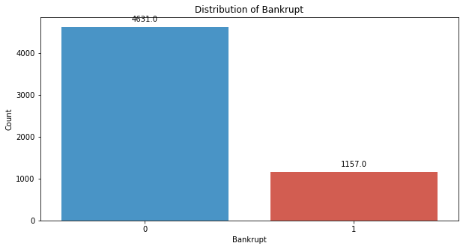
k_values = range(1, 35)
# Initialize lists to store accuracy scores for each K
f1_scores = []
# Iterate through different values of K
for k in k_values:
knn_classifier = KNeighborsClassifier(n_neighbors=k)
knn_classifier.fit(X_resampled_smote, y_resampled_smote)
y_val_pred_smote = knn_classifier.predict(X_val_smote)
f1_value = metrics.f1_score(y_val_smote, y_val_pred_smote)
f1_scores.append(f1_value)
# Plot the results to find the "elbow"
plt.figure(figsize=(10, 6))
plt.plot(k_values, f1_scores, marker='o', linestyle='-')
plt.title("K-NN F1 Score vs. Number of Neighbors (K)")
plt.xlabel("Number of Neighbors (K)")
plt.ylabel("F1 Score")
plt.grid(True)
plt.show()
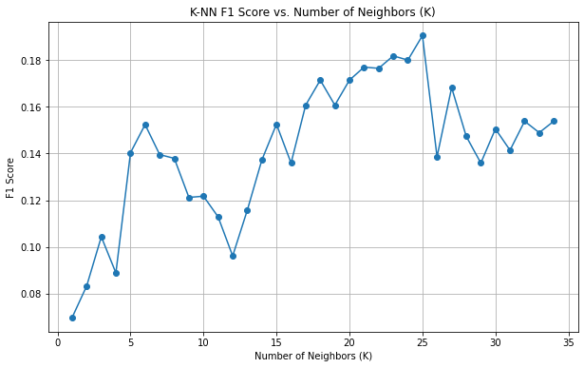
k = 25
knn_classifier_smote = KNeighborsClassifier(n_neighbors=k)
knn_classifier_smote.fit(X_resampled_smote, y_resampled_smote)
KNeighborsClassifier(n_neighbors=25)
y_val_pred_smote = knn_classifier_smote.predict(X_val_smote)
validation_accuracy = accuracy_score(y_val_smote, y_val_pred_smote)
print("Validation Accuracy:", validation_accuracy)
Validation Accuracy: 0.916911045943304
conf_matrix_validation = confusion_matrix(y_val_smote, y_val_pred_smote)
print("Confusion matrix")
print(conf_matrix_validation)
Confusion matrix
[[928 56]
[ 29 10]]
TN, FP, FN, TP = conf_matrix_validation.ravel()
accuracy = (TP + TN) / (TP + TN + FP + FN)
precision = TP / (TP + FP)
recall = TP / (TP + FN)
f1_score = 2 * (precision * recall) / (precision + recall)
# Display other metrics
print(f"Accuracy: {accuracy:.2f}")
print(f"Precision: {precision:.2f}")
print(f"Recall: {recall:.2f}")
print(f"F1 Score: {f1_score:.2f}")
Accuracy: 0.92
Precision: 0.15
Recall: 0.26
F1 Score: 0.19
y_test_pred_smote = knn_classifier_smote.predict(X_test_smote)
test_accuracy = accuracy_score(y_test_smote, y_test_pred_smote)
print("Testing Accuracy:", test_accuracy)
Testing Accuracy: 0.9159335288367546
conf_matrix_testing = confusion_matrix(y_test_smote, y_test_pred_smote)
print("Confusion matrix")
print(conf_matrix_testing)
Confusion matrix
[[933 51]
[ 35 4]]
TN, FP, FN, TP = conf_matrix_testing.ravel()
accuracy = (TP + TN) / (TP + TN + FP + FN)
precision = TP / (TP + FP)
recall = TP / (TP + FN)
f1_score = 2 * (precision * recall) / (precision + recall)
# Display other metrics
print(f"Accuracy: {accuracy:.2f}")
print(f"Precision: {precision:.2f}")
print(f"Recall: {recall:.2f}")
print(f"F1 Score: {f1_score:.2f}")
Accuracy: 0.92
Precision: 0.07
Recall: 0.10
F1 Score: 0.09
# Compute ROC curve and ROC area for each class
fpr_val, tpr_val, _ = roc_curve(y_val_smote, y_val_pred_smote)
roc_auc_val = auc(fpr_val, tpr_val)
fpr_test, tpr_test, _ = roc_curve(y_test_smote, y_test_pred_smote)
roc_auc_test = auc(fpr_test, tpr_test)
# Plot ROC curve
plt.figure(figsize=(8, 8))
plt.plot(fpr_val, tpr_val, color='darkorange', lw=2, label=f'Validation ROC curve (area = {roc_auc_val:.2f})')
plt.plot(fpr_test, tpr_test, color='green', lw=2, label=f'Test ROC curve (area = {roc_auc_test:.2f})')
plt.plot([0, 1], [0, 1], color='navy', lw=2, linestyle='--')
plt.xlim([0.0, 1.0])
plt.ylim([0.0, 1.05])
plt.xlabel('False Positive Rate')
plt.ylabel('True Positive Rate')
plt.title('Receiver Operating Characteristic (ROC) Curve')
plt.legend(loc="lower right")
plt.show()
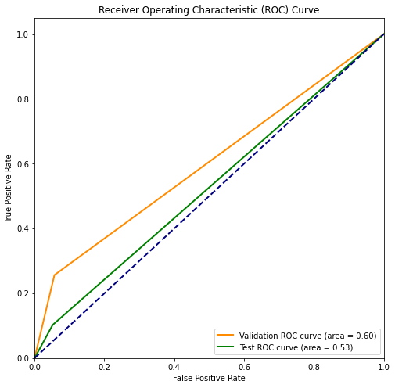
# divinding our dataset into training dataset
X_train_adasyn, X_temp_adasyn, y_train_adasyn, y_temp_adasyn = train_test_split(X, y, test_size=0.3, random_state=42)
X_val_adasyn, X_test_adasyn, y_val_adasyn, y_test_adasyn = train_test_split(X_temp_adasyn, y_temp_adasyn, test_size=0.5, random_state=42)
adasyn = ADASYN(sampling_strategy='minority', random_state=42)
X_resampled_adasyn, y_resampled_adasyn = smote.fit_resample(X_train_adasyn, y_train_adasyn)
#Distribution representation
plt.figure(figsize = (10,5))
colors = ["#3498db", "#e74c3c"]
ax = sns.countplot(x=y_resampled_smote, data=df,palette=colors)
for p in ax.patches:
ax.annotate(f'{p.get_height()}', (p.get_x() + p.get_width() / 2., p.get_height()),
ha='center', va='center', xytext=(0, 10), textcoords='offset points')
# Add labels and title
plt.xlabel('Bankrupt')
plt.ylabel('Count')
plt.title('Distribution of Bankrupt')
# Show the plot
plt.show()
k_values = range(1, 35)
# Initialize lists to store accuracy scores for each K
f1_scores = []
# Iterate through different values of K
for k in k_values:
knn_classifier = KNeighborsClassifier(n_neighbors=k)
knn_classifier.fit(X_resampled_adasyn, y_resampled_adasyn)
y_val_pred_adasyn = knn_classifier.predict(X_val_adasyn)
f1_value = metrics.f1_score(y_val_adasyn, y_val_pred_adasyn)
f1_scores.append(f1_value)
# Plot the results to find the "elbow"
plt.figure(figsize=(10, 6))
plt.plot(k_values, f1_scores, marker='o', linestyle='-')
plt.title("K-NN F1 Score vs. Number of Neighbors (K)")
plt.xlabel("Number of Neighbors (K)")
plt.ylabel("F1 Score")
plt.grid(True)
plt.show()
k = 25
knn_classifier_smote = KNeighborsClassifier(n_neighbors=k)
knn_classifier_smote.fit(X_resampled_adasyn, y_resampled_adasyn)
KNeighborsClassifier(n_neighbors=25)
y_val_pred_adasyn = knn_classifier_smote.predict(X_val_adasyn)
validation_accuracy = accuracy_score(y_val_adasyn, y_val_pred_adasyn)
print("Validation Accuracy:", validation_accuracy)
Validation Accuracy: 0.916911045943304
conf_matrix_validation = confusion_matrix(y_val_adasyn, y_val_pred_adasyn)
print("Confusion matrix")
print(conf_matrix_validation)
Confusion matrix
[[928 56]
[ 29 10]]
TN, FP, FN, TP = conf_matrix_validation.ravel()
accuracy = (TP + TN) / (TP + TN + FP + FN)
precision = TP / (TP + FP)
recall = TP / (TP + FN)
f1_score = 2 * (precision * recall) / (precision + recall)
# Display other metrics
print(f"Accuracy: {accuracy:.2f}")
print(f"Precision: {precision:.2f}")
print(f"Recall: {recall:.2f}")
print(f"F1 Score: {f1_score:.2f}")
Accuracy: 0.92
Precision: 0.15
Recall: 0.26
F1 Score: 0.19
y_test_pred_adasyn = knn_classifier_smote.predict(X_test_adasyn)
test_accuracy = accuracy_score(y_test_adasyn, y_test_pred_adasyn)
print("Testing Accuracy:", test_accuracy)
Testing Accuracy: 0.9159335288367546
conf_matrix_testing = confusion_matrix(y_test_adasyn, y_test_pred_adasyn)
print("Confusion matrix")
print(conf_matrix_testing)
Confusion matrix
[[933 51]
[ 35 4]]
TN, FP, FN, TP = conf_matrix_testing.ravel()
accuracy = (TP + TN) / (TP + TN + FP + FN)
precision = TP / (TP + FP)
recall = TP / (TP + FN)
f1_score = 2 * (precision * recall) / (precision + recall)
# Display other metrics
print(f"Accuracy: {accuracy:.2f}")
print(f"Precision: {precision:.2f}")
print(f"Recall: {recall:.2f}")
print(f"F1 Score: {f1_score:.2f}")
Accuracy: 0.92
Precision: 0.07
Recall: 0.10
F1 Score: 0.09
# Compute ROC curve and ROC area for each class
fpr_val, tpr_val, _ = roc_curve(y_val_adasyn, y_val_pred_adasyn)
roc_auc_val = auc(fpr_val, tpr_val)
fpr_test, tpr_test, _ = roc_curve(y_test_adasyn, y_test_pred_adasyn)
roc_auc_test = auc(fpr_test, tpr_test)
# Plot ROC curve
plt.figure(figsize=(8, 8))
plt.plot(fpr_val, tpr_val, color='darkorange', lw=2, label=f'Validation ROC curve (area = {roc_auc_val:.2f})')
plt.plot(fpr_test, tpr_test, color='green', lw=2, label=f'Test ROC curve (area = {roc_auc_test:.2f})')
plt.plot([0, 1], [0, 1], color='navy', lw=2, linestyle='--')
plt.xlim([0.0, 1.0])
plt.ylim([0.0, 1.05])
plt.xlabel('False Positive Rate')
plt.ylabel('True Positive Rate')
plt.title('Receiver Operating Characteristic (ROC) Curve')
plt.legend(loc="lower right")
plt.show()

