import pandas as pd
import numpy as np
import seaborn as sns
import matplotlib.pyplot as plt
import warnings
warnings.filterwarnings(action="ignore")
from sklearn.model_selection import train_test_split
from sklearn.metrics import accuracy_score, classification_report
from sklearn.ensemble import AdaBoostClassifier
from sklearn.neural_network import BernoulliRBM
from sklearn.preprocessing import StandardScaler
from imblearn.over_sampling import SMOTE
import tensorflow as tf
from tensorflow.keras.models import Sequential
from tensorflow.keras.layers import Dense
from tensorflow.keras.layers import LSTM
from sklearn.metrics import roc_curve, auc
from sklearn import metrics
from sklearn.metrics import confusion_matrix
from sklearn.datasets import make_classification
from sklearn.metrics import accuracy_score, precision_score, recall_score, f1_score
C:\Users\agarw\anaconda3\lib\site-packages\scipy\__init__.py:146: UserWarning: A NumPy version >=1.16.5 and <1.23.0 is required for this version of SciPy (detected version 1.26.2
warnings.warn(f"A NumPy version >={np_minversion} and <{np_maxversion}"
#importing data from the dataset
df = pd.read_csv(r"C:\Users\agarw\OneDrive\Desktop\Dissertation\data.csv")
#checking for bankrupt companies 0 is non-bankrupt and 1 is bankrupt
bankrupt_data = df['Bankrupt?'].value_counts()
bankrupt_data
Bankrupt?
0 6599
1 220
Name: count, dtype: int64
#Distribution representation
plt.figure(figsize = (10,5))
colors = ["#3498db", "#e74c3c"]
ax = sns.countplot(x=df['Bankrupt?'], data=df,palette=colors)
for p in ax.patches:
ax.annotate(f'{p.get_height()}', (p.get_x() + p.get_width() / 2., p.get_height()),
ha='center', va='center', xytext=(0, 10), textcoords='offset points')
# Add labels and title
plt.xlabel('Bankrupt')
plt.ylabel('Count')
plt.title('Distribution of Bankrupt')
# Show the plot
plt.show()
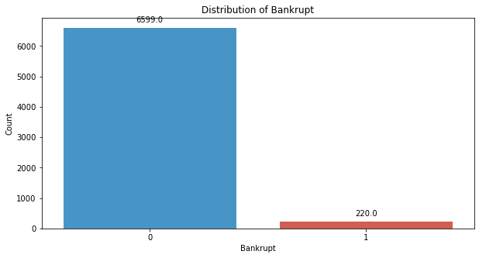
# seperate the Bankrupt label from the dataset
y = df['Bankrupt?']
X = df.drop(['Bankrupt?'], axis = 1)
# divinding our dataset into training dataset
X_train, X_temp, y_train, y_temp = train_test_split(X, y, test_size=0.4, random_state=42)
plt.figure(figsize = (10,5))
colors = ["#3498db", "#e74c3c"]
ax = sns.countplot(x=y_train, data=df,palette=colors)
for p in ax.patches:
ax.annotate(f'{p.get_height()}', (p.get_x() + p.get_width() / 2., p.get_height()),
ha='center', va='center', xytext=(0, 10), textcoords='offset points')
# Add labels and title
plt.xlabel('Bankrupt')
plt.ylabel('Count')
plt.title('Distribution of Bankrupt')
# Show the plot
plt.show()
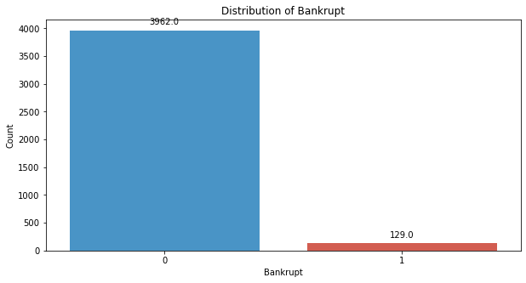
# divinding our dataset into testing and validation
X_val, X_test, y_val, y_test = train_test_split(X_temp, y_temp, test_size=0.5, random_state=42)
smote = SMOTE(sampling_strategy=0.25, random_state=42)
X_train_resampled, y_train_resampled = smote.fit_resample(X_train, y_train)
plt.figure(figsize = (10,5))
colors = ["#3498db", "#e74c3c"]
ax = sns.countplot(x=y_train_resampled, data=df,palette=colors)
for p in ax.patches:
ax.annotate(f'{p.get_height()}', (p.get_x() + p.get_width() / 2., p.get_height()),
ha='center', va='center', xytext=(0, 10), textcoords='offset points')
# Add labels and title
plt.xlabel('Bankrupt')
plt.ylabel('Count')
plt.title('Distribution of Bankrupt')
# Show the plot
plt.show()
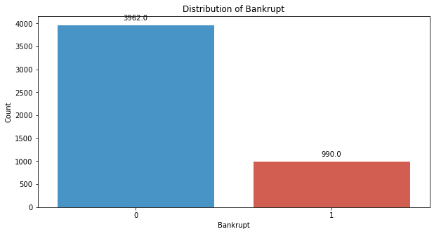
# Standardize the data
scaler = StandardScaler()
X_train_resampled = scaler.fit_transform(X_train_resampled)
X_val = scaler.transform(X_val)
X_test = scaler.transform(X_test)
# Reshape data for LSTM
time_steps = 2 # Since there are no timestamps
features = X_train_resampled.shape[1]
X_train_resampled.shape
(4952, 95)
y_train.shape
(4091,)
X_val.shape
(1364, 95)
X_test.shape
(1364, 95)
features
95
X_train_reshaped = X_train_resampled.reshape(-1, time_steps, features)
X_val_reshaped = X_val.reshape(-1, time_steps, features)
X_test_reshaped = X_test.reshape(-1, time_steps, features)
y_train_reshaped = np.array(y_train_resampled).reshape(-1, time_steps)
y_val_reshaped = np.array(y_val).reshape(-1, time_steps)
y_test_reshaped = np.array(y_test).reshape(-1, time_steps)
X_train_reshaped.shape
(2476, 2, 95)
y_train_reshaped.shape
(2476, 2)
X_val_reshaped.shape
(682, 2, 95)
X_test_reshaped.shape
(682, 2, 95)
y_train_reshaped.shape
(2476, 2)
y_val_reshaped.shape
(682, 2)
y_test_reshaped.shape
(682, 2)
# Build LSTM model
model = Sequential()
model.add(LSTM(units=30, activation='relu', input_shape=(time_steps, features)))
model.add(Dense(units=2, activation='sigmoid'))
model.compile(optimizer='adam', loss='binary_crossentropy', metrics=['accuracy'])
# Train the model using the resampled training data and validate on the validation set
model.fit(X_train_reshaped, y_train_reshaped, epochs=50, batch_size=32,verbose=2)
Epoch 1/50
78/78 - 1s - 17ms/step - accuracy: 0.5206 - loss: 0.3777
Epoch 2/50
78/78 - 0s - 2ms/step - accuracy: 0.6135 - loss: 0.1890
Epoch 3/50
78/78 - 0s - 1ms/step - accuracy: 0.5868 - loss: 0.1451
Epoch 4/50
78/78 - 0s - 1ms/step - accuracy: 0.5210 - loss: 0.1246
Epoch 5/50
78/78 - 0s - 1ms/step - accuracy: 0.5109 - loss: 0.1113
Epoch 6/50
78/78 - 0s - 1ms/step - accuracy: 0.5020 - loss: 0.0991
Epoch 7/50
78/78 - 0s - 1ms/step - accuracy: 0.4499 - loss: 0.0908
Epoch 8/50
78/78 - 0s - 1ms/step - accuracy: 0.4548 - loss: 0.0837
Epoch 9/50
78/78 - 0s - 1ms/step - accuracy: 0.4604 - loss: 0.0766
Epoch 10/50
78/78 - 0s - 1ms/step - accuracy: 0.4693 - loss: 0.0709
Epoch 11/50
78/78 - 0s - 1ms/step - accuracy: 0.4612 - loss: 0.0643
Epoch 12/50
78/78 - 0s - 1ms/step - accuracy: 0.4750 - loss: 0.0607
Epoch 13/50
78/78 - 0s - 1ms/step - accuracy: 0.4523 - loss: 0.0560
Epoch 14/50
78/78 - 0s - 1ms/step - accuracy: 0.4713 - loss: 0.0516
Epoch 15/50
78/78 - 0s - 1ms/step - accuracy: 0.4632 - loss: 0.0471
Epoch 16/50
78/78 - 0s - 1ms/step - accuracy: 0.4507 - loss: 0.0426
Epoch 17/50
78/78 - 0s - 1ms/step - accuracy: 0.4439 - loss: 0.0394
Epoch 18/50
78/78 - 0s - 1ms/step - accuracy: 0.4628 - loss: 0.0361
Epoch 19/50
78/78 - 0s - 1ms/step - accuracy: 0.4507 - loss: 0.0326
Epoch 20/50
78/78 - 0s - 1ms/step - accuracy: 0.4540 - loss: 0.0290
Epoch 21/50
78/78 - 0s - 1ms/step - accuracy: 0.4592 - loss: 0.0265
Epoch 22/50
78/78 - 0s - 1ms/step - accuracy: 0.4435 - loss: 0.0240
Epoch 23/50
78/78 - 0s - 1ms/step - accuracy: 0.4532 - loss: 0.0217
Epoch 24/50
78/78 - 0s - 1ms/step - accuracy: 0.4342 - loss: 0.0192
Epoch 25/50
78/78 - 0s - 1ms/step - accuracy: 0.4366 - loss: 0.0175
Epoch 26/50
78/78 - 0s - 1ms/step - accuracy: 0.4346 - loss: 0.0160
Epoch 27/50
78/78 - 0s - 2ms/step - accuracy: 0.4414 - loss: 0.0144
Epoch 28/50
78/78 - 0s - 2ms/step - accuracy: 0.4164 - loss: 0.0127
Epoch 29/50
78/78 - 0s - 1ms/step - accuracy: 0.4346 - loss: 0.0115
Epoch 30/50
78/78 - 0s - 2ms/step - accuracy: 0.4326 - loss: 0.0101
Epoch 31/50
78/78 - 0s - 1ms/step - accuracy: 0.4188 - loss: 0.0091
Epoch 32/50
78/78 - 0s - 1ms/step - accuracy: 0.4184 - loss: 0.0101
Epoch 33/50
78/78 - 0s - 1ms/step - accuracy: 0.4079 - loss: 0.0086
Epoch 34/50
78/78 - 0s - 1ms/step - accuracy: 0.4144 - loss: 0.0087
Epoch 35/50
78/78 - 0s - 1ms/step - accuracy: 0.3914 - loss: 0.0075
Epoch 36/50
78/78 - 0s - 1ms/step - accuracy: 0.4103 - loss: 0.0167
Epoch 37/50
78/78 - 0s - 1ms/step - accuracy: 0.4103 - loss: 0.0131
Epoch 38/50
78/78 - 0s - 2ms/step - accuracy: 0.4120 - loss: 0.0102
Epoch 39/50
78/78 - 0s - 2ms/step - accuracy: 0.4156 - loss: 0.0051
Epoch 40/50
78/78 - 0s - 1ms/step - accuracy: 0.4035 - loss: 0.0043
Epoch 41/50
78/78 - 0s - 1ms/step - accuracy: 0.4156 - loss: 0.0039
Epoch 42/50
78/78 - 0s - 1ms/step - accuracy: 0.4087 - loss: 0.0035
Epoch 43/50
78/78 - 0s - 1ms/step - accuracy: 0.4023 - loss: 0.0032
Epoch 44/50
78/78 - 0s - 1ms/step - accuracy: 0.4051 - loss: 0.0029
Epoch 45/50
78/78 - 0s - 1ms/step - accuracy: 0.3950 - loss: 0.0026
Epoch 46/50
78/78 - 0s - 1ms/step - accuracy: 0.3942 - loss: 0.0024
Epoch 47/50
78/78 - 0s - 1ms/step - accuracy: 0.3889 - loss: 0.0022
Epoch 48/50
78/78 - 0s - 1ms/step - accuracy: 0.3897 - loss: 0.0020
Epoch 49/50
78/78 - 0s - 1ms/step - accuracy: 0.3922 - loss: 0.0019
Epoch 50/50
78/78 - 0s - 1ms/step - accuracy: 0.3853 - loss: 0.0017
<keras.src.callbacks.history.History at 0x21ff74cf700>
y_pred_val = model.predict(X_val_reshaped)
y_pred_val_binary = (y_pred_val > 0.5).astype(int)
22/22 ━━━━━━━━━━━━━━━━━━━━ 0s 6ms/step
# Evaluate the model's performance on the Validation set
val_accuracy = accuracy_score(y_val_reshaped, y_pred_val_binary)
precision = precision_score(y_val_reshaped, y_pred_val_binary,average='micro')
recall = recall_score(y_val_reshaped, y_pred_val_binary,average='micro')
f1_value = f1_score(y_val_reshaped, y_pred_val_binary,average='micro')
val_report = classification_report(y_val_reshaped, y_pred_val_binary)
print("Accuracy", val_accuracy)
print("Precision", precision)
print("Recall", recall)
print("F1 Score", f1_value)
print("Validation Classification Report:\n", val_report)
Accuracy 0.9193548387096774
Precision 0.3018867924528302
Recall 0.41025641025641024
F1 Score 0.34782608695652173
Validation Classification Report:
precision recall f1-score support
0 0.32 0.48 0.38 21
1 0.27 0.33 0.30 18
micro avg 0.30 0.41 0.35 39
macro avg 0.30 0.40 0.34 39
weighted avg 0.30 0.41 0.35 39
samples avg 0.02 0.02 0.02 39
conf_matrix = confusion_matrix(y_val_reshaped.ravel(), y_pred_val_binary.ravel())
print("Confusion Matrix")
print(conf_matrix)
Confusion Matrix
[[1288 37]
[ 23 16]]
y_pred_test = model.predict(X_test_reshaped)
y_pred_test_binary = (y_pred_test > 0.5).astype(int)
22/22 ━━━━━━━━━━━━━━━━━━━━ 0s 838us/step
# Evaluate the model's performance on the Testing set
val_accuracy = accuracy_score(y_test_reshaped, y_pred_test_binary)
precision = precision_score(y_test_reshaped, y_pred_test_binary,average='micro')
recall = recall_score(y_test_reshaped, y_pred_test_binary,average='micro')
f1_value = f1_score(y_test_reshaped, y_pred_test_binary,average='micro')
val_report = classification_report(y_test_reshaped, y_pred_test_binary)
print("Accuracy", val_accuracy)
print("Precision", precision)
print("Recall", recall)
print("F1 Score", f1_value)
print("Validation Classification Report:\n", val_report)
Accuracy 0.8929618768328446
Precision 0.265625
Recall 0.3269230769230769
F1 Score 0.2931034482758621
Validation Classification Report:
precision recall f1-score support
0 0.30 0.39 0.34 23
1 0.24 0.28 0.25 29
micro avg 0.27 0.33 0.29 52
macro avg 0.27 0.33 0.30 52
weighted avg 0.26 0.33 0.29 52
samples avg 0.02 0.02 0.02 52
conf_matrix = confusion_matrix(y_test_reshaped.ravel(), y_pred_test_binary.ravel())
print("Confusion Matrix")
print(conf_matrix)
Confusion Matrix
[[1265 47]
[ 35 17]]
# Compute ROC curve and ROC area for each class
fpr_val, tpr_val, _ = roc_curve(y_val_reshaped.ravel(), y_pred_val_binary.ravel())
roc_auc_val = auc(fpr_val, tpr_val)
fpr_test, tpr_test, _ = roc_curve(y_test_reshaped.ravel(), y_pred_test_binary.ravel())
roc_auc_test = auc(fpr_test, tpr_test)
# Plot ROC curve
plt.figure(figsize=(8, 8))
plt.plot(fpr_val, tpr_val, color='darkorange', lw=2, label=f'Validation ROC curve (area = {roc_auc_val:.2f})')
plt.plot(fpr_test, tpr_test, color='green', lw=2, label=f'Test ROC curve (area = {roc_auc_test:.2f})')
plt.plot([0, 1], [0, 1], color='navy', lw=2, linestyle='--')
plt.xlim([0.0, 1.0])
plt.ylim([0.0, 1.05])
plt.xlabel('False Positive Rate')
plt.ylabel('True Positive Rate')
plt.title('Receiver Operating Characteristic (ROC) Curve')
plt.legend(loc="lower right")
plt.show()
