import pandas as pd
import numpy as np
import seaborn as sns
import matplotlib.pyplot as plt
import warnings
warnings.filterwarnings(action="ignore")
from sklearn.model_selection import train_test_split
from sklearn.neighbors import KNeighborsClassifier
from sklearn.metrics import accuracy_score, classification_report
from sklearn.model_selection import RepeatedStratifiedKFold, StratifiedKFold
from imblearn.over_sampling import SMOTE
from sklearn.metrics import ConfusionMatrixDisplay
from sklearn.metrics import confusion_matrix
from sklearn.metrics import ConfusionMatrixDisplay
from sklearn.datasets import make_classification
from sklearn.metrics import accuracy_score, precision_score, recall_score, f1_score
#importing data from the dataset
df = pd.read_csv(r"C:\Users\agarw\OneDrive\Desktop\Dissertation\data.csv")
#checking for bankrupt companies 0 is non-bankrupt and 1 is bankrupt
bankrupt_data = df['Bankrupt?'].value_counts()
bankrupt_data
0 6599
1 220
Name: Bankrupt?, dtype: int64
#Distribution representation
plt.figure(figsize = (10,5))
ax = sns.countplot(df['Bankrupt?'])
ax.bar_label(ax.containers[0])
plt.title('Class Distribution \n (0:Financially Stable || 1:Financially Unstable)', fontsize = 14)
plt.show()
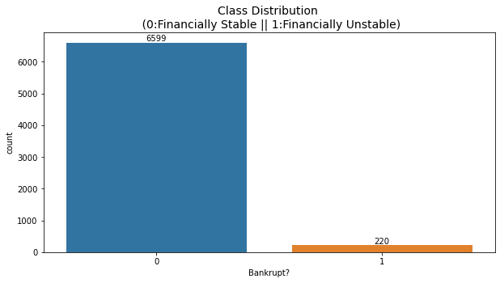
# seperate the Bankrupt label from the dataset
y = df['Bankrupt?']
X = df.drop(['Bankrupt?'], axis = 1)
# divinding our dataset into training dataset
X_train, X_temp, y_train, y_temp = train_test_split(X, y, test_size=0.3, random_state=42)
plt.figure(figsize = (10,5))
ax = sns.countplot(y_train)
ax.bar_label(ax.containers[0])
plt.title('Class Distribution \n (0:Financially Stable || 1:Financially Unstable)', fontsize = 14)
plt.show()
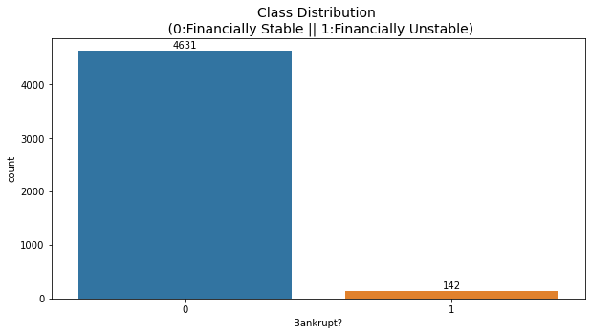
# divinding our dataset into testing and validation
X_val, X_test, y_val, y_test = train_test_split(X_temp, y_temp, test_size=0.5, random_state=42)
k_values = range(1, 10)
# Initialize lists to store accuracy scores for each K
accuracy_scores = []
# Iterate through different values of K
for k in k_values:
knn_classifier = KNeighborsClassifier(n_neighbors=k)
knn_classifier.fit(X_train, y_train)
y_val_pred = knn_classifier.predict(X_val)
accuracy = accuracy_score(y_val, y_val_pred)
accuracy_scores.append(accuracy)
# Plot the results to find the "elbow"
plt.figure(figsize=(10, 6))
plt.plot(k_values, accuracy_scores, marker='o', linestyle='-')
plt.title("K-NN Accuracy vs. Number of Neighbors (K)")
plt.xlabel("Number of Neighbors (K)")
plt.ylabel("Accuracy")
plt.grid(True)
plt.show()
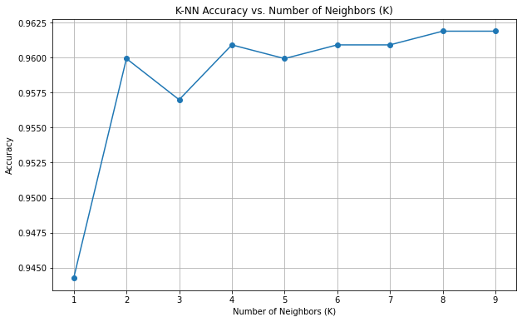
k = 8
knn_classifier = KNeighborsClassifier(n_neighbors=k)
# Step 4: Train the classifier on the training data
knn_classifier.fit(X_train, y_train)
KNeighborsClassifier(n_neighbors=8)
# Step 5: Predict on the validation data
y_val_pred = knn_classifier.predict(X_val)
# Step 6: Evaluate the model on the validation data
validation_accuracy = accuracy_score(y_val, y_val_pred)
validation_precision = precision_score(y_val, y_val_pred)
print("Validation Accuracy:", validation_accuracy)
print("Precision score:", validation_precision)
Validation Accuracy: 0.9618768328445748
Precision score: 0.0
conf_matrix_validation = confusion_matrix(y_val, y_val_pred)
print("Confusion matrix")
print(conf_matrix_validation)
Confusion matrix
[[984 0]
[ 39 0]]
TN, FP, FN, TP = conf_matrix_validation.ravel()
accuracy = (TP + TN) / (TP + TN + FP + FN)
precision = TP / (TP + FP)
recall = TP / (TP + FN)
f1_score = 2 * (precision * recall) / (precision + recall)
# Display other metrics
print(f"Accuracy: {accuracy:.2f}")
print(f"Precision: {precision:.2f}")
print(f"Recall: {recall:.2f}")
print(f"F1 Score: {f1_score:.2f}")
Accuracy: 0.96
Precision: nan
Recall: 0.00
F1 Score: nan
# Step 7: Predict on the testing data
y_test_pred = knn_classifier.predict(X_test)
# Step 8: Evaluate the model on the testing data
test_accuracy = accuracy_score(y_test, y_test_pred)
print("Testing Accuracy:", test_accuracy)
Testing Accuracy: 0.9618768328445748
conf_matrix_testing = confusion_matrix(y_test, y_test_pred)
print("Confusion matrix")
print(conf_matrix_testing)
Confusion matrix
[[984 0]
[ 39 0]]
TN, FP, FN, TP = conf_matrix_testing.ravel()
accuracy = (TP + TN) / (TP + TN + FP + FN)
precision = TP / (TP + FP)
recall = TP / (TP + FN)
f1_score = 2 * (precision * recall) / (precision + recall)
# Display other metrics
print(f"Accuracy: {accuracy:.2f}")
print(f"Precision: {precision:.2f}")
print(f"Recall: {recall:.2f}")
print(f"F1 Score: {f1_score:.2f}")
Accuracy: 0.96
Precision: nan
Recall: 0.00
F1 Score: nan

APPLYING SMOTE
# divinding our dataset into a training dataset
X_train, X_temp, y_train, y_temp = train_test_split(X, y, test_size=0.3, random_state=42)
smote = SMOTE(sampling_strategy=1, random_state=42)
X_resampled, y_resampled = smote.fit_resample(X_train, y_train)
plt.figure(figsize = (10,5))
ax = sns.countplot(y_resampled)
ax.bar_label(ax.containers[0])
plt.title('Class Distribution \n (0:Financially Stable || 1:Financially Unstable)', fontsize = 14)
plt.show()
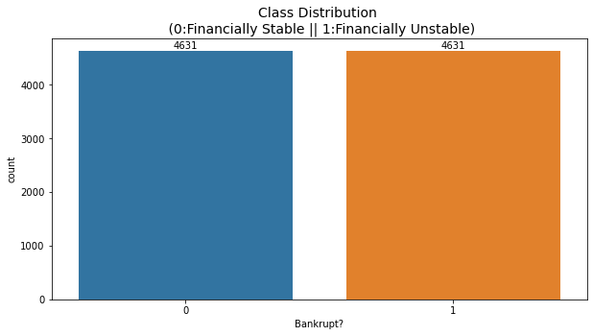
k_values = range(1, 10)
# Initialize lists to store accuracy scores for each K
accuracy_scores = []
# Iterate through different values of K
for k in k_values:
knn_classifier = KNeighborsClassifier(n_neighbors=k)
knn_classifier.fit(X_resampled, y_resampled)
y_val_pred = knn_classifier.predict(X_val)
accuracy = accuracy_score(y_val, y_val_pred)
accuracy_scores.append(accuracy)
# Plot the results to find the "elbow"
plt.figure(figsize=(10, 6))
plt.plot(k_values, accuracy_scores, marker='o', linestyle='-')
plt.title("K-NN Accuracy vs. Number of Neighbors (K)")
plt.xlabel("Number of Neighbors (K)")
plt.ylabel("Accuracy")
plt.grid(True)
plt.show()
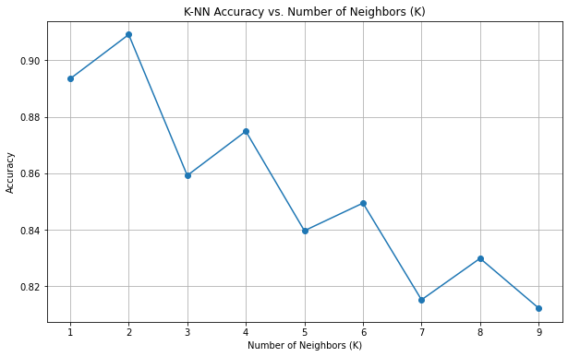
k = 2
knn_classifier_smote = KNeighborsClassifier(n_neighbors=k)
knn_classifier_smote.fit(X_resampled, y_resampled)
KNeighborsClassifier(n_neighbors=2)
y_val_pred = knn_classifier_smote.predict(X_val)
validation_accuracy = accuracy_score(y_val, y_val_pred)
print("Validation Accuracy:", validation_accuracy)
Validation Accuracy: 0.9090909090909091
conf_matrix_validation = confusion_matrix(y_val, y_val_pred)
print("Confusion matrix")
print(conf_matrix_validation)
Confusion matrix
[[925 59]
[ 34 5]]
TN, FP, FN, TP = conf_matrix_validation.ravel()
accuracy = (TP + TN) / (TP + TN + FP + FN)
precision = TP / (TP + FP)
recall = TP / (TP + FN)
f1_score = 2 * (precision * recall) / (precision + recall)
# Display other metrics
print(f"Accuracy: {accuracy:.2f}")
print(f"Precision: {precision:.2f}")
print(f"Recall: {recall:.2f}")
print(f"F1 Score: {f1_score:.2f}")
Accuracy: 0.91
Precision: 0.08
Recall: 0.13
F1 Score: 0.10
y_test_pred = knn_classifier_smote.predict(X_test)
test_accuracy = accuracy_score(y_test, y_test_pred)
print("Testing Accuracy:", test_accuracy)
Testing Accuracy: 0.9110459433040078
conf_matrix_testing = confusion_matrix(y_test, y_test_pred)
print("Confusion matrix")
print(conf_matrix_testing)
Confusion matrix
[[923 61]
[ 30 9]]
TN, FP, FN, TP = conf_matrix_testing.ravel()
accuracy = (TP + TN) / (TP + TN + FP + FN)
precision = TP / (TP + FP)
recall = TP / (TP + FN)
f1_score = 2 * (precision * recall) / (precision + recall)
# Display other metrics
print(f"Accuracy: {accuracy:.2f}")
print(f"Precision: {precision:.2f}")
print(f"Recall: {recall:.2f}")
print(f"F1 Score: {f1_score:.2f}")
Accuracy: 0.91
Precision: 0.13
Recall: 0.23
F1 Score: 0.17

