TITLE: CA Implementation Document

NAME: Darragh Mac Lochlainn

STUDENT NUMBER: 20076319

MODULE: Relational Databases

DATE: 03 / 12 / 2017

Table Of Contents:

Page No. | Contents of Page
1 | Title Page.
2 | Table Of Contents.
3 | Introduction, Business Description.
4 | Business Description.
5 | Entity relational Diagram.
6 | Normalised Tables.
7 | Table Mapping.
8 | Table Mapping.
9 | Table Mapping.
10 | Frequent Queries.
11 | User Priveliges.

Introduction:

This is the implementation document, for Relational Databases Continuous Assesment, of my Cake Store database. This document covers the changes in the Entity Relationship Diagram from the previous document, the sql implementation, an overview of the normalised tables, a list of frequent queries and a brief overview of user privileges. This document is in a zipped folder with an sql file and a png of the ERD.

Business Description:

Stores:
No change in this entity.

Employees:
Schedule instance was removed for normalisation and all subtypes were removed. Subtypes were replaced with Job Title instance. May now make one or more Recipies.

Customers:
Loyalty Card was removed due to redundancy.

Menus:
primary key changed to Name instead of Date Made. Price instance was removed due to normalisation. Must have or more non-transferrable Menu Items.

Recipies:
This new entity was added. Stores a primary key of Name and may have Description stored. Must be made by one and only Employee. Must make up one and only one Prepared Items.

Prepared Items:
This new entity was added. Stores a primary key of Name and must have an Amount stored. Must have one or more Recipies. Must be made up of one or more Ingredients List. Must be sold as one or more non-transferrable Menu Items.

Menu Items:
This entity was non-transferrable. The Name and Amount instances were removed, And Cost was added. Must be on one and only one Menu. Must be made as one and only one Prepared Items.

Ingredients List:
This new entity was added. Must make one and only one Prepared Items. Must list one and only one Ingredients.

Ingredients:
Amount was changed to Description and is now optional. May be listed by one or more Ingredients Lists. Must be affected by on or more Some Dates

Some Dates:
This new entity was added. May have Occasions stored. This replaced the redundant Special Items entity. Must affect one and only one Ingredients. Must have one and only one Supplier

Suppliers:
No Change to this entity. May supply for one or more Some Dates.

Entity Relationship Diagram:

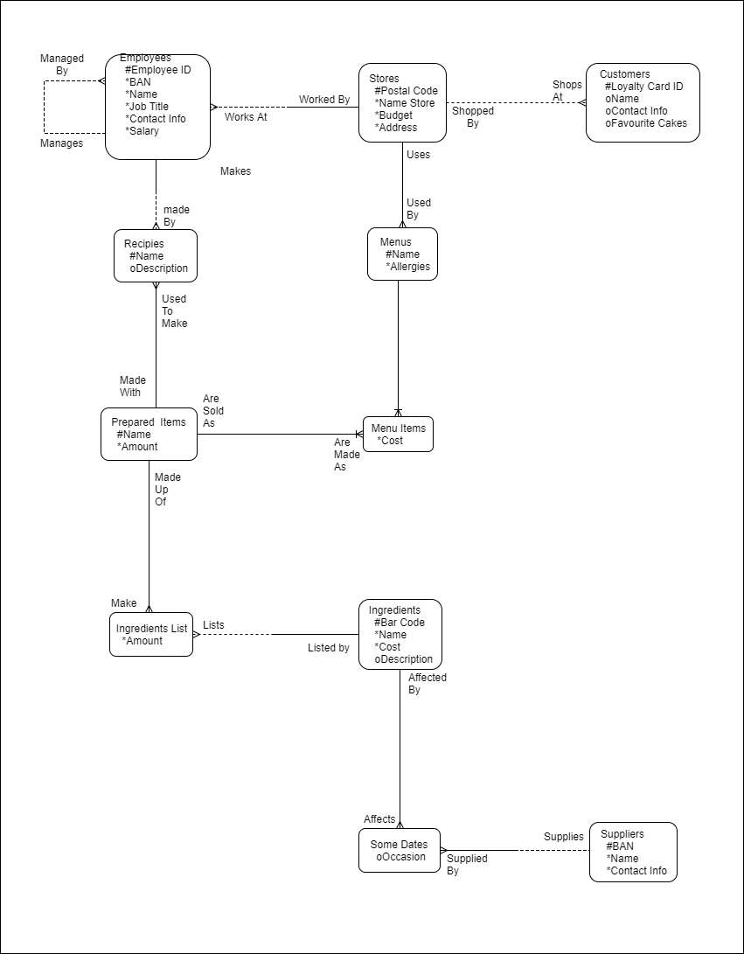
Normalised Tables:
stores(postal_code, name_store, budget, address)

customers(loyaltyCard_ID, nameCustomers, contactInfo, favCakes, postal_code)

employees(employee_ID, banEmployees, nameEmployees, jobTitle, contactInfo, salary, postal_code, manager_ID)

menus(nameMenus, allergies, postal_code)

preparedItems(namePreparedItems, amount)

recipies(nameRecipies, descriptionRecipie, employee_ID, namePreparedItems)

menuItems(costMenu, nameMenus, namePreparedItems)

ingredients(barCode, nameIngredients, costIngredients, decriptionIngredient)

ingredientsList(amount, namePreparedItems, barCode)

suppliers(banSuppliers, nameSuppliers, contactInfo)

someDates(occassion, banSuppliers, barCode)

Table Mapping:

Table Name: stores
Field | Type | Size | Constraints | Description
postal_code | char | 7 | Primary Key | The postal code of the store.
name_store | char | 30 | Not Null | The name of the store.
budget | number | 10,0 | Not Null | The annual amount of money the store works with in a year.
address | char | 50 | Not Null | The physical adddress of the store.

Table Name: customers
Field | Type | Size | Constraints | Description
loyaltyCard_ID | char | 7 | Primary Key | The ID number of the customer’s loyalty card.
nameCustomers | char | 30 |  | The name of the custome.
contactInfo | char | 30 |  | Information to contact the customer.
favCakes | char | 30 |  | The customer's favourite cake type.
postal_code | char | 7 | Foreign Key | The physical adddress of the store.

Table Name: employees
Field | Type | Size | Constraints | Description
employee_ID | char | 7 | Primary Key | The ID number of the employee.
banEmployees | char | 22 | Not Null | The bank account number of the employee.
nameEmployees | char | 30 | Not Null | The name of the employe.
jobTitle | char | 15 | Not Null | The title of the employee's job.
contactInfo | char | 50 | Not Null | Information to contact the employe.
salary | number | 7,2 | Not Null | The amount of money the employee earns per week.
manager_ID | char | 7 |  | The ID number of the manager of the employe.
postal_code | char | 7 | Foreign Key | The physical adddress of the store.

Table Name: menus
Field | Type | Size | Constraints | Description
nameMenus | char | 20 | Primary Key | The name of the menu.
allergies | char | 30 | Not Null | A list of allergies present in the menu.
postal_code | char | 7 | Foreign Key | The physical adddress of the store.

Table Name: preparedItems
Field | Type | Size | Constraints | Description
namePreparedItems | char | 20 | Primary Key | The name of the prepared foods.
amount | number | 3,0 | Not Null | The amount of prepared foods.

Table Name: recipies
Field | Type | Size | Constraints | Description
nameRecipies | char | 20 | Primary Key | The name of the recipies.
descriptionRecipie | char | 80 |  | A description of what the recipie will make.
employee_ID | char | 7 | Foreign Key | The ID number of the employee.
namePreparedItems | char | 20 | Foreign Key | The name of the prepared foods.

Table Name: menuitems
Field | Type | Size | Constraints | Description
costMenu | Number | 5,2 | Not Null | The cost of the menu item.
nameMenus | char | 20 | Foreign Key | The name of the menu.
namePreparedItems | char | 30 | Foreign Key | The name of the prepared foods.

Table Name: ingredients
Field | Type | Size | Constraints | Description
barCode | number | 12,0 | Primary Key | The barcode of the ingredient.
nameIngredients | char | 20 |  | The name of the ingredient.
costIngredients | number | 5,2 |  | The cost of the ingredient.
decriptionIngredient | char | 30 |  | A description of the ingredient.

Table Name: ingredientsLists
Field | Type | Size | Constraints | Description
amount | number | 4,0 | Not Null | The ammount of ingredients needed for the prepared item.
namePreparedItems | char | 20 | Foreign Key | The name of the prepared foods.
barCode | number | 12,0 | Foreign Key | The barcode of the ingredient.

Table Name: suppliers
Field | Type | Size | Constraints | Description
banSuppliers | char | 22 | Primary Key | The bank account number of the supplier.
nameSuppliers | char | 30 |  | The name of the supplier.
contactInfo | char | 30 |  | Information to contact the supplier.

Table Name: someDates
Field | Type | Size | Constraints | Description
occassion | char | 15 |  | A specific occasion such as birthdays or christmas.
banSuppliers | char | 20 | Foreign Key | The bank account number of the supplier.
barCode | number | 12,0 | Foreign Key | The barcode of the ingredient.

Frequent Queries:
SELECT postal_code, name_store, budget, address
FROM store
WHERE budget <= 20000;
Looking for all stores with a budget less then or equal to 20000.

SELECT loyaltyCard_ID, nameCustomers, contactInfo, favCakes, postal_code
FROM customers
WHERE favCakes IN('Chocolate');
Looking for all customers who like chocolate cake.

SELECT employee_ID, banEmployees, nameEmployees, jobTitle, contactInfo, salary, postal_code
FROM employee
WHERE nameEmployees LIKE '%Smith';
Looking for all employees with the last name smith.

SELECT nameMenus, allergies, postal_code
FROM menu
WHERE allergies LIKE 'Nuts';
Looking for all menus that have nut allergies.

SELECT namePreparedItems, amount
FROM preparedItems
WHERE amount <= 25;
Looking for all items that are 25 or fewer

SELECT nameRecipies, descriptionRecipie, employee_ID, namePreparedItems
FROM recipie
WHERE nameRecipies = 'Apple Pie';
Looking for all recipies of apple pie.

SELECT costMenu, nameMenus, namePreparedItems
FROM menuItems
WHERE costMenu <= 20.00;
Looking for all items that cost €20 or less.

SELECT barCode, nameIngredients, costIngredients, decriptionIngredient
FROM ingredient
WHERE nameIngredients LIKE 'Sugar';
Looking for all sugar ingredients.

SELECT amount, barcode, namePreparedItems
FROM ingredientsLists
WHERE amount <= 40;
Looking for all Lists that have 40 or less ingredients

SELECT banSuppliers, nameSuppliers, contactInfo
FROM suppliers
WHERE nameSuppliers LIKE '%SMITH' AND contactInfo LIKE '%@email.com';
Looking for all suppliers that use an email.

SELECT occassion, banSuppliers, barCode
FROM someDates
WHERE occassion = 'Annual';
Looking for all annual dates.

User Priveliges:
Most tables are read and write for most staff. All tables may be read and updated by admins. Employees, Suppliers and Stores may only be updated by managers and higher. These are sensitive and must be restricted to authorised personnel.

